Ryan Herrmann

Lab 6a

BMED 430

**Introduction**

The purpose of this lab was to use python to solve for the 1D heat equation for temperature of a bar that is insulated and exposed on both ends. The first part of the lab was solved via linsolve built in function.

**Numerical Methods**

The numerical method used was the built in linsolver.

**Pseudo Code**

* Import required packages
* Define constants and input data
  + Sigfigs
  + Length of rod
  + Points on the rod
* Create the matrix that will define the points on the rod
* Use numpy.linalg.solve
* Export to dataframe
* Use df to csv
* Plot the resulting graph
* Save fig

**Output**

The graph for the heat versus length is shown in Figure 1.

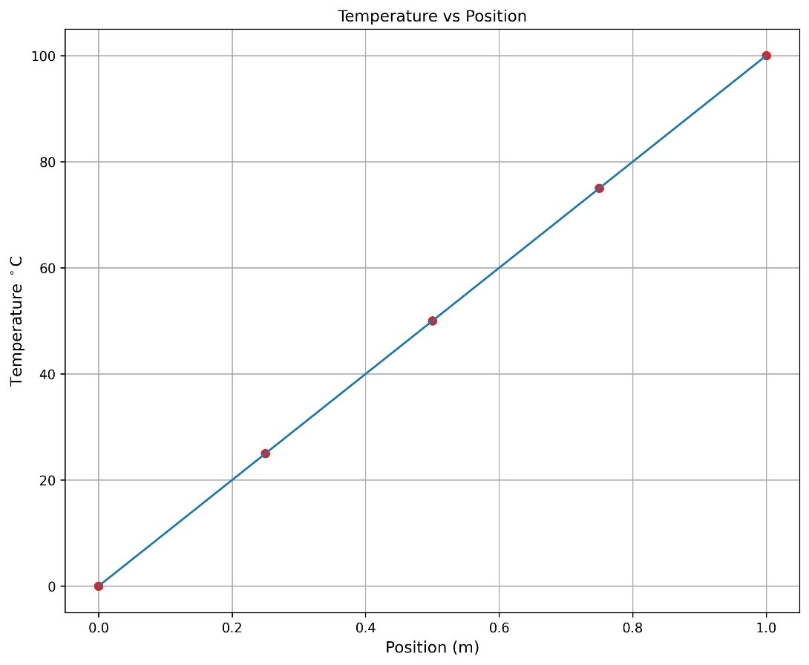

**Figure 1: Temperature of the rod based on position of the points:** the graph of the rod temp when the side was exposed  
Table 1 shows the points and the temp at the time.

**Table 1: Position on the rod and temperature associated with it**

|  |  |
| --- | --- |
| Position (m) | Temperature (C) |
| 0 | 0 |
| 0.25 | 25 |
| 0.5 | 50 |
| 0.75 | 75 |
| 1 | 100 |

**Discussion**

This proved that the built in solver for python works, and the linsolve can be used to solve for heat linearly.

**Appendix**

import numpy as np

import matplotlib.pyplot as plt

import pandas

#setup m matrix finite diff metrix

#setup c matrix solution matrix

L = 1 #m

sigfigs = 4

n = 3

n1 = n+1

n2 = n1 + 1

dx = L/n1

mMat = np.zeros((n2,n2))

cMat = np.zeros((n2))

mMat[n1,n1] = 1

mMat[0,0] = 1

cMat[-1] = 100.00

LoHS = 0.0

L_xp = [0]

L_xpf = ['%.*g'%(sigfigs,LoHS)]

#append format so that I dont have to keep writing the same thing over and over

def L_xpfAppend(n):

    L_xpf.append('%.*g' % (sigfigs,n))

for i in range(1,n1):

    L_xp.append(i*dx)

    L_xpfAppend(i*dx)

    mMat[i,i] = -2

    mMat[i, i-1] = 1

    mMat[i, i+1] = 1

    cMat[i] = 0

#test print matrix

print(mMat)

print(cMat)

L_xp.append(L)

L_xpfAppend(L)

solve = np.linalg.solve(mMat,cMat)

#test print

print(solve)

print(L_xp)

fig = plt.figure(figsize = (10,8))

plt.plot(L_xp, solve, 'o', color = "tab:red")

plt.plot(L_xp, solve, '-', color = "tab:blue")

plt.title('Temperature vs Position', fontsize = 12)

plt.ylabel('Temperature $^\circ$C', fontsize = 12)

plt.xlabel('Position (m)', fontsize = 12)

plt.grid(True)

plt.show()

fig.savefig('Heat_Transfer/ResultFig.jpeg',dpi = 300,bbox_inches = 'tight')

results = {'Position (m)': L_xpf, 'Temperature (C)': solve}

df1 = pandas.DataFrame(results)

print(df1)

with open('Heat_Transfer/TempTable.csv','w',newline='') as f:

    df1.to_csv(f)

    f.write("\n")