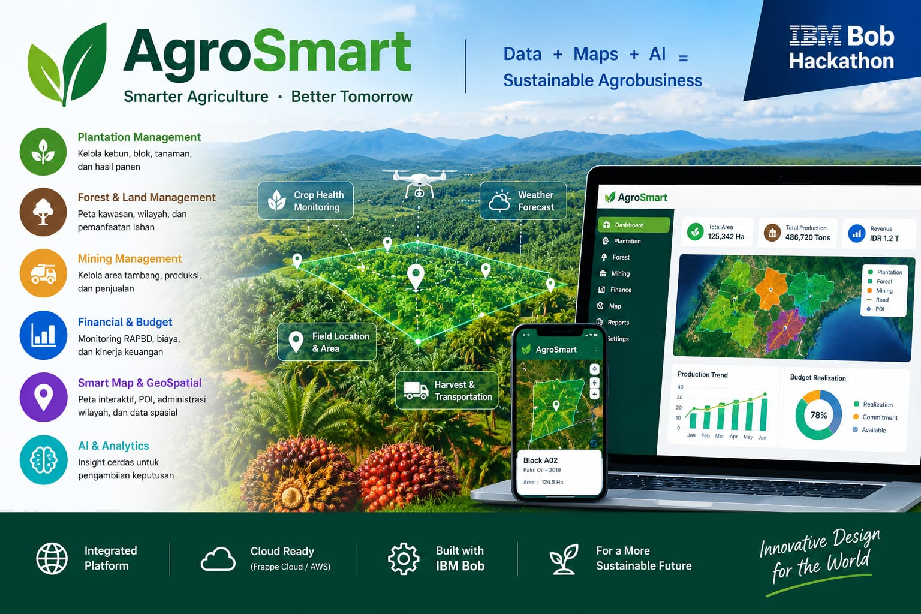
erpAgroSmart — AI-Powered Palm Oil Plantation Intelligence
IBM Bob Hackathon Submission
Integrated ERP + Indonesian Palm Oil Standards & Compliance Library · Financial Reporting · Mapping/GIS Integration
About Inodesain — IBM Business Partner
Inodesain is a long-established IBM Business Partner (IBM BP) with deep roots in the Indonesian agrobusiness sector. For many years, Inodesain has delivered enterprise-grade technology solutions to plantation companies, helping them digitise operations, manage assets, and make data-driven decisions across some of Indonesia's largest palm oil and forestry estates.
As a trusted IBM Business Partner, Inodesain combines IBM's enterprise technology platform with deep domain expertise in:
• Plantation Management — end-to-end estate operations from nursery to mill
• Forest & Land Management — GIS mapping, kawasan, and land utilisation
• Financial Reporting — full GL with Chart of Accounts, double-entry journal ledger, CPO/Kernel sales, COGS, budget variance, and KPI financial dashboard
• Mapping & GIS Integration — interactive block compliance map, infrastructure POI overlays, spatial gap heatmap, and click-to-inspect IBM Bob AI panel
• AI & Analytics — intelligent insights for faster, better decision-making
Now Upgrading with IBM Bob AI Capabilities
Inodesain is now taking its battle-tested agrobusiness platform to the next level by embedding IBM Bob AI as the intelligence layer. erpAgroSmart is not a new product built from scratch — it is the evolution of years of real-world plantation ERP experience, supercharged with AI capabilities: natural language Q&A against live operational data, automatic Indonesian Palm Oil Standards compliance scoring across 50+ parameters, and AI-driven corrective recommendations grounded in Indonesian palm oil agronomy standards.
1. Executive Summary
erpAgroSmart is a comprehensive web-based ERP system purpose-built for Indonesian palm oil plantation management. It covers the full operational chain — from nursery and field operations through to mill processing, inventory, and financial reporting — all within a single integrated platform.
The system is powered by IBM Bob AI, which enables plantation managers to interact with their operational data through natural language Q&A, automatically benchmark actual performance against GAPKI / PPKS / SNI / RSPO / ISPO standards, and receive intelligent recommendations when deviations are detected.
Key Value Proposition: erpAgroSmart transforms raw plantation data into actionable compliance intelligence — answering the question every Indonesian estate manager needs answered daily: "Is my plantation meeting Indonesian Palm Oil standards?"
2. Problem Statement
Indonesia is the world's largest palm oil producer, contributing over 60% of global supply. Yet most plantation operations — particularly small and medium estates — suffer from three critical gaps:
- 1. Fragmented Data: Production, cost, quality, and agronomic data live in separate spreadsheets with no unified view.
- 2. No Standards Benchmark: Managers have no automated way to compare actual performance against GAPKI, PPKS, SNI, RSPO, or ISPO benchmarks across 50+ parameters.
- 3. Slow Decision-Making: Without an AI layer, identifying root causes of underperformance — such as low OER, high harvest losses, or off-standard fertilizer doses — requires days of manual analysis.
3. Solution: erpAgroSmart Platform
erpAgroSmart solves all three gaps through a unified architecture: a full-stack plantation ERP with IBM Bob AI embedded as a compliance and advisory engine.
3.1 System Architecture
erpAgroSmart is built on a 5-level organisational hierarchy that mirrors how Indonesian palm oil estates are actually structured:
Level 1: Company → Level 2: Business Unit (Estate / Mill / Nursery) → Level 3: Division (Afdeling) → Level 4: Planting Year → Level 5: Block
Figure: erpAgroSmart Infrastructure in Plantation — Connecting People, Land and Resources
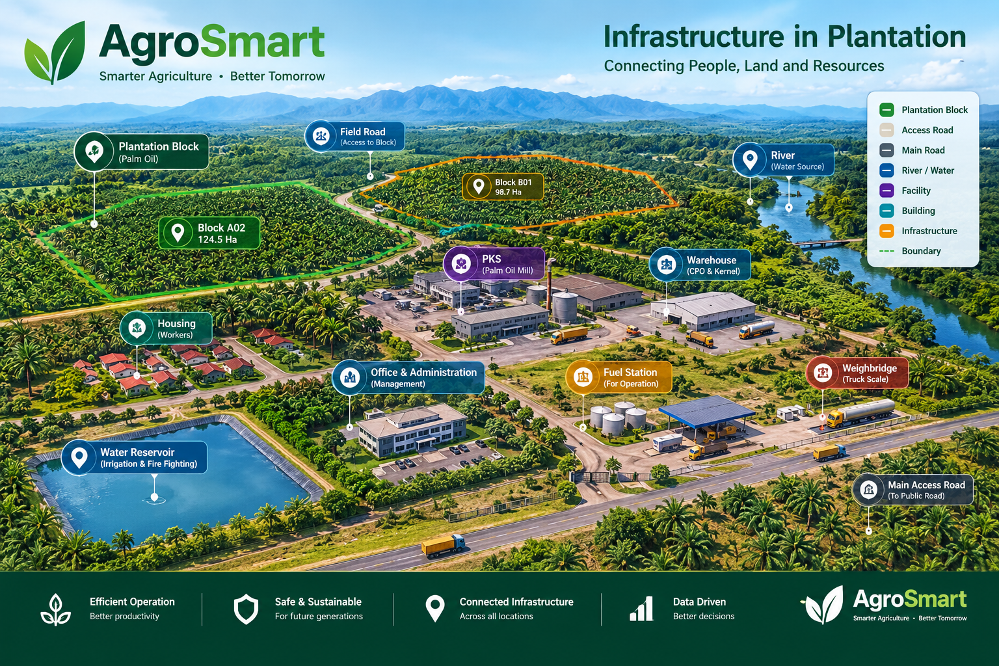
Technology Stack: PHP 8+ · MariaDB / PostgreSQL · Bootstrap 5 · React (Analytics Dashboard) · Apache / XAMPP · IBM Bob AI
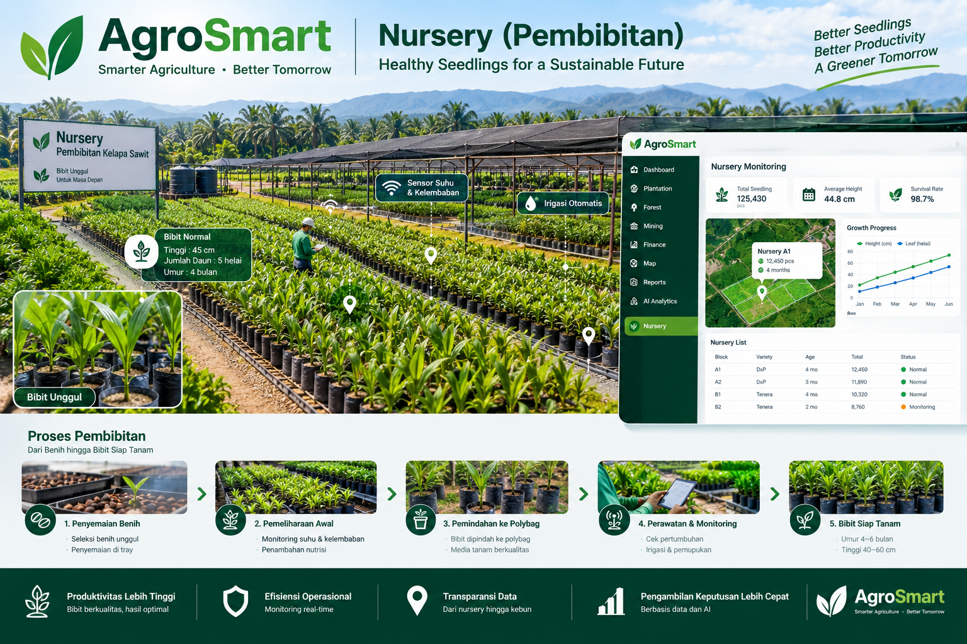
Figure: erpAgroSmart Nursery Module — Healthy Seedlings for a Sustainable Future
3.2 Modules Built
Module | Key Features | Status
Master Data | Companies, Business Units, Divisions, Planting Years, Blocks (5-level hierarchy), Plant Varieties, Workers, Partners | Ready
Nursery | Seedling stock, Production planning, Distribution tracking | Ready
Field Operations | Work orders, Maintenance, Fertilization, Pest control | Ready
Harvesting | Harvest plans, Realizations, Productivity tracking, Quality control, FFB delivery | Ready
Mill Operations | CPO/Kernel processing, Production records, Quality control (OER, FFA, KER, moisture) | Ready
Inventory | CPO stock, Kernel stock, Materials management | Ready
Financial | Chart of Accounts (49 GL accounts), double-entry journal entries (42 posted), CPO & Kernel sales ledger (IDR 62.1B YTD), COGS recognition, OpEx accruals, depreciation (IDR 677.5M H1), budget variance rollup with missed-execution flags (8 gaps), KPI actuals vs targets (10 KPIs × monthly) | Ready
Reports & Analytics | KPI Dashboard (10 KPIs × monthly actuals + targets), Cost by block/activity, Budget variance with gap analysis, Profitability by product (CPO/Kernel), React Dashboard, Variance Report | Ready
Indonesian Industry Standards Library | 50+ parameters across 10 categories: Plantation, Mill, Nursery, Infrastructure, Finance, Fertilization, Weed Control, Pest & Disease, Agro Chemical, Sustainability | Ready
Industry Standard Compliance Analyzer | Actual vs Standard dashboard — automatic pass/warn/fail scoring per parameter with IBM Bob AI recommendations | Hackathon Build
User Authentication | Role-based login (admin, manager, user), session management, company/division scoping | Ready
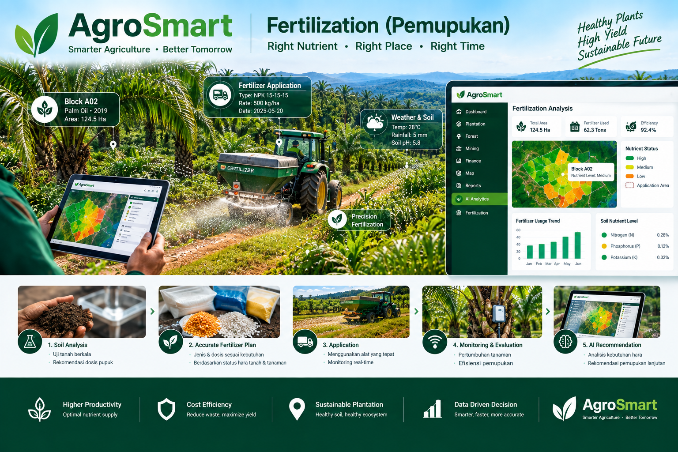
Figure: Fertilization Module — Precision Nutrient Management for Maximum Palm Oil Yield
4. Indonesian Palm Oil Standards Integration
At the core of erpAgroSmart's competitive advantage is its embedded Indonesian Palm Oil Standards Library — a comprehensive, machine-readable reference of Indonesian palm oil industry benchmarks drawn from six authoritative sources:
GAPKI (Gabungan Pengusaha Kelapa Sawit Indonesia) | PPKS Medan (Pusat Penelitian Kelapa Sawit) | SNI 8171:2015 & SNI 7182:2015 | Permentan RI (No. 11/2015, 98/2013, 39/2017, 47/2017) | RSPO P&C 2018 | ISPO 2020
4.1 Standards Coverage — 50+ Parameters Across 10 Categories
Category | Key Parameters | Source
Plantation | SPH 136-148/ha, Normal plant ratio >=92%, Dead plant <2%, TM ratio >=70%, FFB yield >=20 ton/ha/yr, ABW 15-25 kg, Harvest interval 7-14 days, Harvest losses <2% | GAPKI / PPKS 2018-2022
Mill | OER >=22%, KER >=4.5%, Oil losses <1.65%, FFA <3.5%, Moisture <0.15%, Capacity utilisation 70-95% | SNI 7182:2015 / GAPKI
Nursery | Germination rate >=80%, Pre/Main nursery survival >=90%, Abnormal seedlings <5%, Height at 9 months 100-150 cm, Leaf count >=9 | SNI 8171:2015 / PPKS 2019
Infrastructure | Production road density 100-150 m/ha, Main road 30-60 m/ha, Road width >=6m (prod) / >=9m (main), Bridge density 0.5-3/km | GAPKI / Ditjenbun 2017-2018
Fertilization | Urea 1.5-2.5 kg/palm/yr, TSP 0.75-1.5 kg/palm/yr, MOP 2.0-3.5 kg/palm/yr, Kieserit 0.75-1.5 kg/palm/yr, Realization >=90%, Frequency 2-4x/year | PPKS Medan 2020
Weed Control | Piringan clean >=85%, Gawangan clean >=80%, Rotation 60-120 days, Herbicide dose 1.5-3.0 L/ha, Manual norm 80-120 palms/HK | PPKS / GAPKI 2018-2019
Finance | Production cost <Rp800/kg FFB, Maintenance cost <Rp8 juta/ha/yr | GAPKI Benchmark 2023
Sustainability | Conservation area >=20% of HGU, Riparian buffer >=50m | ISPO 2020 / RSPO P&C 2018
Pest & Disease | Ganoderma infection <10%, Rat damage <5%, Census frequency >=2x/year | PPKS / GAPKI 2019
Agro Chemical | Pesticide registered use only, PHI compliance, Operator PPE 100%, Calibration frequency >=2x/year | Permentan No.39/2017
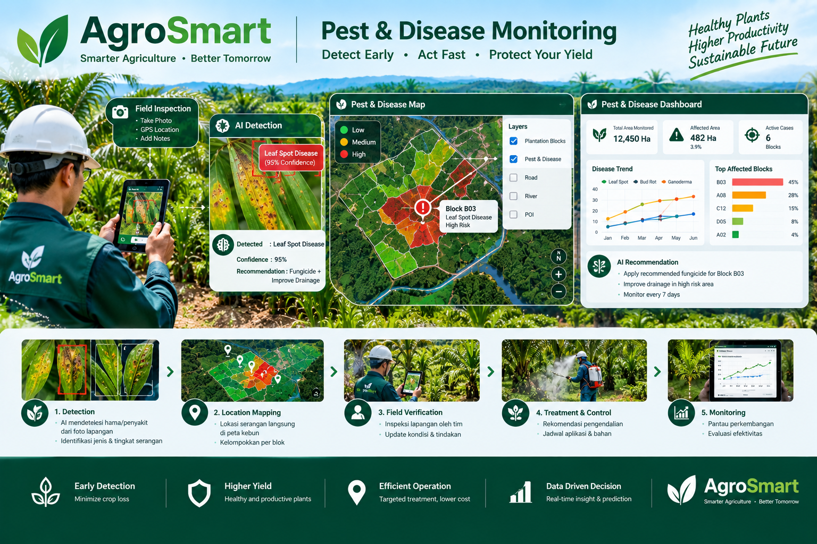
Figure: Pest & Disease Control Module — Early Detection and Integrated Management for Healthy Palm Oil Estates
5. IBM Bob AI Integration
IBM Bob AI is the intelligence layer that transforms erpAgroSmart from a data recording system into a proactive advisory platform. For the Hackathon, Bob is integrated as a structured compliance Q&A engine — delivering pre-defined, standards-grounded answers for every Indonesian Palm Oil Standards gap detected. Free-form natural language Q&A is planned as a future enhancement (see Section 10).
5.1 Structured Indonesian Palm Oil Standards Compliance Q&A (Hackathon Feature)
Managers can ask Bob questions in plain language against their live plantation data. For example:
- "What is the current OER for our Riau mill this month?"
- "Which blocks have below-standard SPH?"
- "Is our fertilizer realization rate meeting PPKS recommendations?"
- "What corrective actions should we take for blocks with harvest losses above 5%?"
5.2 Indonesian Palm Oil Standards Compliance Analyzer Dashboard (Hackathon Feature)
The flagship feature being built during the Hackathon is the Indonesian Palm Oil Standards Compliance Analyzer — a dashboard that automatically joins every actual KPI from the database against the standards library and produces a compliance scorecard:
- PASS (green): Actual meets or exceeds the GAPKI/SNI/PPKS standard
- WARN (amber): Actual is in the warning zone — requires attention
- FAIL (red): Actual is below minimum standard — immediate action required
For every WARN or FAIL parameter, IBM Bob automatically generates a plain-language explanation of the deviation and a prioritised list of corrective recommendations — grounded in the specific standard being violated (e.g. PPKS fertilization norms, SNI mill quality thresholds, ISPO sustainability requirements).
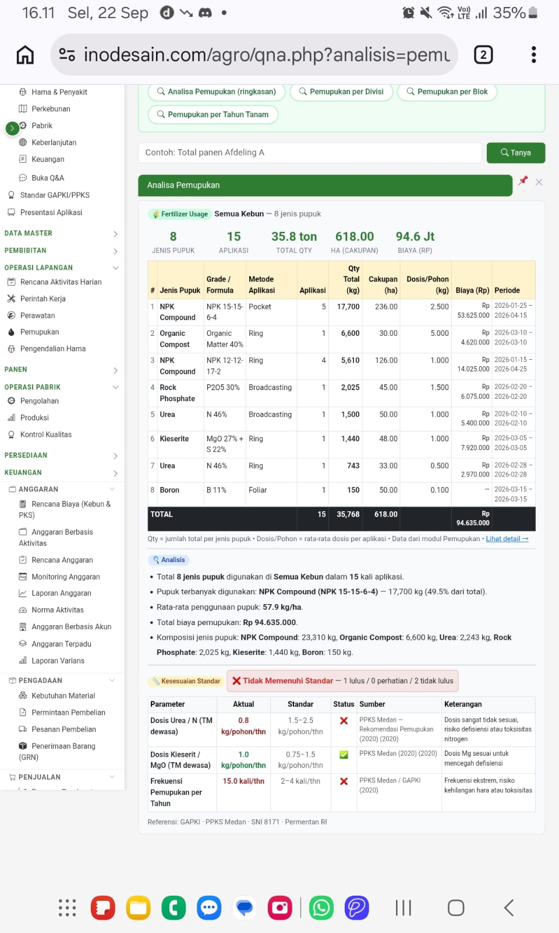

6. Technical Architecture
- Backend: PHP 8+, Apache, XAMPP — pure PHP architecture with no framework overhead, enabling fast deployment on any estate office server.
- Database: MariaDB / PostgreSQL — full relational schema with 40+ tables, referential integrity, stored procedures, triggers, and computed views.
- Frontend: Bootstrap 5 + Bootstrap Icons for the main ERP interface. React (Vite) for the interactive analytics dashboard.
- Standards Engine: config/standards.php — a pure PHP constants file defining 50+ standards with pass_min, pass_max, warn_min, warn_max, display, source, and notes per parameter. Zero database dependency — portable and maintainable.
- AI Layer: IBM Bob — accessed via the agro_std_check() function which returns pass/warn/fail status for any actual value against any standard, feeding Bob with structured context for compliance narration.
7. Hackathon Demo Flow
The demo will follow this narrative arc, showing judges a complete end-to-end journey from raw data to AI-powered compliance insight:
- Step 1 — Login: Manager logs in. Session scoped to their company, business unit, and role.
- Step 2 — Dashboard: Overview of total area, active blocks, production YTD, mill OER, and budget variance.
- Step 3 — Live Data: Navigate to Harvesting > Realizations to show actual FFB data. Navigate to Mill > Quality to show OER, FFA, KER actuals.
- Step 4 — Indonesian Palm Oil Standards Library: Open standards.php to show the 50+ parameter reference — filterable by category, sourced from GAPKI/PPKS/SNI/RSPO/ISPO.
- Step 5 — Indonesian Palm Oil Standards Compliance Analyzer (Hackathon Feature): Show the actual vs standard scorecard. Bob highlights deviations in red/amber and narrates corrective actions.
- Step 6 — Bob Structured Compliance Q&A: For each failing parameter, Bob is triggered with a structured prompt (e.g. "Fertilization realization is 74% vs PPKS minimum 90%. Give 3 corrective actions.") — returning a standards-cited recommendation. Demonstrates AI compliance advisory without free-form NLP.
8. Competitive Differentiation
erpAgroSmart stands apart from generic ERP systems and plantation management tools in five ways:
- 1. Indonesian Industry Standards Embedded — Not just data collection, but automatic compliance scoring against GAPKI, PPKS, SNI, RSPO, and ISPO.
- 2. Full Operational Chain — Covers nursery to mill, from seedling germination rates to CPO FFA quality, within a single unified system. No data silos, no manual exports.
- 3. IBM Bob as Agronomy Advisor — Bob does not just surface data; it interprets deviations, cites the relevant standard (e.g. 'Your OER of 20.5% is below the SNI 7182:2015 minimum of 22%'), and recommends specific interventions grounded in Indonesian palm oil agronomy best practice.
9. Hackathon Roadmap
The following features have been built or are being enhanced during the Hackathon:
- Indonesian Palm Oil Standards Compliance Analyzer Dashboard — the gapki_compliance.php page joining all actuals against the standards library with pass/warn/fail visual scorecard per category.
- IBM Bob Compliance Narration — Bob AI integration on the compliance page, generating plain-language deviation explanations and corrective action recommendations in Bahasa Indonesia.
- Cross-Module KPI Drill-Down — Allow Bob to drill from a failing compliance parameter directly to the source transaction records (e.g. from low OER to the specific mill processing batches causing it).
- Trend Analysis — Historical actual vs standard tracking showing whether compliance gaps are improving or deteriorating over time.
10. Future Development
Beyond the Hackathon, Inodesain has identified the following strategic enhancements — including two capability domains delivered during this Hackathon (Financial Reporting and GIS/Mapping Integration) and three AI-powered visual intelligence capabilities planned for future phases:
10.1 Advanced Financial Reporting (Delivered in Hackathon)
erpAgroSmart's financial module has been elevated from basic journal entry recording to a full plantation-grade reporting engine. Delivered capabilities include: (a) General Ledger with 49 Chart of Accounts across 6 account types; (b) Monthly CPO/Kernel sales ledger — IDR 62.1 billion CPO + Kernel (Jan–Sep 2026) posted to AR and Revenue GL; (c) Budget Variance rollup with 8 missed executions flagged; (d) 10-KPI financial dashboard with monthly actuals vs annual targets. Roadmap: automated P&L generation, cost-per-kg-FFB trending, SAP/Odoo journal synchronisation.

10.2 Mapping & GIS Integration (Delivered in Hackathon)

erpAgroSmart integrates geospatial intelligence directly into plantation operations — a live spatial view where every block, road, facility, and compliance score is visible on an interactive map. Delivered capabilities: (a) Leaflet.js block compliance map colour-coded by Indonesian Palm Oil Standards score (green/amber/red); (b) Infrastructure POI overlays — roads, bridges, warehouses, nursery, mill — with automatic density check vs Indonesian Palm Oil Standards; (c) Click-to-inspect side panel showing block metrics and IBM Bob's top corrective recommendation; (d) Spatial gap heatmap revealing operational gap clusters by geography. Roadmap: GPS track logging, drone imagery, NDVI rasters, BIG basemap integration.

10.3 Visual Pest & Disease Detection System (Future)

erpAgroSmart's Pest & Disease Control module is currently record-based. The next evolution is an AI-powered visual detection layer — enabling field workers and drones to submit photos directly into the system for automatic pest identification, severity classification, and PPKS-grounded treatment recommendations.
Phase 1 — Photo Upload + IBM Bob Analysis
- Field workers upload block photos via erpAgroSmart. IBM Bob identifies the pest or disease, estimates severity, and recommends treatment in Bahasa Indonesia — grounded in Indonesian Palm Oil Standards.
Phase 2 — watsonx.ai Image Classification
- Integration with IBM watsonx.ai trained on Indonesian palm oil pest taxonomy (Ganoderma, Bagworm, Rat damage, Leaf Blight, etc.) — auto-filling pest type, name, and severity upon photo submission.
Phase 3 — Drone & On-Premise IoT Integration
- On-premise YOLOv8 model deployed alongside erpAgroSmart for remote estates with no internet connectivity — processing drone imagery locally with full data sovereignty across Indonesian plantation sites.
10.4 Visual FFB (Fresh Fruit Bunch) Grading System (Future)
FFB quality grading is currently done manually at the ramp — a time-consuming, subjective process prone to human error. AI-powered visual grading replaces manual inspection with instant, objective, camera-based quality scoring at the point of delivery.
- Automatic Ripeness Classification: Camera at the FFB ramp captures bunch images. AI classifies each bunch as Unripe / Ripe / Overripe / Empty / Abnormal — directly mapping to PPKS grading standards (ABW 15–25 kg, ripeness fraction ≥65%).
- OER Prediction & Mill Linkage: Grading results feed directly into erpAgroSmart's FFB Delivery and Mill Processing modules — enabling predictive OER calculation before bunches enter the press, reducing FFA and quality deviations.
- Indonesian Palm Oil Standards Compliance & Bob Narration: IBM Bob automatically flags grading deviations against SNI 7182:2015 and PPKS harvest quality standards, and generates corrective harvesting instructions for the field team — closing the loop from mill back to block.
Vision: From reactive record-keeping to proactive field, financial & spatial intelligence — where every block on the map shows its live compliance score, every journal entry traces to a plantation activity, every field photo becomes an AI-analysed data point, and every manager question gets a grounded, standards-cited answer from IBM Bob.
10.5 Free-Form Natural Language Q&A (Future)
The Hackathon delivers structured compliance Q&A via templated Bob prompts. The next step is enabling plantation managers to ask Bob any question in plain language against their live operational data — without pre-defined templates.
- Example future queries: "Which blocks have below-standard SPH?" · "Is our fertilizer realization meeting PPKS recommendations?" · "What is the OER trend for our Riau mill this quarter?"
- What it requires: Dynamic SQL generation from natural language, live database context injection into Bob prompts, multi-table query reasoning across the full erpAgroSmart schema — significant engineering effort beyond the Hackathon scope.
11. Team & Closing Statement
erpAgroSmart was built for and during the IBM Bob Hackathon as a real-world demonstration of what AI-powered ERP can deliver for the Indonesian palm oil sector — the backbone of the nation's agricultural economy.
Indonesia produces 60% of the world's palm oil. Helping its plantation managers operate at Indonesian Palm Oil Standards, with full financial transparency and spatially-aware operations — through intelligent, affordable, and locally-grounded software — is not just a product opportunity. It is a national competitiveness imperative.
erpAgroSmart + IBM Bob: Indonesian Palm Oil Standards Compliant · Financially Transparent · Spatially Intelligent.
--- End of Submission Document ---
Built with IBM Bob | IBM Bob Hackathon 2026 | erpAgroSmart v2.0

