
Computer Science 328 -01

Due Date: Satuday, January 20, 2024 (before midnight)

Lab Assignment #1
Objectives:
- Getting the basic hardware and software required for the course
- Creating three virtual machines with two Debian-based Linux distros
- Getting familiar with some commonly used Linux commands.
- Setting static ip addresses for all VMs
- Testing the connectivity between all virtual machines

Please open this word file on your host operating systems (Windows or Mac OS) and insert your screenshots to complete this lab.When you are done, export this Word document as a PDF file using your name as part of the file name. For example, student John Smith would like to submit this Lab, he should name the PDF file as “JSmith_Lab1.pdf”.

Hardware Required: PC running with Windows/Linux (or MacBook/Mac Mini running with Mac OS ) with at least 90 GB free disk space.

Software Required: VMWare Workstation Pro 17 for Windows/Linux (or VMWare Fusion Pro 13 for Mac OS)
- Your instructor will request one of the lab technicians to create a VMWare Academy Account for each of you for downloading the required software you need. Just in case any delay may occur for the availability of your VMWare accounts, you can download the evaluation copy from VMWare site directly and use it temporarily until your VMware accounts are completed and available for you.
https://www.vmware.com/ca/products/workstation-pro/workstation-pro-evaluation.html
https://www.vmware.com/ca/products/fusion/fusion-evaluation.html

Task 1: Creating Ubuntu 22 (30 GB disk space required)

- For all computers except M1/M2 Macbook/Mac Mini, please download the iso file from the link below:
Download Ubuntu 20.04 LTS Desktop instead of Ubuntu 22.04

- For M1/M2 MacBook/Mac mini computers, please download Ubuntu 22.04 desktop (64-bit ARMv8/AArch64 Desktop image) from here below:
Ubuntu 22.04.3 LTS (Jammy Jellyfish) Daily Build

- Use VMWare Workstation or Fusion to create a new Ubuntu Linux VM with the iso file you just downloaded.
Settings: Machine Name => Ubuntu VM1 , RAM => 2GB or more, Disk size => 32GB, First user account: your own username => jsmith, dling, etc, with any password you prefer (should be simple and easy to remember – write it down and save it somewhere)

Using VMWare WorkStation:
https://www.makeuseof.com/install-ubuntu-on-vmware-workstation/
https://www.youtube.com/watch?v=22UhAw7bJ9s
Using VMWare Fusion:
https://youtu.be/jdBuSgwu1aA

- Run Ubuntu VM1 with VMWare Workstation or Fusion.

Next right-click on the desktop, and open a terminal. Install a package named “net-tools”:
$ sudo apt update
$ sudo apt –y install net-tools

- Use ‘ifconfig -a’ shell command to find out the current IPv4 address/netmask information that your VM is using. Take a screen shot of your terminal which should look similar as the screen shot below with a different “inet addr” on ens33 interface.

Insert your screen shot into the empty space immediately below the “cs213” sample screen shot:
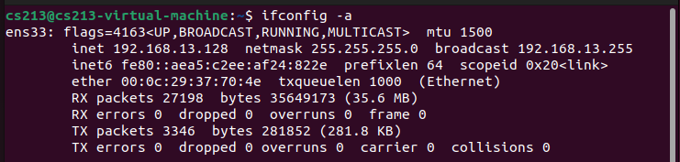
Your Terminal screen shot here:

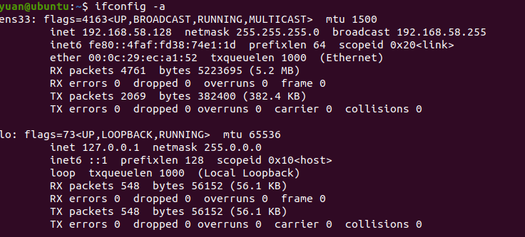

- Click on the Ubuntu Software Icon , type “chromium” (Chrome compatible) web browser in the search box and choose “chromium” for installation.

- Next open Chromium browser to make sure that it connects to the internet. Take a screen shot of your browser to the website www.google.com, insert your screen shot into the box below:
Your Chromium browser screen shot here:
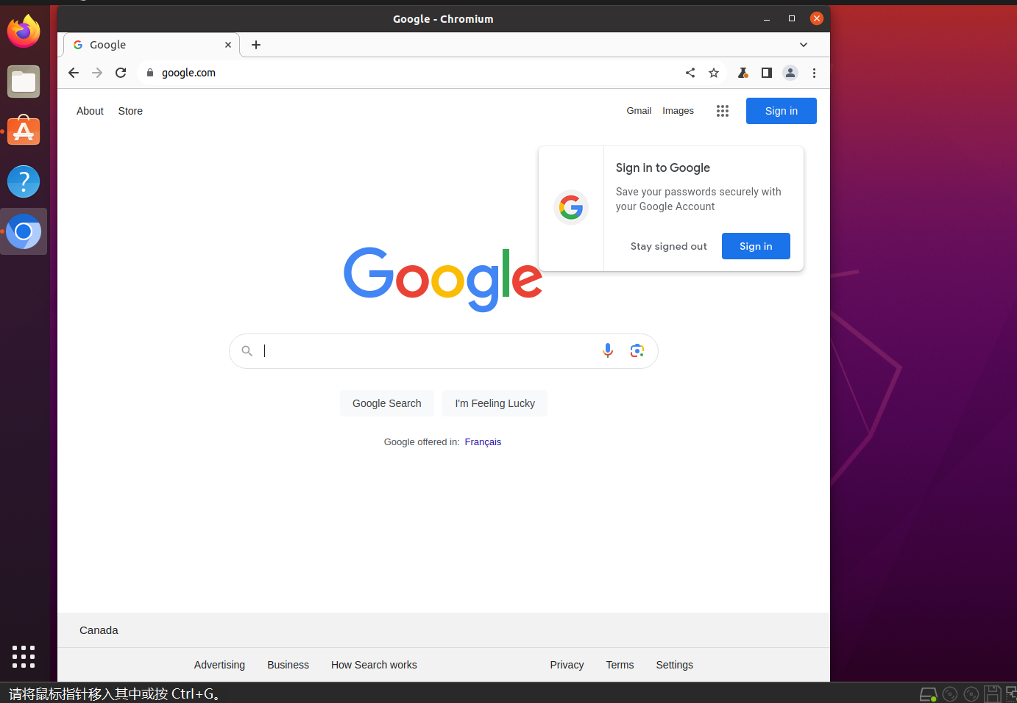

Task 2: Installing another Ubuntu with a different name
- This can be done quickly by copying the Ubuntu VM1 just created earlier in Task1 and saving it into a different folder => rename the folder name of the copied version from Ubuntu VM1 to Ubuntu VM2=> cut the “Ubuntu VM2” folder and paste it into the same folder where the original Ubuntu VM1 is located. Now you should have two independent versions of Ubuntu under two different folders. Last step is to open the copied version with VMWare Workstation/Fusion and rename it as “Ubuntu VM2” as shown below:

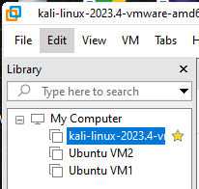

- Open Firefox browser this time to make sure that it connects to the “www.yahoo.com” site. Take a screen shot of your browser and insert your screen shot into the box below:
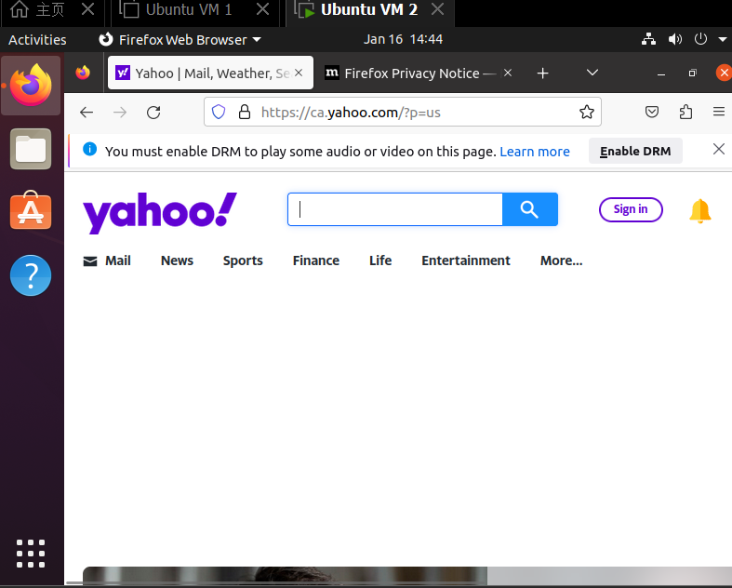

- Open a terminal, type the Linux shell command below to find out the IP address/Netmask information that Ubuntu VM2 is using:
$ ifconfig –a

Take a screen shot of your Ubuntu terminal, which is similar to the screen shot (cs213) as shown below with a different IP (inet) address:

.

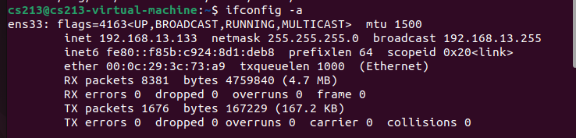
Your Terminal screen shot here:

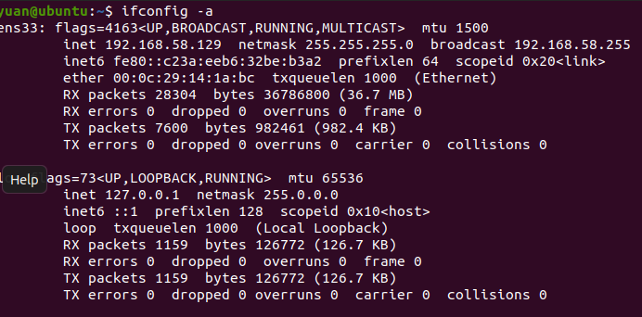

Task 3: Installing Kali Linux
- For Mac computers with M1/M2 chips, download “Kali Linux for Apple Silicon” from the link below and create a Kali Linux VM with Fusion yourself.
https://www.kali.org/get-kali/#kali-installer-images
https://www.youtube.com/watch?v=LJo9EUwXiHo

- For other computers, download the pre-built Kali Linux 64-bit VMWare VM image from the link below:
https://www.kali.org/get-kali/#kali-virtual-machines

- Uncompress the image file, then use VMWare Workstation or Fusion to open/run the VMWare VM image with the username: kali and password: kali

- Open Firefox browser to make sure that it connects to the “Google” site. Take a screen shot of your browser and insert it into the box below:

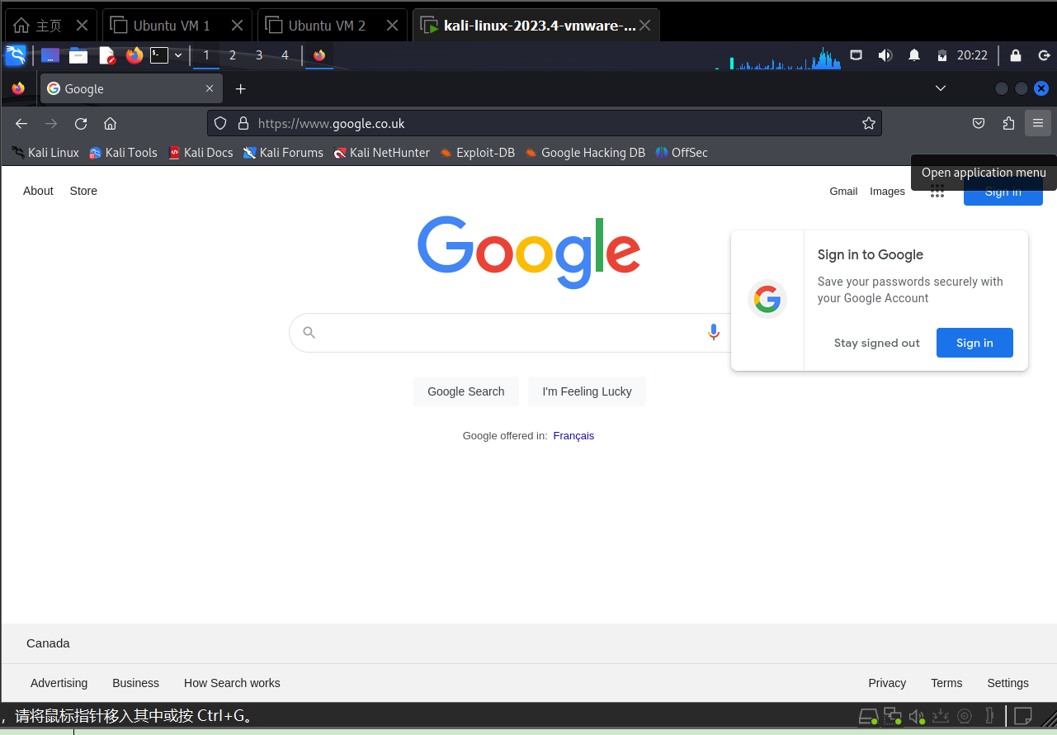

Next click on the Terminal icon at the top panel to open a terminal, type the shell command to find out the IP address/Netmask information that the VM is using:

$ ifconfig –a

Take a screen shot of your terminal, which is similar to the screen shot as shown below. Insert your screen into the empty space immediately below the displayed screen shot:
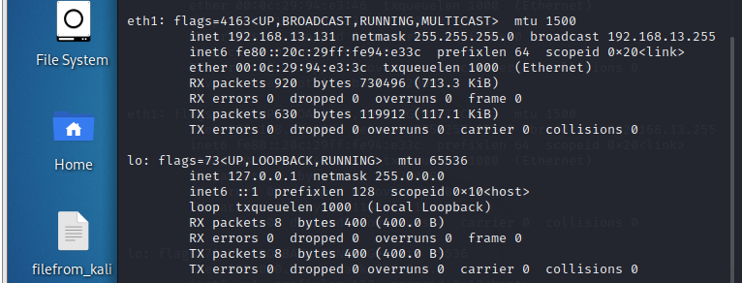
Insert your screen shot below here:
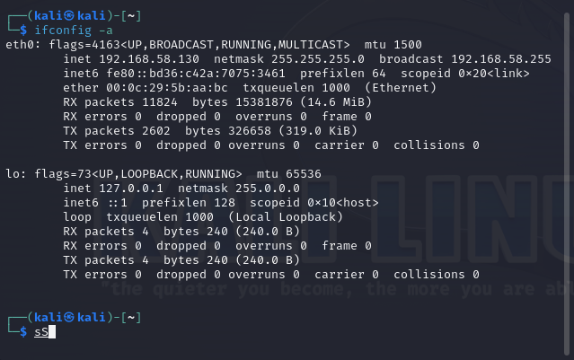

Continue with your Kali Linux VM, explore the GUI desktop and then follow the following site with examples to get familiar with some commonly used shell commands:
https://www.kompulsa.com/ubuntu-commands-a-cheat-sheet-with-examples/

Screen shots from your Kali Linux VM:
Screen shot #1: Desktop background changed
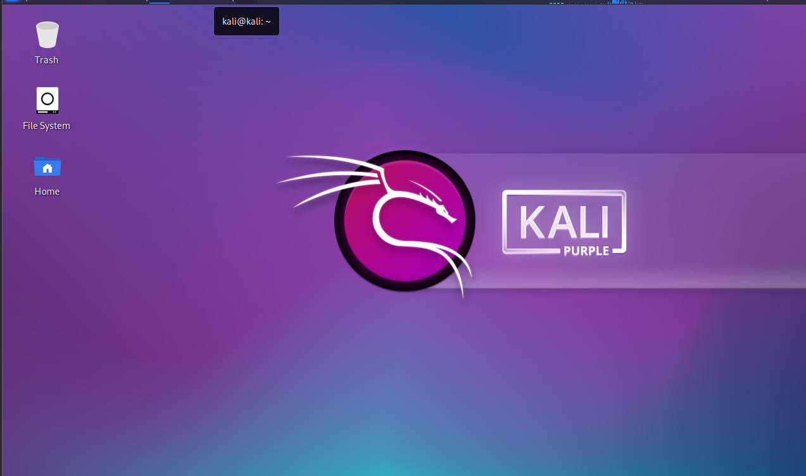

Screen shot #2: Install chromium web browser using “sudo apt install chromium” command => add it to the top panel
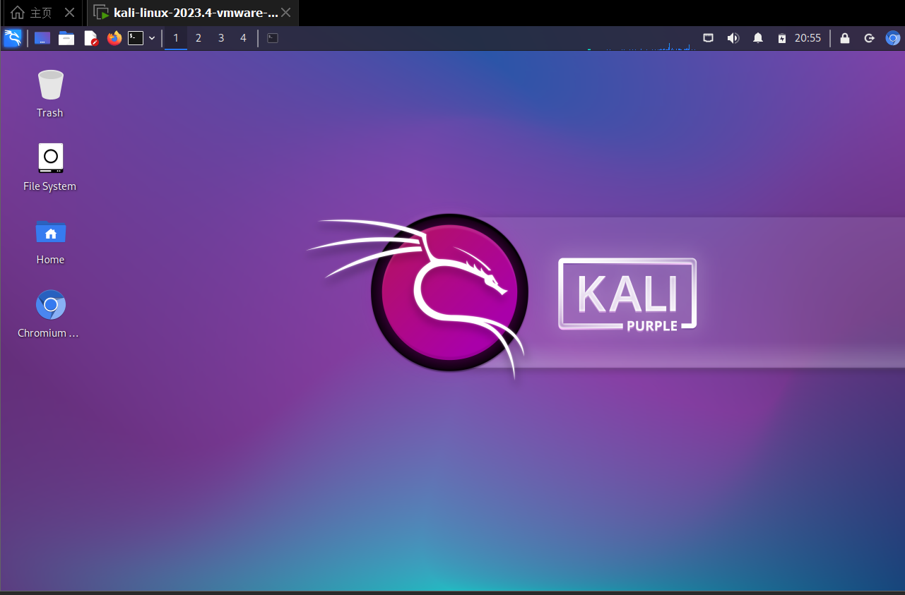

Screen shot #3: Start or restart Apache2 using “sudo service apache2 restart” command, then open the chromium browser and enter http://localhost/ into the URL box.
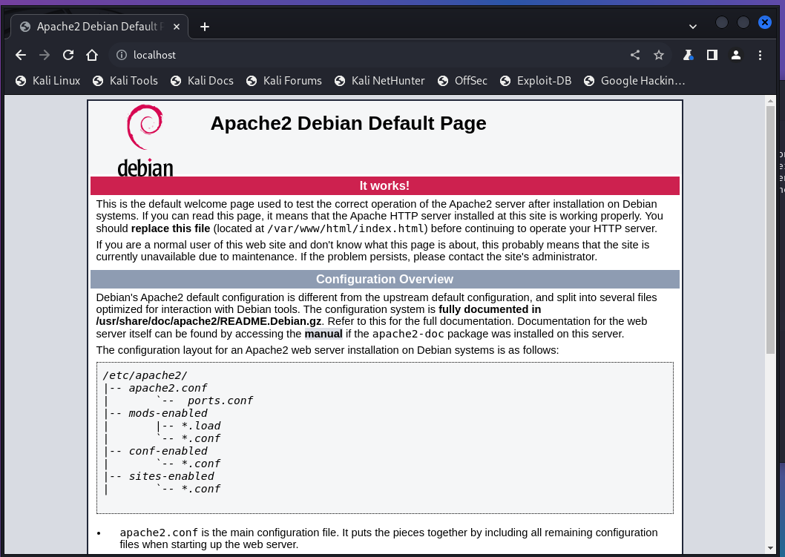

Task 4: Setting static ip addresses for all VMs
Please refer to the pdf files in Jan 9 folder from Moodle for setting static ip addresses for both Ubuntu VMs. Please use host address 11 for VM1 (e.g. 192.168.13.11) and host address 22 for VM2 (192.168.13.22).

Please refer to the following youtube video for setting a static ip address for Kali VM with host address 33 (192.168.13.33).
https://www.youtube.com/watch?v=G_HLBwqg1mo

Next issue the command “ifconfig -a” at a terminal of each VM and take a screen shot of the terminal one VM at a time. Insert each screen shot below:

Screen shot of Ubnunt VM1:
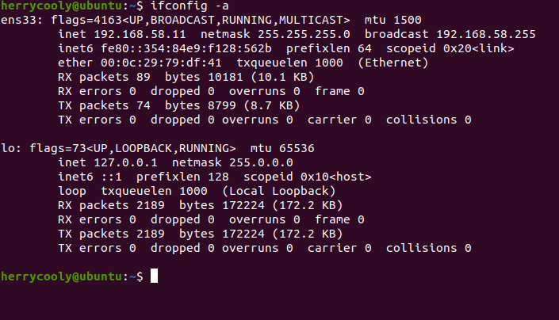

Screen shot of Ubuntu VM2:

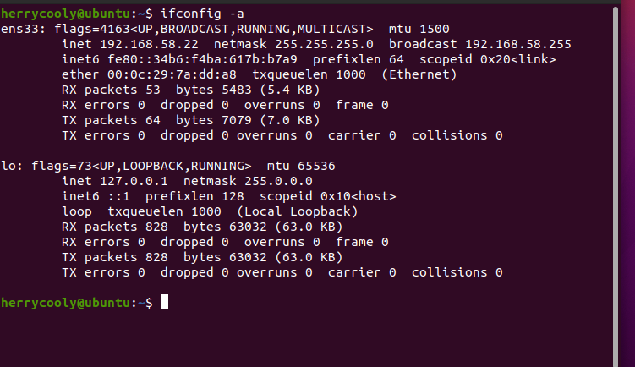

Screen shot of Kali VM:

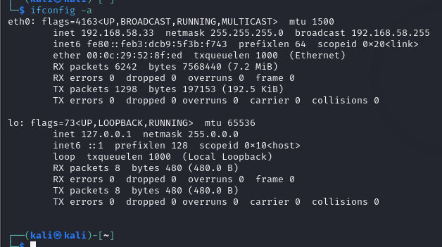

Task 5: Using ping command to make sure that these three VMs are able to communicate to each other.

Ping from a Ubuntu VM2 terminal to Ubuntu VM1 (static IP) 5 times with a count switch like this:
$ ping –c 5 192.168.13.11

Take a screen shot of the results in the Ubuntu VM2 terminal. Insert your screenshot here below:

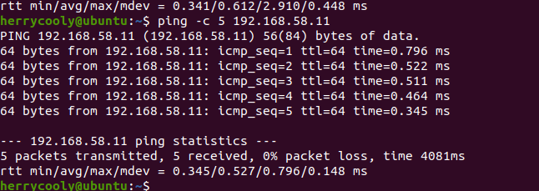

Ping from a Ubuntu VM1 terminal to Ubuntu VM2, take a screen shot of the results in the Ubuntu VM1 terminal. Insert your screenshot here below:
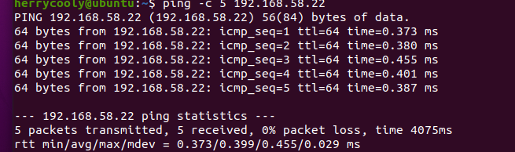

Ping from a Ubuntu VM1 terminal to Kali Linux, take a screen shot of the results in the Ubuntu VM1 terminal. Insert your screenshot here below:

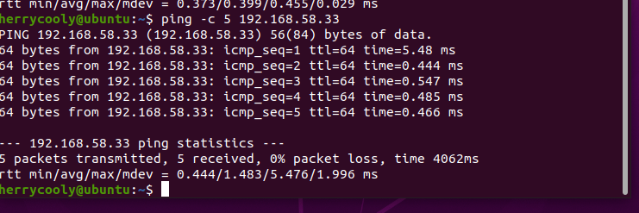

Ping from a Ubuntu VM2 terminal to Kali Linux, take a screen shot of the results in the Ubuntu VM2 terminal. Insert your screenshot here below:

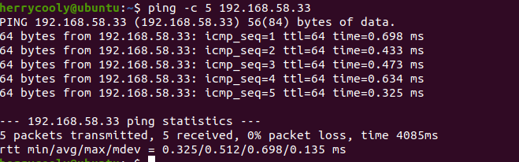

Ping from a Kali Linux terminal to Ubuntu VM1, take a screen shot of the results in the Kali Linux terminal. Insert your screenshot here below:

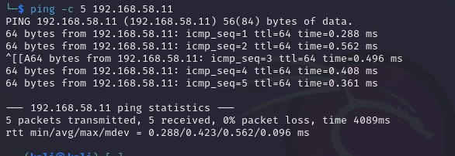

Ping from a Kali Linux terminal to Ubuntu VM2, take a screen shot of the results in the Kali Linux terminal. Insert your screenshot here below:
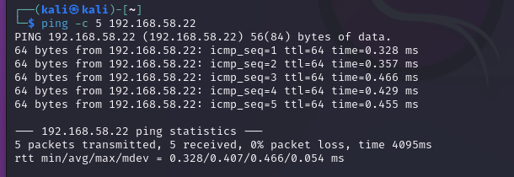

Submitting your work:

Export this Words document (embedded with your screen shots ) as a PDF file, and then submit the pdf file into our Moodle course site by the due date - Saturday, January 20, 2024 (before midnight).

