
Computer Science 328 -01

Lab Assignment 7

Due Date: Sunday, March 17, 2024 (before midnight)

Objective: Experimenting basic Ethical Hacking techniques

- Please note that an Ubuntu 20.04 virtual machine is required in order to see the hacking results for a few hacking exercises in this lab. If you don’t have one, you can download it from a Google drive here:
https://drive.google.com/file/d/1vMXZtiAUYdRgJZYV4C7_-skgStquc40o/view?usp=sharing

1: Running Nmap from Kali VM
- Nmap is one of most commonly used hacking tool to explore open ports of all computers available in a network very quick and easy. Please refer to the following Youtube video to learn what you can do with Nmap tool:
https://www.youtube.com/watch?v=4t4kBkMsDbQ&list=PLIhvC56v63IIJZRa3lzK6IeBQOH_VFjUQ&index=4

- Then try these nmap commands with Kali VM. Click on Applications icon from Kali VM => 01- Information Gathering => nmap => a terminal will pop up as shown below:
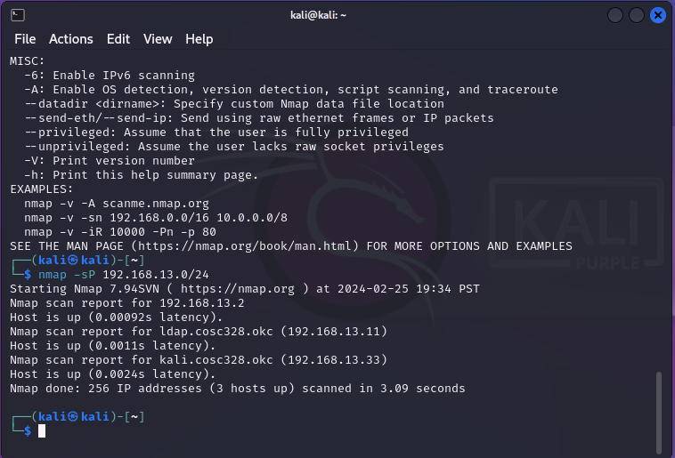
Enter the command “nmap –sP 192.168.n.0/24” at the terminal (where n is your NAT subnet number, and 13 as shown in the image above was the NAT subnet on your instructor’s desktop) to find out which computers are up and running in your NAT subnet: 192.168.n.0/24 for all your VMs. Take a screen shot and insert your screen shot below:
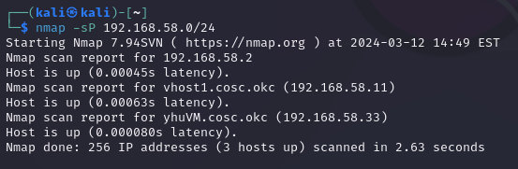

- Next try the command “nmap –sT –p 80,443 192.168.n.0/24” to find out all computers with port 80 and 443 open in the subnet, take a screen shot and insert your screen shot below:
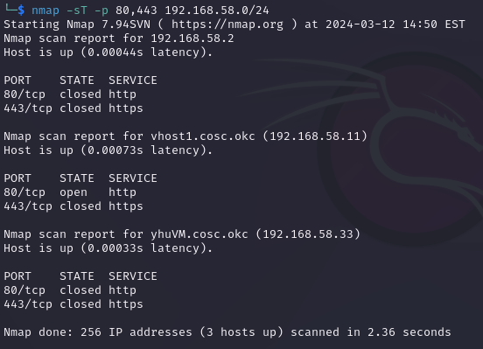

2: Setting up Telnet server to be hacked using Wireshark

- Start Ubuntu VM2 (Ubuntu 20.04), and open a terminal for setting up a Telnet server.
- Update repository list, then upgrade and install Telnet server:
$ sudo apt update
$ sudo apt upgrade
$ sudo apt install telnetd
- Next verify Telnet status is active as shown below:
$ sudo systemctl status inetd
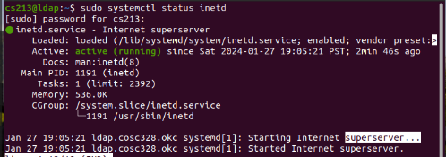
- If any firewall is running on your system (try “sudo ufw status” command to find out (i.e. active)),
then we need to enable the necessary port (23). Otherwise we can ignore the following steps.
$ sudo ufw allow 23
$ sudo ufw reload
$ sudo ufw enable
- Since Telnet client comes as a pre-installed package, we can switch to Ubuntu
VM1 and try to telnet to Ubuntu VM2 with a terminal immediately:
$ telnet 192.168.13.22 //with username: cs213 and password: letmein
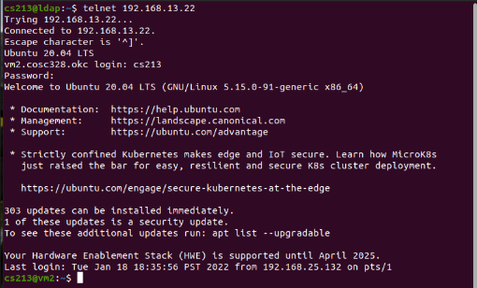

- Take a screen shot of your VM1’s terminal to show the telnet connect to your VM2, and insert the screen below:
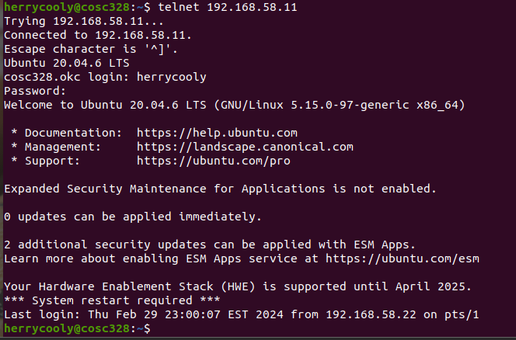

PS:
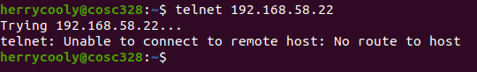
VM2 can telnet to VM1 but not the other way round for some reason(even after followed the lab instruction for opening ports).

- Now switch to Kali VM, and open the Wireshark application.
- First start capturing the interface eth0 (connecting to NAT subnet) with Wireshark, specify telnet as filter as shown below:
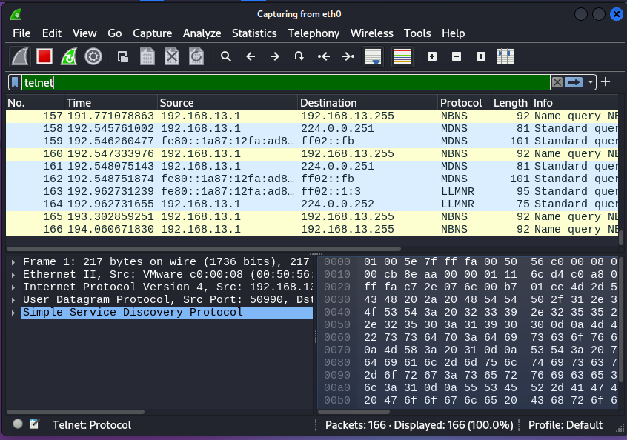

- Next make a telnet connection from Ubuntu VM1 (192.168.13.11) to VM2 (192.168.13.22) machine using the command:

$ telnet 192.168.13.22 //with username: cs213 and password: letmein

- Then switch back to your Kali VM machine, and stop capturing packets with Wireshark. Take a look at the Wireshark capturing screen:
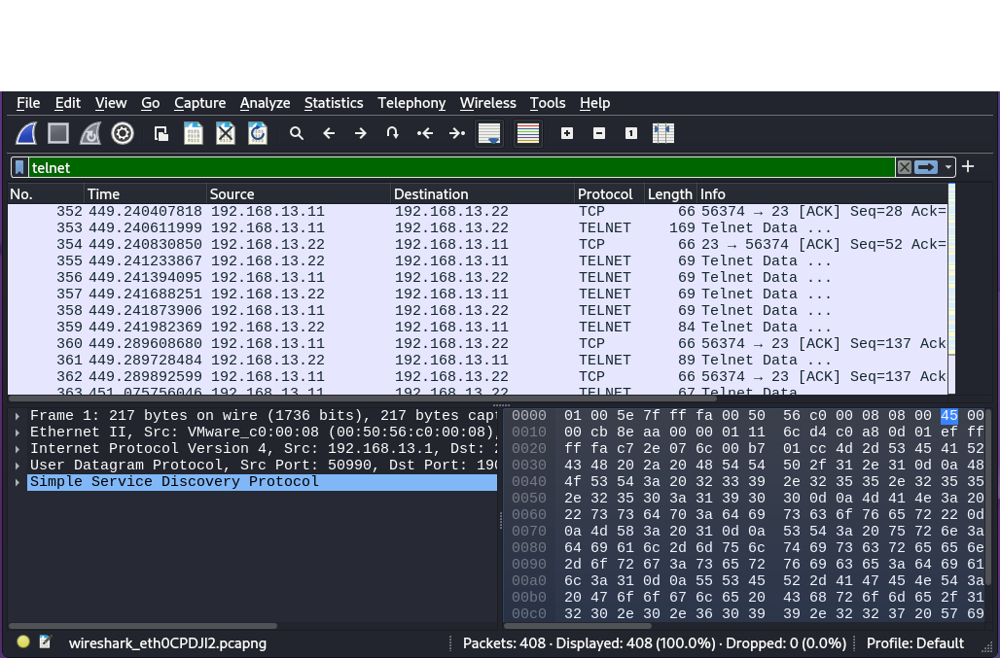

Let’s look at the Telnet Data (starting from frame #364 in this example) for the username:

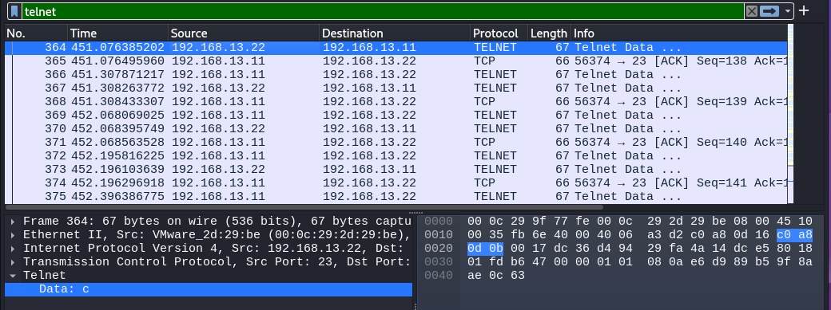

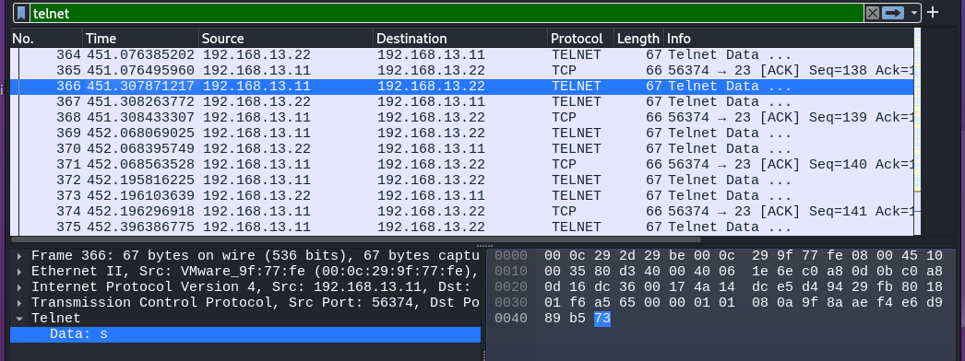

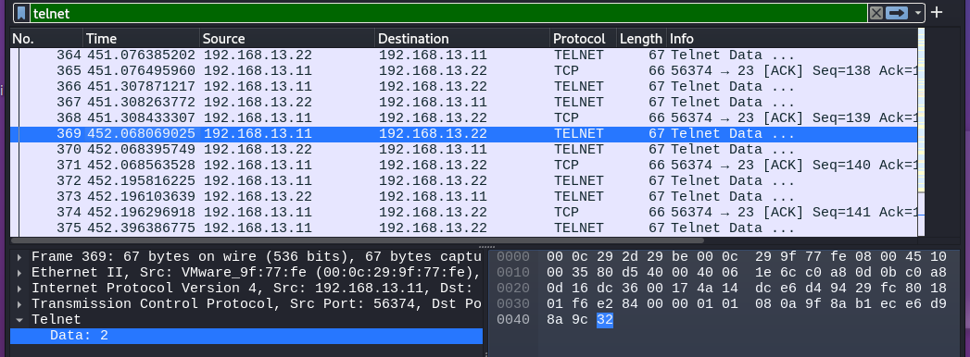

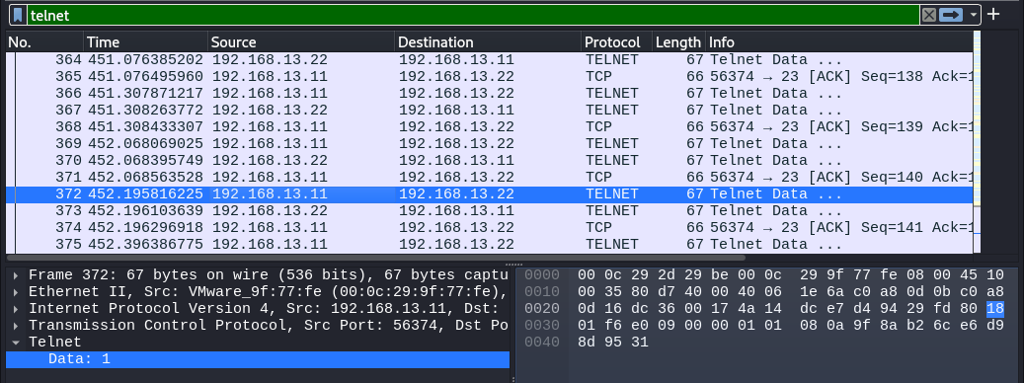

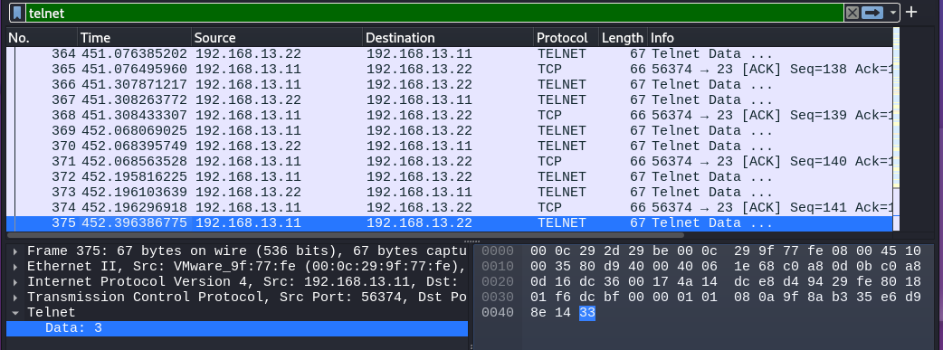

And now let’s look at the Telnet Data (starting from frame #383 in this example) for the password:
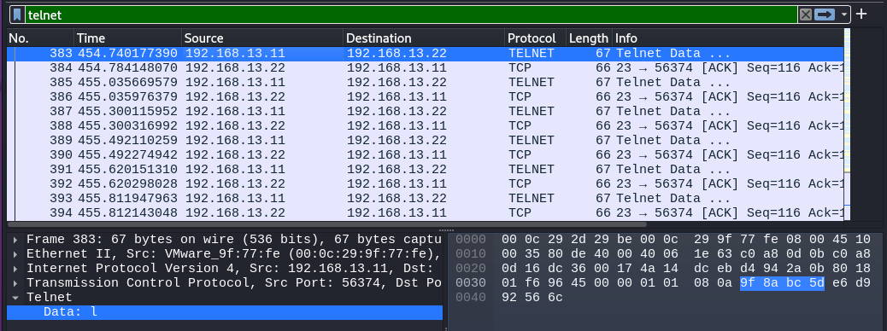
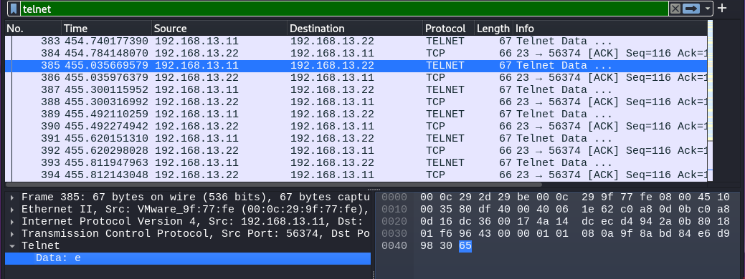

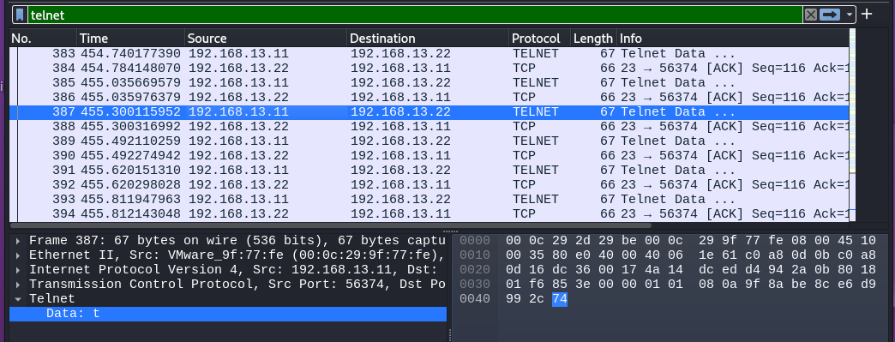
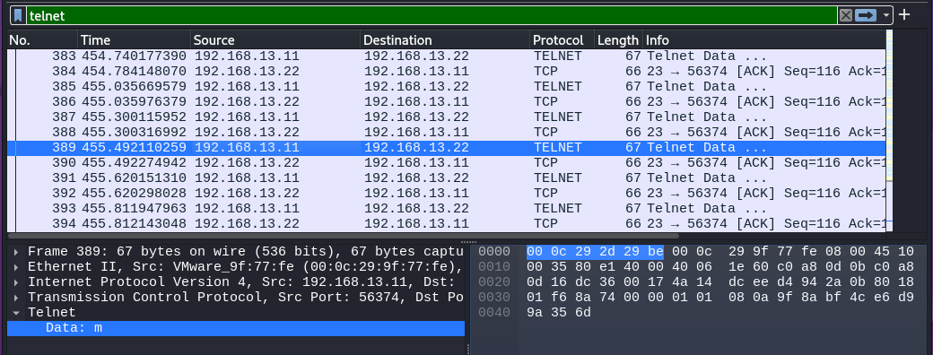
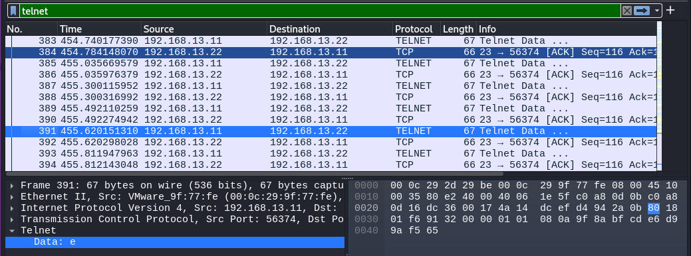

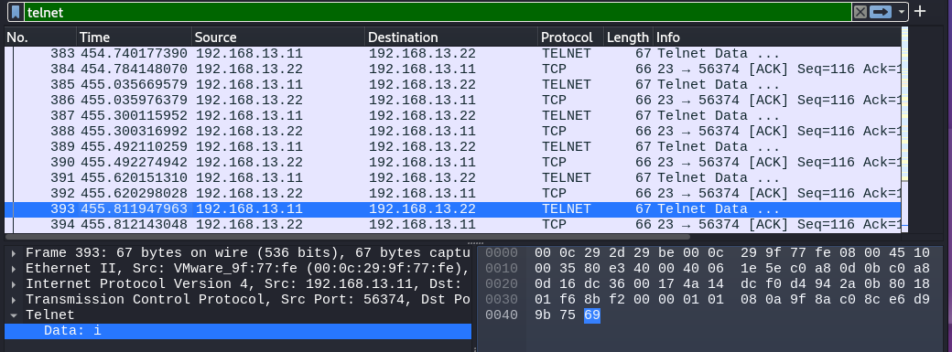

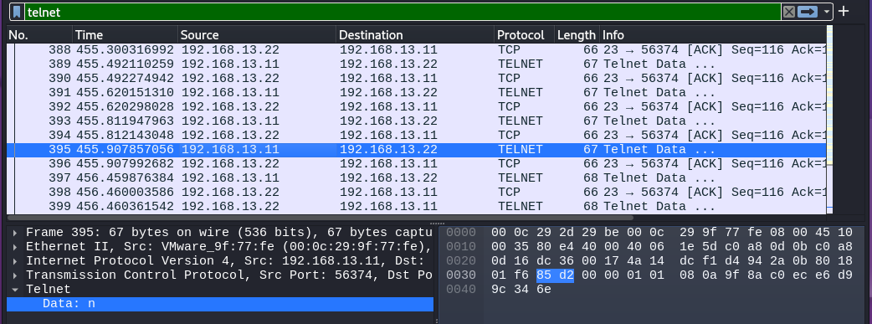

- Now it’s your turn to do the same thing and take your similar screen shots for the password part only from your Kali VM and insert them below:

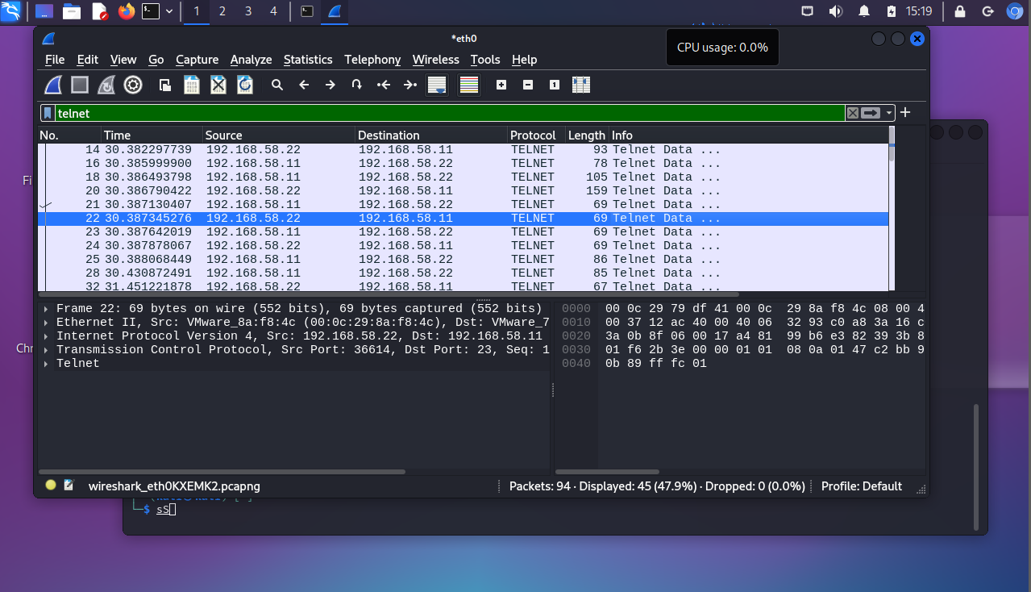

3: Sniffing HTTP data packets using Wireshark

Open Wireshark in your Kali VM and capture the interface eth0 (NAT subnet) with http as the new filter.
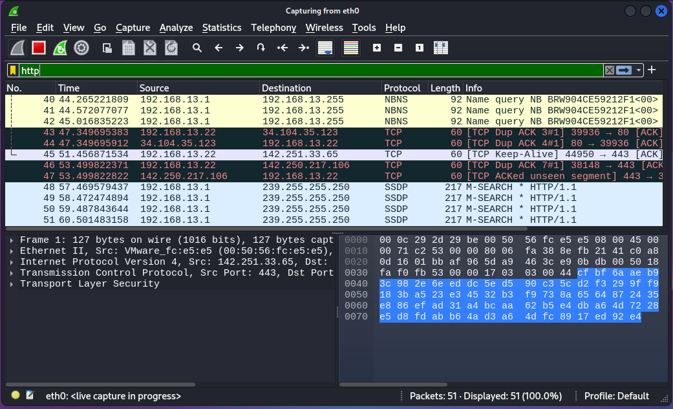
Next refer to the site below:

https://www.guru99.com/wireshark-passwords-sniffer.html

and follow the steps for sniffing a test site (http://www.techpanda.org/) with a browser running in an Ubuntu 20.04 VM. The username and password to be used are admin@google.com and Password2010 respectively for logging into the test site.

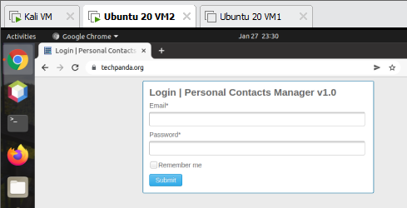

When you logged into the site successfully in your Ubuntu VM, you switch back to Kali VM and stop the packets capturing in WireShark. Look for a captured HTTP packet using POST method in Wireshare:
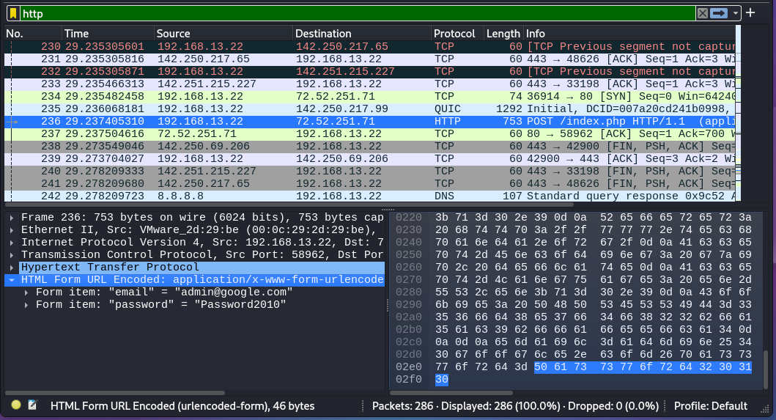

4: MITM attack with ARP poisoning
- Need an Ubuntu 20.04 VM to be used as a targeted victim in order to see the results.
- Please follow the instructions from “ MITM attack with ARP Poisoning using Ettercap.pdf” , and see if you are able to come up with similar results like this:
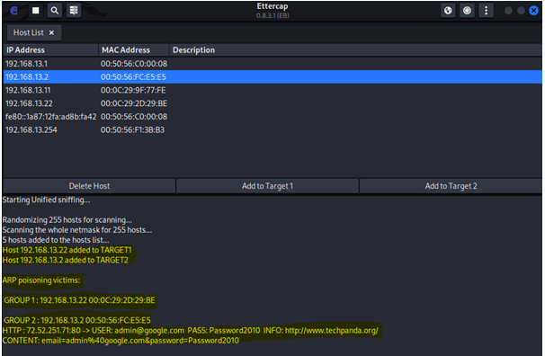

Screen shot of your results here:
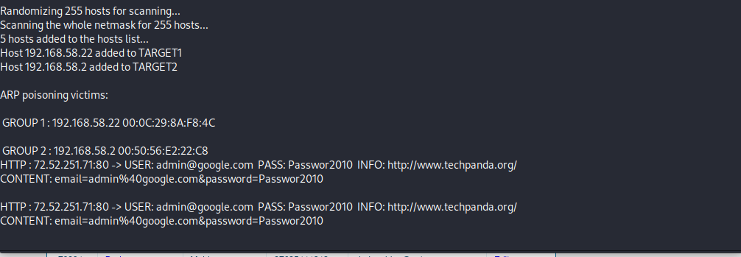

5: Password cracking for hashed passwords
Please refer to the site regarding password hashing (Encrypt) and password cracking (Decrypt):
https://10015.io/tools/md5-encrypt-decrypt

Example1: with a simple password: letmein
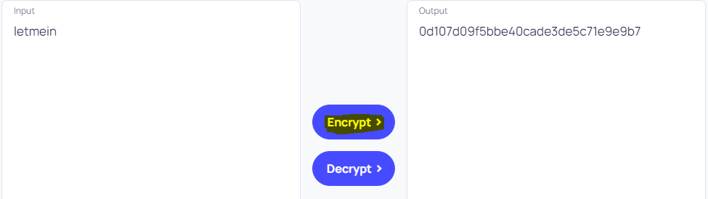

To crack (decrypt) the hashcode “0d107d09f5bbe40cade3de5c71e9e9b7 “, it took a second or less to generate the output “letmein”
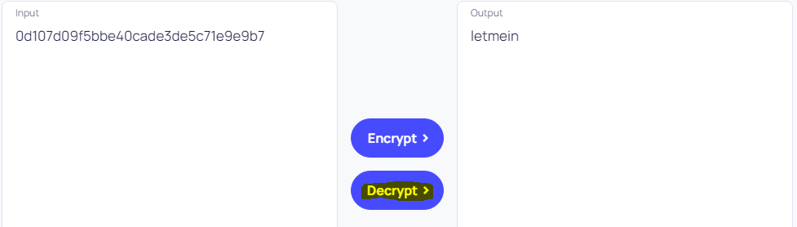

Example2: with a relatively strong password: cs328@okc
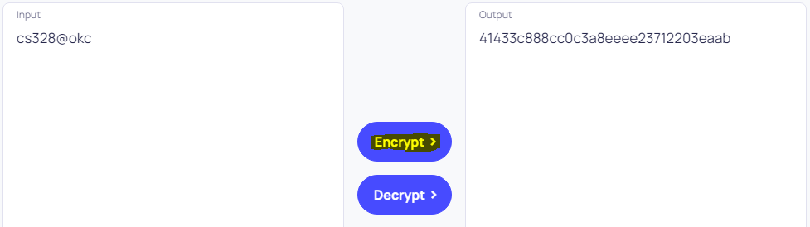
To crack (decrypt) the hashcode “41433c888cc0c3a8eeee23712203eaab”, it couldn’t crack the password successfully within a reasonable time frame and required more character sets and more trial count.

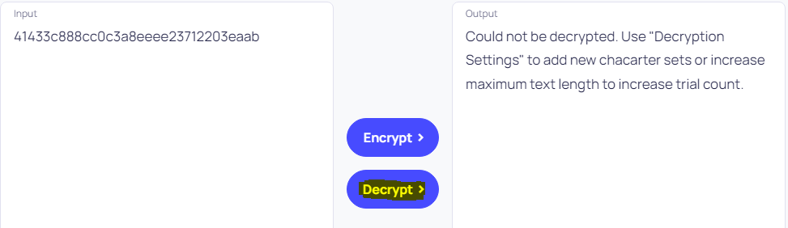
Now it’s your turn to try a simple password “goforit”, take a screen shot for encrypt and decrypt operation respectively and insert them below:
Screen shot for encrypting “goforit”:
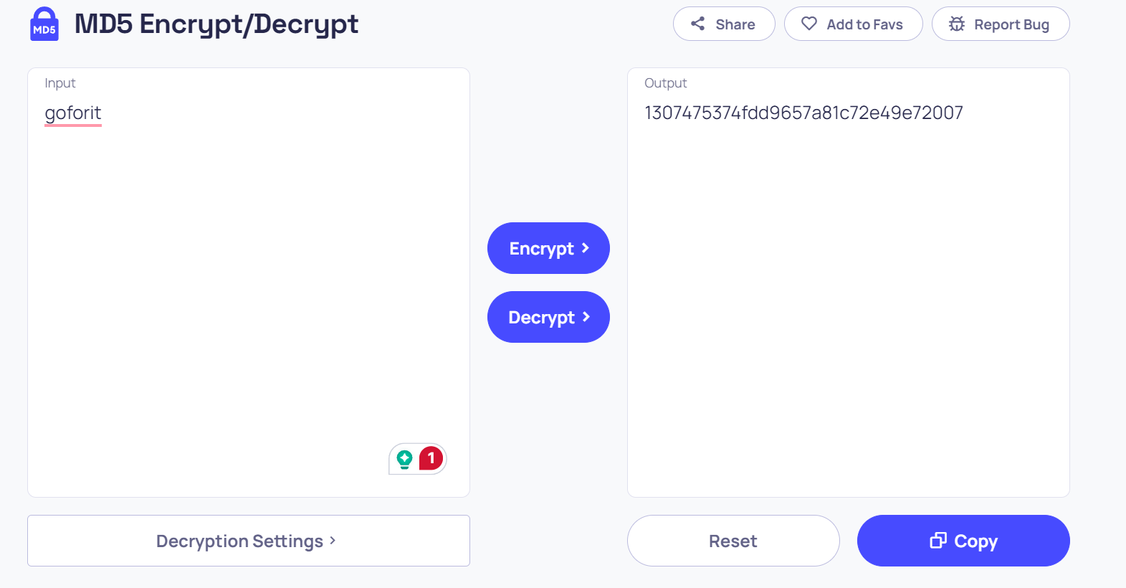
Screen shot for decrypting the hashed code, trying to get the output “goforit”:
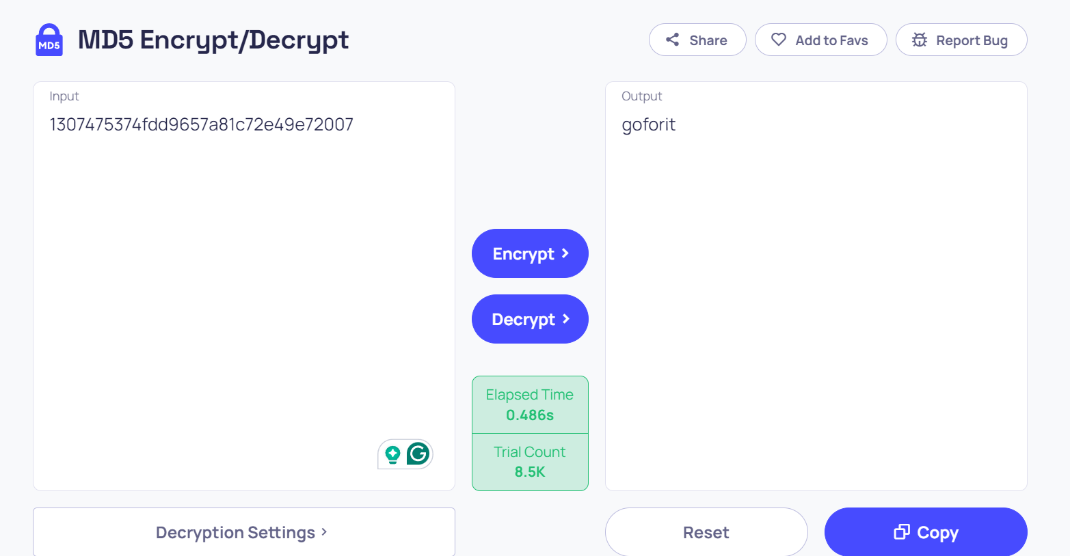

Now try a slightly stronger password “GoForIt”, take screen shots and insert them below:
Screen shot for encrypting “GoForIt”:
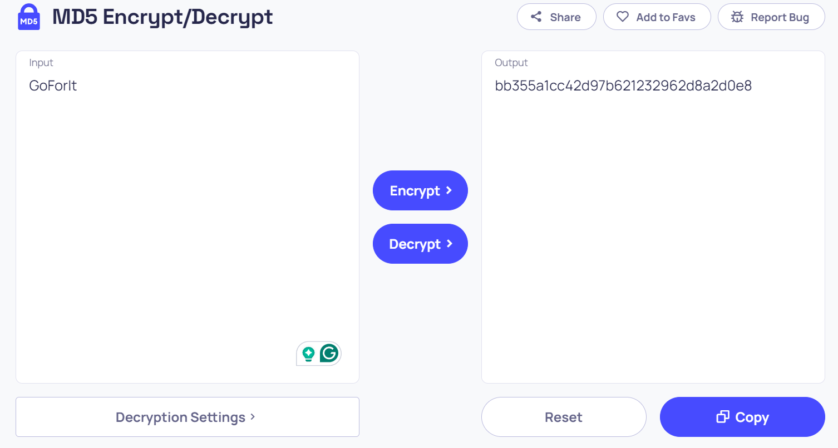

Screen shot for decrypting the hashed code, trying to get the output “GoForIt”:

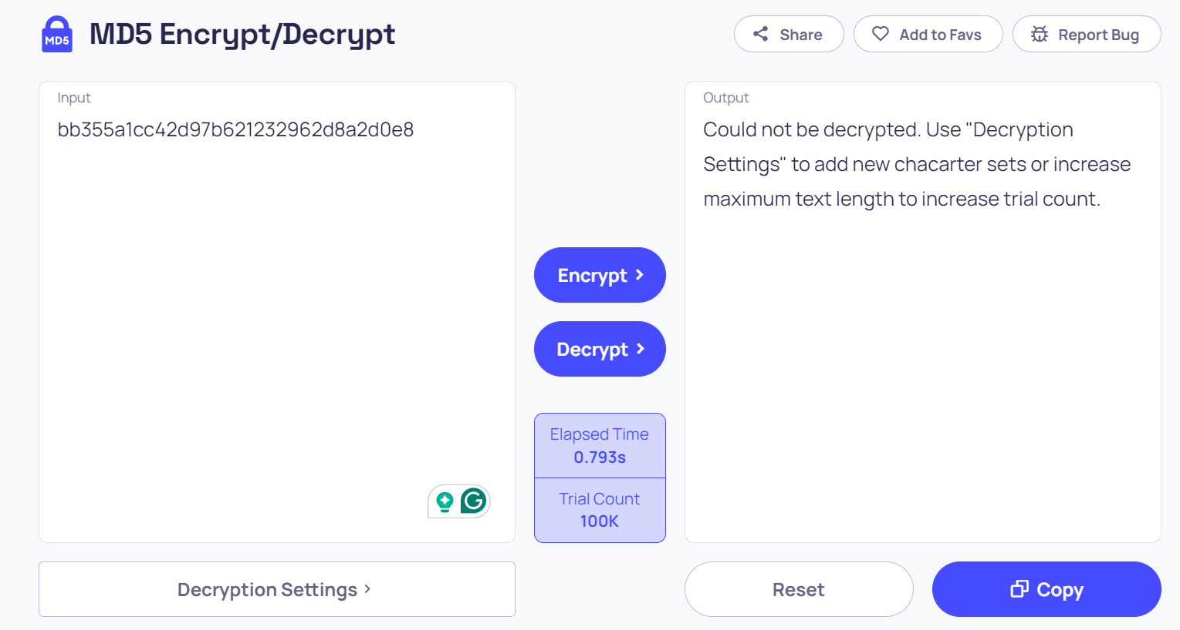

Submitting your work:

Export this Word document with all your answers and screen shots as PDF format, and then submit your PDF file via Lab 7 assignment tab on Moodle by Sunday, March 17, 2024 (midnight).

