COSC 341 Lab1: Design Principles

Yuan Hu
300311827

Subject Chosen: BC-Wine Tripper

Introduction
Wine Tripper is a mobile application that collects information about most wineries in British Colombia, there are more then 100+ wineries collected in this app. The user can find the opening hours, locations, contact information about each winery and able to add their favorite wines to the list. Speak by its name, this makes it a ideal tool for those who want to go on a winery tour.
This app is build on the idea of helping tourists find winery in BC province at their convenience and offering a platform for smaller business to present their wine product. The latest release is in 2015 and the author continued to update information about wineries up to now.

Wine Tripper
Functional Requirement
- Home page
- Inspect a list that shows all wineries across BC province
- Error handling - user can email a correction to the developer
- Export favorite wines as a list and sent them to a email account
- Add ratings to wineries
- A real-time map for all wineries - with colored pin to show opening status
- A button that can center your location on the map
- Apply/Clear filters - (only show open, only show favorites, only show highly rated)
- Create note for specific winery
- Check update
- Turn on/off sharing anonymous data - winery ratings, favorites and notes
- Add a winery as favorite
- Save/Store/Delete data
- Chose preferred way to contact winery
- Chose preferred third- party map app for the winery
- Add wines for the specific winery
- Inspect all the wines added by other user for the specific winery

Non-functional requirements:
- Internet connection
- Smart phone
- Reliable information source
- Background picture for home page
- Scalable map
- Responsive app design

Learnability
The overall learnability for wine tripper is relatively low , it doesn’t take much time to understand how it works. After downloading it, you should be able to see the homepage with 4 headers(Figure 1). The headers are straight-forward and give some details about itself e.g. Under Wineries, you can see the sum of wineries and under wines, there is a hint ‘Add your wines here’. User could easily chose the content they would like to enter. When tapping on ‘Wineries’, the use should be able to see a full list of winery names arranged in alphabetical order(Figure 2). For user’s convenience, the app has a search box for wineries, this is really useful when user just look for certain winery without looking everywhere in the list.

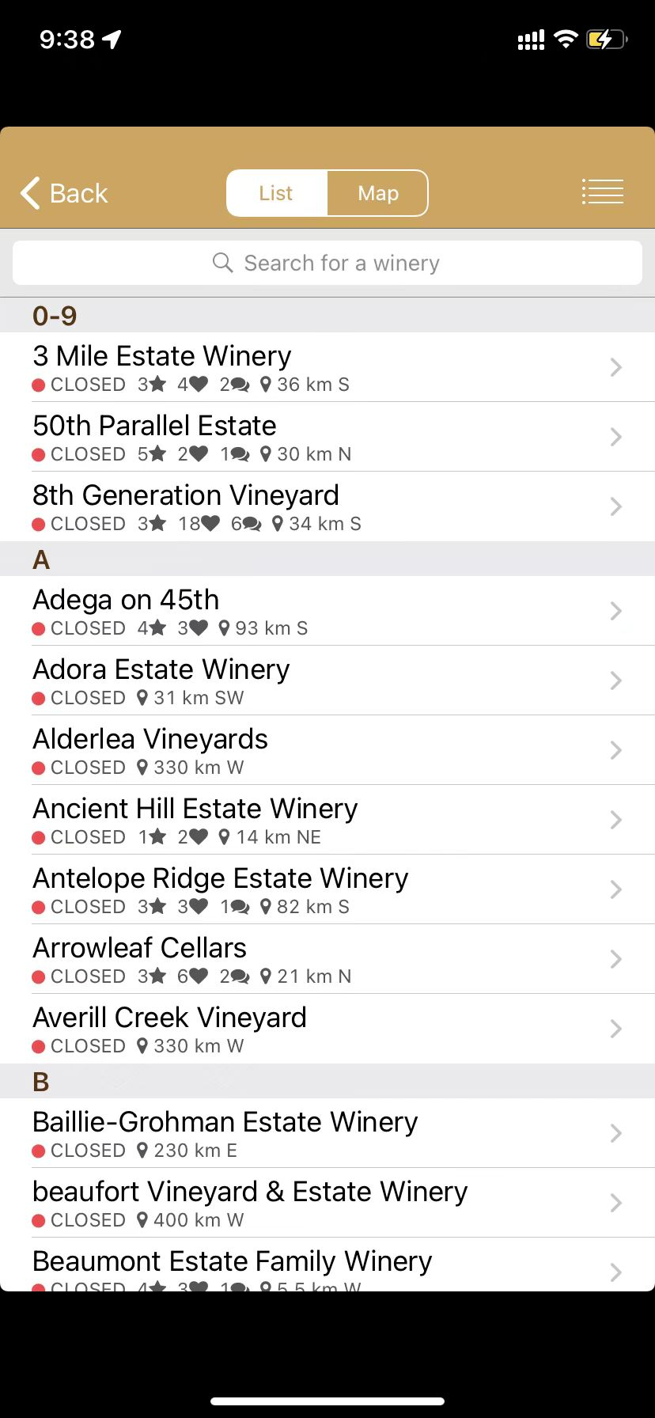
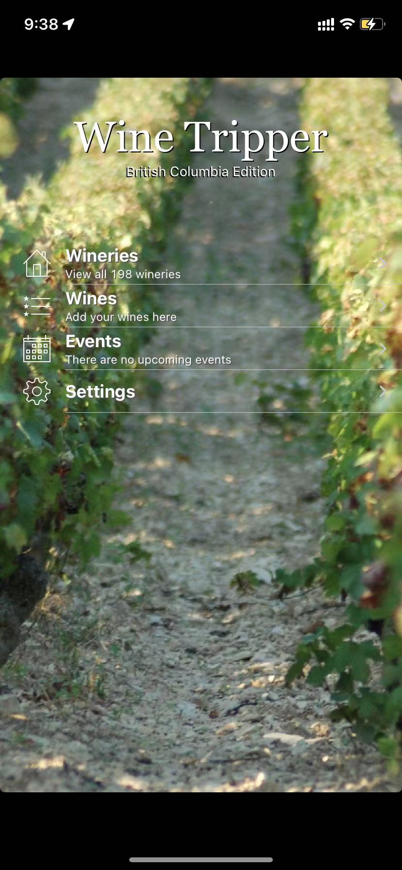

Figure 1 Figure 2

If the user only want the opened wineries, Figure 3 shows that the user can set up a filter for their search. For example, to show only open ones, just tap the top right corner of Figure 2, and then click ‘Only show open’ and then tap ‘Apply filter’ under the Actions column, then user should see all opened ones. The filter also allow user to sort the name list by name, area, city, proximity etc. The user can also clear out the filter if they no longer need it.
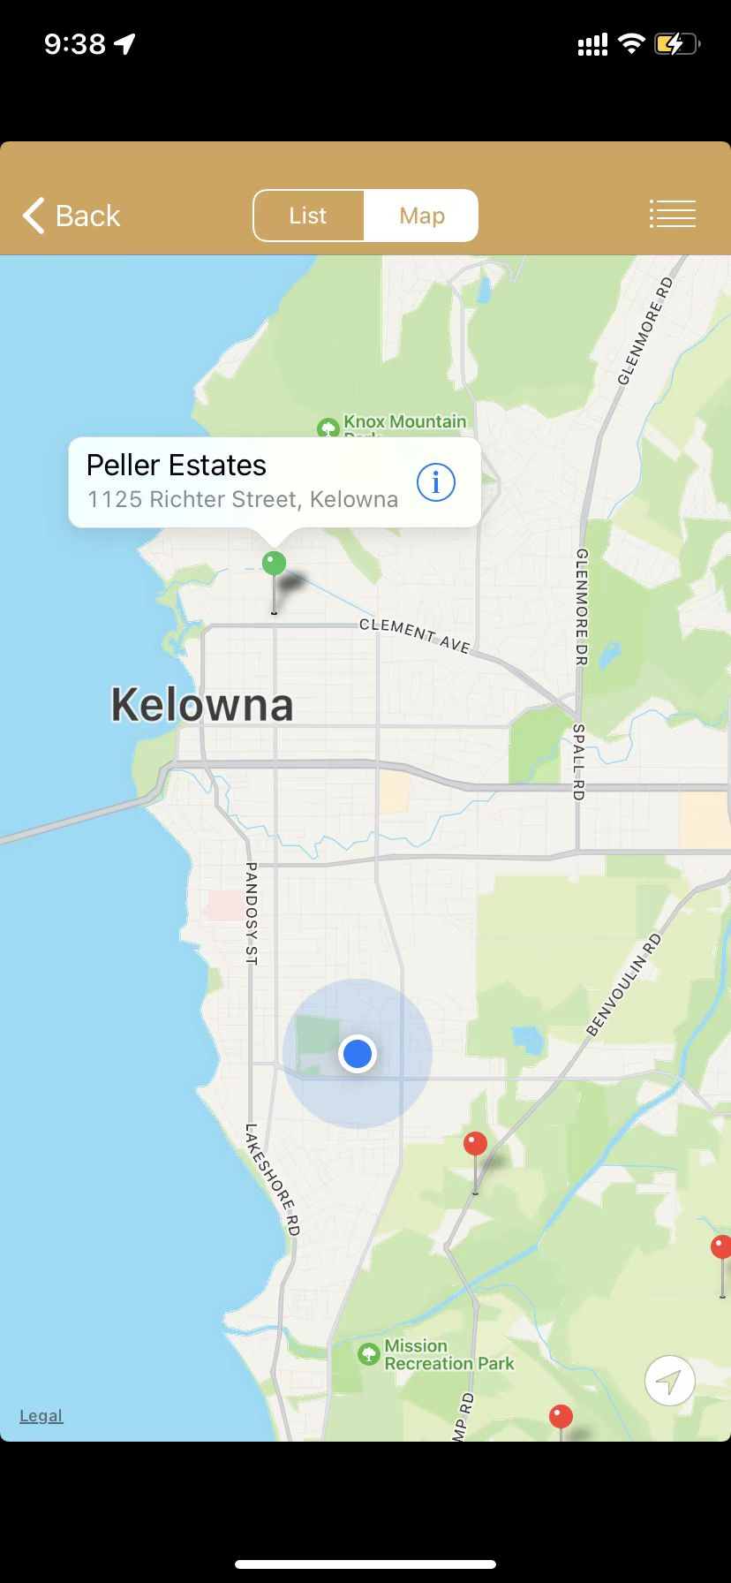
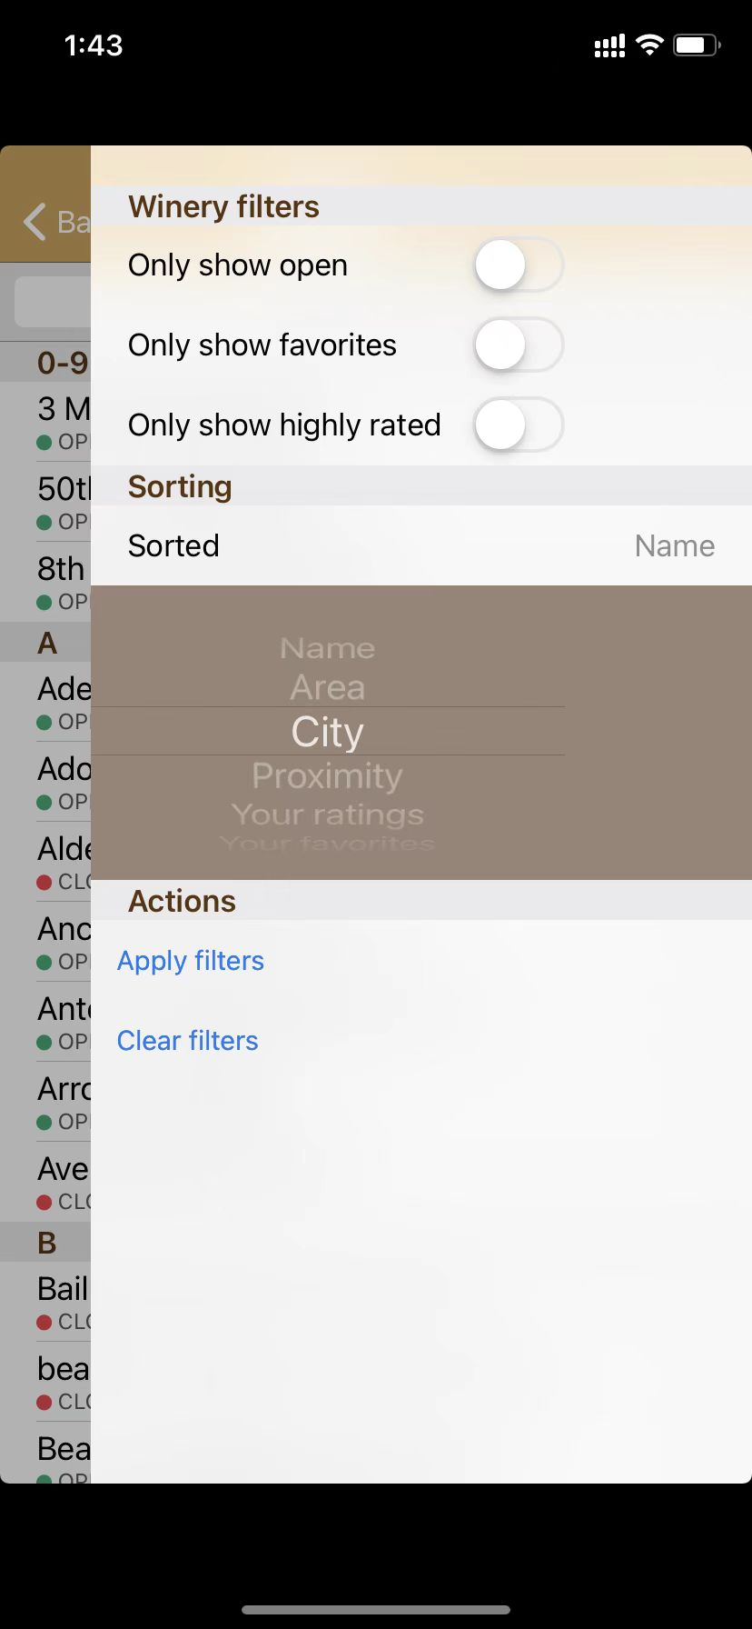

Figure 3 Figure 4

And on the top center of Figure 2, the user can switch to map view. This will show the user’s and wineries’ location on the map(Figure 4), the filter function also applies to map view. Just like most map program. The user could easily locate themselves with the button on the bottom right
of Figure 4.
When user clicks on a winery, whether on name list or map list, they should see Figure 5. This has information of the exact location, opening hours, Rating, and contact info. It could be hard for user to use it for the first time since the icons for opening hours(in a shape of clock) and contact information(in a shape of square with a arrow) doesn’t have any notation.
For wines and notes, the user can add them through the bottom navigation bar or go back to homepage and add them to the list like Figure 6. There may be a problem when add winery to the wine, the user have to chose the winery from 198 names which is quite time-consuming.

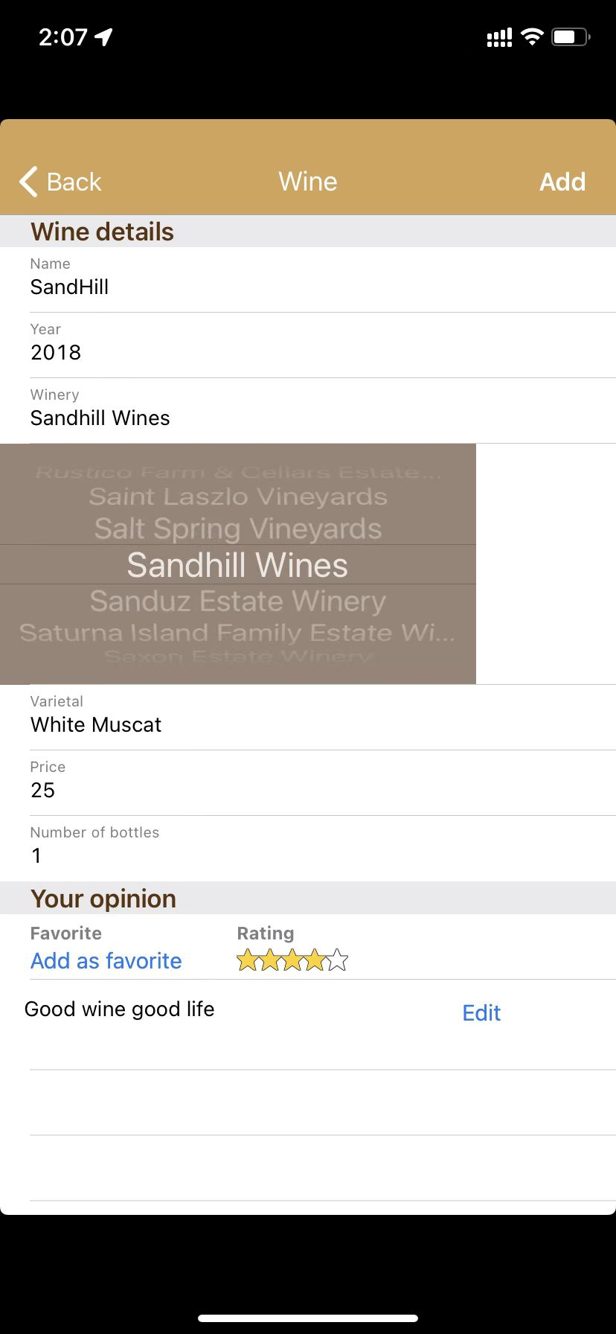
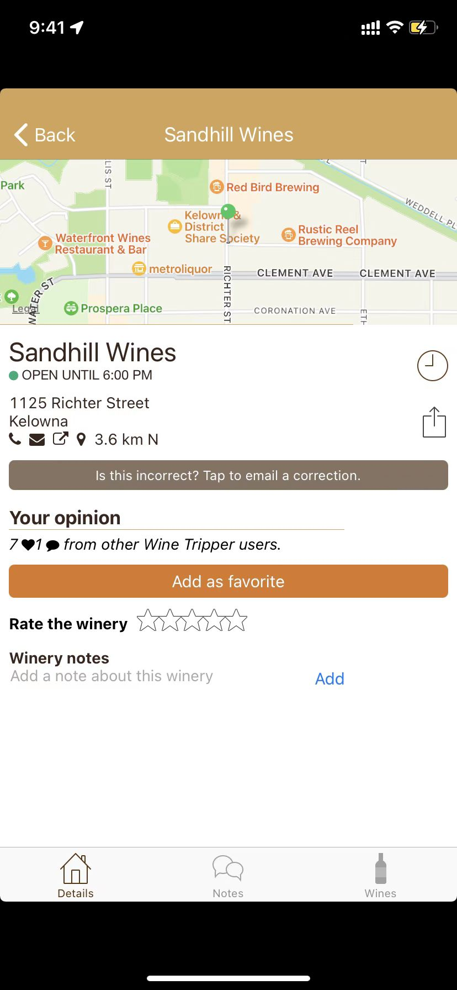
Figure 5 Figure 6

Overall, this app is easy to learn. The user will easily find the wineries and along with their information.

Efficiency
The layout and the design makes this app very efficient to use, the user can plan their wine trip based on the map view or just simply search for one specific winery for location. This app could also works in offline mode, the user could use it in suburb areas without any problem. There is no wait time also, users do not need to wait for the a search task to complete.

Memorability
It really doesn’t need the user to remember anything. The contents and functions are straight-forward so that even after a few month the user hasn’t use it, they should have no problem using it again.

User Errors
The user will make errors when trying to open the details of a winery on the map view, even when zoomed in, it is still hard to tap the pin accurately, and sometimes if the user tap too fast, the system will consider this action as a double tap, which will zoom in/out the map automatically rather then giving information of winery. The fix is not hard, just try to zoom in again and try to tap once for every 3 seconds

Satisfaction
For user, wine tripper not only give you all the details about the winery but also enable you to add wine to a specific winery, in order that the user knows what wine does the winery has. Map view gives you straight-forward information and makes it lot easier to plan for a winery trip. However, I found one comment on App Store very interesting, the user gave out 4 out of 5, hoping the app could have a UPC scanner to quickly update wine list(Figure 7).

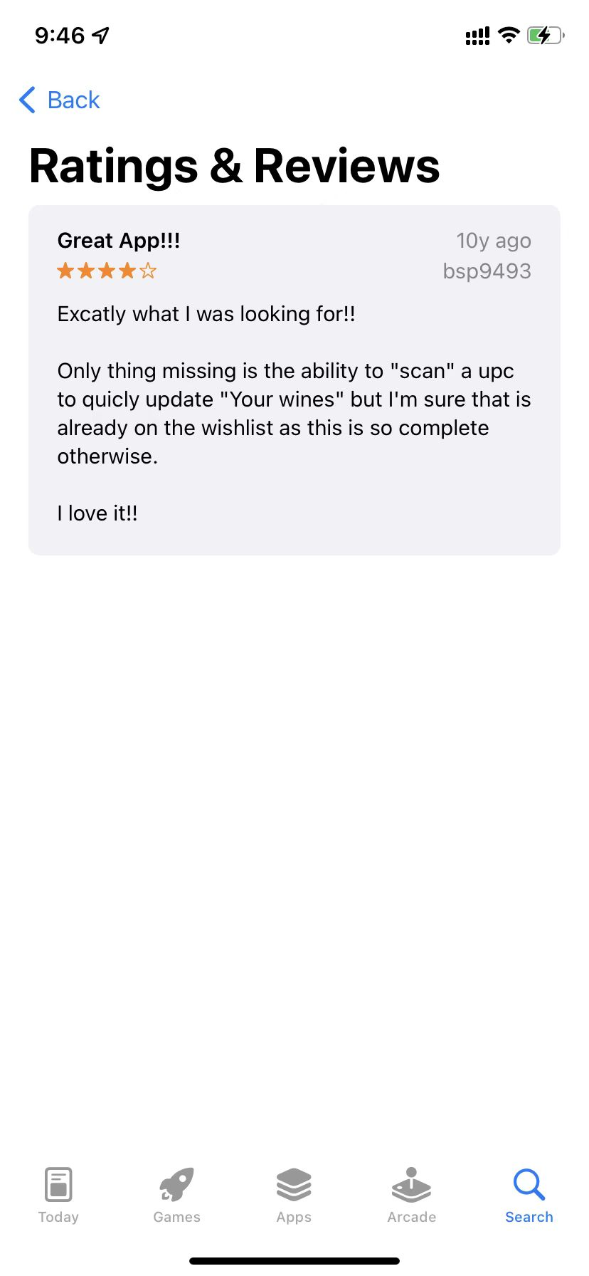
Figure 7

Design Suggestion
My first suggestion would be change the transparency background picture of homepage to 50%, green bushed with bright sunlight doesn’t have strong contrast with white font, therefore, it could be confusing for user to recognize them.(Figure 1.1)
Second suggestion would be when adding wine to the winery, the user should be able to type in the key words and the name would show up under the text box rather than scrolling over all 198 names.(Figure 6.1)
Another design flaw would be map view, it is really difficult to tap the winery on map view, make the pin a little bit bigger or remove double-tap zoom function, it’s frustrating when you finally zoomed in just to get the winery information you want and then ended up zoomed back.(Figure 4.1)
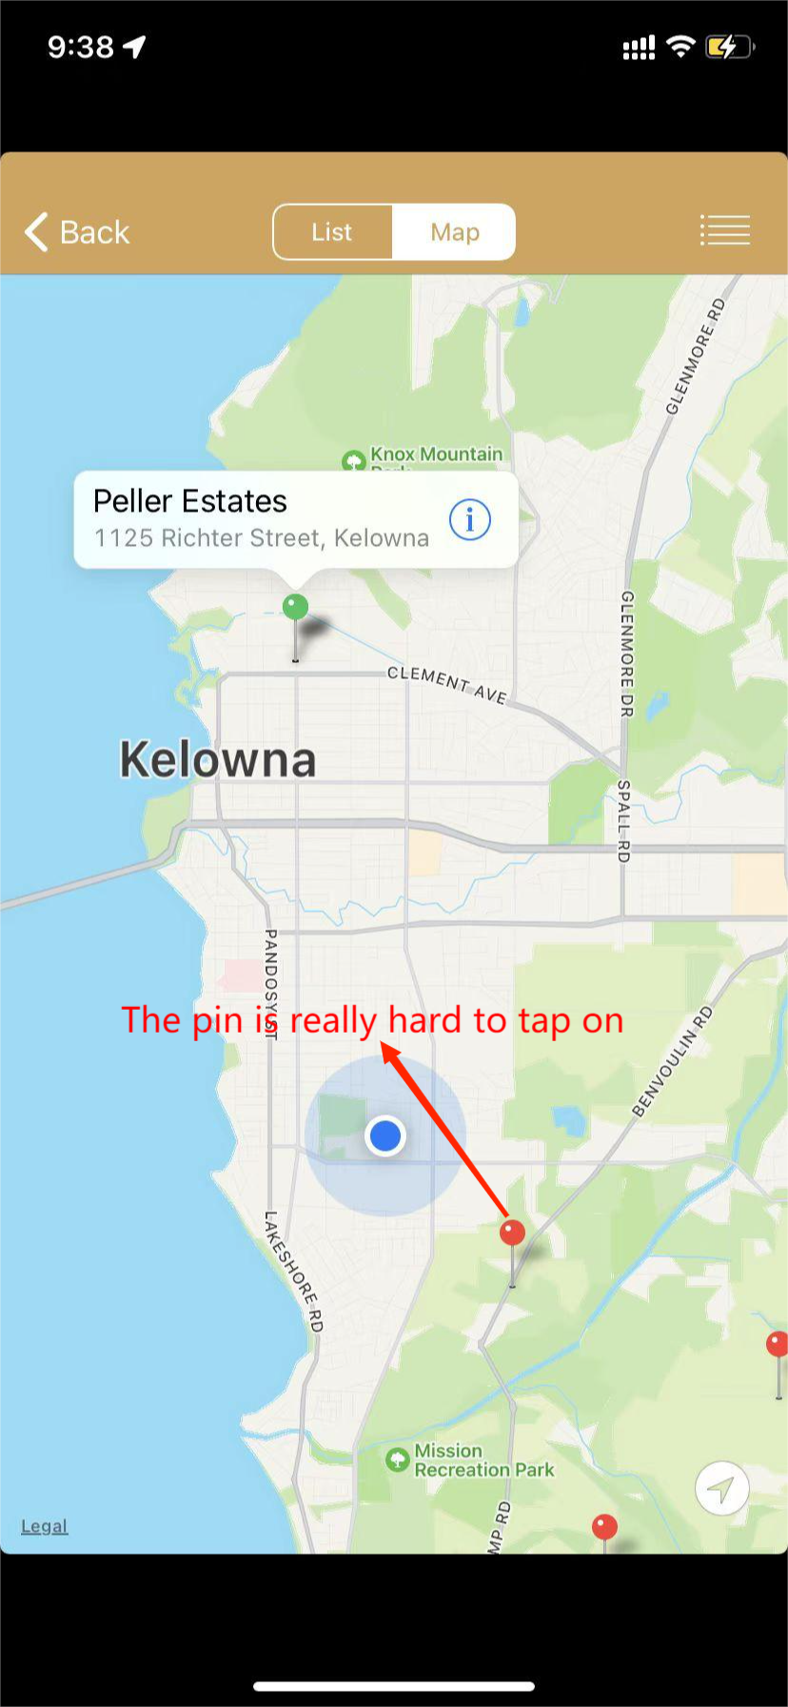
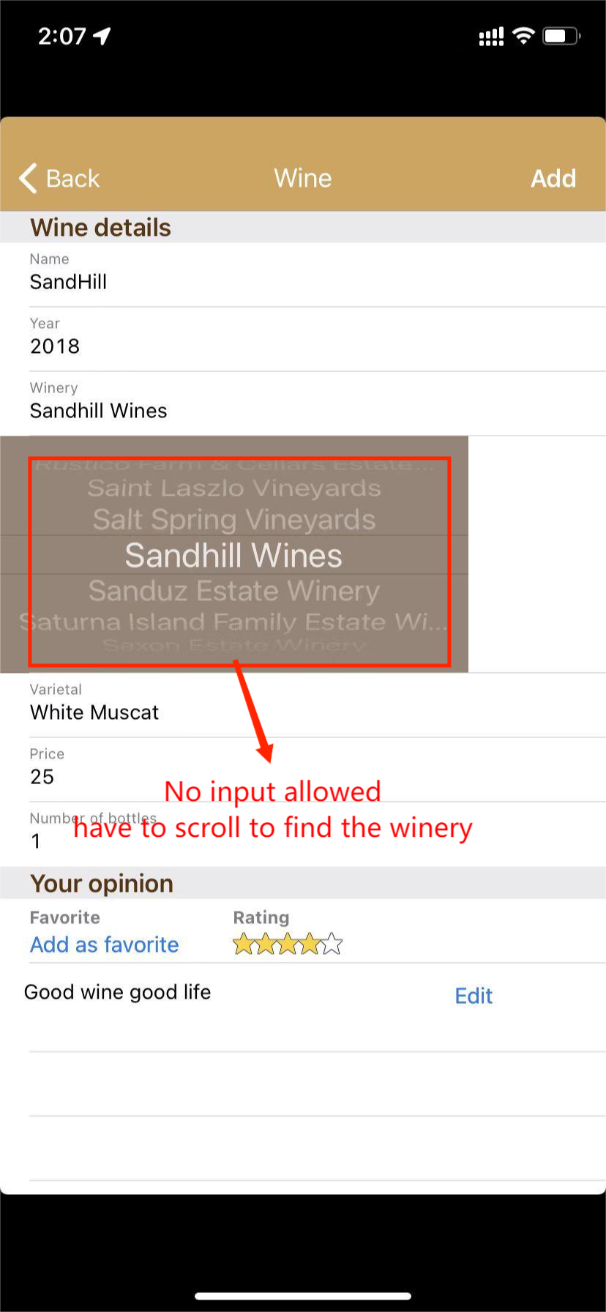
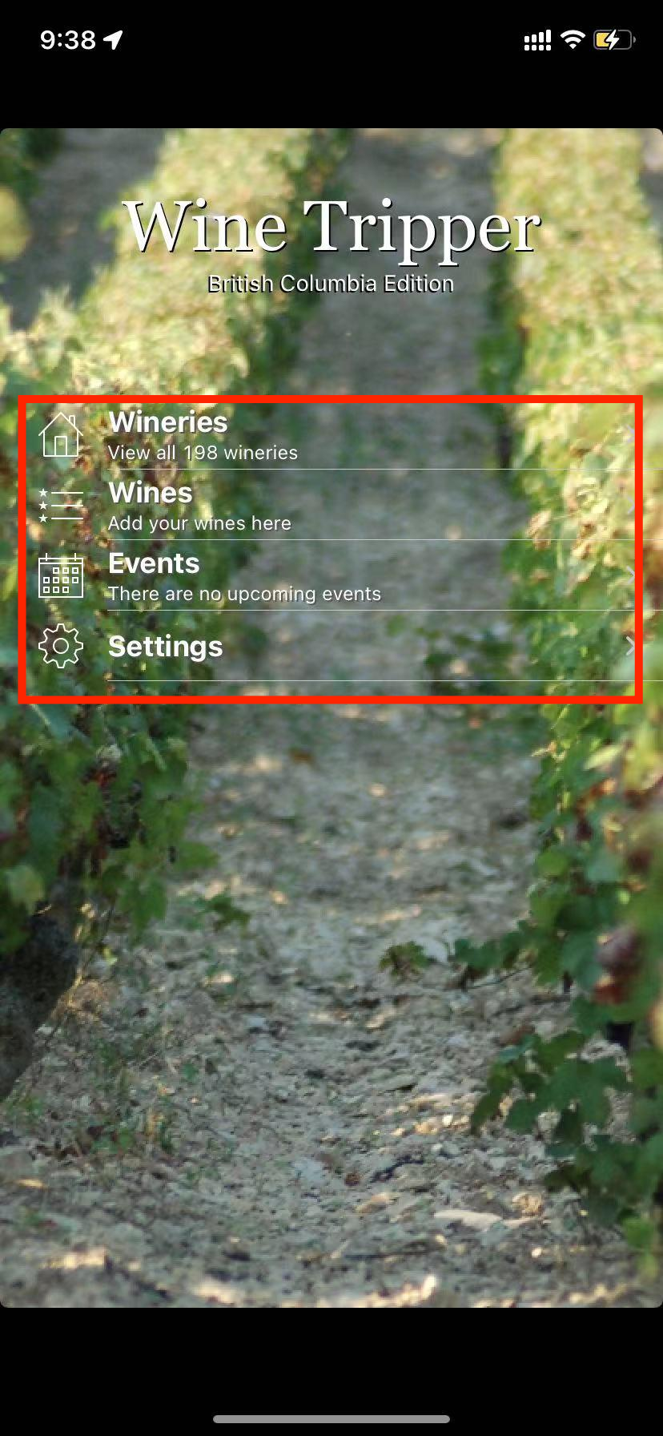
Figure1.1 Figure4.1 Figure 6.1

10 Rules of User Interface Design

Rule of Thumb | Is this rule being applied?  How so? | Is this rule violated? How so? | How can this rule further improve usability, utility and desirability?
1.Visibility of system status | Yes, Dark text with brighter color, Icons, map | Yes, for the home page, the background picture affect user to see text cleared | Change the background picture for better visibility
2.Match between  system and real world | Map view helps user find close wineries and useful for trip planning | No
3.User control and  freedom | Can add favorites and report incorrect information | No
4.Consistency and  standards | Icons, colors and themes are consistent on different pages | No
5.Error prevention | No error can be made for the user, however the user can report error for the developer | No
6. Recognition rather  than recall | Icons and labels are very external consistent, the user should be familiar with some of contents before using wine tripper | Yes, even the icon are very consistent with most of the apps, finding contact info on Figure 5 took me some time to realize the user have to tap the button to show contact info | Present contact information directly to the user will improve desirability and usability for the user
7.Flexibility and efficiency of use | Wine tripper has no loading time and require no data to run  It’s a very efficient tools if just looking for wineries in BC | No
8.Aesthetic and minimalist design | The design is outdated as this is a 10 years old application, however it still follows minimalist design principle | Yes, outdated design for aesthetic principle | Update the application manually will improve user desirability
9.Help users recognize diagnose and recover form errors | The user could report any misinformation to the developer | No
10. Help and  documentation | Developer has user support service and offer contact information for the user | No

Link for this application (Wine Tripper)
https://apps.apple.com/ca/app/wine-tripper-british-columbia-edition/id336715795 (IOS version)

