RenderMan and OpenGL Shaders

CS557

Chao Zhang

Project #2

1. Source listings

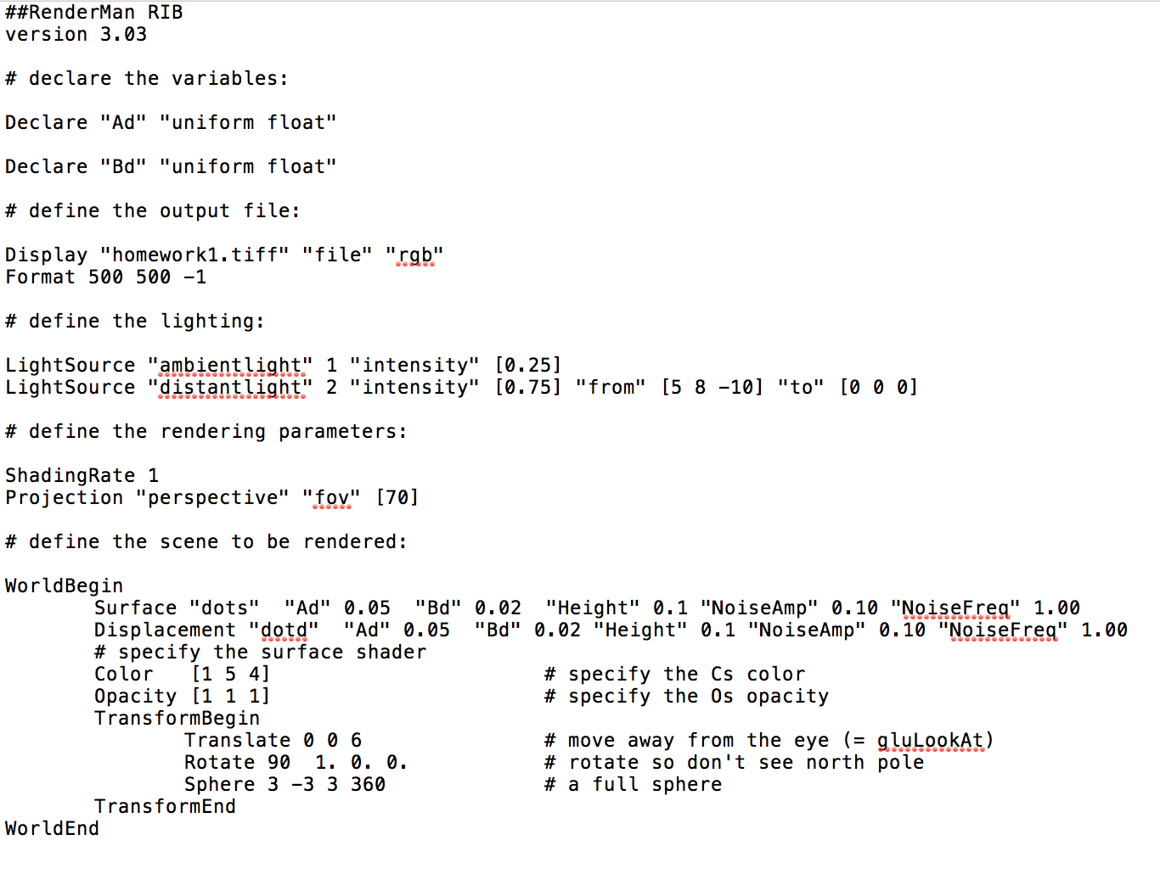

Rib file

The different between this file and the project 1 rib file is this rib file use two shaders, the surface and the displacement. Those two shaders will be compiled separately. And all the color and lights is the same as the project 1.

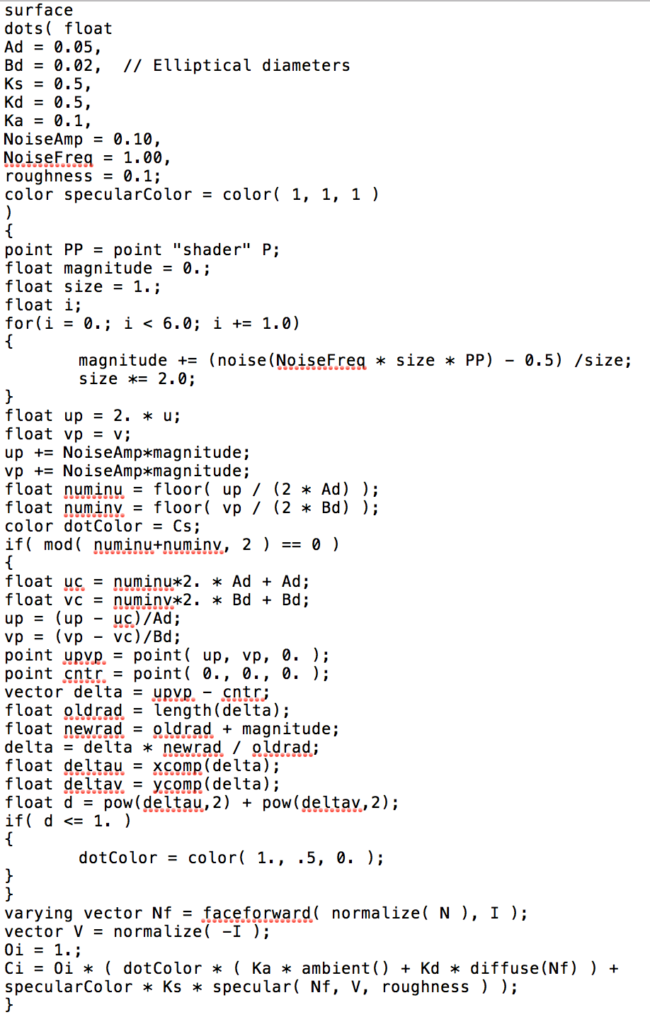

surface sl file

This sl file is for the surface shader. This code is based on the first project’s sl file, I add the noise on it. For the noise, I set NoiseAmp and nosieFreq. magnitude += (noise(NoiseFreq \* size \* PP) - 0.5) /size is used to get the magnitude for of the noise the after this, this point will be changed by this magnitude as

up += NoiseAmp\*magnitude;

vp += NoiseAmp\*magnitude;

The code vector delta = upvp – cntr used to get the vertor from the center to the point(u, v). oldrad is the length of the vector and the newrad is the length of the point after noise to the center. Then I use delta = delta \* newrad / oldrad to get the new vector.

deltau = xcomp(delta);

deltav = ycomp(delta);

Those two can get the position to the new point. With the new position of the point, we can get the distance from this point to center which is d = pow(deltau,2) + pow(deltav,2); Then I give the point the color of beaver orange.

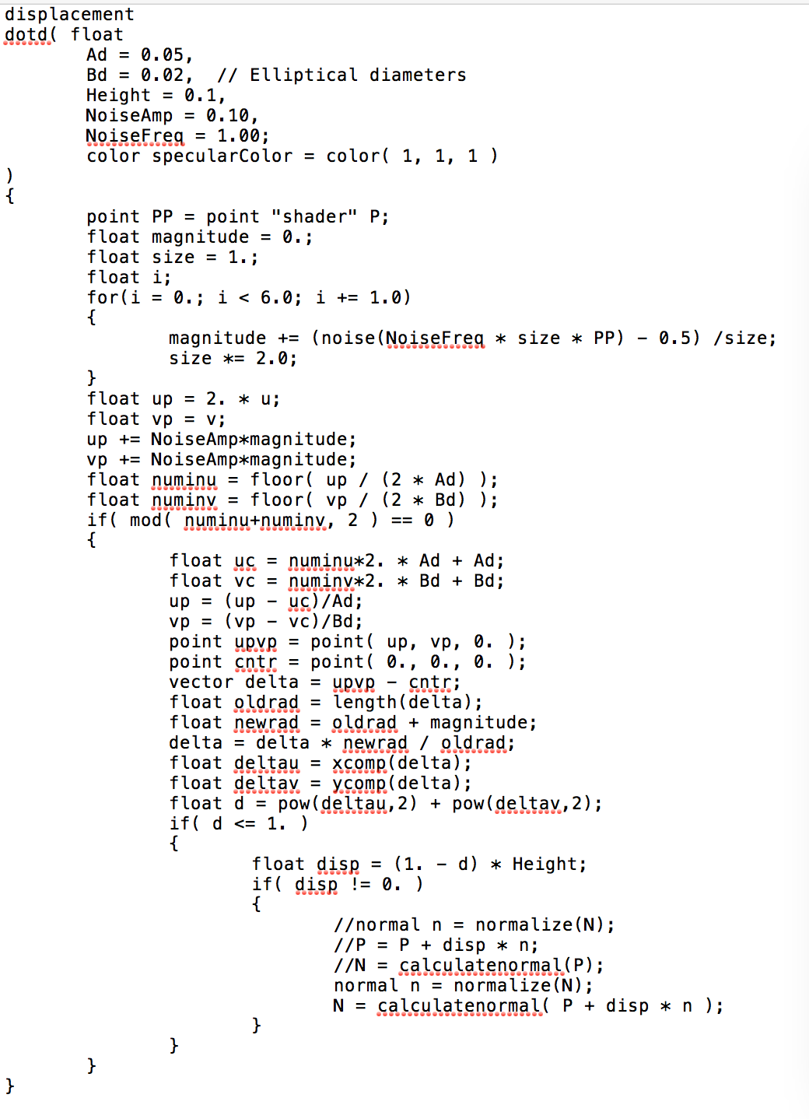

displacement sl file

The displacement file is almost like the surface file. This file have no code about the light or color. After noise, the points also need to have a height.

disp = (1. - d) \* Height

the 1 – d can make it smooth. When the d is bigger, the result of 1- d will be smaller. This means the point near the center will higher than the point far from the center and it will be smooth.

//normal n = normalize(N);

//P = P + disp \* n;

//N = calculatenormal(P);

This will calculate the normal and then replace the normal.

normal n = normalize(N);

N = calculatenormal( P + disp \* n );

This will calculate the normal but not replace it, so this is the bump displacement.

1. Results

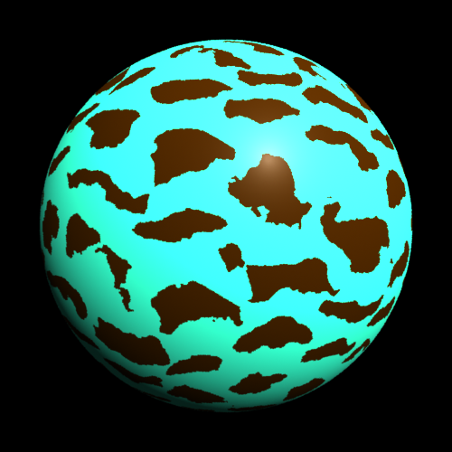

Surface only

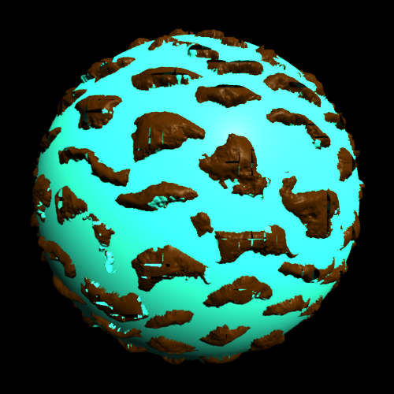

Surface and displacement

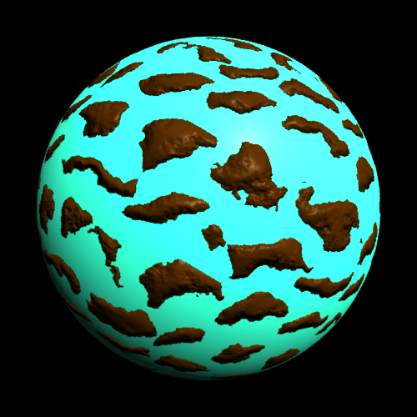

Surface and bump displacement