AGGREGATE FUNCTIONS
2520030187
Harshit Sajjanapu

1.FINDING TOTAL
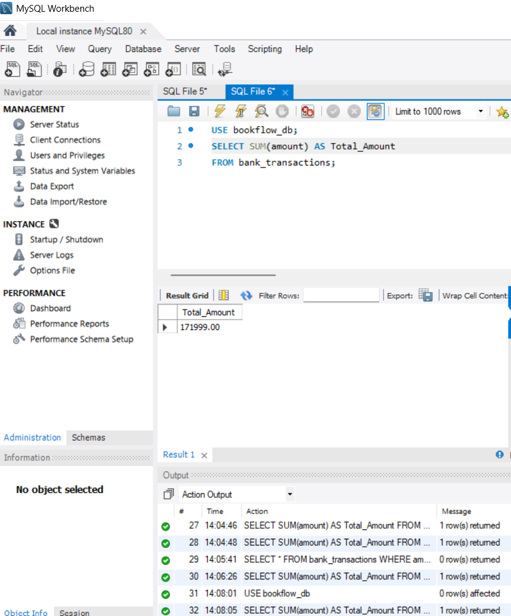
2.USING MAX FINDING HIGHEST TRANSACTION AMOUNT
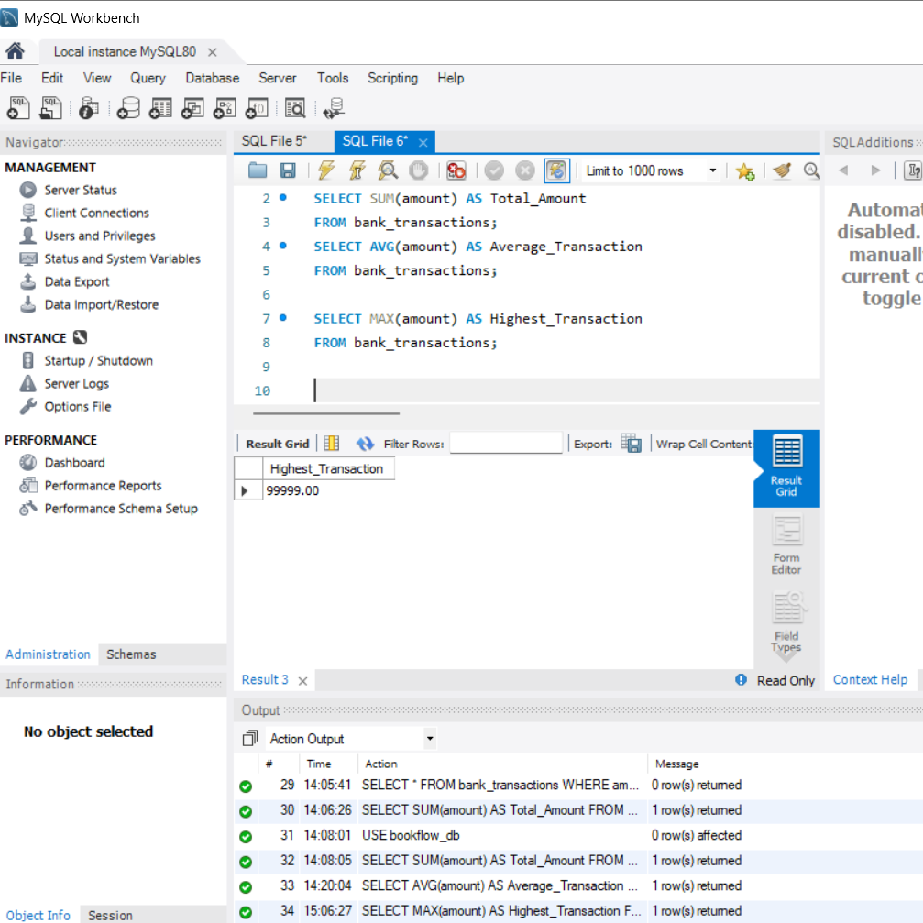

3.USING MIN() FINDING THE MIN MUM TRANSACTION
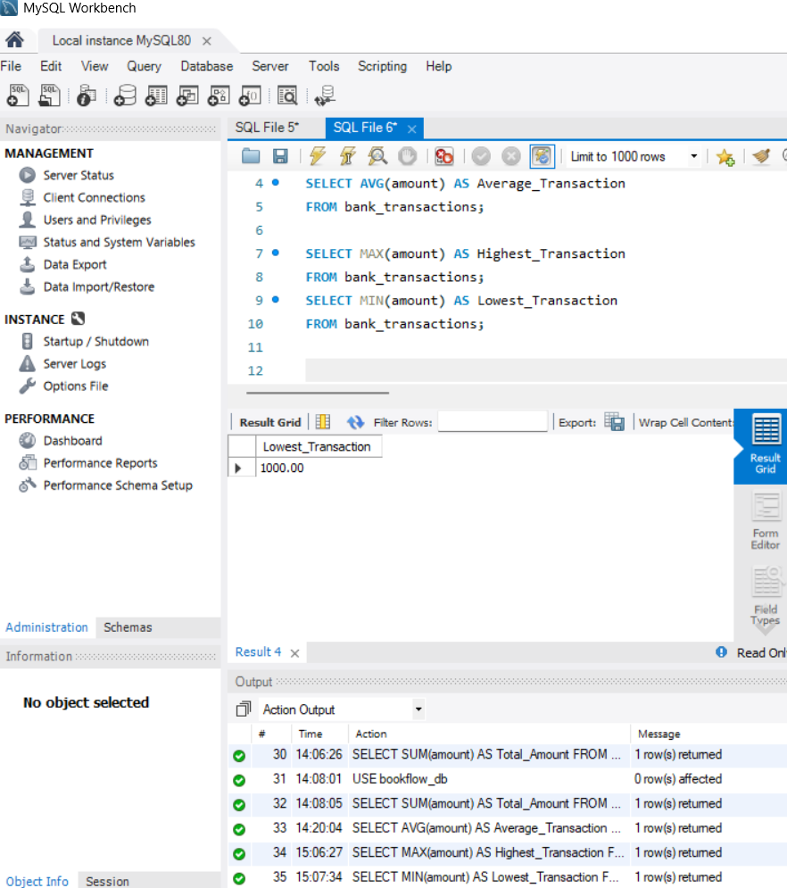

4.TO FIND no. of TRANSACTIONS
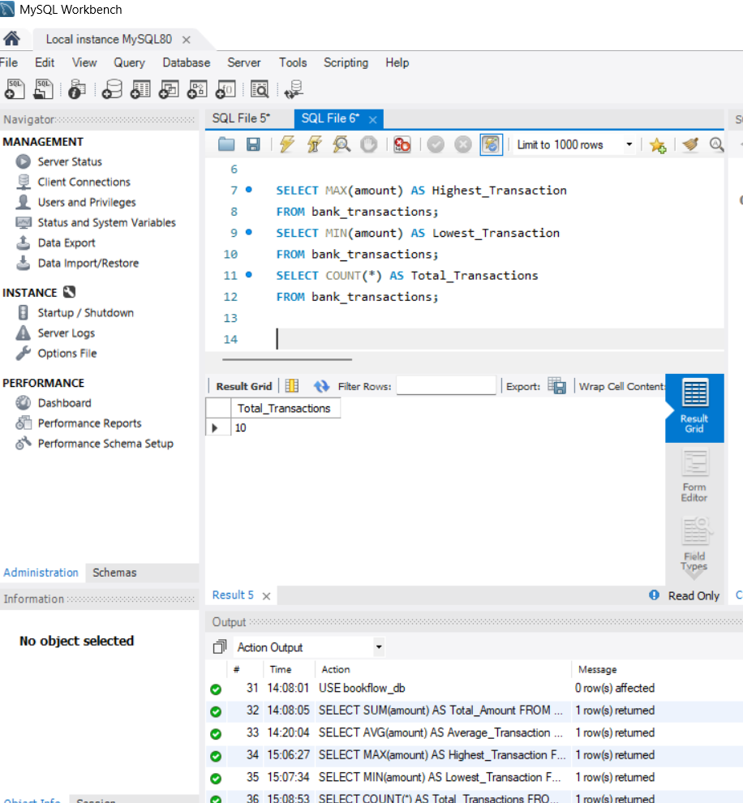

5.TO FIND TOTAL AMOUNT DEPOSITED
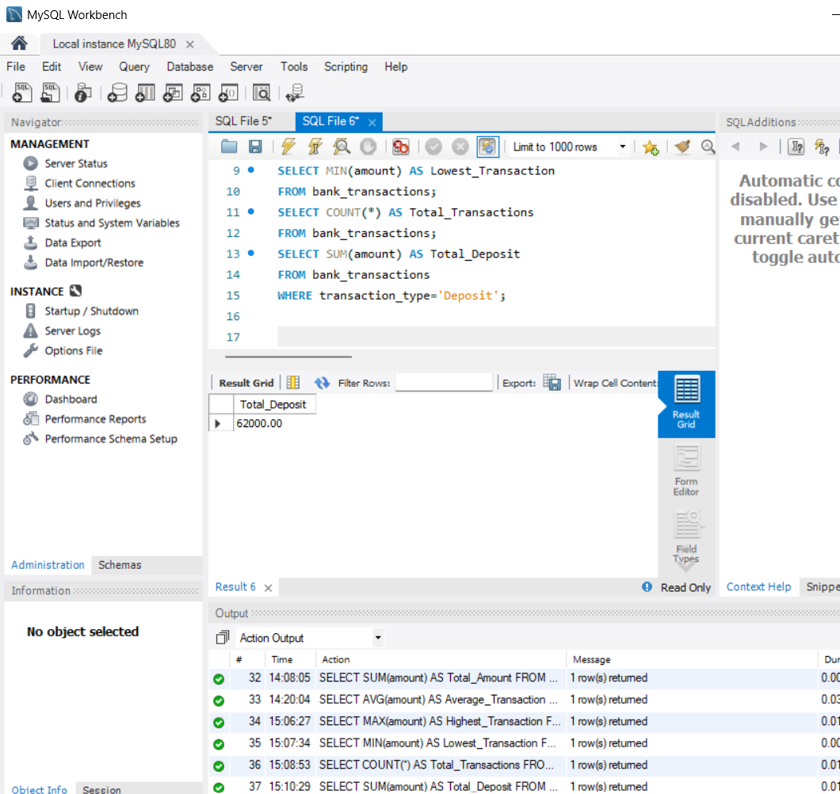

6.TOTAL TRANSACTION AMOUNTS FROM EACH BRANCH
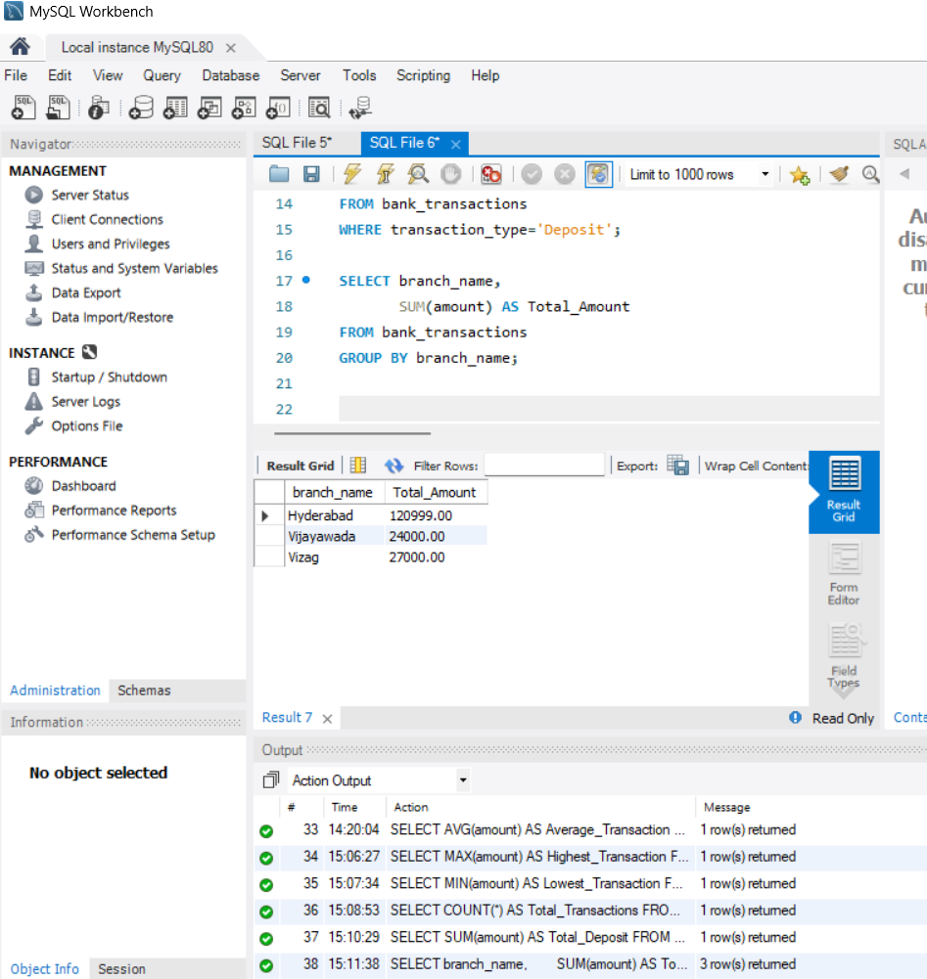

7.TRANSACTION AMOUNT MORE THAN $20,000
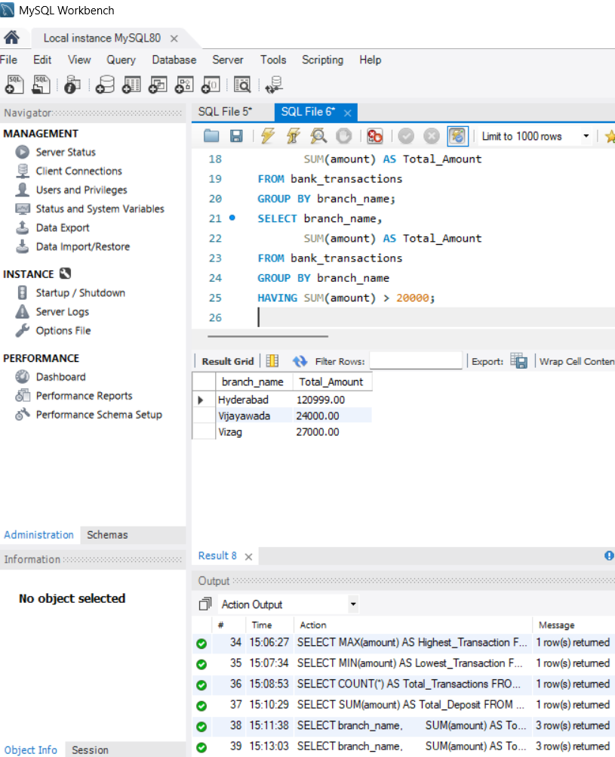

8.RANKING OF TRANSACTIONS
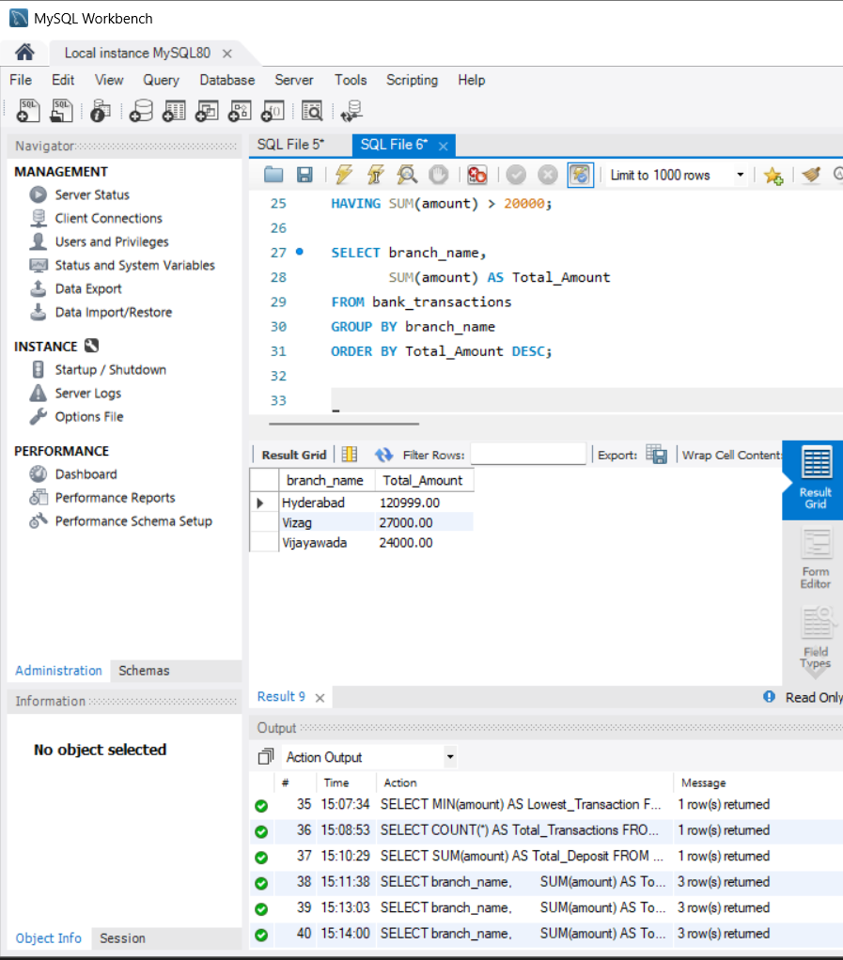

9.No. of TRANSACTIONS IN DESCENDING ORDER
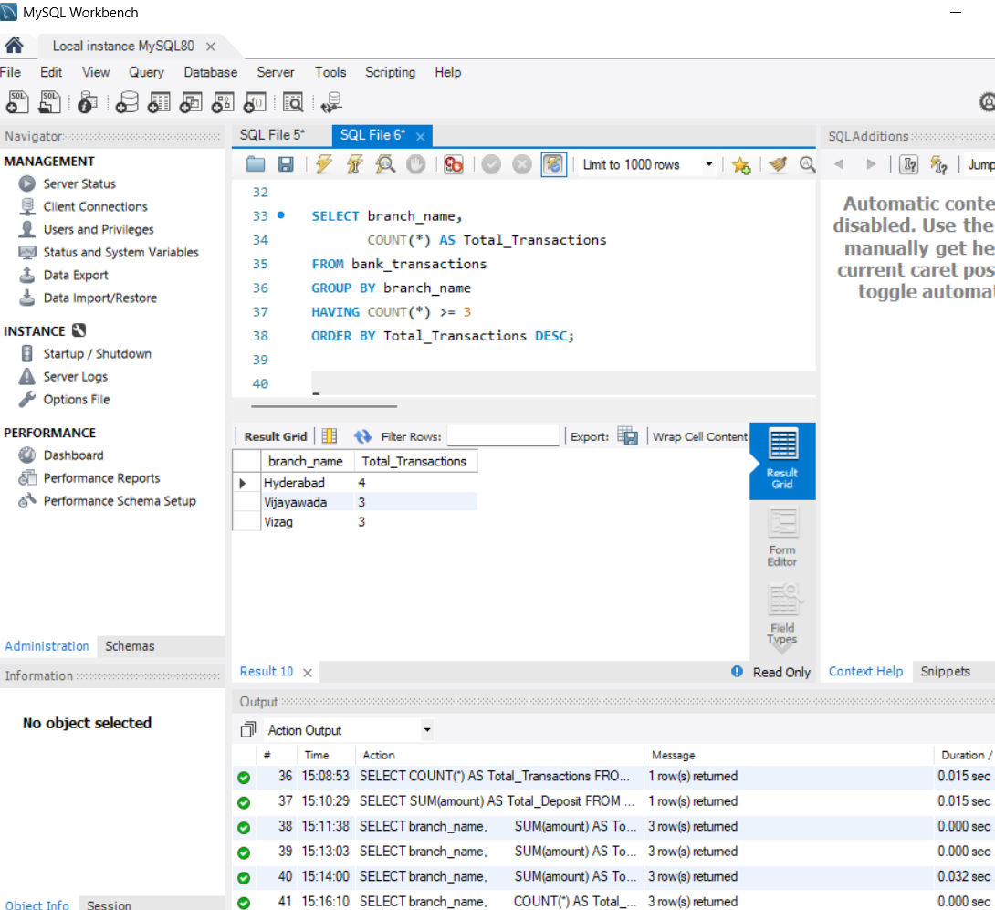

10.WHERE + COUNT used count how many withdraws are there
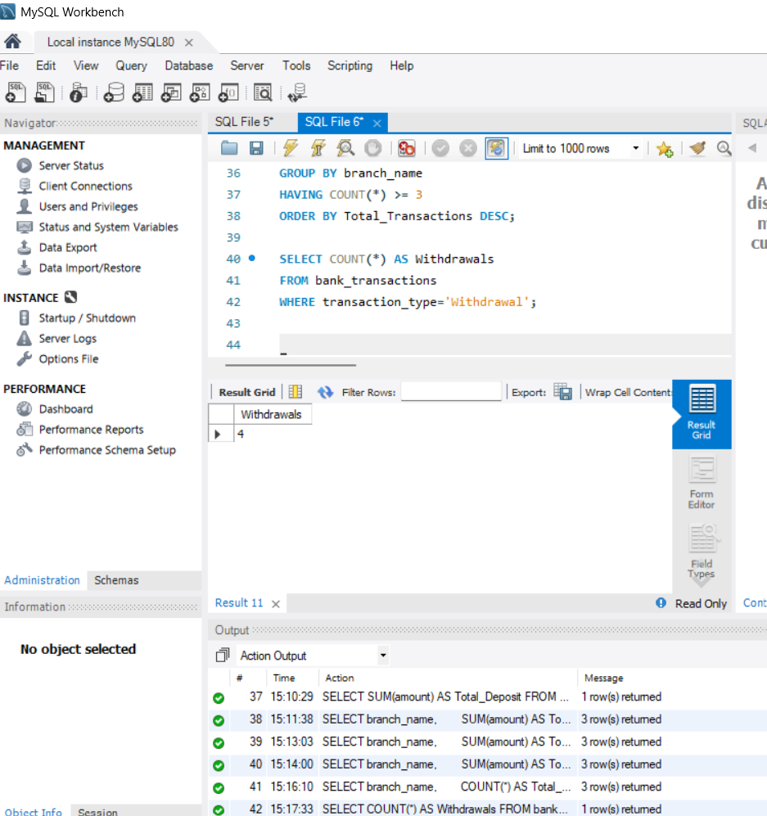

11.USING WHERE + AVG TO FIND AVG DEPOSITED AMOUNT
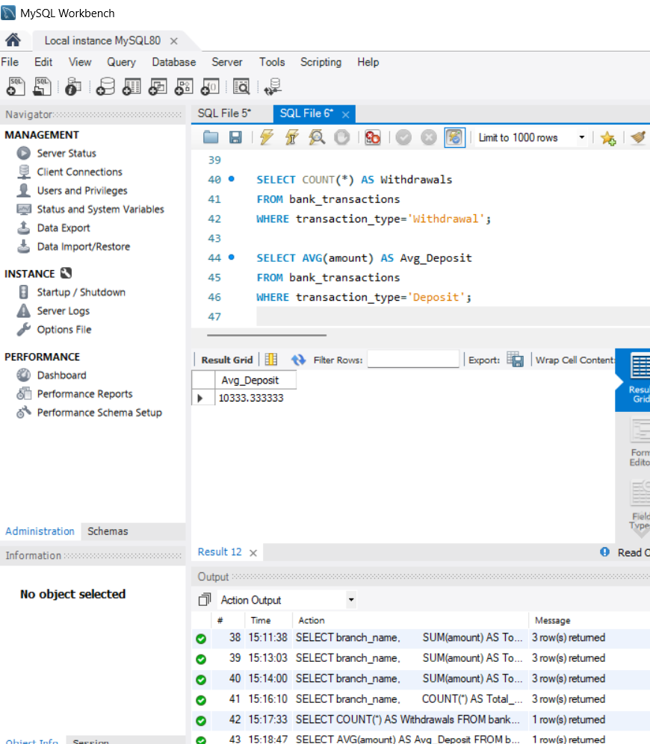

12.FINDING THE HIGHEST TRANSACTION IN EACH BRANCH USING GROUP BY MAX
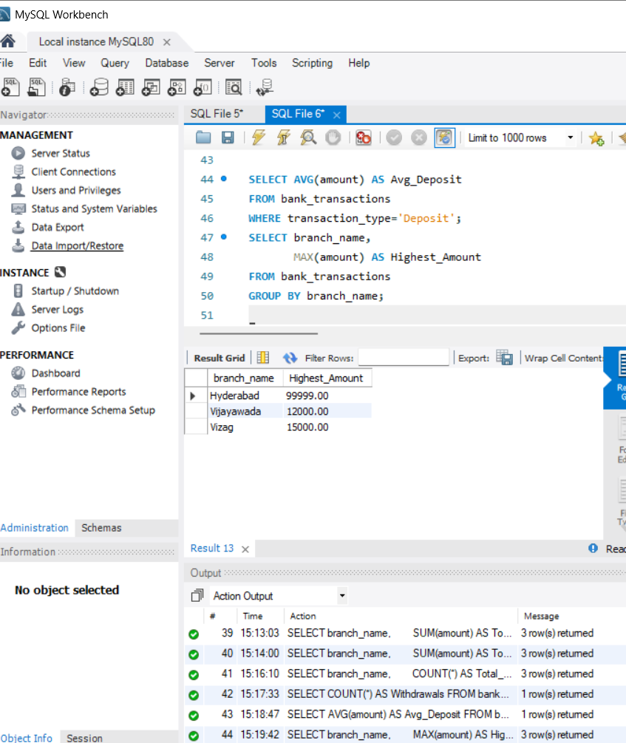

13.FINDING THE MIN TRANSACTION USING GROUP BY MIN()
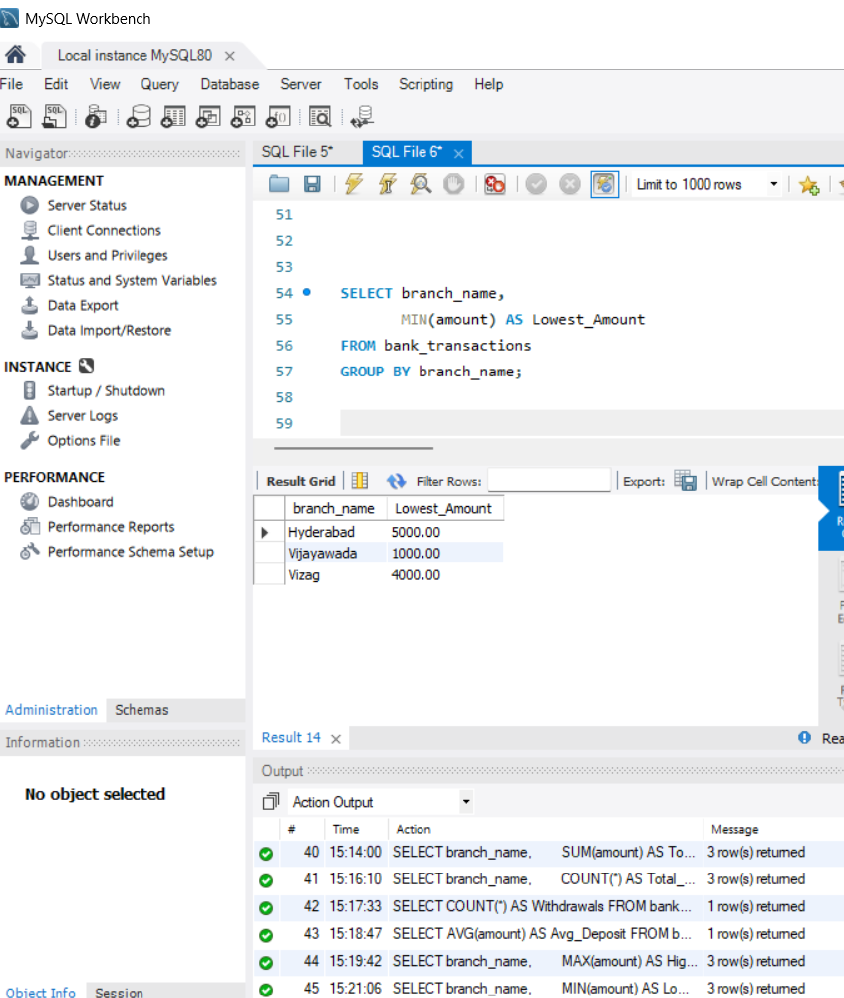

15.TO FIND NUMBER OF CUTOMERS TOOK TRANSACTIONS
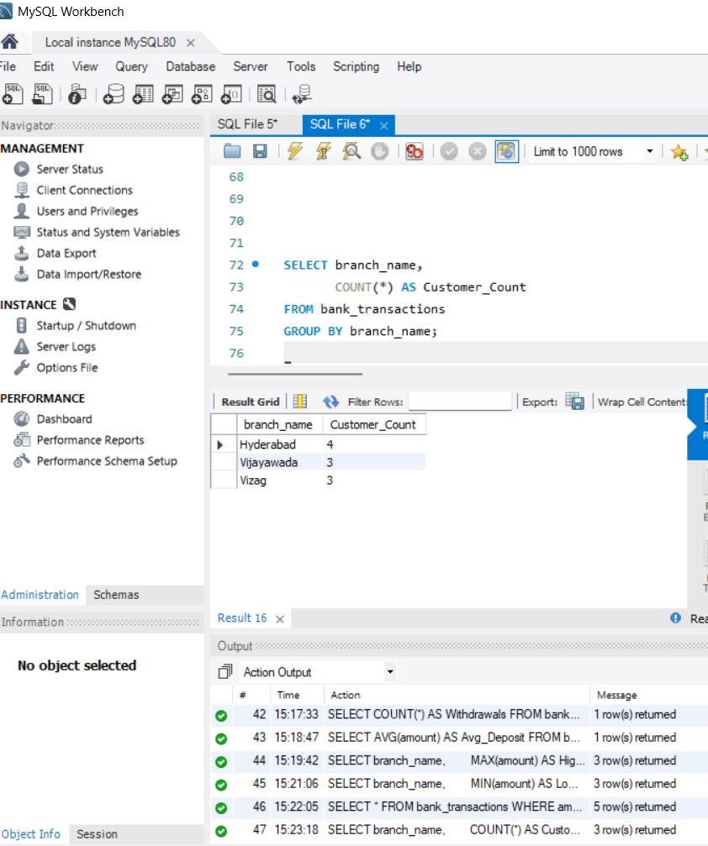

16.BRANCHES THAT TOOK TRANSACTIONS MORE THAN 3 TIMES
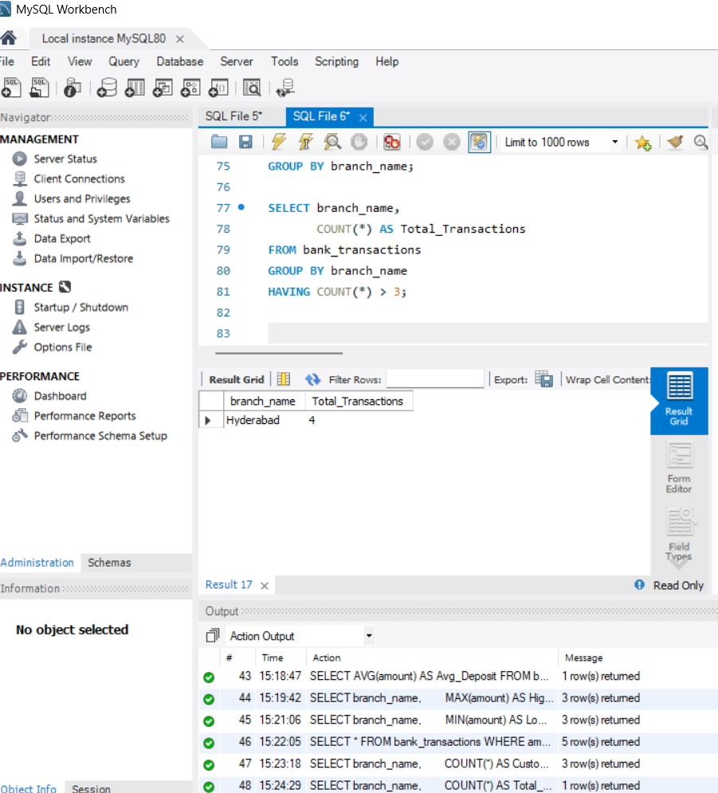

17.AVG TRANSACTION AMOUNT FOR EACH BRANCH
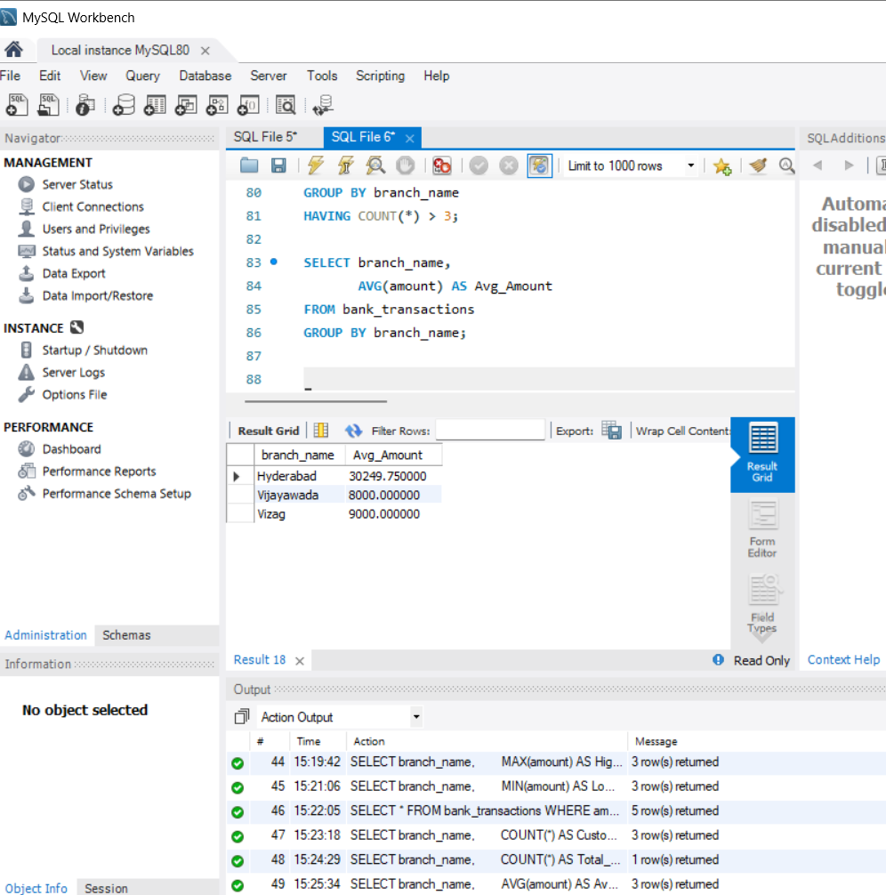

18.BRANCHES WHOSE TOTAL DEPOSITAL AMOUNT EXCEEDS $15,000
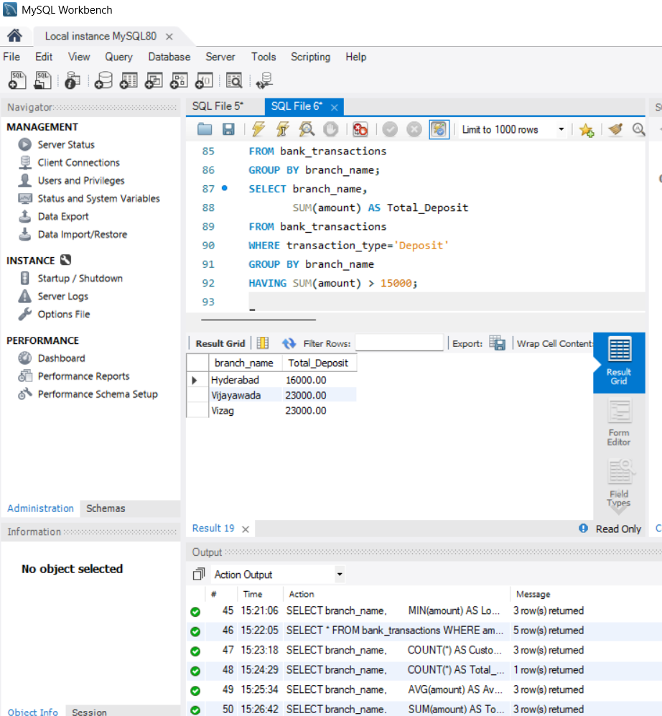

19.AVG TRANSACTION AMOUNT IS GREATER THAN $7000
