

* PREAMBLE
  + Fell free to interrupt me if something is not clear.
  + A few slides, main goal: exchange between you and me:   
    interrupt me!
  + Focus on front-end technologies
* In order to “Deliver Appealing and Engaging Apps”, you need tools and guidance. This is what the UX Architecture team does.
* A new way of building and testing apps.
* Not only it requires focus is new at Medavie and requires a change in the way we think web apps.



* Provides guidance for developers:
  + Guide and help fixing coding issues
* Keep up to date with the (r)evolutions of the web
  + Evolutions of HTML (5)/CSS (3) /JS (6)
  + Most of the existing technologies are pretty stable but the way they are used is constantly evolving.
* Investigates and defines UX stack of tools:
  + Gives developers tools

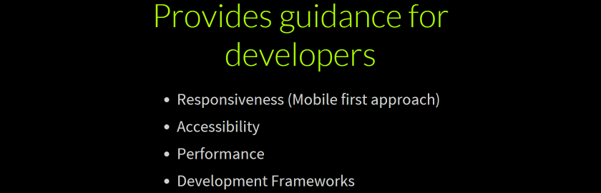

* Summary of
* Each one of these topics would require a (long) presentation by itself.

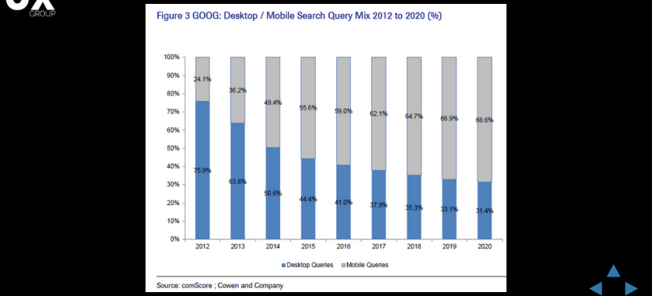

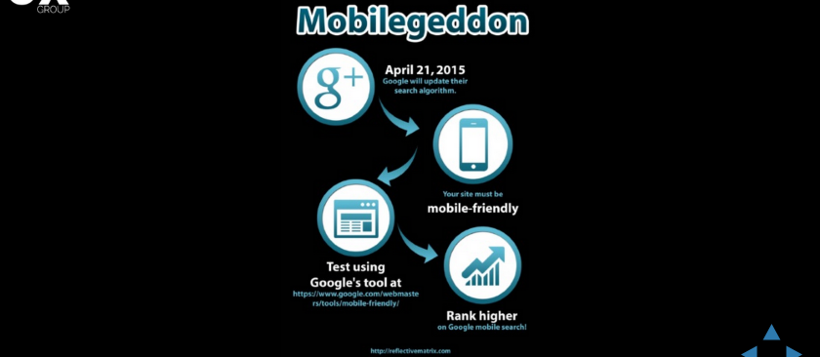





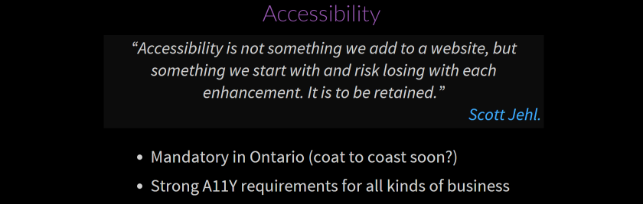

* ensuring that as many users as possible can navigate and comprehend a website.



