Hyperparameter Optimization Using a Hybrid Bayesian-PSO Framework for Customer Churn Prediction with Imbalanced Datasets
Abstract
Customer churn prediction in the banking and telecommunications sectors faces two interrelated challenges: class imbalance and the sensitivity of Deep Neural Network (DNN) performance to hyperparameter configuration. Most prior approaches address these challenges separately and in an ad hoc manner, leaving a gap for integrated end-to-end optimization pipelines. This study proposes the Hybrid Bayesian–PSO (HBP) framework, a sequential two-phase hyperparameter optimization strategy that combines the global exploration capability of particle swarm optimization with the sample-efficient local exploitation of Bayesian optimization via a Tree-structured Parzen Estimator. SMOTE–Tomek Links resampling was embedded as a fold-internal component to prevent data leakage. The framework was evaluated on two publicly available datasets from distinct industry domains under stratified 10-fold cross-validation with nonparametric statistical testing and benchmarked against a manual baseline (a replication of an expert configuration), standalone PSO, and standalone Bayesian optimization. Systematic hyperparameter optimization consistently outperformed manual tuning, with large effect sizes on both datasets (r = 0.63–0.82), and statistical significance was achieved on the higher-dimensional telecommunications dataset (Friedman p = 0.026). HBP consistently attained the highest AUC-ROC (0.8598 on banking; 0.8421 on telecommunications), the highest calibrated macro-F1, and the lowest AUC standard deviation, while selecting the most parsimonious architecture among all methods, with up to approximately eight times fewer parameters than PSO. The numerical advantage of HBP over standalone PSO and BO did not reach statistical significance after Holm–Bonferroni correction, a pattern consistent with the limited statistical power of the single-seed protocol. The primary contribution of this study is not a statistically demonstrated numerical superiority but the provision of an integrated resampling–HPO pipeline that consistently yields the best-performing, most stable, and most parameter-efficient models, positioning HBP as a principled framework for data-adaptive DNN configuration.
Keywords: Bayesian optimization, Customer churn, Deep Neural Network, Hyperparameter Optimization, Particle Swarm Optimization

1 Introduction
The banking sector occupies a distinctive position in the data economy: customers are not merely service recipients but also primary contributors to the informational assets that underpin operational intelligence. In this context, customer churn, the decision by an account holder to terminate their relationship with a financial institution, constitutes a form of strategic asset erosion with direct implications for long-term financial sustainability. Retaining an existing customer has been estimated to cost five to twenty-five times less than acquiring a new customer (Gallo, 2014). Research by Bain & Company indicates that a five-percent improvement in customer retention can increase profitability by 25% to 95%, attributable to the higher transaction volumes and lower per-customer servicing costs associated with a loyal clientele (Reichheld, 2001). Therefore, accurate churn prediction is a strategic imperative that drives the need for reliable, data-driven early warning systems.
The rapid maturation of deep learning over the past decade has created substantial opportunities for developing more capable churn prediction models (Imani, Joudaki, and Beikmohammadi, 2025). Among the available deep learning architectures, Deep Neural Networks (DNNs) have demonstrated competitive performance for customer churn classification, supported by their capacity to process high-dimensional tabular datasets and their strong generalization to unseen instances (Jamal et al., 2024). This effectiveness is consistent with a broader body of evidence demonstrating that DNNs can surpass traditional machine learning algorithms in terms of classification accuracy and robustness (LeCun, Bengio and Hinton, 2015). However, deploying DNNs for banking churn prediction introduces two interrelated challenges. First, churn datasets are inherently class-imbalanced; the fraction of customers who discontinue their relationship with the institution is substantially smaller than that of retained customers, biasing standard classifiers towards the majority class (Gkonis, 2025). This asymmetry produces deceptively high overall accuracy while suppressing minority class sensitivity, causing a disproportionate number of at-risk customers to go undetected, a false-negative pattern with direct financial consequences. Second, the predictive effectiveness of a DNN is critically dependent on the appropriate selection of hyperparameters. Configuration decisions, such as network depth, neurons per layer, learning rate, batch size, dropout rate, and training duration, exert simultaneous, non-linear, and jointly interactive effects on model quality (Hasan, Hasan and Hossain, 2022; Peng, 2024), making manual or heuristic configuration both unreliable and resource-intensive.
The hyperparameter optimization (HPO) literature has evolved from exhaustive enumeration strategies, such as grid and random searches, to principled probabilistic methods (Muntasir Nishat et al., 2022; Pramesti et al., 2025). In parallel, the class-imbalance challenge has been addressed through a range of resampling strategies, including the Synthetic Minority Oversampling Technique (SMOTE), Edited Nearest Neighbours (ENN), and Tomek Links (Gkonis, 2025; Imani, Joudaki and Beikmohammadi, 2025; Pramesti et al., 2025). Despite these advances, most published studies have addressed these two challenges in isolation. Recent systematic analyses indicate that end-to-end frameworks capable of simultaneously handling class imbalances and automating hyperparameter selection remain rare. Although such integration is widely acknowledged as important, it has yet to become standard practice in industry-grade predictive modelling (Hertel, Baldi and Gillen, 2022). Consequently, studies that explore the combination of resampling and hyperparameter tuning generally rely on ad hoc procedures rather than principled optimization pipelines.
The most directly relevant prior work is the comprehensive DNN benchmark study by Gkonis and Tsakalos (Gkonis, 2025), which systematically compared activation functions, optimizer combinations, and resampling strategies for banking churn prediction. Their analysis identified the combination of the APTx activation function, the RAdam optimiser, and SMOTE–Tomek Links resampling as achieving the highest AUC of 78.50% on a standard benchmark dataset. Critically, the authors explicitly acknowledged several limitations that define the research gap addressed in the present study. Hyperparameter selection was performed manually using default values, a fixed training budget of 100 epochs, a batch size of 16, and hidden-layer widths determined through a simple input–output averaging heuristic rather than structured optimisation. Experiments were conducted on a single dataset, leaving the generalizability of the findings unresolved. The authors explicitly noted that applying HPO to their architecture has significant potential for performance improvement, a recommendation that directly motivates the present study. Beyond this benchmark, the broader literature offers more formal frameworks: Particle Swarm Optimisation (PSO) (Ye, 2017), which excels at global search with low computational overhead, and Bayesian Optimisation (BO) (Snoek, Larochelle and Adams, 2012), which achieves substantial sample efficiency through probabilistic surrogate modelling. Both methods individually outperform manual tuning in their respective application domains; however, their sequential integration, in which the PSO global exploration warm-starts the BO surrogate, remains largely unexplored and, to the best of our knowledge, has not been investigated for DNN-based banking churn prediction under class-imbalance conditions.
Bayesian Optimisation (BO) is a sample-efficient sequential strategy that avoids brute-force or random search by constructing a probabilistic surrogate model of the objective function and directing the selection of evaluation candidates through an acquisition function, such as Expected Improvement (Shahriari et al., 2016; Li et al., 2021). Empirical comparisons consistently demonstrate its superiority over grid and random searches in converging towards near-optimal configurations with substantially fewer objective function evaluations (Li et al., 2021). However, this advantage diminishes in high-dimensional mixed-type search spaces, precisely the condition that characterises DNN hyperparameter optimisation, which involves continuous variables (learning rate, dropout rate), integer variables (number of layers, neurons per layer), and categorical variables (batch size). In such spaces, a Gaussian Process (GP) surrogate incurs cubic computational complexity with respect to the number of observations, and poor initialisation causes early trials to behave effectively as random search until the surrogate accumulates sufficient observations, a phenomenon commonly referred to as the cold-start problem (Morar, Marius Tudor ; Knowles, Joshua ; Sampaio, 2017; Jimenez and Katzfuss, 2023)
Particle Swarm Optimisation (PSO) offers a complementary profile that directly addresses these limitations. As a population-based metaheuristic, PSO conducts parallel exploration through a swarm of candidate solutions without relying on a surrogate model, thereby circumventing the cold-start problem inherent to the BO. Furthermore, PSO is amenable to adaptation over mixed continuous–discrete search spaces through velocity clamping and rounding schemes (Ye, 2017). However, its principal limitation is its susceptibility to premature convergence once the swarm collapses around a local optimum, which constrains its precision during refinement. This complementarity motivates a sequential hybrid architecture in which PSO serves as a global exploration engine, identifying promising regions of the hyperparameter space, whereas the top-ranked particle positions are used to warm-start the BO surrogate for local exploitation. Techniques based on BO and PSO individually have demonstrated promising performance in related domains, such as financial forecasting and rolling-element bearing fault diagnosis. However, their sequential integration has received limited attention and, to the best of our knowledge, has not been investigated for DNN-based churn prediction under class-imbalance conditions.
The selection of PSO as the global exploration engine is based on several comparative advantages over alternative metaheuristics. Compared to Genetic Algorithms (GAs), PSO employs a simpler operator design, requiring no crossover or mutation and fewer internal hyperparameters, yielding faster per-iteration convergence at a lower computational overhead (Gad, 2022). The systematic survey by Gad (2022) confirms that PSO's implementation simplicity and natural parallelisability make it particularly well-suited to moderate-dimensional search spaces of the kind encountered in DNN HPO. Relative to the Covariance Matrix Adaptation Evolution Strategy (CMA-ES), PSO offers a substantive advantage in mixed-type search spaces. CMA-ES is fundamentally designed for continuous variables and requires non-trivial modification, specifically margin-based discretization, to handle integer and categorical inputs (Loshchilov and Hutter, 2016; Hernández and Nieuwenhuyse, 2023), whereas PSO can be adapted to mixed continuous–discrete spaces via simpler discretization schemes. Furthermore, CMA-ES requires substantially more function evaluations to achieve satisfactory performance (Hamano, Ryoki and Saito, Shota and Nomura, Masahiro and Shirakawa, 2022), a limitation that is particularly costly when each evaluation entails a complete DNN training run. On the exploitation side, the Tree-structured Parzen Estimator (TPE) variant of Bayesian optimization was selected in preference to GP-based surrogates and the BOHB hybrid. Unlike GP, which models the objective function directly with O(n³) computational complexity per iteration, TPE separately models the density distributions of high- and low-performing configurations, yielding a complexity that scales linearly with the number of observations (Watanabe, no date; Bergstra et al., 2011). This scalability advantage is critical in the present study, in which 150 hyperparameter evaluations were executed per experimental condition. Additionally, TPE natively handles mixed-type search spaces, encompassing continuous (learning rate, dropout), integer (layers, neurons), and categorical (batch size) variables, without requiring specialized kernel engineering as demanded by GP surrogates (Watanabe, no date; Hernández and Nieuwenhuyse, 2023). This choice is consistent with the recent recommendations of Bischl et al. (2023), who identified TPE as an empirically robust method for deep learning HPO in moderate-dimensional search spaces.
Based on the foregoing synthesis, three specific research gaps are identified, each mapped directly to a component of the proposed framework: The first gap concerns hyperparameter configuration practice: the benchmark study of Gkonis and Tsakalos (2025) demonstrates that all DNN hyperparameters were fixed manually using default values, a fixed 100-epoch training budget, a batch size of 16, and hidden-layer widths determined through a simple input–output averaging heuristic; the authors explicitly recommended structured HPO as a priority for future work. This gap is addressed by the HBP framework, which replaces manual tuning with a two-phase, principled optimization pipeline. The second gap concerns sequential PSO–BO integration: although PSO and BO have individually demonstrated effectiveness in hyperparameter optimization tasks (Ye, 2017; Li et al., 2021), their sequential combination, in which PSO global exploration warm-starts the BO surrogate for local exploitation, has not been investigated for DNN-based churn prediction under class imbalance conditions. This gap is addressed by the sequential PSO–BO architecture of HBP, which directly mitigates both the cold-start limitation of standalone BO and the premature convergence tendency of standalone PSO. The third gap concerns resampling integration: the application of SMOTE–Tomek Links within churn prediction pipelines remains limited, and where it has been employed, resampling is typically applied as a static preprocessing step before data partitioning, introducing the risk of data leakage into the evaluation fold (Imani, Joudaki and Beikmohammadi, 2025). This gap is addressed by embedding SMOTE–Tomek Links as a fold-internal component of the HBP pipeline, ensuring that resampling and hyperparameter decisions are co-optimized under conditions that reflect true out-of-fold generalization.
Building on the identified gaps, this study develops a Hybrid Bayesian–PSO (HBP) framework for DNN hyperparameter optimization in the customer churn prediction domain. The principal contributions of this study are threefold. First, a sequential HBP framework is proposed that integrates the global exploration capability of PSO with the local exploitation efficiency of BO-TPE within a unified HPO pipeline for DNN configuration, directly resolving the cold-start limitation of standalone BO while mitigating the premature convergence tendency of standalone PSO. Second, SMOTE–Tomek Links resampling is embedded as a fold-internal component of the HBP pipeline, ensuring that resampling and hyperparameter decisions are co-optimized under conditions that reflect true out-of-fold generalization rather than being treated as a static preprocessing step applied before data partitioning. Third, the generalisability of the proposed framework is evaluated across two publicly available datasets from structurally comparable problem settings, tabular binary classification, spanning distinct industry domains, providing an empirical basis for assessing the external validity of the approach.

2 Related Work

2.1 Customer Churn Prediction
Customer churn refers to the event in which a customer ceases to use a product or service. Because acquiring new customers is far more expensive than retaining existing ones, early churn prediction is a critical activity in the banking and telecommunications sectors (Reichheld, 2001; Gallo, 2014). A recent systematic review by Imani et al. (2025), which analyzed 240 indexed studies from 2020 to 2024, documented a clear shift from conventional statistical methods to machine learning (ML) and deep learning (DL) approaches, while identifying three recurring challenges: model interpretability, class imbalance, and concept drift. Among DL architectures, the Deep Neural Network (DNN) exhibits competitive performance for tabular churn classification owing to its capacity to process high-dimensional data and its strong generalization (LeCun, Bengio and Hinton, 2015; Jamal et al., 2024). However, the advantage of DNN over MLP depends heavily on its component configuration (activation function, optimizer), and explicitly acknowledges that their study did not address class imbalance beyond stratification (Domingos and Ojeme, 2021). This limitation underscores that the potential of DNNs cannot be realized without simultaneously addressing two issues: hyperparameter configuration and data imbalance.

2.2 Class Imbalance and Resampling
Churn datasets are inherently imbalanced; the proportion of churning customers is generally much smaller than that of retained customers, biasing conventional classifiers towards the majority class. Data-level resampling strategies have evolved from simple oversampling to synthetic methods, such as SMOTE, and subsequently to hybrid methods that combine oversampling with undersampling-based cleaning. SMOTE–Tomek Links combines two complementary mechanisms: SMOTE synthesizes minority-class samples by interpolating them toward their nearest neighbors (Chawla et al., 2002), whereas Tomek Links removes ambiguous cross-class pairs near the decision boundary (Batista, Prati and Monard, 2004). This combination has proven effective for churn prediction, as demonstrated by Gkonis and Tsakalos (2025), who identified it as the best-performing resampling strategy on a banking benchmark. The application of SMOTE–Tomek specifically to churn prediction remains relatively limited, leaving room for exploration (Haddadi et al., 2024).

2.3 Hyperparameter Optimization
Appropriate hyperparameter selection significantly affects DNN performance. The HPO literature has moved from exhaustive search to two more principled paradigms. The first is population-based metaheuristics, with Particle Swarm Optimisation (PSO) as the principal representative; (Ye, 2017)showed that PSO is effective for automatic DNN parameter selection owing to its global exploration with low computational overhead. Similar approaches have since proven successful across domains, from large-scale COVID-19 data analysis (Salem, Mead and El-taweel, 2024)to fault diagnosis in medical imaging. The second paradigm is probabilistic optimization, most notably Bayesian optimization (BO), which attains high sample efficiency through a surrogate model.
These two paradigms possess complementary strengths: PSO excels at global exploration but is prone to premature convergence, whereas BO excels at local exploitation but suffers from a cold-start problem in high-dimensional spaces. This complementarity motivates the hybrid approach. Li et al., (2021) explored combining BO with particle swarm in parallel and reported faster convergence. However, as a comprehensive review by Bischl et al. (2023) also emphasizes, sequential integration, in which the PSO exploration phase directly warm-starts the BO exploitation phase, remains understudied, particularly in the context of DNN-based churn prediction under class imbalance.

2.4 Previous Research and Research Positioning
Several key bodies of literature were mapped to provide a clear overview of where this study stands relative to previous research. The results of this mapping are shown in Table 1, where bold values are the proposed research.
Table 1 Synthesis of Selected Studies..
Author (Year) | Domain | Model | HPO Method | Integrated Pipeline
Gkonis & Tsakalos (2025) | Banking | DNN (APTx+RAdam) | Manual (default) | No. Resampling explored, HPO not
Ye (2017) | General | DNN | PSO | Partial. HPO only, no resampling
Imani & Arabnia (2023) | Churn (multi) | ML (various) | Grid/Random search | Partial  (sampling + ad hoc HPO)
Haddadi et al. (2024) | Churn (multi) | Comparative ML | No | No. Resampling focuses only
Imani et al. (2025) | Churn (review) | ML/DL (survey) | Various (survey) | No. Survey confirms integration gap
Li et al. (2021) | General | NN | BO + PSO (parallel) | Partial (hybrid HPO, no resampling)
Salem et al. (2024) | COVID-19 (big data) | ML | PSO | Partial. HPO only
Bhatnagar & Srivastava (2025) | Telecom | ML (RF, SVM, etc.) | HP tuning | Partial. Balancing + tuning separate
Singh et al. (2025) | Churn (telco) | Ensemble + SMOTE | HP tuning | Partial. Not end-to-end per-fold
Bergstra & Bengio (2012) | General | NN | Random vs Grid Search | No. Budget-comparison foundation
Bischl et al. (2023) | General (survey) | ML/DL | HPO survey (TPE, BO, etc.) | No. Survey, not a pipeline
This study (HBP) | Banking & Telco | Feedforward DNN | HBP: PSO + BO-TPE | Yes. Per-fold resampling + hybrid end-to-end HPO

Based on the literature synthesis, three research gaps were identified. First, Gkonis and Tsakalos (2025) explored activation functions and resampling for churn DNNs but did not explicitly apply hyperparameter optimization, a limitation they acknowledged. Second, although PSO (Ye, 2017) and BO (Snoek, Larochelle and Adams, 2012) have been used separately, their combination in a hybrid framework for HPO in churn prediction has not been previously explored. Third, the application of SMOTE-Tomek in this context remains limited (Haddadi et al., 2024). This research addresses all three gaps by proposing the Hybrid Bayesian-PSO (HBP) framework that combines PSO exploration and BO exploitation, evaluated on a DNN with SMOTE-Tomek, using the Gkonis and Tsakalos (2025) baseline as a controlled comparison.

3 Proposed Method
This study compared four experimental conditions (C1–C4) on two churn classification datasets with different characteristics. Figure 1 illustrates the overall research process. This study was designed as a comparative experimental study that hierarchically compared four model configurations.
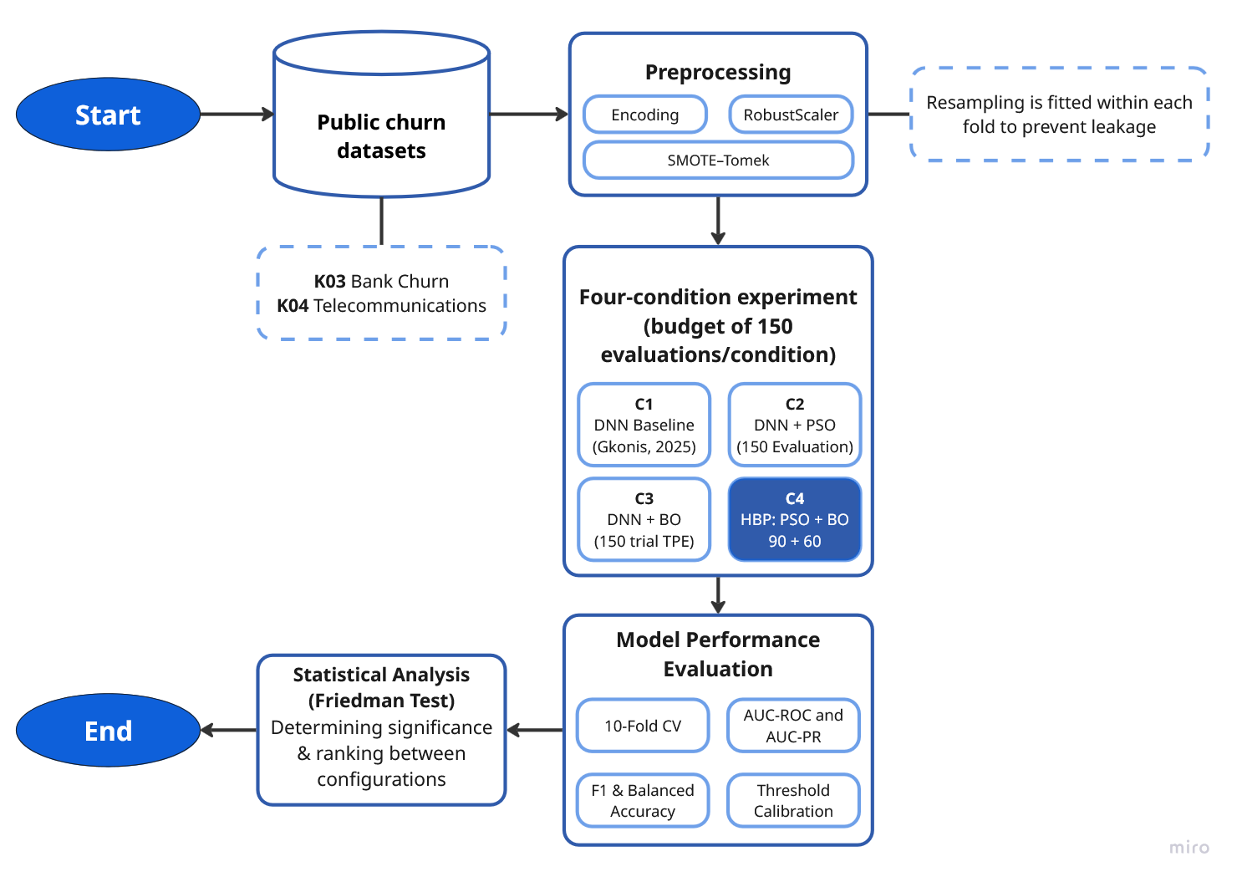
Fig 1 Overall Research Workflow.

3.1 Dataset
Two publicly available datasets were selected based on three eligibility criteria: (1) a binary churn label as the classification target, (2) a tabular feature structure without inherent temporal sequentiality that is compatible with feedforward DNN architectures, and (3) an Imbalance Ratio (IR) greater than 2.0 to ensure relevance to the class-imbalance problem. The use of two datasets from distinct industry domains, banking and telecommunications, is motivated by the need to assess the cross-domain generalizability of the proposed framework, a gap identified in prior work. Dataset K03 (Churn Modelling) serves as the primary benchmark, enabling direct methodological comparison with Gkonis and Tsakalos (2025), whose study provides an empirical foundation for the fixed architectural choices adopted here. Dataset K04 (Telco Customer Churn) extends the evaluation to a different industrial sector, thereby allowing cross-domain validation. Table 2 summarizes these specifications.

Table 2. Dataset Spesification
Dataset Code | Domain | Samples | Features | IR | Source
K03 | Banking | 10,000 | 13 | 3.91 | Kaggle: shrutimechlearn/churn-modelling
K04 | Telecommunications | 7,043 | 45* | 2.77 | Kaggle: blastchar/telco-customer-churn
*) The 45 features in K04 result from One-Hot Encoding of 21 original columns (including categorical variables such as InternetService, Contract, and PaymentMethod).

The imbalance ratio (IR) is calculated as the ratio of the number of majority class samples to the number of minority class samples:

$IR=\frac{Nminority}{ ​Nmajority}$ (1)

The difference in feature dimensionality between the two datasets is highly pronounced: K04 yields 45 features owing to the large number of categorical variables (e.g., contract type, Internet service, and payment method) expanded via one-hot encoding, whereas K03, which primarily comprises numerical features, results in only 13 features. This contrast was deliberately maintained to ensure that the evaluation encompassed two distinct data characteristics.

3.2 Data Preprocessing
Preprocessing was applied identically to both datasets through a single load_and_preprocess() function to ensure consistency. To prevent any information leakage, the entire preprocessing pipeline, consisting of three primary stages, was executed strictly within each cross-validation fold. First, missing TotalCharges values in K04 are filled with the median rather than the mean, as the median exhibits greater robustness against outliers in subscription cost variables. Second, One-Hot Encoding is applied to all categorical variables, including binary ones such as Gender, to avoid imposing ordinality assumptions, following the methodology of Gkonis and Tsakalos (2025). Third, numerical features were scaled using RobustScaler, which normalizes data based on the median. Crucially, the RobustScaler was fitted exclusively on the training fold data and subsequently applied to the validation fold. This practice ensures that no information from the validation set influences the training process, adhering to standard protocols in rigorous model evaluation (Burez and Poel, 2009). Fourth, Customer churn datasets are inherently imbalanced; churners typically represent the minority class with proportions ranging from 5% to 25%, which often biases conventional classifiers toward the majority (non-churn) class. To mitigate this issue, SMOTE-Tomek Links was employed as the resampling strategy. This hybrid, two-phase method addresses class imbalance from both directions simultaneously and was selected based on its empirically demonstrated superiority over standalone SMOTE, ADASYN, random oversampling, and random undersampling when combined with Deep Neural Network (DNN) models on the same banking churn benchmark. Crucially, to ensure strict validation integrity, SMOTE-Tomek Links was applied exclusively to the training data within each validation fold. The framework operates through two distinct phases, SMOTE and Tomek Links.
- Phase 1: SMOTE.
For each minority-class sample xᵢ, one synthetic instance is generated by interpolating toward one of its k = 5 nearest neighbours x̃:
$$x_new = x_i + λ · (x̃ - x_i), λ \sim U(0, 1) (2)$$
This synthesis increases minority-class representation without exact replication, reducing the risk of overfitting to the original distribution. The choice k = 5 follows the empirically validated default for churn datasets.
- Phase 2: Tomek Links.
Following the synthesis phase, Tomek Links are deployed to clean the dataset by removing cross-class sample pairs that act as mutual nearest neighbors. A pair of samples $(xa, xb)$ from opposite classes is formally defined as a Tomek Link. Majority-class samples forming such links are systematically removed. This clearing mechanism sharpens the decision boundary and effectively reduces the class ambiguity often introduced by SMOTE synthesis near the boundary line. This fold-internal application of SMOTE-Tomek Links was rigorously enforced throughout all hyperparameter fitness evaluations within the HBP framework. This setup guarantees that every Area Under the Curve (AUC) estimate utilized to guide the optimization search accurately reflects true out-of-fold generalization.

3.3 DNN Architecture
The base model optimized across all experimental conditions is a feedforward Deep Neural Network (DNN) featuring a hidden block repeated over L layers. Each block comprises a fully connected (dense) layer, batch normalization, the APTx activation function, and dropout. The structural illustration is shown as Figure 2.
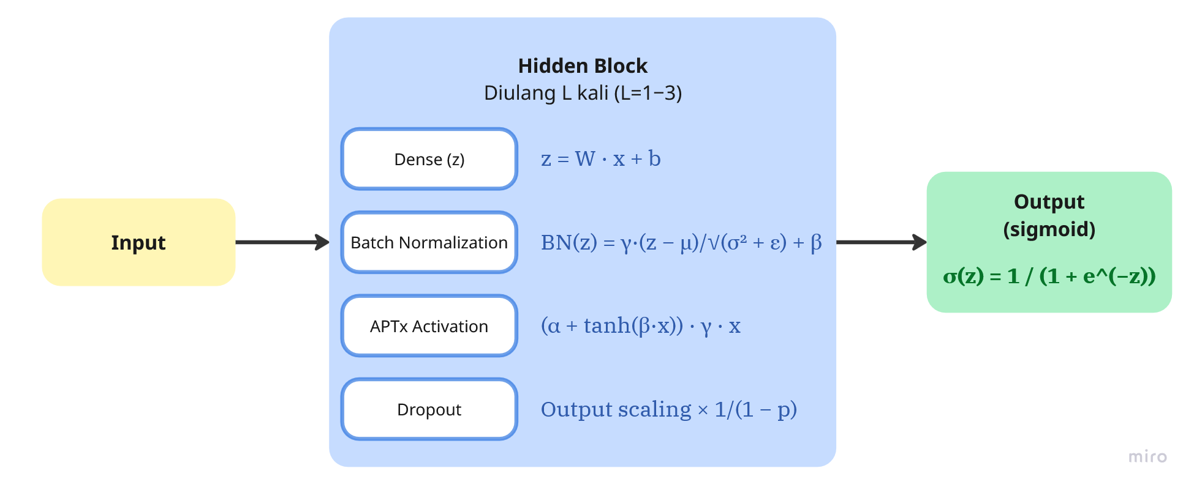
Fig 2 DNN Architecture
The APTx activation function is defined as:
$$APTx\left(x\right)= \left(α + tanh\left(βx\right)\right)· γx \left(3\right)$$
$$with α=1, β=1, γ=1/2$$
Under this configuration, APTx reduces to a scaled Swish, since $½(1 + tanh(x)) = σ(2x), giving APTx(x) = x·σ(2x)$, i.e., Swish with $β=2$. It therefore inherits the smooth, non-monotonic profile that benefits gradient flow — comparable to Mish — while requiring fewer mathematical operations to compute in both the forward and backward passes, as it avoids the softplus and logarithm terms that Mish involves. This choice follows the optimal configuration reported by Gkonis and Tsakalos (2025), who identified APTx+RAdam+SMOTE-Tomek as the best-performing combination on the same K03 dataset. Dropout is applied for regularisation by randomly deactivating neurons with probability p during training, scaling active neurons by 1/(1 − p) to preserve expected output magnitude:
$$ã = (a ⊙ m) / (1 - p), m_i \sim Bernoulli(1 - p) (4)$$
The output layer comprises a single neuron with sigmoid activation, producing a customer churn probability estimate:
$$ŷ = σ(z) = 1 / (1 + e^(-z)) (5)$$
The sigmoid activation is appropriate for binary classification: its output is directly interpretable as P(churn | x), and it pairs naturally with the binary cross-entropy loss, yielding a gradient at the output layer that reduces to the prediction residual:
$$l(y, ŷ) = -[y log(ŷ) + (1-y) log(1-ŷ)] (6)$$
The RAdam optimizer is used with the learning rate as an optimized hyperparameter. RAdam addresses Adam's sensitivity to learning rate selection through an adaptive variance rectification mechanism. Early stopping is configured with patience = 5 epochs, a minimum improvement threshold of δ = 0.001, and restoration of best weights upon termination.

3.4 Experimental Conditions
Four experimental conditions are defined to enable controlled and fair comparisons. Table 3 summarizes the experimental design. The range and scale of each hyperparameter in Table 3 were established on the basis of empirical grounding in the benchmark study and standard practice in search-space design.

Table 3. Experimental conditions and computational budgets.
Cond. | HPO Method | DNN  Configuration | Description
C1 | Manual  (Baseline) | 2 layers, 7  neurons,  lr=0.001 | Replication of Gkonis & Tsakalos (2025)  configuration as lower-bound reference
C2 | PSO  Standalone | PSO-optimized  (10 particles, 15  iter.) | Evaluate PSO-only
C3 | BO Standalone | BO/Optuna-  optimized (150  trials) | Evaluate BO-only HPO
C4 | HBP  (Proposed) | PSO → top-5  warm-start →  BO (60 trials) | Proposed method: PSO exploration +  directed BO exploitation

All of the experimental conditions and computanional budgets was summarized in Table 4. The number of hidden layers was constrained to 1–3 to bracket the two-layer configuration of Gkonis and Tsakalos (2025) while accommodating the characteristics of tabular data, whose structural complexity is limited relative to perceptual modalities, such that overly deep networks tend to over-parameterise and degrade generalisation (Shwartz-Ziv and Armon, 2022). The number of neurons per layer (16–128) expands Gkonis' input–output averaging heuristic (which yields roughly seven neurons) towards larger capacity, and is sampled on a logarithmic scale because the effect of network width on model capacity is multiplicative rather than additive (Bischl et al., 2023). The learning rate spans 10⁻⁴ to 10⁻² on a logarithmic scale—standard practice for hyperparameters whose sensitivity spans several orders of magnitude (Bergstra et al., 2011; Bischl et al., 2023)—so that this range brackets the Adam/RAdam default (10⁻³) at its centre. Dropout is bounded at 0.0–0.4 because regularisation values above 0.5 are rarely beneficial on tabular data and risk impeding the learning of the minority-class signal. Batch size is selected as the power-of-two set {64, 128, 256, 512} for computational efficiency on accelerators, with a range matched to the sizes of both datasets (7,043–10,000 samples). Finally, the training budget is fixed at 100 epochs following Gkonis and Tsakalos for comparability, with early stopping serving as an adaptive bound to prevent overfitting.
Table 4. Experimental conditions and computational budgets.
Hyperparameter | Range / Choices | Scale
Number of hidden layers (L) | 1 – 3 | Discrete
Neurons per layer | 16 – 128 | Logarithmic
Dropout rate | 0.0 – 0.4 | Linear
Learning rate | 10⁻⁴ – 10⁻² | Logarithmic
Batch size | {64, 128, 256, 512} | Categorical
Epochs | 100 (bounded by early stopping) | Fixed

All three optimisation methods are evaluated over an identical search space with an equal evaluation budget of 150 model evaluations per condition, ensuring that any observed advantage cannot be attributed to a larger budget. C1 applies no HPO. In PSO (C2), each particle represents a candidate hyperparameter configuration and updates its velocity and position according to:
$$vᵢ⁽ᵗ⁺¹⁾ = w × vᵢ⁽ᵗ⁾ + c₁r₁(pᵢ⁽ᵗ⁾ - xᵢ⁽ᵗ⁾) + c₂r₂(g⁽ᵗ⁾ - xᵢ⁽ᵗ⁾) (7)$$
$$xᵢ⁽ᵗ⁺¹⁾ = xᵢ⁽ᵗ⁾ + vᵢ⁽ᵗ⁺¹⁾ (5)$$

where vᵢ is the velocity vector of particle i, xᵢ is its position, pᵢ is particle i's personal best, g is the global best, w is the inertia weight, and c₁, c₂ are acceleration coefficients. Table 5 shows the PSO configuration.
Table 5. PSO Configuration
PSO Parameter | Value | Justification | Reference
Swarm size (N) | 10 | Sufficient for 5D space; rule of thumb: 2×n_dim | (Ye, 2017)
Cognitive coeff. (c₁) | 1.5 | Balanced local exploration | (Clerc and Kennedy, 2002)
Social coeff. (c₂) | 1.5 | Symmetric with c₁ for balanced global exploration | (Clerc and Kennedy, 2002)
Inertia (w) | 0.72 | Clerc constriction factor; prevents divergence | (Clerc and Kennedy, 2002)
Total evaluations (C2) | N × T = 150 | Equal budget to C3 for fair comparison | (Bergstra et al., 2011)
BO (C3) employs the Tree-structured Parzen Estimator (TPE), which models the densities of high-performing configurations ℓ(x) and low-performing configurations g(x), selecting the next candidate by maximising the improvement ratio:
x$_next = argmax_x l(x) / g(x) (8)$
Configuration C3 performs 150 trials with 5 random warm-up trials for initialisation equal to C2's total evaluations to ensure a fair comparison under equal computational budget, following the controlled comparison principle of Bergstra and Bengio (2012).
The proposed configuration, Hybrid Bayesian–PSO (HBP/C4), combines both methods sequentially. PSO executes a global exploration phase (10 particles × 9 iterations = 90 evaluations), after which the five most promising and diverse configurations from the swarm are used to warm-start the BO exploitation phase (5 + 55 = 60 trials). The total evaluation budget for C4 remains 150, identical to C2 and C3. This mechanism leverages PSO's ability to broadly explore the search space and BO's ability to refine solutions in promising regions, thereby mitigating the cold-start problem that BO commonly encounters in high-dimensional mixed hyperparameter spaces. Configuration C1 serves as a manual baseline with no optimisation. The complete HBP workflow shows in Figure 3.

3.5 Evaluation Protocol and Performance Metrics
Configuration C3 performs 150 trials with 5 random warm-up trials for initialisation, equal to C2's total evaluations to ensure a fair comparison under equal computational budget, following the controlled comparison principle of Bergstra and Bengio (2012). The proposed configuration, the Hybrid Bayesian–PSO (HBP/C4), combines both methods sequentially. PSO executes a global exploration phase (10 particles × 9 iterations = 90 evaluations), after which the five most promising and diverse configurations from the swarm are used to warm-start the BO exploitation phase (5 + 55 = 60 trials). The total evaluation budget for C4 remained at 150, identical to those of C2 and C3. This mechanism leverages PSO's ability to broadly explore the search space and BO's ability to refine solutions in promising regions, thereby mitigating the cold-start problem that BO commonly encounters in high-dimensional mixed hyperparameter spaces. Configuration C1 serves as a manual baseline with no optimisation. The complete HBP workflow is shown in Figure 3.
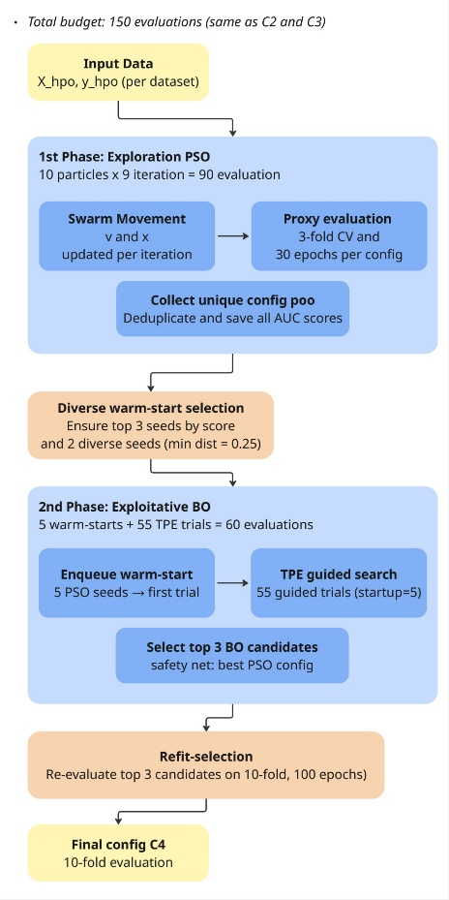
Fig 3 Complete C4 Workflow of Hybrid Bayesian-PSO (HBP)
The final evaluation employed 10-fold stratified cross-validation on the complete dataset, whereas the HPO proxy evaluation used 3-fold cross-validation for computational efficiency. Stratification ensures that the class proportion in each fold mirrors that of the original data, which is critical for stable performance estimation in the presence of class imbalance. Within each fold, 10% of the training partition was further stratified and sampled to serve as an internal validation set for early stopping, with the scaler and SMOTE–Tomek fitted exclusively on the remaining training core. This three-level separation, training core, internal validation, and test fold, guarantees that the stopping criterion never observes test data, and that all reported metrics are computed on samples unseen during training or resampling. The primary evaluation metric is the Area Under the Receiver Operating Characteristic Curve (AUC-ROC). The AUC was designated as the primary metric because it is invariant to class imbalance and classification threshold, preventing comparisons from being distorted by different threshold choices across conditions.

3.6 Statistical Testing
Performance differences across the experimental conditions were assessed using a two-stage nonparametric procedure recommended by Demšar for multiple-classifier comparisons. This approach was adopted, in preference to parametric alternatives such as paired t-tests, because the 10-fold-level AUC values per condition cannot be assumed to be normally distributed, particularly for small n and imbalanced datasets. The Friedman test was chosen as the global test because (1) measurements are repeated (identical folds across conditions), (2) AUC distributions per fold cannot be assumed to be normal, and (3) ordinal rank scaling is more appropriate for data concentrated in a narrow range (0.85–0.86).

3.7 Implementation Environment
Lists of the software environment and libraries used in this study are shown in Table 6.

Table 6. Implementation Environment
Component | Notes
Programming language | Python 3.12
Deep learning framework | TensorFlow 2.20 / Keras 3
Bayesian optimisation | Optuna (TPE sampler)
Swarm optimisation | PySwarms (Global Best PSO)
Class resampling | imbalanced-learn (SMOTE–Tomek)
Pre-processing and metrics | scikit-learn
Statistical testing | SciPy (Friedman, Wilcoxon)
Data manipulation | NumPy, pandas
Reproducibility | Global random seed = 42 (all stochastic components)

4 Results and Discussion
This section presents and discusses the experimental results in an arrangement mapped directly to the three contributions formulated in the Introduction. After summarising the optimal configurations found by each condition (Section 4.1), the next three sections successively examine: the efficacy of the sequential HBP hybrid (Contribution 1, Section 4.2); the added value of fold-internal resampling integration (Contribution 2, Section 4.3); and cross-domain generalisability (Contribution 3, Section 4.4). Each section unifies numerical evidence with its interpretation, making the link between findings and claimed contributions explicit.

4.1 Optimal Configurations per Condition
Before discussing predictive performance, Table 7 summarises the optimal architecture selected by each HPO method together with its estimated parameter count. The immediately apparent pattern, which grounds the discussion of all three contributions, is that HBP (C4) consistently selects the most parsimonious network among all methods, yet still attains the highest AUC.
Table 7. Optimal Architecture and Estimated Parameter Counts Per Condition
Dataset | Condition | Architecture | Parameter
K04 | C2 (PSO) | 3 layers × 128 | ≈ 39,800
 | C3 (BO) | 2 layers × 96 | ≈ 14,200
 | C4 (HBP) | 1 layer × 99 | ≈ 4,900
K03 | C2 (PSO) | 3 layers × 36 | ≈ 3,400
 | C3 (BO) | 3 layers × 36 | ≈ 3,400
 | C4 (HBP) | 2 layers × 28 | ≈ 1,300

As shown in Table 7, C4 selected a single hidden layer (≈ 4,900 parameters), roughly eight times smaller than the three-layer PSO solution (≈ 39,800). The same pattern held on K03, where C4's two-layer, 28-neuron network (≈ 1,300 parameters) was more parsimonious than the three-layer solutions of C2 and C3 (≈ 3,400). This inverse relationship between model size and performance is not coincidental but consistent with the limited structural complexity of tabular data, where deeper, wider networks tend toward over-parameterisation (Shwartz-Ziv and Armon, 2022)

4.2 Efficacy of the Sequential Hybrid (HBP)
The first contribution claims that combining PSO global exploration with BO-TPE local exploitation yields a framework that resolves the cold-start of standalone BO while mitigating the premature convergence of standalone PSO. Figure 4 present the 10-fold evaluation on both datasets.
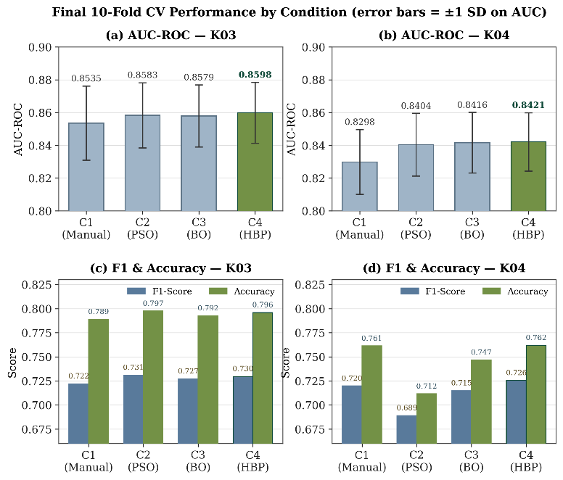
Fig 4 Final 10-Fold CV Evaluation Results
On both datasets, HBP (C4) achieves the highest mean AUC (0.8598 on K03; 0.8421 on K04) together with the lowest standard deviation (0.0186 and 0.0178), indicating the most stable cross-fold performance. This combination of best mean and lowest variance is the central pattern supporting Contribution 1: under a near-saturated performance regime, HBP does not merely match its competitors but does so with greater consistency.
The most instructive evidence for the hybrid mechanism appears in the behaviour of C2 (standalone PSO) on K04. Despite a competitive AUC (0.8404), its macro-F1 collapses to 0.6891 and its accuracy to 0.7116, markedly below the other configurations. This divergence between strong ranking ability (AUC) and weak thresholded decision quality (F1, accuracy) reflects a probability-calibration mismatch: the PSO solution ranks customers well but produces probability outputs poorly centred for the default decision threshold. HBP (C4) does not exhibit this pathology, indicating that the Bayesian refinement stage corrects the calibration weakness of the PSO-only solution, precisely the complementary role on which HBP is predicated.
The mechanism by which HBP locates these efficient solutions lies in the complementarity of its two phases. The PSO exploration phase performs a broad, population-based survey, enabling the swarm to reach regions, including shallow, compact architectures, that a purely local search might bypass. The diverse warm-start then seeds the Bayesian exploitation phase with promising, varied configurations, allowing the TPE surrogate to refine within high-quality regions while avoiding cold-start inefficiency (Bischl et al., 2023). The result is a search that converges on solutions that are simultaneously high-scoring, well-calibrated, and parameter-efficient, a combination no single-method approach achieved consistently across both datasets. This is the parsimony-plus-performance argument that constitutes HBP's unique advantage.

4.3. Fold-Internal Resampling Integration
The second contribution states that embedding SMOTE–Tomek Links as a fold-internal component, rather than a static preprocessing step, ensures that resampling and hyperparameter decisions are co-optimised under conditions reflecting true out-of-fold generalisation. The validity of this claim is most clearly tested on minority-class and threshold-sensitive metrics, as these are the most vulnerable to data leakage and calibration mismatch. On AUC-PR, results are mixed across datasets. On K03, HBP again achieves the highest value (0.6949), marginally ahead of C2 (0.6944). On K04, C4 does not lead this metric; the highest AUC-PR is achieved by C2 (0.6539), whilst C4 records 0.6512. This difference of 0.0027 lies within inter-fold variability and is more appropriately characterised as equivalent performance than a clear advantage.
The gap between AUC-PR (0.64–0.69) and AUC-ROC (0.84–0.86) reflects the added difficulty exposed by the precision–recall framework under class imbalance; observed values lie at roughly 2.4–3.4 times the random baseline, indicating all models capture substantial minority-class signal. On macro-F1, the distinction between thresholds is informative. At the default 0.5 threshold, F1 is suppressed because models trained on SMOTE-balanced data are evaluated against the original imbalanced test distribution, shifting the optimal operating point away from 0.5. At F1@0.5, C4 does not consistently lead: on K03, C2 attains the highest value (0.7310) whilst C4 records 0.7292. However, after threshold calibration on the internal validation set, macro-F1 increases across all configurations, and HBP records the highest F1@opt on both datasets (0.7363 on K04; 0.7581 on K03). This ranking reversal indicates that HBP's full potential is realised only when its operating point is aligned with the true test distribution, something that can be assessed honestly only because calibration is performed within the fold, without touching test data. The most informative finding concerns the optimal threshold values themselves. On both datasets, C4 requires the lowest optimal threshold (0.582 on K04; 0.676 on K03), closest to the neutral 0.5 among all configurations. This implies HBP's probability outputs require the least correction to achieve optimal F1, consistent with a better-calibrated probability distribution, of practical value in production deployments where post-hoc threshold adjustment may be infeasible. On F1-min, which specifically quantifies churn-class performance, C4 attains the highest values on both datasets (0.6160 on K04; 0.6090 on K03). Overall, fold-internal integration demonstrably yields leakage-free estimates together with models of better minority-class calibration.

4.4. Cross-Domain Generalisability
The third contribution evaluates the consistency of the advantage across two datasets from structurally distinct domains, banking (K03) and telecommunications (K04). The Friedman test indicated statistically significant differences among the four configurations on both datasets, with p = 0.026 (statistic = 9.24) on K04 and p = 0.002 (statistic = 14.64) on K03. Pairwise post-hoc Wilcoxon tests with Holm–Bonferroni correction are summarised in Figure 5.
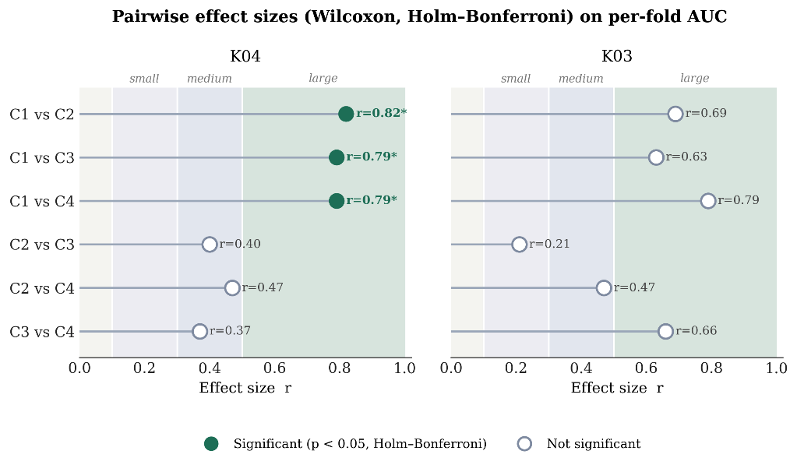
Fig 5. Post-hoc Wilcoxon tests (Holm–Bonferroni) on per-fold AUC. *Significant at α = 0.05
The emerging pattern is dataset-dependent and, in fact, nuances and strengthens Contribution 3. On the higher-dimensional K04 (45 features), all optimisation conditions significantly outperformed the manual baseline (effect size r = 0.79–0.82, large). On the lower-dimensional K03 (13 features), the differences did not reach statistical significance. This finding indicates that the value of an integrated HPO pipeline depends on the complexity of feature representations, a conclusion drawable only because evaluation spanned two domains with differing characteristics. Two observations prevent an overly negative interpretation. First, the effect size for the C3 vs C4 comparison on K03 is large (r = 0.66) despite a non-significant p-value; this pattern, large effect size with a non-significant p-value, is a classical indication of insufficient statistical power owing to a small sample (ten folds from a single seed), rather than the absence of a real effect. Second, all HPO configurations exhibited large effect sizes over the C1 baseline (r = 0.63–0.82). The convergence of performance across C2, C3, and C4 suggests a performance ceiling on both datasets: when the solution space approaches the informational limits of the features, distinct search methods tend to converge on similar solutions. The cross-domain consistency of C4's advantage strengthens the validity of the approach. C4 achieved the best Friedman rank on both datasets (1.80 on K04; 1.40 on K03), alongside the best AUC and stability. An honest exception must be noted on balanced accuracy: C4 does not hold the top rank, on K04 the highest value is C2's (0.7407 vs 0.7401) and on K03 C3's (0.7482 vs 0.7477). Yet the differences in both cases are below 0.001 and practically negligible. Overall, the multi-metric cross-domain picture shows C4 leading or matching on the majority of indicators, with the consistency that lies at the heart of the generalisability claim.

5 Conclusion
This study developed and evaluated an integrated pipeline combining SMOTE–Tomek resampling with Hybrid Bayesian–PSO (HBP) hyperparameter optimisation for DNN-based customer churn prediction, benchmarked against a manual baseline (C1), standalone PSO (C2), and standalone Bayesian Optimisation (C3) on two public datasets. The first and most robust finding is that systematic hyperparameter optimisation consistently outperforms manual tuning: all three optimisation methods (C2, C3, C4) surpassed the C1 baseline with large effect sizes on both datasets and reached statistical significance on K04, reinforcing the importance of structured HPO in building reliable churn prediction models.
Among the methods evaluated, HBP consistently achieved the best or equivalent performance on the majority of primary metrics across both datasets, the highest AUC-ROC (0.8598 on K03; 0.8421 on K04), the highest calibrated macro-F1, the highest minority-class F1, the best Friedman rank (1.40 on K03; 1.80 on K04), and the lowest AUC standard deviation, indicating the greatest stability. More notably, HBP consistently selected the most parsimonious architecture among all optimisation methods, up to roughly eight times fewer parameters than PSO on K04, while maintaining best-in-class performance, in line with the principle of parsimony. Scientific honesty requires acknowledging that the numerical superiority of HBP over standalone PSO and BO does not reach statistical significance after Holm–Bonferroni correction. The primary contribution of this study is therefore not a statistically demonstrated numerical superiority, but the provision of an integrated resampling–HPO pipeline that consistently yields the best-performing, most stable, and most parameter-efficient models, addressing the gap in the systematic integration of these two processes in the context of DNN-based churn prediction.
Several limitations should be acknowledged so that the results are interpreted proportionately, while also pointing to directions for future work. First, and most importantly, the experiments used a single random seed with ten-fold cross-validation; incorporating multiple random seeds would strengthen statistical power, as suggested by the pattern of large effect sizes not yet accompanied by statistical significance. Second, the evaluation was conducted on two datasets from distinct domains, banking and telecommunications; extending it to a larger and more varied set of datasets would further reinforce the external validity of the findings. Third, computational cost was not directly measured, so the efficiency claims are theoretical interpretations grounded in parameter counts. Fourth, the comparison is restricted to four DNN-based configurations and does not yet include non-DNN baselines such as gradient-boosted trees. Fifth, threshold calibration relied on a simple grid search; more sophisticated calibration methods could be explored further.
Building on these limitations, several directions could directly elevate the value of these findings. The foremost priority is to repeat the experimental protocol with multiple random seeds (ideally three to five) and pool the results in a unified statistical analysis; this would clarify whether the consistent numerical advantage of HBP attains statistical significance or is instead confirmed as equivalent, both being valid and more defensible conclusions. Next, extending the evaluation to a broader range of churn datasets, including those with more extreme class imbalance or higher feature dimensionality, would provide a more rigorous assessment of generalisability. Including conventional machine learning baselines such as gradient-boosted trees under the same validation pipeline would position the DNN-HBP approach within the wider landscape of churn prediction methods. Direct measurement of computational cost, training time, FLOPs, and memory consumption would transform the currently theoretical efficiency argument into empirical evidence. Finally, exploring more sophisticated probability-calibration methods such as Platt scaling or isotonic regression could improve minority-class performance, strengthening the practical value of this pipeline in real-world deployment.

References
Batista, G.E.A.P.A., Prati, R.C. and Monard, M.C. (2004) ‘A study of the behavior of several methods for balancing machine learning training data’, SIGKDD Explor. Newsl., 6(1), pp. 20–29. Available at: https://doi.org/10.1145/1007730.1007735.
Bergstra, J. et al. (2011) ‘Algorithms for hyper-parameter optimization’, in Proceedings of the 25th International Conference on Neural Information Processing Systems. Red Hook, NY, USA: Curran Associates Inc. (NIPS’11), pp. 2546–2554.
Bhatnagar, A. and Srivastava, S. (2025) ‘Customer Churn Prediction : A Machine Learning Approach with Data Balancing for Telecom Industry’, (1), pp. 9–18. Available at: https://doi.org/10.47839/ijc.24.1.3873.
Bischl, B. et al. (2023) ‘Hyperparameter optimization: Foundations, algorithms, best practices, and open challenges’, WIREs Data Mining and Knowledge Discovery, 13(2), p. e1484. Available at: https://doi.org/https://doi.org/10.1002/widm.1484.
Burez, J. and Poel, D. Van Den (2009) ‘Expert Systems with Applications Handling class imbalance in customer churn prediction’, Expert Systems With Applications, 36(3), pp. 4626–4636. Available at: https://doi.org/10.1016/j.eswa.2008.05.027.
Chawla, N. V et al. (2002) ‘SMOTE : Synthetic Minority Over-sampling Technique’, 16, pp. 321–357.
Clerc, M. and Kennedy, J. (2002) ‘The particle swarm - explosion, stability, and convergence in a multidimensional complex space’, IEEE Transactions on Evolutionary Computation, 6(1), pp. 58–73. Available at: https://doi.org/10.1109/4235.985692.
Domingos, E. and Ojeme, B. (2021) ‘Experimental Analysis of Hyperparameters for Deep Learning-Based Churn Prediction in the Banking Sector’. Available at: https://doi.org/https://doi.org/10.3390/computation9030034.
Gad, A.G. (2022) Particle Swarm Optimization Algorithm and Its Applications : A Systematic Review, Archives of Computational Methods in Engineering. Springer Netherlands. Available at: https://doi.org/10.1007/s11831-021-09694-4.
Gallo, A. (2014) The Value Of Keeping the Right Customers, Harvard Business Review. Available at: https://hbr.org/2014/10/the-value-of-keeping-the-right-customers.
Gkonis, V. (2025) ‘Deep Dive Into Churn Prediction in the Banking Sector : The Challenge of Hyperparameter Selection and Imbalanced Learning’, pp. 281–296. Available at: https://doi.org/10.1002/for.3194.
Haddadi, S.J. et al. (2024) ‘Customer churn prediction in imbalanced datasets with resampling methods: A comparative study’, Expert Syst. Appl., 246(C). Available at: https://doi.org/10.1016/j.eswa.2023.123086.
Hamano, Ryoki and Saito, Shota and Nomura, Masahiro and Shirakawa, S. (2022) CMA-ES with margin: lower-bounding marginal probability for mixed-integer black-box optimization, Association for Computing Machinery. Association for Computing Machinery. Available at: https://doi.org/10.1145/3512290.3528827.
Hasan, M.R., Hasan, M.M. and Hossain, M.Z. (2022) ‘Outcomes of Deep Neural Network Hyperparameter Tuning on Bengali Speech Token Classification’, in 2022 International Conference on Innovations in Science, Engineering and Technology (ICISET), pp. 445–450. Available at: https://doi.org/10.1109/ICISET54810.2022.9775837.
Hernández, A.M. and Nieuwenhuyse, I. Van (2023) A survey on multi ‑ objective hyperparameter optimization algorithms for machine learning, Artificial Intelligence Review. Springer Netherlands. Available at: https://doi.org/10.1007/s10462-022-10359-2.
Hertel, L., Baldi, P. and Gillen, D.L. (2022) ‘Reproducible Hyperparameter Optimization’, Journal of Computational and Graphical Statistics, 31(1), pp. 84–99. Available at: https://doi.org/10.1080/10618600.2021.1950004.
Imani, M. (2023) ‘Hyperparameter Optimization and Combined Data Sampling Techniques in Machine Learning for Customer Churn Prediction : A Comparative Analysis’.
Imani, M., Joudaki, M. and Beikmohammadi, A. (2025) ‘Customer Churn Prediction : A Systematic Review of Recent Advances , Trends , and Challenges in Machine Learning and Deep Learning’, pp. 1–38.
Jamal, S. et al. (2024) ‘Customer churn prediction in imbalanced datasets with resampling methods : A comparative study’, Expert Systems With Applications, 246(January), p. 123086. Available at: https://doi.org/10.1016/j.eswa.2023.123086.
Jimenez, F. and Katzfuss, M. (2023) ‘Scalable Bayesian Optimization Using Vecchia Approximations of Gaussian Processes’, in F. Ruiz, J. Dy, and J.-W. van de Meent (eds) Proceedings of The 26th International Conference on Artificial Intelligence and Statistics. PMLR (Proceedings of Machine Learning Research), pp. 1492–1512. Available at: https://proceedings.mlr.press/v206/jimenez23a.html.
LeCun, Y., Bengio, Y. and Hinton, G. (2015) ‘Deep learning.’, Nature, 521(7553), pp. 436–444. Available at: https://doi.org/10.1038/nature14539.
Li, Y. et al. (2021) ‘Bayesian Optimization with Particle Swarm’, in 2021 International Joint Conference on Neural Networks (IJCNN), pp. 1–6. Available at: https://doi.org/10.1109/IJCNN52387.2021.9533761.
Loshchilov, I. and Hutter, F. (2016) ‘Cma-es h o d n n’, (2001).
Morar, Marius Tudor ; Knowles, Joshua ; Sampaio, S. (2017) ‘Initialization of Bayesian Optimization Viewed as Part of a Larger Algorithm Portfolio’, in Data Science meets Optimization Workshop: CEC2017 \& CPAIOR 2017.
Muntasir Nishat, M. et al. (2022) ‘A Comprehensive Investigation of the Performances of Different Machine Learning Classifiers with SMOTE-ENN Oversampling Technique and Hyperparameter Optimization for Imbalanced Heart Failure Dataset’, Scientific Programming, 2022(1), p. 3649406. Available at: https://doi.org/https://doi.org/10.1155/2022/3649406.
Peng, C. (2024) ‘Comprehensive Analysis of the Impact of Learning Rate and Dropout Rate on the Performance of Convolutional Neural Networks on the CIFAR-10 Dataset’, Applied and Computational Engineering, pp. 183–192. Available at: https://doi.org/10.54254/2755-2721/102/20241161.
Pramesti, B.T. et al. (2025) ‘Klasifikasi Data Tidak Seimbang Menggunakan SMOTE- ENN dengan Optimasi Bayesian’, 8(2021), pp. 12207–12210.
Reichheld, F. (2001) Prescription for cutting costs. Available at: https://media.bain.com/Images/BB_Prescription_cutting_costs.pdf.
Salem, H.S., Mead, M.A. and El-taweel, G.S. (2024) ‘Particle Swarm Optimization-Based Hyperparameters Tuning of Machine Learning Models for Big COVID-19 Data Analysis’, pp. 160–183. Available at: https://doi.org/10.4236/jcc.2024.123010.
Shahriari, B. et al. (2016) ‘Taking the Human Out of the Loop: A Review of Bayesian Optimization’, Proceedings of the IEEE, 104(1), pp. 148–175. Available at: https://doi.org/10.1109/JPROC.2015.2494218.
Shwartz-Ziv, R. and Armon, A. (2022) ‘Tabular data: Deep learning is not all you need’, Information Fusion, 81, pp. 84–90. Available at: https://doi.org/https://doi.org/10.1016/j.inffus.2021.11.011.
Snoek, J., Larochelle, H. and Adams, R. (2012) ‘Practical Bayesian Optimization of Machine Learning Algorithms’, in F. Pereira et al. (eds) Advances in Neural Information Processing Systems. Curran Associates, Inc. Available at: https://proceedings.neurips.cc/paper_files/paper/2012/file/05311655a15b75fab86956663e1819cd-Paper.pdf.
Suguna, R. et al. (2025) ‘Mitigating class imbalance in churn prediction with ensemble methods and SMOTE’, Scientific Reports, 15(1), p. 16256. Available at: https://doi.org/10.1038/s41598-025-01031-0.
Watanabe, S. (no date) ‘Tree-Structured Parzen Estimator: Understanding Its Algorithm Components and Their Roles for Better Empirical Performance’, pp. 1–70.
Ye, F. (2017) ‘Particle swarm optimization-based automatic parameter selection for deep neural networks and its applications in large-scale and high-dimensional data’, PLOS ONE, 12(12), pp. 1–36. Available at: https://doi.org/10.1371/journal.pone.0188746.

