Galvez, Hance Henley S. BSIT4-1AA 11/07/2023

Network Technology 2  
04 Laboratory Exercise 1 – ARG

# Screenshot the Subnets page showing the two (2) subnets

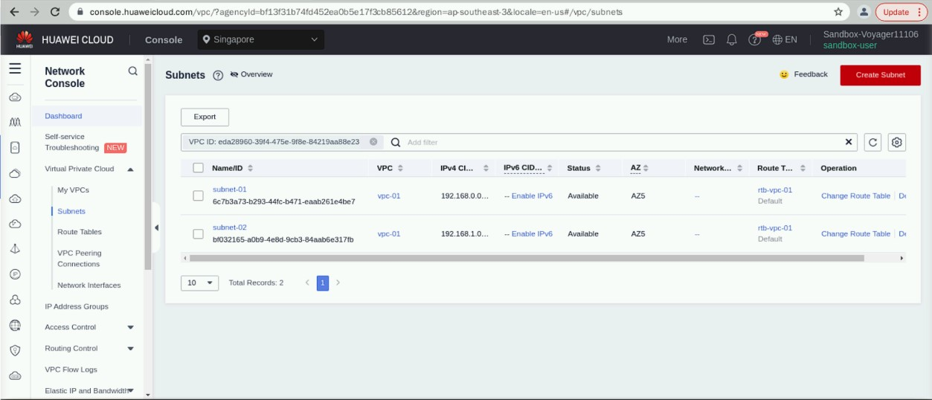

# Screenshot the page showing the content of the Inbound Rules tab

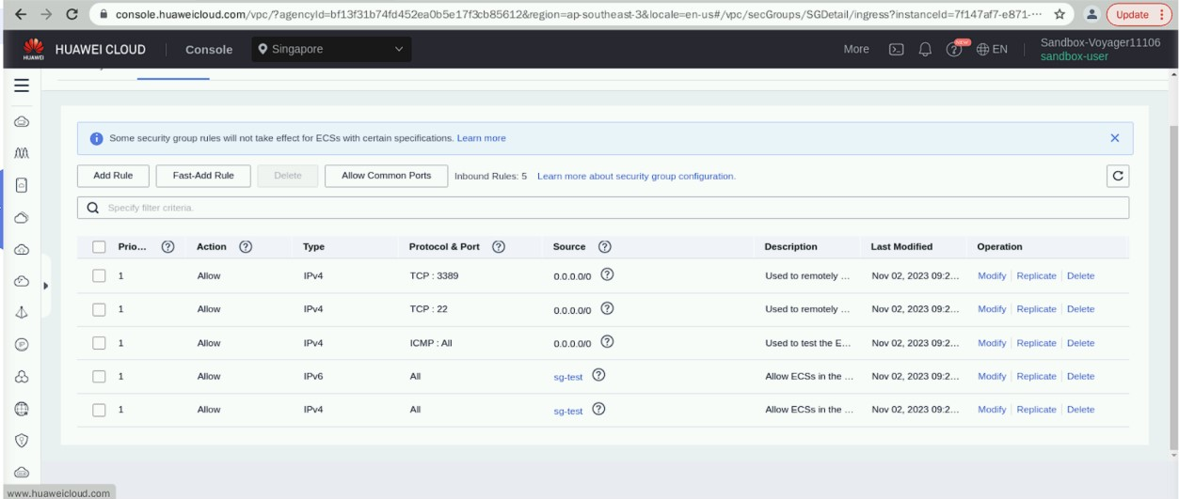

# Screenshot the Elastic Cloud Server page showing the two (2) ECSs

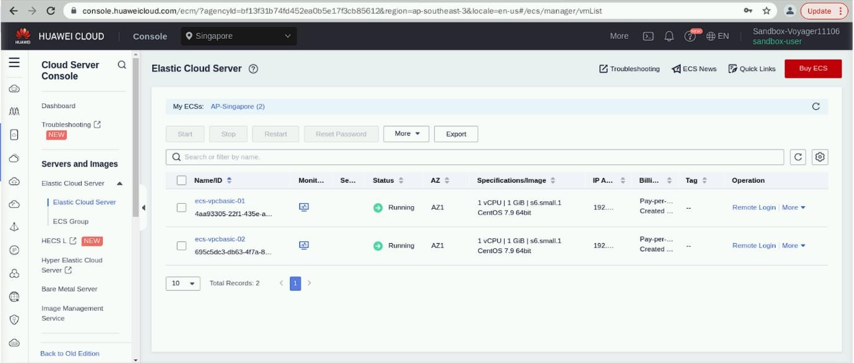

1. **Go back to your running Linux ECS, then ping your second ECS. You should be able to ping successfully.**

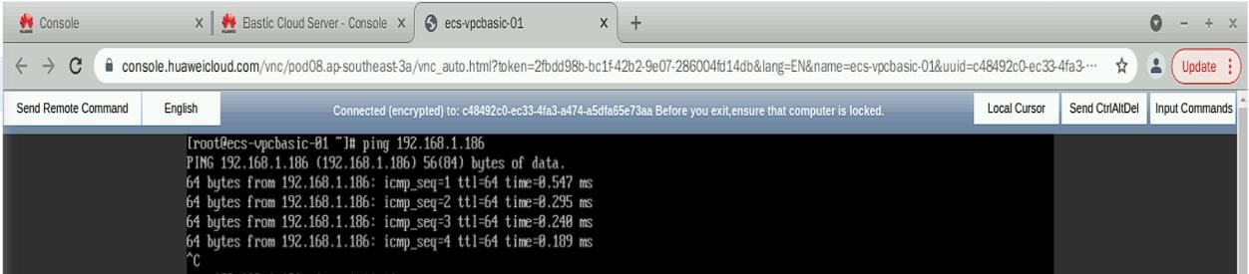

# This time, access the second ECS using the ssh command. (Ex. ssh 192.168.1.37)

**Enter the same password. Now that you are logged in to the second ECS, ping the first ECS.**

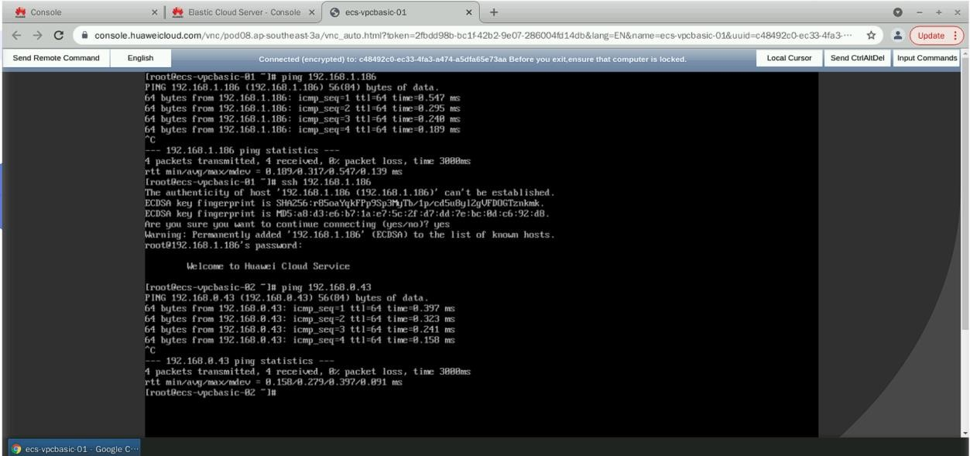

# Part 3

# In exactly four (4) sentences, discuss the benefit of implementing a security group. (10 points)

- The implementation of a security group offers a crucial security layer by finely controlling both incoming and outgoing network traffic, ensuring that only authorized personnel can access valuable resources. This approach significantly reduces the risk of cyber threats and provides real-time protection. Moreover, security groups simplify network administration by categorizing resources with similar access requirements, streamlining management while bolstering security. In essence, security groups play an integral role in fortifying data protection, enhancing access control, and maintaining network integrity.