Galvez, Hance Henley S. BSIT3-2AA 05/20/2023

Management Information Systems  
09 Quiz 1

Instructions

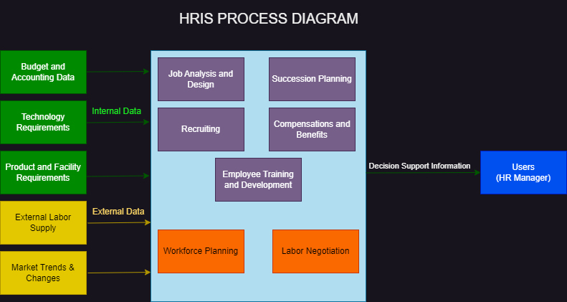Recreate the HRIS process diagram.