Galvez, Hance Henley S. BSIT3-2AA 05/20/2023

Management Information Systems  
09 Task Performance 1

Search for an online recruitment application/website. Provide/answer the following:

1. **Name of the app/website (2 points)**

* Teamtailor

<https://www.teamtailor.com/en/?utm_term=job%20hiring%20platforms&utm_campaign=XX_XX_PF_ACQ_GG_SRC-GEN+English&utm_source=google&utm_medium=cpc&hsa_acc=9453729495&hsa_cam=19577743579&hsa_grp=143675460165&hsa_ad=645194611358&hsa_src=g&hsa_tgt=kwd-740455349936&hsa_kw=job%20hiring%20platforms&hsa_mt=e&hsa_net=adwords&hsa_ver=3&gad=1&gclid=CjwKCAjw36GjBhAkEiwAKwIWyVxJmejz1OXKyxBTC0mIhpGs5rraB8juPHc6esXwWK4uFqWzU89D7RoCycYQAvD_BwE>

1. **Screenshot of the home page (3 points)**

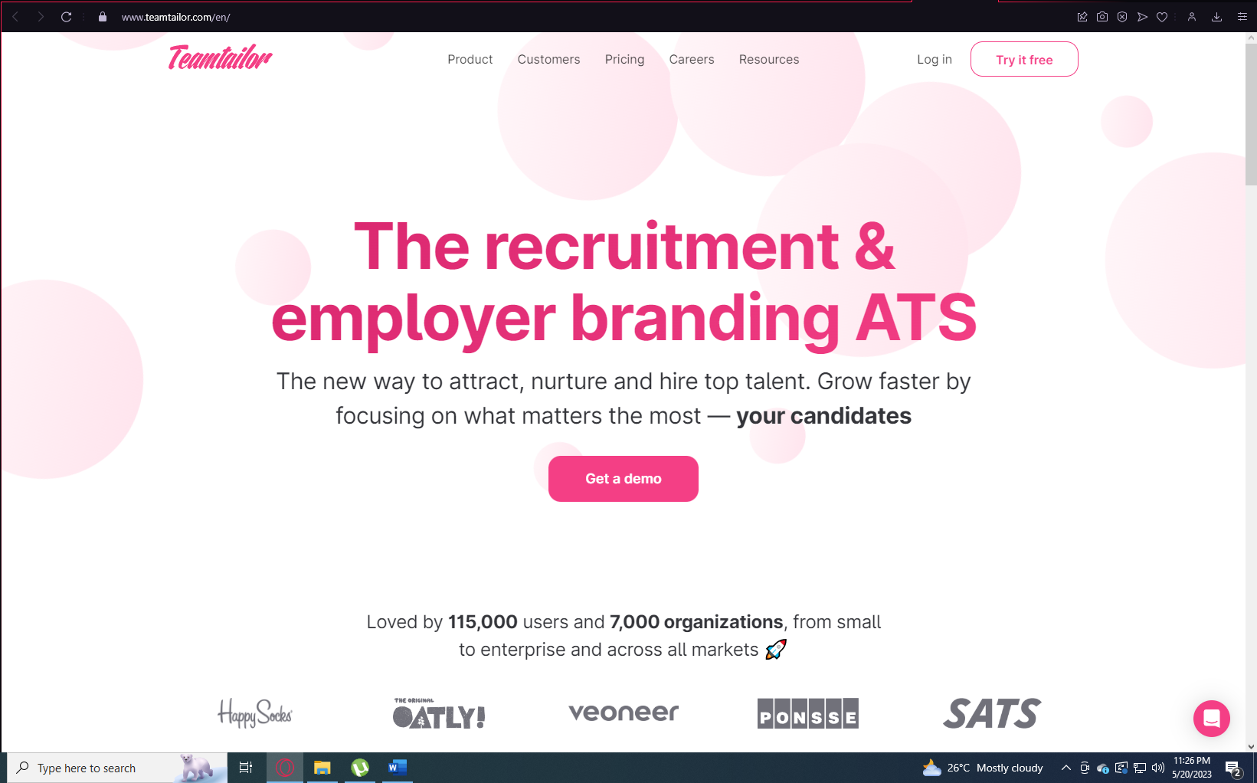

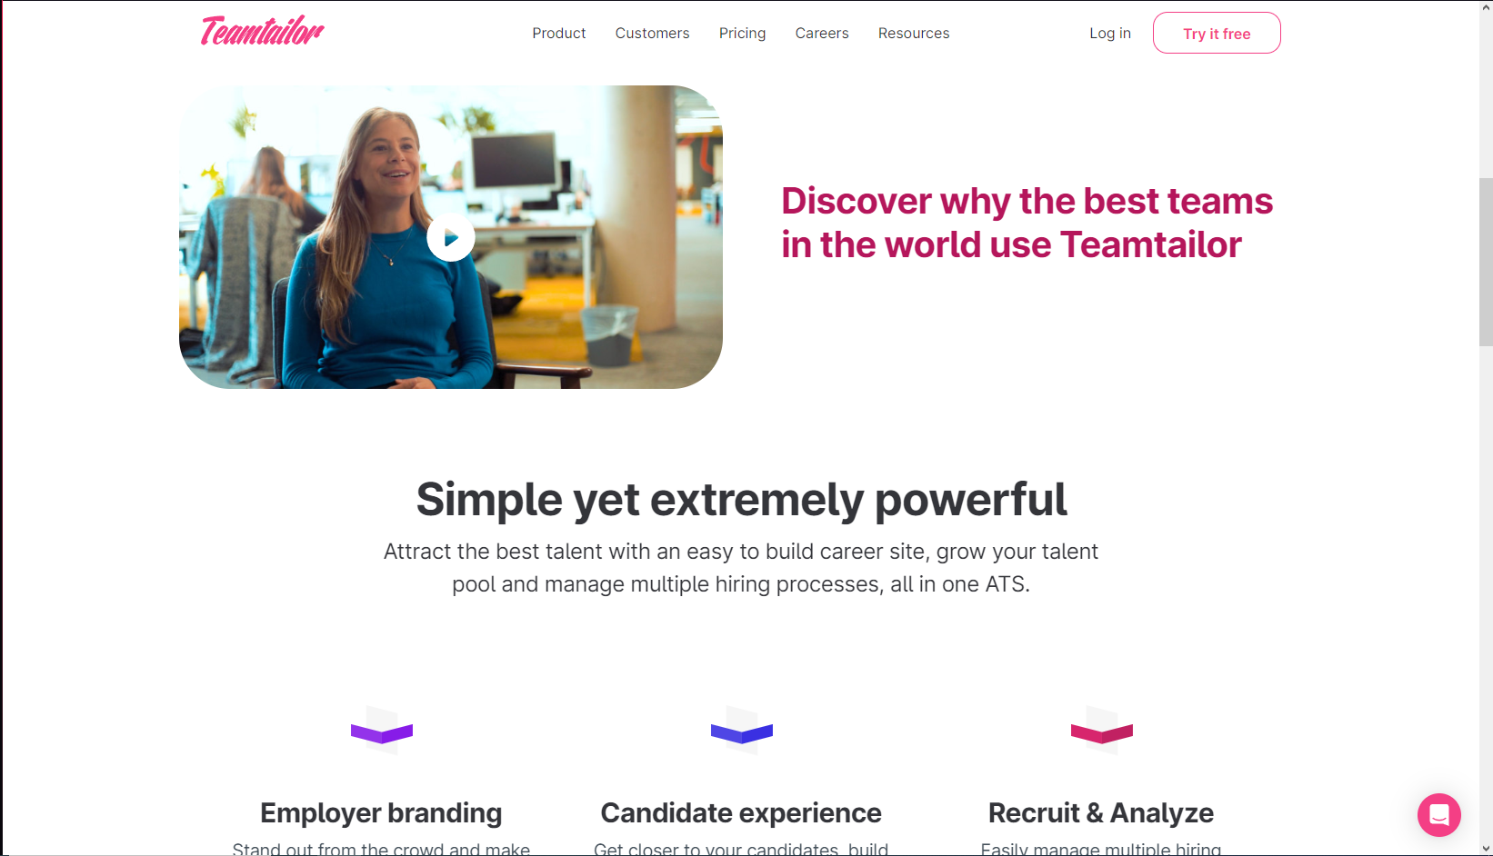

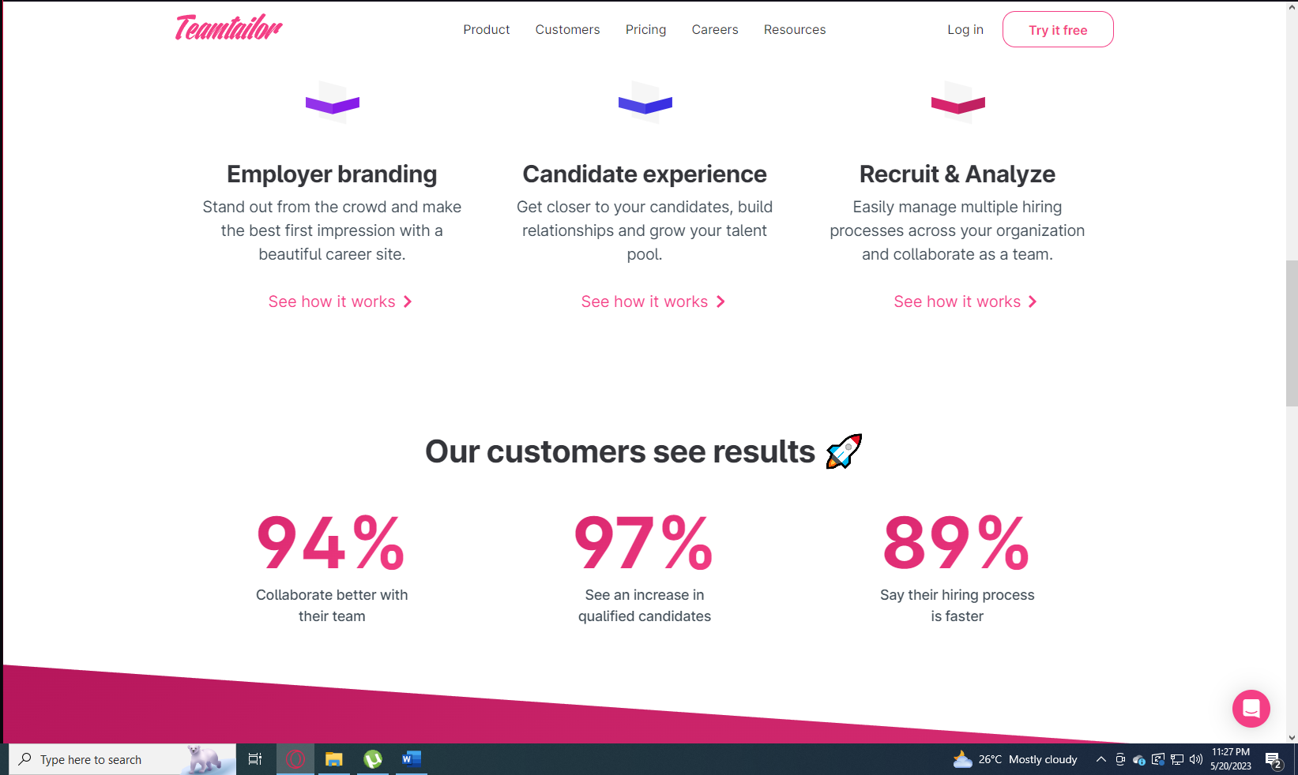

1. **Purpose of the app/website (5 points)**

* Teamtailor is an online recruitment application that helps streamline the hiring process for employers and improve the job search experience for candidates. It offers various features and tools to attract, engage, and hire top talent.

1. **Description of three (3) unique/interesting features of the app/website (3 items x 5 points)**

* Three unique/interesting features of Teamtailor are:
  + Customizable Career Page: Teamtailor allows employers to create a branded and customizable career page that showcases their company culture, values, and job opportunities. This feature helps create a compelling employer brand and attracts the right candidates.
  + Talent Pool Management: Teamtailor provides a talent pool management system, allowing recruiters to create and maintain a database of potential candidates. Recruiters can easily search and filter candidates based on skills, experience, and other criteria, making it easier to source candidates for future job openings.
  + Collaborative Hiring: Teamtailor enables collaboration among hiring teams by providing features such as feedback sharing, interview scheduling, and applicant rating. Recruiters and hiring managers can efficiently collaborate, share feedback, and track the progress of candidates, leading to faster and more effective hiring decisions.

**Assuming you are tasked to modify the app/website, what are the changes that you will apply to it? (15 points)**

If tasked to modify Teamtailor, some possible changes that could be applied are:

1. Enhanced Candidate Matching: Implement an AI-powered candidate matching algorithm that leverages data from resumes, job descriptions, and candidate profiles to provide more accurate and relevant job matches for both employers and candidates.
2. Integration with Assessment Tools: Integrate with popular assessment and pre-employment testing tools to allow employers to easily incorporate assessments into their hiring process. This would provide valuable insights into a candidate's skills and abilities, helping employers make more informed hiring decisions.
3. Improved Analytics and Reporting: Enhance the analytics and reporting capabilities of Teamtailor to provide deeper insights into hiring metrics and trends. This could include generating customizable reports, visualizing data through graphs and charts, and providing benchmarking data to help employers optimize their recruitment strategies.

These modifications would further streamline the recruitment process, improve the quality of candidate matches, and provide valuable data-driven insights for employers using Teamtailor.