**WEB-BASED RABBIT FARM MANAGEMENT SYSTEM FOR DADIANGAS RABBIT FARMERS AGRICULTURE COOPERATIVE**

**A Capstone Project Proposal**

**Presented to the Faculty of the**

**Information and Communications Technology Program**

**STI College General Santos, Inc.**

**In Partial Fulfilment**

**of the Requirements for the Degree**

**Bachelor of Science in Information Technology**

**Joshua Jules T. Ruloma**

**Philip Rohjan A. Cabrias**

**Kyle Jhon T. Rentura**

**Joshua V. Dela Cerna**

**November 2023**

**ENDORSEMENT FORM FOR PROPOSAL DEFENSE**

**TITLE OF RESEARCH: WEB-BASED RABBIT FARM MANAGEMENT FOR DADIANGAS RABBIT FARMERS AGRICULTURE COOPERATIVE**

**NAME OF PROPONENTS:** Joshua Jules T. Ruloma

Philip Rohjan A. Cabrias

Kyle John T. Rentura

Joshua V. Dela Cerna

In Partial Fulfilment of the Requirements

for the degree Bachelor of Science in Information Technology

has been examined and is recommended for Proposal Defense.

**ENDORSED BY:**

Ms. Noelyn G. Datahan, MIT

**Capstone Project Adviser**

**APPROVED FOR PROPOSAL DEFENSE:**

Ms. Ivy Grace Laurente

**Capstone Project Coordinator**

**NOTED BY:**

Julie B. Ocenar, MIT, LPT

**Program Head**

**November 2023**

**APPROVAL SHEET**

This capstone project proposal titled**:** Web-Based Rabbit Farm Management prepared and submitted by **Joshua Jules T. Ruloma., Philip Rohjan A. Cabrias, Kyle John T. Rentura,** and **Joshua V. Dela Cerna**, in partial fulfillment of the requirements for the degree of Bachelor of Science Information Technology, has been examined and is recommended for acceptance and approval**.**

Ms. Noelyn G. Datahan

**Capstone Project Adviser**

Accepted and approved by the Capstone Project Review Panel

in partial fulfillment of the requirements for the degree of

Bachelor of Science in Information Technology

|  |  |
| --- | --- |
| Ms. Julie B. Ocenar, LPT, MIT | Engr. Ann Gilyn B. Premarion, MIM, MAEd |
| **Panel Member** | **Panel Member** |

Mr. Henley P. Sales

**Lead Panelist**

**Noted:**

|  |  |
| --- | --- |
| Ms. Ivy Grace Laurente | Ms. Julie B. Ocenar, LPT, MIT |
| **Capstone Project Coordinator** | **Program Head** |

**November 2023**

**ACKNOWLEDGEMENT**

The proponents would like to express their gratitude to all who supported them and especially to the Almighty God, for guiding and giving them enough strength and wisdom to accomplish this manuscript despite all the challenges they have encountered. This capstone project's completion involves countless hours of determination, assessment, and collaborative effort, and it would not have been possible without the unyielding support and contributions of several people and organizations. We are appreciative to each of them:

To their Capstone Coordinator and Adviser, **Ms. Kristel Joy Tulagan, MIT, Ms. Ivy Grace Laurente** and **Mrs Noelyn G. Datahan** who gave and shared their precious time and knowledge to them.

To the Rabbit Farms especially Mashimaro Rabbitry for allowing the developers to conduct their survey and share their data and information about the management of their farm.

To the Chairman of DRFAC, **Mr. Gunther Alonzo,** and to **Ms. Cherry Layno** for sharing their knowledge about rabbit farming and for allowing us to propose and gather data and information to their cooperative.

To the proponents’ parents for their support and understanding in making this study especially for the financial support.

This manuscript would not be possible without your help and support for the completion of this manuscript.

Thank you so muc

**The Proponents**

# **Abstract**

Title of research**:** WEB-BASED RABBIT FARM MANAGEMENT SYSTEM FOR

DADIANGAS RABBIT FARMERS AGRICULTURE COOPERATIVE

Researchers**:** Joshua Jules T. Ruloma

Philip Rohjan A. Cabrias

Kyle John T. Rentura

Joshua V. Dela Cerna

Degree: Bachelor of Science in Information Technology

Date of Completion: November 2023

Key words: rabbit farm management system, rabbits, and rabbit farmers

The proponent of the study aims to fulfill the needs of the host company, Dadiangas Rabbit Farmers Agriculture Cooperative, by implementing a comprehensive and innovative solution designed to streamline and enhance the efficiency of rabbit farming operations. With the increasing demand for high-quality rabbit products, there is a growing need for advanced management tools to optimize production, ensure animal welfare, and facilitate decision-making processes. This initiative aims to support the organization in efficiently managing various aspects of a rabbit farm. This project explores the development and implementation of a web-based platform tailored specifically for rabbit farmers.

The proponent conducted a comprehensive data gathering to align to create an effective rabbit farm management system for managing rabbit farms in Dadiangas Rabbit Framers Agriculture Cooperative. The survey covered a spectrum of aspects and essential elements that will be incorporated into the system to guarantee its success and efficiency.

The proponent has developed a system designed to address the issues faced by Dadiangas Rabbit Farmers Agriculture Cooperative is structured with two distinct user levels: administrators, and rabbit farmers, have each assigned distinct roles, after successfully implementation and web publication of the system, the proponents initiated a beta testing phase with initiated a beta testing phase with consist of questions base on design, useability, functionality, and appropriateness. The following data gathered from the respondents by the proponents:

The respondents strongly agree (4.55) that the fields and commands are easy to understand," indicating a strong consensus among the respondents in strongly agreeing with this aspect. This high score suggests that the website's interface is intuitive and user-friendly, aligning with the objective of developing a user-friendly system. They also strongly agree (4.8) that The system can generate print, excel, and PDF reports on all modules, this exceptionally high score implies that the system's ability to produce reports in various formats is a highly valued and effective feature, greatly facilitating data management and analysis. They srongly agree (4.5) that the system caters the need of the user, indicating that respondents strongly agree that the system effectively addresses the specific needs of the users. Overall, the system that the proponents developed for the host company has already helped them solve some of its problems. Based on the results of the system testing, which show that the system has achieved its goals, the proponents have drawn conclusions and made recommendations based on the information we have collected.

# **TABLE OF CONTENTS**

**Title Page i**

**Endorsement Form for Proposal Defense ii**

**Approval Sheet iii**

**Acknowledgement iv**

**Abstract vi**

**Table of Contents v****ii**

**Introduction 1**

**Project Context 1**

**Purpose and Description of the Project 3**

**Objectives of the Study 4**

**Scope and Limitations of the Study 6**

**Review of Related Literature/Systems 10**

**Review of Related Literature 10**

**Related Studies and/or Systems 14**

**Synthesis 17**

**Technical Background 19**

**Overview of Current Technologies to be Used in the System 19**

**Calendar of Activities 20**

**Resources 25**

**Methodology, Result and Discussion 27**

**Methodology 27**

**Requirement Analysis 31**

**Requirement Documentation 33**

**Design of Software, System, Product, and/or Process 36**

**Development and Testing**

**Description of Prototype 37**

**Conclusion and Recommendation 41**

**Appendix**

**Resource Persons 29**

|  |  |
| --- | --- |
| **Evaluation Tool/Test Documents** | **99** |

**Acceptance Letter 37**

**Accomplishment Reports 38**

|  |  |  |
| --- | --- | --- |
| **Certificates and Formal Letters** | **40** | |
| **Accomplishment and Consultation Forms** | **44** | |
| **Photo Documentaiton** | **47** | |
| **Personal Technical Vitae** | |

# **Chapter I**

# **Introduction**

**Project Context**

Managing a rabbit farm can be quite challenging as it requires dedication and a lot of attention. Owning a rabbit farm should be decided carefully as there are many factors that some breeders struggle with. If you are a person who is willing to keep one or two it may require some level of patience and commitment. Providing sustenance and maintaining to rabbit farm is one of the challenges most rabbit farmers face as sometimes it is hard to decide which kind of food to give. Considering the type of food, you are providing to your rabbits helps them live a long, healthy, and happy life. Determining the age and condition of your rabbits can help decide which kind of nourishment to give. This is important as it will determine how your rabbits will live.

Rabbit farming is one of the emerging businesses in the agriculture industry. Rabbit farming is the process of breeding and reproducing rabbits. In addition, rabbit farming can be a great source of income. Rabbits are commonly used as pets and can be found in any pet store due to their fluffy and cute appearance. There are many varieties of rabbits, and most people are confused about which one to keep for farming and as a pet. Rabbit farmers crossbreed different kinds of rabbits to produce different varieties of rabbits. Pure breeds were used along with their crossbreds, locally bred populations of indigenous genetic types that would not be well suited to the rabbit- farming methods of today. Rabbits make excellent pets, but they can also be used for meat Moreover, Agricultural livestock serve as a source of food and also make a significant contribution to global agricultural development. In the study of Said (2021), a significant portion of the world's population receives its protein intake from the livestock sector, particularly those living in developing countries.

Rabbit farmers recognize rabbits as a valuable source of nutritious meat, akin to traditional livestock such as pork, chicken, and beef. In some regions, rabbits are viewed as a cost-effective and easy-to-raise alternative to chickens. Although the concept of raising rabbits for meat is not widely known in General Santos City, many people see rabbits as adorable pets. However, there is a growing trend in the Philippines towards consuming rabbit meat, with an increasing demand. Notably, returning OFWs (Overseas Filipino Workers) are investing in rabbit farming, recognizing the potential for a profitable business with these endearing animals. (Brosas, 2022).

The proposed project titled "Web-Based Rabbit Farm Management System" aims to contribute to the awareness and acceptance of rabbit farming in. This system will play an important role in increasing the interest of farmers in engaging in rabbit farming practices. Rabbit farming holds significance in the country as it supports livelihoods and provides essential resources that benefit the well-being of the people. Additionally, rabbit farming has positive environmental implications, as rabbits naturally assist in composting and generate valuable manure fertilizer.

The system will assist rabbit farmers to efficiently manage their farms, tracking breeding progress, monitoring the health of the rabbits, recording the pedigree of the rabbits, monitoring the feed inventory, tracking the vaccination given to their rabbits, and monitoring the death and sale of their rabbit in their rabbit farm. The system also notifies users about important updates and provides comprehensive information about rabbit breeds suitable for effective rabbit farm management. This feature enables users to access valuable insights on different rabbit breeds, their characteristics, and their suitability for various aspects of rabbit farming operations. By gaining access to such information, users can make informed decisions related to rabbit management, including selecting the right breeds for specific purposes such as meat production, fur quality, or pet breeding. This ensures that the overall management of the rabbit farm is optimized, leading to improved productivity and success in the industry.

The specific problems present in the rabbit farms are the following:

* The rabbit farmers have difficulty managing their tasks including, tracking breeding progress, monitoring the health of the rabbits, monitoring the feed inventory, tracking the vaccination given to their rabbits, and monitoring the sales and death of their rabbit in their rabbit farm.
* The rabbit farmers have difficulty recording the pedigree of the rabbits, and usually record it manually which is inefficient in their part in operating their rabbit farm.
* The manual records are often kept in physical formats like files or notebooks, limiting accessibility and mobility.
* The rabbit farmers are doing manual data recording, in large rabbit farms, it is labor-intensive, making it challenging to organize and access information.

To solve this problem stated, the proponents decided to develop The Web-Based Rabbit Farm Management system that provide comprehensive tools and features to efficiently manage various aspects of a rabbit farm, including breeding and gestation, pedigree, vaccination, feeds inventory, sales and death monitoring, and health monitoring. By implementing this system, rabbit farmers in General Santos City can optimize their operations, streamline processes, and enhance their overall productivity and success in the industry.

**Purpose and Description of the Project**

The Web-Based Rabbit Farm Management project is a comprehensive system designed for rabbit farmers in General Santos City. The system comprises two types of accounts: The User and the Admin Account. The User Account is tailored to meet the specific needs of rabbit farmers, providing features that enable efficient management of their farms. This includes pedigree tracking to maintain records of the lineage and ancestry of their rabbits, as well as feed inventory and health monitoring to ensure proper nutrition and well-being of the rabbits, and monitoring the breeding and gestation of the rabbits. Additionally, the account allows user to track vaccination history to ensure timely and appropriate healthcare measures are taken.

The project aims to develop an efficient web-based rabbit farm management system that empowers rabbit farmers. This system will enable users to access valuable tools and resources for efficiently managing their rabbit farms, leading to improved farm management practices and successful outcomes. By utilizing the system, users can achieve positive results in overall farm operations and work towards enhancing their rabbit farming practices and achieving their goals in farm management.

On the other hand, the Admin Account serves as the administrative interface of the system. Admins are responsible for managing user accounts, enhancing the application's functionalities, and monitoring the activities of the farmers and their farms. The admin account ensures that the system operates smoothly and facilitates effective communication between farmers and the system administrators.

**Objectives of the Study**

Our study aims to develop a user-friendly Web-Based Rabbit Farm Management System, improving farm operations and overall management in rabbit farming. Through comprehensive modules, we empower farmers to optimize productivity and achieve successful outcomes in rabbit farming.

* To develop a user-friendly and efficient system that enables farmers to effectively manage their rabbit farms and streamline farm operations.
* To design a Dashboard Module that provides a visually appealing interface, offering farmers a comprehensive overview of vital rabbit farm metrics, including total rabbit count, mortality rate, survival rate, revenue from sales, and other essential performance indicators.
* To create a comprehensive Rabbit Management module that allows users to maintain detailed records of individual rabbits, including breed, birthdate, weight, and pedigree, facilitating better monitoring of rabbit growth, behavior, and health.
* To design a Vaccination module that helps farmers keep track of vaccination records for each rabbit, ensuring timely and appropriate vaccinations, and generating reports on vaccination history for informed decision-making.
* To implement a Feeds Inventory module that enables users to maintain an accurate inventory of feeds and feed-related supplies, providing real-time updates on stock levels, generating alerts for low inventory, and facilitating efficient procurement and distribution of feeds.
* To create a Health Management module that allows farmers to record and monitor the health of rabbits, including illnesses, treatments, medications, and recovery progress, providing insights into recurring health issues and supporting preventive measures.
* To design a Monitor Death module that enables users to record and track rabbit deaths, including cause, date, and observations, facilitating analysis of mortality rates and identification of potential health concerns.
* To implement a Monitor Sales module that helps farmers manage and track rabbit sales, including buyer information, transaction details, and pricing, generating reports on sales performance, revenue generation, and customer history for better sales management.
* To develop a comprehensive Report module that generates informative reports based on recorded data, providing valuable insights into various aspects of rabbit farming, such as vaccination history, feed consumption, health records, sales performance, and overall farm management.

**Scope and Limitations of the Study  
  
 Scope**

The Rabbit Farm Management System is a comprehensive software application designed to streamline and enhance the management of rabbit farms. The system will provide a range of features and functionalities to support efficient farm operations, improve productivity, and optimize decision-making processes. The scope of the system includes the following module:

**Rabbit Farmer Account:**

1. User Registration and Authentication Module: The system will facilitate rabbit farmers in the creation of user accounts and the secure authentication process to access the web-based platform.

2. Dashboard Module: The Dashboard module offers a comprehensive overview of essential metrics, encompassing total rabbit population and the functionality to add, list, and breed rabbits.

3. Pedigree Information Module: This module has been developed to facilitate the viewing, tracking, and recording of rabbit pedigree information for individual rabbits. Users are provided with the capability to maintain comprehensive pedigree records, encompassing lineage and genetic details. The module enables users to track the lineage of rabbits, record the names and pertinent information of their parents and grandparents. This valuable information serves breeding purposes, ensures the preservation of bloodlines, and aids users in making informed decisions related to genetic traits and characteristics.

4. Nest Boxes Module: Within this module, users can access comprehensive doe pregnancy information, which includes details such as the due date, the count of live kits and deceased kits, as well as the status of the pregnancy, indicating whether it was successful or unsuccessful.

5. Vaccination History Module: This module allows users to both record and access the vaccination history of rabbits, including details such as the type of vaccination and the date of vaccination.

6. Feeds Inventory Module: The system will systematically manage an inventory of feeds and feed-related supplies, which may include hay, pellets, vegetables, and fruits. Users have the capability to record data concerning feed volumes, purchases, and consumption. The system will offer real-time updates on feed stock levels and generate alerts for low inventory.

* + Input (Purchase): Within the Feeds Inventory module, the system will include a sub-module specifically designed to manage the input of feeds through purchases. Users can record information related to feed purchases, purchase dates, and quantities. The sub-module will provide a centralized location for tracking and managing feed procurement, ensuring accurate inventory updates, and facilitating efficient supply chain management.
  + Output (Consumption): Another sub-module within the Feeds Inventory module will focus on tracking the output or consumption of feeds on the farm. Users can record information such as the volume of feed consumed by rabbits over a specific period, and any notable observations. The sub-module will provide insights into feed consumption patterns, assist in managing feed distribution, and generate reports on feed utilization.

7. Health Management Module: The system will include the listing and continuous monitoring of rabbit health. Users will be able to meticulously document the condition of the rabbits and access records displaying their weight, overall condition, and corresponding dates. Furthermore, this module will include a feature for rabbit diet recommendations, which provides guidance on the recommended food based on the rabbit's weight and age, contributing to their optimal care and well-being.

8. Monitor Death Module: This module will allow users to record and track the unfortunate event of rabbit deaths. Users can enter relevant details such as cause of death, date, and any observations. The system will provide insights into mortality rates and identify potential health concerns.

9. Sales Tracking Module: This module allows users to manage and keep tabs on rabbit sales. Users can record sales details like transaction dates and prices, and the system provides reports on sales performance.

10. Report Module: Users will have the capability to generate comprehensive reports across different areas, encompassing rabbit information, vaccination history, feeds inventory, health records, and monitoring of both deaths and sales.

**Admin Account:**

1. Dashboard: The admin dashboard is a central, real-time control hub providing a comprehensive overview of the Rabbit Farm Management System's performance and status. It offers a visual snapshot of essential farm data, with a primary focus on total rabbit population details.
2. Visualization: The system provides tools for creating visual reports and charts. These visuals help administrators understand and track essential data like mortality rates and survival trends, facilitating better decision-making.
3. Manage User: Administrators have the authority to manage user accounts, granting or revoking access privileges, and overseeing user roles. They can add, edit, or remove user accounts, ensuring that only authorized personnel can access and modify farm data.
4. Settings: This component allows administrators to configure and customize system settings.

**Limitations:**

* The system doesn’t record the parents in the pedigree module of the purchased rabbit added to the system.
* The pedigree module only can track up to third generation of the rabbit.
* The system doesn’t have the module that allows user to record the breeding of their rabbit to other rabbit from other rabbit farms.
* The system intended for user who are members in Dadiangas Rabbit Farmers Agriculture Cooperative.

**Chapter II**

**REVIEW OF RELATED LITERATURE**

**Review of Related Literature**

Rabbit farming is a growing sector of the livestock industry in the Philippines and is believed to be profitable when managed properly because of its potential as a healthy meat source and a source of income. This establishes benchmark data on rabbit farming in Partido, Camarines Sur, Philippines to aid in the decision-making process of Local Government Units, agricultural extension workers, researchers, associations of rabbit breeders and raisers, and entrepreneurs, for relevant interventions. It focuses on the profile of rabbits raised in the area, sources of rabbit stocks, the costs associated with the purchase and disposal of stocks, perceptions of raisers towards meat, and the challenges in raising and processing meat from rabbits. The collaboration with Local Government Units and the snowball method helped to identify rabbit raisers as key sources of information. Several breeds were identified, and descriptively defined, and sources inside and outside of the district were tracked down. Meat breeds including New Zealand, Californian, Chinchilla, Hyla Optima, Palomino, and Flemish Giant are among these breeds. English Spot, Holland Lop, Lion Lop, Fuzzy Lop, and Lionhead were frequently raised as pets. The preference for the breed is mainly based on raiser-perceived breeds’ meat quality and market potential. As a promising sector, issues in producing rabbits and processing their meat necessitate focus and interventions. (Lorio, J. P, & Villareal, G. M., 2023)

Rabbit farming has recently contributed to major impacts on food security in both local and holistic aspects. This paper aimed to identify the socio-demographic profile of rabbit raisers in Partido and characterize their motivation in pursuing rabbit production. This study was conducted in the 4th congressional district of Camarines Sur. It had a total of 24 rabbit farmer respondents who are raising at least 10 rabbit heads and with one-year production experience from the municipalities of Tigaon, Goa, and San Jose. Mixed methods research design was utilized in the study reinforced with open-ended interview questions. The data gathered were analysed by means of descriptive statistics. Findings revealed that the majority of the rabbit raisers were composed of young self-employed professionals who had 1 - 2 years of engagement in rabbit production. 70% started raising rabbits for the purpose of pets or leisure then learned to shift production for the purpose of selling and personal consumption. (Lopez, R. J. D., 2022)

This study aimed to apply welfare protocols for growing rabbits, bucks, does, and kits on farms with different rabbit production purposes: meat, pets, and teaching/research. Two separate protocols based on the 4 principles of Welfare Quality (good feeding, housing, health, and behavior) were used, one for growing rabbits and one for does, bucks, and kits. The protocols for growing rabbits, does, bucks, and kits helped demonstrate the principles of good housing and good health presented acceptable results with recommendations for improvements. However, good feeding and appropriate behaviors had the best welfare results. In addition, an adaptation of the protocols is suggested to make them more appropriate and reliable for Brazilian conditions. Additionally, rabbit welfare divulgation among farms should be implemented to help them improve. (Kassy G.D. et.al., 2020)

Rabbit farming is known as cuniculture. It is low costable farming and has alternative breeding methods. Additionally, the interesting part is that they are a family-friendly animal. Raising rabbits as a pet or raising them for meat can both be profitable. However, people are raising them on a small farm as a profitable business. Rabbit rearing business is picking up as meat consumption increases. Most of the people are considering starting a commercial rabbit farming business along with other livestock. Rabbit breeding, rabbit kid care, rabbit feed management are major parts of rabbit farming projects. (Dr. Singh, R., 2020)

Rabbits are unique animals found in many different continents and climatic zones. Domestic rabbits are the descendants of *Oryctolagus cuniculus*, a species native to the western Mediterranean basin (Spain and North Africa) and it is said to have originated from the European wild rabbit. Rabbits have been used as experimental animals in genetics and breeding since the beginning of the century. Rabbit bucks are ready for reproduction at 32 weeks of age when sperm production is known to have stabilized. Lack of detailed information about the anatomy and morphological structures of rabbit bucks, their reproductive organs and its physiology, hampers the reproductive index in multiplication and breeding of rabbits. This review is centered on gathering relevant information about the morphology and reproductive physiology of rabbit bucks with emphasis on showing some aspects relating to their sexual maturity, occurrence of puberty, reproductive distinctiveness, seminal characteristics, number, size of glands and their location, sperm production and Spermatogenesis for a better breeding purpose. (Onuoha, C.H. 2020)

A referencing system to collect and analyse the performance of French organic rabbit farms was created using an Excel application. Reproduction data were compiled for six farms over 3 years of production (2015–2017). Does were housed in movable cages on pasture or in individual paddocks, and the livestock size averaged 33 does and varied largely according to the farm (from 8 to 62). The productive time of a doe averaged 374 days and was highly variable (75%). Female mortality averaged 17% over the period, while culling reached 10%. With 4.8 matings, 2.7 parturitions per female/year were obtained (60% fertility rate), yielding a total of 21.6 rabbits born alive and 16.7 weaned (26% mortality from birth to weaning). The yearly turnover of a full-time rabbit farmer (80 females) would potentially be around 26.3 k€/year. The database is expanding to a larger number of farms owing to the deployment of a smartphone application (GAELA). It enables management assistance for the rabbit farms and performance collection synchronized with a national secured database. (Gidenne, T. et.al., 2020)

A study was conducted in Northern Province of Rwanda, from the College of Agriculture and Veterinary Medicine, Busogo Campus located in Musanze district to evaluate the effect of feed type on rabbit growth in rabbit intensification systems in Rwanda. The Complete Randomized Design (CRD) was used and data were collected on rabbit growth weekly for a period of 12 weeks. The experiment was composed of three treatments replicated ten times. The treatments included three types of feeds namely; cabbage combined with *Mucuna pruriens*added to local forage (I), cabbages combined with *Leucaena leucocephala* added to local forage (II) and a control composed of other varieties of locally available forage, such as *Bidens pilosa*, *Crassocephalum vitellium* and *Galinsoga parviflora* (III) which was considered as the control (Farmers practice). The feeds were given to ten rabbits separated in individual cages, and each rabbit was considered a replicate. Water was given ad libitum. One month old rabbits (weaners) were used and data were collected after one week of adaptation for 12 weeks. (Gatesi, J. , Ayuke, F. and Musinguzi, S. 2023)

Despite substantial advances in breeding efficiency over the last 40 years, feed still represents the majority of production cost (±60%). Feed efficiency, mostly expressed as Feed Conversion Ratio (FCR), is a key indicator to judge the financial and environmental performance of a farming system. Moreover, by improving the feed efficiency, excretion and gas losses in the environment are reduced. In conventional rabbit farming, the farm FCR (maternity + fattening units) in European farms was decreased by 10% (decrease from 3.8 to 3.4) during the past 15 years, as well as nitrogen and phosphorus excretion. This improvement can be attributed to joined progresses in health control, feeding strategies (including feed restriction), housing management and genetic potential of animals. This review summarizes the impact of various factors to improve FCR for conventional rabbit farming. To optimize rabbit farm FCR, the reproducing stock as well as the fattening unit must be considered. After the sanitary management, the reproductive performances of the flock are a good leverage to improve farm FCR. The use of balanced diets preserving digestive health of the growing rabbit, together with an appropriate feeding restriction after weaning, is also a good leverage. Research in genetics also contributes in lowering farm FCR, by two ways: increasing the growth rate and/or reducing the feed intake for a fixed growth. ([Gidenne, T.](https://www.cabdirect.org/cabdirect/search/?q=au%3a%22Gidenne%2c+T.%22), et. al. 2019)

Rabbit has emerged as a key livestock that is increasingly being raised by farmers in Kenya. However, diseases and inadequate technical knowledge amongst animal health providers on these diseases are the major challenges facing the sustainability of rabbit farming in Kenya. This study was designed to determine the prevalence, etiology and clinical presentation of diseases of domestic rabbits with an aim of enhancing their diagnosis and management in the field situation. The cross sectional survey was conducted in 61 farms in rabbit producing areas in Kenya. Direct observational assessment and structured questionnaires were used to determine husbandry practices and health status in the farms. A total of 61 live rabbits, 320 bacteriological swabs, 363 fecal samples, and 21 skin scrapings were collected from randomly selected rabbits and examined for etiological agents of disease in the laboratory. ([Okumu, P. O.](https://www.cabdirect.org/cabdirect/search/?q=au%3a%22Okumu%2c+P.+O.%22),  et. al. 2015)

Researchers of the present study set out the main results of a comprehensive analysis concerning the current state of Russian rabbit meat market. They determined technological and economic advantages of rabbit breeding in comparison with other types of farm animals. They confirmed experimentally the increase of breeding efficiency with the introduction of vitamin-mineral complex preparations into the diet of meat breed rabbits in the form of "Ushastik" premix and E-selenium. (Alekseeva, L. V., Lukyanov, A. A. and Bogdanova, O. V. 2018)

**Related Studies and/or Systems**

This section consists of foreign and local sources both unpublished and published studies that are related to the proponents’ study. These sources included in the related studies has a great contribution to the proponents’ study.

**Foreign**

**Everbreed: Rabbit Management Software**

Everbreed is built for all your devices and operating systems so you can access your rabbit records on your phone, tablet, laptop or desktop computer. Wherever you go, we’re with you. Save time and breed better rabbits with a well-organized and optimized rabbitry. Making a rabbit pedigree with Everbreed is painless and straightforward. Genealogy record-keeping with online and printed pedigrees is as efficient as it gets. The system allows you to make plans months in advance in order to perfect breeding efficiency. So, your kits will always be big enough on butcher days and well-furred for show days. (Everbreed, 2023)

**Health Management System for Rabbit Breeding in China**

This study developed a health management system for rabbit breeding in China that included vaccination, medication, and hygiene practices. It also incorporated biosecurity measures to prevent and control disease outbreaks. The study found that a health management system can improve rabbit performance and reduce economic losses due to disease. (Li, J., Wang, Y., & Li, Y. 2019).

**SPACE 2021 RABBIT: A collaborative rabbit management system for dynamic farm monitoring**

The rabbit breeders/ farmer enter their daily data directly. This brings many advantages. Firstly, the application allows the farmer to monitor his farm and read the data in real-time, with the calculated technical results, as well as monitoring graphs (mortality curves, monitoring the mortality of females over the cycle and according to their parity. The information entered by the farmer is automatically sent to the feed technician on a database accessible via PC. The technician thus has reliable and up-to-date support for reactive and relevant advice. These include a management sheet summarising the technical and economic results (results per batch and annual results). (Feedia, 2021)

# **Rab-KAMS: A reproducible knowledge management system with visualization for preserving rabbit farming and production knowledge**

It is a comprehensive rabbit farm management system that covers all aspects of rabbit farming, from breeding and feeding to health and marketing. The sudden rise in rural-to-urban migration has been a key challenge threatening food security and most especially the survival of Rabbit Farming and Production (RFP) in Sub-Saharan Africa. Currently, significant knowledge of RFP is going into extinction as evident by the drastic fall in commercial rabbit farming and production indices. Hence, the need for a system to proactively preserve RFP knowledge for future potential farmers cannot be overemphasized.  It is a cloud-based system that can be accessed from any device with an internet connection.

**Integrated Production System for Rabbit and Poultry Farming in Africa**

This study explored the integration of rabbit breeding and production with poultry farming in Africa to create a sustainable and diversified farming system. It investigated the economic and environmental benefits of such a system, such as reduced input costs, increased crop yields, and improved soil fertility. The study concluded that an integrated production system can improve the income and livelihoods of smallholder farmers in the region. (Smith, P., Mhlanga, M., & Ndlovu, C. (2018).

**Local**

**Development of a Feed Management System for Rabbit Production in the Philippines**

This study aimed to develop a feed management system for rabbit production in the Philippines that optimizes feed formulation, delivery, and storage. It also incorporated alternative feed sources such as forages and by-products to reduce feed costs and environmental impacts. The study found that the use of alternative feed sources can improve the economic viability of rabbit production in the country. (Buenafe, O., Serrano, M., & Boac, M. (2017).

**Environmental Control System for Rabbit Production in a Tropical Country**

This study designed and implemented an environmental control system for rabbit production in a tropical country like the Philippines. It regulated temperature, humidity, and air quality, as well as included measures for reducing energy consumption and greenhouse gas emissions. The study concluded that an environmental control system can improve rabbit performance and reduce mortality rates in hot and humid climates. (Roque, M., & Espiritu, E. (2016).

**Evaluation of Rabbit Breeds for Meat Production in the Philippines**

This study evaluated the performance of different rabbit breeds for meat production in the Philippines. It compared growth rates, feed conversion ratios, and carcass characteristics of three breeds: New Zealand White, California White, and Chinchilla. The study found that the New Zealand White breed had the highest growth rate and feed efficiency, as well as the best meat quality. (Dayo, E., Claudio, L., & Agbisit, A. (2018).

**Development of a Health Management System for Rabbit Breeding in the Philippines**

This study developed a health management system for rabbit breeding in the Philippines that included disease prevention, diagnosis, and treatment. It also incorporated biosecurity measures to prevent the spread of infectious diseases within the rabbitry. The study found that a health management system can improve rabbit performance and reduce economic losses due to disease outbreaks. (Rodriguez, J., Aquino, R., & Garcia, R. (2019).

**Integrated Production System for Rabbit and Cassava Farming in the Philippines**

This study explored the integration of rabbit breeding and production with cassava farming in the Philippines to create a sustainable and diversified farming system. It investigated the economic and environmental benefits of such a system, such as reduced input costs, increased crop yields, and improved soil health. The study concluded that an integrated production system can improve the income and food security of smallholder farmers in the country. (Padilla, A., Cruz, L., & Eusebio, R. (2020).

**Synthesis**

The related literature and studies presented above are all associated with the proponents' research, which can support the prior studies mentioned above. This study is a continuation of the other related studies mentioned above because it covers a different aspect of rabbit breeding than the others. In particular, the study "Web-Based Rabbit Farm Management" only covers the data management of the breeders' and farmers' rabbits; it is unable to cover other aspects of the processes or scope of rabbit breeding, leaving a gap in the study and requiring the proponents to finish what they have started. Breeders and farmers have advantages from using a web-based rabbit farm management, including higher productivity, better data management, and accessibility. Rabbit breed portals have been shown to be a win-win solution for both breeders who have the same aim for their rabbits to be bred, despite issues such as maintaining system security, user data protection, and user-friendliness needing to be solved.

**Chapter III**

**TECHNICAL BACKGROUND**

**Overview of Current Technologies to be Used in the System**

This section presents the discussions on the current trends and technologies to be employed in the development and implementation of the Web-Based Rabbit Farm Management.

The Web-based Rabbit Farm Management aims to incorporate cutting-edge technologies to provide rabbit farmers/raisers and enthusiasts with an efficient and user-friendly platform. The system will leverage web development frameworks, such as JavaScript and CSS on Rails, to create a robust and interactive interface. A reliable database management system (DBMS) will be utilized to ensure secure and efficient storage of rabbit data. The system will feature a comprehensive breed database, containing detailed information about various rabbit breeds, including their characteristics, origin, and care requirements.

The Web-Based Rabbit Farm Management will be designed with a responsive layout, ensuring seamless user experience across multiple devices. It will incorporate a user authentication and authorization system to protect sensitive data and ensure secure access for registered users. The technology will streamline the duties of rabbit farmers by centralizing tasks associated with pedigree, food, vaccination, and breeding, giving them a complete answer for effective breeding operations and lineage tracing. To streamline inventory management, the system will include inventory tracking features, allowing farmers to manage their rabbit inventory effectively. This will enable farmers to add new rabbits, update information, monitor nest boxes, record pedigree and track breeding activities.

In conclusion, the Web-Based Rabbit Farm Management will employ current trends and technologies to deliver an innovative and effective platform for rabbit breeders and enthusiasts. The incorporation of these technologies will enhance usability, streamline inventory management, and provide breeders with valuable tools to support their breeding endeavors.

**Calendar of Activities**

The following activities, both finished and ongoing by the proponent throughout the development of the project proposal, are listed:

The first activity was group formation, which took place during the First Week. Students in Capstone 1 were required to form groups of two to four members in order to collaborate on a project. The creation of research titles comes next. This task took place during the Second Week when the newly established group or project proponents were developing their project titles based on their own interests. The proponent decide to propose their established titles in the Third Week. In the Fourth Week, the three titles were accepted and become candidates for proposal, and chose to defend the two which is the Car Rental System, and Rabbit Portal. They defend the two titles to the panelist, and the panelist chose the Rabbit Breed Portal in the Fifth Week. In the Sixth Week, the group made a selection of Capstone Adviser and decided to choose Ma’am Noelyn L. Garcia as their Capstone Adviser, and they start the writing of Chapter 1- Introduction, completed the first chapter of the project documentation during this activity. The proponent conducted a data gathering, proposed a mock-up design, and did some revisions of the Chapter 1 – Introduction in the Seventh Week. The group started their Chapter 2- Review of Related Literature, searching for Review of Related Literature, and Review of Related of the Studies, and started to do the system, creating the First Module of system: User module, and Admin module,. This activity happened and started on the Eighth Week in which the proponents started creating their first module of the system including the design and functions and it’s still on-going. In the Ninth Week. The group did a revision of the Chapter 2- Review of Related Literature and did a 16% of the system. The group start writing the Chapter 3 – Technical Background, the third part of the project documentation, which details the adjustments, overview of the technologies to be used in the system, and information gathering was started. After the creation of chapter 3 the proponent started the

**Legends:**

**Blue - Completed Activities Yellow - On-going Activities**

|  |  |  |  |  |  |  |  |  |  |  |  |  |  |  |  |  |  |  |  |  |  |  |  |  |  |  |  |  |  |  |  |  |  |  |  |  |  |  |  |  |  |  |  |  |  |  |  |  |
| --- | --- | --- | --- | --- | --- | --- | --- | --- | --- | --- | --- | --- | --- | --- | --- | --- | --- | --- | --- | --- | --- | --- | --- | --- | --- | --- | --- | --- | --- | --- | --- | --- | --- | --- | --- | --- | --- | --- | --- | --- | --- | --- | --- | --- | --- | --- | --- | --- |
| **MONTH** | **FEBRUAR Y** | | | | **MARCH** | | | | **APRIL** | | | | **MAY** | | | | **JUNE** | | | | **JULY** | | | | **AUGUST** | | | | **SEPTEMB ER** | | | | **OCTOBE R** | | | | **NOVEMB ER** | | | | **DECEMBE R** | | | | **JANUAR Y** | | | |
| **ACTIVITY** |
| **Formation of Group** |  |  |  |  |  |  |  |  |  |  |  |  |  |  |  |  |  |  |  |  |  |  |  |  |  |  |  |  |  |  |  |  |  |  |  |  |  |  |  |  |  |  |  |  |  |  |  |  |
| **Orientation** |  |  |  |  |  |  |  |  |  |  |  |  |  |  |  |  |  |  |  |  |  |  |  |  |  |  |  |  |  |  |  |  |  |  |  |  |  |  |  |  |  |  |  |  |  |  |  |  |
| **Formation of Research**  **Titles** |  |  |  |  |  |  |  |  |  |  |  |  |  |  |  |  |  |  |  |  |  |  |  |  |  |  |  |  |  |  |  |  |  |  |  |  |  |  |  |  |  |  |  |  |  |  |  |  |
| **Title Presentation and Selection** |  |  |  |  |  |  |  |  |  |  |  |  |  |  |  |  |  |  |  |  |  |  |  |  |  |  |  |  |  |  |  |  |  |  |  |  |  |  |  |  |  |  |  |  |  |  |  |  |
| **Project Adviser Selection** |  |  |  |  |  |  |  |  |  |  |  |  |  |  |  |  |  |  |  |  |  |  |  |  |  |  |  |  |  |  |  |  |  |  |  |  |  |  |  |  |  |  |  |  |  |  |  |  |
| **Creation of Chapter I: Introduction** |  |  |  |  |  |  |  |  |  |  |  |  |  |  |  |  |  |  |  |  |  |  |  |  |  |  |  |  |  |  |  |  |  |  |  |  |  |  |  |  |  |  |  |  |  |  |  |  |
| **Online Data Gathering** |  |  |  |  |  |  |  |  |  |  |  |  |  |  |  |  |  |  |  |  |  |  |  |  |  |  |  |  |  |  |  |  |  |  |  |  |  |  |  |  |  |  |  |  |  |  |  |  |
| **Creation of Chapter II: Review of Related**  **Literature** |  |  |  |  |  |  |  |  |  |  |  |  |  |  |  |  |  |  |  |  |  |  |  |  |  |  |  |  |  |  |  |  |  |  |  |  |  |  |  |  |  |  |  |  |  |  |  |  |
| **Creation of the Chapter III: Technical Background** |  |  |  |  |  |  |  |  |  |  |  |  |  |  |  |  |  |  |  |  |  |  |  |  |  |  |  |  |  |  |  |  |  |  |  |  |  |  |  |  |  |  |  |  |  |  |  |  |
| **Creation of the First Modules of The system: User module, Dashboard and Admin module,** |  |  |  |  |  |  |  |  |  |  |  |  |  |  |  |  |  |  |  |  |  |  |  |  |  |  |  |  |  |  |  |  |  |  |  |  |  |  |  |  |  |  |  |  |  |  |  |  |
| **On-site Visitation and Data Gathering to Host Company** |  |  |  |  |  |  |  |  |  |  |  |  |  |  |  |  |  |  |  |  |  |  |  |  |  |  |  |  |  |  |  |  |  |  |  |  |  |  |  |  |  |  |  |  |  |  |  |  |
| **Creation of the Rabbit info module consisting of sub-modules; Pedigree info and Nest Boxes** |  |  |  |  |  |  |  |  |  |  |  |  |  |  |  |  |  |  |  |  |  |  |  |  |  |  |  |  |  |  |  |  |  |  |  |  |  |  |  |  |  |  |  |  |  |  |  |  |
| **Creation of the Vaccination History Module** |  |  |  |  |  |  |  |  |  |  |  |  |  |  |  |  |  |  |  |  |  |  |  |  |  |  |  |  |  |  |  |  |  |  |  |  |  |  |  |  |  |  |  |  |  |  |  |  |
| **Weekly Consultation with the Adviser** |  |  |  |  |  |  |  |  |  |  |  |  |  |  |  |  |  |  |  |  |  |  |  |  |  |  |  |  |  |  |  |  |  |  |  |  |  |  |  |  |  |  |  |  |  |  |  |  |
| **Creation of the Feed Inventory Module consisting of sub-modules: Inpput (Purchase) and Output (Consumption)** |  |  |  |  |  |  |  |  |  |  |  |  |  |  |  |  |  |  |  |  |  |  |  |  |  |  |  |  |  |  |  |  |  |  |  |  |  |  |  |  |  |  |  |  |  |  |  |  |
| **Creation of the Health Management Module** |  |  |  |  |  |  |  |  |  |  |  |  |  |  |  |  |  |  |  |  |  |  |  |  |  |  |  |  |  |  |  |  |  |  |  |  |  |  |  |  |  |  |  |  |  |  |  |  |
| **Creation of the Monitor Death Module** |  |  |  |  |  |  |  |  |  |  |  |  |  |  |  |  |  |  |  |  |  |  |  |  |  |  |  |  |  |  |  |  |  |  |  |  |  |  |  |  |  |  |  |  |  |  |  |  |
| **Creation of The Monitoring Sales Module** |  |  |  |  |  |  |  |  |  |  |  |  |  |  |  |  |  |  |  |  |  |  |  |  |  |  |  |  |  |  |  |  |  |  |  |  |  |  |  |  |  |  |  |  |  |  |  |  |
| **Creation of the Report Module** |  |  |  |  |  |  |  |  |  |  |  |  |  |  |  |  |  |  |  |  |  |  |  |  |  |  |  |  |  |  |  |  |  |  |  |  |  |  |  |  |  |  |  |  |  |  |  |  |
| **Mock Defense with Adviser and Mock Panels** |  |  |  |  |  |  |  |  |  |  |  |  |  |  |  |  |  |  |  |  |  |  |  |  |  |  |  |  |  |  |  |  |  |  |  |  |  |  |  |  |  |  |  |  |  |  |  |  |
| **Actual Defense** |  |  |  |  |  |  |  |  |  |  |  |  |  |  |  |  |  |  |  |  |  |  |  |  |  |  |  |  |  |  |  |  |  |  |  |  |  |  |  |  |  |  |  |  |  |  |  |  |
| **Revision of Presentation/ Re-Defense** |  |  |  |  |  |  |  |  |  |  |  |  |  |  |  |  |  |  |  |  |  |  |  |  |  |  |  |  |  |  |  |  |  |  |  |  |  |  |  |  |  |  |  |  |  |  |  |  |
| **Beta Testing** |  |  |  |  |  |  |  |  |  |  |  |  |  |  |  |  |  |  |  |  |  |  |  |  |  |  |  |  |  |  |  |  |  |  |  |  |  |  |  |  |  |  |  |  |  |  |  |  |
| **Submission of Final Manuscript** |  |  |  |  |  |  |  |  |  |  |  |  |  |  |  |  |  |  |  |  |  |  |  |  |  |  |  |  |  |  |  |  |  |  |  |  |  |  |  |  |  |  |  |  |  |  |  |  |

**Resources**

Resources that are needed by the users of the system and are being used by the proponents/developers of the system:

**Users:**

**Hardware:**

1. Desktop Computer – a personal computing device typically situated on a desk or workstation, serving as a stationary for users to access the system with stability and efficiency. A desktop computer with atleast of Intel Core i-3 and/or AMD 8 peocessor, 8GB of RAM, and a 500GB hard drive. Whether for work or leisure, desktops provide a dedicated and reliable platform for users in a fixed location, offering a comfortable environment for system interaction.

2. Laptop Computer – a portable personal computing device that offers the flexibility to access the system anywhere. With their compact design and battery-powered capabilities, laptops empower users to remain connected and productive on the go, making them an ideal choice for those who require mobility and the ability to access the system from diverse locations. A laptop computer with atleast Core-i3 processor, NVIDIA GeForce MX350 with 2GB VRAM, 1TB hard drive, and RAM

**Developers:**

**Hardware**

1. Desktop Computer – a personal computer on top of a desk and used on a single location. A desktop computer with at least Intel Core-i3 (6th gen or newer) or equivalent processor, at least 512MB and more of RAM, and a 500GB hard drive for installation of the software and for free space for later use.

2. Laptop Computer – a portable personal computer with a screen display and alphanumeric keyboard. A Laptop computer with at least Intel Core i3 (6th gen or newer) at least 512MB and more of RAM, and a 500Gb hard drive for installation of the software and for free space for later use.

**Software**

1. XAMPP: is a free and open-source cross-platform web server solution. It includes Apache web server, MySQL database management system, and PHP and Perl programming languages. XAMPP is used for testing and developing web applications locally before deploying them to a live server.

2. Visual Studio: is a fully-featured Integrated Development Environment (IDE) developed by Microsoft. It is used for developing desktop, web, and mobile applications using a wide range of programming languages, including C++, C#, and Visual Basic. Visual Studio provides a comprehensive set of tools for developing and debugging applications, as well as for managing source code and collaborating with other developers.

3. PHPMyAdmin: is an open-source, free administrative tool for online databases powered by MariaDB and MySQL.

4. SQL Manager for MySQL: a program that supports MySQL features like views, stored procedures, and functions that is compatible with any version of MySQL. The 2010 version of the MySQL SQL manager.

5. Microsoft Word: a word processing program that allows users to type and save documents in the 2010 and 2019 versions.

6. Microsoft PowerPoint: In the 2019 edition, a slideshow presentation application is utilized to produce visual presentations.

7. Bootstrap- a free and open-source CSS framework directed at responsive, mobile first front-end we development. It contains HTML, CSS and(optionally) JavaScript based design templates for typography, forms, buttons, navigation, and other interface components.

In conclusion, the system will be developed using a combination of HTML, CSS, PHP, and Java for programming languages. XAMPP will be used for database management, and Visual Studio for web development. These technologies have been carefully selected to ensure optimal performance, scalability, and maintainability of the system.

**Chapter IV**

**METHODOLOGY, RESULTS, AND DISCUSSION**

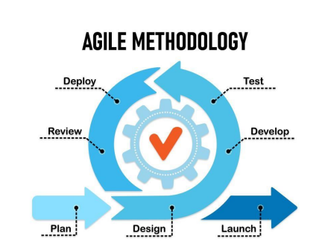**Methodology**

Figure 1. Agile Method Model

In developing the proposed system, the proponents utilized the agile methodology. Agile is an iterative approach in which requirements and solutions progress through collaboration between self-organizing cross-functional teams. The agile method entails delivering functionality incrementally and frequently, allowing for regular user feedback and continuous process improvement as needed (Palachuk, 2021). The agile methodology begins with planning, followed by design, development, testing, deployment, review, and launching of the system.

The **Planning** began as soon as the team had four members. After assembling the team, the proponents start planning what should be the proposed project's title. As soon as the project title is approved, the proponents have determined what programming language, database, and software and hardware requirements the proponents used during the project development process as well as the persons that are involved in the project. Also, the proponents went to rabbit farm in Gensan and conducted observations based on the project proposal. Furthermore, the proponents agreed and delegated the tasks for documentation and system development.

The **Designing Phase** began drafting the survey questionnaires for the data collection process. Proponents created an entity relationship diagram (ERD), a structural diagram used in database designing, and a use case diagram, a graphical representation of how different users will interact with the system. Additionally, use case diagrams outlined the system's events and the sequence to make it easier to identify, understand, and organize the system's requirements and functionalities.

During the **Development Phase**, proponents categorized and developed the modules required on the rabbit farmer and admin sides. The proponents looked for a bootstrap template for the user interface. Proponents created the database in phpMyAdmin, a free web tool that gives a user-friendly interface for working with the MySQL database management system. The proponents used PHP, a scripting language, to create a user-friendly and responsive website, and JavaScript to make highly dynamic and interactive interfaces that improve user experiences. And the proponents use CSS to provide styling for web pages and HTML to structure the web page and its content. The system is built and debugged using Visual Studio Code, a code editor. The system's modules are built one after the other**.**

**Testing Phase** begins after each module is completed. The proponents conducted unit, integration, and alpha testing. The proponents took the inputs into testing and addressed errors and enhanced the system’s functions. After testing, the developers began uploading the web files to make it accessible to its users.

**Deployment Phase** - The proponents chose Hostinger as the web host. The proponents continually test the system and conducted beta testing to let end users try the website.

**Review Phase -** End users are actively involved in enhancing the system through frequent feedback, and the system is constantly monitored for improvements and maintenance. The proponents conducted the review. Proponents checked all the feedback given by the system testers regarding the system. Proponents taken into consideration on errors encountered by end users during testing. After the review phase, the system is launched by the proponents. the proponents ensured that the website is ready to be used and accessed by end users.

**Launch Phase -** the system is launched by the proponents. the proponents ensured that the website is ready to be used and accessed by end users.

**Requirement Analysis**

**Who - The People Involved**:

* Rabbit Farmer - These users are actively involved in activities related to the care, breeding, and management of their rabbit populations.
* Admin - These users the administrators who are responsible for system management and oversight.

**What - The Business Activity:**

The core business activities that the system will support include:

* Monitoring and managing the health and well-being of rabbits.
* Maintaining detailed records of individual rabbits, including pedigrees.
* Managing breeding schedules and tracking mating pairs.
* Handling sales and inventory of rabbits and related products.
* Ensuring the overall success and sustainability of rabbit farming endeavors.

**Where - The Environment:**

The system is designed to operate within the environment of rabbit enthusiasts, which includes:

* Home-based rabbit farms and breeders' facilities.
* Small-scale rabbit farming operations.

**When - The Timing:**

* The system will be available for use at any time, allowing users to perform tasks and access information as needed.
* Timing includes managing daily routines for rabbit care, tracking breeding cycles, and monitoring growth over time.

**How - How Current Procedures Are Performed:**

* The current procedures in rabbit farming often involve manual record-keeping, spreadsheets, and paper-based documentation.
* The proposed Rabbit Farm Management System will automate these processes by providing user-friendly interfaces for entering and retrieving data.
* It will include features for generating reports, charts, and reminders to enhance decision-making and productivity.
* The system will facilitate collaboration among users, enabling them to share knowledge and best practices related to rabbit farming.

Requirement Documentation

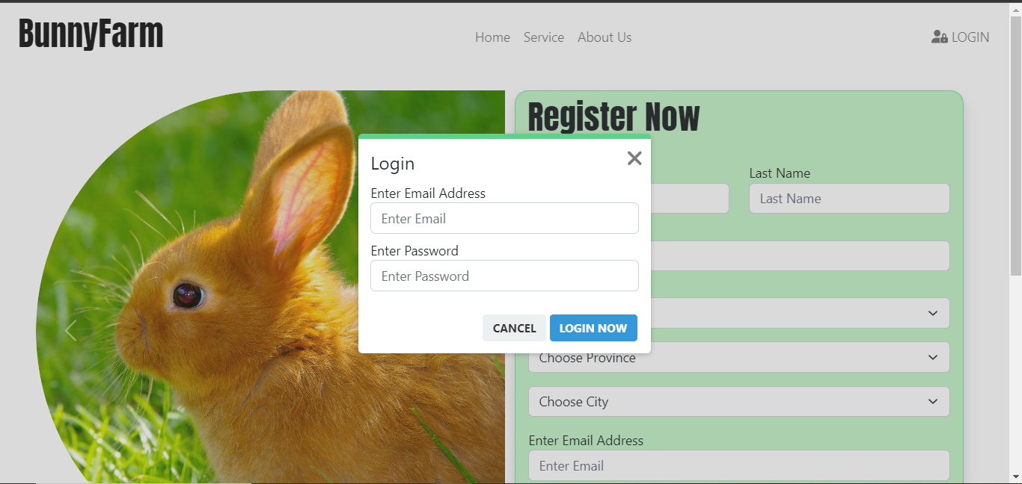

Figure 1.1 Log in and Sign up Module

The login and Sign up module is where the user will put their username/email and

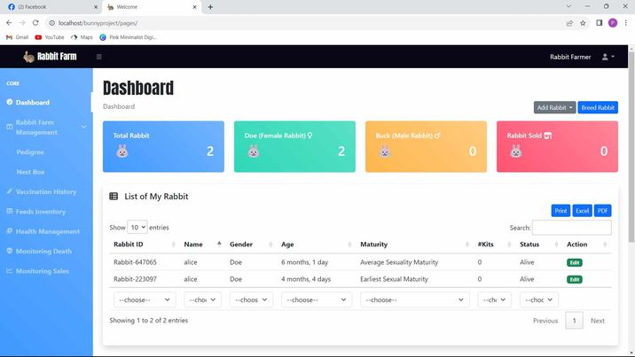passwords to access the website.

Figure 1.2 Dashboard

The dashboard is where the user will see the information about the total of their rabbits (buck and doe), information of their rabbits, total sale, and breeding information.

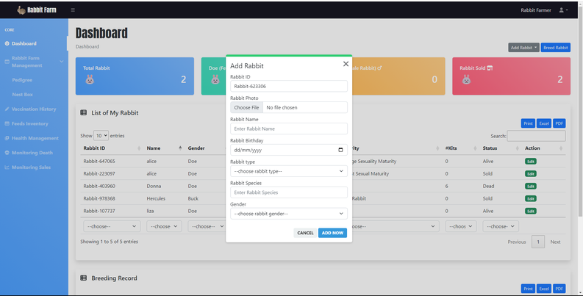Figure 1.3 Add New Rabbits Feature

The Add New Rabbits Feature is where the user will add the new rabbit and input

their information such as the name, gender, birthday, weight, breed type, their

father, and mother.

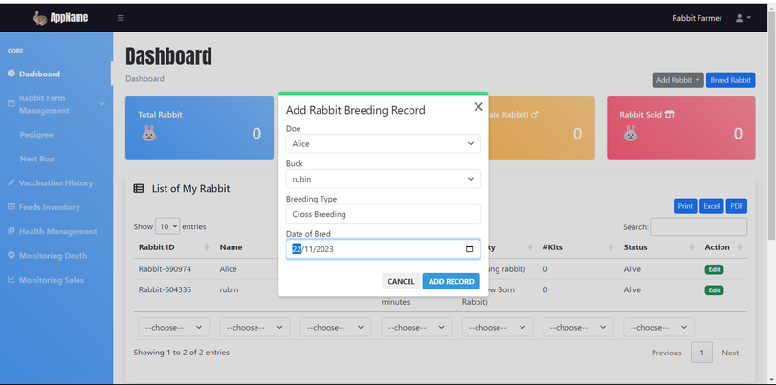

Figure 1.4 Breed Rabbits Feature

The Breed Rabbits feature is where the user will input the doe and the buck that

being bred, and the date which when the breeding happens.

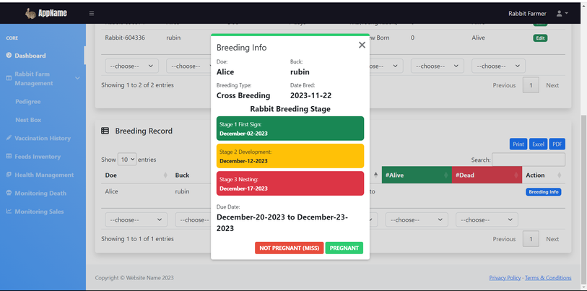Figure 1.5 Breeding Info Feature

The Breeding Info feature is where the user will input whether the breeding is

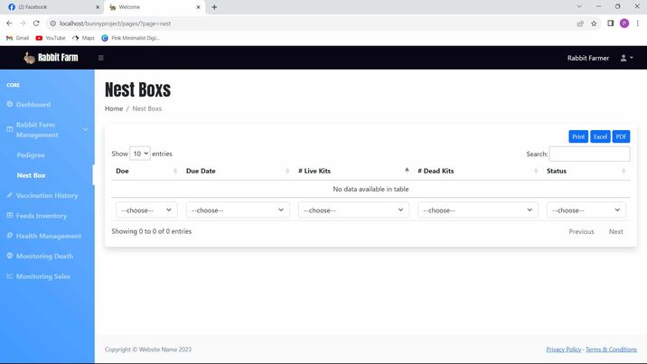successful or not by checking rabbit pregnancy stage.

Figure 1.6 NestBox Info Feature

The NestBox feature is where the user will input the information of the number of

kits that are alive and dead.

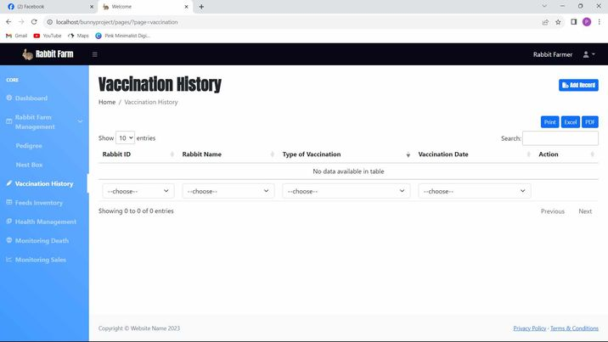

Figure 1.7 Vaccination History

The vaccination history module is where the user will add, and update the information of the vaccination of their rabbits.

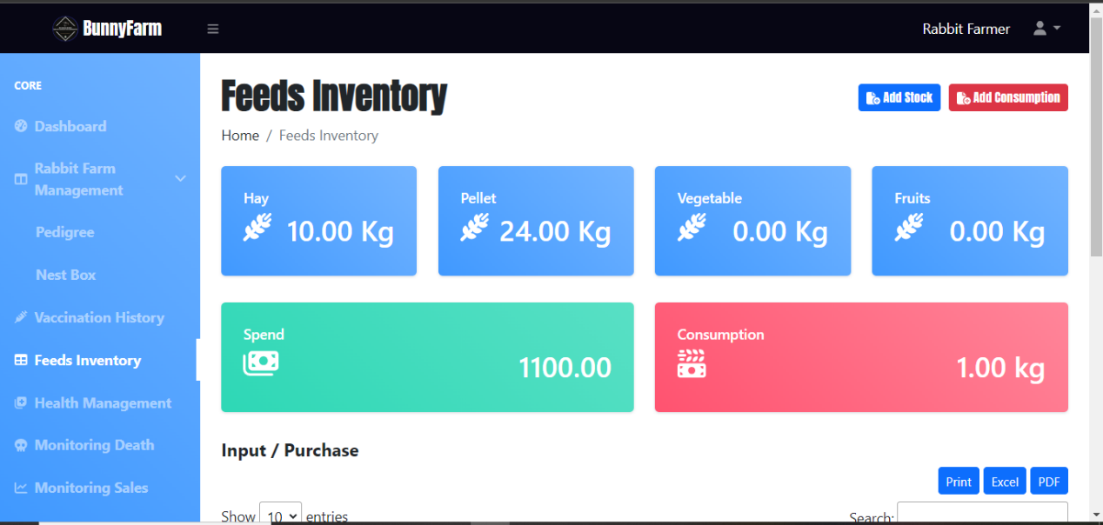

Figure 1.8 Feeds Inventory

The feeds inventory module is where the user will input the information of the feeds they will give to their rabbits, also they can see here the stock of the feeds and update the consumption of the feeds.

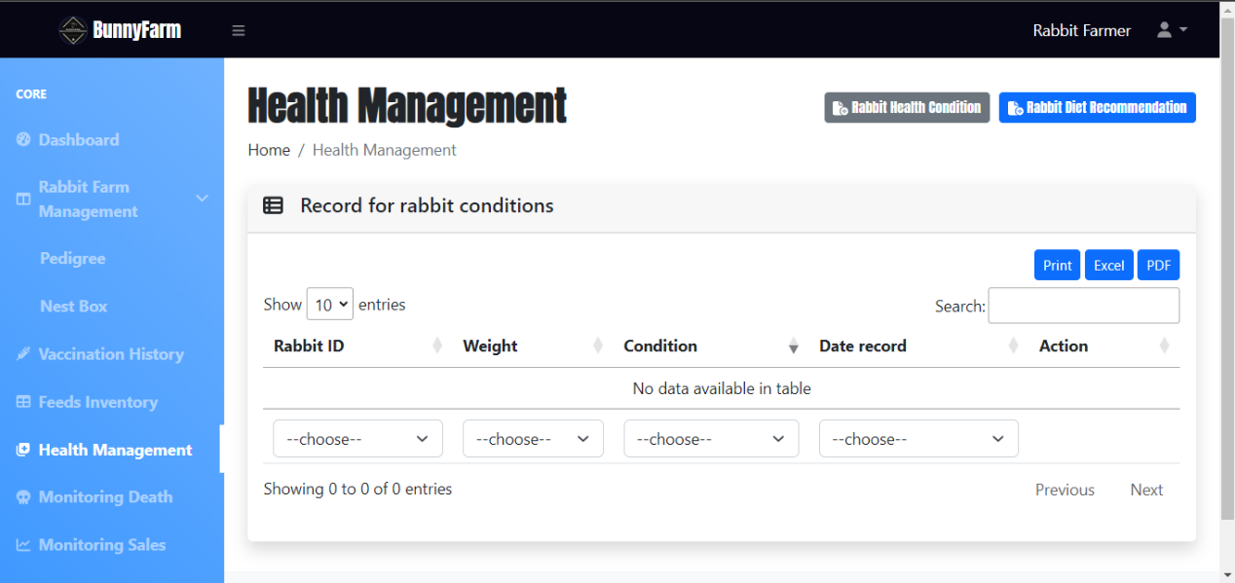

Figure 1.9 Health Management

The health management module is where the user will input the health condition of the rabbits, and also see the diet recommendation of the specific weight and age of the rabbit.

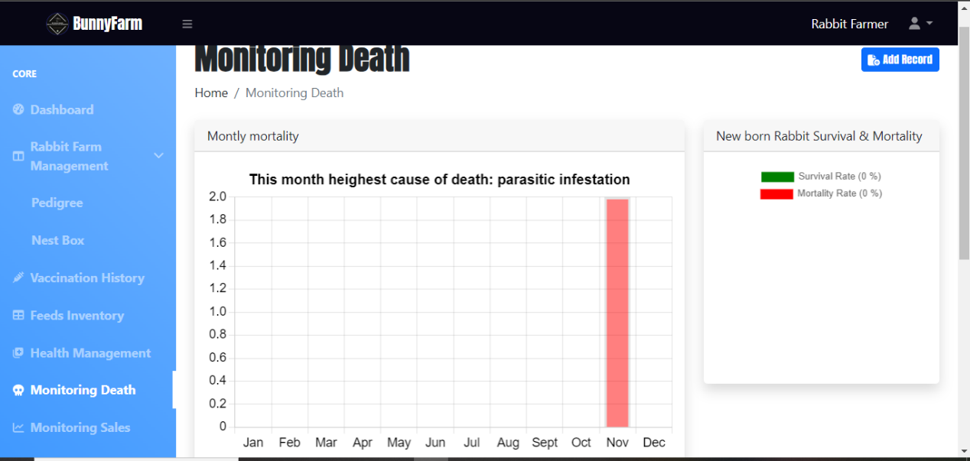

Figure 1.10 Monitoring Death

The monitoring death module is where the user will monitor the death of the rabbit by adding the record of the specific deceased rabbit.

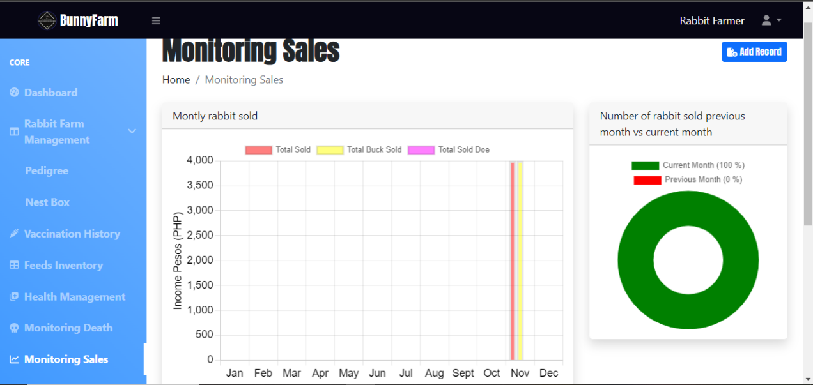

Figure 1.11 Monitoring Sales

The monitoring sales module is where the user will monitor the sales of the rabbit by add the record of the sold rabbit/s.

Design of Software, System, Product, and/or Processes

The design of the software and/or the system is represented through an entity relationship diagram. The diagram below is also the diagram representation of the database of the system. The relationship between entity sets is depicted using an ER diagram. An entity set is a collection of comparable entities that may or may not contain properties. An entity in a database management system is a table or an attribute of a table, hence an ER diagram depicts the entire logical structure of a database by displaying relationships between tables and their characteristics. Below is the relationship of different entities from the database.

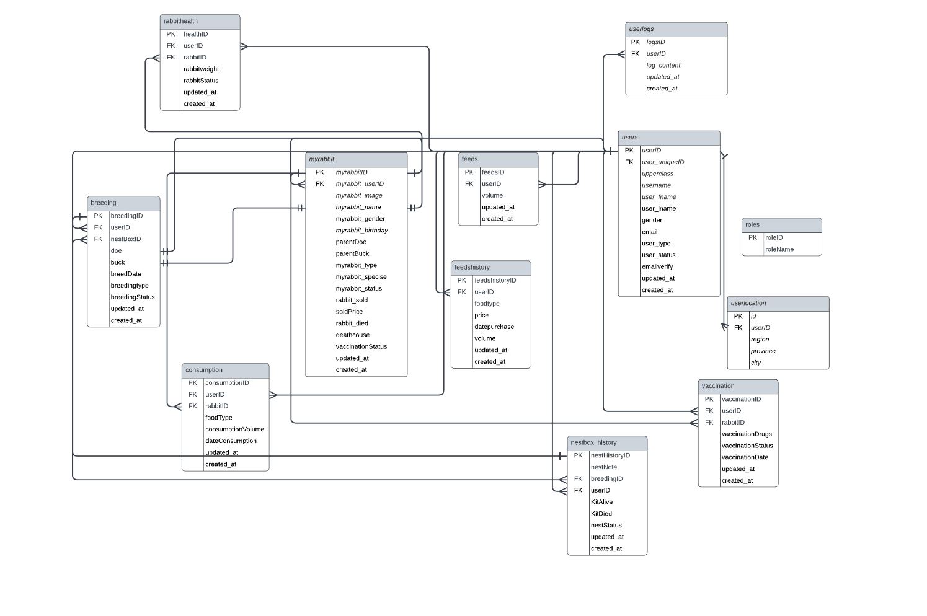

Figure 2. Entity Relationship Diagram

Use case diagrams are used as a visual reference for system analysis and function modeling. These diagrams are used to represent the many functionalities through the use cases when evaluating a system's needs. In this section presents the use-case diagram and associated processes for various system user levels.

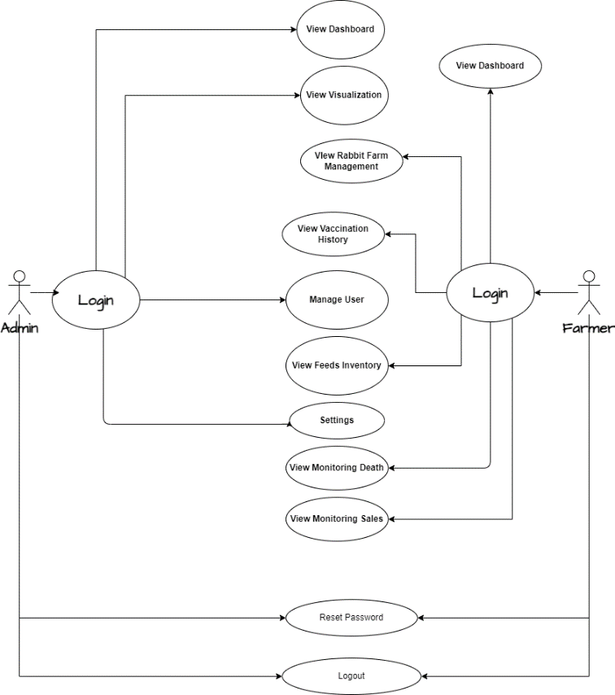

Figure 3. Use-case for all user level

Figure 3 shows the overall workflow for every user level in the system. There are modules specific to each user level that are only accessible or manipulated within the system.

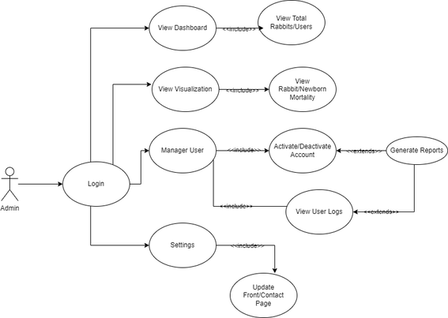

Figure 4. Use Case for Admin

Figure 4 shows the module to which the Admin user level has access within the system. The specified user level has limited access to modules that are exclusively assigned to the said user level.

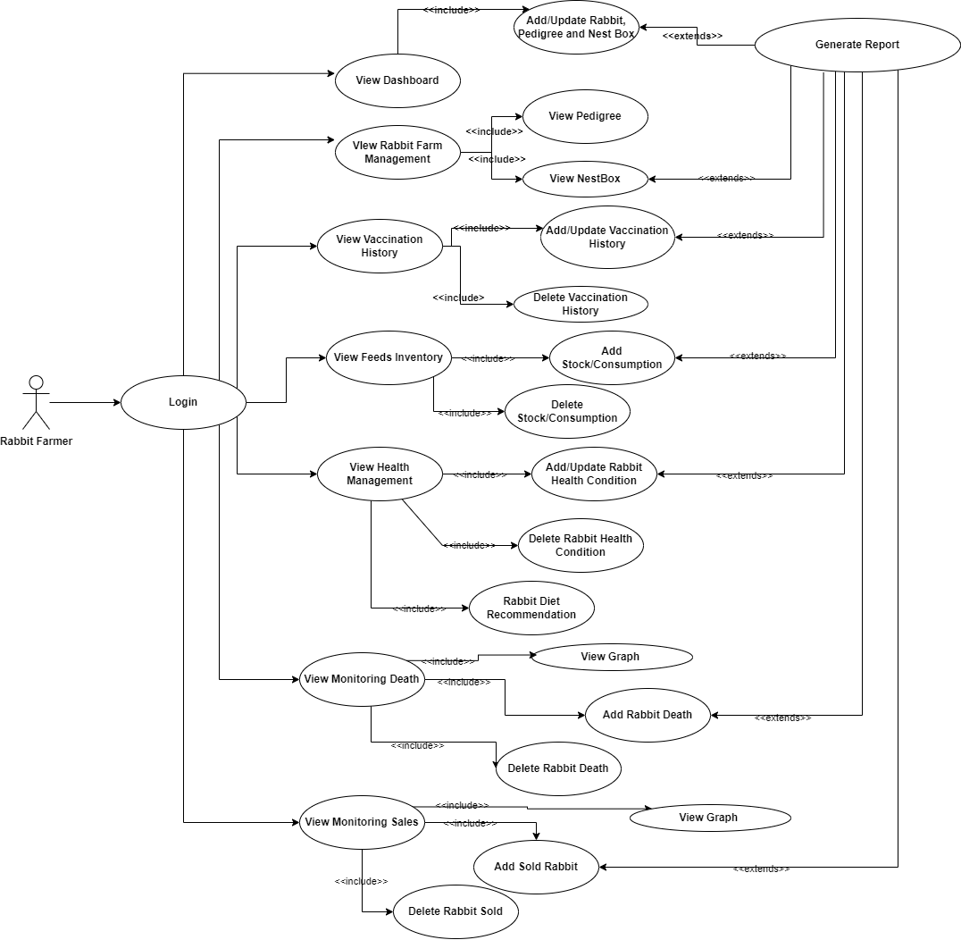

Figure 5. Use Case for Rabbit Farmer

Figure 5 shows the modules which the Rabbit Farmer user level can access within the system. All modules are accessible to the mentioned user level.

**Development and Testing**

In testing the performance of the system, the proponents performed the following tests to ensure that the proposed system is working properly:

**Unit Testing**

The proponents conducted a unit of a functionalities of each module of the proposed system to test if it is properly working and has no errors.

The proponents developed every module in accordance with the specified tasks that each module must complete. The proponents conducted actual tests of the modules and verified every result. During the test, proponents observed errors similar to logical errors, in which the program produced incorrect output. The proponents checked and fixed the codes after discovering all the errors.

**Integration Testing**

Proponents examined the system’s modules as a whole to guarantee connectivity between individual modules by reviewing the logic implemented and determining if the output satisfies the requirements. During the test, the proponents encountered errors, inaccurate outcomes, and other functions that needed to respond correctly. The proponents immediately went over the code and the checked the data flow.

**Alpha Testing**

The proponents uploaded the system to the web host and conducted alpha testing to ensure that the system could operate without errors, bugs or other system process issues before releasing the final system to the end users. Proponents took on the roles of patients and doctors during the test to experience the system’s operation from both perspectives. The proponents reviewed every transaction in the system to check if anything needed to be polished. There have been times when a patient’s proponents immediately addressed the problem, and the code and data flow were checked and revoked.

**Beta Testing**

In order to assess how well the system performed, the proponents conducted beta testing with the system’s intended users including admin and rabbit farmer. The proponents gave a system overview during the testing. After the end users explore the system’s feature, the proponents provide an evaluation form, requesting users to evaluate the system honestly based on its functionality and design. The proponents compiled of all the ratings, comments and recommendations to the system that the beta testers had provided.

**Description of Prototype**

The system prototype will perform the functionalities that are needed by the host company which is the Rabbit Farmers Agriculture Cooperative. The system requirements include the following functionalities:

* The system will allow the user to maintain detailed records of individual rabbits, including breed, age, weight, pedigree, and specific characteristics, facilitating better monitoring of rabbit growth, behavior, and health. by allowing them to add, update, and delete information. This provides the ability to manage newly added data from the system to the database for ensuring data.
* The system will allow user to manage and track the vaccination records for each rabbit, ensuring timely and appropriate vaccinations, and generating reports on vaccination.
* The system will allow users to maintain an accurate inventory of feeds and feed-related supplies, providing real-time updates on stock levels, generating alerts for low inventory, and facilitating efficient procurement and distribution of feeds.
* The system will allow the user to record and monitor the health of rabbits, such as condition view the rabbit health condition.
* The system will allow the user to record and track rabbit deaths, including cause, date, and observations, facilitating analysis of mortality rates and identification of potential health concerns.
* The system will enable the user to manage and track rabbit sales, including transaction details and pricing, generating reports on sales performance and total rabbit counts per month for better sales management.
* The system will enable users to generate reports based on recorded data, offering valuable insights into various aspects of rabbit farming, such as vaccination history, feed consumption, health records, sales performance, and overall farm management.

The above mentioned functionalities have been achieved by the proponents. The system requirements will be tested and evaluated by using the system testing as software testing method. The system will be evaluated by allowing the end-users from Rabbit Farmers Agriculture Cooperative to manipulate and use the system for them to test the functionality of the system. After the system testing, the end-users are given an evaluation form for them to rate and evaluate the prototype.

**RESULT & DISCUSSION**

The subsequent section of this capstone project proposal will present the results and discussions derived from the development and implementation of the Web-Based Rabbit Farm Management System. It will focus on the system's effectiveness in enhancing farm operations, rabbit health, and overall management. The following analysis will encompass comprehensive modules designed to empower farmers for the optimization of productivity and the attainment of successful outcomes in rabbit farming.

|  |  |  |
| --- | --- | --- |
| **Statement** | **Mean** | **Verbal Interpretation** |
| 1. The overall design is appealing. | 4.25 | Strongly Agree |
| 2. The screen layouts are consistent. | 4.20 | Agree |
| 3. The icons and colors are appropriate. | 4.20 | Agree |
| 4. The fields and commands are easy to understand. | 4.55 | Strongly Agree |
| 5. The font style, color, and size are pleasing and visible enough to be read | 4.30 | Strongly Agree |
| Overall Mean | 4.30 | Strongly Agree |

Table 1. Respondents' Perception of the Web-Based Rabbit Farm Management System Website Design

Figure 6. The mean rate of the design of the website

In the table, a comprehensive assessment of respondents' perceptions regarding the design of the Web-Based Rabbit Farm Management System website has been observed. The highest mean score, which was 4.55, was assigned to the statement, "The fields and commands are easy to understand," indicating a strong consensus among the respondents in strongly agreeing with this aspect. This high score suggests that the website's interface is intuitive and user-friendly, aligning with the objective of developing a user-friendly system.

On the other hand, the lowest mean score of 4.20 was attributed to two statements: "The screen layouts are consistent" and "The icons and colors are appropriate," both of which were rated as "Agree." While these scores indicate a favorable perception, they also point to a marginally lower level of agreement compared to the other statements. This implies that there may be room for improvement in ensuring consistency in screen layouts and the choice of icons and colors. These aspects are essential in web design as they contribute to user satisfaction and navigation efficiency.

The overall mean score for all the statements in the table is 4.30, signifying a collective "Strongly Agree" rating. This high overall mean reflects a predominantly positive perception of the website's design. It suggests that the design attributes, such as appealing aesthetics, clear and pleasing font styles, and effective use of colors and icons, are well-received by the respondents. This alignment between the respondents' perceptions and the study's objectives implies that the user-friendly design approach adopted in the Web-Based Rabbit Farm Management System is indeed successful in enhancing farm operations, rabbit health, and overall management, as stated in the study's objectives.

In a study conducted by Ellis in 2023, it was revealed that the significance of user-friendly website design extends beyond mere aesthetics, as it plays a pivotal role in heightening user engagement and overall satisfaction. This underscores the holistic impact of design on the user experience, emphasizing the need for interfaces that are not only visually appealing but also highly functional. Furthermore, the research conducted by Yu and colleagues in 2019 emphasized the critical role of clear and intuitive interfaces in web-based applications. They found that such interfaces are instrumental in optimizing user productivity, enabling individuals to navigate digital platforms with ease and efficiency. The results in this table are in line with these findings, highlighting the importance of user-friendly design principles in the context of the Rabbit Farm Management System website.

|  |  |  |
| --- | --- | --- |
| **Statement** | **Mean** | **Verbal Interpretation** |
| 1. The registration process to the website is easy. | 4.45 | Strongly Agree |
| 2. The login process to the website is easy. | 4.55 | Strongly Agree |
| 3. The forms are accessible. | 4.2 | Agree |
| 4. The transition from one module to another is smooth without errors. | 4.25 | Strongly Agree |
| 5. The button perform performs its own function. | 4.35 | Strongly Agree |
| 6. The system’s modules are accessible. | 4.4 | Strongly Agree |
| 7. The system can add, update, delete and store rabbit information. | 4.3 | Strongly Agree |
| 8. The forms are accessible, easy to use and understand. | 4.35 | Strongly Agree |
| 9. The system modules is usable and helpful. | 4.35 | Strongly Agree |
| 10. The system can generate print, excel and pdf reports on all modules. | 4.8 | Strongly Agree |
| 11. The system is user-friendly. | 4.35 | Strongly Agree |
| 12. The system is responsive. | 4.2 | Agree |
| 13. The system is recommendable to other rabbit farmers. | 4.5 | Strongly Agree |
| Overall Mean | 4.39 | Strongly Agree |

Table 2. Respondents' Perception of the Web-Based Rabbit Farm Management System Website Functionality

Figure 7. The mean rate of the design of the website functionality

Table 2 presents the respondents' perception of the Web-Based Rabbit Farm Management System's website functionality, along with their corresponding mean scores and verbal interpretations. The study aimed to assess the system's usability and overall functionality to provide insights into its effectiveness in supporting rabbit farming operations.

The highest mean score in this table is attributed to Statement 10, "The system can generate print, excel, and PDF reports on all modules," which received a mean score of 4.8. This exceptionally high score implies that the system's ability to produce reports in various formats is a highly valued and effective feature, greatly facilitating data management and analysis. This result is in line with findings from Dhanaraju et al. (2022), who emphasized the importance of reporting capabilities in farm management systems, as it aids in decision-making and overall farm efficiency. The high rating for this statement indicates that the system excels in this crucial aspect, potentially contributing to the success of rabbit farming operations by providing essential data in convenient formats.

On the other hand, Statement 3, "The forms are accessible," and Statement 12, "The system is responsive," received the lowest mean scores of 4.2 each, falling into the "Agree" category. This suggests that while these aspects of the system are generally satisfactory, there is room for improvement. Saleem et al. (2022) highlighted the critical role of accessibility and responsiveness in user satisfaction with web-based systems. Although respondents in our study found these aspects to be acceptable, there is a clear opportunity for improvement. Enhancements in accessibility and responsiveness have the potential to significantly enhance the overall user experience and satisfaction with the system.

The overall mean score of 4.39, which is close to the highest possible score of 5, indicates an overwhelmingly positive consensus among respondents regarding the system's website functionality. This high score reflects a strong agreement among participants, affirming the effectiveness and user-friendliness of the Web-Based Rabbit Farm Management System. These findings underscore the system's significant role in enhancing various aspects of rabbit farming, from farm operations to the health of the rabbits. It demonstrates the system's potential to streamline and improve the management of rabbit farms, making it a valuable tool for farmers seeking to optimize their operations and achieve better outcomes.

|  |  |  |
| --- | --- | --- |
| **Statement** | **Mean** | **Verbal Interpretation** |
| 1. User-friendly/Ease of use. | 4.35 | Strongly Agree |
| 2. Suited to the abilities and skills of the user. | 4.2 | Agree |
| 3. The system caters the need of the user. | 4.5 | Strongly Agree |
| 4. The system modules are clear and precise. | 4.35 | Strongly Agree |
| Overall Mean | 4.35 | Strongly Agree |

Table 3. Respondents' Perception of the Web-Based Rabbit Farm Management System Website Appropriateness

Figure 8. The mean rate of the Appropriateness

Table 3 presents a detailed analysis of the respondents' perceptions regarding the appropriateness of the Web-Based Rabbit Farm Management System website. The study reveals that the overall mean score is 4.35, indicating a strong consensus among respondents that the website is highly appropriate for its intended purpose. The interpretation of the highest, lowest, and overall mean scores, along with their implications, and reference related articles and studies was discussed below.

The highest mean score was attributed to the statement "The system caters the need of the user," with a score of 4.5, indicating that respondents strongly agree that the system effectively addresses the specific needs of the users. This finding aligns with the principles of user-centric design, which emphasize tailoring systems to meet the unique requirements of the target audience. According to Samsukha (2023) on user-centric website design highlighted the importance of aligning system functionality with user needs to enhance usability and overall user satisfaction. The high rating in this category underscores the successful alignment of the Web-Based Rabbit Farm Management System with the needs of its users.

Conversely, the lowest mean score of 4.2 was associated with the statement "Suited to the abilities and skills of the user." While still in the "Agree" range, this score suggests that respondents found room for improvement in terms of matching the system to the users' abilities and skills. This outcome indicates the need to further refine the system to better cater to users with varying levels of expertise. The study by Lawless (2023) suggests that a system that aligns with users' abilities and skills can lead to improved usability and reduced user frustration. Therefore, this result implies that the Web-Based Rabbit Farm Management System is well-matched to the users' competencies, which is crucial for effective system utilization.

The overall mean score of 4.35 is a culmination of the individual item scores and signifies a strong consensus among the respondents that the Web-Based Rabbit Farm Management System website is highly appropriate for their needs. This overall mean score is a testament to the success of the system in meeting the expectations of its users and aligning with the principles of user-friendly design. It underscores the system's capacity to enhance farm operations, promote rabbit health, and improve overall farm management.

Table 4. Overall Respondents' Perception of the Web-Based Rabbit Farm Management System

|  |  |  |
| --- | --- | --- |
| **Indicators** | **Mean** | **Verbal Interpretation** |
| Design of the Website | 4.30 | Strongly Agree |
| Functionality of the Website | 4.39 | Strongly Agree |
| Appropriateness | 4.35 | Strongly Agree |
| Overall Mean | 4.35 | Strongly Agree |

Table 4 presents a comprehensive overview of the respondents' perception of the Web-Based Rabbit Farm Management System, focusing on key indicators such as the design of the website, functionality, appropriateness, and the overall mean score. The results clearly indicate a highly positive assessment of the system by the respondents.

The mean score for the "Design of the Website" is 4.30, reflecting a "Strongly Agree" interpretation. This suggests that the respondents found the website's design to be exceptionally appealing and user-friendly. This is in line with findings from a related study by Jongmans et al. (2022) on the impact of website design on user satisfaction in e-commerce noted that well-designed websites tend to enhance user experiences and promote engagement, which aligns with the favorable perception observed in this study.

The "Functionality of the Website" received a mean score of 4.39, also indicating a "Strongly Agree" interpretation. This underscores the system's robust functionality, suggesting that it effectively supports various farm management tasks. This result is consistent with findings from a study by Anderson and Lee (2019), which emphasized that functionality and ease of navigation are essential attributes for web-based platforms in the agricultural sector, as they directly influence users' ability to manage their operations efficiently.

Similarly, the "Appropriateness" indicator scored 4.35, again signifying a "Strongly Agree" perception among respondents. This implies that the system is well-suited for the specific needs and demands of rabbit farming. Research by Pelaez et al. (2023) underscored the significance of aligning technology solutions with the specific needs of the end-users to ensure successful adoption. The positive perception of appropriateness underscores the potential of the Web-Based Rabbit Farm Management System to contribute to improved rabbit health and overall farm management.

When considering the overall mean score of 4.35, it is evident that respondents strongly agree with the overall utility of the Web-Based Rabbit Farm Management System. This collective affirmation is a positive indication of the system's potential to improve farm operations, rabbit health, and overall management, aligning with the objectives of this study.

**Implementation Plan**

The proponents performed a new installation of the proposed system at the Dadiangas Rabbit Agriculture Farm Cooperative of General Santos City to test and evaluate if the proposed system achieves its main objectives. The system was deployed on the web host using the domain name bunnyfarm.online, where the rabbit farmers can access the system’s featured services online. The user’s need to rate the design and functionality of the system honestly. Doing so will help the system’s proponents in improving the system. The complied evaluation tools containing the end user’s feedback can be found in the

During the system’s implementation, the proponents conducted a beta testing for the rabbit farmers to explain the technical aspects of utilizing the website. After familiarizing the system with the end users, a system evaluation will be carried out to know the end user’s feedback regarding the system’s performance.

The proponent’s system requires end users to have a computer set or laptop with at least Windows 7 OS. The users must have a browser like Google Chrome, Brave and Microsoft Edge. And a stable internet connection of at least 5-10 Mbps.

**Implementation Results**

The system is being deployed under the domain name bunnyfarm.online by the proponents. End users can successfully access and register on the website during the beta testing. The rabbit farmer can use the system to add rabbit, breed a rabbit, search for pedigree, view the nest box, monitor the feeds inventory, manage the rabbit health, add/view the vaccination history and track, or monitor the rabbit cause of death and rabbit sales. The admin can also login by providing this extension “?page=super admin” next to the domain name and can use the system to view the total users and rabbit, visualization of the mortality rates, manage users and modified the front and contact page. From start to finish, the processes were executed successfully. The proponents gathered feedback from the end users during the beta test of the proposed system and will use those feedback as a guide for further system enhancement.

**CONCLUSIONS AND RECOMMENDATIONS**

Technology allows people to communicate immediately, get information instantly, and interact online. Technology improvements have made everything accessible to people, improving their quality of life and convenience. Technology also enhances workplace efficiency by streamlining time-consuming procedures, such as recording data or information of rabbits or on how rabbit farmers manage their rabbits. In this connection, the proponents freely adopt the advancement of the technology by proposing the Web-based Rabbit Farm Management to gain the real experience and benefits of the technological advancement, particularly in managing rabbit farms.

The proposed system has provided a module for managing the rabbit’s information that the users can view and a module that enables the ability to monitor all the rabbit’s information and on how to manage it. The system provides a module that requires an email account for verification of the registration of the users which are the rabbit farmers. The system has a module that can add rabbit’s information, can add rabbit from purchase and breeding, can breed rabbits, a dashboard that show’s the total rabbits as well as the doe and bucks and also rabbits that are sold, and also show the lists of rabbits with its information and breeding records. The system has a module that shows the pedigree of each rabbit and nest boxes. The system has a module that allows users to monitor the vaccination history, feeds inventory through input and output, health management, monitor mortality and sales of a rabbit.

Based on the beta test evaluation of the proposed system, the users which are the rabbit farmers/owners have a positive evaluation of the design and functionality of the website are relevant.

The proponents will recommend further enhancement of the developed system to have a feature to generate a QR Code that will show the rabbit’s profile, and also to have a feature when the user reset the account password the system will send auto generated code to the Email that was provided during the registration for strong authentication.

**REFERENCE**

Anderson, P., & Lee, M. (2019). Functional Aspects of Web-Based Agricultural Systems. Agricultural Technology Review, 45(2), 201-216.

Dhanaraju M, Chenniappan P, Ramalingam K, Pazhanivelan S, Kaliaperumal R. (2022, September 7). Smart Farming: Internet of Things (IoT)-Based Sustainable Agriculture. Agriculture. 2022; 12(10):1745. <https://doi.org/10.3390/agriculture12101745>

Ellis, T. (2023). The Psychology Behind Successful Web Design. https://h2o-digital.com/the-psychology-behind-successful-web-design/

Jongmans, E., Jeannot, F., Liang, L., & Demperat, M. (2022, July). Impact of website visual design on user experience and website evaluation: the sequential mediating roles of usability and pleasure. DOI:10.1080/0267257X.2022.2085315

Lawless, J. (2023, July 18). What Is User Experience (UX) Design?. https://purplegriffon.com/blog/what-is-ux

Martínez-Peláez, R.; Ochoa-Brust, A.; Rivera, S.; Félix, V.G.; Ostos, R.; Brito, H.; Félix, R.A.; Mena, L.J. (2023, June 7). Role of Digital Transformation for Achieving Sustainability: Mediated Role of Stakeholders, Key Capabilities, and Technology. <https://doi.org/10.3390/su151411221>

Saleem, U., Yi, S., Bilal, M., Topor, D. I., & Capusneanu, S. (2022, August 24). The impact of website quality on customer satisfaction and eWOM in online purchase intention: The moderating role of gender in risk-taking. https://doi.org/10.3389/fpsyg.2022.945707

Samsukha, A. (2023, August 5). Importance of User-Centered Design in App and Website Development. <https://www.emizentech.com/blog/importance-of-user-centered-design.html>

Yu, Y., Yan, X., Zhang, X., & Zhou, S. (2019). What They Gain Depends on What They Do: An Exploratory Empirical Research on Effective Use of Mobile Healthcare Applications. https://scholarspace.manoa.hawaii.edu/server/api/core/bitstreams/976ac64f-479e-4902-a67b-087d8bf4c9fc/content

Lorio, J.P. and Villareal, G.M. (2023) Discovering Rabbit (Oryctolagus cuniculus L.) Farming in Partido, Camarines Sur, Philippines: Raisers’ Perspectives. Open Access Library Journal, 10, 1-16. doi: 10.4236/oalib.1109765.

Lopez, R.J.D. (2022) Characterization of Rabbit (Oryctolagus cuniculus) Production System in Partido. Open Access Library Journal, 9, 1-11. doi: 10.4236/oalib.1109272.

Kassy G.D., Tâmara D.B., Leandro B.C. *et al.* (2020) .Rabbit welfare protocols under Brazilian conditions: The applicability of welfare protocols in rabbit farms for different purposes – First results,

Journal of Veterinary Behavior, Volume 54, Pages 36-53, ISSN 1558-7878,

https://doi.org/10.1016/j.jveb.2022.06.002.

Gidenne, T., Savietto, D., Goby, J.P. *et al.* (2020) A referencing system to analyse performances of French organic rabbit farms. *Org. Agr.* 10 (Suppl 1), 125–129 (2020). https://doi.org/10.1007/s13165-020-00315-1

Onuoha, C.H. (2020) Reproductive Physiology of Male Rabbits: A Key Factor in Buck Selection for Breeding (Paper Review). Advances in Reproductive Sciences, 8, 97-112. doi: 10.4236/arsci.2020.82009.

Dr. Singh, R. (2020). Rabbit Farming Detailed Project Report (DPR) For (100+20) Rabbit. https://www.pashudhanpraharee.com/rabbit-farming-detailed-project-report-dpr-for-10020-rabbit/

Gatesi, J. , Ayuke, F. and Musinguzi, S. (2023) Rabbit Intensification Systems in Rwanda: Feeding Influence and Growth. Journal of Agricultural Chemistry and Environment, 12, 44-49. doi: 10.4236/jacen.2023.121004.

Gidenne, T.  Garreau, H. ;  Maertens, L. ;  Drouilhet, L. (2019).  Feed efficiency in rabbit farming: ways of improvement, technico-economical and environmental impacts, 32, 431-444. doi: 10.20870/productions-animales.2019.32.3.2946

Okumu, P. O.,  Gathumbi, P. K.,  Karanja, D. N., Bebora, L. C.,  Mande, J. D., Serem, J. K.,  Wanyoike, M. M. Gachuiri, C., Mwanza, R. N. and Mailu, S. K. (2015). Survey of health status of domestic rabbits in selected organized farms in Kenya.  Retrieve from  http://www.ijvets.com/.../15-21.pdf

Alekseeva, L. V.; Lukyanov, A. A.; Bogdanova, O. V. (2018). Biologically active substance application efficiency for meat rabbit breeding.  Retrieved from <https://web.s.ebscohost.com/abstract?direct=true&profile=ehost&scope=site&authtype=crawler&jrnl=13079867&AN=134567502&h=CbH5tWGZBqNUco%2f3tO1v0lFYy5a7yCAMr6nJN8REyaFHSun8yw6GNmyM2lf6%2bxh7a8ZeoL167tAikY2r27Cc2g%3d%3d&crl=c&resultNs=AdminWebAuth&resultLocal=ErrCrlNotAuth&crlhashurl=login.aspx%3fdirect%3dtrue%26profile%3dehost%26scope%3dsite%26authtype%3dcrawler%26jrnl%3d13079867%26AN%3d134567502>

Everbreed (2023) Everbreed: Rabbit Management Software. https://everbreed.com/

Li, J., Wang, Y., & Li, Y. (2019). Health management system for rabbit breeding in China. World Rabbit Science, 27(4), 231-238.

Feedia. (2021). SPACE 2021 RABBIT: A collaborative rabbit management system for dynamic farm monitoring. https://www.feedia-techna.com/en/blog/space-2021-rabbit-collaborative-rabbit-management-system-dynamic-farm-monitoring

Lopata, R., & Blache, D. (2016). Environmental control system for rabbit production in Australia. World Rabbit Science, 24(3), 149-158.

M., Fagbola & Thakur, Surendra & Olugbara, Oludayo. (2019). Rab-KAMS: A Reproducible Knowledge Management System with Visualization for Preserving Rabbit Farming and Production Knowledge. International Journal of Advanced Computer Science and Applications. 10. 10.14569/IJACSA.2019.0100135.

Smith, P., Mhlanga, M., & Ndlovu, C. (2018). Integrated production system for rabbit and poultry farming in Africa. World Rabbit Science, 26(4), 273-283.

Buenafe, O., Serrano, M., & Boac, M. (2017). Development of a feed management system for rabbit production in the Philippines. Philippine Journal of Veterinary and Animal Sciences, 43(2), 145-153.

Roque, M., & Espiritu, E. (2016). Environmental control system for rabbit production in a tropical country. Philippine Journal of Veterinary Medicine, 53(2), 25-35.

Dayo, E., Claudio, L., & Agbisit, A. (2018). Evaluation of rabbit breeds for meat production in the Philippines. Philippine Journal of Veterinary Medicine, 55(1), 18-27.

Rodriguez, J., Aquino, R., & Garcia, R. (2019). Development of a health management system for rabbit breeding in the Philippines. Philippine Journal of Veterinary Medicine, 56(1), 23-30.

Padilla, A., Cruz, L., & Eusebio, R. (2020). Integrated production system for rabbit and cassava farming in the Philippines.

**APPENDICES**

**Appendix A: Resource Persons**

**RESOURCE PERSONS**

Ms. Kristel Joy Tulagan, MIT

**Capstone Project 1 – Coordinator**

**STI College – General Santos**

Mrs. Noelyn G. Datahan

**Capstone Project 1 & 2 – Adviser**

**STI College – General Santos**

Ms. Ivy Grace Laurente

**Capstone Project 1 & 2 – Coordinator**

**STI College – General Santos**

Mr. Gunther Alonzo

**DRFAC Chaiman**

**Dadiangas Rabbit Farmers Agriculture Cooperative**

Ms. Cherry Layno

**DRFAC Member**

**Dadiangas Rabbit Farmers Agriculture Cooperative**

Mr. Jefrey Lorento

**DRFAC Member**

**Dadiangas Rabbit Farmers Agriculture Cooperative**

Theody Soria

**Respondent**

LM Backyard Rabbitry

**Respondent**

**LM Backyard Rabbitry – General Santos**

Russell John

**Respondent**

Zyke Lacoto

**Respondent**

Girlie N. Solis

**Respondent**

Grace Batomalaque

**Respondent**

**Appendix C: Evaluation Tool/Test Documents**

Name : Date :   
Age : Gender:   
General Direction: Please answer this evaluation form honestly. Check the box that corresponds to your answer. Use the following scales for rating.

|  |  |  |  |  |  |
| --- | --- | --- | --- | --- | --- |
| **A. DESIGN OF THE WEBSITE** | **1** | **2** | **3** | **4** | **5** |
| 1. The overall design is appealing. |  |  |  |  |  |
| 2. The screen layouts are consistent. |  |  |  |  |  |
| 3. The icons and colors are appropriate. |  |  |  |  |  |
| 4. The fields and commands are easy to understand. |  |  |  |  |  |
| 5. The font style, color, and size are pleasing and visible enough to be read |  |  |  |  |  |

|  |  |  |  |  |  |
| --- | --- | --- | --- | --- | --- |
| **B. FUNCTIONALITY OF THE WEBSITE** | **1** | **2** | **3** | **4** | **5** |
| 1. The registration process to the website is easy. |  |  |  |  |  |
| 2. The login process to the website is easy. |  |  |  |  |  |
| 3. The forms are accessible. |  |  |  |  |  |
| 4. The transition from one module to another is smooth without errors. |  |  |  |  |  |
| 5. The button perform performs its own function. |  |  |  |  |  |
| 6. The system’s modules are accessible. |  |  |  |  |  |
| 7. The system can add, update, delete and store rabbit information. |  |  |  |  |  |
| 8. The forms are accessible, easy to use and understand. |  |  |  |  |  |
| 9. The system modules is usable and helpful. |  |  |  |  |  |
| 10. The system can generate print, excel and pdf reports on all modules. |  |  |  |  |  |
| 11. The system is user-friendly. |  |  |  |  |  |
| 12. The system is responsive. |  |  |  |  |  |
| 13. The system is recommendable to other rabbit farmers. |  |  |  |  |  |

**1(Strongly Disagree) 2 (Disagree) 3 (Neutral) 4 (Agree) 5 (Strongly Agree)**

|  |  |  |  |  |  |
| --- | --- | --- | --- | --- | --- |
| **C. APPROPRIATENESS** | **1** | **2** | **3** | **4** | **5** |
| 1. User-friendly/Ease of use. |  |  |  |  |  |
| 2. Suited to the abilities and skills of the user. |  |  |  |  |  |
| 3. The system caters the need of the user. |  |  |  |  |  |
| 4. The system modules are clear and precise. |  |  |  |  |  |

**If there any comments/suggestions, feel free to write them below:**

**_______________________________________________________________________________________________________________________________________________________________________________________________________________________________________________________________  
Name and Signature : ____________________**

**Interview**

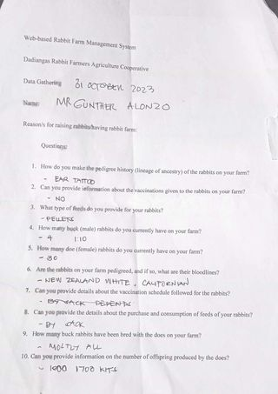



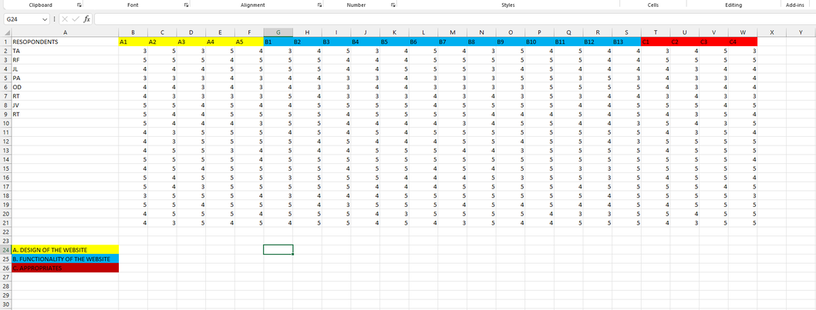

**Appendix F: Certificates And Formal Letters**

ACCEPTANCE LETTER

ADVISER’S ACCEPTANCE FORM

NAME OF ROPONENTS: Joshua Jules T. Ruloma

Philip Rohjan A. Cabrias

Kyle John T. Rentura

Joshua V. Dela Cerna

APPROVED RESEARCH TITLE: Web-Based Rabbit Farm Management

AREA OF STUDY: Desktop Application

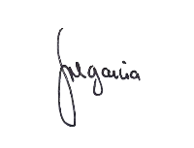CONFORME:

Noelyn G Datahan

Capstone Project Adviser

APPROVED BY:

Kristel Joy C. Tulagan, MIT Date: 23 March 2023

Capstone Project Coordinator

NOTED BY:

Julie B. Ocenar, MIT

Program Head

June 13, 20 23

Dadiangas Rabbit Farmes Agriculture Cooperative

Orilliano Subdivision, 14 Orillano Homes,

General Santos City, 9500

South Cotabato

Good day!

We, the students of STI College General Santos Inc. pursuing Bachelor of Science in Information Technology are developing a system for our research title named "Web-based Rabbit Farm Management” We aim to develop a web portal that will help rabbit farm owners in General Santos in managing their rabbit farm

In line with this, we are respectfully asking for your permission to allow and approve us to have a data gathering and gather information in your rabbit farm, and implement our proposed system in your cooperative as partial completion of the requirements

Your cooperation will greatly contribute to the success of our study. Thank you in advance for your consideration and cooperation.

With sincerely appreciation,



Joshua Jules Ruloma Philip Rohjan Cabrias



Kyle Jhon Rentura Joshua Dela Cerna

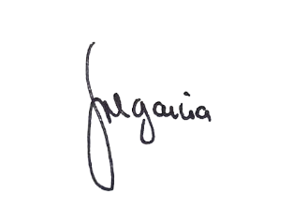

**NOELYN G. DATAHAN**

Capstone Project Adviser

# **CERTIFICATE OF STATISTICIAN**

This certifies that the research study entitled **“WEB-BASED RABBIT FARM MANAGEMENT FOR DADIANGAS RABBIT FARMERS AGRICULTURE COOPERATIVE”** conducted by **Joshua Jules T. Ruloma, Philip Rohjan A. Cabrias, Kyle Jhon T. Rentura, & Joshua V. Dela Cerna** of the Bachelor of Science in Information Technology program at STI College General Santos, Inc., has been statistically processed and analyzed by the undersigned.

This certification is hereby granted on the 9th day of November 2023, in response to the researchers' formal request, with the intent of enabling its legitimate use for both academic and legal purposes.

Noted by:

**KATE LINDSEY C. BARBA**

Statistician

**Appendix G: Accomplishment And Consultation Forms**

ACCOMPLISHMENT AND CONSULTATION FORM

INSTRUCTION: List all the activities, improvements or accomplishments that have been made in your Capstone Project Documentation and System/Prototype. This form may be reproduced as you go along with your Capstone Project. This form should be submitted to your Capstone Project Adviser every week.

Capstone Project Title: Rabbit breed portal

Week Number: Week 1

|  |  |
| --- | --- |
| ACTIVITY/  ACCOMPLISHMENT | REMARKS/ COMMENTS/ SUGGESTIONS/  DELIVERABLES and DUE DATE |
| * **Orientation** |  |
| Prepared by:    Ruloma, Joshua Jules T.    Cabrias, Philip Rohjan A. | Rentura, Kyle John T.    Dela Cerna, Joshua V. |
| Checked by:  Capstone Project Adviser  Date Signed: | Noted by:  KRISTEL JOY C. TULAGAN, MIT  Capstone Project Coordinator  Date Signed: |

ACCOMPLISHMENT AND CONSULTATION FORM

INSTRUCTION: List all the activities, improvements or accomplishments that have been made in your Capstone Project Documentation and System/Prototype. This form may be reproduced as you go along with your Capstone Project. This form should be submitted to your Capstone Project Adviser every week.

Capstone Project Title: Rabbit breed portal

Week Number: Week 2

|  |  |
| --- | --- |
| ACTIVITY/  ACCOMPLISHMENT | REMARKS/ COMMENTS/ SUGGESTIONS/  DELIVERABLES and DUE DATE |
| * **The group think what title to propose.** |  |
| Prepared by:    Ruloma, Joshua Jules T.    Cabrias, Philip Rohjan A. | Rentura, Kyle John T.    Dela Cerna, Joshua V. |
| Checked by:  Capstone Project Adviser  Date Signed: | Noted by:  KRISTEL JOY C. TULAGAN, MIT  Capstone Project Coordinator  Date Signed: |

ACCOMPLISHMENT AND CONSULTATION FORM

INSTRUCTION: List all the activities, improvements or accomplishments that have been made in your Capstone Project Documentation and System/Prototype. This form may be reproduced as you go along with your Capstone Project. This form should be submitted to your Capstone Project Adviser every week.

Capstone Project Title: Rabbit breed portal

Week Number: Week 3

|  |  |
| --- | --- |
| ACTIVITY/  ACCOMPLISHMENT | REMARKS/ COMMENTS/ SUGGESTIONS/  DELIVERABLES and DUE DATE |
| * **The group decided to propose 3 titles.** |  |
| Prepared by:    Ruloma, Joshua Jules T.    Cabrias, Philip Rohjan A. | Rentura, Kyle John T.    Dela Cerna, Joshua V. |
| Checked by:  Capstone Project Adviser  Date Signed: | Noted by:  KRISTEL JOY C. TULAGAN, MIT  Capstone Project Coordinator  Date Signed: |

ACCOMPLISHMENT AND CONSULTATION FORM

INSTRUCTION: List all the activities, improvements or accomplishments that have been made in your Capstone Project Documentation and System/Prototype. This form may be reproduced as you go along with your Capstone Project. This form should be submitted to your Capstone Project Adviser every week.

Capstone Project Title: Rabbit breed portal

Week Number: Week 4

|  |  |
| --- | --- |
| ACTIVITY/  ACCOMPLISHMENT | REMARKS/ COMMENTS/ SUGGESTIONS/  DELIVERABLES and DUE DATE |
| * **3 titles is accepted and we decided to defend the 2 titles which is the Car Rental System and the Rabbit Portal.** |  |
| Prepared by:    Ruloma, Joshua Jules T.    Cabrias, Philip Rohjan A. | Rentura, Kyle John T.    Dela Cerna, Joshua V. |
| Checked by:  Capstone Project Adviser  Date Signed: mm/dd/yyyy | Noted by:  KRISTEL JOY C. TULAGAN, MIT  Capstone Project Coordinator  Date Signed: |

ACCOMPLISHMENT AND CONSULTATION FORM

INSTRUCTION: List all the activities, improvements or accomplishments that have been made in your Capstone Project Documentation and System/Prototype. This form may be reproduced as you go along with your Capstone Project. This form should be submitted to your Capstone Project Adviser every week.

Capstone Project Title: Rabbit breed portal

Week Number: Week 5

|  |  |
| --- | --- |
| ACTIVITY/  ACCOMPLISHMENT | REMARKS/ COMMENTS/ SUGGESTIONS/  DELIVERABLES and DUE DATE |
| * **The group defend the 2 titles and the panelists choose the Rabbit Breed Portal.** |  |
| Prepared by:    Ruloma, Joshua Jules T.    Cabrias, Philip Rohjan A. | Rentura, Kyle John T.    Dela Cerna, Joshua V. |
| Checked by:  Capstone Project Adviser  Date Signed: | Noted by:  KRISTEL JOY C. TULAGAN, MIT  Capstone Project Coordinator  Date Signed: |

ACCOMPLISHMENT AND CONSULTATION FORM

INSTRUCTION: List all the activities, improvements or accomplishments that have been made in your Capstone Project Documentation and System/Prototype. This form may be reproduced as you go along with your Capstone Project. This form should be submitted to your Capstone Project Adviser every week.

Capstone Project Title: Rabbit breed portal

Week Number: Week 6

|  |  |
| --- | --- |
| ACTIVITY/  ACCOMPLISHMENT | REMARKS/ COMMENTS/ SUGGESTIONS/  DELIVERABLES and DUE DATE |
| * **Selection of Capstone Adviser and the group choose Ma'am Noelyn L. Garcia as our Capstone Adviser** * **Chapter 1 - Introduction** | Project Context   * **Add citation** * **Specify that the project is only for rabbit breeders in Gensan.**   Purpose and Description of the Project   * **Describe first the system, the platform, then cite or enumerate the functions of the system and end with the purpose of the system.** * **Do not use we instead the proponents.**   Objectives of the Study   * **General and specific objectives** * **Revised – Start the statement with *to develop or create a module* then definition.**   Scope and Limitation  Scope   * **The system should have 2 accounts, an admin account and for the breeder account.** * **Separate the 2 accounts with their modules.** * **Specify the modules and their functions.**   Limitation   * **Can the system be accessed offline?** * **What mobile users? Android based and IOS based?** * **Rephrase limitation number 3.** |
| Prepared by:    Ruloma, Joshua Jules T.    Cabrias, Philip Rohjan A. | Rentura, Kyle John T.    Dela Cerna, Joshua V. |
| Checked by:  NOELYN L. GARCIA  Capstone Project Adviser  Date Signed: 03/26/2023 | Noted by:  KRISTEL JOY C. TULAGAN, MIT  Capstone Project Coordinator  Date Signed: |

ACCOMPLISHMENT AND CONSULTATION FORM

INSTRUCTION: List all the activities, improvements or accomplishments that have been made in your Capstone Project Documentation and System/Prototype. This form may be reproduced as you go along with your Capstone Project. This form should be submitted to your Capstone Project Adviser every week.

Capstone Project Title: Rabbit breed portal

Week Number: Week 7

|  |  |
| --- | --- |
| ACTIVITY/  ACCOMPLISHMENT | REMARKS/ COMMENTS/ SUGGESTIONS/  DELIVERABLES and DUE DATE |
| * Data Gathering * Propose Mock-up Design * Revision of Chapter 1 - Introduction   Project Context  **We added citations on the project context and specified that the project is only for rabbit breeders in Gensan.**  Purpose and Description of the Project  **The Purpose and Description of the project has been changed based on the suggestions and the word “we” has been changed to “proponents”.**  Objectives of the study  **The objective of the study has been revised based on the suggestion.**  Scope and limitation  Scope  **Two accounts have been made, one for the administrator and the breeder. We also added modules for the administrator.**  Limitation    **Limitation number 1 and has been specified that the application can be accessed offline and online. Also specified that it is an android based application.**  **Limitation number 3 have been rephased.** | * **Submit your Chapter 2 next week.** * **Include the result of your data gathering in your Chapter 1** |
| Prepared by:      Cabrias, Philip Rohjan A. | Rentura, Kyle John T.    Dela Cerna, Joshua V. |
| Checked by:  NOELYN L. GARCIA  Capstone Project Adviser  Date Signed: | Noted by:  KRISTEL JOY C. TULAGAN, MIT  Capstone Project Coordinator  Date Signed: |

ACCOMPLISHMENT AND CONSULTATION FORM

INSTRUCTION: List all the activities, improvements or accomplishments that have been made in your Capstone Project Documentation and System/Prototype. This form may be reproduced as you go along with your Capstone Project. This form should be submitted to your Capstone Project Adviser every week.

Capstone Project Title: Rabbit breed portal

Week Number: Week 8

|  |  |
| --- | --- |
| ACTIVITY/  ACCOMPLISHMENT | REMARKS/ COMMENTS/ SUGGESTIONS/  DELIVERABLES and DUE DATE |
| * Chapter 2 - Review of Related Literature * Project Progress (10-15%) | * **Submit your revised Chapter 2 next week.** * **I’ll check one module of Admin account next week as well.** |
| Prepared by:    Ruloma, Joshua Jules T.    Cabrias, Philip Rohjan A. | Rentura, Kyle John T.    Dela Cerna, Joshua V. |
| Checked by:  NOELYN L. GARCIA  Capstone Project Adviser  Date Signed: | Noted by:  KRISTEL JOY C. TULAGAN, MIT  Capstone Project Coordinator  Date Signed: |

ACCOMPLISHMENT AND CONSULTATION FORM

INSTRUCTION: List all the activities, improvements or accomplishments that have been made in your Capstone Project Documentation and System/Prototype. This form may be reproduced as you go along with your Capstone Project. This form should be submitted to your Capstone Project Adviser every week.

Capstone Project Title: Rabbit breed portal

Week Number: Week 9

|  |  |
| --- | --- |
| ACTIVITY/  ACCOMPLISHMENT | REMARKS/ COMMENTS/ SUGGESTIONS/  DELIVERABLES and DUE DATE |
| * Revision of Chapter 2 - Review of Related Literature * Project Progress (16-30%) | * **Start your Chapter 3 – Technical Background** * **Please send your revised Chapter 1 with the result of your data gathering** |
| Prepared by:    Ruloma, Joshua Jules T.    Cabrias, Philip Rohjan A. | Rentura, Kyle John T.    Dela Cerna, Joshua V. |
| Checked by:A handwritten signature on a black background  Description automatically generated with low confidence  NOELYN L. GARCIA  Capstone Project Adviser  Date Signed: | Noted by:  KRISTEL JOY C. TULAGAN, MIT  Capstone Project Coordinator  Date Signed: |

ACCOMPLISHMENT AND CONSULTATION FORM

INSTRUCTION: List all the activities, improvements or accomplishments that have been made in your Capstone Project Documentation and System/Prototype. This form may be reproduced as you go along with your Capstone Project. This form should be submitted to your Capstone Project Adviser every week.

Capstone Project Title: Rabbit breed portal

Week Number: Week 10

|  |  |
| --- | --- |
| ACTIVITY/  ACCOMPLISHMENT | REMARKS/ COMMENTS/ SUGGESTIONS/  DELIVERABLES and DUE DATE |
| * Chapter 3 - Technical Background * Project Progress (31-45%) | * **Send the revised Chapter 3 next week.** * **I’ll check the progress of your system next week as well.** |
| Prepared by:    Ruloma, Joshua Jules T.    Cabrias, Philip Rohjan A. | Rentura, Kyle John T.    Dela Cerna, Joshua V. |
| Checked by:A handwritten signature on a black background  Description automatically generated with low confidence  NOELYN L. GARCIA  Capstone Project Adviser  Date Signed: | Noted by:  KRISTEL JOY C. TULAGAN, MIT  Capstone Project Coordinator  Date Signed: |

ACCOMPLISHMENT AND CONSULTATION FORM

INSTRUCTION: List all the activities, improvements or accomplishments that have been made in your Capstone Project Documentation and System/Prototype. This form may be reproduced as you go along with your Capstone Project. This form should be submitted to your Capstone Project Adviser every week.

Capstone Project Title: Rabbit breed portal

Week Number: Week 11

|  |  |
| --- | --- |
| ACTIVITY/  ACCOMPLISHMENT | REMARKS/ COMMENTS/ SUGGESTIONS/  DELIVERABLES and DUE DATE |
| * Revision of Chapter 3 - Technical Background * Project Progress (61-75%) | * **75% of the System Development was not met.** * **Make sure to present a functional module next week.** |
| Prepared by:    Ruloma, Joshua Jules T.    Cabrias, Philip Rohjan A. | Rentura, Kyle John T.    Dela Cerna, Joshua V. |
| Checked by:A handwritten signature on a black background  Description automatically generated with low confidence  NOELYN L. GARCIA  Capstone Project Adviser  Date Signed: | Noted by:  KRISTEL JOY C. TULAGAN, MIT  Capstone Project Coordinator  Date Signed: |

ACCOMPLISHMENT AND CONSULTATION FORM

INSTRUCTION: List all the activities, improvements or accomplishments that have been made in your Capstone Project Documentation and System/Prototype. This form may be reproduced as you go along with your Capstone Project. This form should be submitted to your Capstone Project Adviser every week.

Capstone Project Title: Rabbit breed portal

Week Number: Week 12

|  |  |
| --- | --- |
| ACTIVITY/  ACCOMPLISHMENT | REMARKS/ COMMENTS/ SUGGESTIONS/  DELIVERABLES and DUE DATE |
| * Revision of documents especially Chapter 1 and 2 * Data gathering * Project Progress (75%) | * **Still data gathering results were not discussed in Chapter 1.** * **75% of the System Development was not met.** |
| Prepared by:    Ruloma, Joshua Jules T.    Cabrias, Philip Rohjan A. | Rentura, Kyle John T.    Dela Cerna, Joshua V. |
| Checked by:  NOELYN L. GARCIA  Capstone Project Adviser  Date Signed: | Noted by:  KRISTEL JOY C. TULAGAN, MIT  Capstone Project Coordinator  Date Signed: |

ACCOMPLISHMENT AND CONSULTATION FORM

INSTRUCTION: List all the activities, improvements or accomplishments that have been made in your Capstone Project Documentation and System/Prototype. This form may be reproduced as you go along with your Capstone Project. This form should be submitted to your Capstone Project Adviser every week.

Capstone Project Title: Rabbit breed portal

Week Number: Week 13

|  |  |
| --- | --- |
| ACTIVITY/  ACCOMPLISHMENT | REMARKS/ COMMENTS/ SUGGESTIONS/  DELIVERABLES and DUE DATE |
| * Revision of documents especially Chapter 1 and 2 * Data gathering * Project Progress (75%) | * **We will have a consultation meeting next week.** * **Please make sure to present functional module not only ui.** |
| Prepared by:    Ruloma, Joshua Jules T.    Cabrias, Philip Rohjan A. | Rentura, Kyle John T.    Dela Cerna, Joshua V. |
| Checked by:  NOELYN L. GARCIA  Capstone Project Adviser  Date Signed: | Noted by:  KRISTEL JOY C. TULAGAN, MIT  Capstone Project Coordinator  Date Signed: |

ACCOMPLISHMENT AND CONSULTATION FORM

INSTRUCTION: List all the activities, improvements or accomplishments that have been made in your Capstone Project Documentation and System/Prototype. This form may be reproduced as you go along with your Capstone Project. This form should be submitted to your Capstone Project Adviser every week.

Capstone Project Title: Rabbit breed portal

Week Number: Week 14

|  |  |
| --- | --- |
| ACTIVITY/  ACCOMPLISHMENT | REMARKS/ COMMENTS/ SUGGESTIONS/  DELIVERABLES and DUE DATE |
| * Revision of documents especially Chapter 1 and 2 * Data gathering * Project Progress (75%) | * **Send a complete and revised document from Chapter 1 – 3.** * **Still 75% of the system was not met, so paki double time po.** |
| Prepared by:    Ruloma, Joshua Jules T.    Cabrias, Philip Rohjan A. | Rentura, Kyle John T.    Dela Cerna, Joshua V. |
| Checked by:A handwritten signature on a black background  Description automatically generated with low confidence  NOELYN L. GARCIA  Capstone Project Adviser  Date Signed: | Noted by:  KRISTEL JOY C. TULAGAN, MIT  Capstone Project Coordinator  Date Signed: |

ACCOMPLISHMENT AND CONSULTATION FORM

INSTRUCTION: List all the activities, improvements or accomplishments that have been made in your Capstone Project Documentation and System/Prototype. This form may be reproduced as you go along with your Capstone Project. This form should be submitted to your Capstone Project Adviser every week.

Capstone Project Title: Rabbit breed portal

Week Number: Week 15

|  |  |
| --- | --- |
| ACTIVITY/  ACCOMPLISHMENT | REMARKS/ COMMENTS/ SUGGESTIONS/  DELIVERABLES and DUE DATE |
| * Mock defense * Endorsement letter signed by the Adviser * Suggestions/recommendations by the panelists from mock defense | * **Include in your document and system the suggestions and recommendations given by the panel.** * **Please make sure to attend our consultation meeting next week, we will discuss about the Final defense and checking of document and system.** |
| Prepared by:    Ruloma, Joshua Jules T.    Cabrias, Philip Rohjan A. | Rentura, Kyle John T.    Dela Cerna, Joshua V. |
| Checked by:A handwritten signature on a black background  Description automatically generated with low confidence  NOELYN L. GARCIA  Capstone Project Adviser  Date Signed: | Noted by:  KRISTEL JOY C. TULAGAN, MIT  Capstone Project Coordinator  Date Signed: |

ACCOMPLISHMENT AND CONSULTATION FORM

INSTRUCTION: List all the activities, improvements or accomplishments that have been made in your Capstone Project Documentation and System/Prototype. This form may be reproduced as you go along with your Capstone Project. This form should be submitted to your Capstone Project Adviser every week.

Capstone Project Title: Rabbit breed portal

Week Number: Week 16

|  |  |
| --- | --- |
| ACTIVITY/  ACCOMPLISHMENT | REMARKS/ COMMENTS/ SUGGESTIONS/  DELIVERABLES and DUE DATE |
| * Actual Defense * Revision of document especially the Chapter 1 (Objectives and Scope) * Required to re-defense * Recommendations and suggestions of panelists (Document and System Improvement) | * **Revise your document based on the suggestions of the panelists.** * **I’ll check the changes made of your system next week.** |
| Prepared by:    Ruloma, Joshua Jules T.    Cabrias, Philip Rohjan A. | Rentura, Kyle John T.    Dela Cerna, Joshua V. |
| Checked by:  NOELYN L. GARCIA  Capstone Project Adviser  Date Signed: | Noted by:  KRISTEL JOY C. TULAGAN, MIT  Capstone Project Coordinator  Date Signed: |

ACCOMPLISHMENT AND CONSULTATION FORM

INSTRUCTION: List all the activities, improvements or accomplishments that have been made in your Capstone Project Documentation and System/Prototype. This form may be reproduced as you go along with your Capstone Project. This form should be submitted to your Capstone Project Adviser every week.

Capstone Project Title: Rabbit breed portal

Week Number: Week 17

|  |  |
| --- | --- |
| ACTIVITY/  ACCOMPLISHMENT | REMARKS/ COMMENTS/ SUGGESTIONS/  DELIVERABLES and DUE DATE |
| * Revision of Document especially the Chapter 1 (Objectives and Scope) And the Chapter 2 (RRL and RSS) * System Improvement required by the panelists | * **Please let me see and check your document and the progress of your system especially the Rabbit Management Module.** |
| Prepared by:    Ruloma, Joshua Jules T.    Cabrias, Philip Rohjan A. | Rentura, Kyle John T.    Dela Cerna, Joshua V. |
| Checked by:A handwritten signature on a black background  Description automatically generated with low confidence  NOELYN L. GARCIA  Capstone Project Adviser  Date Signed: | Noted by:  KRISTEL JOY C. TULAGAN, MIT  Capstone Project Coordinator  Date Signed: |

ACCOMPLISHMENT AND CONSULTATION FORM

INSTRUCTION: List all the activities, improvements or accomplishments that have been made in your Capstone Project Documentation and System/Prototype. This form may be reproduced as you go along with your Capstone Project. This form should be submitted to your Capstone Project Adviser every week.

Capstone Project Title: Rabbit breed portal

Week Number: Week 18 & 19

|  |  |
| --- | --- |
| ACTIVITY/  ACCOMPLISHMENT | REMARKS/ COMMENTS/ SUGGESTIONS/  DELIVERABLES and DUE DATE |
| * Revision of Document especially the Chapter 1 (Objectives and Scope) And the Chapter 2 (RRL and RSS) * System Improvement required by the panelists | * **Send your revised manuscript within this week following all the suggestions from the panelists as well as the system.** |
| Prepared by:    Ruloma, Joshua Jules T.    Cabrias, Philip Rohjan A. | Rentura, Kyle John T.    Dela Cerna, Joshua V. |
| Checked by:A handwritten signature on a black background  Description automatically generated with low confidence  NOELYN L. GARCIA  Capstone Project Adviser  Date Signed: | Noted by:  KRISTEL JOY C. TULAGAN, MIT  Capstone Project Coordinator  Date Signed: |

ACCOMPLISHMENT AND CONSULTATION FORM

INSTRUCTION: List all the activities, improvements or accomplishments that have been made in your Capstone Project Documentation and System/Prototype. This form may be reproduced as you go along with your Capstone Project. This form should be submitted to your Capstone Project Adviser every week.

Capstone Project Title: Rabbit breed portal

Week Number: Week 20

|  |  |
| --- | --- |
| ACTIVITY/  ACCOMPLISHMENT | REMARKS/ COMMENTS/ SUGGESTIONS/  DELIVERABLES and DUE DATE |
| * Actual Re-defense * Revised documents * Improvement of System` | * **Send your revised manuscript within this week following all the suggestions from the panelists.** |
| Prepared by:    Ruloma, Joshua Jules T.    Cabrias, Philip Rohjan A. | Rentura, Kyle John T.    Dela Cerna, Joshua V. |
| Checked by:  NOELYN L. GARCIA  Capstone Project Adviser  Date Signed: | Noted by:  KRISTEL JOY C. TULAGAN, MIT  Capstone Project Coordinator  Date Signed: |

ACCOMPLISHMENT AND CONSULTATION FORM

INSTRUCTION: List all the activities, improvements or accomplishments that have been made in your Capstone Project Documentation and System/Prototype. This form may be reproduced as you go along with your Capstone Project. This form should be submitted to your Capstone Project Adviser every week.

Capstone Project Title: Rabbit breed portal

Week Number: Week 21

|  |  |
| --- | --- |
| ACTIVITY/  ACCOMPLISHMENT | REMARKS/ COMMENTS/ SUGGESTIONS/  DELIVERABLES and DUE DATE |
| * Submission of Final Manuscript | * **Send your document before tomorrow afternoon.** |
| Prepared by:    Ruloma, Joshua Jules T.    Cabrias, Philip Rohjan A. | Rentura, Kyle John T.    Dela Cerna, Joshua V. |
| Checked by:A handwritten signature on a black background  Description automatically generated with low confidence  NOELYN L. GARCIA  Capstone Project Adviser  Date Signed: | Noted by:  KRISTEL JOY C. TULAGAN, MIT  Capstone Project Coordinator  Date Signed: |

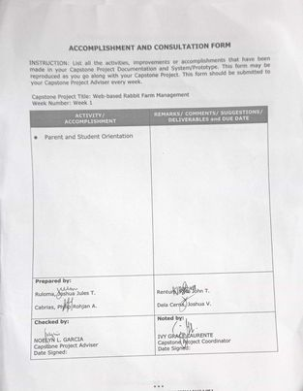

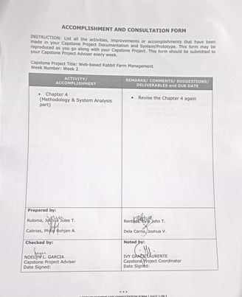

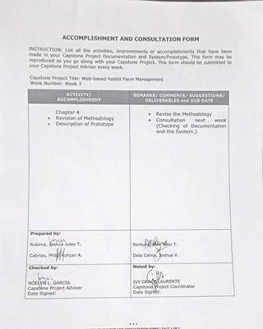

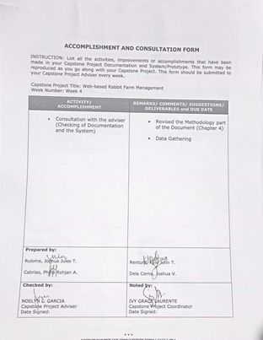

**Appendix I: Photo Documentation**

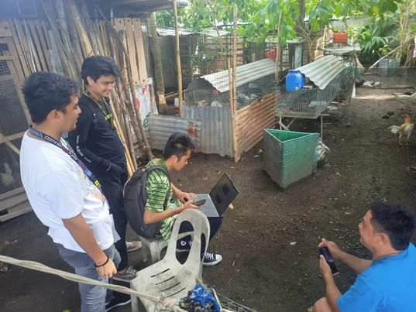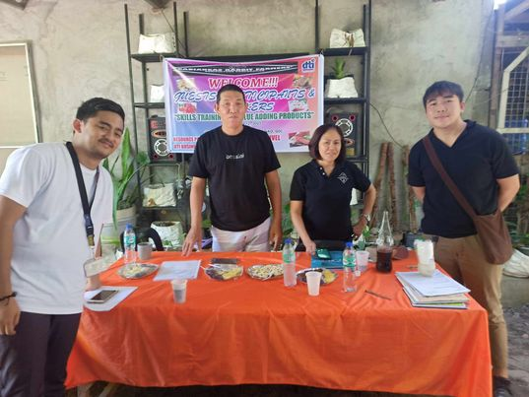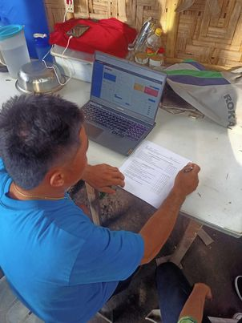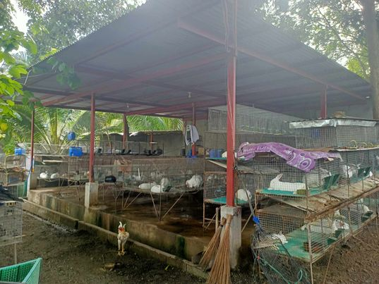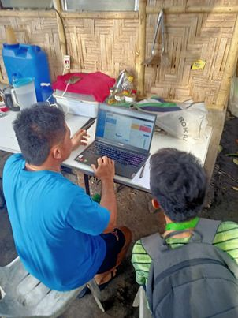

**Appendix J: Personal Technical Vitae**

PERSONAL TECHNICAL VITAE

**Curriculum of Vitae**

**JOSHUA JULES RULOMA**

**Ligtas Subdivision, Polomolok, South Cotabato**[**jruloma071826@gmail.com**](mailto:ralphbinas101699@gmail.com)

**09192854738**

**EDUCATIONAL BACKGROUND**

**Level       Inclusive Dates Name of the school/institution**

**Tertiary Present STI College of General Santos City**

**Vocational/Technical     - -**

**High School April 2019 San Lorenzo Ruiz Academy Polomolok**

**Elementary March 2013 Dole Cannery Elementary School**

**PROFESSIONAL OR VOLUNTEER EXPERIENCE**

**Inclusive Dates Nature of Experience/ Name and Address of Company or Job Title Organization**

**AFFILIATIONS**

**Inclusive Dates Name of Organization Position**

**SKILLS**

**Skills Level of Competency Date Acquired**

**TRAININGS, SEMINARS, OR WORKSHOP ATTENDED**

**Inclusive Dates Title of Training, Seminar or Workshop**



**Curriculum of Vitae**

**JOSHUA DELA CERNA**

**Block 4b, Purok SanMiguel, Barangay Calumpang, General Santos City** [**delacerna562@gmail.com**](mailto:ralphbinas101699@gmail.com)

**09774567630/09945817517**

**EDUCATIONAL BACKGROUND**

**Level       Inclusive Dates Name of the school/institution**

**Tertiary Present STI College of General Santos City**

**Vocational/Technical     - -**

**High School April 2019 General Santos City National High School**

**Elementary March 2013 H.N Cahilsot Central Elementary School**

**PROFESSIONAL OR VOLUNTEER EXPERIENCE**

**Inclusive Dates Nature of Experience/ Name and Address of Company or Job Title Organization**

**January-April IT Support Rell & Renn Fishing Corporation, 2020 Purok Banisil, Tambler, GSC**

**October- November Maxim Rider Maxim – Rides & Foods Delivery, 2nd 2022 Floor, Shell Compound, Mabuhay Rd, GSC**

**AFFILIATIONS**

**Inclusive Dates Name of Organization Position**

**March Community Christian Fellowship Youth Staff**

**2017**

**SKILLS**

**Skills Level of Competency Date Acquired**

**National Certification II- COC 1, COC 2, COC 3, & COC 4 November**

**CSS 2018**

**TRAININGS, SEMINARS, OR WORKSHOP ATTENDED**

**Inclusive Dates Title of Training, Seminar or Workshop**

**May 2018 CCF (Community Christian Fellowship) Training Session for Playing Instruments (Drums)**



**Curriculum of Vitae**

**PHILIP ROHJAN A. CABRIAS**

Agan Ligaya Subdivision Block 11 Lot 8, General Santos

[Philiprohjan_cabrias@yahoo.com](mailto:Philiprohjan_cabrias@yahoo.com)

09383249425/0916733035

**EDUCATIONAL BACKGROUND**

**Level       Inclusive Dates Name of the school/institution**

**Tertial Present STI College of General Santos City**

**Vocational/Technical     - -**

**High School April 2019 Isulan National Highschool**

**Elementary March 2013 Emma learning Center**

**PROFESSIONAL OR VOLUNTEER EXPERIENCE**

**Inclusive Dates Nature of Experience/Job Title Name and Address of Company or Organization**

**AFFILIATOINS**

**Inclusive Dates Name of Organization Position**

**SKILLS**

**Skills Level of Competency Date Acquired**

**TRAININGS, SEMINARS, OR WORKSHOP ATTENDED**

**Inclusive Dates Title of Training, Seminar or Workshop**

**September 2018 English Workshop**



**Curriculum of Vitae**

**KYLE JHON T. RENTURA**

**Sanchez Subd. Poblacion, Polomolok, South Cotabato**

[**janrentura24@gmail.com**](mailto:ralphbinas101699@gmail.com)

**09512653225**

**EDUCATIONAL BACKGROUND**

**Level       Inclusive Dates Name of the school/institution**

**Tertiary Present STI College of General Santos City**

**Vocational/Technical     - -**

**High School April 2019 Poblacion Polomolok National High School**

**Elementary March 2013 Polomolok Central Elementary School**

**PROFESSIONAL OR VOLUNTEER EXPERIENCE**

**Inclusive Dates Nature of Experience/ Name and Address of Company or Job Title Organization**

**April – May SPES Municipality of Polomolok**

**AFFILIATIONS**

**Inclusive Dates Name of Organization Position**

**February 2017 Christian Youth Ministry Youth Staff**

**SKILLS**

**Skills Level of Competency Date Acquired**

**National Certification II- COC 1, COC 2, COC 3, & COC 4 November**

**CSS 2018**

**TRAININGS, SEMINARS, OR WORKSHOP ATTENDED**

**Inclusive Dates Title of Training, Seminar or Workshop**