Project Title: Résumé Screening App
Group Members:
Student HCT ID Contribution Summary (1 line)
Name
Hessa  Khalfan |  | Set up the Add New Candidate form and workflow logic, managed applicant data and records, configured the Score  Breakdown panel, and tested the AI Assistant and all screens.
Nourah  Abdulla |  | Customized the application's visual theme and layout using  Lovable, configured the Dashboard screen, set up the Smart Filters panel, and used AI tools to generate the process diagram.
Maryam Ali  Abdulla |  | Configured the AI scoring logic, set up the notification system and email automation, designed the Scoring Criteria screen, and conducted overall system testing.

Instructor: Dr. Amala Rajan
Campus: Sharjah

Contents
1. INTRODUCTION 5
2. DELIVERABLE 1 — BUSINESS PROCESS DEFINITION (15 marks) 5
2.1. Scenario Overview 5
2.2. Purpose of the System 5
2.3. Intended Users 6
2.4. Workflow or Logic Requirements 6
2.5. Process Diagram 7
3. DELIVERABLE 2 — APP DESIGN & BUILD (25 marks) 8
3.1. Platform Used 8
3.2. Data Source (if applicable) 8
3.3. USER INTERFACE DESIGN 8
3.4. Screen List & Description 9
3.5. Screenshots (MANDATORY) 10
DELIVERABLE 3 — FUNCTIONAL FEATURES & LOGIC IMPLEMENTATION (25 marks) 13
4.1Logic Features Implemented 13
4.2 Explanation: How Do These Features Improve User Experience? 14
4.3. Explanation: How Do These Features Improve User Experience? 14
5. DELIVERABLE 4 — WORKFLOW AUTOMATION & AI INTEGRATION (10 marks) 15
5.1Type of Automation Used 15
5.2. Purpose of the Automation 15
5.3. Step-by-Step Workflow Description 15
5.4. Automation Screenshots 16
6. Group Member Contributions 18
1. REPORT QUALITY (Group – Embedded in 50 Marks) 23
Project Deliverables 25
Rubric 26
Analytical Rubric: Group Project (50 marks) 26
Analytical Rubric: Individual Component (50 marks) 27

Table of Figures
Figure 1 - End-to-End Workflow of the AI-Powered Résumé Screening Process- simple ............................................7
Figure 2 End-to-End Workflow of the AI Powered Resume Scanner- detailed .............................................................7
Figure 3: Home Screen .....................................................................................................................................................10
Figure 4: Form screen .......................................................................................................................................................10
Figure 5: Navigation buttons ...........................................................................................................................................11
Figure 6: Review/Output screen......................................................................................................................................11 Figure 7: Data table ..........................................................................................................................................................11
Figure 8: Additional Screen (AI Assistant).......................................................................................................................12
Figure 9: Additional Screen (Recruiter Actions and Notification).................................................................................12
Figure 10: The Score Breakdown panel on the Candidate Detail screen, showing the automated point-by-point
calculation that produces the final AI score ...................................................................................................................16
Figure 11: The Recruiter Actions section, showing the "Shortlist for Interview", "Mark Accepted", and "Reject"
buttons, along with the automated email notification triggers. ..................................................................................17 Figure 12: The AI Assistant interface 1, demonstrating the conversational AI integration for on-demand HR
support and candidate analysis.].....................................................................................................................................17
Figure 13: The AI Assistant interface 2, demonstrating the conversational AI integration for on-demand HR
support and candidate analysis.].....................................................................................................................................17 Figure 14: Evidence of collaboration (MS Teams) .........................................................................................................19
Figure 15: : Evidence of collaboration (Google Meet) ...................................................................................................19

1. INTRODUCTION
The project is called BankScreen. It is an AI-assisted web application designed specifically for the banking sector, built using the Lovable no-code platform. The core idea behind BankScreen came from a real and pressing challenge that banks face every hiring cycle: the sheer volume of résumés that HR teams must process for highly specialized roles. Positions such as Compliance Officer, AML Analyst, and Risk Analyst require candidates with very specific certifications, clearance levels, and regulatory knowledge. Manually reviewing hundreds of applications for these criteria is both time-consuming and error-prone, making it an ideal candidate for AIassisted automation.
BankScreen addresses this problem by providing a centralized platform where HR managers can import candidate data, have it automatically scored against a transparent, rule-based algorithm, and view the results on an interactive dashboard. The application also features a conversational AI Assistant that can answer HR-related questions and provide candidate-specific analysis on demand. The purpose of this project is to demonstrate how AI-powered no-code tools can be leveraged to build functional, real-world business applications without requiring deep programming expertise. This directly aligns with CLO4 of the CIS 2603 course, which focuses on building generative AI-powered applications using no-code platforms.

2. DELIVERABLE 1 — BUSINESS PROCESS DEFINITION (15 marks)

2.1. SCENARIO OVERVIEW
The banking sector has a unique challenge regarding recruitment because of its high level of regulation. Each position within the bank, whether it is that of a Branch Manager or IT Security Specialist, comes with certain regulatory requirements. It is not uncommon for the HR department in banks to receive several hundred résumés for a single vacant position, where each résumé will have to be reviewed based on a number of factors such as education, work experience, certifications (ACAMS, CFA, CAMS), AML/KYC, and security clearance.
The fundamental issue with the current method is the fact that it is both tedious and risky. There is always a possibility that some of the key qualifications might be overlooked, while inconsistency in applying the same standards across applicants is another risk. The intended users of BankScreen are, first of all, bank HR recruiters and hiring managers, and then secondarily bank department heads and administrators. The key benefits of this system are the time-saving aspect, the standardization of the process, and highlighting the best candidates right away.

2.2. PURPOSE OF THE SYSTEM
There are four main objectives behind BankScreen design. First of all, efficiency is provided through the fact that the program can process and score more than 120 CVs within a matter of seconds, whereas an HR department will need hours to perform the same task manually. Second, there is the goal of automation since the system generates an automatic scoring algorithm for each job candidate taking into account the experience, education, certificates, and other variables. Third, there is a concept of AI-Assistance which is embedded into BankScreen's functionality, and the system features conversational AI that answers HR questions, offers interview approaches and evaluates certain candidates upon request. Finally, there is a purpose of decision-making optimization that provides a list of ranked candidates on one single dashboard.

2.3. INTENDED USERS
The system is designed to serve three distinct types of users, each with a different set of responsibilities within the hiring process.
User Type | Role | Tasks in the System
Primary User | HR Recruiter | Upload or enter candidate data, apply smart filters to narrow down the pool, review individual score breakdowns, and shortlist candidates for interviews.
Secondary User | Bank Manager | Review the top-ranked candidates on the dashboard, examine their detailed AI score breakdowns, and make final hiring decisions.
Admin / Reviewer | System Admin | Manage the scoring rules and criteria, monitor overall dashboard statistics, and ensure the system is functioning correctly.

2.4. WORKFLOW OR LOGIC REQUIREMENTS
The end-to-end workflow of BankScreen follows a logical, five-step process that transforms raw candidate data into actionable hiring intelligence.
1.Input: The HR recruiter enters candidate data into the system such as the person's name, applied job title, number of years of experience, level of education, banking certificates, AML/KYC understanding, security clearance, availability, GPA, and language fluency.
2.Logic: The system rule engine then processes each input based on the defined criteria. In other words, it determines whether the candidate has got a PhD, is a holder of CFA certificate, or has any experience in banking.
3.Scoring: Each criterion is worth a certain number of points, which get summed up and produce an overall score out of 100. For instance, a PhD earns 14 points, CAMS certification – 22 points, and each year of experience brings 2 points (up to 25 points maximum).
4.Banding: Automatically, the system assigns the candidate to one of the four banding ranges (Strong – 80100 points; Qualified – 60-79; Borderline – 40-59 points; Low fit – 0-39 points).
5.Output: The system updates the main dashboard in real-time, displaying the new candidate's scores and ranking among top 5 candidates.

2.5. PROCESS DIAGRAM
The following diagram illustrates the end-to-end workflow of the AI-powered résumé screening process, from initial data input through to the final output on the dashboard.

INPUT  (Candidate Data) | → | EXPERIENCE Scoring | → | EDUCATION  &  Certification | → | COMPLIANCE  Factors | → | OUTPUT  (Score + Band)

Figure 1 - End-to-End Workflow of the AI-Powered Résumé Screening Process- simple
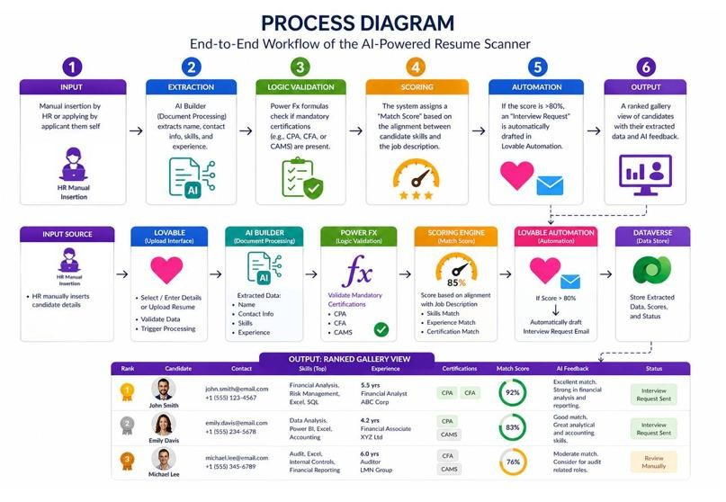
Figure 2 End-to-End Workflow of the AI Powered Resume Scanner- detailed
In this workflow, the recruiter starts by checking his dashboard that has all candidates’ details and resume links . An AI tool then automatically reads each resume and pulls out important information like name, skills, experience, and contact details. Next, the system checks whether the candidate has any required certifications, such as a CPA or CFA. Based on how well the candidate’s skills match the job description, a match score is calculated. If the score is above 80%, the app automatically drafts an interview request. Finally, the recruiter sees a ranked list of all candidates, including their scores, key information, AI feedback, and status such as whether an interview request was sent or if the candidate needs a manual review.

3. DELIVERABLE 2 — APP DESIGN & BUILD (25 marks)

3.1. PLATFORM USED
We selected Lovable as our development platform because it offers an exceptional balance between speed, capability, and professional output. Lovable is a modern AI-assisted no-code platform that interprets natural language descriptions and generates fully functional web application code. This allowed our team to focus on the design and logic of the application rather than on low-level implementation details. Lovable enabled us to construct a professional, banking-standard interface complete with a dynamic dashboard, interactive data visualizations, and a smart conversational assistant — all features that would typically require a team of experienced developers to build from scratch. The platform proved to be an excellent choice for building a modern web application that looks and functions like enterprise-grade software.

3.2. DATA SOURCE (IF APPLICABLE)
Dataset Name: Bank_ResumeScreening_Data_120
- Field 1: Name, Position, Years of Experience, Education Level
- Field 2: Banking Certification, AML/KYC Knowledge, Previous Banking Experience, Security Clearance
- Field 3: GPA, Languages, Skills, AI Score
- Additional fields: Availability, Status, Reviewer Notes
Lovable, which is backed by Supabase, was used to store the data directly in its own database. As such, all the personal information of each candidate is stored safely in the database. With the data layer already incorporated in the software, any changes made to the candidates on the platform will be reflected on the dashboard in real time when the user makes changes to their statuses. There are currently 120 sample candidates on 10 different banking jobs in the database.

3.3. USER INTERFACE DESIGN
The user interface design of BankScreen is clean, intuitive, and highly professional. We selected a primary color palette of Navy Blue and White, as these colors are universally associated with trust, reliability, and financial institutions. The layout is structured to maximize usability and minimize the cognitive load on the user. The navigation bar at the top of every screen provides clear, one-click access to all four main sections of the application: Dashboard, Applicants, AI Assistant, and Scoring Criteria. Each screen is designed with a specific user task in mind, ensuring a logical and efficient workflow from start to finish.

3.4. SCREEN LIST & DESCRIPTION
BankScreen consists of five distinct screens, each serving a specific purpose within the overall application workflow.
Screen Name | Purpose | Key Controls
Dashboard | Serves as the application's home screen, providing a macro-level overview of the entire hiring pipeline. | Summary metric cards (Total  Applicants, Avg AI Score,  Shortlisted, Under Review), Top 5 Candidates list, bar chart of Avg Score by Role, "Review Applicants" and "View Scoring Criteria" CTA buttons.
Applicants | Displays the complete list of all candidates and provides advanced filtering and sorting capabilities. | Smart Filters panel (text search, Position dropdown,  Status dropdown, Security Clearance dropdown, experience slider, sort order), "Add Candidate" button, colorcoded candidate cards with score badges.
Candidate Detail | Shows the full profile of an individual candidate, including their complete score breakdown. | Experience & Qualifications section, Skills tags, Compliance  & Availability section, editable  Reviewer Notes, Score  Breakdown panel, Recruiter  Action buttons (Shortlist, Accept, Reject), email notification buttons.
AI Assistant | Provides a conversational AI interface for HR-related queries and candidate-specific analysis. | Candidate selection dropdown, chat interface, suggested question buttons, text input field with Send button.
Scoring Criteria | Displays the full, transparent set of rules used by the AI to calculate candidate scores. | Information cards for each scoring dimension (Experience, Education, Certification, etc.), Score Bands legend.

These five screens work together seamlessly to form a complete, end-to-end recruitment application. The Dashboard serves as the entry point, giving the user an immediate macro-level view of the hiring pipeline. From there, users navigate to the Applicants screen for granular filtering and individual candidate review. The Candidate Detail screen provides a deep dive into any specific applicant, with a transparent score breakdown that justifies the AI's assessment. The Scoring Criteria screen provides full transparency into the algorithm, building trust with users, while the AI Assistant offers on-demand intelligent support throughout the entire process.

3.5. SCREENSHOTS (MANDATORY)
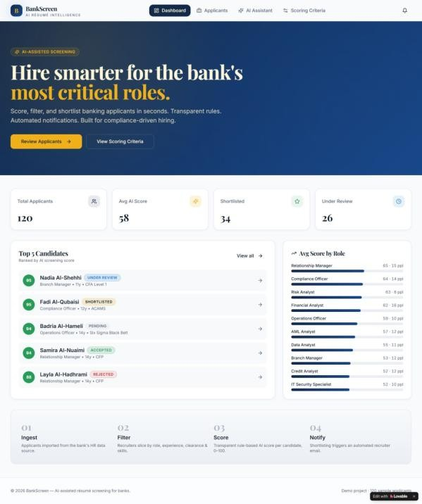
Figure 3: Home Screen
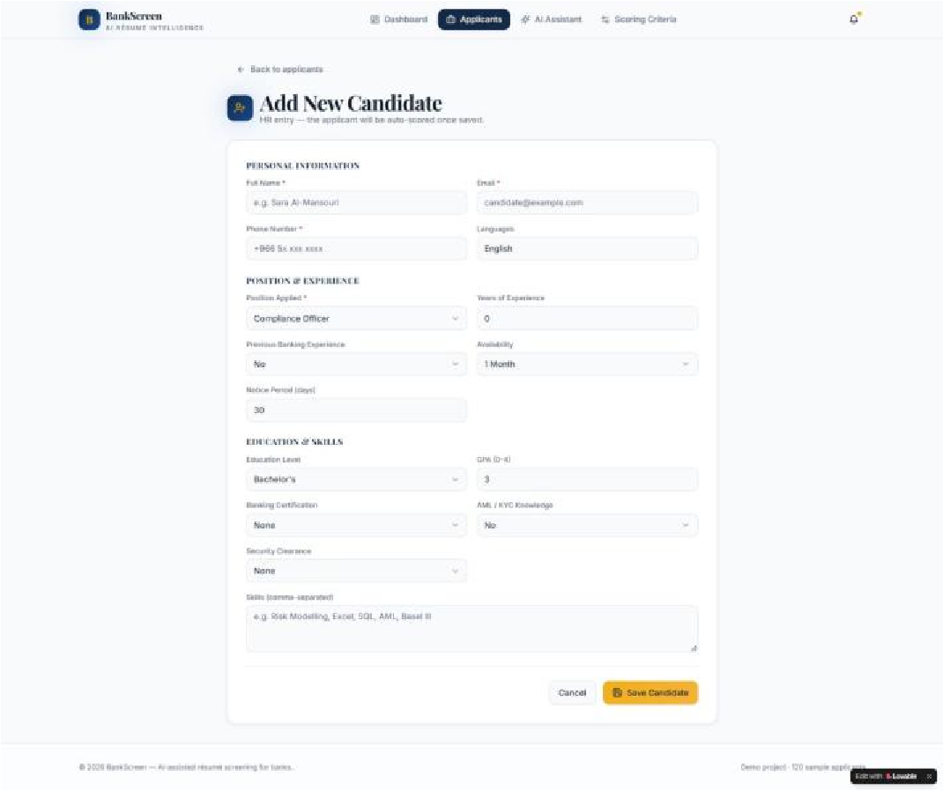
Figure 4: Form screen

Figure 5: Navigation buttons
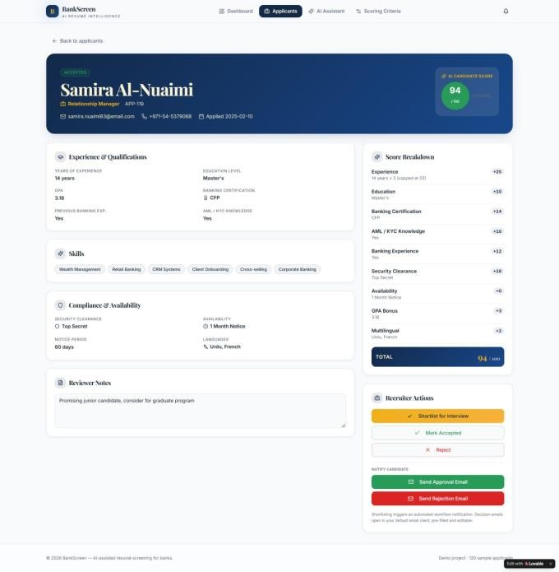
Figure 6: Review/Output screen
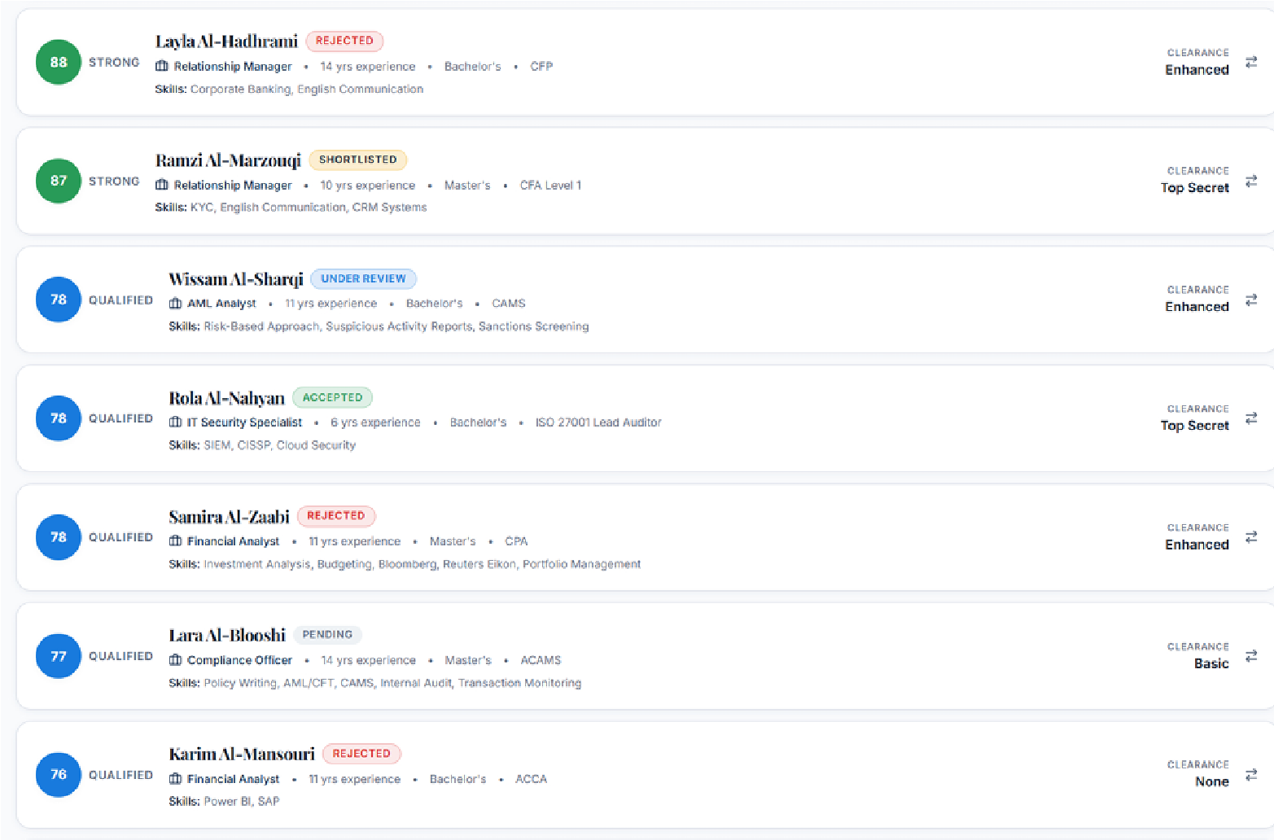
Figure 7: Data table
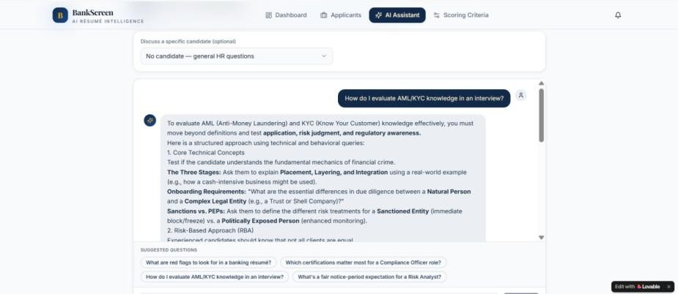
Figure 8: Additional Screen (AI Assistant)
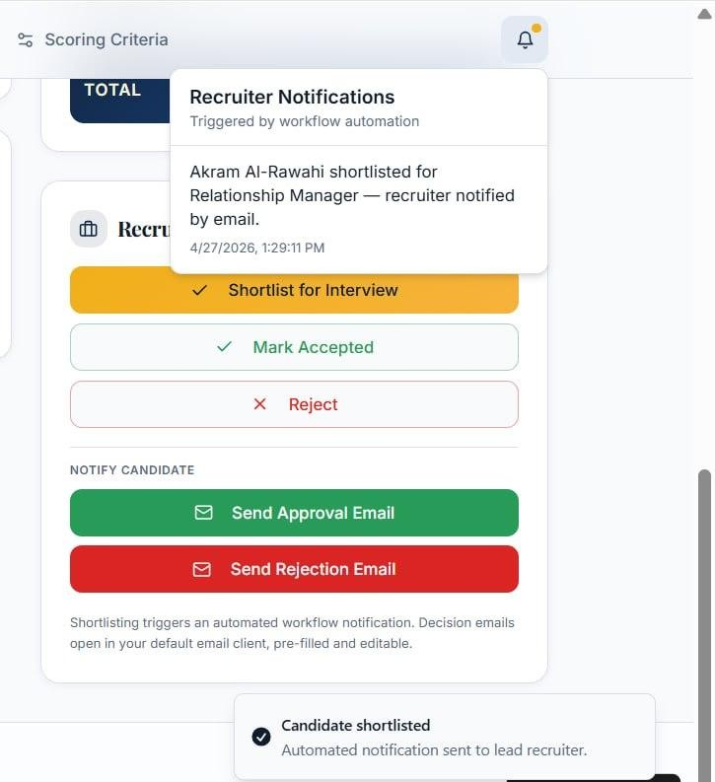
Figure 9: Additional Screen (Recruiter Actions and Notification)
The screenshots collectively illustrate the complete application workflow, from the high level dashboard overview to the detailed individual candidate analysis. The Smart Filters on the Applicants screen demonstrate the system's powerful search and filtering capabilities, while the Score Breakdown panel on the Candidate Detail screen showcases the transparency of the AI scoring logic. The AI Assistant and Scoring Criteria screens further highlight the advanced features of the application, demonstrating its suitability as a professional HR tool.

DELIVERABLE 3 — FUNCTIONAL FEATURES & LOGIC IMPLEMENTATION (25 marks)

4.1LOGIC FEATURES IMPLEMENTED
- Search and filtering functions: The Applicants screen has a Smart Filters panel where the recruiter can search by name, skill, or language using a search bar. There are also dropdown filters for Position, Status, and Security Clearance, plus a slider to set the minimum years of experience. All filters work together at the same time and the list updates instantly.
- Dropdown-based logic: The Add New Candidate form uses dropdowns for fields like Education Level, Banking Certification, AML/KYC Knowledge, and Security Clearance. Each option the user selects directly affects the candidate's final score. For example, if the recruiter selects "PhD", the system automatically adds +14 points to the score.
- Required field validations: Some fields in the Add New Candidate form are required, like Full Name, Email, Phone Number, and Position Applied. These are marked with a red asterisk (*). The form will not submit if any of these fields are left empty, which helps keep the data clean and complete.
- Conditional visibility: On the Candidate Detail page, the Score Breakdown panel only shows the scoring categories that apply to that specific candidate. Also, the notification bell icon only lights up when a workflow action has been triggered, like when a candidate gets shortlisted.
- Dynamic output generation: After a new candidate is saved, the app automatically calculates their AI score out of 100 and shows a full breakdown of how the score was calculated. It also automatically assigns them a band label like "Strong" or "Qualified" based on their score, without the recruiter doing anything manually.
- AI-generated feedback: The AI Assistant screen lets the recruiter ask HR-related questions and get smart answers instantly. They can also select a specific candidate from a dropdown and ask the AI to analyze their profile. The AI gives detailed and helpful responses like interview questions or advice about certifications.
- Data-dependent navigation: When the recruiter clicks "Shortlist for Interview" on a candidate's page, the app automatically updates the candidate's status, sends a notification to the recruiter, and opens a pre-filled approval email ready to send. If the recruiter clicks "Reject", a pre-filled rejection email opens instead. All the candidate's details like name, email, and position are already filled in automatically.
These logic features were added to make the hiring process faster and more accurate. The filters and dropdowns help recruiters find the right candidates quickly without going through all applicants manually. The validation rules make sure no important information is missing. The automatic scoring and banding saves a lot of time because the recruiter does not need to calculate anything. The AI Assistant gives extra support when the recruiter needs advice or interview questions. Overall, all these features work together to make BankScreen a practical and efficient tool for bank HR teams.

4.2 Explanation: How Do These Features Improve User Experience?
The following logic rules are implemented in the AI scoring engine:
Formula 1 (Education Points):
If Education = "PhD" then +14 points; If "Master's" then +10 points; If "Bachelor's" then +6 points.
Explanation:
This rule ensures that higher educational attainment is consistently and automatically rewarded, removing subjective bias from the initial screening.

Formula 2 (Experience Scoring):
Score = Years of Experience × 2 (Maximum 25 points) Explanation:
This rule proportionately rewards candidates with more industry experience up to a logical cap, ensuring experience is valued but does not overshadow critical certifications.

Formula 3 (AML/KYC Knowledge):
If AML/KYC = "Yes" then +10 points; If "No" then 0 points Explanation:
For a banking environment, AML and KYC knowledge is a critical compliance requirement. This binary rule ensures that candidates without this knowledge are scored lower, regardless of other qualifications.

4.3. Explanation: How Do These Features Improve User Experience?
The logic features improve user experience by automating routine steps such as filtering, validation, and score calculation. Users spend less time searching for data and receive immediate feedback through dynamic score breakdowns and AI suggestions. These logical enhancements make the system more reliable, user-friendly, and efficient, allowing HR recruiters to focus on interviewing the best candidates rather than manually reading hundreds of résumés.

5. DELIVERABLE 4 — WORKFLOW AUTOMATION & AI INTEGRATION (10 marks)

5.1Type of Automation Used
[X] Email notification (automated approval/rejection emails)
[X] AI-generated suggestions and responses (HR Assistant chatbot)
[X] Conditional workflow actions (shortlisting triggers automated notification)
[X] Automatic score calculation (triggered on candidate data entry)

5.2. Purpose of the Automation
The automation features in BankScreen serve a dual purpose: to accelerate the HR workflow and to ensure consistency in candidate communication. The most significant automation is the score calculation engine, which runs automatically whenever a candidate's data is entered or updated. This eliminates the need for HR staff to manually calculate scores using spreadsheets, a process that is both time-consuming and error-prone.
The second major automation is the email notification workflow. When a recruiter clicks "Shortlist for Interview" on a candidate's detail page, the system triggers an automated workflow notification and simultaneously prepares a pre-filled, editable approval email. Similarly, clicking "Reject" prepares a pre-filled rejection email. This ensures that all candidates receive timely and professional communication, regardless of the recruiter's workload.
Finally, the AI Assistant provides an intelligent, on-demand automation layer. Instead of HR staff spending time researching interview questions or certification requirements, they can simply ask the AI Assistant. The assistant can provide advice on topics such as identifying red flags in a banking résumé, evaluating AML/KYC knowledge in an interview, or understanding the most important certifications for a specific role. It can also be directed to analyze a specific candidate's profile, providing a more nuanced assessment than the rule-based score alone.

5.3. Step-by-Step Workflow Description
The following steps describe the complete automated workflow within BankScreen, from initial data entry to final candidate notification.
Step 1 Add: A new candidate's information is entered into the system via the "Add Candidate" form on the Applicants screen. The form captures all relevant data fields, including position, experience, education, and certifications.
Step 2 Analyze: The system's rule-based engine immediately parses the submitted data, evaluating each field against the predefined scoring criteria stored in the Scoring Criteria screen.
Step 3 score: The engine calculates the total score by summing the points for all applicable criteria. For example, a candidate with 11 years of experience, a PhD, a CFA Level 1 certification, AML/KYC knowledge, prior banking experience, Basic security clearance, immediate availability, a GPA of 3.79, and three languages would receive a score of 95/100.
Step 4 Categorize: The candidate is automatically assigned to a score band. A score of 95 places the candidate in the "Strong" band (80–100).
Step 5 Dashboard: The main dashboard updates in real time to reflect the new candidate, adjusting the "Total Applicants" count, the "Average AI Score", and the "Top 5 Candidates" list if the new candidate's score is high enough.
Step 6 Action: The recruiter reviews the candidate's detail page and clicks "Shortlist for Interview". This action triggers an automated workflow notification and changes the candidate's status to "Shortlisted". The system simultaneously prepares a pre-filled approval email for the recruiter to review and send.
Step 7 Assist: The recruiter navigates to the AI Assistant, selects the candidate from the dropdown, and asks for tailored interview questions. The AI generates relevant, role-specific questions based on the candidate's profile and the requirements of the position.

5.4. Automation Screenshots
The following screenshots document the key automation features of BankScreen.
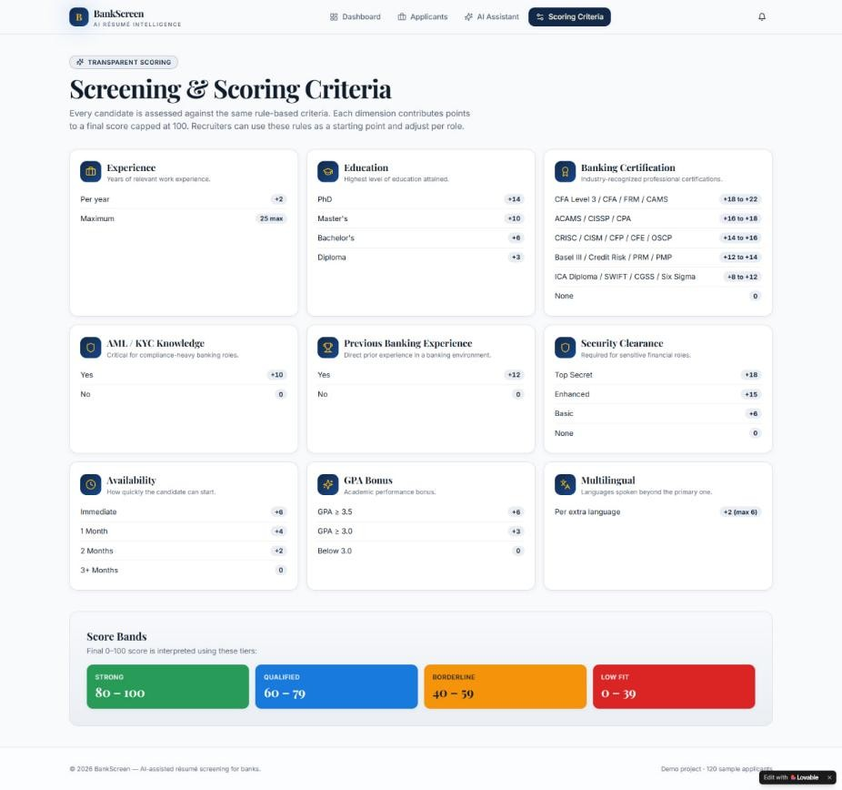
Figure 10: The Score Breakdown panel on the Candidate Detail screen, showing the automated point-by-point calculation that produces the final AI score

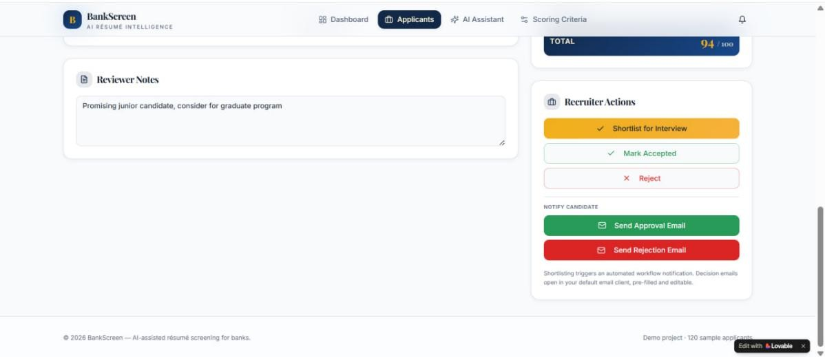
Figure 11: The Recruiter Actions section, showing the "Shortlist for Interview", "Mark Accepted", and "Reject" buttons, along with the automated email notification triggers.
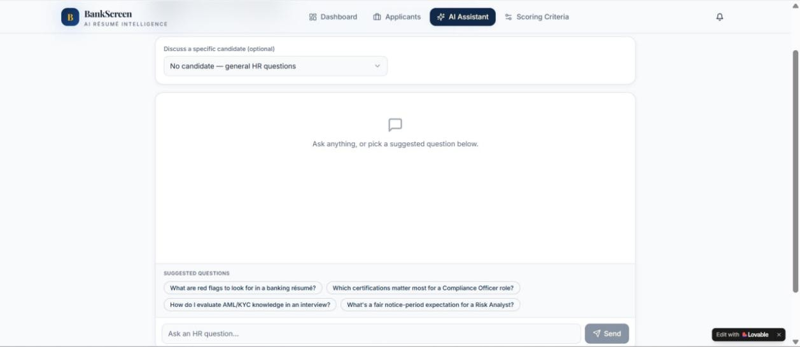
Figure 12: The AI Assistant interface 1, demonstrating the conversational AI integration for on-demand HR support and
candidate analysis.]
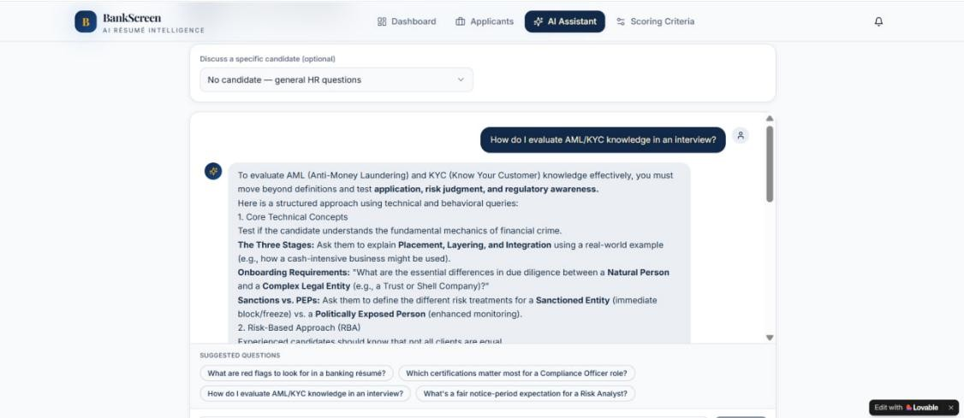
Figure 13: The AI Assistant interface 2, demonstrating the conversational AI integration for on-demand HR support and candidate analysis.]

6. Group Member Contributions
The following table summarizes the individual contributions of each group member to the BankScreen project.
Student Name | HCT ID | Detailed Contribution
Hessa Khalfan |  | - Configured the Shortlist, Accept, and Reject workflow logic on the Candidate Detail page.  - Set up the Add New Candidate form for HR data entry using Lovable. Organized and managed the applicant data, statuses, and records within the system.  - Configured the Score Breakdown panel to display point values per scoring dimension.  - Tested the AI Assistant responses and conducted user acceptance testing across all screens.
Nourah  Abdulla |  | -Customized the overall visual theme, color scheme, and layout of the application using Lovable's built-in options.  - Configured the Dashboard screen to serve as the main entry point of the application.  - Used AI tools to generate the end-to-end process diagram illustrating the application workflow.  - Set up and configured the Smart Filters panel on the Applicants screen.  Configured the navigation bar and page routing between all screens.
Maryam Ali |  | - Configured the AI scoring rules and point values for all nine scoring criteria using Lovable.  - Set up the automated notification system triggered when a candidate is shortlisted.  - Configured the AI Assistant screen and its suggested HR questions. Set up the pre-filled Approval and Rejection email templates.  - Designed the Scoring Criteria screen layout and conducted overall system testing.

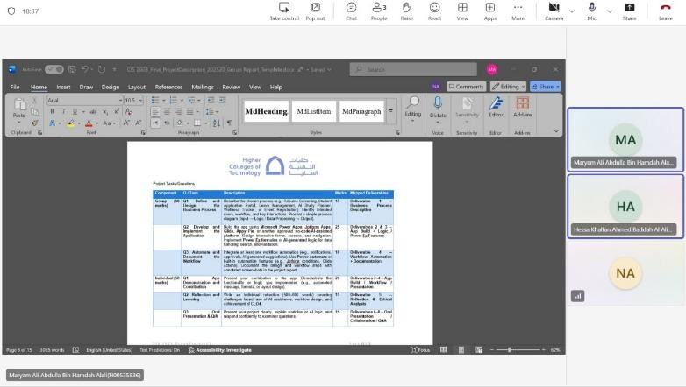
Figure 14: Evidence of collaboration (MS Teams)
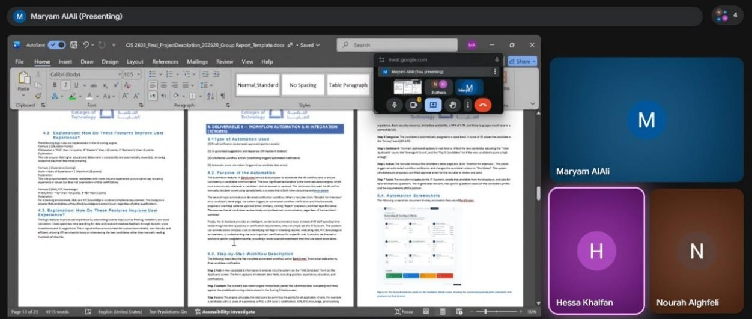
Figure 15: : Evidence of collaboration (Google Meet)

7. Group Member Written Reflections
Reflection 1 – Nourah Abdulla
Individual Reflection – BankScreen Project
Working on the BankScreen project was my first real experience building a functional, AI-powered web application without writing traditional code. My primary responsibilities were customizing the visual theme and layout using Lovable, configuring the Dashboard screen, setting up the Smart Filters panel, and using AI tools to generate the process diagram. This taught me how nocode platforms can produce professional, enterprise-ready results when combined with thoughtful design.
One of the main challenges I faced was balancing visual appeal with functional clarity. Banking users expect a clean, trustworthy interface, so I chose a navy blue and white colour scheme. However, making sure that buttons, cards, and filters remained readable and accessible across different screen sizes required multiple iterations. I had to test the application on different monitor sizes and adjust padding, font sizes, and spacing repeatedly. Another challenge was designing the Smart Filters panel to work smoothly with multiple dropdowns, a search bar, and an experience slider all updating the candidate list in real time. Initially, the filters would conflict or reset incorrectly. For example, selecting a position from the dropdown would sometimes clear the security clearance filter. After carefully testing each combination and adjusting Lovable’s conditional visibility and event settings, I resolved these issues.
A third challenge was configuring the Dashboard to display accurate summary statistics. The metric cards for Total Applicants, Average AI Score, Shortlisted, and Under Review had to pull live data from the database and update instantly when candidates were added or modified. I learned how to bind these cards to database queries and set appropriate refresh triggers.
I used Lovable’s AI-assisted design tools extensively. For example, I described the desired layout for the Dashboard in natural language “a dashboard with four metric cards at the top, a bar chart in the middle, and a top five candidates list on the right” and Lovable generated the base structure automatically. I then manually refined spacing, colours, and typography to match banking standards. I also used an external AI image generator to help create the end-to-end process diagrams (Figures 1 and 2 in the report), prompting it to produce a clean flowchart, which I then annotated to match our exact workflow from data input to final output.
Regarding workflow design, I ensured that the Dashboard served as the central entry point, providing immediate macro-level insights before users drilled down into the Applicants screen. The Smart Filters panel was designed to reduce cognitive load recruiters can filter by position, status, security clearance, and years of experience simultaneously, and the results update instantly without page reloads. I also configured the navigation bar to provide one-click access to all four main sections: Dashboard, Applicants, AI Assistant, and Scoring Criteria.
From this project, I learned that no-code platforms are not just toys for prototyping; they are serious tools for building real business applications. I also learned the importance of user-centered design every colour, button, and filter must serve a clear purpose. Team collaboration was essential; we used Microsoft Teams and Google Meet weekly to align our work, resolve conflicts, and test integration. I learned to communicate design decisions clearly to Hessa and Maryam so that their logic and automation features would fit seamlessly into the interface I built.
Achievement of CLO4:
CLO4 requires building generative AI-powered applications using no code platforms. I achieved this by using Lovable’s AI generation to create screens, applying AI tools to produce professional diagrams, and integrating those outputs into a fully functional recruitment app. I moved from concept to deployment without traditional coding, exactly as CLO4 demands.

Reflection 2 – Hessa Khalfan
Individual Reflection – BankScreen Project
As a group member on BankScreen, I focused on the core functional logic that makes the application actually work for HR recruiters. My responsibilities included setting up the Add New Candidate form, managing applicant data and records, configuring the Score Breakdown panel, and testing the AI Assistant across all screens. This project showed me how AI-assisted no-code development can replace hundreds of lines of manual code with smart, visual configuration.
The biggest challenge I faced was ensuring that the Add New Candidate form correctly captured all required fields while enforcing validation rules. Some fields like Full Name, Email, and Position Applied were mandatory, and the form had to reject incomplete submissions with clear error messages. Configuring this in Lovable required careful use of conditional logic and field properties. Another challenge was linking the form data to the scoring engine so that each candidate’s score would calculate automatically upon submission. Initially, scores would not update correctly or would show as zero until I reconfigured the data binding between the form and the database. I spent several hours testing different field mappings before finding the correct configuration.
A second major challenge was managing applicant records and statuses consistently across the entire application. When a recruiter shortlisted a candidate on the detail page, that status had to update instantly on the Dashboard and in the main applicants table. I discovered that Lovable required specific trigger conditions to refresh data across different screens. After experimenting with different refresh settings and consulting Lovable’s documentation, I implemented a solution where any status change would force a re-fetch of the data from the database, ensuring real-time consistency.
I used Lovable’s built-in AI assistance to generate the initial structure of the Add New Candidate form, including dropdowns for Education Level, Banking Certification, AML/KYC Knowledge, and Security Clearance. I then manually added validation rules and tested each field with both valid and invalid inputs. For the Score Breakdown panel, I configured it to display points per dimension (e.g., +14 for PhD, +22 for CAMS, +2 per year of experience) dynamically based on the candidate’s submitted data. I also extensively tested the AI Assistant by asking it various HR questions such as “What are the key certifications for a compliance officer?” and verifying that responses were relevant and accurate for the banking sector.
Regarding workflow design, I ensured that the Score Breakdown panel was fully transparent recruiters can see exactly why a candidate received a specific score, which builds trust in the AI. I also organized the applicant data management so that statuses like “Shortlisted,” “Rejected,” and “Accepted” would persist correctly in the database and reflect on the Dashboard in real time.
The workflow from form submission → scoring → breakdown display → recruiter action is now seamless and intuitive.
From this project, I learned that building logic in no-code platforms requires systematic testing. A small misconfiguration in a dropdown’s value can break the entire scoring engine. I also learned the value of transparency in AI systems users will not trust an automated score if they cannot see how it was calculated. Team collaboration was strong: Nourah designed the interface, Maryam set up scoring rules and emails, and I handled data forms, records, and testing. We used Google Meet to demonstrate features to each other weekly and resolved conflicts by referring back to real banking requirements.
Achievement of CLO4:
CLO4 was achieved by building a generative AI-powered application using Lovable, a no-code platform. I directly configured AIassisted forms with validation, dynamic scoring logic linked to a database, and an AI chatbot assistant all without traditional programming. This meets the course outcome of demonstrating no-code AI application development.

Reflection 3 – Maryam Ali Abdulla
Individual Reflection – BankScreen Project
My role in the BankScreen project centered on the intelligence behind the application: configuring the AI scoring logic, setting up the notification system and email automation, designing the Scoring Criteria screen, and conducting overall system testing. This experience directly demonstrated how no code platforms can implement complex, rule based decision-making that would normally require a backend developer.
A significant challenge I faced was designing the scoring algorithm to be both comprehensive and fair. The system had to assign points for nine different criteria: years of experience, education level, banking certifications , AML/KYC knowledge, previous banking experience, security clearance, availability, GPA, and language fluency. Each criterion had different weightings (e.g., up to 25 points for experience, 22 points for CAMS, 14 points for a PhD). Ensuring that Lovable correctly summed these points and applied banding logic (Strong, Qualified, Borderline, Low fit) required meticulous testing across dozens of sample candidates. A small mistake, such as assigning the wrong point value to a dropdown option, would cascade through the entire scoring engine. Debugging without traditional code meant carefully inspecting each conditional rule in Lovable’s visual interface.
Another challenge was setting up email automation so that clicking “Shortlist for Interview” or “Reject” would open prefilled, editable emails. Initially, dynamic fields like the candidate’s name appeared as blank variables. After reviewing Lovable’s variable syntax, I discovered that field names had to exactly match database column names, including case sensitivity. Once corrected, the automation worked flawlessly. I also had to decide what the rejection email should say by balancing professionalism with empathy which introduced an ethical dimension I had not anticipated.
I used Lovable’s AI assisted logic builder extensively. I entered natural language descriptions like “If education equals PhD, add 14 points,” and Lovable generated the underlying conditional logic automatically. This was a powerful demonstration of generative AI in action. I also used Lovable’s automation triggers to configure the notification system: when a recruiter clicks “Shortlist,” the system updates the candidate’s status, displays a notification bell, and prepares an approval email. I designed the Scoring Criteria screen as clean information cards so that any user can see the complete rulebook, making the AI transparent and auditable.
Regarding workflow design, I ensured the scoring engine runs automatically on candidate submission, and that banding is immediate. Email notifications are triggered only by explicit recruiter actions to prevent accidental communications. I also tested the AI Assistant by asking questions like “Generate interview questions for an AML analyst,” and the responses were surprisingly useful.
From this project, I learned that no code tools require strict testing and attention to detail. Transparency in scoring is essential for user trust HR recruiters will not trust a black-box score. I also learned that I enjoy logic and automation more than visual design.
Team collaboration was excellent: Nourah handled visuals, Hessa managed forms, and I focused on logic, automation, and testing.
We used MS Teams and Google Meet weekly.
Achievement of CLO4:
CLO4 was fully achieved by building a generative AI-powered application using Lovable. I configured AI scoring logic across nine criteria, automated email workflows, and an AI Assistant all without writing traditional code. This demonstrates the ability to create functional, transparent, AI powered no-code applications.

1. REPORT QUALITY (Group – Embedded in 50 Marks)
Students do NOT write a separate section here – this is to guide formatting.
The Report Quality component is assessed across all sections above (Deliverables 1–4) and includes:
- Title page and proper headings
- Table of contents
- Introduction included
- Clear app design description with screenshots
- Logic and workflow explained clearly
- Group member roles and contributions indicated
- Writing that is clear, organized, and properly formatted
- Correct grammar, spelling, and academic tone You may use this checklist:
☐ Title page included
☐ Table of contents
☐ All Deliverables 1–4 completed
☐ Screenshots are clear and labelled
☐ At least one process diagram provided
☐ Logic and formulas explained
☐ Group roles described
☐ Professional writing style
☐ No major grammar or spelling errors



Project Tasks/Questions
Component Q / Task |  | Description | Marks | Mapped Deliverables
Group (50  marks) | Q1. Define and  Design the  Business Process | Describe the chosen process (e.g., Résumé Screening, Student Application Portal, Leave Management, AI Study Planner, Wellness Tracker, or Event Registration). Identify intended users, workflow, and key interactions. Present a simple process diagram (Input → Logic / Data Processing → Output). | 15 | Deliverable 1 –  Business Process  Description
 | Q2. Develop and Implement the  Application | Build the app using Microsoft Power Apps, Jotform Apps, Glide, Appy Pie, or another approved no-code/AI-assisted platform. Design interactive forms, screens, and navigation. Implement Power Fx formulas or AI-generated logic for data handling, search, and validation. | 25 | Deliverables 2 & 3 –  App Build + Logic /  Power Fx Features
 | Q3. Automate and Document the  Workflow | Integrate at least one workflow automation (e.g., notifications, approvals, AI-generated suggestions). Use Power Automate or built-in automation features (e.g., Jotform conditions, Glide actions). Document the design and workflow steps with annotated screenshots in the project report. | 10 | Deliverable 4 –  Workflow Automation  + Documentation
Individual (50 marks) | Q1. App  Demonstration and  Contribution | Present your contribution to the app. Demonstrate the functionality or logic you implemented (e.g., automated message, formula, or layout design). | 20 | Deliverables 2–4 – App  Build / Workflow /  Presentation
 | Q2. Reflection and Learning | Write an individual reflection (500–600 words) covering challenges faced, use of AI assistance, workflow design, and achievement of CLO4. | 15 | Deliverable 5 –  Reflection & Ethical  Analysis
 | Q3. Oral  Presentation & Q/A | Present your project clearly, explain workflow or AI logic, and respond confidently to examiner questions. | 15 | Deliverables 6–8 – Oral  Presentation /  Collaboration / Q&A

C I S 2 6 0 3 G r o u p P r o j e c t V 1 P a g e 24 | 28

Project Deliverables
Project Report (50%)
- The written report is a group submission. It must be structured, professional, and include the following components:
  - Deliverable 1: Business Process Definition (Q1)
Describe the chosen process (e.g., Résumé Screening, Student Application Portal, Leave Management, AI Study Planner, Wellness Tracker, or Event Registration).
Identify the purpose, intended users, and workflow or logic requirements.
Present a simple process diagram showing input → logic/data processing → output.
  - Deliverable 2: App Design and Build (Q2)
Develop the application using Microsoft Power Apps, Jotform Apps, Glide, Appy Pie, or another AI-assisted no-code/low-code platform.
Create a Canvas-style or equivalent interface with structured data entry (for data-connected apps) or logical user interaction (for logic-driven apps). Demonstrate screen design, navigation flow, and usability, ensuring the app meets the needs of the chosen scenario.
  - Deliverable 3: Functional Features and Logic Implementation (Q2)
Apply Power Fx formulas, conditional logic, or AI-generated expressions to implement search, filtering, validation, or dynamic feedback.
Include examples of the logic or formula used with screenshots of both code and app output.
Clearly explain how these features improve user experience and automate decision-making. 4. Deliverable 4: Workflow Automation and AI Integration (Q3)
Integrate at least one workflow automation or AI-powered interaction (e.g., notifications, approvals, automated suggestions, or confirmation messages).
Use Power Automate or built-in automation tools in other platforms (e.g., Jotform conditions, Glide actions, or Appy Pie workflows).
Document the workflow or automation process with annotated screenshots and a short explanation of its role in the system.
5. Report Quality
The report must follow a professional format and include: title page, table of contents, introduction, app design description with screenshots, logic and workflow explanation, and group member roles and contributions.
Writing must be clear, organized, and properly formatted, demonstrating analytical and communication skills.
- Individual Project Components (50%)
- Each student will be assessed individually on the following components: 6. Oral Communication (10 marks)
Present individual contributions using a PowerPoint slide summarizing key tasks handled (e.g., UI design, automation, testing, or logic creation). 7. Follow-up Questions and Discussion (30 marks)
Answer examiner questions confidently, demonstrating a clear understanding of the app’s features, workflows, AI logic, or automation design.
The focus will be on the student’s ability to explain both technical reasoning and ethical considerations of using AI-assisted platforms.
8. Reflection and Collaboration (10 marks)
Submit an individual reflection (500–600 words) describing challenges faced, tool or AI usage, workflow design, and lessons learned.
Reflect on how CLO4 (Building AI-powered no-code applications) was achieved.
Include a dedicated presentation slide highlighting personal contributions, learning outcomes, and team collaboration insights.
Note: Each student must have one individual reflection slide during the oral presentation to demonstrate contribution and learning. This ensures that collaboration, reflection, and key takeaways are clearly and fairly represented for assessment.

Rubric
Please note that the Project rubric should reflect the project description and be CAP-compliant. Please feel free to customize the descriptors as per the project requirements and course level.

Analytical Rubric: Group Project (50 marks)
Weight: 50% of Project Grade | Mapped CLO: CLO4 – Build generative AI-powered applications using no-code platforms
Criterion | Absent / Insufficient (F < 60%) | Emerging (60–69%) | Satisfactory (70–76%) | Competent (77–86%) | Mastering (87–100%) | Marks
Q1. Define and Design the  Business Process  (Deliverable 1 – 15 marks) | - No clear process description or irrelevant scenario.  - Missing workflow / logic diagram or user identification.  - No understanding of data or interaction flow. | - Basic process described but lacks clarity or logical flow.  - Users identified but workflow vague / incomplete.  - Diagram missing key elements. | - Process adequately defined with users and workflow.  - Diagram presented with minor gaps.  - Shows limited real-world relevance. | - Process clearly defined with justified purpose and realistic workflow.  - Users and data/logic flow well mapped.  - Diagram accurate and readable. | - Insightful process definition showing innovation and precision.  - Excellent user-workflow linkage.  - Visually clear, professionally drawn diagram illustrating end-toend logic or automation. | 15
Q2. Develop and Implement the Application (Deliverables  2 & 3 – 25 marks) | - No working app or irrelevant platform.  - Interface incomplete / non-functional.  - No data connection or logical interaction. | - Partially functional app with major issues in navigation or storage.  - Weak layout or inconsistent design. | - Functional app on approved no-code platform with basic features working.  - Minor usability or layout issues.  - Limited Power Fx / logic applied. | - Well-designed app showing smooth navigation and validation using Power Fx or AI-generated logic.  - Data or logic flows implemented effectively.  - Minor bugs only. | - Highly polished, fully functional app with optimized UX and advanced logic.  - Power Fx / AI rules enhance efficiency (search, filters, validation).  - Seamless data or logic integration and error handling. | 25
Q3. Automate and Document the Workflow (Deliverable 4 – 10 marks) | • No automation or AI  interaction implemented. | • Automation incomplete or not functional. | • Basic working automation (e.g., notification / autoreply) implemented. | • Effective automation tested and explained with | • Robust, well-integrated automation (approval, email, | 10
 | • No documentation or screenshots. | • Limited explanation or missing impact. | • Documentation present but lacks clarity. | screenshots showing its process benefit. | multi-step, or AI-driven suggestion).  • Comprehensive documentation with impact analysis and visual clarity.
Report Quality (Formatting & Professionalism – included across Deliverables) | - Report incomplete or missing key sections.  - Frequent errors or poor structure. | - Report contains most components but lacks logical flow.  - Errors reduce readability. | - Complete report with required sections and basic visuals.  - Some formatting issues. | - Well-structured and formatted report with clear screenshots and flowcharts.  - Minor technical issues only. | - Highly professional report with analytical writing, visual cohesion, and group contribution summary.  - Readable, precise, and publication-ready. | —
→ Total Group Marks |  |  |  |  |  | 50

Analytical Rubric: Individual Component (50 marks)
Weight: 50% of Project Grade | Mapped CLO: CLO4 – Demonstrate applied no-code app development, reflection, and professional communication.
Criterion | Absent / Insufficient (F < 60%) | Emerging (60–69%) | Satisfactory (70–76%) | Competent (77–86%) | Mastering (87–100%) | Marks
Q1. App  Demonstration & Contribution (20 marks) | - Did not participate or unable to demonstrate contribution.  - No understanding of app features or logic. | - Minimal demo with unclear personal contribution.  - Unable to explain app logic, Power Fx, or automation. | • Demonstrates part of the app but lacks depth or clarity. • Some difficulty explaining Power Fx, logic, or workflow. | - Clear demonstration of a specific feature built.  - Shows sound understanding of app architecture, Power Fx, or AI logic. | - Outstanding demo of personally developed feature. • Explains logic or Power Fx integration fluently.  - Shows initiative, creativity, and design thinking in app development. | 20
Q2. Reflection and Learning (15 marks) | - No or incomplete reflection.  - Superficial statements with no evidence of learning. | - Limited reflection with vague discussion of challenges.  - No link to CLO4 or AI usage. | • Adequate reflection covering challenges and outcomes. • Mentions CLO4 but lacks analysis or insight. | - Well-structured reflection identifying key challenges, logic design, AI tool usage, and workflow planning.  - Demonstrates clear achievement of CLO4. | - Highly analytical, personal, and insightful reflection.  - Integrates technical, ethical, and learning dimensions.  - Strong evidence of growth, professional awareness, and CLO4 mastery. | 15
Q3. Oral Presentation & Q/A (15 marks) | - Absent or unable to present.  - Fails to answer questions or show understanding. | - Reads slides with limited confidence.  - Answers only basic questions. | - Presents adequately with reasonable fluency.  - Answers most questions correctly. | - Confident delivery with clear visuals and timing.  - Answers all questions with good understanding of logic and workflow. | - Professional, engaging delivery with fluent responses.  - Demonstrates deep understanding of app architecture, AI logic, and workflow automation. | 15
Collaboration and  Professional  Conduct | - Did not collaborate or communicate with team.  - Conflicts unresolved or disruptive. | • Limited collaboration; weak communication and inconsistent participation. | - Participates cooperatively but not proactively.  - Occasional lapses in coordination. | • Positive collaboration; supports peers and meets deadlines. • Resolves issues constructively. | • Exemplary collaboration and leadership. • Fosters respectful, innovative, and highly productive teamwork. | —
→ Total Individual  Marks |  |  |  |  |  | 50

