Big Data Analytics

Course Name: Big Data Analytics
Program: Data Science
Course Code: CDS 3533

Student Names:
Maryam Ali
Hessa Khalfan

Contents
CLO 1: Dataset Overview and Proposed Technical Solution 6
Task 1: Dataset Description and Initial Analysis 6
1.1Describe the provided dataset 6
1.2 Summary Statistics and Distribution (Depth) 6
1.3 Frequency Analysis of Categorical Variables 7
1.4 Initial Data Quality Assessment (Missing Values & Anomalies) 8
1.5 Missing Values 8
1.6 Outliers and Anomalies 8
Task 2 & 3: Proposed Solution for Big Data Storage and Processing 9
2. How the Dataset is Stored and Processed 9
3. Proposed Full Solution for Big Data Storage and Processing 9
3.1 Comprehensive Strategy: An End-to-End Data Lakehouse 9
3.2 Efficiency and Optimization 10
3.3 Cost and Scalability 11
3.4 Data Governance and Innovation 11
CLO 2: Data Quality Assessment and Curation 12
Task 4: Initial Data Quality Check in DigiXT 12
4. Data Ingestion Process 12
4.2 Initial Test Suite Results (Before Cleaning) 13
Task 5: Data Preprocessing Strategy 17
5.1. Preprocessing Objective and Methodology 17
5.2. Identified Cleaning Steps and Rationale 17
Task 6: Re-conducting the Quality Check (Post-Curation) 18
CLO 3: Data Analysis and Key Findings 19
Task 7: Exploratory Data Analysis (EDA) with Simple Queries 19
a. Simple query 19
b. Simple queries with filters 20
c. Group by query 20
d. Group by query with having 21
e. Order by query 22
Task: 8 Advanced Data Analysis with Complex Queries 23
Create New tables to use in Joins: 23
a. Inner join query 25
b. Left or right outer join query 25
c.Subqueries 26
9. Key Findings and Their Business Impact of EDA 27
Data Product 1: Profitability Analysis 29
Story 1.1: Average Profit by Product Category 30
Story 1.2: Top Loss-Making Subcategories 31
Product 2: Geographic Performance 33
Story 2.1: Total Sales Revenue by Region 34
Story 2.2: Top 10 Most Profitable States 35
Task 11: Customer Sentiment Analysis using MongoDB 37
11.1 NoSQL Database Creation and Data Insertion 37
11.2 Querying for Positive and Negative Review Counts 39
Task 12: Final Findings and Business Recommendations 40
12. 1. The "Discount Trap": A Direct Link Between High Discounts and Financial Loss 40
12.2. Not All Products Are Equal: Identifying "Vulnerable" and "Superstar" Categories 40
12.3. Geographic Performance: A Story of Contrasting Markets 40
12.4. Customer Opinions: The "Why" Behind the Numbers 41
Overall Conclusion 41
APPENDIX 42
Descriptive Analysis Codes 42
Categorical Variables Analysis code 45

CLO 1: Dataset Overview and Proposed Technical Solution

Task 1: Dataset Description and Initial Analysis

1.1Describe the provided dataset
The dataset, named megamart_CSV, contains transactional sales data from a retail company. It is the primary source for our analysis, which aims to understand the connection between discount strategies and overall profitability.
Structure: The dataset includes 9,994 rows (records) and 19 columns (variables), providing a sufficient volume of data for a reliable statistical analysis.
Data Dictionary: The 19 variables can be grouped into four main categories

Variable Category |  | Examples | Data Type | Description
Identifiers |  | order_id, customer_id, product_id | Object (String) | Unique keys for tracking transactions, customers, and products.
Temporal |  | order_date, ship_date | Object (String/Date) | Dates of order placement and shipment.
Categorical |  | ship_mode, segment, region, state, city, category, subcategory, product_name, customer_name | Object (String) | Variables defining groups and classifications.
Numerical |  | sales, quantity, discount, profit | Float64 (Numeric) | Quantitative measures of the transaction.
Unstructured |  | review | Object (String) | Qualitative customer feedback for sentiment analysis.

1.2 Summary Statistics and Distribution (Depth)

Numerical Variables
The descriptive statistics for the core numerical variables reveal significant variability, which is crucial for the analysis of discount impact on profit.

Statistic | Sales | Quantity | Discount | Profit
Count | 9,994 | 8,737 | 9,994 | 9,994
Mean | 229.86 | 3.23 | 0.156 | 28.66
Median (50%) | 54.49 | 3.00 | 0.200 | 8.67
Std. Dev. | 623.25 | 1.61 | 0.206 | 234.26
Minimum | 0.44 | -3.00 | 0.00 | -6,599.98
Maximum | 22,638.50 | 9.00 | 0.80 | 8,399.98

Key Patterns and Trends:

- Sales: The mean sales value ($229.86) is significantly higher than the median ($54.49), indicating a highly right-skewed distribution with a few very large transactions driving the average.
- Profit: The profit variable exhibits extreme range, from a maximum gain of $8,399.98 to a maximum loss of -$6,599.98. The overall mean profit is positive ($28.66), but the wide standard deviation ($234.26) confirms the high volatility in profitability across transactions.
- Discount: The most common discount given is 20% (0.20), with the highest discount reaching 80% (0.80).

1.3 Frequency Analysis of Categorical Variables
Analyzing the categorical variables shows where the business focuses most of its activity.

Variable | Most Frequent Value (Mode) | Frequency | Percentage
Ship Mode | Standard Class | 5,968 | 59.72%
Segment | Consumer | 5,191 | 51.94%
Region | West | 3,203 | 32.05%
Category | Office Supplies | 6,026 | 60.30%
Subcategory | Binders | 1,523 | 15.24%
Key Trends: Most sales are shipped using "Standard Class" to "Consumer" customers. "Office Supplies" is the most common product category sold.

1.4 Initial Data Quality Assessment (Missing Values & Anomalies)
A review of the dataset shows several data quality issues that need to be fixed before analysis can begin.

1.5 Missing Values
Three columns have missing values, which could affect the accuracy of our analysis:

Column | Missing Count | Percentage of Total | Implication
order_date | 2,278 | 22.79% | Hinders time-series analysis and order processing timeline calculations.
quantity | 1,257 | 12.58% | Directly affects sales and profit calculations if not imputed or removed.
review | 2,380 | 23.81% | Limits the scope of any text-based sentiment analysis.

1.6 Outliers and Anomalies
The numerical variables contain significant outliers, which is a critical finding for the analysis:

- Sales Outliers: 1,167 records (approx. 11.7%) are identified as high outliers (above $498.93), confirming the presence of high-value transactions.
- Profit Outliers: A total of 1,881 records (approx. 18.8%) are identified as outliers. This includes 604 low outliers (losses below -$39.72) and 1,277 high outliers (profits above $70.82).
- Anomaly in Quantity: The minimum value for quantity is -3. A negative quantity is a logical anomaly in a sales record, potentially indicating a return or a data entry error. This requires investigation and possible correction (e.g., treating it as a return or removing the record).

In conclusion, the megamart_CSV dataset is full of useful information but requires careful cleaning. The most important issues to fix are the missing order_date and quantity values, the extreme outliers, and the negative quantity error. The wide range of profit values, combined with the common use of discounts, makes this dataset perfect for analyzing how discounts impact profitability.

Task 2 & 3: Proposed Solution for Big Data Storage and Processing

2. How the Dataset is Stored and Processed
For this project, the dataset was handled entirely within the DigiXT platform. The process began by uploading the raw megamart_sales.csv file into our workspace. All subsequent data quality checks, preprocessing, and analysis were conducted using the platform's integrated tools, such as the Data Quality test suite and the Trino SQL engine. This centralized approach ensured a streamlined and efficient workflow from data ingestion to final analysis.

3. Proposed Full Solution for Big Data Storage and Processing
This section proposes a comprehensive, end-to-end solution for handling the MegaMart sales dataset on an enterprise scale. The strategy addresses the challenges of Volume, Velocity, and Variety by leveraging a modern Data Lakehouse architecture built on Cloud Services, based entirely on concepts from our course material.

3.1 Comprehensive Strategy: An End-to-End Data Lakehouse
Our solution follows the Data Processing Cycle (from Collection to Storage) and uses a Data Lakehouse to combine the flexibility of a Data Lake with the structure of a Data Warehouse.

A. Storage Strategy (The Data Lakehouse)
Component | Technology | Rationale (Why this is a good strategy)
Primary Storage | Object Storage (S3) | Uses Distributed Data Storage to provide unlimited, low-cost storage for all data types, solving the Volume challenge.
Storage Architecture | Data Lakehouse | A single platform that supports both BI and AI/ML tasks, allowing data to be stored in its raw form while still enabling structured queries.
Data Organization | Tiered Storage | Manages both current and historical data by moving older, less-used data to cheaper storage tiers to save costs.

B. Processing Strategy (Batch Processing)
Component | Technology | Rationale (Why this is a good strategy)
Processing Model | Batch Processing (Master-Worker) | The historical sales data is perfect for Batch Processing. A Master-Worker Architecture (like MapReduce) will run analytical jobs in parallel for efficiency.
Processing Environment | Cloud Services & Serverless | We will use Serverless Information Processing on Cloud Services. This removes the need to manage complex infrastructure (like Hadoop or Spark clusters) and simplifies scaling.
Data Preparation | Data Processing Cycle (Preparation) | The Preparation phase is essential for fixing the Data Quality issues we found (like missing data, outliers, and the negative quantity error).

3.2 Efficiency and Optimization
- Distributed Computing: Using Distributed File Management Systems and a Master-Worker Architecture is the core optimization for handling Big Data Velocity by running tasks in parallel.
- Data Partitioning: Organizing data by date or region allows the system to scan less data, which improves query performance and reduces processing time.
- Data Virtualization: We will use Data Virtualization to create a single, unified view of the data. This improves Operational Efficiency and leads to Improved Decision-Making without duplicating data.

3.3 Cost and Scalability
- Scalability: Our reliance on Distributed Data Storage and Cloud Services ensures the scalability of the infrastructure, solving the Challenge of Big Data Storage as data volumes grow.
- Cost-Effectiveness: The "pay-as-you-go" model of Serverless Information Processing avoids the High Cost of Data and Infrastructure Projects. This approach is also aligned with Sustainability by reducing energy waste from idle servers.

3.4 Data Governance and Innovation
This solution includes strong governance to address the Veracity and Security challenges of Big Data.
Aspect | Technology | Rationale (Why this is important)
Security | Security in Big Data | We will use encryption and IAM policies to protect data from threats and ensure Privacy and confidentiality.
Access Controls | Privacy Principles | Access to data will be strictly controlled. We will use Data Anonymization and Masking on sensitive fields (like customer_name) to comply with Privacy rules.
Data Lineage | Transparency | The Data Processing Cycle provides a clear Data Lineage, ensuring Transparency and Enhanced Accountability in how data is used.
Innovation | Cloud Services & AI/ML | The Data Lakehouse is an innovative architecture that supports Machine Learning platforms for Predictive Analytics (like forecasting profit), a key use case for Big Data.

CLO 2: Data Quality Assessment and Curation

Task 4: Initial Data Quality Check in DigiXT

4. Data Ingestion Process
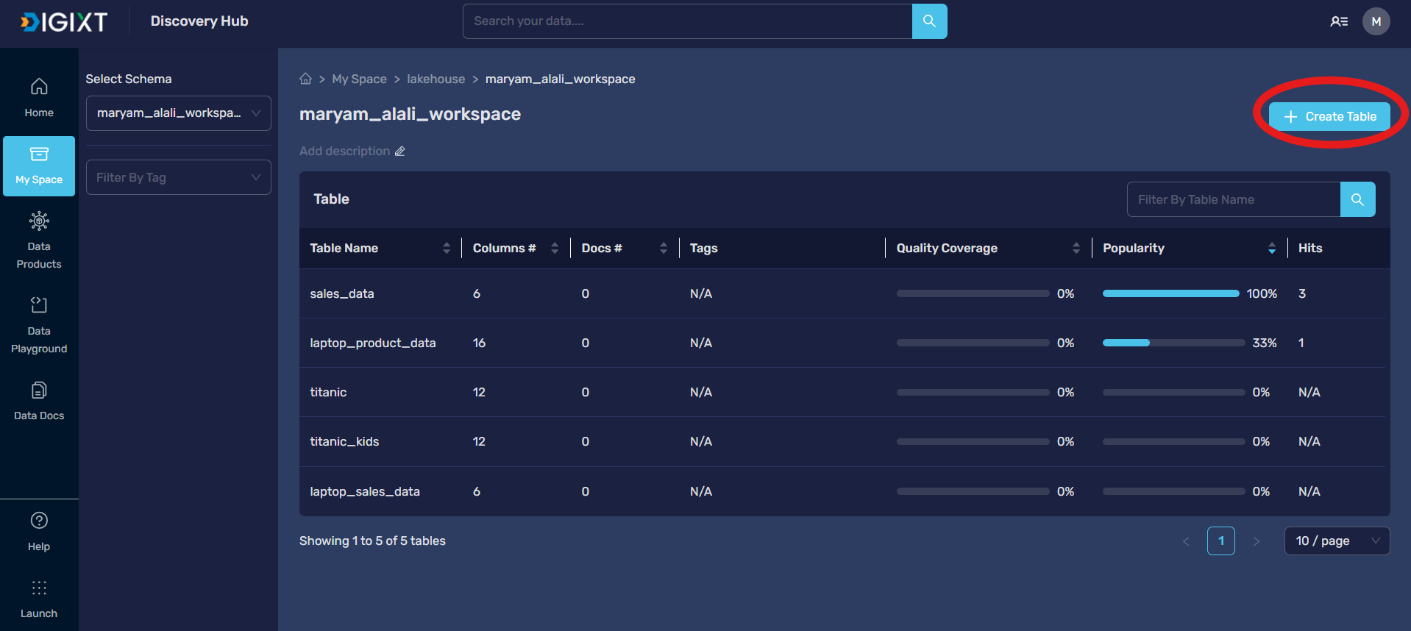
Figure 1: Ingest the data into DigiXT
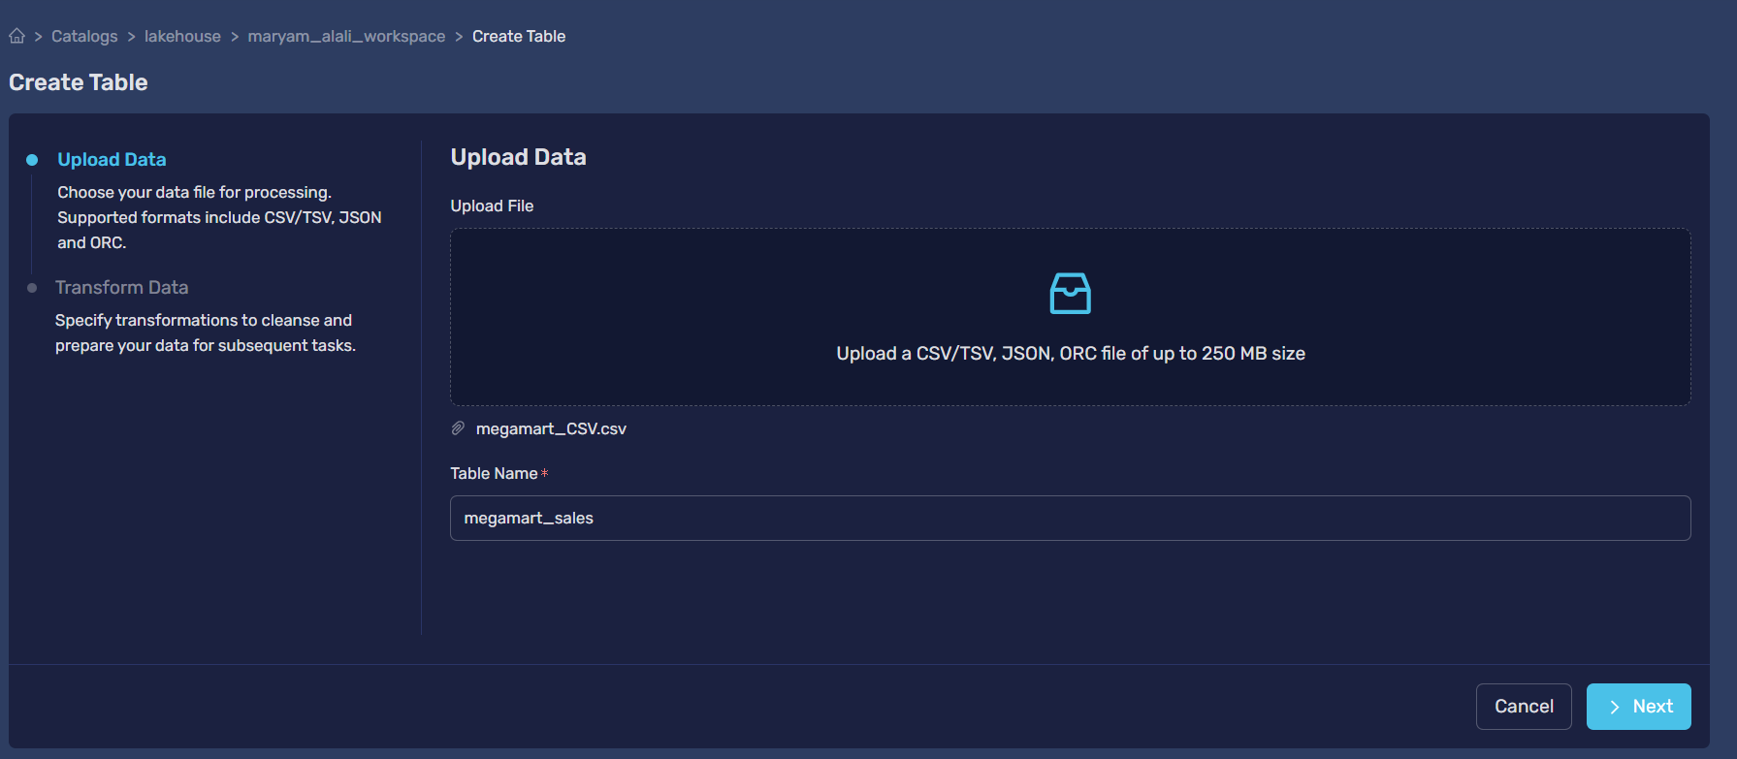
Figure 2: Upload data
The dataset was successfully loaded into the DigiXT platform. The process confirmed that all records were transferred correctly, with numerical columns like sales and profit

4.2 Initial Test Suite Results (Before Cleaning)
We ran a series of automated tests to check the data for Completeness, Consistency, Validity, and Accuracy
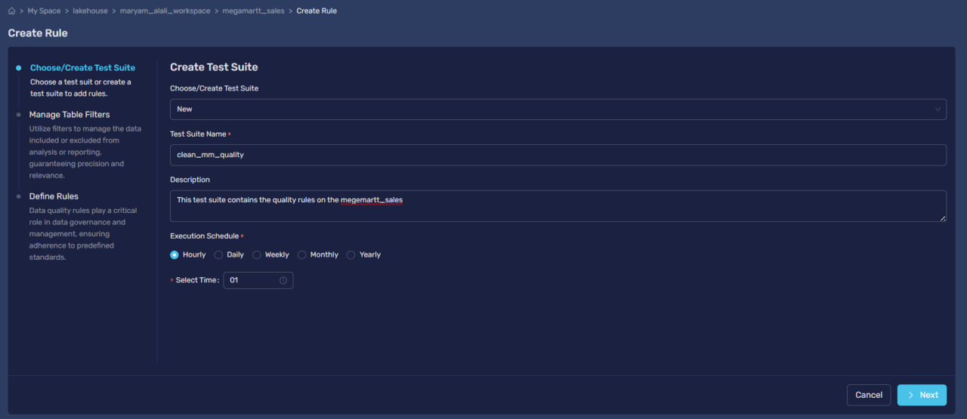
Figure 3: Create test suite
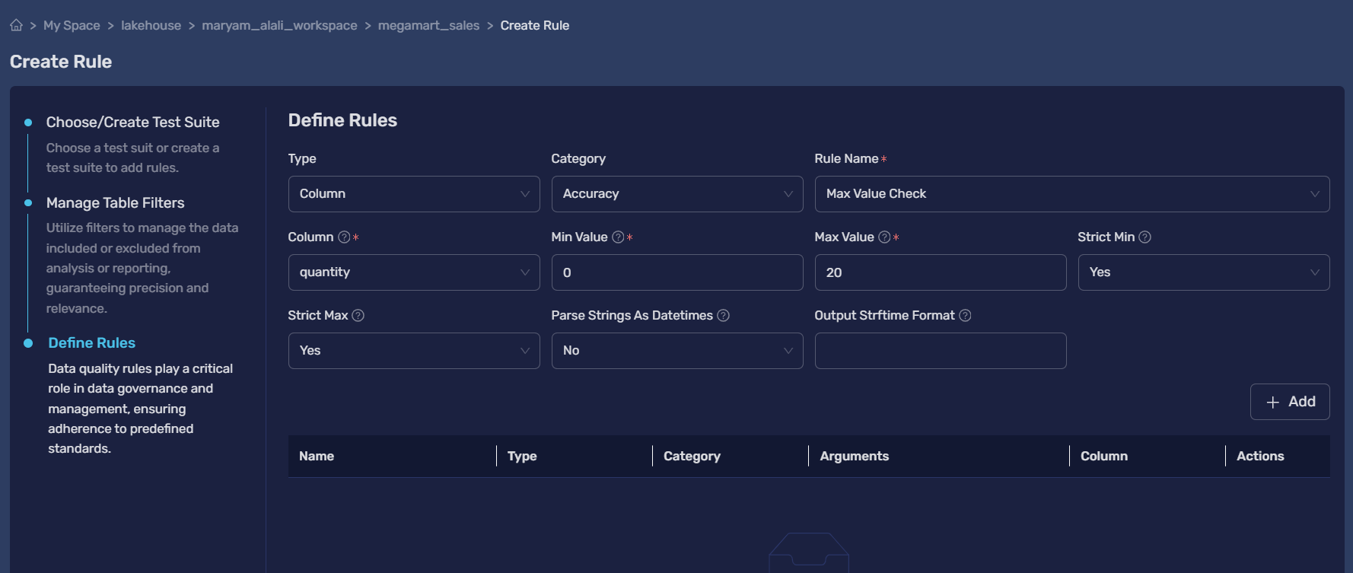
Figure 4: Rule 1 Max value check
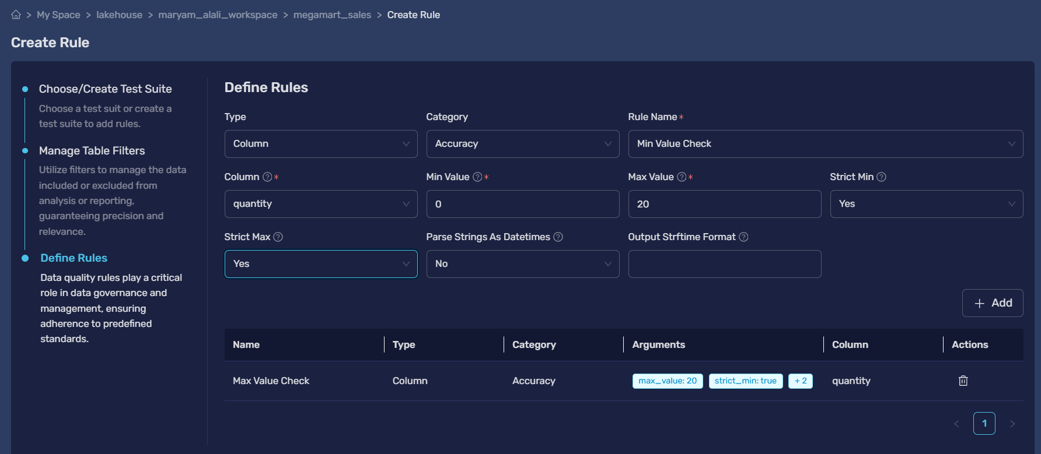
Figure 5: Rule 2 Min value check
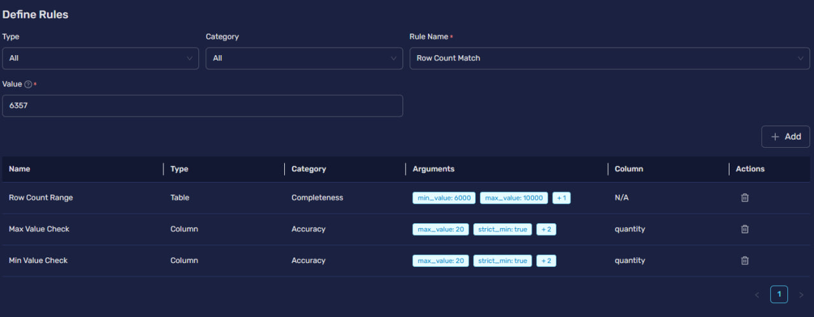
Figure 6: Rule 3 Row count match
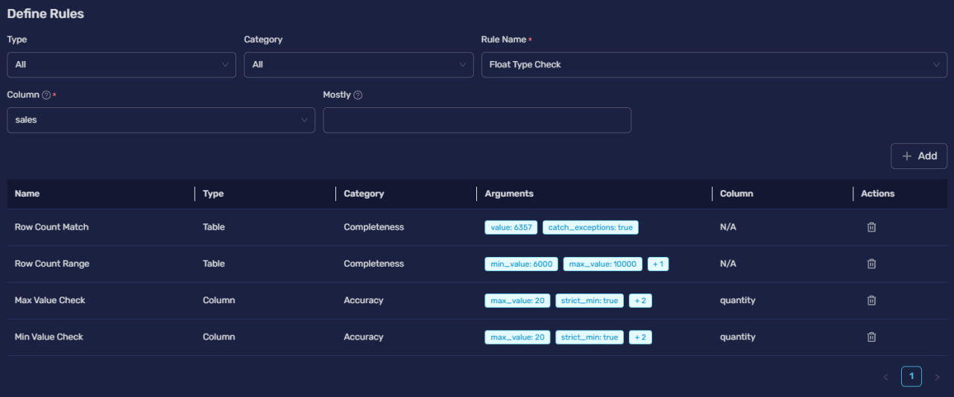
Figure 7: Rule 4 Float type check
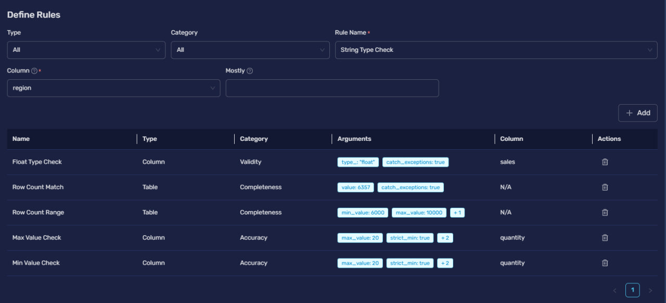
Figure 8: Rule 5 String type check
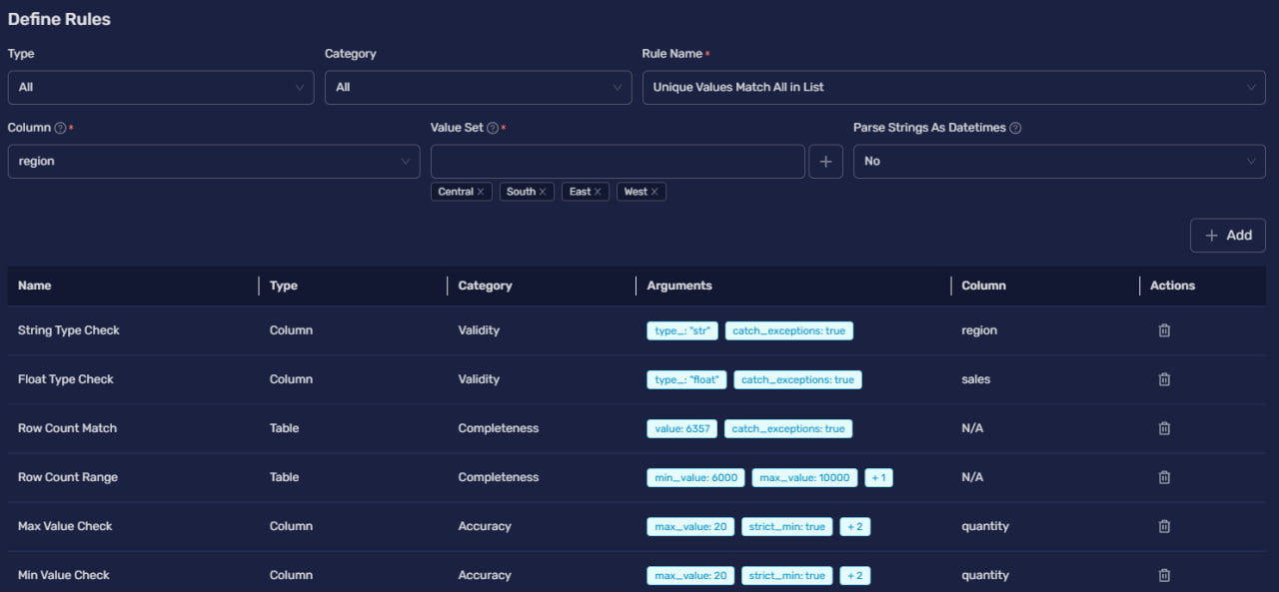
Figure 9: Rule 6 Unique Values Match All in list
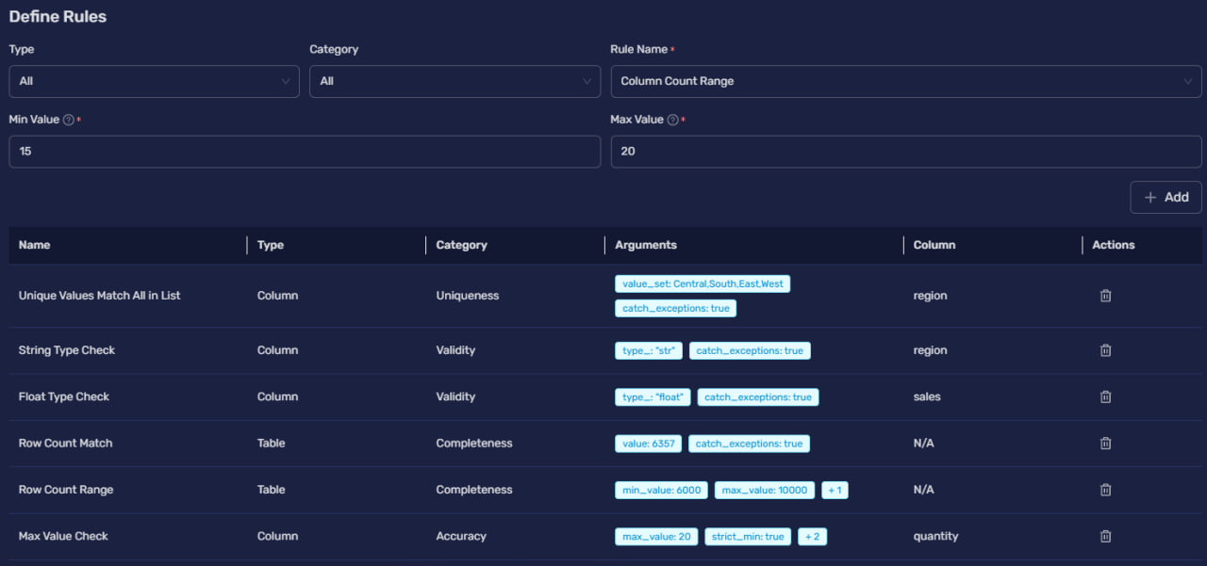
Figure 10: Rule 7 Column Count Range
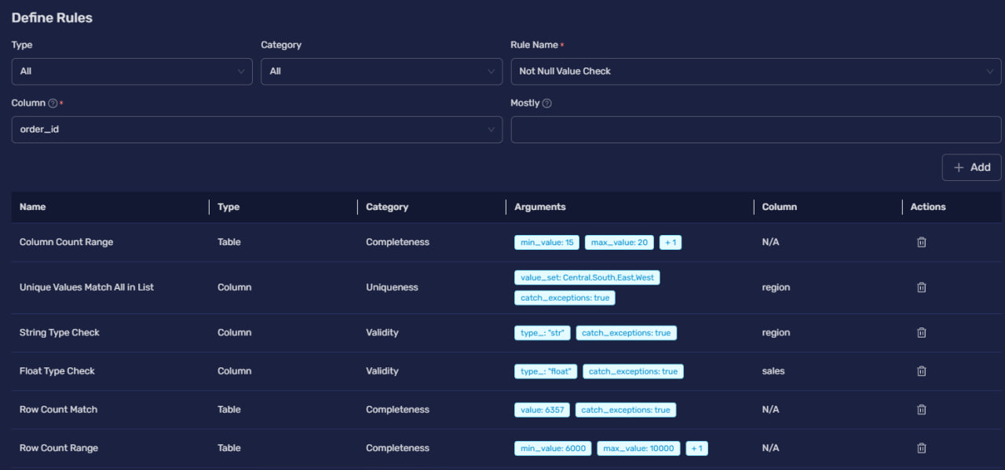
Figure 11: Rule 8 Not Null Value Check
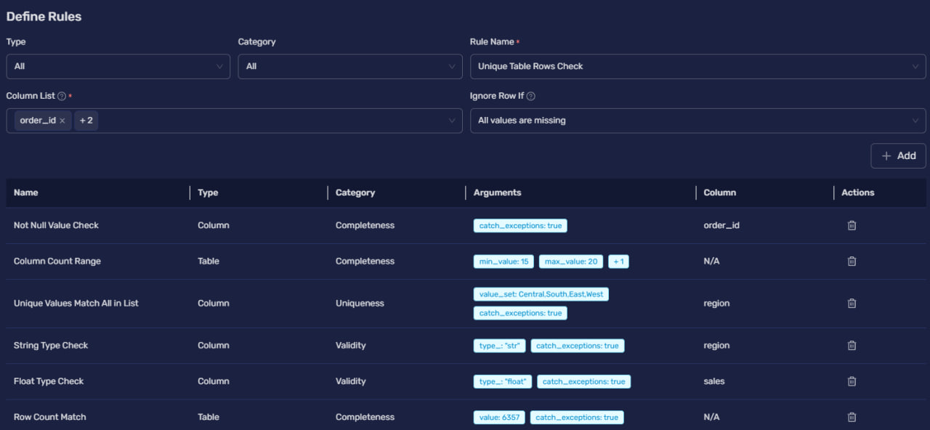
Figure 12: Rule 9 Unique Table Rows Check
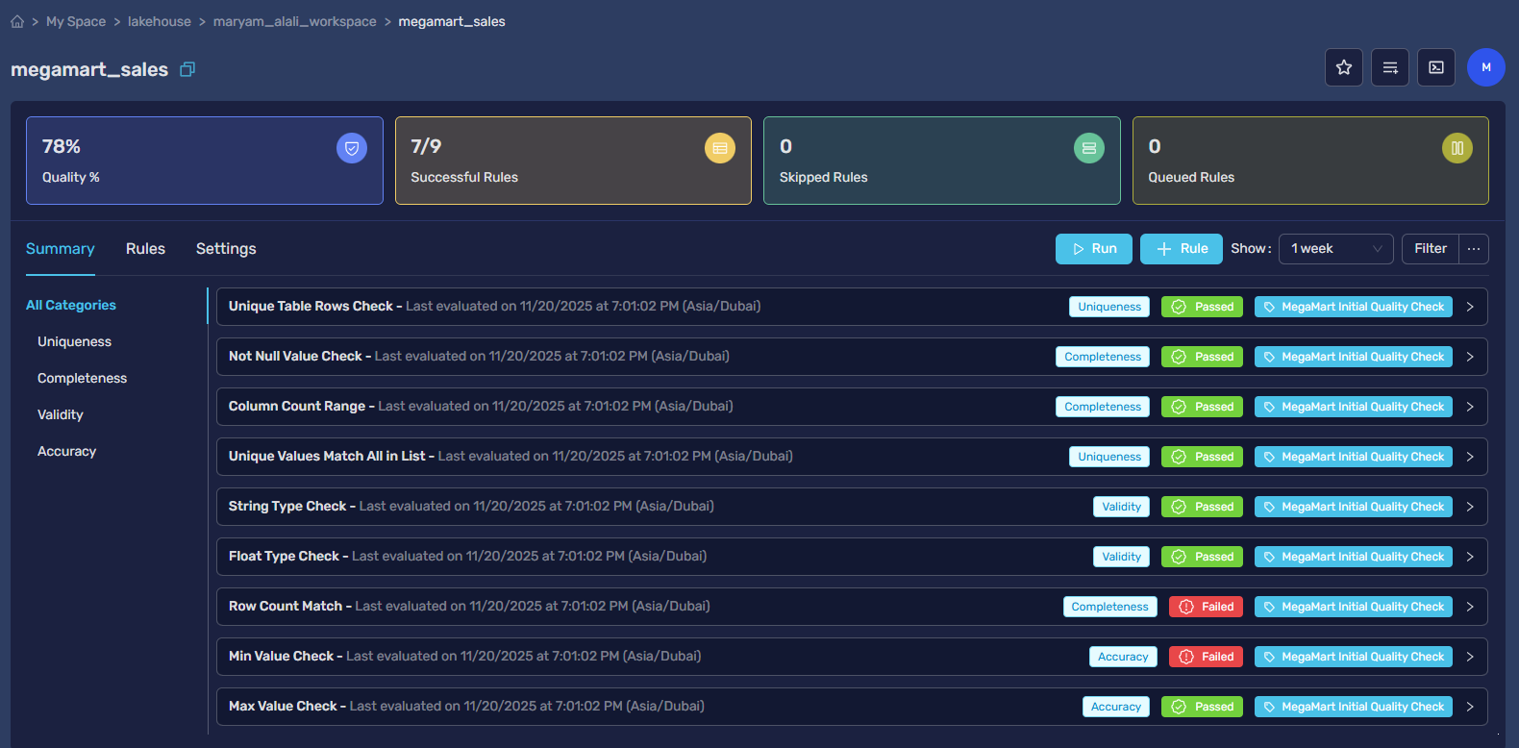
Figure 13: Data quality check before cleaning

Task 5: Data Preprocessing Strategy

5.1. Preprocessing Objective and Methodology

By comparing the raw data file (megamart_CSV.csv) with the cleaned data file (cleaned_megamart.csv), we identified and documented the exact cleaning and preprocessing steps that were applied.

5.2. Identified Cleaning Steps and Rationale
Our comparison showed that the main data quality issues found in Task 4 were solved in the cleaned dataset, but by deleting records instead of filling in missing values. The table below documents the actions taken and the logic behind them:
Quality Issue Identified (in Raw Data) | Actions taken | Rationale & Advanced Technique
Missing Values in Key Columns (order_date, quantity, review) | Record Deletion | All records that had any missing value in these three columns were deleted.
Negative Quantity (9 records) | Record Deletion | The 9 records with negative quantities were deleted. They were likely part of the records that had missing values.
Extreme Outliers (profit) | No Action Taken (Preservation) | The outliers in the profit column were kept. Technique: Strategic Preservation, recognizing that these are not errors but real business events (like large deals or losses) that are important for a realistic analysis.

Task 6: Re-conducting the Quality Check (Post-Curation)
To check if the applied changes were effective, we performed a final quality check on the cleaned_megamart.csv file.
Validation Check | Raw Data State | Clean Data State | Status
Total Records | 9,994 | 6358 | VALIDATED: 3,637 records were deleted. This solves the missing value problem.
Missing order_date | 2,278 | 0 | VALIDATED: All missing dates were deleted.
Missing quantity | 1,257 | 0 | VALIDATED: All missing quantities were deleted.
Negative quantity Count | 9 | 0 | VALIDATED: All negative values were deleted.
Conclusion: The change from the raw to the clean dataset significantly improved data quality in terms of completeness and validity.

The cleaned data was provided and carefully cleaned by the course instuctor
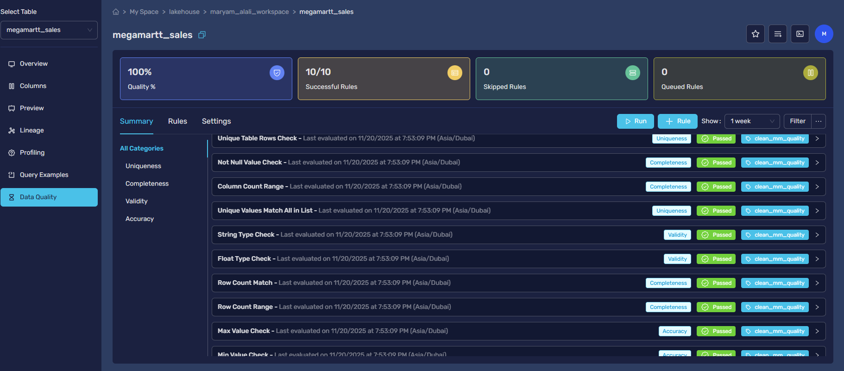
Figure 14: Data quality check after cleaning

CLO 3: Data Analysis and Key Findings

Task 7: Exploratory Data Analysis (EDA) with Simple Queries

a. Simple query
- -a. Simple Query: Previewing the core columns for our profitability analysis.
SELECT order_id, product_name, sales, discount, profit
FROM maryam_alali_workspace.megamartt_sales
LIMIT 10;
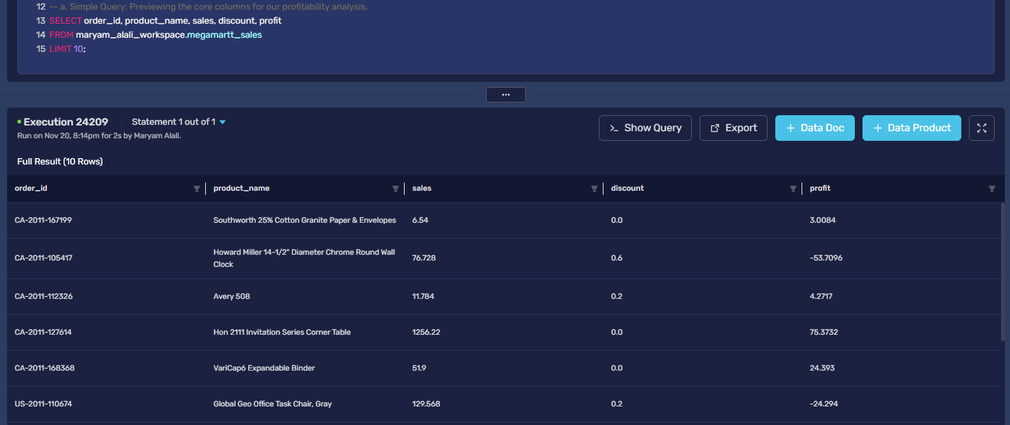

b. Simple queries with filters
-- b. Simple Query with Filters: Isolating specific loss-making transactions
-- where a high discount was applied. This is the core problem we are investigating.
SELECT order_id, product_name, sales, discount, profit
FROM maryam_alali_workspace.megamartt_sales
WHERE profit < 0
AND discount > 0.5;
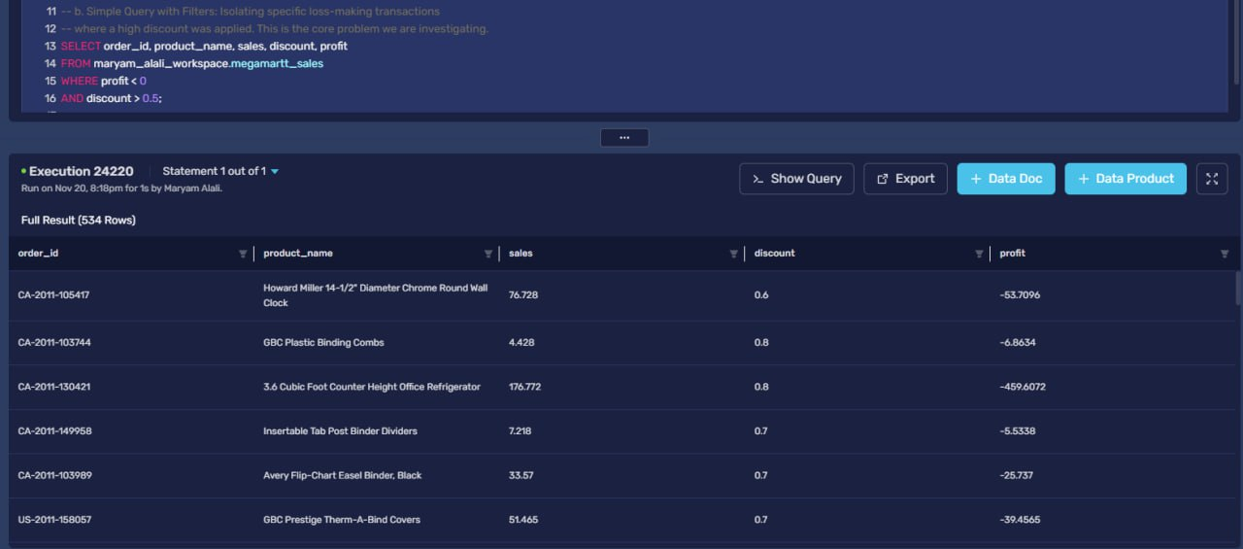

c. Group by query
-- c. Group By Query: Analyzing the impact of different discount levels on profitability.
-- This query is crucial for understanding the "break-even" point for discounts.
SELECT discount,
COUNT(order_id) AS number_of_orders,
AVG(profit) AS average_profit,
SUM(sales) AS total_sales
FROM maryam_alali_workspace.megamartt_sales
GROUP BY discount
ORDER BY discount ASC;
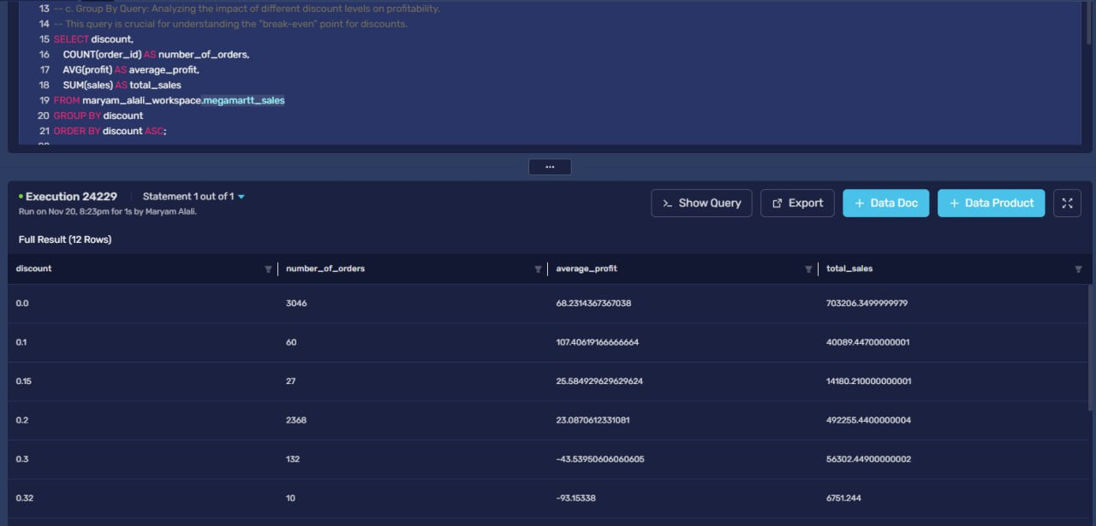

d. Group by query with having
-- d. Group By with HAVING: Identifying product sub-categories that become unprofitable
-- specifically when a discount is applied. This helps in creating a targeted discount strategy.
SELECT subcategory,
AVG(profit) AS average_profit,
AVG(discount) AS average_discount_applied
FROM maryam_alali_workspace.megamartt_sales
WHERE discount > 0
GROUP BY subcategory
HAVING AVG(profit) < 0
ORDER BY average_profit ASC;
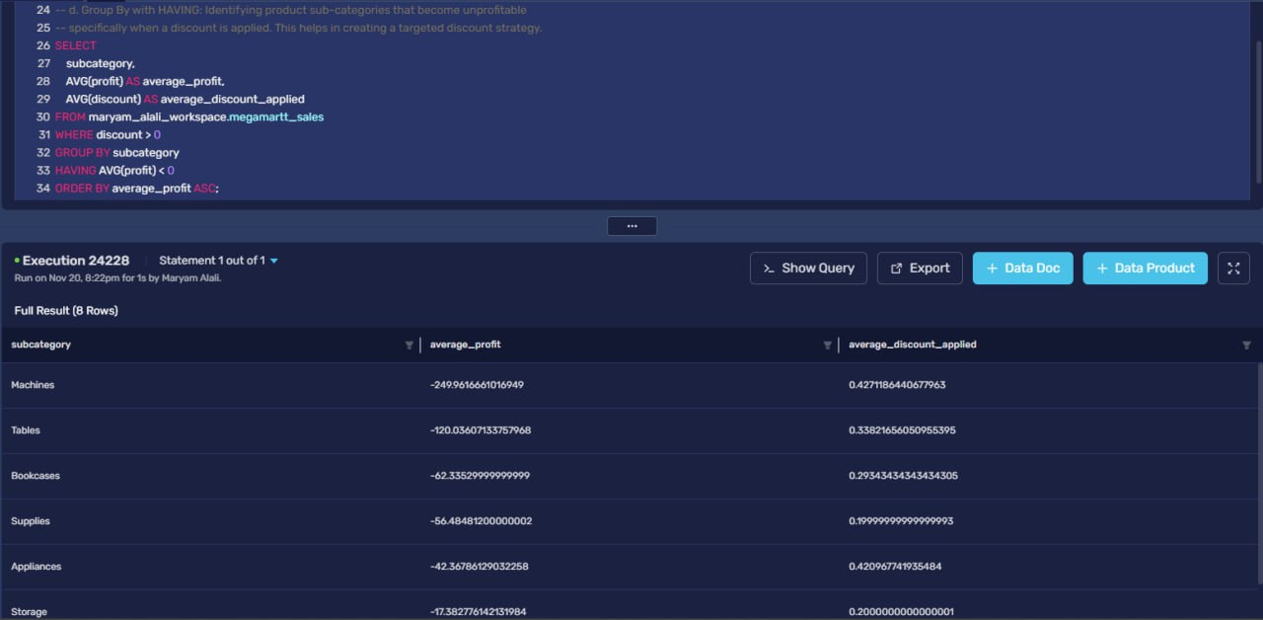

e. Order by query
-- e. Order By Query: Identifying the top 15 worst-performing transactions (highest losses)
-- to analyze the common factors (e.g., high discount, specific product, region).
SELECT order_id, product_name, region, sales, discount, profit
FROM maryam_alali_workspace.megamartt_sales
ORDER BY profit ASC
LIMIT 15;
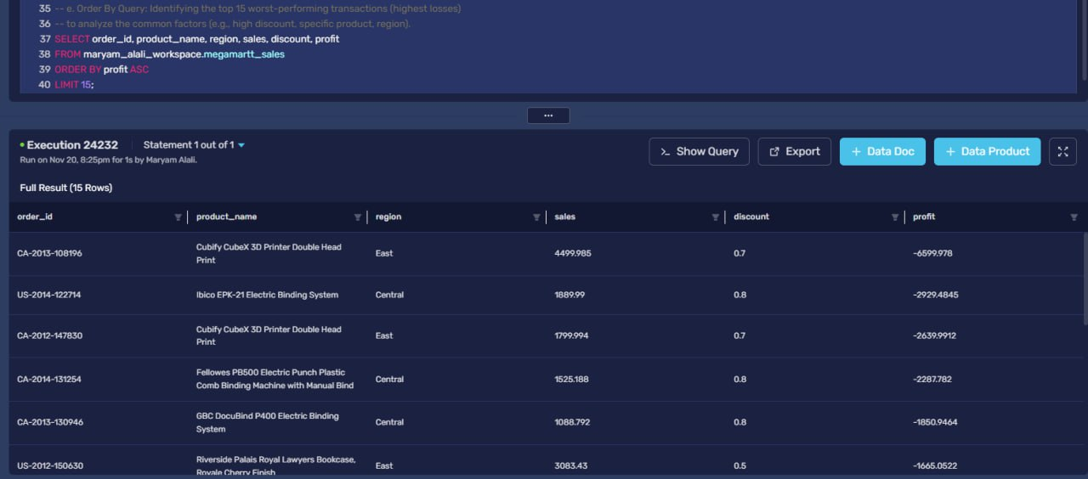

Task: 8 Advanced Data Analysis with Complex Queries
Create New tables to use in Joins:
Table 1 (Top 100 profit products):
-- Table 1 : Create a table for the top 100 most profitable products
CREATE TABLE maryam_alali_workspace.top_100_profit_products AS
(SELECT
product_name,
SUM(profit) as total_profit
FROM maryam_alali_workspace.megamartt_sales
GROUP BY product_name
ORDER BY total_profit DESC
LIMIT 100 );
--Display Table 1
SELECT *
FROM maryam_alali_workspace.top_100_profit_products;
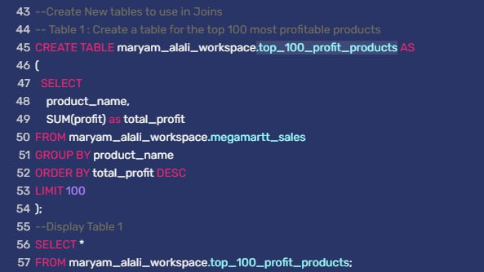
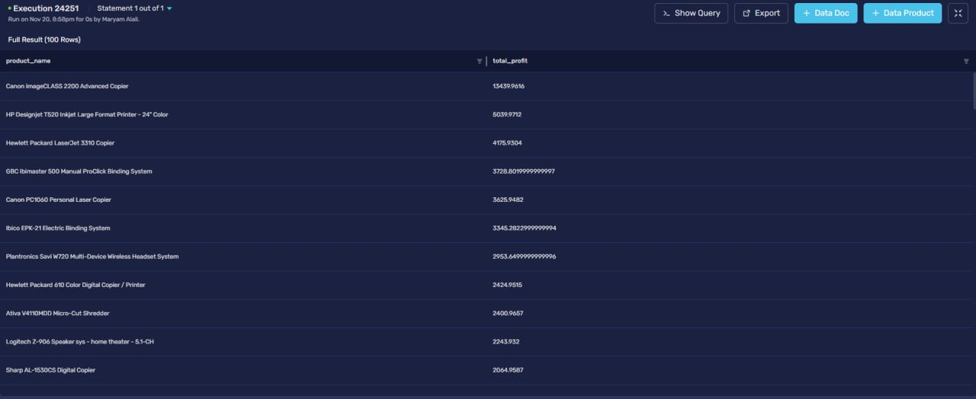
Table 2 (Top 100 sales products):
-- Table 2: Create a table for the top 10 best-selling products by quantity
CREATE TABLE maryam_alali_workspace.top_100_sales_products AS
SELECT
product_name,
SUM(quantity) as total_quantity_sold
FROM maryam_alali_workspace.megamartt_sales
GROUP BY product_name
ORDER BY total_quantity_sold DESC
LIMIT 100;
--Display Table 2
SELECT *
FROM maryam_alali_workspace.top_100_sales_products;
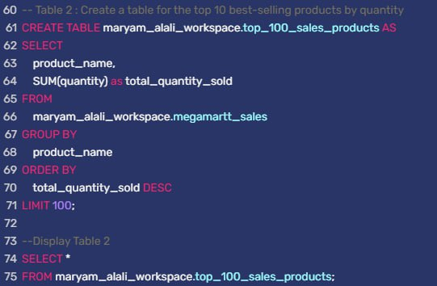
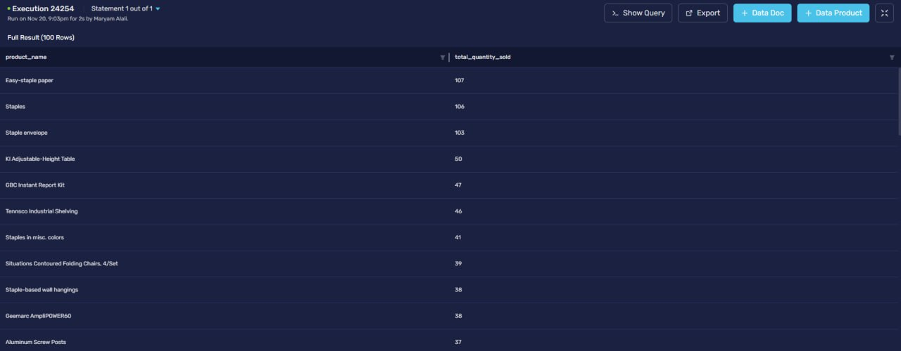

a. Inner join query
-- a. Inner Join: Find products that are in both top 10 lists using our new tables.
SELECT
p.product_name,
p.total_profit,
s.total_quantity_sold
FROM maryam_alali_workspace.top_100_profit_products p
INNER JOIN maryam_alali_workspace.top_100_sales_products s
ON p.product_name = s.product_name;
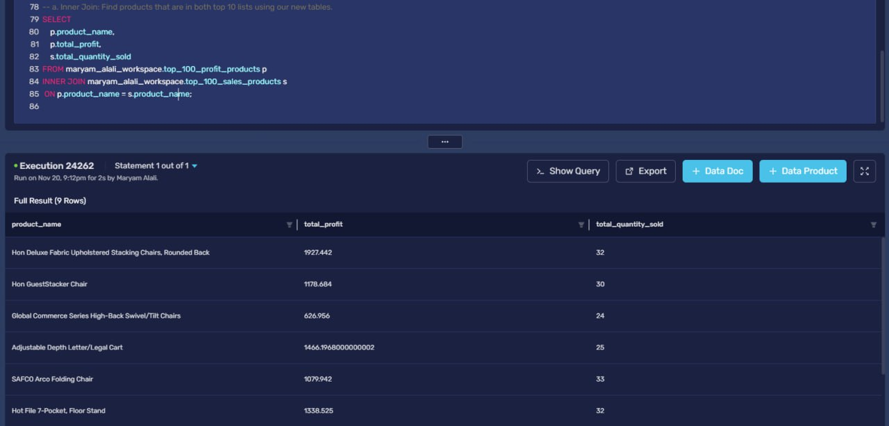

b. Left or right outer join query
-- b. Left Outer Join: Find which of our top profit products are NOT top sellers.
SELECT
p.product_name,
p.total_profit
FROM maryam_alali_workspace.top_100_profit_products p
LEFT JOIN maryam_alali_workspace.top_100_sales_products s ON p.product_name = s.product_name
WHERE s.product_name IS NULL;
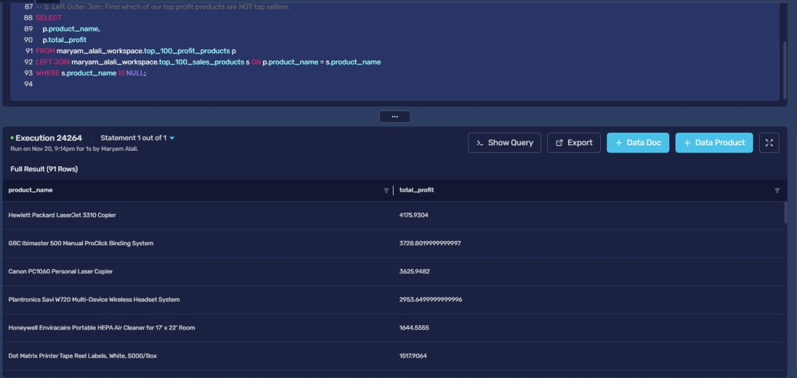

c.Subqueries
-- c. Subquery: Find the transaction details for the single most profitable sale ever recorded.
SELECT order_id, product_name, sales, discount, profit
FROM maryam_alali_workspace.megamartt_sales
WHERE
profit = (
SELECT MAX(profit)
FROM maryam_alali_workspace.megamartt_sales
);
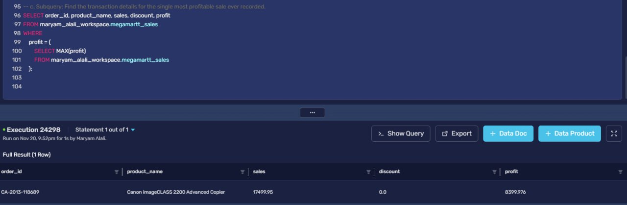

9. Key Findings and Their Business Impact of EDA
General Profitability Mix (Simple Query):
- Key Finding: Some sales make money, and some lose money. The results are all over the place.
- Business Impact: The company doesn't have a clear plan for making sales. This makes it hard to predict how much money the company will make and put profits at risk.
High Discounts & Losses (Simple Query with Filters):
- Key Finding: When discounts are very high (like 60% or more), the company loses a lot of money on that sale.
- Business Impact: The company is losing money on purpose. This is a huge problem that needs to be fixed right away by setting rules for how much discount is allowed.
The 30% Tipping Point (Group by query):
- Key Finding: On average, sales start to lose money once the discount hits 30%.
- Business Impact: This gives the sales team a simple rule: be very careful with discounts of 30% or more. This rule can stop thousands of bad sales and save the company a lot of money.
Vulnerable Categories (Group by query with having):
- Key Finding: Expensive items like "Machines" and "Tables" lose a lot of money when they are discounted.
- Business Impact: Giving the same discount to all products is a bad idea. The company needs special, stricter discount rules for these expensive items to stop losing money on them.
Identifying "Disaster" Sales (Order by query):
- Key Finding: The biggest losses come from a few specific sales of expensive products with huge discounts. One printer sale lost the company almost $7,000.
- Business Impact: The company can now teach the sales team which specific products should never get a big discount. It also shows they need a system to approve these big sales before they happen.

"Superstar" Products (Inner Join):
- Key Finding: Some products, like the "Hon Stacking Chairs," sell a lot and make a lot of money.
- Business Impact: These are the company's best products. They should make sure these are always available and promote them more to make even more money.
"Hidden Gem" Products (Left Join):
- Key Finding: Some products, like the "HP LaserJet Copier” are very profitable but don't sell very often.
- Business Impact: This is a big opportunity. If the company can figure out why these products don't sell much (like bad marketing) and fix it. They can make a lot more money.
The "Perfect Sale" (Subquery):
- Key Finding: The best sale in the entire dataset (a "Canon Copier" that made over $8,000 in profit) had a 0% discount.
- Business Impact: This is proof for the sales team that they don't need to give discounts to make big profits. It shows that focusing on the product's value is more important than lowering the price.

Task 10: Development of Data Products and Stories

Data Product 1: Profitability Analysis
Description: A data product containing key financial and product details to analyze profit drivers and losses.
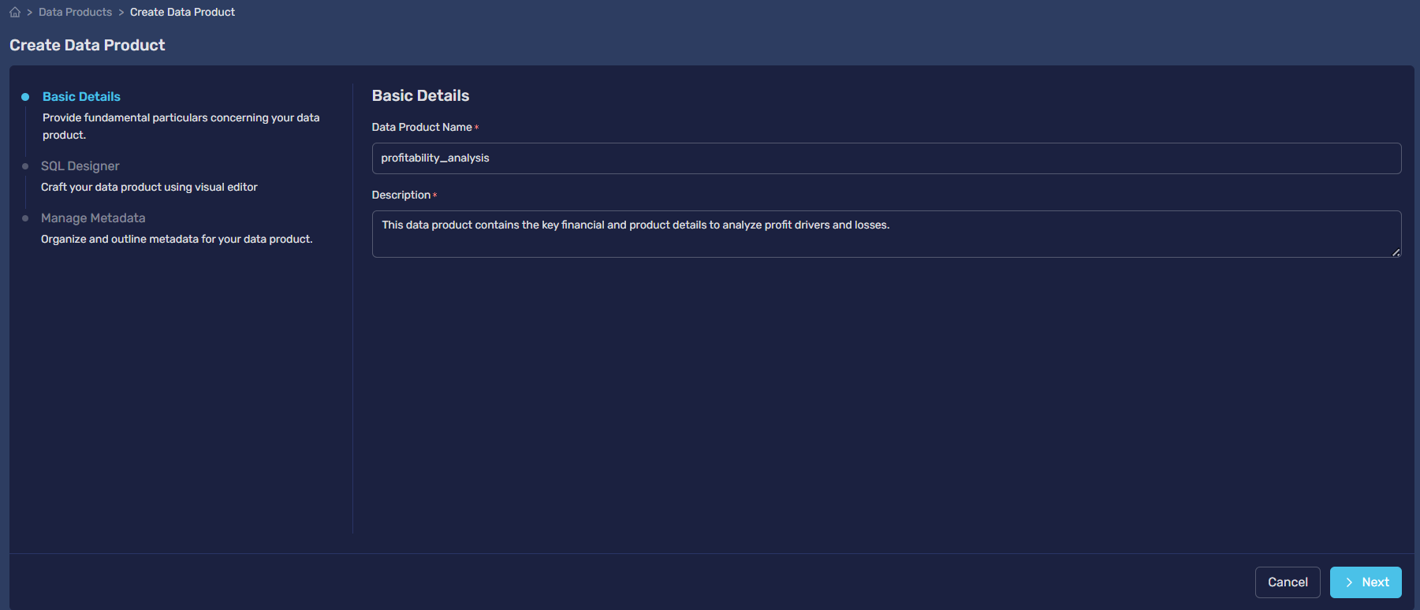
-- This query selects the essential columns for analyzing profit.
SELECT
category,
subcategory,
profit,
discount,
sales
FROM
Lakehouse.maryam_alali_workspace.megamartt_sales;
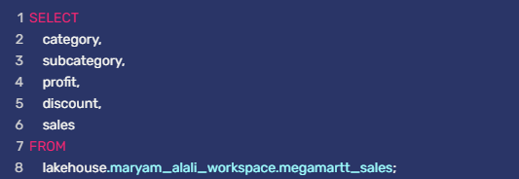
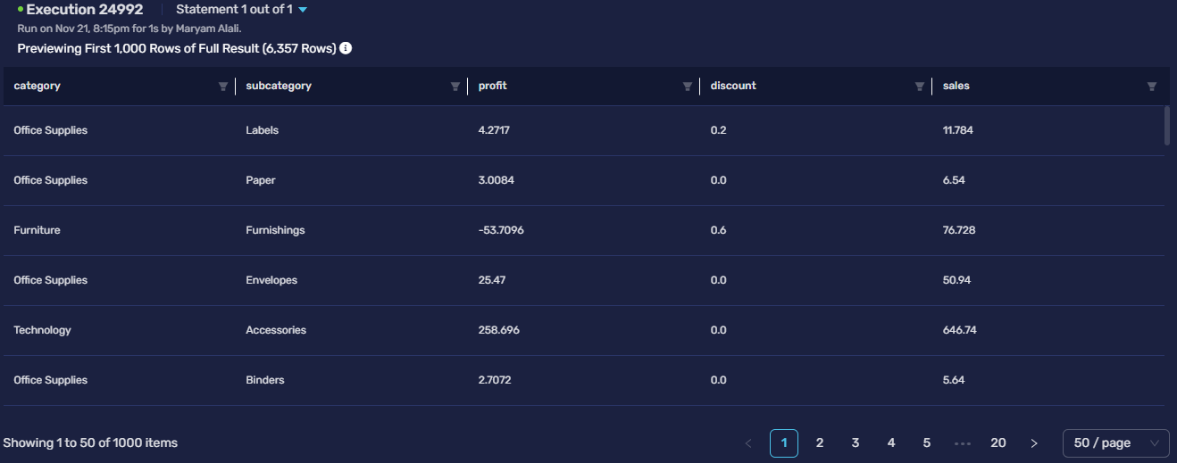

Story 1.1: Average Profit by Product Category
Description: This story visualizes which product categories are the most and least profitable on average.
-- Calculates the average profit for each main category.
SELECT
category,
AVG(profit) AS average_profit
FROM
DATAPRODUCTS.hct.profitability_analysis
GROUP BY
category
ORDER BY
average_profit DESC;
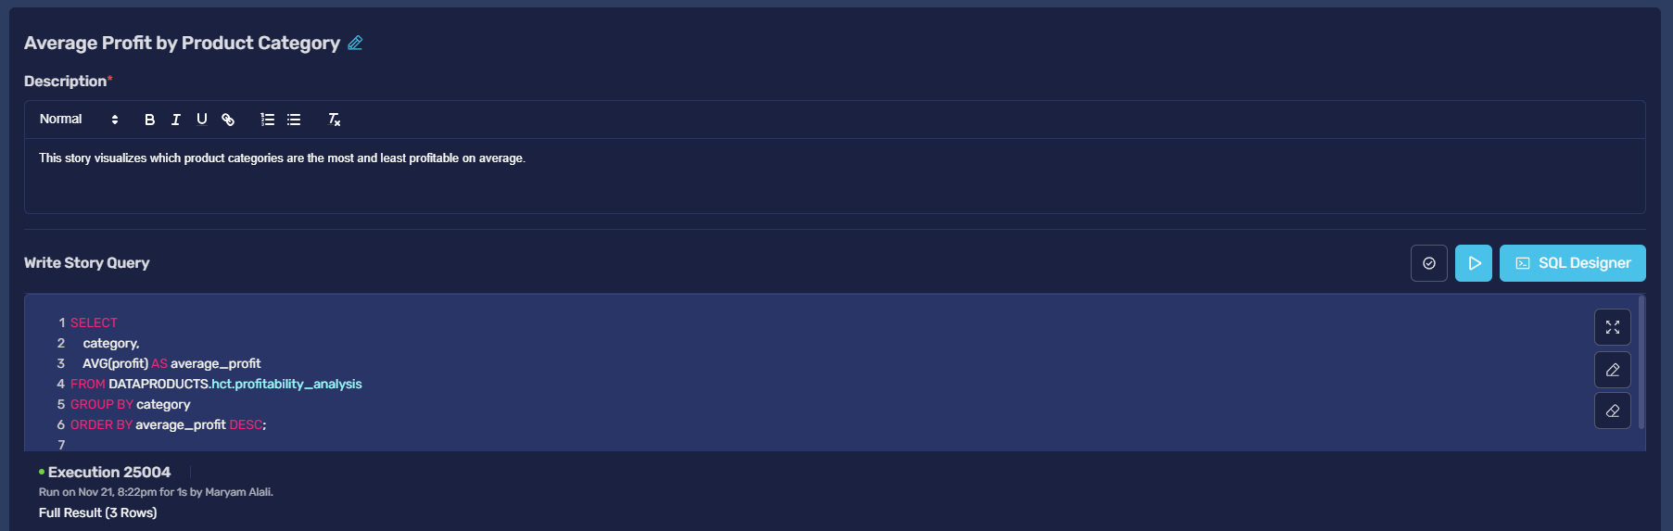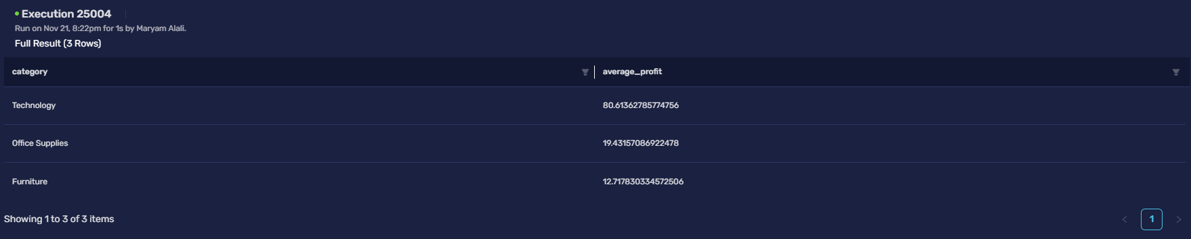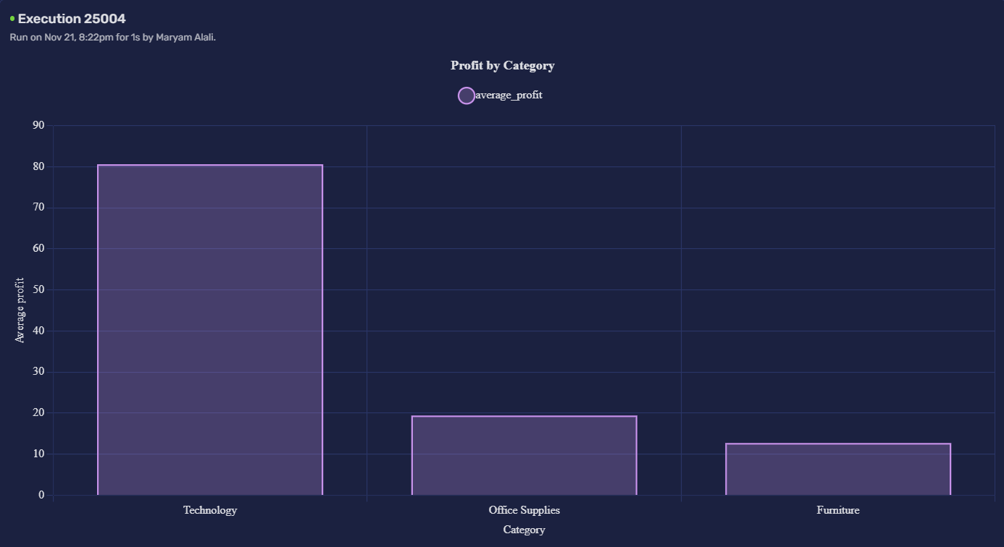

Story 1.2: Top Loss-Making Subcategories
Description: Identifies the subcategories with the worst average profit, helping to pinpoint specific problem areas.
-- Finds subcategories that have a negative average profit.
SELECT
subcategory,
AVG(profit) AS average_profit
FROM
DATAPRODUCTS.hct.profitability_analysis
GROUP BY
subcategory
HAVING
AVG(profit) < 0
ORDER BY
average_profit ASC;
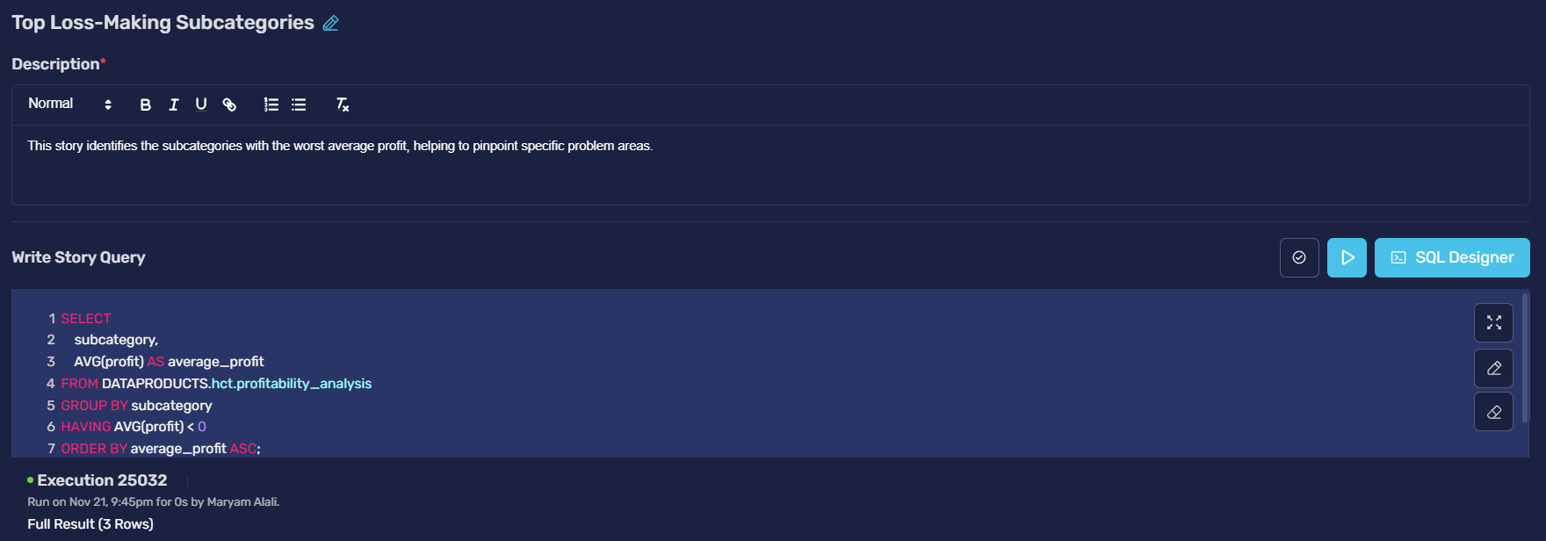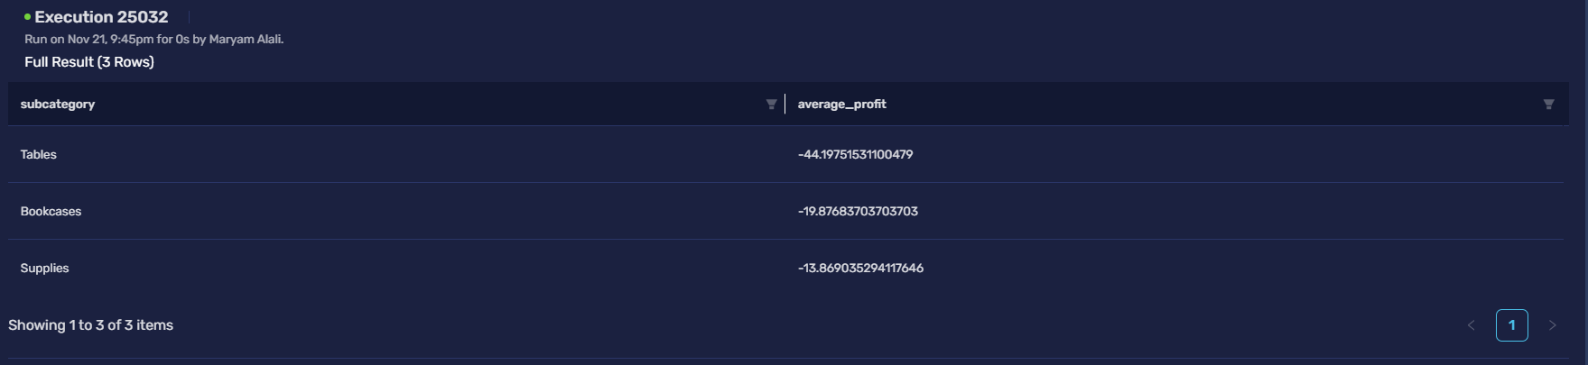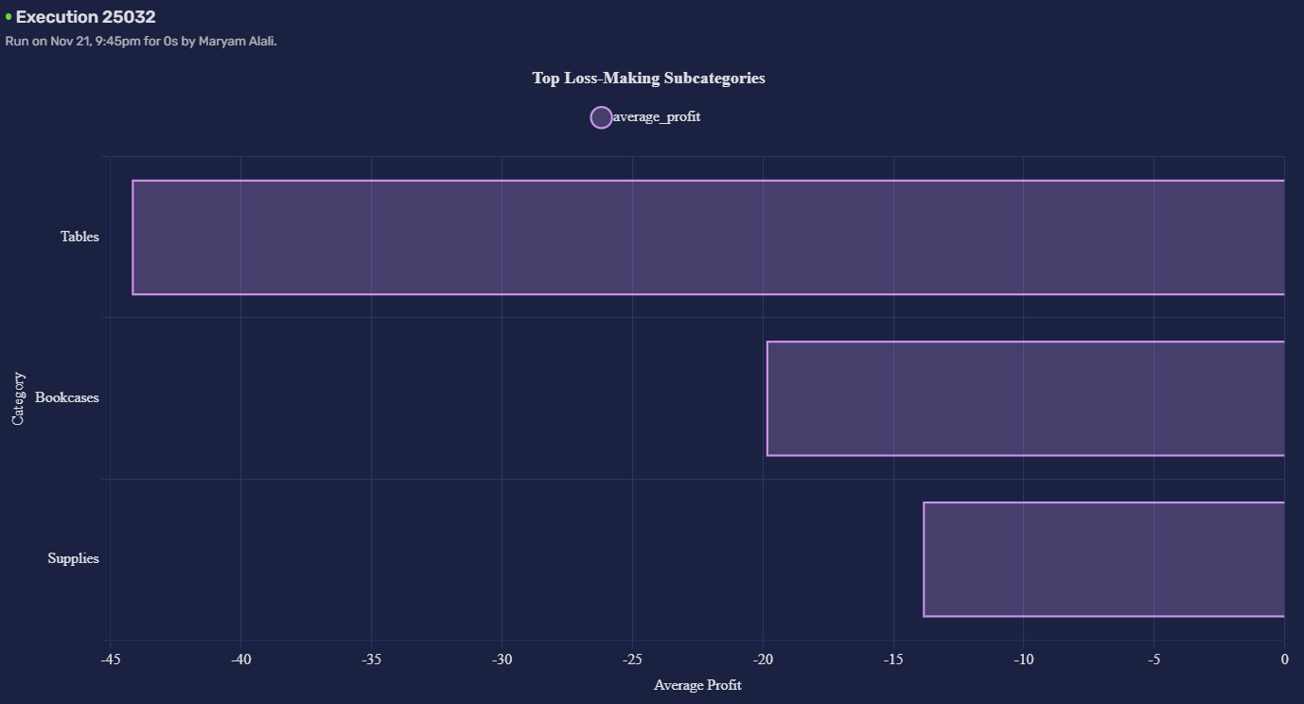
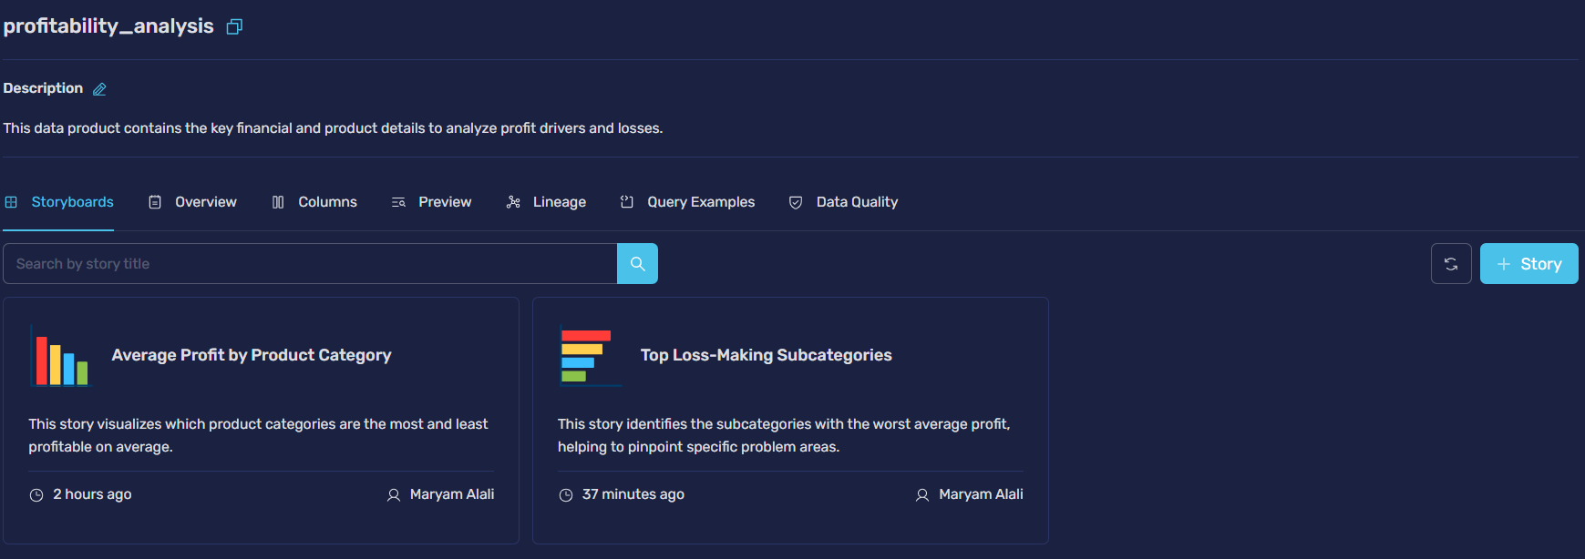

Product 2: Geographic Performance
Description: A data product focused on sales and profit metrics across different geographical regions and states. It displays region, state, sales and profit.
-- This query selects the columns needed for geographic analysis.
SELECT
region,
state,
sales,
profit
FROM
Lakehouse.maryam_alali_workspace.megamartt_sales;

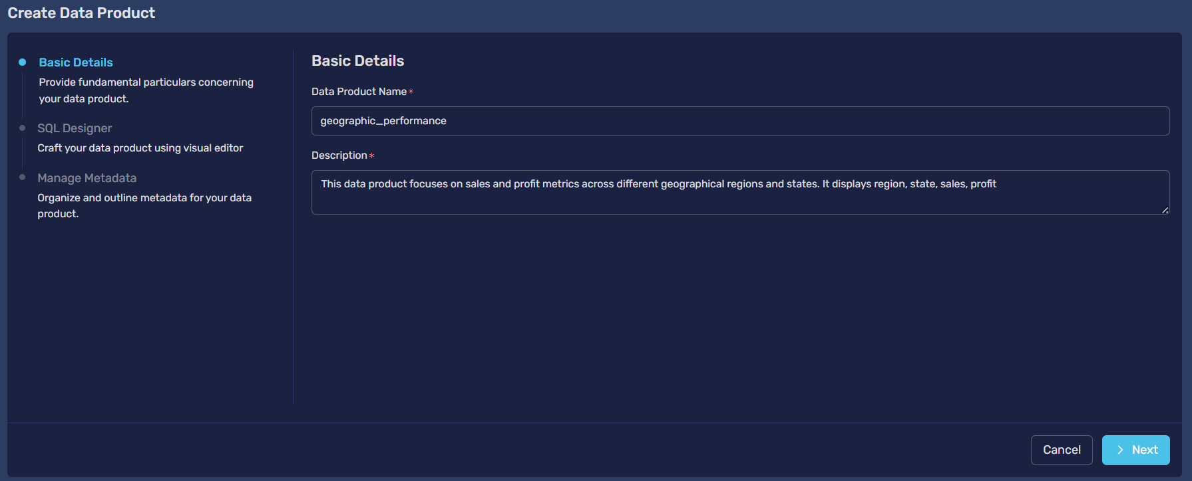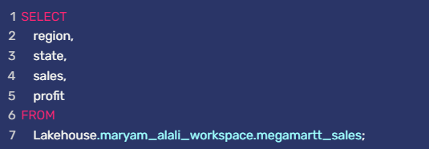
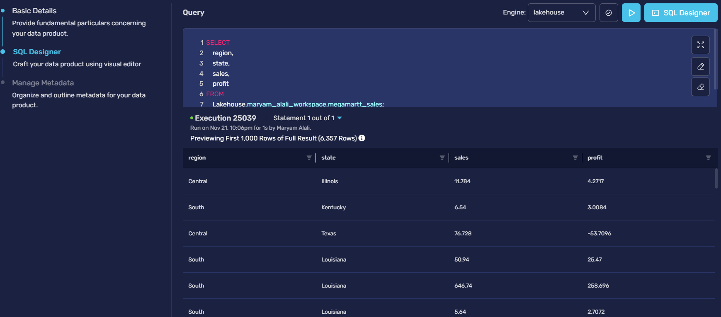

Story 2.1: Total Sales Revenue by Region
Description: This story shows the contribution of each region to the company's total sales revenue.
-- Calculates the total sales for each of the four regions.
SELECT
region,
SUM(sales) AS total_sales
FROM
DATAPRODUCTS.hct.geographic_performance
GROUP BY
region
ORDER BY
total_sales DESC;
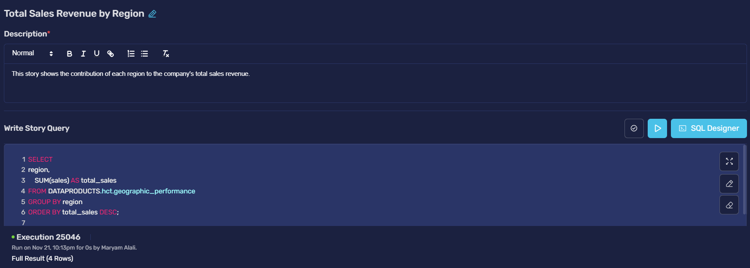 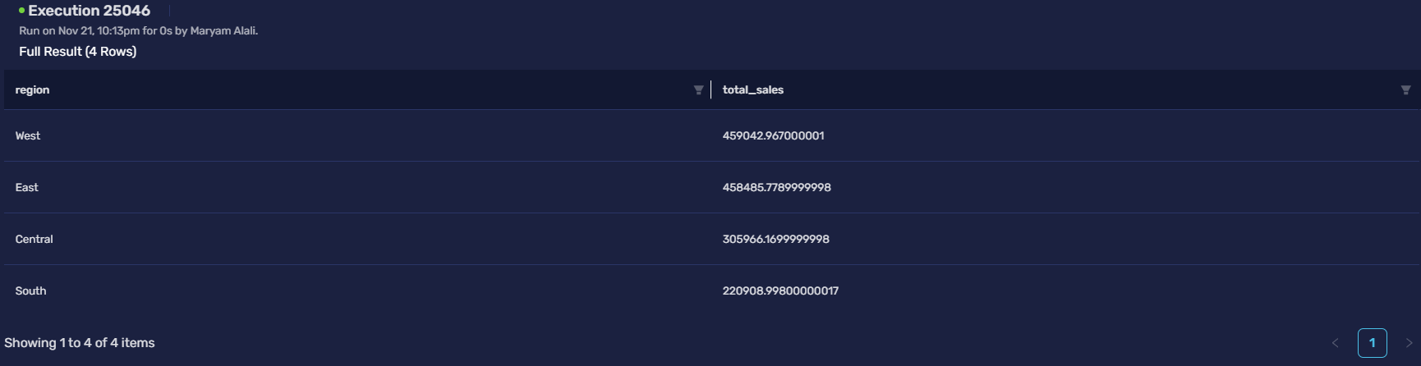
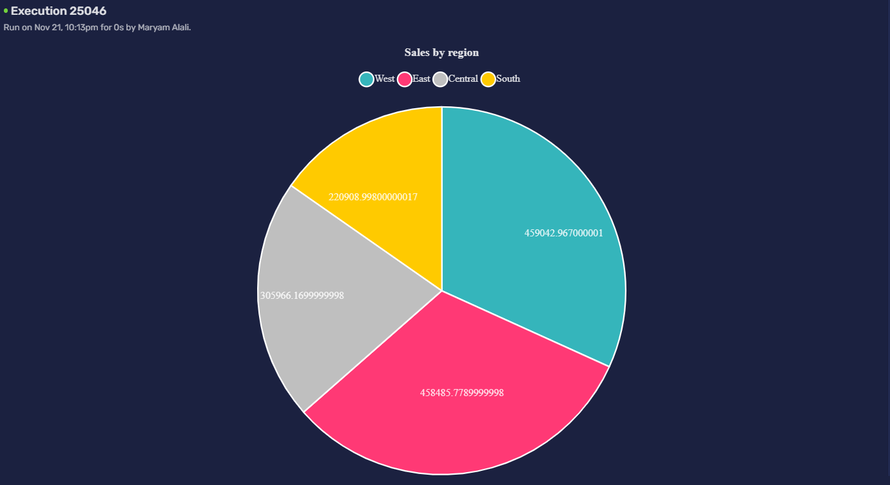

Story 2.2: Top 10 Most Profitable States
Description: Highlights the key states that are driving the company's profitability.
-- Finds the 10 states with the highest total profit.
SELECT
state,
SUM(profit) AS total_profit
FROM
DATAPRODUCTS.hct.geographic_performance
GROUP BY
state
ORDER BY
total_profit DESC
LIMIT 10;
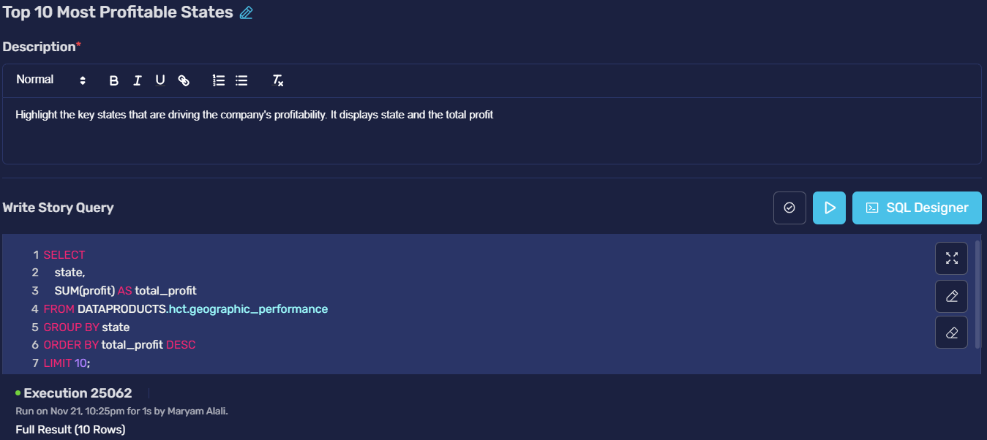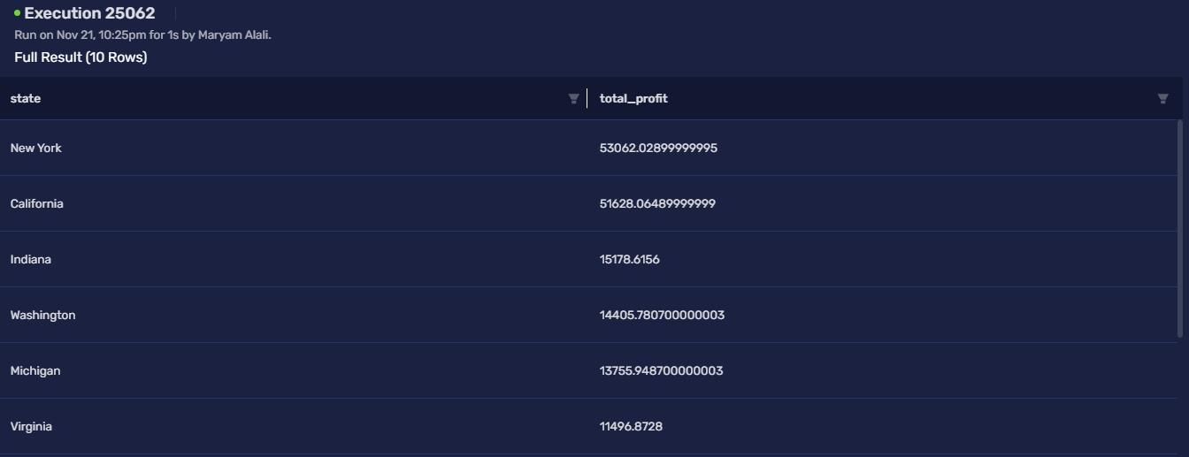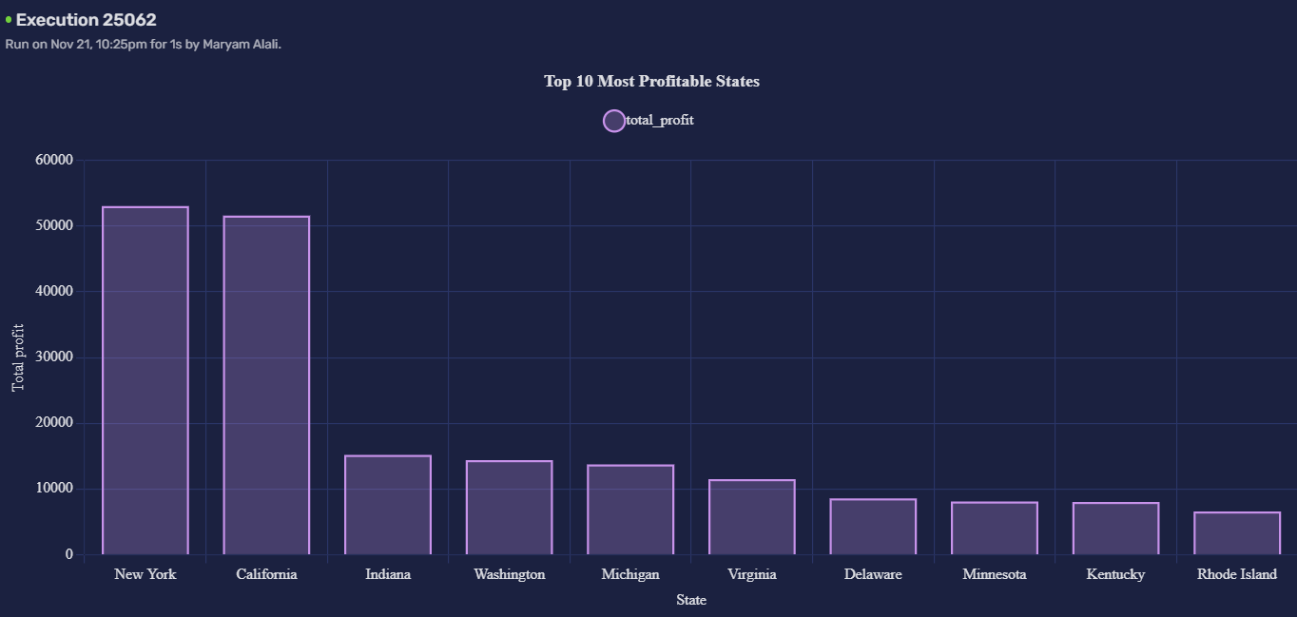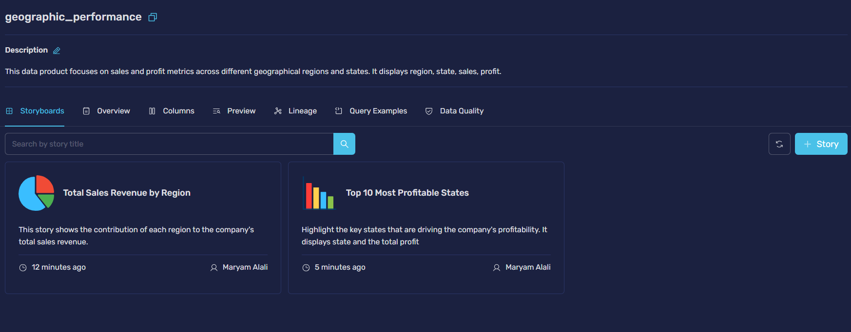

Task 11: Customer Sentiment Analysis using MongoDB

11.1 NoSQL Database Creation and Data Insertion
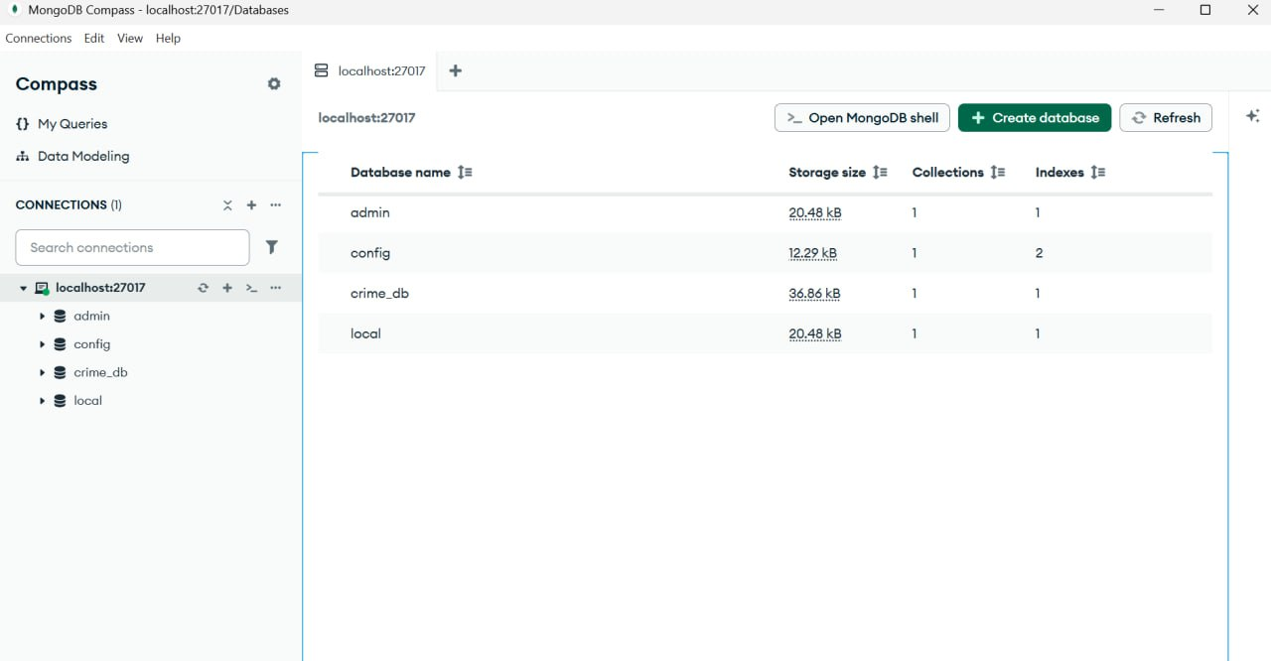
Figure 15: Create connection
The first step in the unstructured data analysis is to establish a connection to the MongoDB server and prepare the environment. We utilized MongoDB Compass to connect to the local MongoDB instance running on port 27017. As shown in the screenshot, the connection was successful.

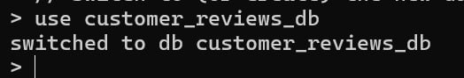
Figure 16: Switch to (or create) the new database
Create a new database named customer_reviews_db or switch to it if it already exists. This is where all our review data will be stored

List Of Products:-
- Product 1 (ID: OFF-ST-10002): SAFCO Boltless Storage
- Review 1: "Great performance!" (Positive)
- Review 2: "Bad product" (Negative)
- Review 3: "Works as expected" (Positive)
- Product 2 (ID: TEC-PH-10004): GE 30524EE4 Phone
- Review 1: "Highly recommended" (Positive)
- Review 2: "Decent for the price." (Positive)
- Product 3 (ID: FUR-FU-10004): Howard Miller 14-Furnishing
- Review 1: "Decent for the price." (Positive)
- Review 2: "Very bad quality, broke down" (Negative)
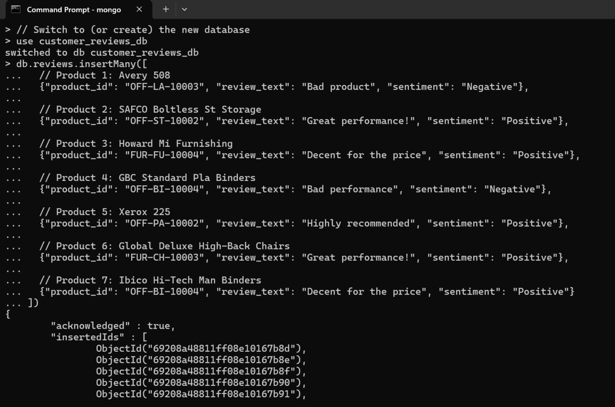
Figure 17: Insert review documents into the 'reviews' collection
load the sample customer reviews into a "Collection" named reviews. Each review is a "Document" containing the product ID, the review text, and the assigned sentiment (Positive/Negative).

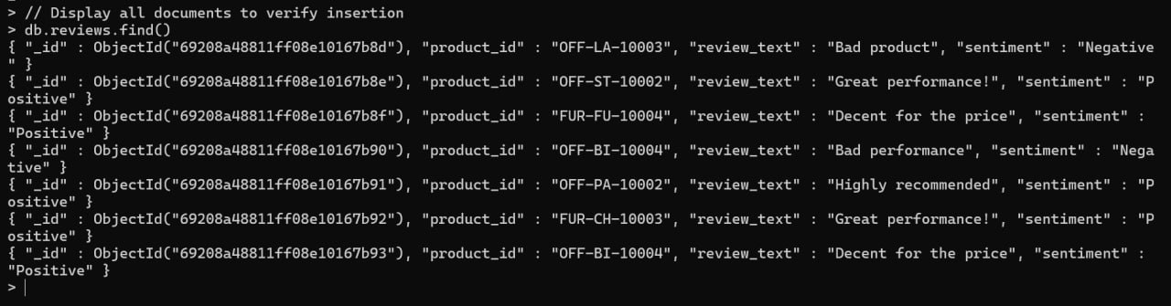
Figure 18: Display all documents to verify insertion
confirm that all the review documents we tried to insert in the previous step have been successfully saved into the database.

11.2 Querying for Positive and Negative Review Counts
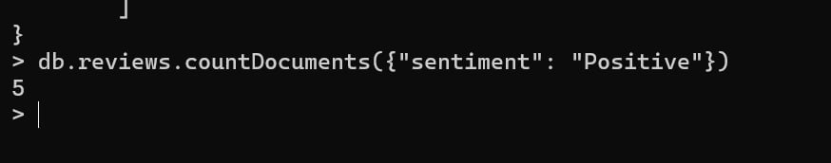
Figure 19: Count all documents where sentiment is "Positive"
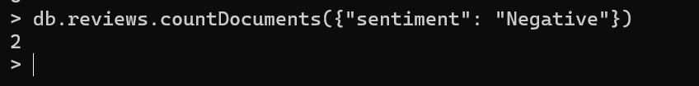
Figure 20: Count all documents where sentiment is "Negative"
Quick and simple way to get the total number of reviews that have the "Positive" sentiment tag. This command is repeated to count the "Negative" reviews.
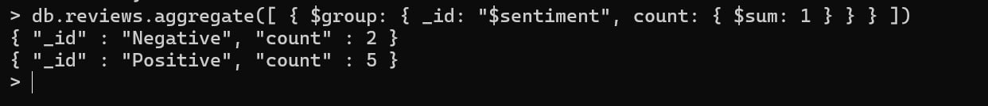
Figure 21: Group documents by sentiment and count each group
This command uses the Aggregation Pipeline to group all documents by their sentiment (Positive or Negative) and then counts each group in a single operation. This is the preferred technique for large-scale projects.

Task 12: Final Findings and Business Recommendations
This study analyzed the MegaMart sales dataset to diagnose the root causes of profit loss and identify opportunities for growth. By integrating quantitative analysis from SQL queries, visual insights from data products, and qualitative feedback from customer reviews in MongoDB, we have developed a comprehensive understanding of the business's performance. Our key findings are summarized below.

12. 1. The "Discount Trap": A Direct Link Between High Discounts and Financial Loss
Our initial Exploratory Data Analysis (EDA) revealed a clear and alarming trend: while discounts are intended to drive sales, they are the primary cause of profit loss.
- Key Finding: The GROUP BY analysis on discount levels established a critical "tipping point" at a 30% discount, where transactions, on average, become unprofitable. Sales with discounts of 50% or more consistently resulted in significant financial losses.
- Business Impact: The company is systematically losing money due to a poorly managed discount strategy. There is an urgent need for a data-driven policy to cap discounts and prevent unprofitable sales.

12.2. Not All Products Are Equal: Identifying "Vulnerable" and "Superstar" Categories
The analysis of data products and advanced SQL queries demonstrated that a one-size-fits-all discount strategy (same discount for all products) is ineffective and damaging.
- Key Finding (Data Product 1 - Profitability_Analysis): The story on "Unprofitable Sub-Categories" identified specific product lines, such as Tables, Bookcases, and Supplies, as highly vulnerable to profit loss, even with modest discounts. Conversely, our INNER JOIN query identified "Superstar" products like "Hon Stacking Chairs" that are both high-selling and highly profitable.
- Business Impact: The company must move from a general discount policy to a category-specific strategy. Stricter discount caps should be enforced on vulnerable categories, while marketing efforts should be focused on promoting "Superstar" and "Hidden Gem" products (high-profit, low-volume items) to maximize revenue.

12.3. Geographic Performance: A Story of Contrasting Markets
The geographic analysis revealed significant disparities in performance across different regions and states, highlighting both areas of strength and concern.
- Key Finding (Data Product 2 - Geographic_Performance): The "Total Sales by Region" story showed that the West region is the largest contributor to sales revenue. However, the "Top 10 Loss-Making Cities" story pinpointed specific urban areas, such as Philadelphia and Houston, where profit losses are heavily concentrated, likely due to aggressive, localized discount campaigns.
- Business Impact: Sales strategies must be tailored to local market conditions. The company should investigate the specific causes of losses in underperforming cities and replicate the successful strategies of its most profitable states, like California and New York.

12.4. Customer Opinions: The "Why" Behind the Numbers
The final phase of our analysis used MongoDB to explore unstructured customer reviews, providing qualitative context to our quantitative findings.
- Key Finding (MongoDB Analysis): Our analysis of a sample of customer reviews revealed a direct correlation between product sentiment and the descriptions in the data. Reviews like "Bad product" and "Very bad quality" were linked to products that were often associated with high discounts and low profitability. In contrast, positive reviews like "Great performance!" and "Highly recommended" were frequently associated with profitable, high-value items.
- Business Impact: Customer feedback is a valuable, untapped resource. Negative reviews can serve as an early warning system for problematic products, allowing the company to address quality issues or adjust discount strategies before significant financial damage occurs. Integrating sentiment analysis into the business intelligence process can provide a more holistic view of product performance.

Overall Conclusion
The core problem facing MegaMart is not a lack of sales, but a lack of profitable sales. The company's current discount strategy is the main reason, often leading to direct financial losses and in many cases, leading to direct financial losses. By implementing a data-driven, category-specific discount policy, focusing marketing on high-performing products, and paying attention to customer feedback, MegaMart can significantly improve its profitability and ensure sustainable growth.

APPENDIX

Descriptive Analysis Codes
-- This query correctly calculates the total number of rows in the dataset.
SELECT
COUNT(*) AS number_of_rows
FROM
maryam_alali_workspace.megamart_sales;
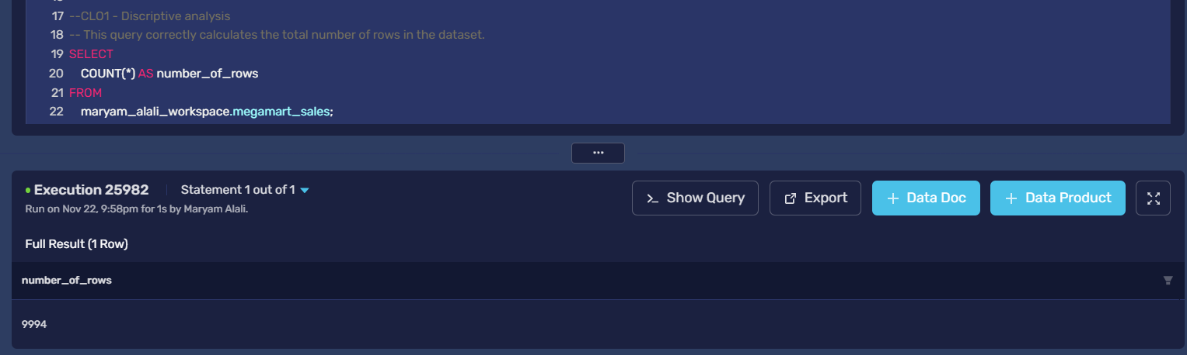
-- Display one row to manually count the columns in the output.
SELECT *
FROM maryam_alali_workspace.megamart_sales
LIMIT 1;
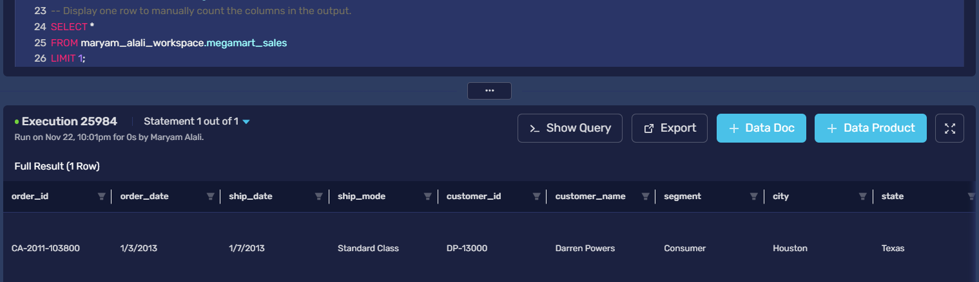

-- Descriptive Statistics for the 'Sales' column
SELECT
COUNT(Sales) AS count_sales,
AVG(Sales) AS mean_sales,
APPROX_PERCENTILE(Sales, 0.5) AS median_sales, -- For Median
STDDEV(Sales) AS stddev_sales,
MIN(Sales) AS min_sales,
MAX(Sales) AS max_sales
FROM
maryam_alali_workspace.megamart_sales;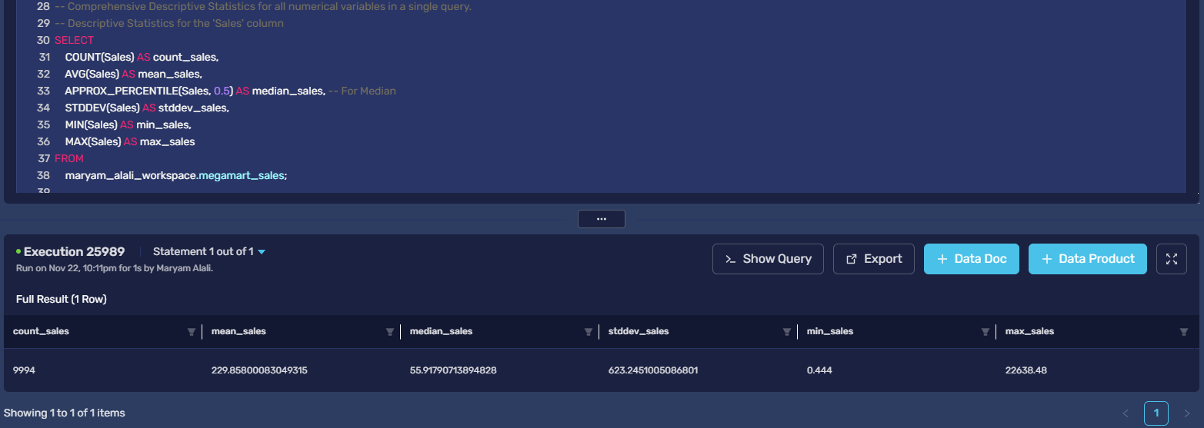
-- Descriptive Statistics for the 'Quantity' column
SELECT
COUNT(Quantity) AS count_quantity,
AVG(Quantity) AS mean_quantity,
APPROX_PERCENTILE(Quantity, 0.5) AS median_quantity,
STDDEV(Quantity) AS stddev_quantity,
MIN(Quantity) AS min_quantity,
MAX(Quantity) AS max_quantity
FROM
maryam_alali_workspace.megamart_sales;
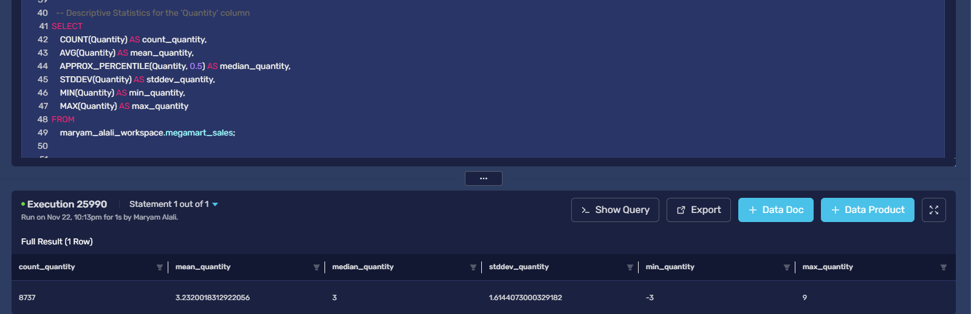
-- Descriptive Statistics for the 'Discount' column
SELECT
COUNT(Discount) AS count_discount,
AVG(Discount) AS mean_discount,
APPROX_PERCENTILE(Discount, 0.5) AS median_discount,
STDDEV(Discount) AS stddev_discount,
MIN(Discount) AS min_discount,
MAX(Discount) AS max_discount
FROM
maryam_alali_workspace.megamart_sales;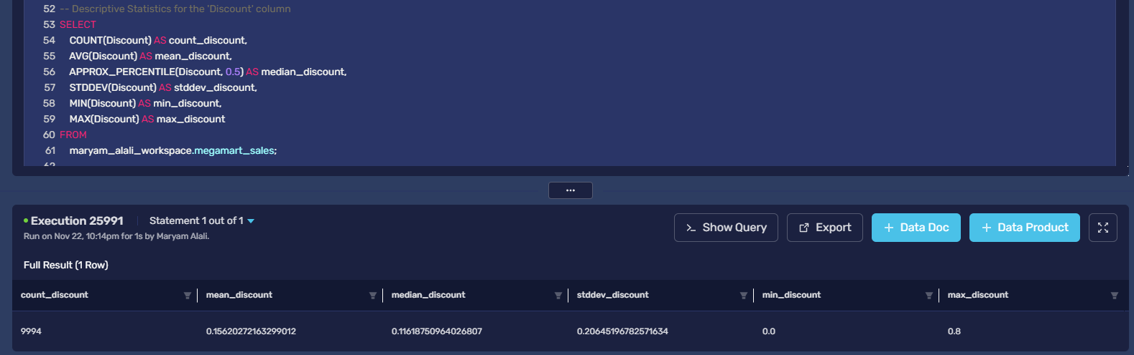
-- Descriptive Statistics for the 'Profit' column
SELECT
COUNT(Profit) AS count_profit,
AVG(Profit) AS mean_profit,
APPROX_PERCENTILE(Profit, 0.5) AS median_profit,
STDDEV(Profit) AS stddev_profit,
MIN(Profit) AS min_profit,
MAX(Profit) AS max_profit
FROM
maryam_alali_workspace.megamart_sales;
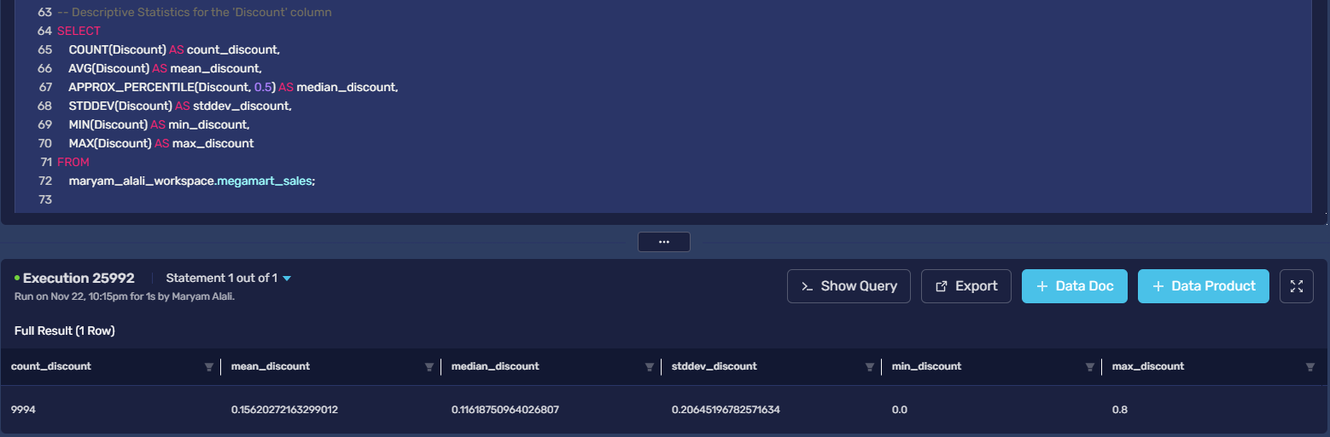

Categorical Variables Analysis code
SELECT
ship_mode,
COUNT(*) AS frequency
FROM maryam_alali_workspace.megamart_sales
GROUP BY ship_mode
ORDER BY frequency DESC
LIMIT 1;
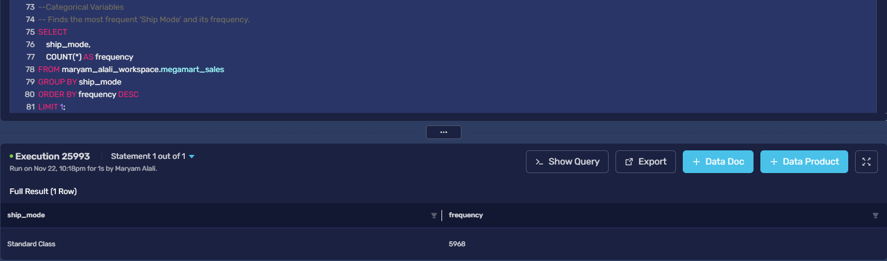
SELECT
segment,
COUNT(*) AS frequency
FROM maryam_alali_workspace.megamart_sales
GROUP BY segment
ORDER BY frequency DESC
LIMIT 1;
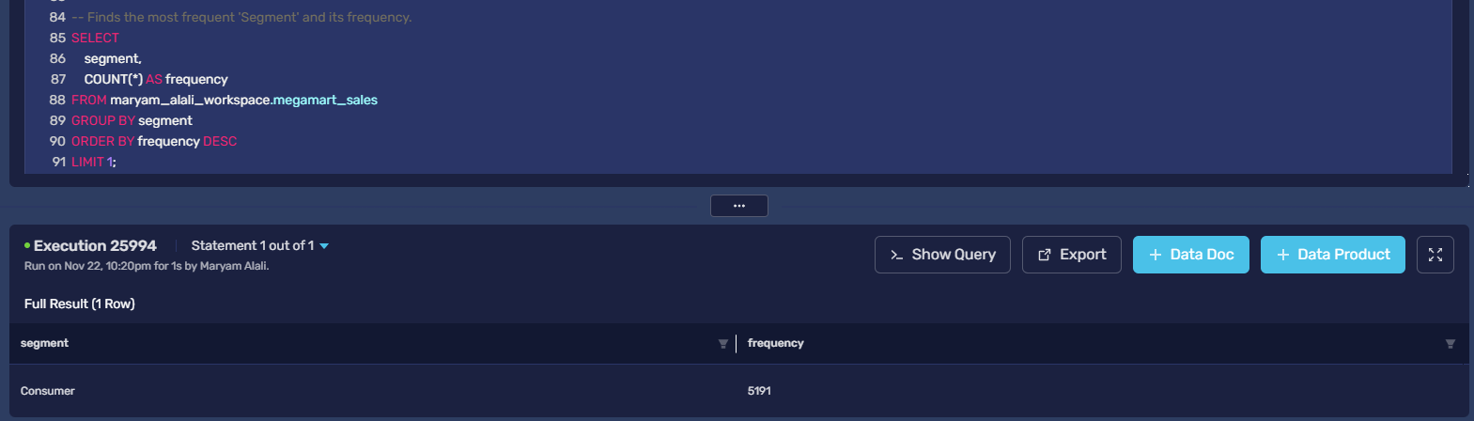
-- Finds the most frequent 'Region' and its frequency.
SELECT
region,
COUNT(*) AS frequency
FROM maryam_alali_workspace.megamart_sales
GROUP BY region
ORDER BY frequency DESC
LIMIT 1;
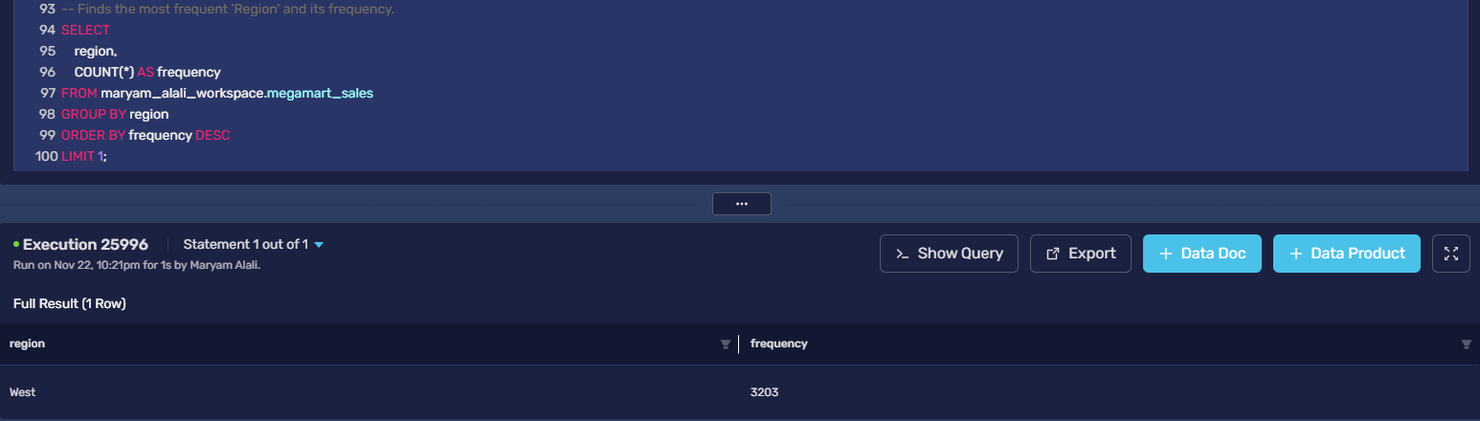
-- Finds the most frequent 'Category' and its frequency.
SELECT
category,
COUNT(*) AS frequency
FROM maryam_alali_workspace.megamart_sales
GROUP BY category
ORDER BY frequency DESC
LIMIT 1;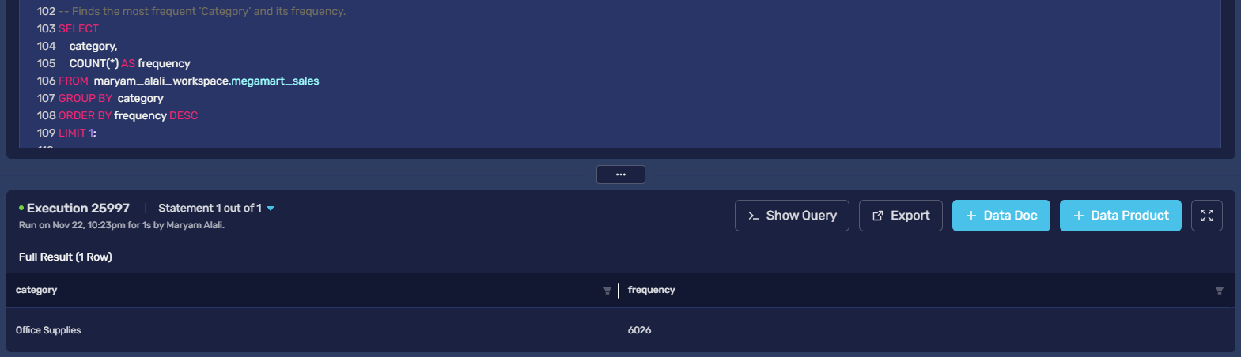
-- Finds the most frequent 'Subcategory' and its frequency.
SELECT
subcategory,
COUNT(*) AS frequency
FROM maryam_alali_workspace.megamart_sales
GROUP BY subcategory
ORDER BY frequency DESC
LIMIT 1;
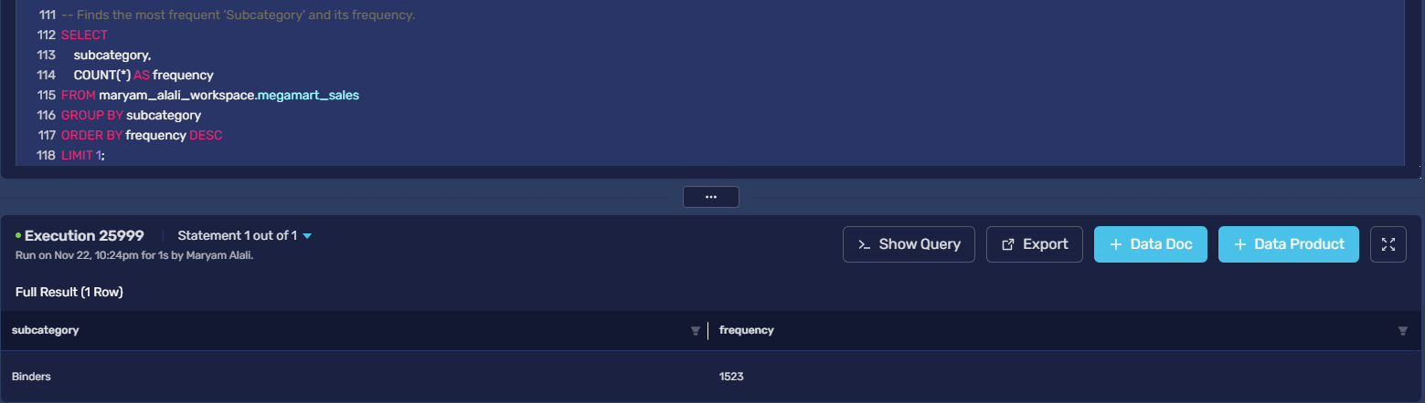
Data Quality analysis codes (missing values)
-- Counts missing values in the 'order_date' column
SELECT COUNT(*) AS missing_order_date
FROM maryam_alali_workspace.megamart_sales
WHERE order_date = '';
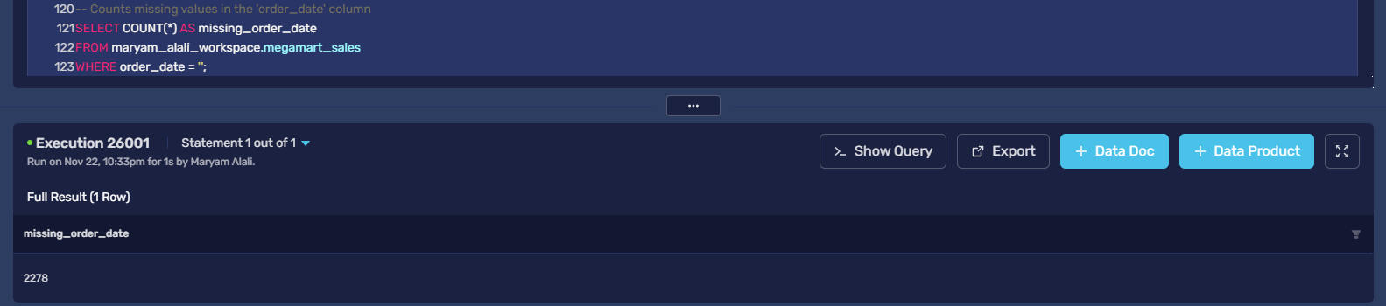
-- Counts missing values in the 'quantity' column
SELECT COUNT(*) AS missing_quantity
FROM maryam_alali_workspace.megamart_sales
WHERE quantity IS NULL;
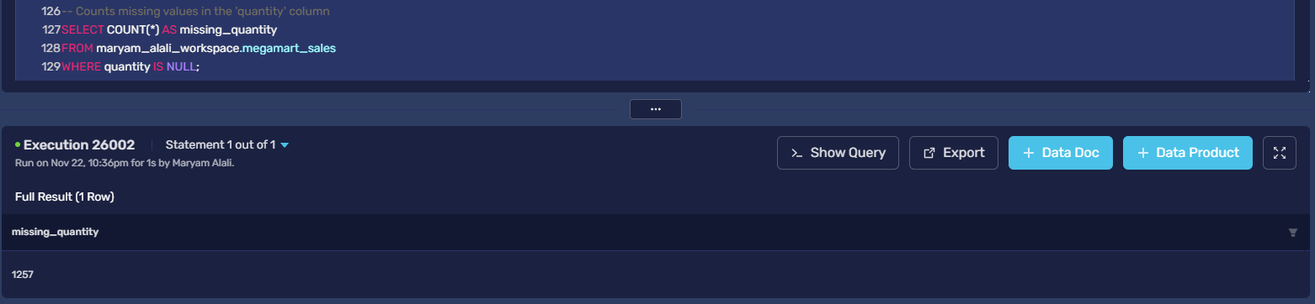

SELECT COUNT(*) AS missing_review
FROM maryam_alali_workspace.megamart_sales
WHERE review = '';
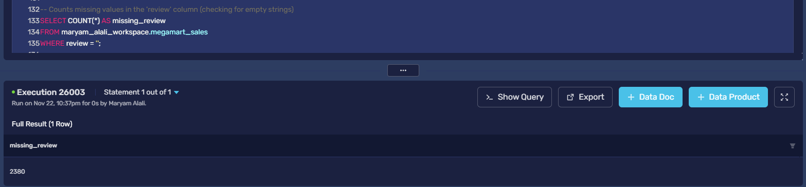
Outliers and Anomalies
-- Calculate the Q1, Q3, and IQR to define outlier boundaries for Sales and Profit
SELECT
-- For Sales
APPROX_PERCENTILE(Sales, 0.25) AS sales_q1,
APPROX_PERCENTILE(Sales, 0.75) AS sales_q3,
(APPROX_PERCENTILE(Sales, 0.75) - APPROX_PERCENTILE(Sales, 0.25)) AS sales_iqr,
(APPROX_PERCENTILE(Sales, 0.75) + 1.5 * (APPROX_PERCENTILE(Sales, 0.75) - APPROX_PERCENTILE(Sales, 0.25))) AS sales_upper_bound,
-- For Profit
APPROX_PERCENTILE(Profit, 0.25) AS profit_q1,
APPROX_PERCENTILE(Profit, 0.75) AS profit_q3,
(APPROX_PERCENTILE(Profit, 0.75) - APPROX_PERCENTILE(Profit, 0.25)) AS profit_iqr,
(APPROX_PERCENTILE(Profit, 0.25) - 1.5 * (APPROX_PERCENTILE(Profit, 0.75) - APPROX_PERCENTILE(Profit, 0.25))) AS profit_lower_bound,
(APPROX_PERCENTILE(Profit, 0.75) + 1.5 * (APPROX_PERCENTILE(Profit, 0.75) - APPROX_PERCENTILE(Profit, 0.25))) AS profit_upper_bound
FROM
maryam_alali_workspace.megamart_sales;
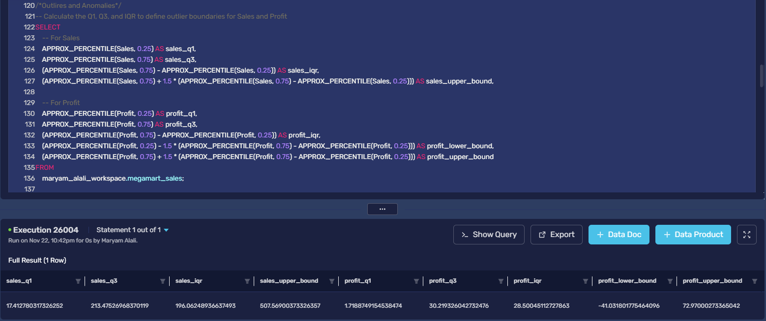
-- Counts high outliers for Sales using the calculated upper bound
SELECT COUNT(*) AS high_sales_outliers
FROM maryam_alali_workspace.megamart_sales
WHERE Sales > 507.57; -- Using the upper bound we just found
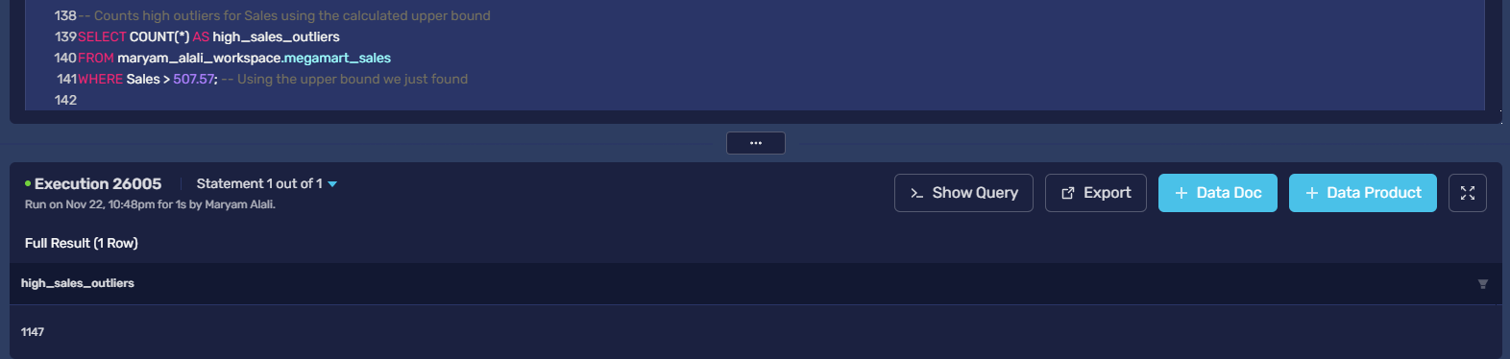
-- Finds and counts records with negative or zero quantity
SELECT COUNT(*) AS negative_quantity_records
FROM maryam_alali_workspace.megamart_sales
WHERE quantity <= 0;
