1. Method & Sample
We apply two post-hoc explanation methods to a stratified sample of 500 test instances (376 income ≤ 50K / 124 > 50K, preserving the 75.2/24.8 class split). SHAP uses TreeExplainer, computing exact Shapley values for the Random Forest and extracting the positive-class slice → (500 × 14) matrix. LIME uses LimeTabularExplainer fitted on the full 36,155-row training set; for each instance a locally-weighted ridge model is fitted over 1,000 perturbations, with weights extracted via feature index from local_exp[1] → (500 × 14) matrix. Both notebooks share sample_indices.npy to guarantee identical instances.
SHAP matrix | SHAP mean |v| | LIME matrix | LIME mean |w| | Rank diff (mean)
(500 × 14) | 0.0318 | (500 × 14) | 0.0789 (2.5× SHAP) | 3.00 / 14

2. Results
Feature Ranking: SHAP vs. LIME  Feature SHAP LIME |Δ|  relationship 1 6 5  education-num 2 5 3  marital-status 3 4 1  age 4 7 3  capital-gain 5 1 4  hours-per-week 6 3 3  occupation 7 11 4  sex 8 10 2  education 9 9 0  capital-loss 10 2 8  fnlwgt 11 12 1  workclass 12 13 1  race 13 14 1  native-country 14 8 6  Mean absolute rank difference 3.00 | Key Observations  SHAP distributes importance evenly across relational and educational features (relationship rank 1, mean |SHAP| = 0.077). LIME is dominated by capital-gain (mean |weight| = 0.594, 6.6× the second feature), reflecting the extreme leverage of this sparse feature on local linear boundaries. The largest divergences — capital-loss (diff 8), native-country (diff 6), relationship (diff 5) — imply that PGI/PGU masking will select different features per method, producing structurally different faithfulness profiles. Minority subgroups with small sample counts (Amer-Indian-Eskimo n=6, Other n=4, 65+ n=18) will yield high-variance metric estimates in the next step.  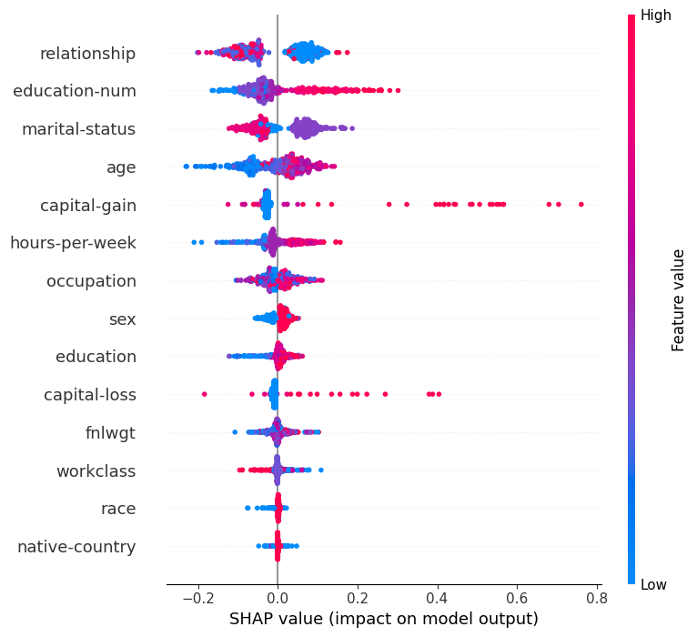  Fig. 1 — SHAP beeswarm (n=500). Each dot is one instance; colour = feature value (red high, blue low). relationship, education-num, marital-status dominate. capital-gain's wide spread reflects sparse but extreme values  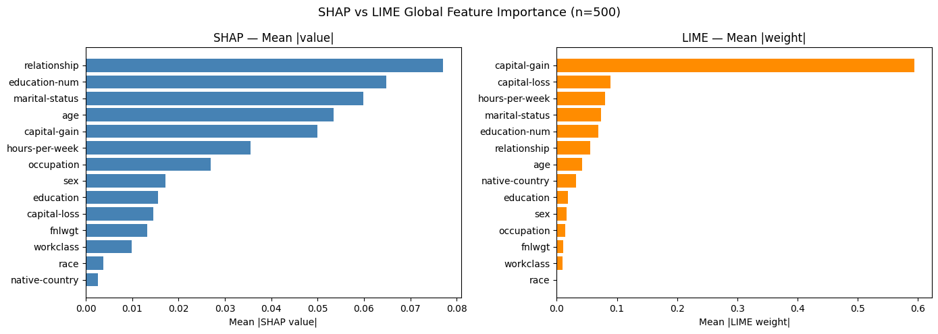  Fig. 2 — SHAP vs. LIME global importance. Left (blue): SHAP — evenly distributed. Right (orange): LIME — capital-gain bar dwarfs all others, making it the near-universal top-k choice in PGI masking regardless of subgroup

