MOUNT KENYA UNIVERSITY
CHAMAPLUS: A CREDIT-AWARE DECISION SUPPORT PLATFORM FOR INFORMAL SAVINGS GROUPS IN KENYA
BY
EDNA KEMUNTO BITANGE
BBIT/2023/41222
SCHOOL OF COMPUTING AND INFORMATICS
DEPARTMENT OF ENTERPRISE COMPUTING
A PROJECT REPORT SUBMITTED TO THE SCHOOL OF COMPUTING AND INFORMATICS IN PARTIAL FULFILLMENT OF THE REQUIREMENTS FOR THE AWARD OF THE DEGREE OF BACHELOR OF BUSINESS INFORMATION TECHNOLOGY OF MOUNT KENYA UNIVERSITY
2025/2026

DECLARATION
I declare that this project report is my original work and has not been submitted to any other institution for the award of a degree, diploma, or any other academic qualification.
All sources of information and ideas from other authors have been acknowledged appropriately through citations and references.
Student Name: ______________________________
Registration Number: ________________________
Signature: __________________________________
Date: ______________________________________
Supervisor's Declaration
I confirm that this project report has been submitted for examination with my approval as the appointed project supervisor.
Supervisor's Name: __________________________
Signature: __________________________________
Date: ______________________________________

APPROVAL
This project report titled: Chamaplus: A Credit-Aware Decision Support Platform for Informal Savings Groups in Kenya has been submitted for examination with the approval of the project supervisor.
Supervisor:
Name: _________________________________________
Signature: _____________________________________
Date: _________________________________________

DEDICATION
I dedicate this project to my family and everyone who supported me throughout my studies. Their encouragement, patience and support gave me the motivation to continue even when the development process became challenging.
I also dedicate this work to the members of informal savings groups whose everyday financial activities inspired the development of ChamaPlus.

ACKNOWLEDGEMENT
I would like to thank God for giving me the strength and determination to complete this project. I am grateful to my project supervisor for the guidance, corrections and advice provided throughout the development of the system and preparation of this report. I also appreciate the School of Computing and Informatics and the Department of Enterprise Computing/Information Technology for providing the academic environment and requirements that guided this project. Finally, I thank my family, friends and colleagues for their encouragement and support throughout the project. Their contribution, whether directly or indirectly, helped me complete this work.

ABSTRACT
Informal savings groups, commonly known as chamas, play an important role in collective saving, access to credit and investment among communities in Kenya. However, many groups continue to depend on manual records, spreadsheets and messaging platforms to manage contributions, loans, member information and group activities. These approaches can make it difficult to maintain accurate records, monitor loan repayments, generate timely reports and support consistent loan decision-making. This project developed ChamaPlus, a mobile-based credit-aware decision support platform for informal savings groups in Kenya. The system provides functionality for user and chama management, member management, contribution management, loan management, meetings and attendance, notifications, reporting and credit assessment. The platform also provides role-based access so that activities such as recording contributions, managing members and managing loan products are controlled according to the user's role within a chama. The system was developed using a mobile application and a web-based REST API backend. The mobile application was implemented using Flutter, while the backend was developed using Django and Django REST Framework. The backend uses a relational database and exposes versioned REST APIs through which the mobile application communicates with the system. Authentication uses token-based authentication, while role-based permissions are used to control access to chama activities. The system also includes dashboards and reporting features to provide summaries of contributions, loans, repayments, meetings and member performance. The project focused on building a functional prototype that addresses the identified problems of manual chama management while retaining human involvement in important decisions. In particular, the credit score is intended to support loan decisions rather than replace the chama committee's final decision. The completed system was tested at both unit and feature levels, with automated tests used throughout development to verify important functionality.
Keywords: ChamaPlus, chamas, informal savings groups, contribution management, loan management, credit scoring, mobile application, decision support, financial reporting.

TABLE OF CONTENT
DECLARATION ii
APPROVAL iii
DEDICATION iv
ACKNOWLEDGEMENT v
ABSTRACT vi
TABLE OF CONTENT vii
LIST OF TABLES xiii
LIST OF FIGURES xiv
LIST OF APPENDICES xv
CHAPTER ONE 1
INTRODUCTION 1
1.0 Introduction 1
1.1 Background of the Study 2
1.2 Problem Statement 2
1.3 Objectives of the Study 3
1.4 Scope and Limitations of the Study 4
1.5 Justification of the Study 4
1.6 Project Risks and Mitigation 5
1.7 Budget and Resources 5
CHAPTER TWO 6
LITERATURE REVIEW 6
2.0 Introduction 6
2.1 Informal Savings Groups 6
2.2 Digital Management of Savings Groups 7
2.3 Contribution Management 8
2.4 Loan Management 8
2.5 Credit Assessment and Decision Support 9
2.6 Governance and Committee Decision-Making 10
2.7 Reporting and Decision Support 10
2.8 Role-Based Access in Financial Systems 11
2.9 Existing System and Identified Gap 11
2.10 Summary of the Literature Review 12
CHAPTER THREE 14
RESEARCH METHODOLOGY 14
3.0 Introduction 14
3.1 Research Approach 14
3.2 System Development Methodology 15
3.2.1 Overview of SDLC Models 15
3.2.2 Agile Iterative and Incremental Methodology 15
3.2.3 Justification for Using Agile Iterative and Incremental Development 16
3.2.4 ChamaPlus Development Increments 17
3.3 Data Collection Methods 17
3.3.1 Requirements Discussions 17
3.3.2 Observation 18
3.3.3 Document and Literature Review 18
3.4 Data Analysis Techniques 18
3.5 Development and Testing Tools 18
3.5.1 Mobile Application Tools 18
3.5.2 Backend Tools 19
3.5.3 Database and Version Control 19
3.6 Project Schedule and Cost 19
3.7 Ethical and Security Considerations 19
CHAPTER FOUR 20
SYSTEM ANALYSIS AND REQUIREMENT MODELLING 20
4.0 Introduction 20
4.1 Analysis of the Current System 20
4.1.1 Description of Current Chama Operations 20
4.1.2 Limitations of the Current System 21
4.2 Description of the Proposed System 21
4.3 Fact-Finding and Data Gathering Methods 22
4.4 Functional Requirements 22
4.5 Non-Functional Requirements 24
4.6 User Roles and Actors 24
4.7 System Modelling 25
4.7.1 Use Case Analysis 25
4.7.2 Context-Level Data Flow Diagram 26
4.7.3 Level 1 Data Flow Diagram 26
4.7.4 Process Descriptions 27
4.8 Feasibility Study 28
4.8.1 Technical Feasibility 28
4.8.2 Economic Feasibility 28
4.8.3 Operational Feasibility 28
CHAPTER FIVE 29
SYSTEM DESIGN 29
5.0 Introduction 29
5.1 Architectural Design Overview 29
5.2 System Architecture 29
5.3 Mobile Application Design 30
5.4 Backend and API Design 31
5.5 Database Design 31
5.5.1 Conceptual Design 31
5.5.2 Logical Design 32
5.5.3 Physical Design 33
5.6 Credit Scoring Design 33
5.7 Security Design 34
5.8 Interface Design 35
5.8.1 Input Design 35
5.8.2 Output Design 35
5.9 Navigation and Screen Structure 36
CHAPTER SIX 37
SYSTEM IMPLEMENTATION AND TESTING 37
6.0 Introduction 37
6.1 Development Environment and Tools 37
6.2 Implementation Approach 37
6.3 Backend Implementation 38
6.4 Mobile Application Implementation 38
6.5 Module Implementation Summary 39
6.6 Test Plan 39
6.7 Testing Approach 40
6.7.1 Unit Testing 40
6.7.2 Widget and Screen Testing 40
6.7.3 API and Integration Testing 40
6.7.4 Regression Testing 40
6.8 Test Cases and Results 40
6.9 Changeover Strategy 42
6.10 Implementation Challenges 42
CHAPTER SEVEN 43
LIMITATIONS, CONCLUSIONS AND RECOMMENDATIONS 43
7.0 Introduction 43
7.1 Limitations of the Study 43
7.2 Conclusions 44
7.3 Recommendations 45
REFERENCES 46
APPENDICES 49

LIST OF TABLES
Table 1.1: Project Risks and Mitigation 5
Table 2.1 Credit-Scoring Model Factors 9
Table 2.2 compares manual chama management, existing digital approaches and the proposed ChamaPlus system across selected features. 11
Table 4.1 Functional requirements for ChamaPlus 22
Table 5.1 Main API resource groups 31
Table 5.2 Selected physical database tables 33
Table 5.3 Credit scoring weights and risk bands 34
Table 6.1 Module implementation summary 39
Table 6.2 Representative test cases and results 41
Table 7.1 Conclusion by project objective 44

LIST OF FIGURES
Figure 2.1 Conceptual Framework 12
Figure 3.1 Agile iterative development process for ChamaPlus 16
Figure 4.1 Use Case Diagram 25
Figure 4.2 Context-Level DFD (Level 0) 26
Figure 4.3: Level 1 Data Flow Diagram 27
Figure 5.1 System Architecture Diagram 30
Figure 5.2 Entity Relationship Diagram 32
Figure 5.3: Navigation/Screen Structure 36

LIST OF APPENDICES
APPENDIX I: PROJECT GANTT CHART 49
APPENDIX II: WORK BREAKDOWN STRUCTURE 50
APPENDIX III: PROJECT NETWORK DIAGRAM 51
APPENDIX IV: SAMPLE SOURCE CODE 52
APPENDIX V: USER MANUAL - CHAMAPLUS MOBILE APPLICATION 54

CHAPTER ONE

INTRODUCTION

1.0 Introduction
Informal savings groups, commonly referred to as chamas in Kenya, provide a way for people to save money collectively and support one another financially (Kimuyu, 1999). Members contribute agreed amounts, maintain group records, access loans where applicable, and participate in decisions concerning the management of group funds. As the number of members and financial transactions increases, keeping these records accurately becomes more demanding.
Traditionally, many informal savings groups depend on manual records, spreadsheets, mobile messaging applications and other separate methods to manage their activities. While these approaches can support basic record keeping, they can make it difficult to maintain consistent information about members, contributions, loans, repayments and group activities. They can also make it harder for members and committee officials to obtain a clear view of the group's current financial position.
ChamaPlus was developed to address these challenges through a centralized mobile-based platform for managing chama activities. The system brings together member management, contributions, loan management, meetings, notifications and reporting within one application. It also provides dashboards and credit-related information intended to support chama officials when reviewing member financial activity and making lending decisions.
The system consists of a mobile application and a backend application programming interface through which the mobile application communicates with the server. The application uses role-based access to distinguish activities available to different chama members and provides reporting functionality for viewing financial and operational information.
The project therefore focuses on developing a practical system that can improve the organization of chama records and make important group information easier to access while retaining the involvement of chama officials in decision-making.

1.1 Background of the Study
Chamas operate through collective financial activities in which members contribute funds and, depending on the group's rules, may access loans or participate in other financial activities. These activities require accurate records because contributions, loan balances, repayments, membership and group decisions need to be tracked over time.
As groups grow, relying on separate records and communication channels can create difficulties in maintaining a consistent view of the group's activities. Information may be distributed between contribution records, loan records, member lists and meeting records. Johnson and Nino-Zarazua (2011) note that informal savings arrangements in Kenya operate under different frameworks, which increases the need for organized digital record-keeping. This creates a need for a system that brings these activities together and provides authorized members with access to relevant information.
The ChamaPlus project was conceived as a response to this need. The approved project concept identifies the system as a credit-aware decision support platform for informal savings groups in Kenya, with emphasis on contribution management, loan management, credit assessment, committee decision-making and reporting. The proposed system was intended to provide a mobile platform through which chama activities could be managed in a more organized manner.
The completed system extends this concept into a working application covering chama onboarding and membership, contributions, loans, meetings and governance, notifications, reporting, user profiles and role-based access. Credit information is used as decision support rather than replacing the chama's own decision-making process.

1.2 Problem Statement
Informal savings groups need reliable records to manage their members, contributions, loans, repayments and other group activities. However, when these activities are managed using separate manual or semi-digital records, maintaining accurate and up-to-date information can become difficult.
The separation of member records, contribution records, loan information, meeting activities and reports can also make it difficult for chama officials to obtain a complete view of member participation and financial activity. In addition, preparing summaries and reports manually can require additional time and may increase the possibility of recording or calculation errors.
There is therefore a need for an integrated system that can provide a common platform for managing chama membership, contributions, loans, meetings and reporting while also providing useful financial information to support decision-making.
ChamaPlus addresses this problem by providing a centralized mobile platform that connects these activities through a common backend and database. The system provides role-based functionality, contribution and loan records, credit-related information, meeting management and reporting capabilities in one application.

1.3 Objectives of the Study
The general objective of this project was to design and develop ChamaPlus, a mobile-based credit-aware decision support platform that supports the management of members, contributions, loans, meetings, notifications, reports and other chama operations in Kenya.
The specific objectives of the study were:
1. To investigate the challenges experienced in managing chama membership and financial activities using conventional manual and semi-digital approaches.
2. To design and develop ChamaPlus, an integrated mobile platform supporting membership management, contributions, loans, governance, reporting and credit-aware decision support for chama operations in Kenya.
3. To test and evaluate the functionality, reliability and usability of the developed ChamaPlus prototype.
The research questions aligned with these objectives were:
- What challenges affect chama record-keeping and financial management?
- How can an integrated mobile platform support membership, financial operations, governance and credit-aware loan decisions?
- To what extent does ChamaPlus meet its functional and non-functional requirements?

1.4 Scope and Limitations of the Study
The scope of this project covered the design and development of a functional ChamaPlus prototype consisting of a Flutter mobile application and a Django REST Framework backend connected through versioned REST APIs and a MySQL relational database. The implemented scope included user registration and authentication, password reset, chama creation and joining, invite-code and phone-based invitations, membership and role management, contribution cycles and contribution recording, loan products and loan applications, committee voting, loan disbursement and repayments, credit scoring, meetings and attendance, meeting minutes and action items, notifications, dashboards, reports, exports, and profile or settings management.
The study did not include production deployment at national scale, direct M-Pesa or payment-gateway integration, direct SMS or email provider integration, a full web administration portal, biometric authentication, or multi-language support. These were treated as future enhancements. In addition, live synchronization required internet connectivity, some notification preferences remained locally managed until full backend preference APIs were completed, and credit scoring was limited to information recorded within the system.

1.5 Justification of the Study
This project was justified on academic, practical and social grounds. Academically, it provided an opportunity to integrate knowledge and skills acquired in software development, database design, mobile application development, security and project management within the Bachelor of Business Information Technology programme. Practically, chamas remain an important informal savings mechanism in Kenya, yet many groups still depend on fragmented manual records that make financial monitoring and committee decision-making difficult.
The project was also timely because mobile technology and digital financial services have expanded access to financial tools in Kenya (Johnson, 2016; Kusimba & Wanga, 2026). ChamaPlus was technically challenging because it required integration of authentication, role-based access, financial records, governance workflows, reporting and credit-related decision support within one maintainable architecture. The completed system benefits ordinary members through improved transparency, assists chairpersons, treasurers, secretaries and committee members through organized records and summaries, and provides a reference platform for future researchers and developers working on group savings systems.

1.6 Project Risks and Mitigation
Several project risks were identified during development together with corresponding mitigation measures, as summarized below.
Table 1.1: Project Risks and Mitigation
Risk | Potential Effect | Mitigation
Internet failure | Interrupted synchronization | Offline caching and retry mechanisms
Authentication failure | Users unable to access protected functions | JWT validation and token refresh
Data loss | Loss of financial and membership records | Relational database storage and backup practices
Unauthorized access | Exposure of sensitive chama information | JWT authentication and role-based access control
API failure | Mobile functions temporarily unavailable | Error handling, retries and user feedback
Development time constraints | Delayed completion of some modules | Prioritization and phased implementation
Deployment failure | System unavailable in target environment | Environment testing before deployment

1.7 Budget and Resources
The project relied mainly on accessible development resources. Hardware included a development computer and a smartphone or emulator for mobile testing. Software resources included Flutter, Dart, Django, Django REST Framework, MySQL, Git, GitHub, Cursor IDE and other open-source development tools. Human resources included the student developer, the project supervisor and peer support during requirements discussions. Other costs included internet connectivity, electricity, transport for requirements discussions where applicable, and printing and binding of the project report. Because the core technology stack was open source, software licensing costs were minimal.

CHAPTER TWO

LITERATURE REVIEW

2.0 Introduction
This chapter reviews literature related to the development of ChamaPlus. The review focuses on informal savings groups, digital management of savings activities, contribution and loan management, credit assessment and decision-support systems. It also considers existing approaches to managing chama activities and identifies the gap that the ChamaPlus project sought to address.
The purpose of the review was not only to describe existing approaches, but also to examine their relevance to the problem addressed by the project. This helped to establish the basis for combining contribution management, loan management, credit-related information, governance and reporting within one system.

2.1 Informal Savings Groups
Kimuyu (1999) observes that rotating savings and credit associations provide an important informal mechanism for pooling resources and accessing credit outside formal banking channels. In Kenya, such groups are widely known as chamas and remain relevant to household saving, group lending and collective investment. This context explains why accurate membership, contribution and loan records are central to effective chama administration.
FSD Africa (2016) further notes that savings-group programmes can improve financial inclusion by connecting community-based savings with broader financial services. Kusimba and Wanga (2026) add that digital platforms should address transparency and communication weaknesses in informal finance while preserving the mutuality that makes chamas effective. ChamaPlus was developed within this broader recognition that informal savings groups require better organized digital support rather than isolated manual processes.
Informal savings groups provide a mechanism through which members can pool their financial resources and access financial support within a group. In the Kenyan context, such groups are commonly referred to as chamas. Their activities may include regular contributions, lending among members, repayment of loans and collective decision-making.
The management of these activities requires reliable records. Contributions need to be associated with the correct members and periods, while loans require information about applications, approvals and repayments. Group officials also need access to membership and financial information when making decisions.
The ChamaPlus project was based on this understanding of the problem domain. Its architecture defines savings as a separate functional area covering contribution cycles and contribution records, while lending covers loan products, loan applications and repayments.
This separation is useful from a system design perspective because savings and lending involve related but different processes. At the same time, the activities need to be connected because a member's contribution and repayment behaviour can provide information relevant to lending decisions.

2.2 Digital Management of Savings Groups
Digital systems can bring activities that are normally maintained through separate records into a common platform. Ibtasam et al. (2019) argue that digitization of collaborative savings can improve transparency and record accuracy among low-income groups when supported by appropriate mobile tools. In the case of savings groups, this can include member records, contributions, loans, repayments and reports.
The ChamaPlus architecture was designed around this integrated approach. The system contains bounded contexts for identity and access, group management, savings, lending, governance and decision support. It also includes notifications and audit records as cross-cutting functions.
An integrated approach has an important advantage over treating each activity as an independent record. Information can be connected through a common member and chama identity. For example, contribution records can be associated with a member, while loan applications and repayments can also be associated with the same member. This makes it possible to generate member-level summaries without maintaining completely separate records.
However, digitizing records alone does not automatically solve all management problems. A digital system still depends on accurate information being entered and on appropriate access controls. ChamaPlus therefore combines data management with authentication and role-based access. The proposed architecture identifies JWT authentication and role-based access control as part of the identity and access context.

2.3 Contribution Management
Contribution management is a central part of savings-group administration. Members are expected to make contributions according to the arrangements established by their group. Maintaining these records manually can become increasingly difficult as the number of members and contribution periods increases.
A contribution management system needs to answer basic questions such as who contributed, how much was contributed, when the contribution was made and which contribution cycle it belongs to. These relationships form the basis for contribution histories and member summaries.
The ChamaPlus design therefore separates contribution cycles from individual contribution records. The architecture identifies contribution_cycles and contributions as the tables supporting cyclical savings tracking.
This design supports a clearer representation of recurring contributions. Instead of treating every payment as an isolated transaction, contributions can be associated with a particular cycle. This also provides a basis for reporting contribution performance over different periods.

2.4 Loan Management
Loan management involves several activities rather than a single transaction. A typical system needs to represent loan products, applications and repayments. Where group-based lending decisions are used, the system may also need to capture the decision-making process. Francois and Squires (2021) show that linking mobile money networks to group-based savings can improve financial coordination, highlighting the importance of integrating lending workflows with member financial records.
The ChamaPlus architecture defines lending as a lifecycle consisting of application, voting and repayment. The loan context contains loan products, loan applications and repayments. Governance separately contains committee votes and meetings.
This approach reflects the fact that loan administration involves both financial records and group governance. A loan application is a financial request, but its approval may be a group decision. Separating these concerns in the system allows each process to be managed while still connecting them through the relevant loan and member records.
The completed ChamaPlus implementation extends this model with loan-product management, loan applications, voting-related functionality, repayment records and loan dashboards. These functions provide the basic CRUD and reporting capabilities required for the project system.

2.5 Credit Assessment and Decision Support
Credit assessment is another important area of the project. The original system specification does not describe ChamaPlus as an autonomous lending system. Instead, it defines it as a decision-support system, with committee members retaining final authority over loan decisions. Mehmood et al. (2018) similarly emphasize that digital savings systems should support group decision-making rather than replace informal governance structures. Credit scores therefore provide recommendations rather than automatic approvals.
Table 2.1 Credit-Scoring Model Factors
Factor | Weight
Contribution consistency | 35%
Repayment history | 35%
Attendance | 15%
Membership duration | 15%
Total | 100%
The architecture documentation specifies these weights as part of the proposed scoring model.
The model is useful because it does not rely on only one aspect of a member's behaviour. Contribution consistency considers saving behaviour, repayment history considers previous lending activity, attendance provides an indication of participation, while membership duration provides additional context.
However, a numerical score has limitations. It is based on information available in the system and therefore cannot represent circumstances that have not been recorded. For this reason, using the score as decision support rather than an automatic lending decision is appropriate for the project.

2.6 Governance and Committee Decision-Making
Financial management within a chama is closely connected to group governance. Members and officials may need to attend meetings, record attendance, make decisions and maintain records of those decisions.
The ChamaPlus architecture includes governance as a separate functional context containing meetings, attendance and committee votes.
This is relevant to the project because loan decisions should not be viewed only as financial transactions. Where a chama uses committee-based approval, the system should also provide a way to represent the decision-making process.
The completed system therefore includes meetings and attendance functionality alongside the financial modules. This provides a connection between the operational activities of the chama and its governance processes.

2.7 Reporting and Decision Support
Reporting is important because recorded data becomes more useful when it can be converted into understandable summaries. Chama officials may need information about contributions, loans, repayments, member activity and other group activities without examining individual records one by one.
The original architecture includes reporting as a separate area and provides a chama reports endpoint in the proposed API structure.
The completed ChamaPlus application provides dashboards and reports covering areas such as monthly contributions, loans, repayments, attendance and member summaries. This allows information already stored in the system to be presented in a form that can support routine monitoring and decision-making.
The reporting approach also supports the project's requirement for reporting capabilities. Rather than creating reports as an isolated feature, ChamaPlus derives reports from the underlying contribution, loan, meeting and membership data.

2.8 Role-Based Access in Financial Systems
A system that manages financial and membership information needs to distinguish between users with different responsibilities. Not every member should be able to perform administrative or financial operations.
The ChamaPlus architecture defines roles including Chairperson, Treasurer, Secretary, Committee Member, Member and Administrator. It distinguishes the administrator as a platform-level role while the other roles are associated with a chama.
This approach was reflected in the implemented system. For example, contribution recording and loan-product management are restricted according to the user's chama role, while ordinary members can access information appropriate to their membership.
Role-based access therefore forms part of both security and business-process control. It reduces the possibility of users performing operations that fall outside their responsibilities.

2.9 Existing System and Identified Gap
The reviewed project materials identify several separate activities that need to be brought together: member management, contributions, loans, voting, credit scoring and reporting. The architecture also identifies governance, notifications and audit logging as supporting functions.
Table 2.2 compares manual chama management, existing digital approaches and the proposed ChamaPlus system across selected features.
Feature | Manual Chama Management | Existing Digital Tools | ChamaPlus
Member management | Limited or paper-based | Available in some systems | Yes
Contribution tracking | Manual | Partial | Yes
Contribution cycles | Manual | Varies | Yes
Loan management | Manual | Varies | Yes
Committee voting | Limited | Rare or varies | Yes
Meetings and attendance | Manual | Partial | Yes
Credit scoring | Usually absent | Limited | Yes
Notifications | Manual or informal | Varies | Yes
Dashboards | Not available | Varies | Yes
Reports | Manual | Varies | Yes
Role-based access | Informal | Varies | Yes
Earlier systems such as the Chama Online Management System (COMS) demonstrated the value of digitizing chama records through web-based platforms, but many implementations have addressed individual functions rather than integrating savings, lending, governance, credit support and reporting within one mobile decision-support environment (Koskey, 2016).
A key gap identified from the project analysis was therefore not simply the absence of digital records, but the lack of an integrated platform connecting these activities.
A system that manages contributions without connecting them to member records and loan information would provide only part of the required functionality. Similarly, a loan system without repayment history and member-level information would provide limited support for credit assessment. ChamaPlus addresses this gap by connecting the different activities through a common chama and membership structure.
The system also differs from an autonomous lending platform because the credit score is used as a recommendation while the chama committee retains authority over lending decisions.
Figure 2.1 presents the conceptual framework for ChamaPlus. The framework shows how inputs such as members, contributions, loans, meetings, attendance and governance decisions are processed within the ChamaPlus system to produce outputs such as dashboards, notifications, reports, financial summaries and credit-related decision support information.
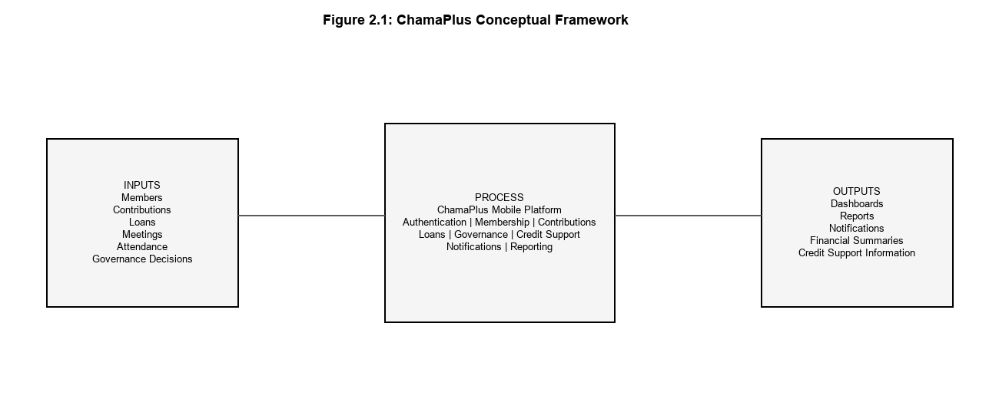
Figure 2.1 Conceptual Framework

2.10 Summary of the Literature Review
The review examined the main areas related to the ChamaPlus project: informal savings-group management, digital record management, contributions, loans, credit assessment, governance, reporting and role-based access.
The review shows that the different activities are closely related. Contribution and repayment records can provide information useful for member summaries and credit assessment, while governance processes provide the human decision-making context around activities such as loan approval.
The main gap addressed by ChamaPlus is therefore the integration of these activities into one mobile-based decision-support platform. The project combines group management, contribution management, loan management, governance, credit-related information, notifications and reporting while maintaining role-based access and human control over important decisions.

CHAPTER THREE

RESEARCH METHODOLOGY

3.0 Introduction
This chapter describes the research and development methodology used to produce ChamaPlus. It explains the research approach, the system development methodology, data collection methods, data analysis techniques, development and testing tools, project schedule and cost, and ethical considerations. Detailed system analysis, design specifications, implementation evidence and test results are presented in Chapters Four, Five and Six respectively.
The methodology combines two related but distinct components. The research approach is applied design-and-development research, because the project addressed a practical problem in chama management and produced a working software artefact for evaluation. The software development methodology is Agile iterative and incremental development, because ChamaPlus was built progressively in functional modules with continuous testing and refinement. Creswell and Creswell (2023) note that the research approach should align with the purpose of the study; Pressman and Maxim (2019) and Sommerville (2016) similarly emphasize that the development methodology should match the nature of the system being constructed.

3.1 Research Approach
The project adopted an applied design-and-development research approach. The approach was appropriate because the study was directed toward addressing a practical problem in the management of informal savings groups through the development of a functional software artefact. Rather than focusing solely on describing the challenges experienced by savings groups, the project translated the identified requirements into a technological solution and evaluated the resulting system through functional and automated testing.
The research process involved understanding the problem domain, identifying system requirements, designing the proposed solution, implementing the system and evaluating its functionality. This approach therefore connected the investigation of the problem with the design and development of ChamaPlus as a practical intervention. Literature on informal savings groups in Kenya provided context for the problem domain (Kimuyu, 1999; Johnson & Nino-Zarazua, 2011; Kusimba & Wanga, 2026).

3.2 System Development Methodology

3.2.1 Overview of SDLC Models
Software development life cycle (SDLC) models provide structured frameworks for planning, building and delivering software systems. Common models include Waterfall, Incremental, Spiral and Agile approaches (Pressman & Maxim, 2019; Sommerville, 2016). The Waterfall model assumes relatively stable requirements and sequential completion of phases before the next phase begins. Agile approaches, by contrast, emphasize iterative delivery, continuous feedback and progressive refinement of working software increments.
For ChamaPlus, an Agile iterative and incremental methodology was more appropriate than a strict Waterfall approach because the system consisted of multiple interconnected modules that were implemented, tested and refined progressively. Authentication and membership were developed before dependent financial modules, testing occurred throughout development, and mobile-backend integration required repeated correction and improvement.

3.2.2 Agile Iterative and Incremental Methodology
The development of ChamaPlus adopted an Agile iterative and incremental methodology. The methodology was selected because the system consisted of multiple interconnected functional modules whose requirements and implementation details required progressive refinement during development. Beck et al. (2001) describe Agile development as an approach that values working software, customer collaboration and responsiveness to change; in this project, those principles were applied through module-based delivery and repeated testing rather than through a formal Scrum framework.
Rather than implementing the entire system as one large sequential build, development was organized into functional increments. Core authentication and membership functionality were implemented first because other modules depended on authenticated users and chama membership. Contribution management was subsequently implemented, followed by loan management, governance and meeting functionality, credit assessment, notifications, reporting and dashboard features.
Each development increment involved requirements analysis, design, implementation and testing. Feedback obtained during testing was used to identify defects, improve existing functionality and refine integration between the mobile application and backend services. The overall development cycle is represented in Figure 3.1.
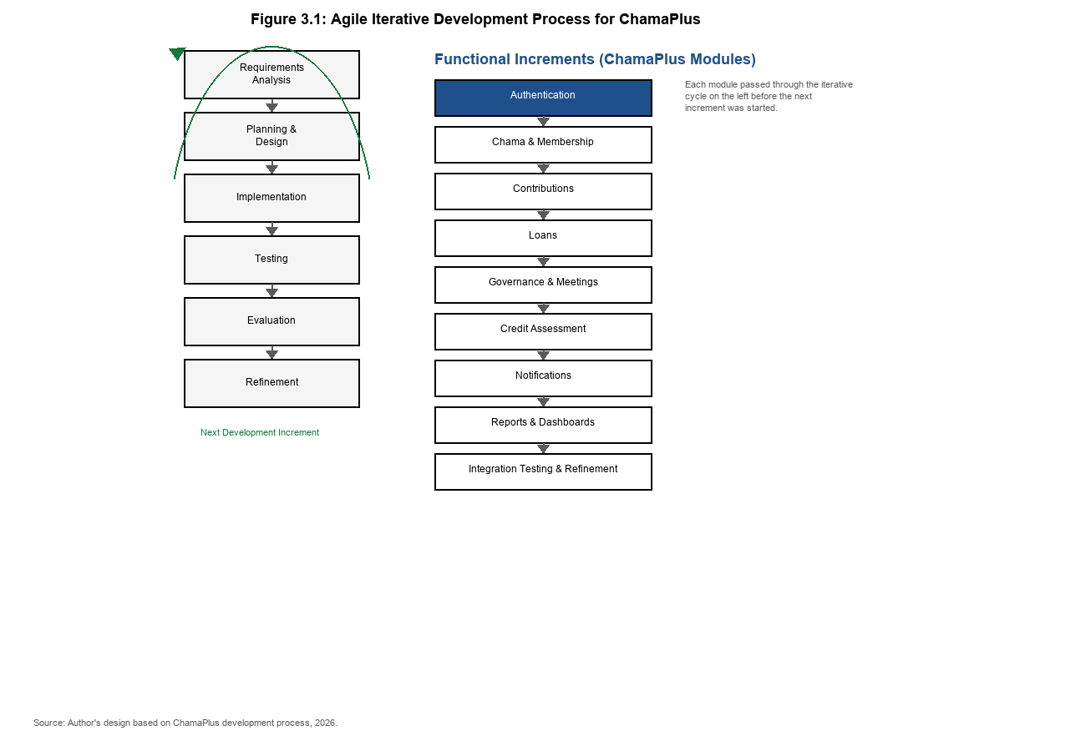
Figure 3.1 Agile iterative development process for ChamaPlus
Source: Author's design, 2026.
The iterative cycle followed in the project can be summarized as: Requirements Analysis → Planning and Design → Implementation → Testing → Evaluation and Refinement → Next Increment. This cycle was repeated until the major functional requirements of ChamaPlus had been implemented and integrated.

3.2.3 Justification for Using Agile Iterative and Incremental Development
Agile iterative and incremental development was selected for ChamaPlus for the following reasons. First, features were implemented progressively rather than in one final delivery, which reduced the risk of discovering major integration problems late in the project. Second, authentication and membership were established before dependent modules such as contributions and loans, which reflects incremental dependency management. Third, testing was conducted throughout development through automated backend and mobile test suites, allowing defects to be corrected before subsequent increments were completed. Fourth, mobile and backend integration required repeated refinement as APIs, repositories and user interfaces were improved. Fifth, reusable interface components and architectural patterns were improved progressively as more modules were added.
Scrum was not used because the project did not follow formal Scrum ceremonies such as sprint planning, daily stand-up meetings, sprint reviews and sprint retrospectives with assigned Product Owner and Scrum Master roles. The project therefore adopted the broader Agile iterative and incremental methodology, which more accurately represents the way ChamaPlus was developed.

3.2.4 ChamaPlus Development Increments
The major development increments for ChamaPlus were implemented in the following order: authentication; chama and membership management; contributions; loans; governance and meetings; credit assessment; notifications; reports and dashboards; and integration testing with final refinement. This sequence allowed each module to be validated before additional dependent functionality was added.

3.3 Data Collection Methods
The techniques used to collect facts and data for ChamaPlus are described below. These methods satisfy the MKU requirement to explain how information was obtained before system analysis and design.

3.3.1 Requirements Discussions
Requirements discussions were used to identify the activities the proposed system needed to support, including member registration, chama creation and joining, contributions, loans, meetings, notifications and reporting. The target users included chama officials such as the Chairperson, Treasurer and Secretary, as well as ordinary members and committee members. Information obtained from these discussions was translated into functional requirements and later into system modules.

3.3.2 Observation
Observation was used to understand how activities such as contributions, membership management and loan processing are currently performed in manual or semi-digital environments. This helped identify the information users need to enter, the outputs they expect to receive, and the control points required for role-based chama administration.

3.3.3 Document and Literature Review
The approved project concept, project requirements and relevant literature were reviewed to ensure that the developed system remained within scope. Literature on informal savings groups, digital finance and chama digitization provided supporting evidence on the problem context and existing approaches (Kimuyu, 1999; FSD Africa, 2016; Koskey, 2016; Ibtasam et al., 2019). The review also helped confirm the minimum system functions required, including CRUD operations, reporting and role-based access control.

3.4 Data Analysis Techniques
Information collected during requirements analysis was analysed by grouping related activities into functional areas such as identity and access, membership, contributions, lending, governance, notifications and reporting. Related requirements were then prioritised and converted into system specifications. Structured requirement tables, use case analysis and data flow diagrams were used as analysis tools in Chapter Four to represent actors, processes and information flows (Pressman & Maxim, 2019). This prevented unrelated functions from being combined and provided a logical basis for the modular application architecture.

3.5 Development and Testing Tools
The tools used to implement and test ChamaPlus are summarised below.

3.5.1 Mobile Application Tools
The mobile application was developed using Flutter and Dart (Google, n.d.; Flutter, n.d.). Flutter supports cross-platform mobile development from a shared codebase. The application used feature-based architecture with Riverpod for state management and GoRouter for navigation. Automated unit and widget tests were executed using the Flutter testing framework (Flutter, n.d.).

3.5.2 Backend Tools
The backend was developed using Django and Django REST Framework (Django Software Foundation, n.d.). It exposes versioned REST APIs consumed by the mobile application and implements authentication, chama management, contributions, loans, meetings, notifications, reports and credit scoring. API endpoints were tested using pytest.

3.5.3 Database and Version Control
MySQL was used as the relational database for storing users, chamas, memberships, contributions, loans, meetings, notifications and audit records. Git and GitHub were used for source-code management and change tracking throughout the project.

3.6 Project Schedule and Cost
Project scheduling was aligned with the Agile iterative development approach described in Section 3.2. Although the overall project timeline was planned using the work breakdown structure and schedule presented in Section 1.8 and in Appendices A, B and C, implementation proceeded incrementally by module rather than as one single end-phase delivery. Each increment included its own design, implementation and testing activities before the next module was started.
Project cost was kept relatively low because the selected technologies were open-source and development was carried out using locally available hardware and software resources described in Section 1.7. The main project constraints were time and connectivity rather than software licensing cost.

3.7 Ethical and Security Considerations
The project involved information relating to users, membership and financial activities. Authentication and role-based access control were therefore implemented to protect sensitive records. The credit score was designed as decision support rather than an automatic loan approval mechanism, preserving committee authority over lending decisions. Sensitive configuration values and signing credentials were excluded from source control, and production-hardening practices were applied before deployment preparation.

CHAPTER FOUR

SYSTEM ANALYSIS AND REQUIREMENT MODELLING

4.0 Introduction
This chapter presents the system analysis and requirement modelling for ChamaPlus. It describes how informal savings groups currently manage their activities, identifies the limitations of manual and fragmented approaches, and defines the requirements for the proposed mobile-based platform. The analysis is supported by requirements discussions, observation of chama management practices, review of the approved project concept, and review of relevant literature on informal finance and digital savings groups (Kimuyu, 1999; Johnson & Nino-Zarazua, 2011; Ibtasam et al., 2019; Kusimba & Wanga, 2026). System modelling tools including use case analysis and data flow diagrams are used to represent the proposed system's actors, processes and information flows (Makalew, 2022; Hutomo & Ilham, 2024).

4.1 Analysis of the Current System

4.1.1 Description of Current Chama Operations
In Kenya, chamas operate as informal, member-managed financial groups in which participants contribute funds regularly and may access loans or collective investment opportunities depending on group rules (Kimuyu, 1999; Kusimba & Wanga, 2026). Kimuyu (1999) estimated that between 45% and 50% of Kenyan households participate in such groups, indicating their importance in household saving and financial support. Johnson and Nino-Zarazua (2011) further observed that different chama types, including merry-go-round, welfare and savings-and-investment groups, operate under distinct frameworks and therefore create different record-keeping and decision-making demands.
In conventional practice, many chamas maintain membership lists, contribution records, loan applications, repayment histories, meeting attendance and financial summaries using separate tools such as paper ledgers, exercise books, spreadsheets, WhatsApp messages and verbal reports during meetings. Treasurers may record contributions manually after each cycle, while secretaries may track attendance separately. Loan requests may be discussed in meetings and approved informally before amounts and repayment schedules are written down later. Although these methods can work for small groups with few transactions, they become increasingly difficult to manage as membership and financial activity grow.

4.1.2 Limitations of the Current System
Analysis of the current/manual approach revealed several operational weaknesses aligned with findings in the literature on informal savings groups. First, records are often fragmented across different books, files and communication channels, making it difficult to obtain a single view of a member's contributions, loans, repayments and attendance (Ibtasam et al., 2019). Second, manual calculation of balances, arrears and group summaries increases the risk of error and delays reporting to members and officials (Hutomo & Ilham, 2024). Third, loan decisions may rely on incomplete information because contribution history, repayment behaviour and attendance records are not always available in one place at the time of approval.
Kusimba and Wanga (2026) note that a major weakness of informal finance is transparency and communication, especially when records depend heavily on interpersonal trust rather than shared digital records. Manual systems also provide limited support for role separation; for example, it may be unclear which official recorded a contribution or approved a loan. Finally, preparing reports for committee review often requires time-consuming manual consolidation, which reduces the frequency and reliability of financial monitoring. These limitations created the need for an integrated digital platform such as ChamaPlus.

4.2 Description of the Proposed System
ChamaPlus is proposed as a mobile-based credit-aware decision support platform that centralizes chama membership, contributions, loans, governance, notifications, reporting and credit-related information within one application supported by a REST API backend. Rather than replacing committee authority, the system is intended to organize records, improve transparency and provide summaries that support human decision-making during activities such as loan approval.
The proposed system supports the full chama lifecycle from user registration and authentication through chama creation or joining, membership management, contribution cycles, loan products, loan applications, committee voting, repayments, meetings, attendance, notifications, dashboards and reports. Research on digital ROSCA platforms suggests that digitization can strengthen informal savings groups by improving record-keeping, reducing delayed payments and creating payment histories that may support financial credibility assessment (Ibtasam et al., 2019; Francois & Squires, 2021). ChamaPlus extends this idea to an accumulating savings and credit association environment in which savings, lending, governance and reporting occur within one integrated platform.

4.3 Fact-Finding and Data Gathering Methods
The facts and data used in this chapter were gathered through the methods described in Chapter Three. Requirements discussions helped identify the activities that chama officials and members needed to perform digitally, including registering members, recording contributions, processing loans, managing meetings and generating reports. Observation helped translate these activities into information inputs and outputs required by the system. Document and requirement review ensured that the analysed system remained aligned with the approved project concept and the implemented ChamaPlus prototype.
Literature review supplemented the primary fact-finding process by providing evidence on the structure of Kenyan chamas, the limitations of manual management and the potential value of mobile-based group finance systems (Kimuyu, 1999; Johnson & Nino-Zarazua, 2011; Kusimba & Wanga, 2026). Earlier local systems such as the Chama Online Management System (COMS) also provided insight into how chama records could be digitized, although ChamaPlus was designed as a mobile-first platform with broader integration of lending, governance, reporting and credit support (Koskey, 2016).

4.4 Functional Requirements
Functional requirements define what the system must allow authorized users to do. They were derived from the problem analysis, project objectives and implemented system modules. The main functional requirements for ChamaPlus are summarized in Table 4.1.
Table 4.1 Functional requirements for ChamaPlus
Requirement ID | Requirement | Description
FR-01 | User registration and authentication | Allow users to register, log in, log out and reset passwords securely.
FR-02 | Chama creation and joining | Allow users to create a chama or join using invite codes or approved join requests.
FR-03 | Membership management | Allow authorized officials to invite members, approve join requests and manage membership status.
FR-04 | Role management | Allow the Chairperson to assign chama roles such as Treasurer, Secretary and Committee Member.
FR-05 | Contribution cycle management | Allow authorized officials to create and manage contribution cycles.
FR-06 | Contribution recording | Allow authorized officials to record contributions and allow members to view contribution history.
FR-07 | Loan product management | Allow authorized officials to create, update and manage loan products.
FR-08 | Loan application processing | Allow members to submit loan applications and allow officials to review them.
FR-09 | Committee voting | Allow committee members to participate in loan approval decisions.
FR-10 | Loan repayment tracking | Allow authorized users to record and monitor loan repayments and outstanding balances.
FR-11 | Credit score support | Generate credit-related information to support loan decisions without automatic approval.
FR-12 | Meeting management | Allow officials to schedule meetings and manage attendance, minutes and action items.
FR-13 | Notifications | Provide in-app notifications for important chama events and status changes.
FR-14 | Dashboards and reports | Provide summaries of contributions, loans, repayments, attendance and member performance.
FR-15 | Profile and settings | Allow users to manage profile details and relevant application settings.

4.5 Non-Functional Requirements
Non-functional requirements define the quality attributes of the system. These requirements were informed by security expectations for financial applications, mobile usability considerations and software engineering best practices for maintainable systems (Makalew, 2022; Hutomo & Ilham, 2024).
Table 4.2 Non-functional requirements for ChamaPlus
Requirement ID | Category | Description
NFR-01 | Security | Protected resources shall require authentication and role-based authorization.
NFR-02 | Usability | The mobile interface shall provide clear navigation and understandable forms.
NFR-03 | Reliability | The system shall handle common network and API failures without crashing.
NFR-04 | Performance | Frequently accessed information shall load efficiently on supported mobile devices.
NFR-05 | Maintainability | The application shall use modular architecture to support future changes.
NFR-06 | Scalability | The system shall allow additional chama features without full restructuring.
NFR-07 | Accessibility | The interface shall support text scaling and semantic labels where applicable.
NFR-08 | Data integrity | Financial and membership records shall be validated before submission.
NFR-09 | Auditability | Important administrative and financial actions shall be traceable through system records.

4.6 User Roles and Actors
ChamaPlus distinguishes platform-level and chama-level actors. At platform level, the Administrator manages system-wide operations. At chama level, the main actors are the Chairperson, Treasurer, Secretary, Committee Member and ordinary Member. A Guest or Invited User represents a person who receives an invitation but has not yet joined a chama. Role-based access control ensures that each actor interacts only with functions appropriate to their responsibilities, which is important in financial systems where not every member should perform administrative or financial operations (Johnson, 2016).

4.7 System Modelling
The proposed system was modelled using standard system analysis tools. Use case analysis was used to represent interactions between actors and system functions. Data flow diagrams were used to show how information moves between users, processes and data stores. These models provide a structured basis for the detailed design presented in Chapter Five and the implementation described in Chapter Six (Makalew, 2022).

4.7.1 Use Case Analysis
Figure 4.1 presents the ChamaPlus use case diagram. The diagram shows that authenticated users interact with membership management, contribution management, loan management, governance, notifications and reporting. Credit assessment is represented as a decision-support function linked to loan review rather than as an autonomous approval mechanism. Optional external services such as SMS, email and payment gateways are shown as future integrations rather than as core implemented actors.
Figure 4.1 Use Case Diagram
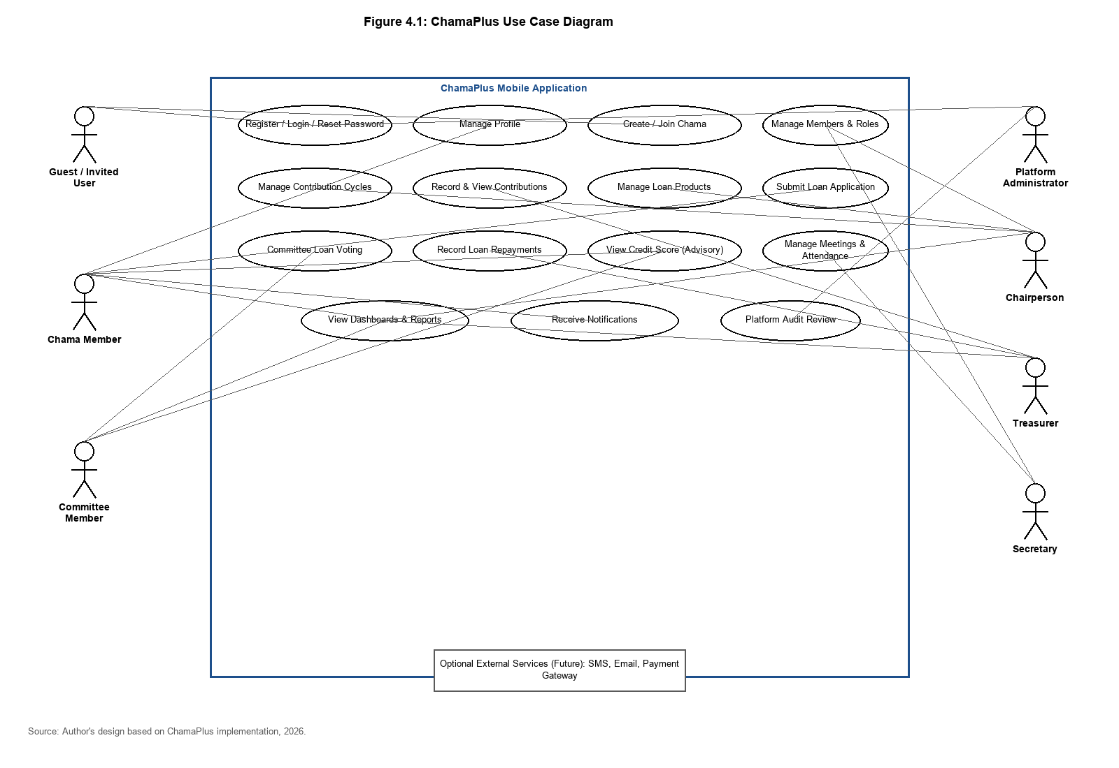
The main use case groups include: (1) authenticate and manage profile; (2) create or join a chama; (3) manage memberships and roles; (4) create contribution cycles and record contributions; (5) manage loan products, applications, voting and repayments; (6) manage meetings, attendance, minutes and action items; (7) receive notifications; and (8) view dashboards and reports.

4.7.2 Context-Level Data Flow Diagram
The context-level DFD in Figure 4.2 shows ChamaPlus as a single process interacting with external entities. The main external entities are the Mobile User, Chama Official and Platform Administrator. The system receives registration details, contribution records, loan requests, meeting information and role-management commands, and produces dashboards, reports, notifications, credit-support information and membership status responses.
Figure 4.2 Context-Level DFD (Level 0)
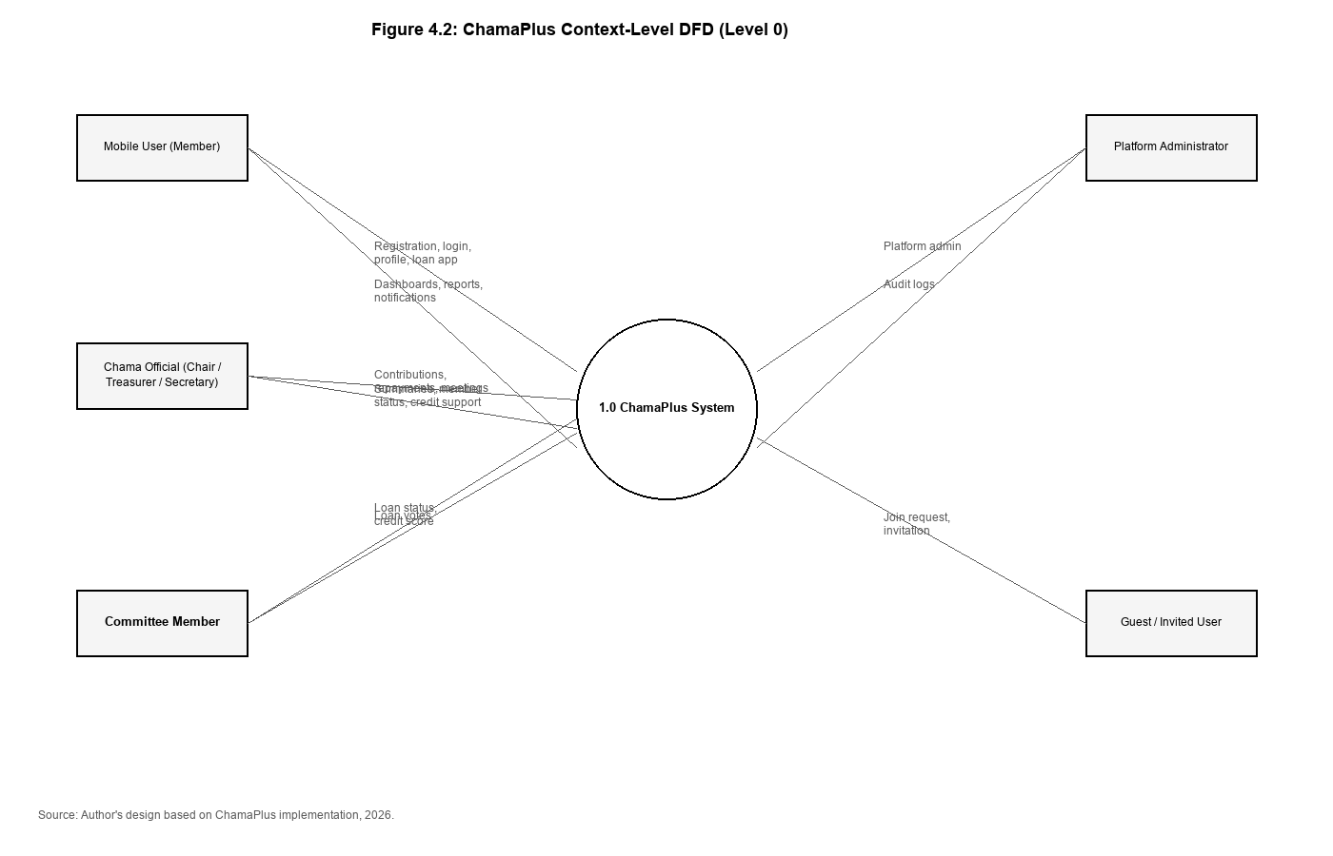

4.7.3 Level 1 Data Flow Diagram
The Level 1 DFD in Figure 4.3 decomposes ChamaPlus into major processes corresponding to the implemented modules. These processes are: 1.0 Authenticate User; 2.0 Manage Chama Membership; 3.0 Manage Contributions; 4.0 Manage Loans; 5.0 Manage Governance; 6.0 Generate Reports and Dashboards; and 7.0 Manage Notifications. Shared data stores include User Records, Chama Records, Membership Records, Contribution Records, Loan Records, Meeting Records and Notification Records.
Figure 4.3: Level 1 Data Flow Diagram
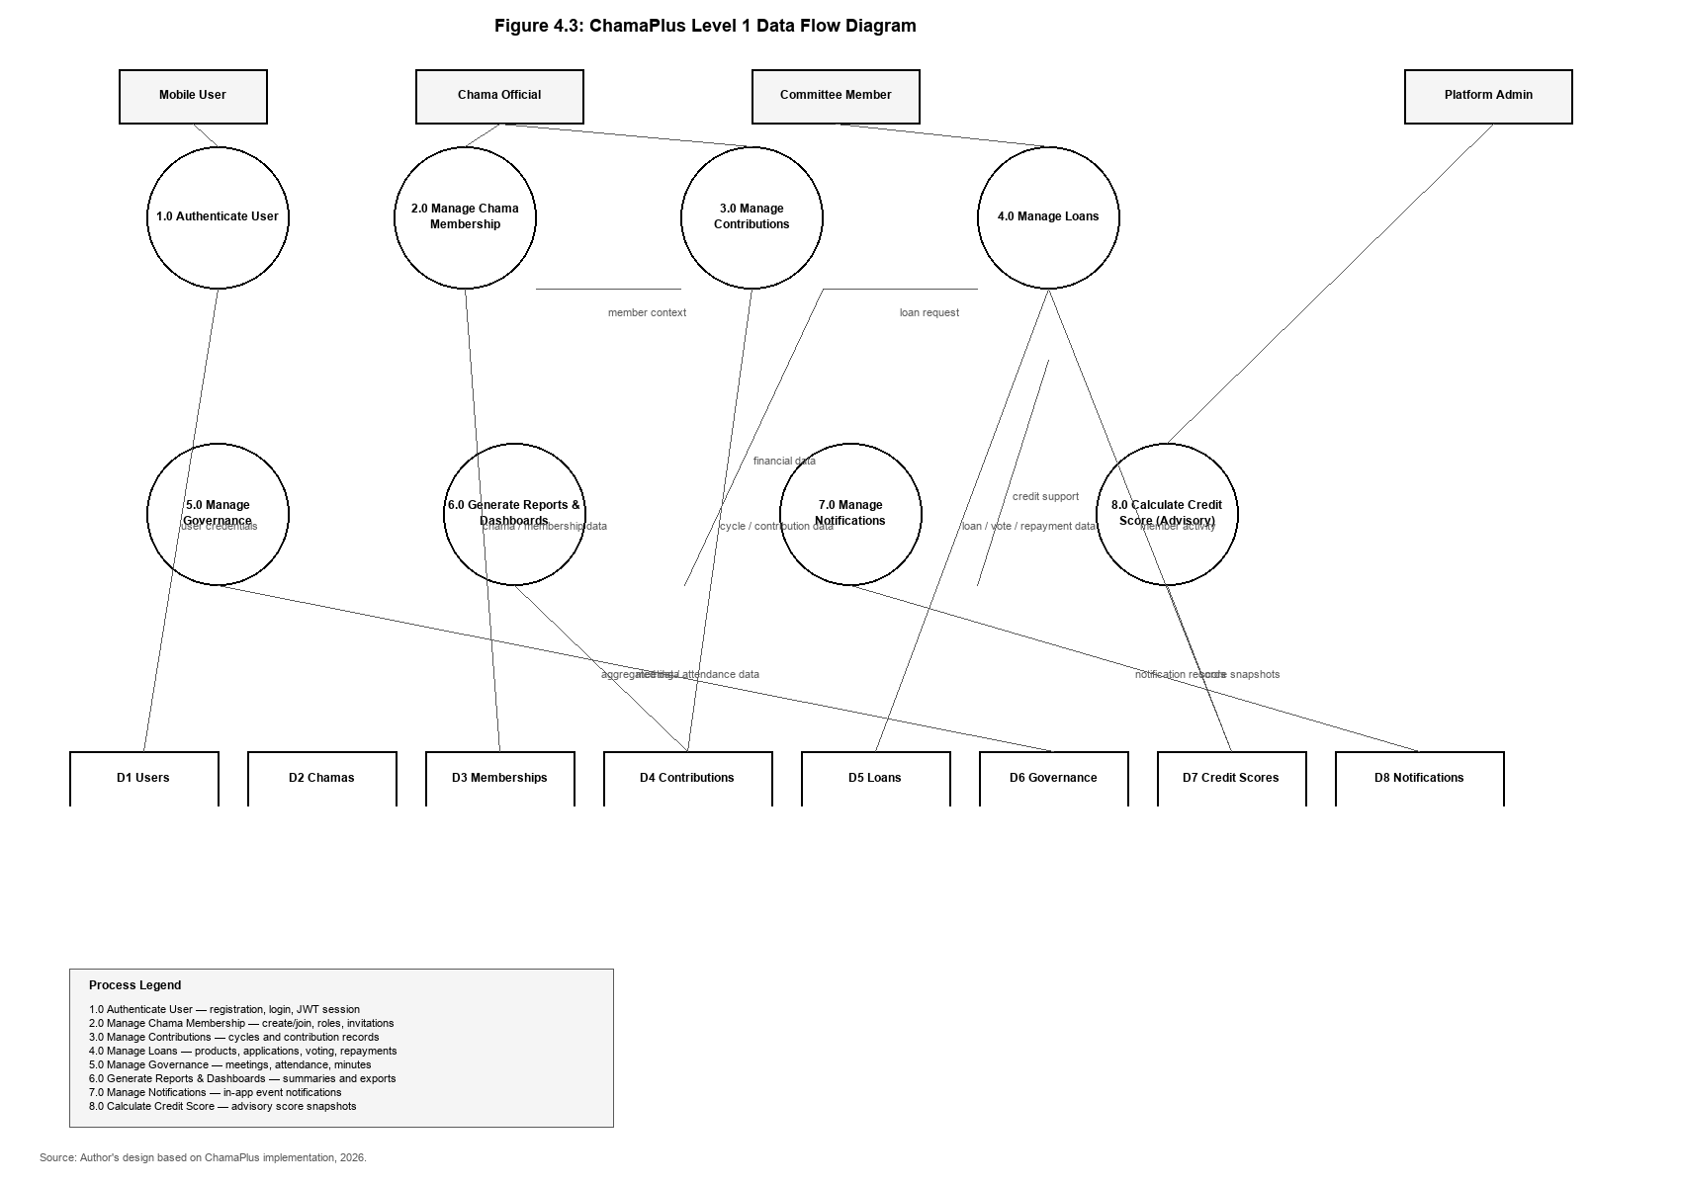

4.7.4 Process Descriptions
Process 1.0 handles registration, login, logout, password reset and token-based session management. Process 2.0 handles chama creation, invite codes, join requests, role assignment and membership status changes. Process 3.0 manages contribution cycles and contribution entries. Process 4.0 manages loan products, applications, committee voting, disbursement and repayments. Process 5.0 manages meetings, attendance, minutes and action items. Process 6.0 aggregates stored data into dashboards and exportable reports. Process 7.0 creates and delivers in-app notifications based on system events.

4.8 Feasibility Study

4.8.1 Technical Feasibility
The project was technically feasible because the selected technologies were mature, well documented and suitable for mobile-to-server application development. Flutter provided a cross-platform mobile interface, Django REST Framework provided a secure API layer, and MySQL provided relational storage for financial and membership records. Similar mobile financial information systems have been successfully implemented using comparable architectures (Hutomo & Ilham, 2024; Makalew, 2022). The implemented prototype confirmed that the proposed modules could be integrated through versioned REST APIs.

4.8.2 Economic Feasibility
The system was economically feasible because the core development stack was open source. The main costs were associated with hardware, internet access, testing devices and developer time rather than software licensing. For chama groups, the long-term benefit expected from improved record-keeping, reduced manual effort and better decision support was considered to outweigh the development and deployment costs of the prototype.

4.8.3 Operational Feasibility
Operationally, the system was feasible because its functions correspond directly to activities already performed by chama officials and members. Mobile access also reflected the widespread use of smartphones in Kenya and the familiarity of users with mobile applications in financial services (Kusimba & Wanga, 2026). The role-based design further supported operational feasibility by mapping system permissions to existing chama roles such as Chairperson, Treasurer, Secretary and Member.
This chapter presented the detailed design of ChamaPlus. It described the three-tier architecture, mobile feature structure, REST API organization, database design, credit-scoring model, security controls and user interface design. The design provides a clear foundation for the implementation and testing presented in Chapter Six. The next chapter describes how the design was implemented, tested and prepared for deployment.

CHAPTER FIVE

SYSTEM DESIGN

5.0 Introduction
This chapter presents the detailed design of ChamaPlus. It describes the system architecture, mobile and backend design, database structure, credit-scoring design, security model and user interface design. The design translates the requirements defined in Chapter Four into a structured technical solution that can be implemented and tested. The layered architecture follows established practice for network-based applications in which presentation, application logic and data storage are separated (Fielding, 2000; Newman, 2021).

5.1 Architectural Design Overview
ChamaPlus was designed using a three-tier client-server architecture. The first tier is the Flutter mobile application, which provides the user interface and local state management. The second tier is the Django REST Framework backend, which exposes versioned REST APIs, enforces authentication and role-based permissions, and implements business rules through a service layer. The third tier is the MySQL relational database, which stores users, chamas, memberships, contributions, loans, governance records, credit scores, notifications and audit logs.
This architecture was selected because it supports separation of concerns, modular development and maintainability. The mobile client does not access the database directly; instead, it communicates with the backend through JSON-based REST endpoints under the /api/v1/ prefix (Richardson, 2013). On the backend, views delegate to service classes, which in turn use repositories and Django ORM models for persistence. This pattern improves testability and keeps business logic out of the presentation layer.

5.2 System Architecture
Figure 5.1 shows the high-level ChamaPlus architecture. The Flutter application is organized into feature modules such as authentication, chamas, contributions, loans, meetings, notifications, reports, dashboard and settings. Shared components for forms, navigation, charts and API-state handling are reused across features. Riverpod is used for state management, Dio for HTTP communication and GoRouter for navigation (Flutter, n.d.).
Figure 5.1 System Architecture Diagram
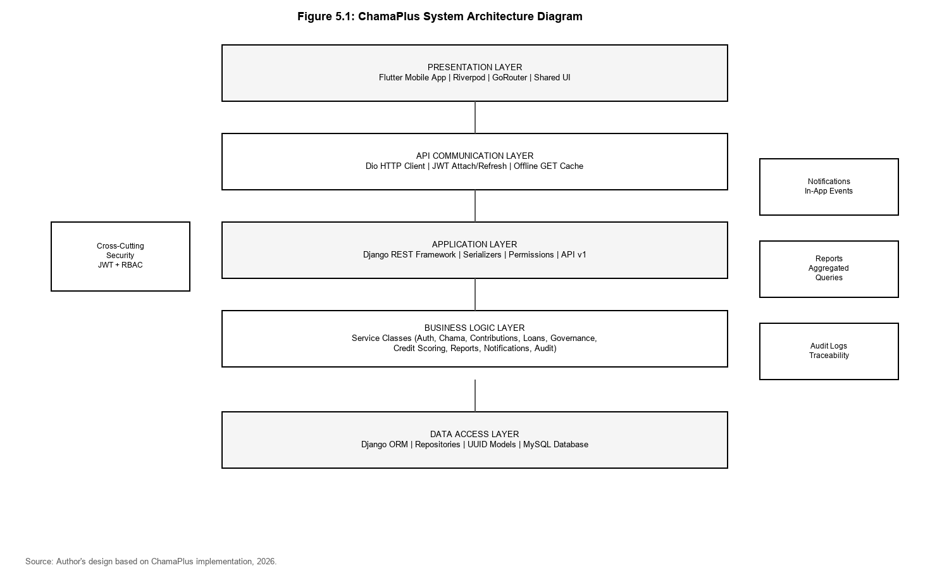
The backend contains Django apps aligned with business domains: accounts, roles, chamas, memberships, contributions, loans, governance, credit_scoring, reports, notifications and audit. Cross-cutting infrastructure includes UUID-based models, timestamped records, standardized API response envelopes, pagination, validation and exception handling. Reports are generated from aggregated queries rather than stored as separate report tables, which reduces duplication and ensures that summaries always reflect current data.

5.3 Mobile Application Design
The mobile application was designed using a feature-based structure. Each major feature contains presentation, domain and data layers. Presentation screens consume Riverpod providers and reusable widgets from the shared design system. This design supports maintainability because business features can evolve independently while sharing common UI patterns such as cards, status chips, empty states, loading indicators and form controls.
The mobile client also includes production-oriented design elements such as offline GET caching for selected endpoints, session-expiry handling, secure token storage, deep-link restoration after authentication and accessibility support including text scaling and semantic labels. These design decisions improve reliability in real-world mobile environments where network interruptions are common (Hutomo & Ilham, 2024).

5.4 Backend and API Design
The backend API was designed as a resource-oriented REST interface. Authentication uses JSON Web Tokens (JWT), with access and refresh tokens issued at login and used on protected routes (JSON Web Token, n.d.). Public routes include registration, login and token refresh, while chama-scoped routes require both authentication and active membership in the target chama.
API responses follow a standard envelope format containing success, message and data fields. Chama-scoped resources are nested under /api/v1/chamas/{chama_id}/ wherever appropriate, which supports multi-tenant data isolation. Primary keys use UUID v4 strings and JSON field names use snake_case. The implemented backend exposes 78 business endpoints across authentication, chama management, contributions, loans, governance, credit scoring, reports, notifications and audit logging.
Table 5.1 Main API resource groups
API Group | Purpose
/api/v1/auth/ | Registration, login, logout, refresh, password reset
/api/v1/users/ | Profile retrieval and update
/api/v1/roles/ | Role catalog
/api/v1/chamas/ | Chama CRUD, invite, join, member listing
/api/v1/memberships/ | Role and status management
/api/v1/chamas/{id}/contribution-cycles/ | Contribution cycle management
/api/v1/chamas/{id}/contributions/ | Contribution recording and listing
/api/v1/chamas/{id}/loan-products/ | Loan product management
/api/v1/chamas/{id}/loan-applications/ | Loan application workflow
/api/v1/chamas/{id}/meetings/ | Meetings, attendance and minutes
/api/v1/chamas/{id}/credit-scores/ | Credit score retrieval and recalculation
/api/v1/chamas/{id}/reports/ | Financial and member reports
/api/v1/notifications/ | In-app notifications
/api/v1/audit-logs/ | Audit trail access

5.5 Database Design

5.5.1 Conceptual Design
The conceptual database design models the main entities and relationships in ChamaPlus. The central entity is the chama, which is linked to users through memberships and roles. Each membership connects one user to one chama with one role and one status. Financial activity is represented through contribution cycles and contributions, while lending activity is represented through loan products, loan applications, committee votes and loan repayments. Governance is represented through meetings, attendance records and meeting minutes. Credit scores are stored as historical snapshots rather than as a single mutable score field.
Figure 5.2 Entity Relationship Diagram
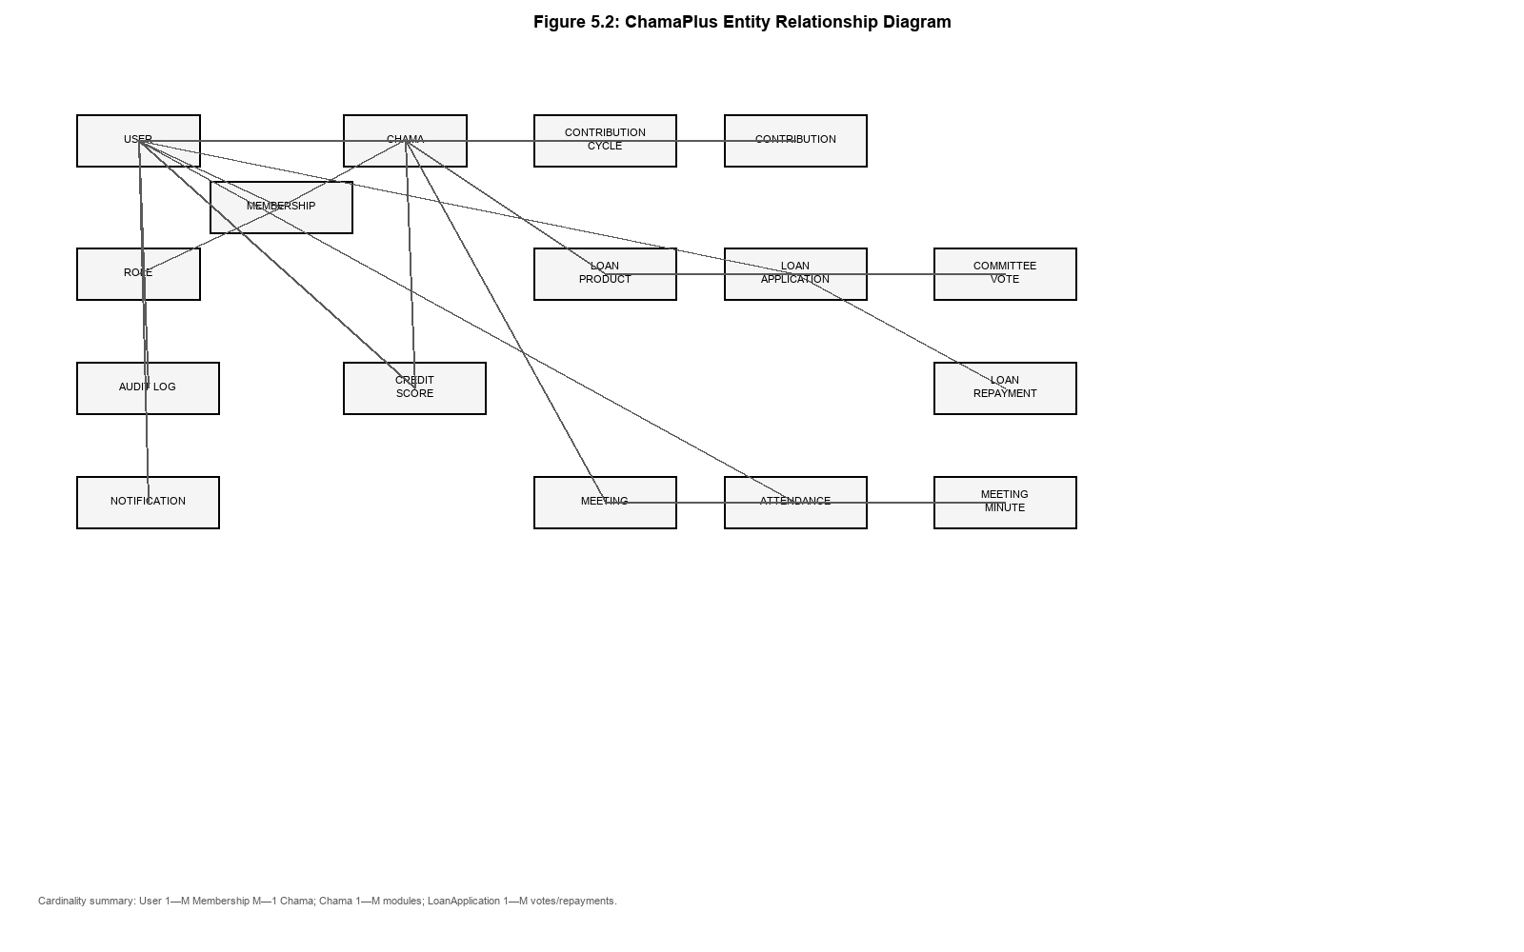

5.5.2 Logical Design
The logical design normalizes the main entities into relational tables with foreign key relationships. A user may belong to multiple chamas through separate membership records, but may hold only one role per chama. Contribution records belong to a contribution cycle and a member, while loan applications belong to a chama, applicant and loan product. Committee votes are linked to loan applications and committee members, ensuring that lending decisions remain traceable. Credit score snapshots are linked to both member and chama so that scores remain group-specific rather than global.
The logical design also supports auditability and data integrity. Financial records such as contributions and repayments store the user who recorded the transaction. Membership status controls API access, and archived chamas are hidden from ordinary queries. Indexes were defined on frequently queried combinations such as chama and status, member and recorded date, and chama-member-calculation date for credit scores.

5.5.3 Physical Design
The physical design implements the logical model in MySQL using Django models. All domain tables inherit UUID primary keys and created/updated timestamps from shared base models. Table 5.2 summarizes selected physical tables and their main attributes.
Table 5.2 Selected physical database tables
Table | Key Fields | Description
users | id (PK, UUID) | Unique user identifier
users | email, phone, password | Authentication and contact details
chamas | id (PK, UUID) | Unique chama identifier
chamas | name, description, location, currency | Chama profile information
chamas | invite_code (unique) | Join code for membership onboarding
chamas | created_by_id (FK → users) | Creator of the chama
memberships | id (PK, UUID) | Unique membership record
memberships | user_id (FK), chama_id (FK), role_id (FK) | Links user to chama and role
memberships | status, joined_at | Membership lifecycle information
contribution_cycles | id (PK), chama_id (FK) | Recurring savings period definition
contribution_cycles | name, amount, start_date, end_date, status | Cycle configuration
contributions | id (PK), cycle_id (FK), member_id (FK) | Member payment within a cycle
contributions | amount, payment_method, reference, recorded_by_id | Contribution transaction details
loan_products | id (PK), chama_id (FK) | Loan product definition for a chama
loan_applications | id (PK), applicant_id (FK), chama_id (FK) | Member loan request
loan_applications | requested_amount, status, outstanding_balance | Loan lifecycle fields
committee_votes | id (PK), application_id (FK), voter_id (FK) | Committee decision record
loan_repayments | id (PK), application_id (FK) | Repayment transaction record
meetings | id (PK), chama_id (FK) | Scheduled governance meeting
attendance | id (PK), meeting_id (FK), member_id (FK) | Meeting attendance record
credit_scores | id (PK), member_id (FK), chama_id (FK) | Advisory credit score snapshot
credit_scores | score, risk_level, breakdown, weights | Transparent scoring output
notifications | id (PK), user_id (FK) | In-app notification record
audit_logs | id (PK), actor_id (FK) | Administrative action audit trail

5.6 Credit Scoring Design
Credit scoring in ChamaPlus was designed as a transparent advisory mechanism rather than an automatic loan approval system. The scoring model uses four weighted components: contribution consistency (35%), repayment history (35%), attendance (15%) and membership duration (15%). Each recalculation produces a historical CreditScore record containing the total score, risk band, factor breakdown, applied weights and calculation timestamp.
The scoring service aggregates data across contributions, repayments, attendance and membership tables through a repository layer. Risk bands are assigned using configurable thresholds: Excellent (80–100), Good (60–79), Fair (40–59) and High Risk (0–39). The score is displayed during loan review as recommendation context, while committee votes remain the authoritative decision mechanism. This design preserves chama governance while still providing structured decision support.
Table 5.3 Credit scoring weights and risk bands
Component / Band | Value | Description
Contribution consistency | 35% | Saving behaviour across cycles
Repayment history | 35% | Past loan repayment performance
Attendance | 15% | Participation in meetings
Membership duration | 15% | Length of active membership
Excellent | 80–100 | Low advisory risk band
Good | 60–79 | Moderate advisory risk band
Fair | 40–59 | Elevated advisory risk band
High Risk | 0–39 | High advisory risk band

5.7 Security Design
Security was considered at authentication, authorization and data-isolation levels. Authentication uses JWT access and refresh tokens. Authorization uses role-based access control with separate platform-level and chama-level permissions. Sensitive operations such as contribution recording, loan product management, role assignment and membership status changes are restricted to authorized officials. Querysets and service-layer checks enforce chama tenancy so that users can access only the groups to which they belong.
Additional security measures include password reset challenges, protected storage of tokens on mobile, exclusion of secrets from source control, audit logging of important actions and validation of financial inputs before persistence. These controls are particularly important because the system stores membership and financial information that must remain confidential within each chama.

5.8 Interface Design

5.8.1 Input Design
Input design focused on clear forms for registration, login, chama creation, contribution recording, loan application submission, meeting scheduling and profile management. Shared form components such as AppTextField, AppPasswordField, dropdowns and date pickers were used to maintain consistent validation, spacing and accessibility across modules (Makalew, 2022). Screenshots of the main input interfaces are provided below.

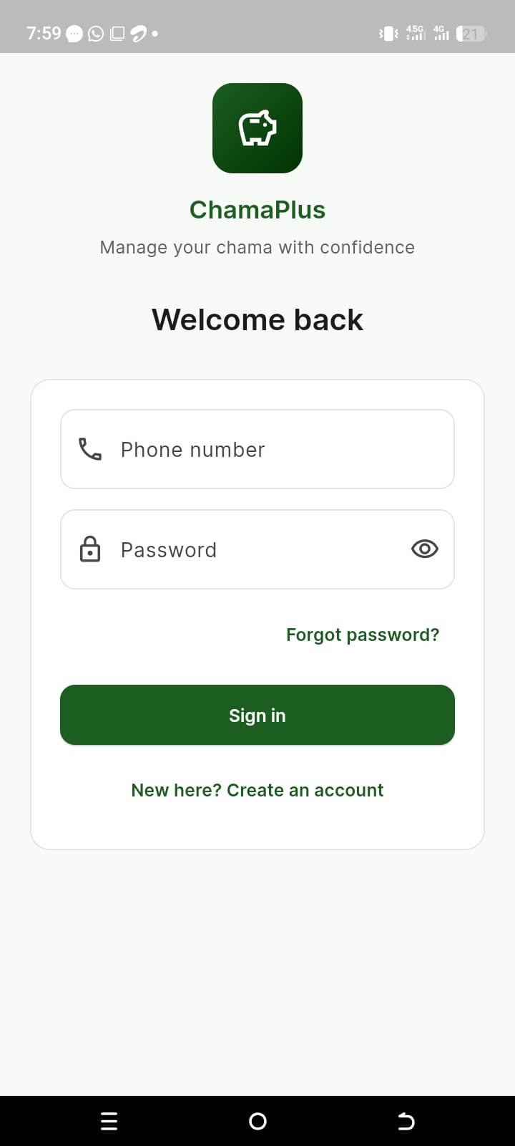
Screenshot 5.1 Login screen

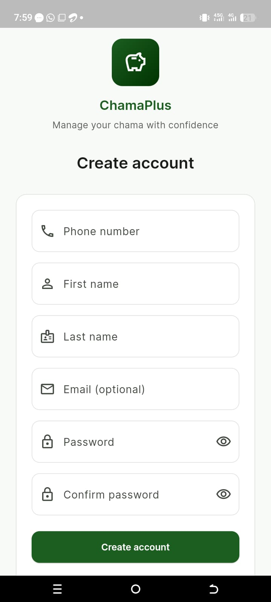
Screenshot 5.2 Registration screen
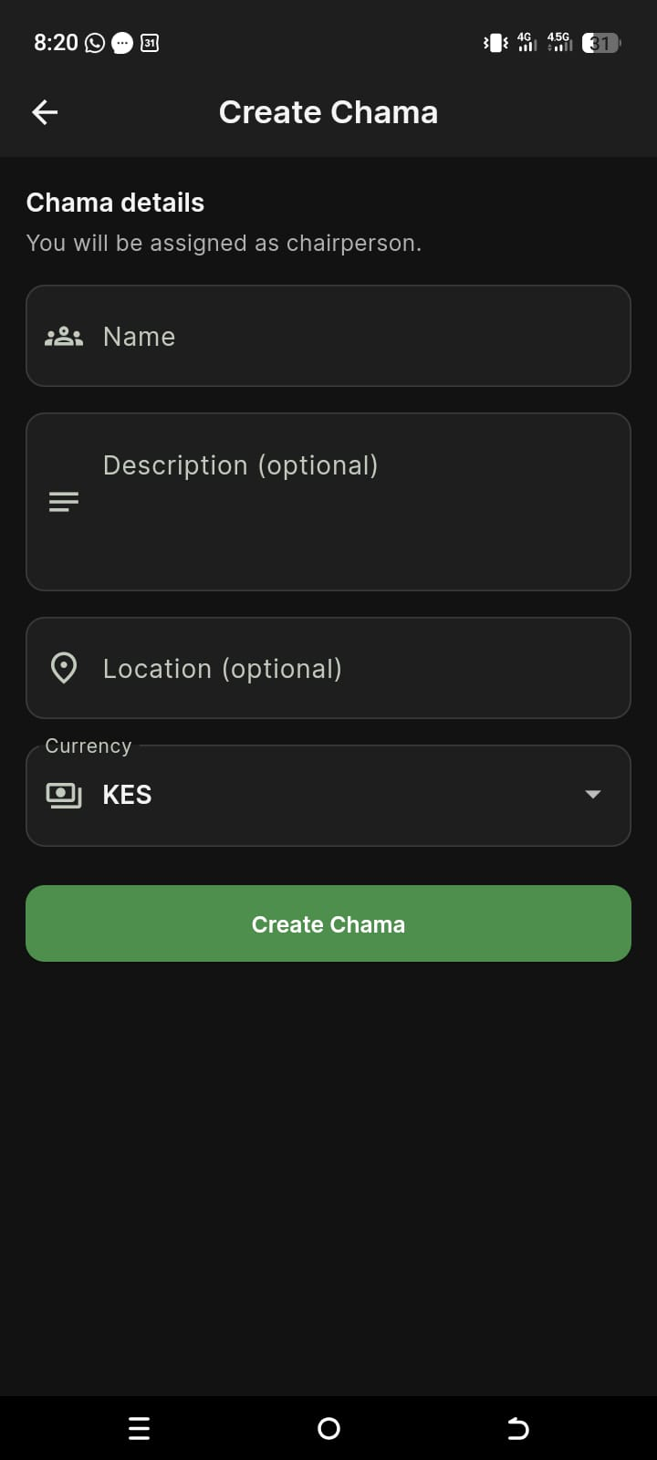
Screenshot 5.3 Create chama screen

Screenshot 5.4 Join chama screen
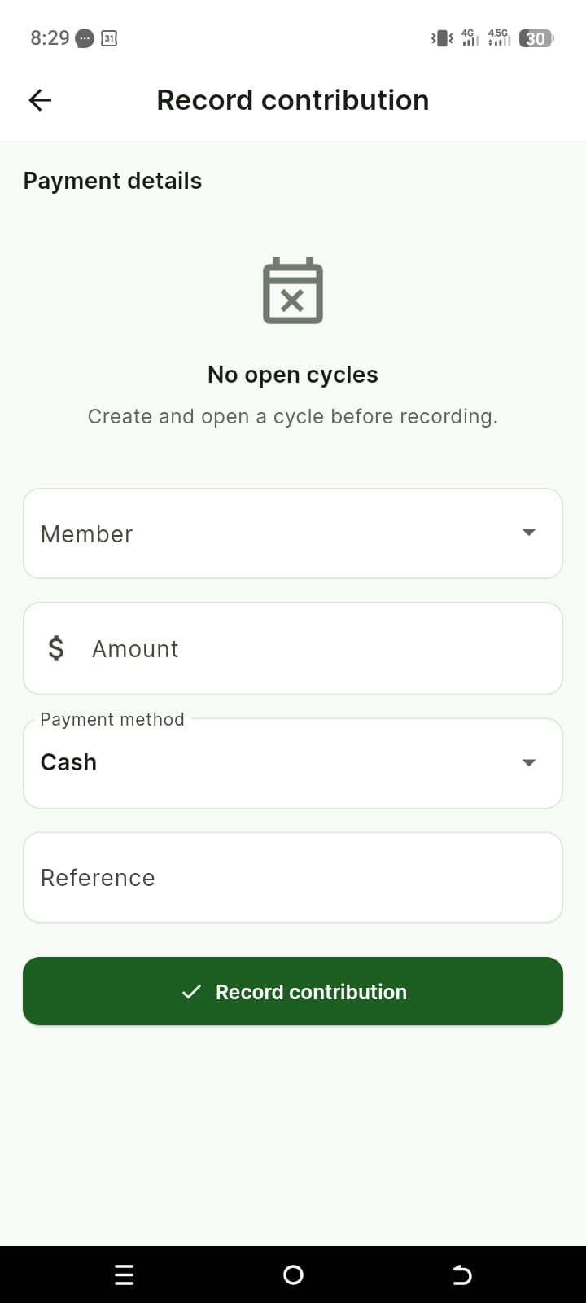
Screenshot 5.6 Record contribution screen
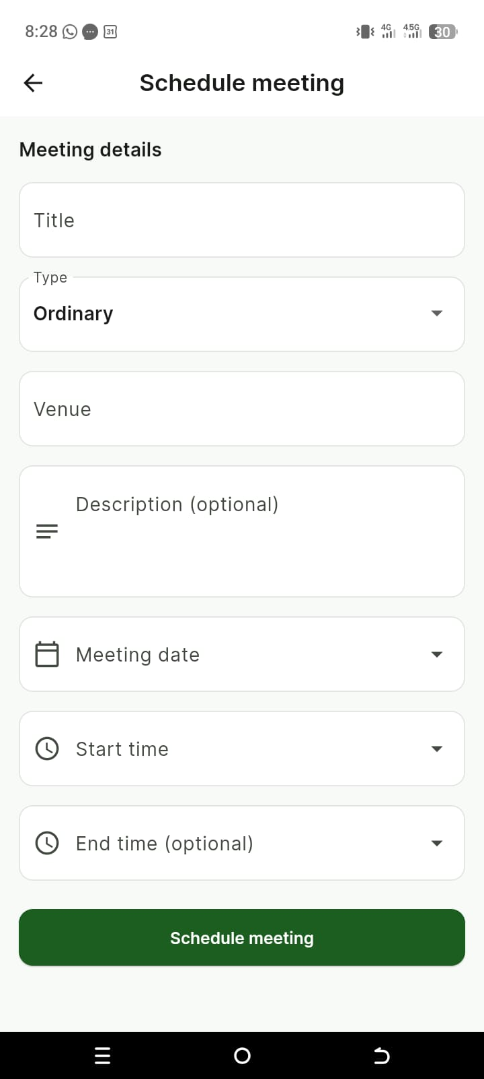
Screenshot 5.9 Schedule meeting screen

5.8.2 Output Design
Output design focused on dashboards, summaries, reports and status displays that help users interpret chama activity quickly. Dashboard cards, charts, report tables and status chips present contributions, loans, attendance and member performance in a readable format. Credit score output is labeled as advisory recommendation information rather than as a final lending decision.
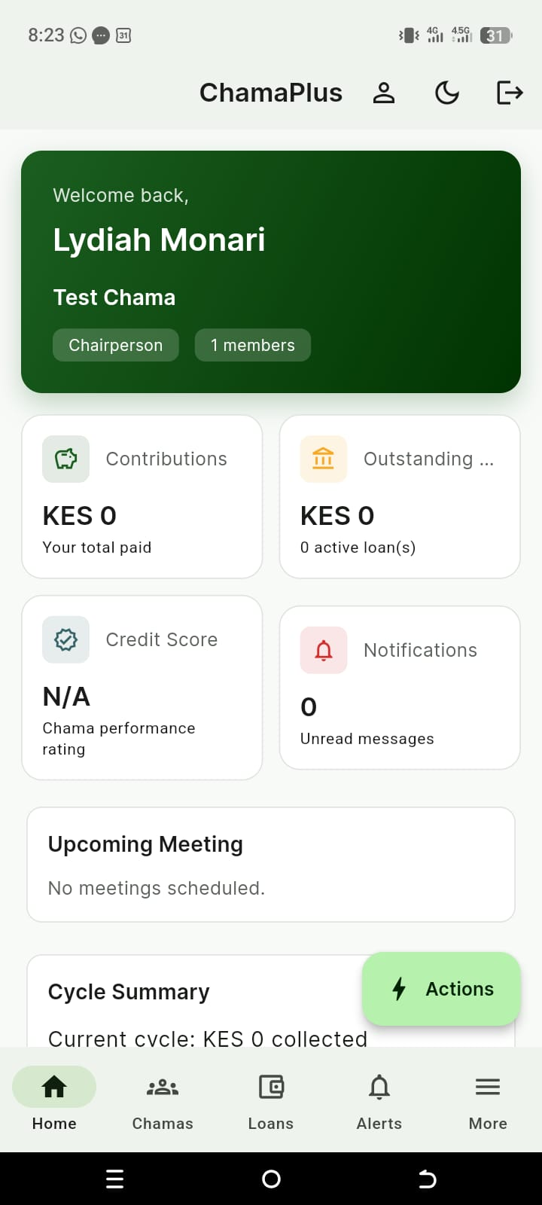
Screenshot 5.10 Dashboard / home screen
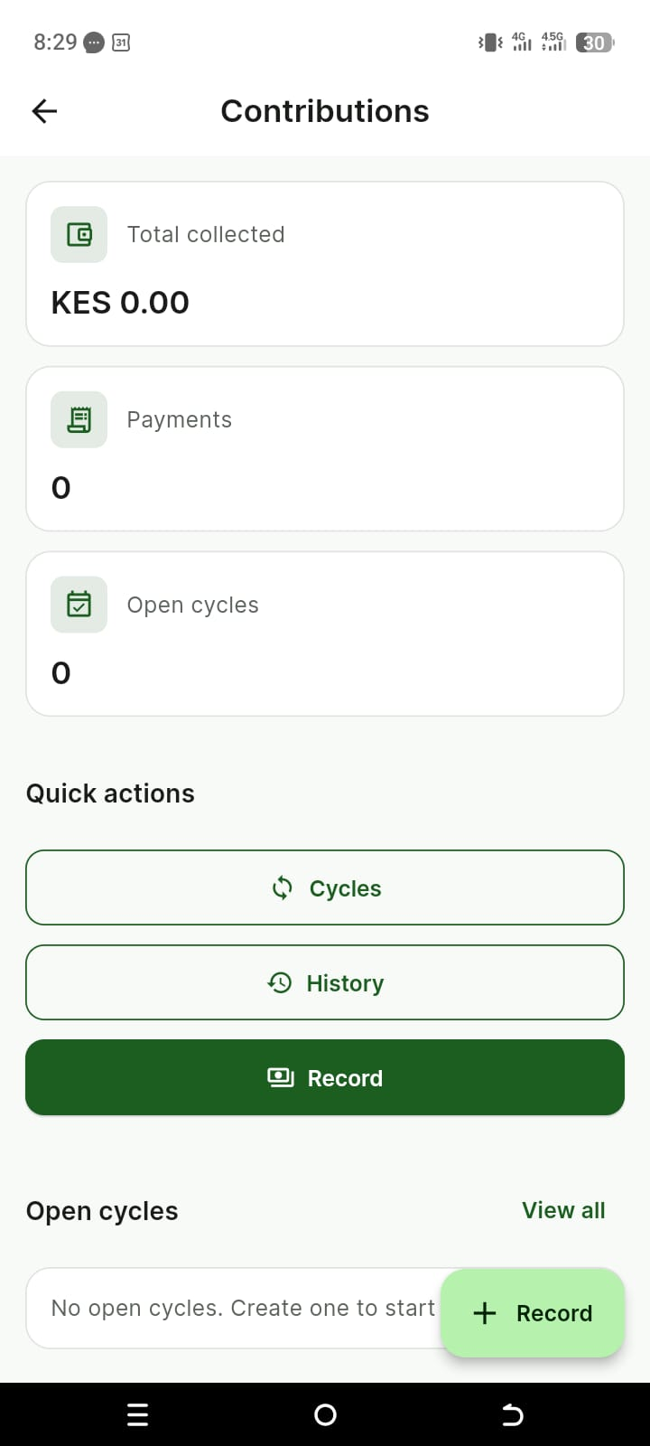
Screenshot 5.11 Contribution dashboard
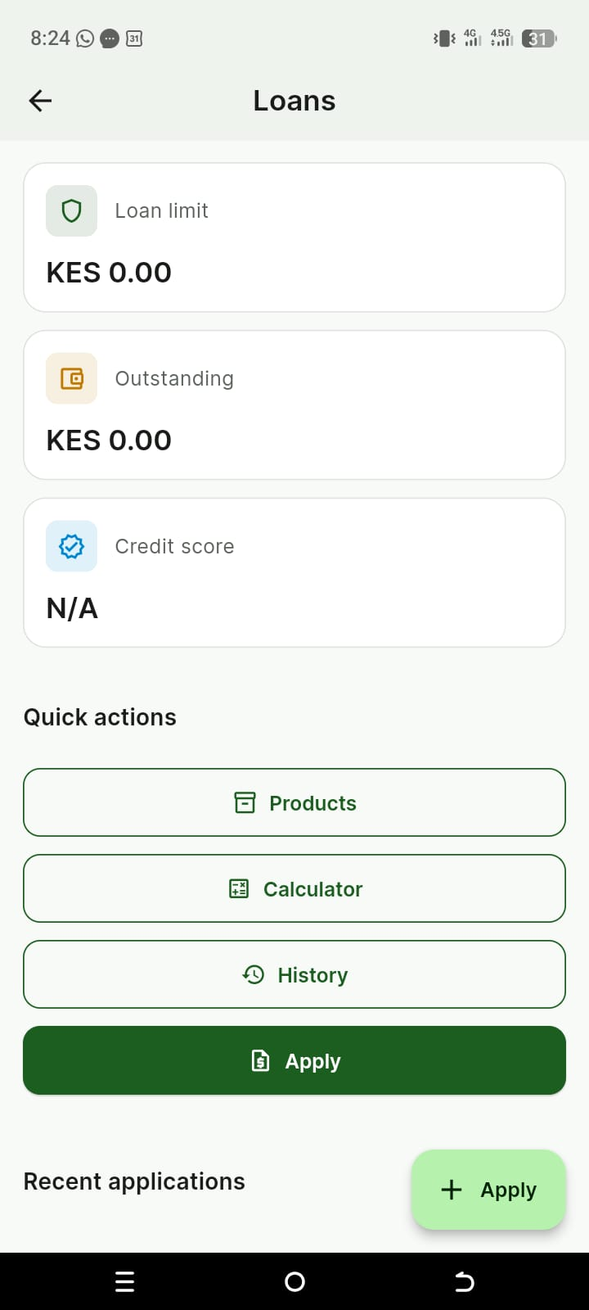
Screenshot 5.12 Loan dashboard
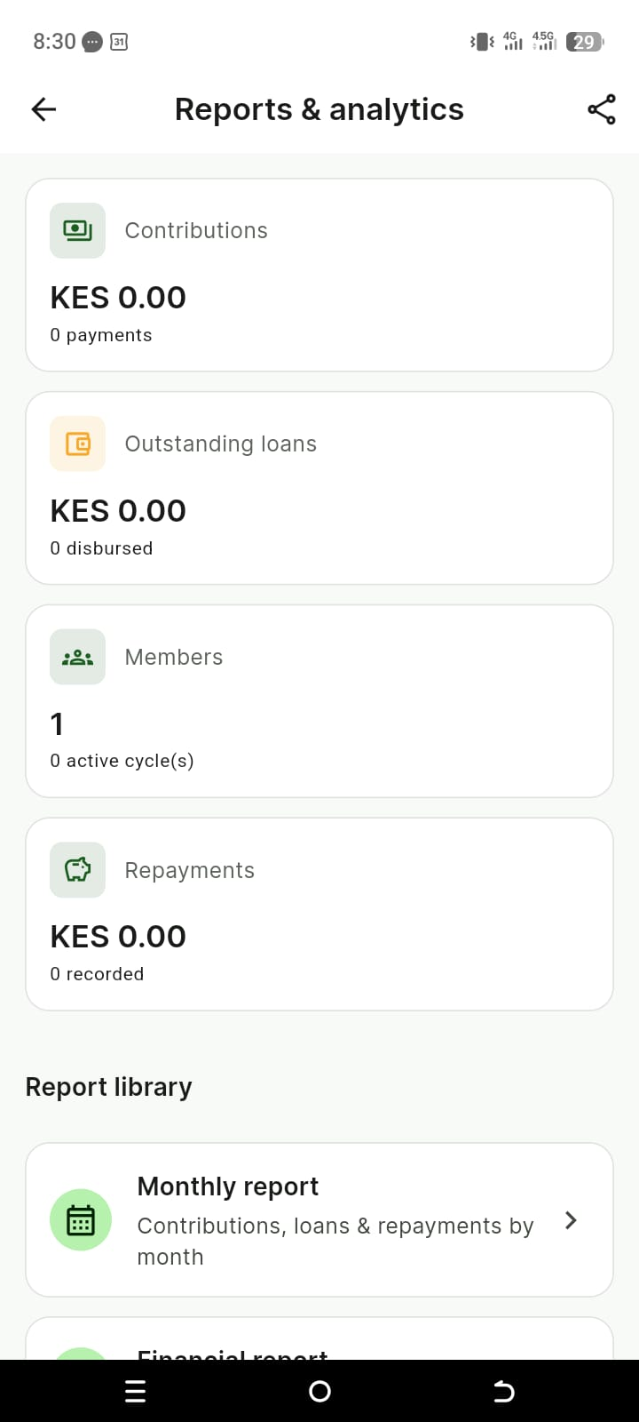
Screenshot 5.14 Reports and analytics screen
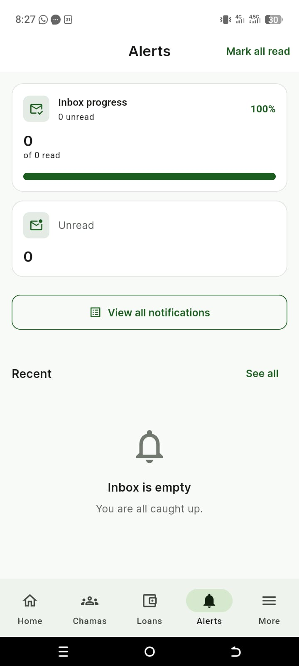
Screenshot 5.15 Notifications / alerts screen
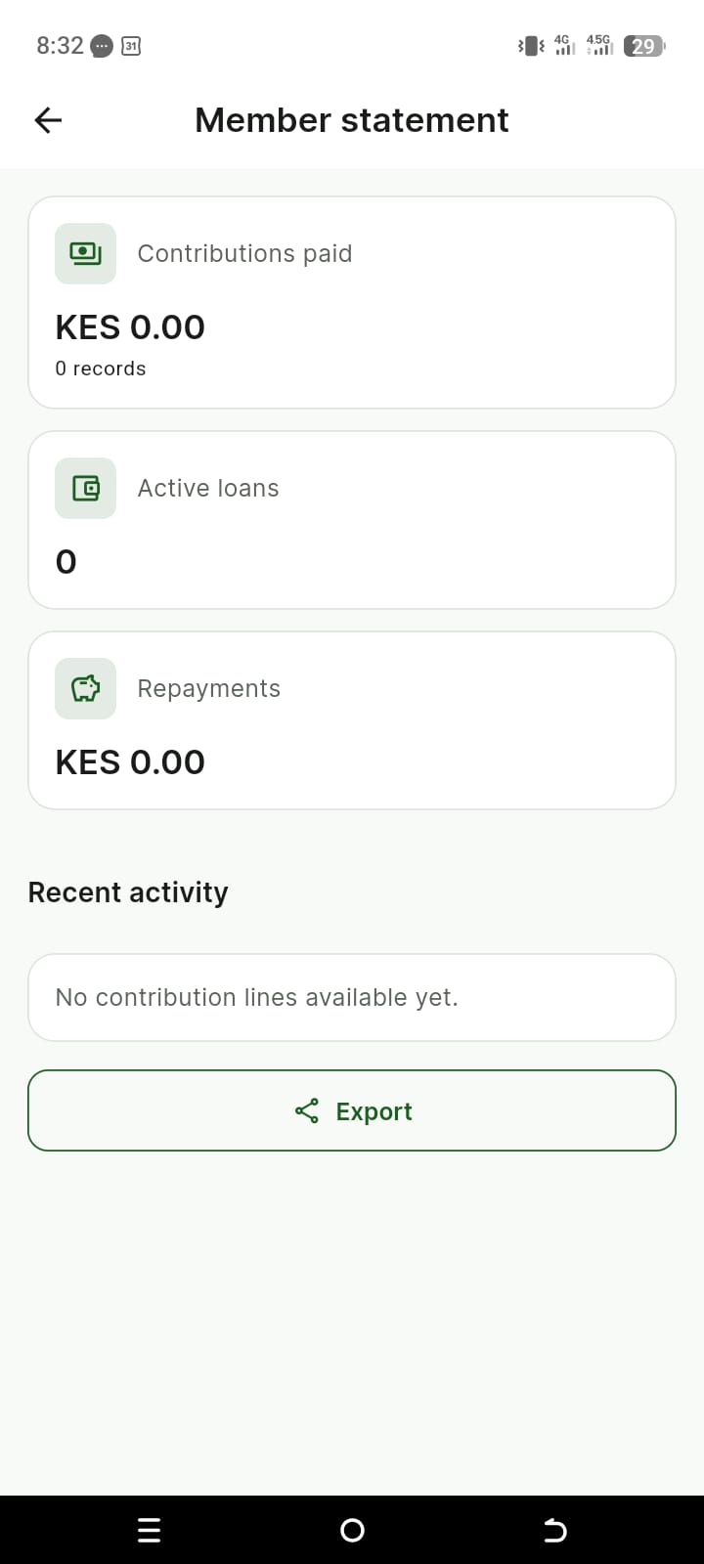
Screenshot 5.16 Member statement screen

5.9 Navigation and Screen Structure
The mobile application uses a shell-based navigation structure with a dashboard entry point and dedicated hubs for chamas, contributions, loans, meetings, notifications, reports and settings. GoRouter manages route transitions and supports restoration of intended deep links after authentication. Figure 5.3 summarizes the main navigation structure.
Figure 5.3: Navigation/Screen Structure
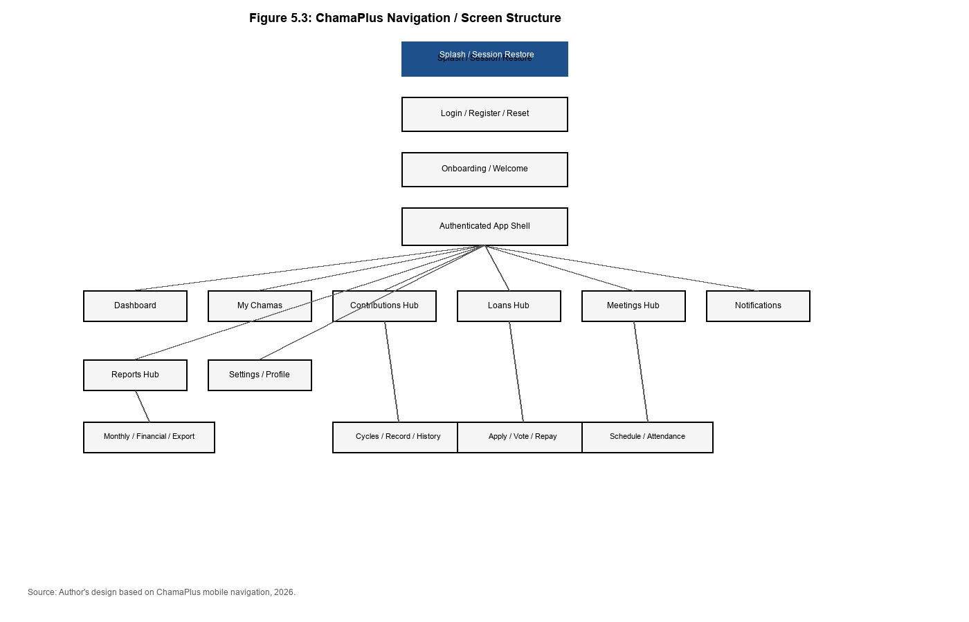

CHAPTER SIX

SYSTEM IMPLEMENTATION AND TESTING

6.0 Introduction
This chapter describes how the ChamaPlus system was implemented and tested. It explains the development environment, implementation approach, module delivery sequence, testing strategy, sample test cases and changeover considerations. The implementation translated the design presented in Chapter Five into a working prototype consisting of a Flutter mobile application and a Django REST Framework backend connected to a MySQL database. Testing was conducted throughout development to verify that the implemented modules satisfied the functional and non-functional requirements defined earlier in the project (Sommerville, 2016; Pressman & Maxim, 2019).

6.1 Development Environment and Tools
ChamaPlus was implemented using a local development environment suitable for mobile and backend software engineering. The main tools included a development computer, Android emulator and/or physical smartphone for mobile testing, Python 3.12, Django 5.0, Django REST Framework, MySQL through XAMPP, Flutter SDK, Dart, Git, GitHub, Cursor IDE and API testing tools such as Swagger UI. The backend used pytest for automated API and service testing, while the mobile application used the Flutter test framework for unit and widget testing (Flutter, n.d.).
Environment-specific configuration was managed through .env files and separate development and production Django settings. Sensitive values such as database credentials, JWT secrets and API base URLs were excluded from version control. This approach supported safer incremental development and prepared the project for later deployment hardening.

6.2 Implementation Approach
Implementation followed the Agile iterative and incremental sequence described in Chapter Three. Core infrastructure and authentication were established first, after which dependent modules were developed, tested and refined before subsequent increments were completed.
On the backend, each business domain was implemented as a separate Django app with models, serializers, views, services, permissions and tests. Business rules were kept in service classes rather than in views directly, which improved maintainability and testability. On the mobile side, each feature was implemented using presentation, domain and data layers with Riverpod providers, repository classes, shared form components and GoRouter navigation.

6.3 Backend Implementation
The backend implementation produced a Django REST API with 12 registered apps and 17 domain database tables. The implemented API exposed 78 business endpoints covering authentication, chama management, memberships, contributions, loans, governance, credit scoring, reports, notifications and audit logs. JWT authentication and role-based permissions were enforced on protected routes, while public routes were limited to registration, login and token refresh.
Important backend implementation features included UUID primary keys, timestamped records, standardized API response envelopes, Kenyan phone-number validation, chama-scoped query filtering, immutable contribution records, loan lifecycle management, committee vote tracking, advisory credit score snapshots and report generation through service-layer aggregation. OpenAPI documentation was also provided through Swagger UI to support manual API verification during testing.

6.4 Mobile Application Implementation
The Flutter mobile application implemented the main user-facing modules required by the project. These included authentication and onboarding, dashboard, chama management, contributions, loans, meetings and governance, notifications, reports, profile and settings. Shared infrastructure provided reusable forms, cards, charts, navigation components, API-state handling, offline GET caching and secure token storage.
Production-hardening activities were also implemented in the mobile client. These included timeout and retry handling, connectivity awareness, offline cache for selected GET requests, JWT refresh with secure logout, deep-link restoration after authentication, user-friendly error messages, accessibility improvements and preparation for release signing. These measures improved the reliability of the application in real mobile environments where intermittent connectivity is common.

6.5 Module Implementation Summary
Table 6.1 summarizes the main ChamaPlus modules, their implementation focus and delivery status at the completion of the project prototype.
Table 6.1 Module implementation summary
Module | Implementation Focus | Status
Authentication & users | User registration, login, logout, password reset, profile management | Implemented
Roles & memberships | Role catalog, chama membership, invitations, join requests, RBAC | Implemented
Chama management | Create/update chama, invite code, member listing | Implemented
Contributions | Contribution cycles, contribution recording, member summaries | Implemented
Loans | Loan products, applications, committee voting, repayments | Implemented
Governance | Meetings, attendance, minutes, action items | Implemented
Credit scoring | Weighted advisory score snapshots and risk bands | Implemented
Reports | Dashboards, monthly/financial/member reports, export support | Implemented
Notifications | In-app notifications for key chama events | Implemented
Audit logging | Traceability for sensitive administrative actions | Implemented
Production hardening | Offline cache, JWT refresh, secure logout, error handling | Implemented
M-Pesa / SMS / email integration | External payment and messaging providers | Not implemented

6.6 Test Plan
The test plan defined how the implemented system would be verified against its requirements. Testing covered unit, widget, API integration and regression levels. The plan focused on critical business rules such as authentication, membership access, contribution recording, loan approval workflow, repayment updates, credit score generation, report generation and role restrictions. Both automated and manual verification were used.
Backend testing used pytest and Django test clients to verify endpoints, services, permissions and database effects. Mobile testing used Flutter test for repositories, providers, widgets and selected screen flows. Manual API testing was also performed using Swagger UI to confirm request and response behaviour for major endpoints.

6.7 Testing Approach

6.7.1 Unit Testing
Unit tests were used to verify discrete pieces of logic such as validators, service methods, serializers, repositories, providers and utility functions. Backend unit and integration tests were organized by Django app, while mobile unit tests were organized by feature module under the test/ directory.

6.7.2 Widget and Screen Testing
Widget tests were used to verify that major screens and reusable components rendered correctly and responded to user interaction as expected. Examples included login and authentication flows, dashboard widgets, chama screens, contribution dashboards, loan screens, governance screens, reports screens, settings screens and shared form components.

6.7.3 API and Integration Testing
API tests verified that backend endpoints returned the correct HTTP status codes, response envelope structure, permission behaviour and business-state transitions. Integration testing confirmed that the mobile application could consume the backend API successfully for the major modules implemented in the prototype.

6.7.4 Regression Testing
Regression testing was performed after major refactors and module additions to ensure that previously working functionality had not been broken. Automated test suites were re-run during development whenever authentication, membership, financial modules or shared mobile infrastructure changed.

6.8 Test Cases and Results
Table 6.2 presents representative test cases used to validate the implemented system. These test cases were selected because they cover the core chama workflows defined in the project objectives.

Table 6.2 Representative test cases and results
Test ID | Test Item | Input/Action | Expected Result | Result
TC-01 | User registration | Valid user details submitted | Account created and success response returned | Pass
TC-02 | User login | Valid credentials submitted | JWT access and refresh tokens issued | Pass
TC-03 | Create chama | Authenticated user creates a new chama | Chama record created with invite code | Pass
TC-04 | Join chama | User submits valid invite code | Membership created or join request recorded | Pass
TC-05 | Record contribution | Treasurer records member contribution | Contribution saved against correct cycle and member | Pass
TC-06 | Submit loan application | Member submits valid loan request | Application stored with pending status | Pass
TC-07 | Committee loan vote | Committee member casts vote | Vote recorded and application status updated | Pass
TC-08 | Record repayment | Treasurer records loan repayment | Outstanding balance updated correctly | Pass
TC-09 | Credit score calculation | Member with contribution and repayment history | Advisory score snapshot generated with breakdown | Pass
TC-10 | Role restriction | Ordinary member attempts treasurer-only action | Access denied by permission layer | Pass
TC-11 | Meeting attendance | Secretary records attendance for a meeting | Attendance records stored correctly | Pass
TC-12 | Generate monthly report | Official requests chama monthly report | Report summary returned from aggregated data | Pass
TC-13 | Mobile login screen | User enters valid credentials in Flutter app | Navigation to authenticated app shell | Pass
TC-14 | Offline GET cache | Network unavailable during cached read | Cached data displayed without crash | Pass
TC-15 | Logout security | User performs secure logout | Tokens and local caches cleared | Pass
At the completion of the prototype, the backend test suite contained 124 automated test functions across accounts, chamas, memberships, contributions, loans, governance, credit scoring, notifications and reports. The mobile test suite contained 244 automated test functions covering repositories, controllers/providers, widgets and selected screen flows. During final test execution, 243 mobile tests passed and 1 test failed in the report export module, indicating that the overall system was largely stable but still required minor correction in non-core export formatting.

6.9 Changeover Strategy
A direct cutover would be risky for chama groups that still depend on manual records. The recommended changeover strategy for ChamaPlus is therefore phased parallel running. In this approach, a chama continues maintaining its existing records while gradually entering new contributions, memberships, loans and meetings into the system. Officials verify that digital summaries match existing records before the group relies on the application as the primary source of truth.
This strategy is appropriate because it reduces the risk of data loss, allows members to adapt to the new system gradually and preserves committee oversight during the transition period. Full migration of historical manual records may be entered selectively for active loans, current contribution cycles and current membership information rather than attempting a complete one-day conversion.

6.10 Implementation Challenges
Several implementation challenges were encountered during development. These included API and mobile integration, consistency of role permissions across backend and frontend, session and token refresh handling, offline caching behaviour, input validation consistency, navigation restoration after authentication and environment configuration for local development. Most of these challenges were resolved through iterative testing, refactoring and production-hardening improvements.
Features intentionally not implemented in the prototype included direct M-Pesa payment integration, direct SMS/email delivery providers, a separate web admin portal and full production deployment. These were documented as future enhancement areas rather than as completed project deliverables.

CHAPTER SEVEN

LIMITATIONS, CONCLUSIONS AND RECOMMENDATIONS

7.0 Introduction
This final chapter presents the limitations encountered during the ChamaPlus project, the conclusions drawn from the study and the recommendations for future improvement. The conclusions are linked directly to the project objectives stated in Chapter One and to the implementation and testing outcomes described in Chapters Five and Six. Together, these sections evaluate the extent to which the project fulfilled its aim of developing a mobile-based credit-aware decision support platform for informal savings groups in Kenya.

7.1 Limitations of the Study
Although ChamaPlus achieved its main prototype objectives, the project faced several limitations. First, the study was constrained by time and resource availability because the system was developed within the academic project period. As a result, some enhancement areas such as payment-gateway integration, direct SMS or email delivery and a dedicated web administration portal were not implemented in the completed prototype.
Second, the evaluation was based mainly on requirements analysis, system testing and developer-led verification rather than a large-scale field deployment with many real chama groups. This limits the extent to which long-term usability, adoption behaviour and operational performance in live community settings can be generalized from the current findings (Kusimba & Wanga, 2026).
Third, the system depends on internet connectivity for live synchronization between the mobile application and the backend. Although offline GET caching was implemented for selected read operations, write actions such as contribution recording, loan processing and meeting updates still require network access. Fourth, the credit-scoring mechanism is based only on information recorded within ChamaPlus. It therefore cannot represent financial behaviour or circumstances that occur outside the system.
Fifth, one automated mobile test related to report export formatting failed during final test execution, indicating that a minor non-core feature still requires correction. Finally, historical manual chama records were not migrated automatically into the system; any adoption by an existing group would therefore require deliberate data entry or a phased transition from manual records.

7.2 Conclusions
The ChamaPlus project successfully demonstrated that a mobile-based platform can integrate membership management, contributions, loans, governance, notifications, reporting and advisory credit information within one chama management solution. The completed prototype addressed the main problem identified in Chapter One, namely the difficulty of maintaining accurate and connected records when chama activities are managed through separate manual or semi-digital methods (Kimuyu, 1999; Ibtasam et al., 2019).
From a design and development perspective, the three-tier architecture consisting of Flutter, Django REST Framework and MySQL proved suitable for the project. The service-layer backend and feature-based mobile architecture supported modular development, testing and future extension. Role-based access control also ensured that sensitive financial and administrative operations were restricted to authorized officials.
Table 7.1 summarizes the conclusion reached for each specific project objective.
Table 7.1 Conclusion by project objective
Objective | Statement | Conclusion
Objective 1 | Investigate challenges in manual and semi-digital chama management | Achieved. Manual record fragmentation, reporting delays, weak role separation and limited decision-support information were identified and addressed through system requirements.
Objective 2 | Design and develop an integrated ChamaPlus mobile platform | Achieved. Secure authentication, membership management, contributions, loans, governance, reporting, notifications and advisory credit scoring were implemented and integrated on the mobile client and Django REST backend.
Objective 3 | Test and evaluate the developed prototype | Largely achieved. Automated backend and mobile test suites were executed successfully, with one minor mobile export-formatting test failure remaining.
In overall terms, the general objective of designing and developing ChamaPlus as a credit-aware decision support platform for informal savings groups in Kenya was achieved. The system provides a practical foundation for improving record-keeping, transparency and committee-supported decision-making in chama environments while preserving human authority over important lending decisions.

7.3 Recommendations
Based on the limitations and conclusions of this study, the following recommendations are made:
1. Future developers should integrate M-Pesa or another trusted payment gateway so that contribution and repayment recording can be linked directly to mobile money transactions rather than relying only on manual entry.
2. Direct SMS, email or push-notification providers should be integrated to improve timely communication of loan decisions, meeting reminders and contribution updates.
3. A pilot deployment should be conducted with one or more real chama groups to evaluate usability, adoption, data accuracy and operational benefits under actual usage conditions.
4. A formal usability study should be carried out with chama officials and ordinary members to measure ease of learning, task completion time and user satisfaction.
5. The credit-scoring model should be refined using larger datasets and clearer sub-formulas for each factor, while retaining its advisory rather than autonomous decision-making role.
6. The remaining report export defect identified during mobile testing should be corrected, and additional automated end-to-end tests should be added for critical user journeys such as login, contribution recording and loan approval.
7. A cloud deployment strategy with secure hosting, database backup, monitoring and maintenance procedures should be implemented before production release.
8. Future research may compare ChamaPlus with existing manual processes and other digital group-savings platforms in Kenya to measure efficiency gains, transparency improvements and member trust over time.

REFERENCES
Anderson, S., & Baland, J.-M. (2002). The economics of ROSCAs and intrahousehold resource allocation. The Quarterly Journal of Economics, 117(3), 963–995. https://doi.org/10.1162/003355302760275702
Beck, K., Beedle, M., van Bennekum, A., Cockburn, A., Cunningham, W., Fowler, M., Grenning, J., Highsmith, J., Hunt, A., Jeffries, R., Kern, J., Marick, B., Martin, R. C., Mellor, S., Schwaber, K., Sutherland, J., & Thomas, D. (2001). Manifesto for agile software development. https://agilemanifesto.org/
Creswell, J. D., & Creswell, J. W. (2023). Research design: Qualitative, quantitative, and mixed methods approaches (6th ed.). Sage Publications.
Django Software Foundation. (n.d.). Django documentation. https://docs.djangoproject.com/
Fielding, R. T. (2000). Architectural styles and the design of network-based software architectures [Doctoral dissertation, University of California, Irvine]. https://www.ics.uci.edu/~fielding/pubs/dissertation/top.htm
Flutter. (n.d.). Flutter architectural overview. https://docs.flutter.dev/resources/architectural-overview
Flutter. (n.d.). Testing Flutter apps. https://docs.flutter.dev/testing
Francois, P., & Squires, M. (2021). Linking mobile money networks to "e-ROSCAs": An experimental study. Science Advances, 7(7), Article eabc5831. https://doi.org/10.1126/sciadv.abc5831
FSD Africa. (2016). Formalising informality: Savings groups, community finance and the role of FSD Kenya. https://fsdafrica.org/publication/1625/
Google. (n.d.). Flutter documentation. https://docs.flutter.dev/
Hutomo, B. A., & Ilham, F. (2024). Design and implementation of a mobile application for a personal financial information system using the Waterfall method. Indonesian Journal of Advanced Research, 5(6), Article 16631. https://doi.org/10.55927/ijar.v5i6.16631
Ibtasam, S., Mehmood, H., Razaq, L., Webster, J., Yu, S., & Anderson, R. (2019). Towards digitization of collaborative savings among low-income groups. Proceedings of the ACM on Human-Computer Interaction, 3(CSCW), Article 35. https://doi.org/10.1145/3359137
Johnson, S. (2016). The impact of mobile money on poor people's financial inclusion in Kenya. In S. Chakrabarti (Ed.), The mobile financial services development report 2016 (pp. 263–270). GSMA.
Johnson, S., & Nino-Zarazua, M. (2011). Financial access and exclusion in Kenya and Uganda. Journal of Development Studies, 47(3), 475–496. https://doi.org/10.1080/00220388.2010.492857
JSON Web Token. (n.d.). Introduction to JSON Web Tokens. https://jwt.io/introduction
Kimuyu, P. K. (1999). Rotating saving and credit associations in rural East Africa. World Development, 27(7), 1299–1308. https://doi.org/10.1016/S0304-3878(99)00062-0
Koskey, A. (2016). Chama online management system (COMS) [Undergraduate project report]. Maasai Mara University.
Kusimba, S., & Wanga, N. (2026). Understanding informality and mutuality in Kenya's digital finance landscape. In I. G. Hoven, S. Y. In, & T. Puschmann (Eds.), Sustainable digital finance (pp. 1–22). Springer. https://doi.org/10.1007/978-3-032-02983-6_15
Makalew, B. A. (2022). Android based personal finance management application: Design and development. Engineering, MAthematics and Computer Science Journal, 4(1), 5–9. https://doi.org/10.21512/emacsjournal.v4i1.8085
Mehmood, H., Ashraf, S., Imran, A., & Ibtasam, S. (2018). Save my money: Digitizing informal collaborative savings in Pakistan. In Proceedings of the 2nd International Conference on HCI and UX (HCIxB 2018). https://hcixb.org/papers_2018/hcixb18-final-11.pdf
Newman, S. (2021). Building microservices: Designing fine-grained systems (2nd ed.). O'Reilly Media.
Pressman, R. S., & Maxim, B. R. (2019). Software engineering: A practitioner's approach (9th ed.). McGraw-Hill Education.
Richardson, L. (2013). RESTful Web APIs. O'Reilly Media.
Royce, W. W. (1970). Managing the development of large software systems: Concepts and techniques. In Proceedings of IEEE WESCON (pp. 1–9).
Royce, W. W. (1970). Managing the development of large software systems: Concepts and techniques. In Proceedings of IEEE WESCON (pp. 1–9).
Sommerville, I. (2016). Software engineering (10th ed.). Pearson.

APPENDICES
APPENDIX I: PROJECT GANTT CHART
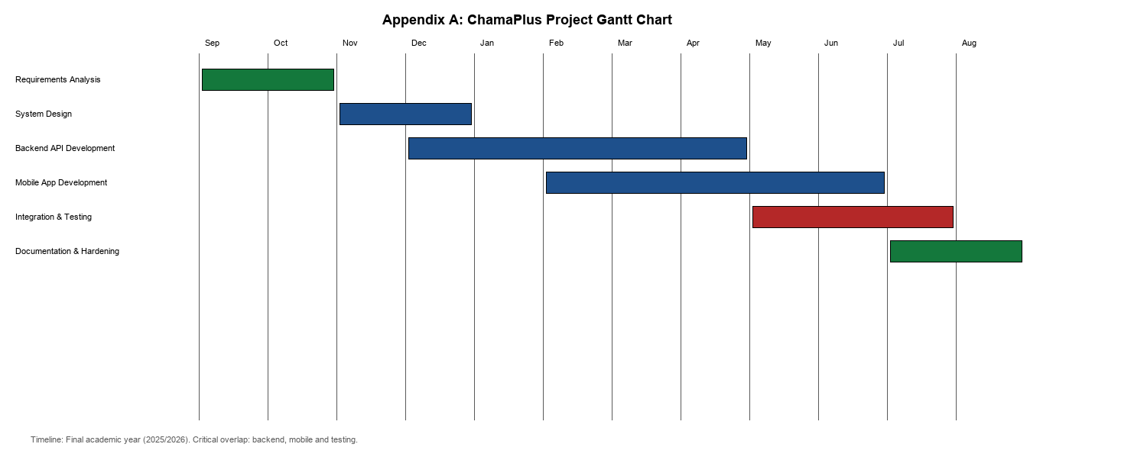

APPENDIX II: WORK BREAKDOWN STRUCTURE
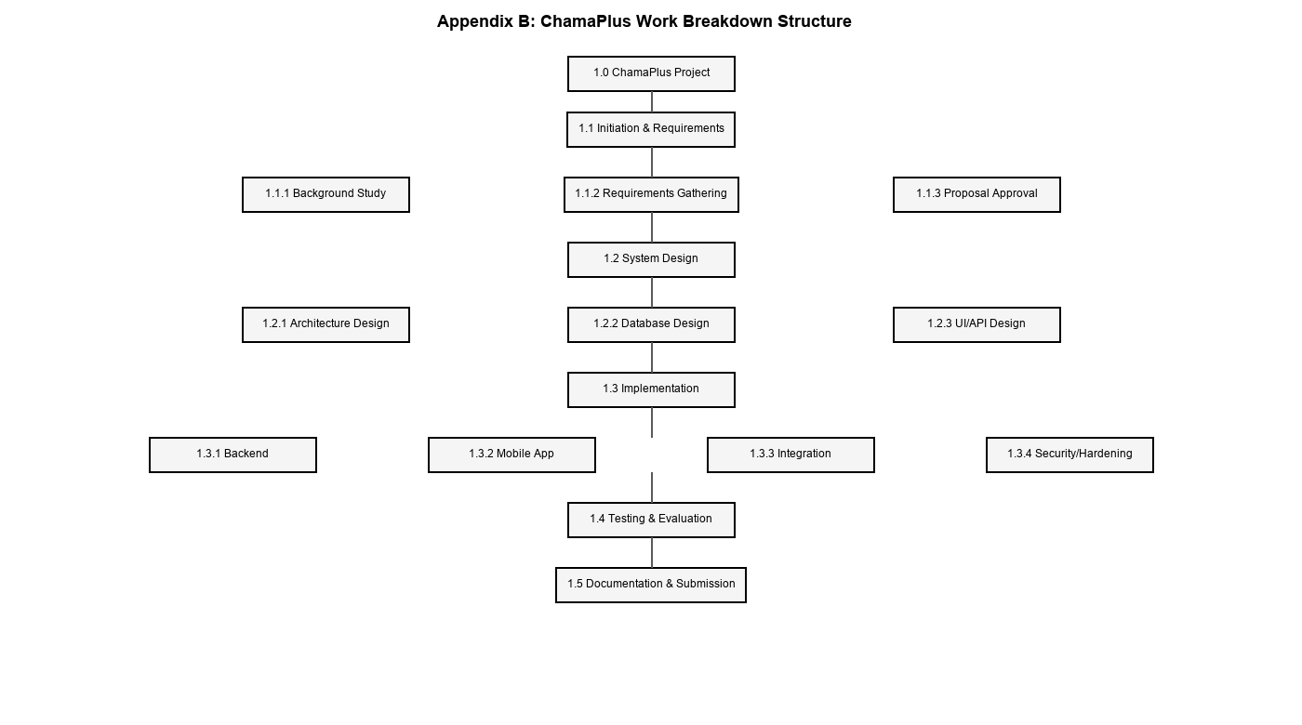

APPENDIX III: PROJECT NETWORK DIAGRAM
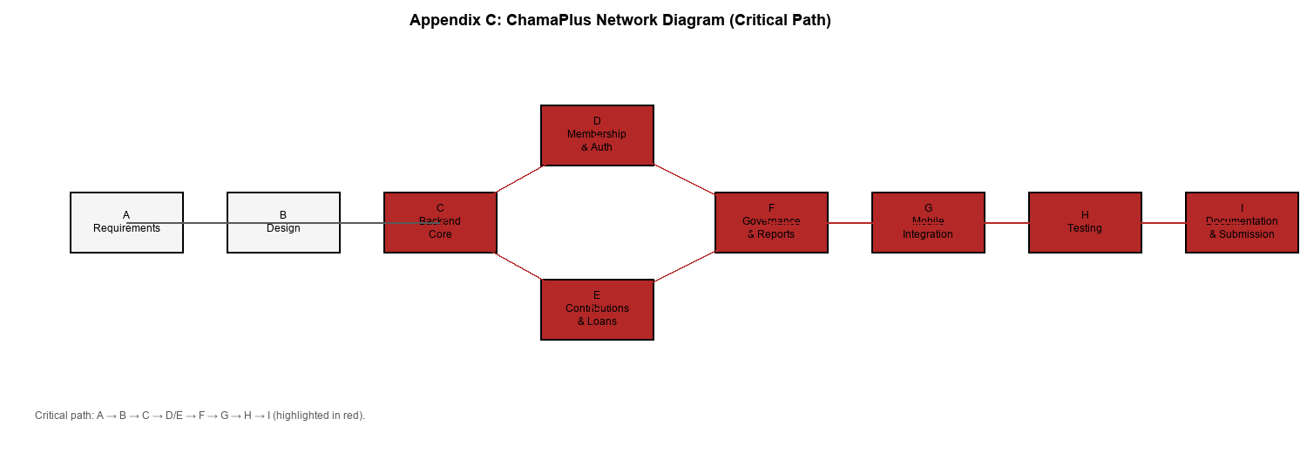

APPENDIX IV: SAMPLE SOURCE CODE
The following code samples are representative extracts from the implemented ChamaPlus system.
# Appendix D — Sample Backend Code: Credit Score Recalculation
# Source: Backend/apps/credit_scoring/services/credit_scoring_service.py
@staticmethod
def recalculate(member, chama, triggered_by=None):
if not MembershipService.user_is_active_member(member, chama):
raise DomainError("Member must be an active member of this Chama.")
weights = get_credit_score_weights()
thresholds = get_risk_thresholds()
components = CreditScoringService.calculate_components(member, chama)
weighted_total = Decimal("0")
breakdown = {}
for key, component_score in components.items():
weight = Decimal(str(weights.get(key, 0)))
points = (component_score * weight).quantize(Decimal("0.01"), rounding=ROUND_HALF_UP)
breakdown[key] = float(points)
weighted_total += component_score * weight
score = int(weighted_total.quantize(Decimal("1"), rounding=ROUND_HALF_UP))
score = max(0, min(100, score))
risk_level = CreditScoringService._determine_risk_level(score, thresholds)
return CreditScore.objects.create(
member=member, chama=chama, score=score, risk_level=risk_level,
breakdown=breakdown, weights=weights, calculated_at=timezone.now(),
triggered_by=triggered_by,
)
# Sample Backend Code: JWT Login
# Source: Backend/apps/accounts/services/auth_service.py
@staticmethod
def login(phone_number, password):
user = authenticate(username=phone_number, password=password)
if user is None:
raise DomainError("Invalid phone number or password.")
if not user.is_active:
raise DomainError("This account is inactive.")

refresh = RefreshToken.for_user(user)
return {"access": str(refresh.access_token), "refresh": str(refresh)}
// Sample Mobile Code: Login via Auth Repository
// Source: Mobile/lib/features/auth/data/repositories/auth_repository_impl.dart
@override
Future<User> login({required String phoneNumber, required String password}) async {
final tokens = await _authApi.login(
LoginRequestDto(phoneNumber: phoneNumber, password: password),
);
await _persistTokens(tokens.access, tokens.refresh);
final userDto = await _authApi.getCurrentUser();
return userDto.toEntity();
}
APPENDIX V: USER MANUAL - CHAMAPLUS MOBILE APPLICATION
1 Installation and Setup
Install the ChamaPlus mobile application on a supported Android device or emulator. Ensure the backend API is running and that the mobile .env file contains the correct API_BASE_URL. Launch the app to open the splash screen, which restores any existing session or redirects to login.
2 Registration and Login
1. Tap Register and enter phone number, password, and optional profile details.
2. After successful registration, the app logs in automatically.
3. Existing users enter phone number and password on the Login screen.
4. Use Forgot Password if you need to reset your credentials.
3 Creating or Joining a Chama
1. From My Chamas, tap Create Chama to register a new group.
2. To join an existing chama, tap Join Chama and enter the invite code or respond to a pending invitation.
3. The Chairperson or Secretary may approve join requests where required.
4 Recording Contributions
1. Open the Contributions hub and select the target chama.
2. Authorized officials create a contribution cycle before recording payments.
3. The Treasurer records each member contribution against the active cycle.
4. Members can view their contribution history and summaries.
5 Loan Management
1. The Chairperson creates loan products.
2. Members submit loan applications from the Loans hub.
3. Committee members review applications, view advisory credit scores and cast votes.
4. The Treasurer records disbursements and repayments.
6 Meetings and Governance
1. Officials schedule meetings from the Meetings hub.
2. The Secretary records attendance and meeting minutes.
3. Action items can be tracked from the meeting details screen.
7 Reports and Notifications
1. Open Reports to view dashboard summaries, monthly reports, financial reports and member statements.
2. Export options are available where supported.
3. Notifications appear in the Notifications screen for important chama events.
8 Profile and Logout
1. Use Settings to update profile details, appearance, security and notification preferences.
2. Use Logout to securely clear tokens and local cached data from the device.

