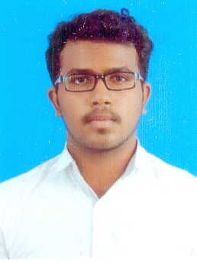

Hesen Nivas M

hesennivas@gmail.com

+91-819-003-8383

**OBJECTIVE**

Exceptionally creative and dependable entry level Web Developer with a motive to learn and gain experience. Broadly and deeply knowledgeable in a wide variety of computer languages as well as the principles and techniques of website construction and maintenance.

**Educational Qualification**

**B.E Autonomous, Anna University, Chennai (2016-2020) 8.92**

Department of Computer Science and Engineering (CGPA till 4rd Sem)

Sri Ramakrishna Engineering College, Coimbatore.

**HSC Matriculation Examination, Tamil Nadu (2015-2016) 95.16%**

Krishnamal Ramasubbaiyer School, Madurai

**SSLC Matriculation Examination, Tamil Nadu (2013-2014) 98.8%**

Krishnamal Ramasubbaiyer School, Madurai

**Technical Skills**

**Programming and Script Languages Proficient in** :C, HTML, CSS, JavaScript, PHP, Python ,Bootstrap, React.js, React Native, Node.js, Restify

**Familiar with** : Docker, APIs, Angular, Redux, Hosting, Webpack, MERN Stack, AJAX, JSON, Firebase, Laravel, Basic Electron, Android Development, OpenCV, Matlab, Mongoose, Arduino, Pandas, , jQuery, Basic Java and C++

**Databases**  : MySQL, PostgreSQL, GraphQL, Mlab

**Tools and Technologies Proficient in** : Xampp, Git, Nginx, GDT,

**Operating Systems** : Windows, Linux(Ubuntu, Kali)

**Area of Interests**

* Web Development and Design
* Mobile App Development and Design
* Data Analysis

**Workshop Attended**

* Attended “**Robotics and Artificial Intelligence**” workshop held at Sri Ramakrishna engineering college.

**Projects Done**

* Project working on **”Students Assessment Analysis Software”** on Web App Development using **Django, Python and JavaScript** which is in the later stage of testing.
* Project worked on **”Online Objective Test System ”** on Web Development using **Django, and JavaScript** which has been successfully built and implemented in our college.
* Project worked on **”Online Staff Registration System ”** on Web Development using **Django, React.js and JavaScript** which has been successfully built and implemented in our college.
* Project worked on **”Accidental Care for Smart India Hackathon”** on Web Development using **JavaScript and PHP**.
* Project worked on **”Hospital Management System ”** on Web Development using **JavaScript and PHP**.
* Project worked on **”News Blog ”** on Web Development using **React and Django**.
* Project working on **”TNAU Consortium Website”** on Web App Development using **Laravel** which is in the later stage of deployment.
* Project worked on **”Obstacle Avoiding Robot”** on AI using Arduino.

**Hobbies**

* Movies and Series
* YouTube
* Reading Books

**Personal Details**

**Date of Birth :** 16-09-1998

**Father’s Name :** Mr. M. Muthukumaran

**Mother’s Name :** Mrs. M. Vanitha Rani

**Address :** No.20, Anna Nagar,

4th Street, Kariyapatti,

Virudhunagar-626106

**Languages Known :** Tamil (Read, Write, Speak)

English (Read, Write, Speak)

**Declaration**

I hereby declare that the above written particulars are true to the best of my knowledge.

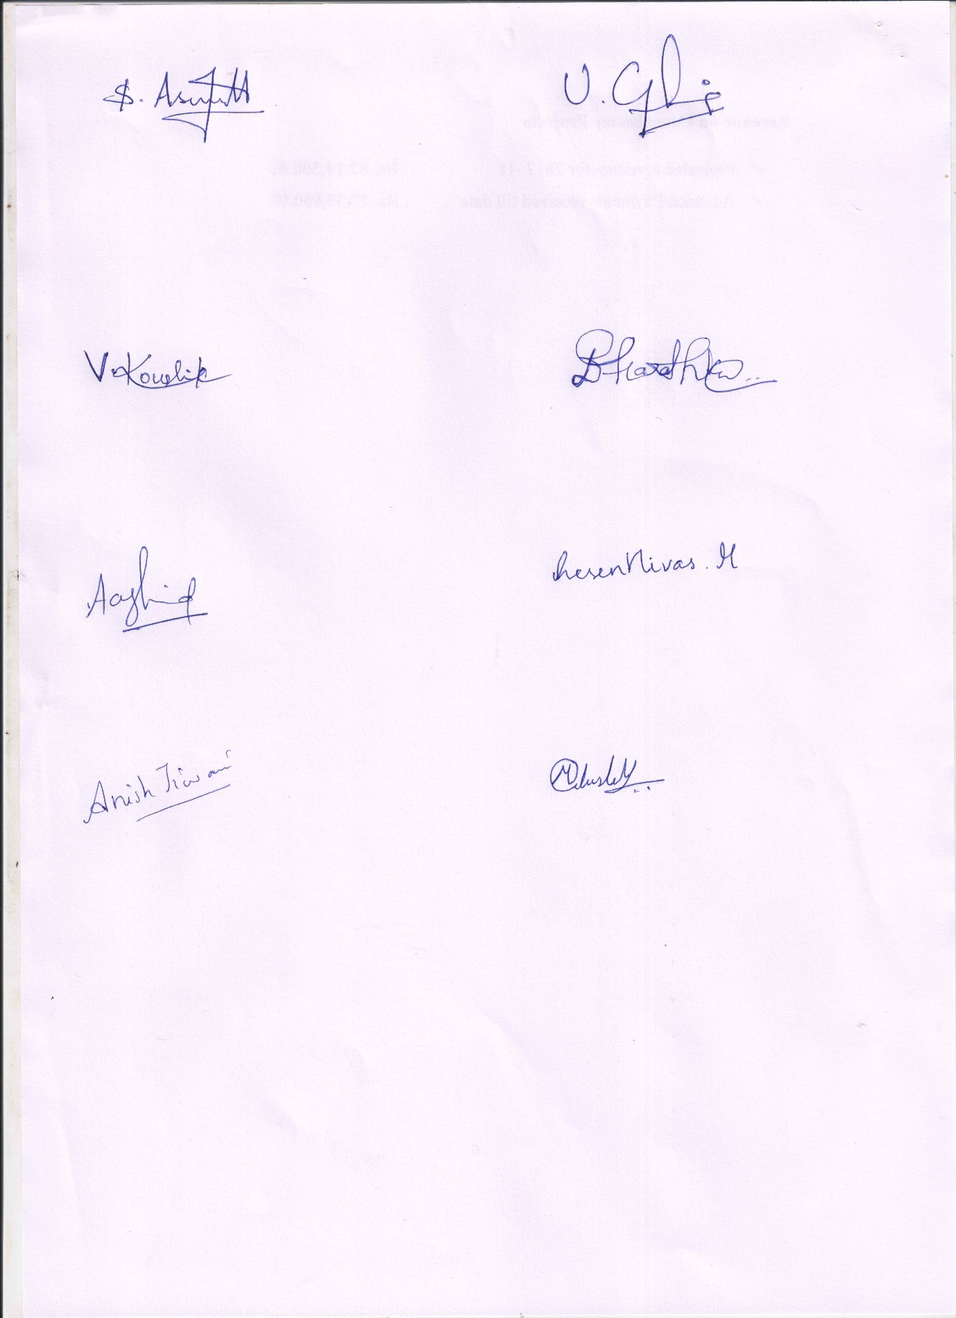

Date: 16-11-2018 (Hesen Nivas M)

BE-CSE