Prepared by: Hesha Sheth

University of Windsor

Advanced Database Topics

Covid -19 dashboard

Using Tableau

**Introduction**

This is a simple Covid-19 Dashboard which will help us to view the current covid-19 cases specifically by country. The purpose of the dashboard is to view the new cases and cumulative cases as well as death cases and cumulative cases by Country wise.

I would like to thank you for their WHO Covid-19 Dataset which is available for researchers.

**Project**

I have used two Covid-19 Dataset from WHO website, links are below:

1. Covid-19 with Daily cases and deaths by date reported to WHO.

The below are some screenshots of the project.

**Covid Cases**

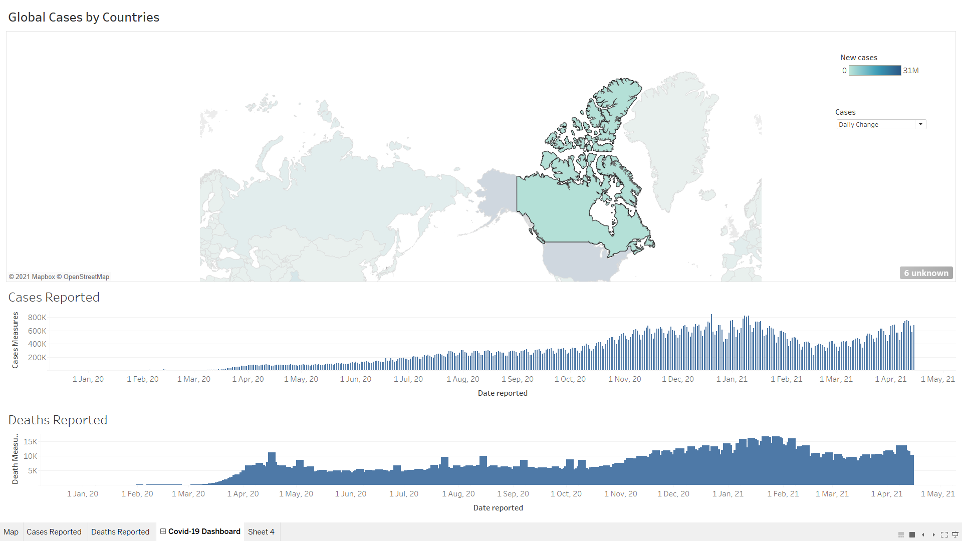

**Covid Cases per Country**

Here, we select Canada which display deaths and new cases recorded until 14 April 2021 in Canada. We can also change the Daily Change to Cumulative view to display the numbers as per our requirement.

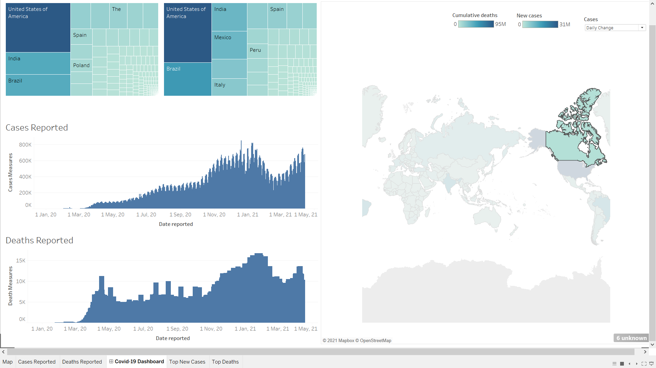

**Display of Top Countries with New Cases and Deaths**

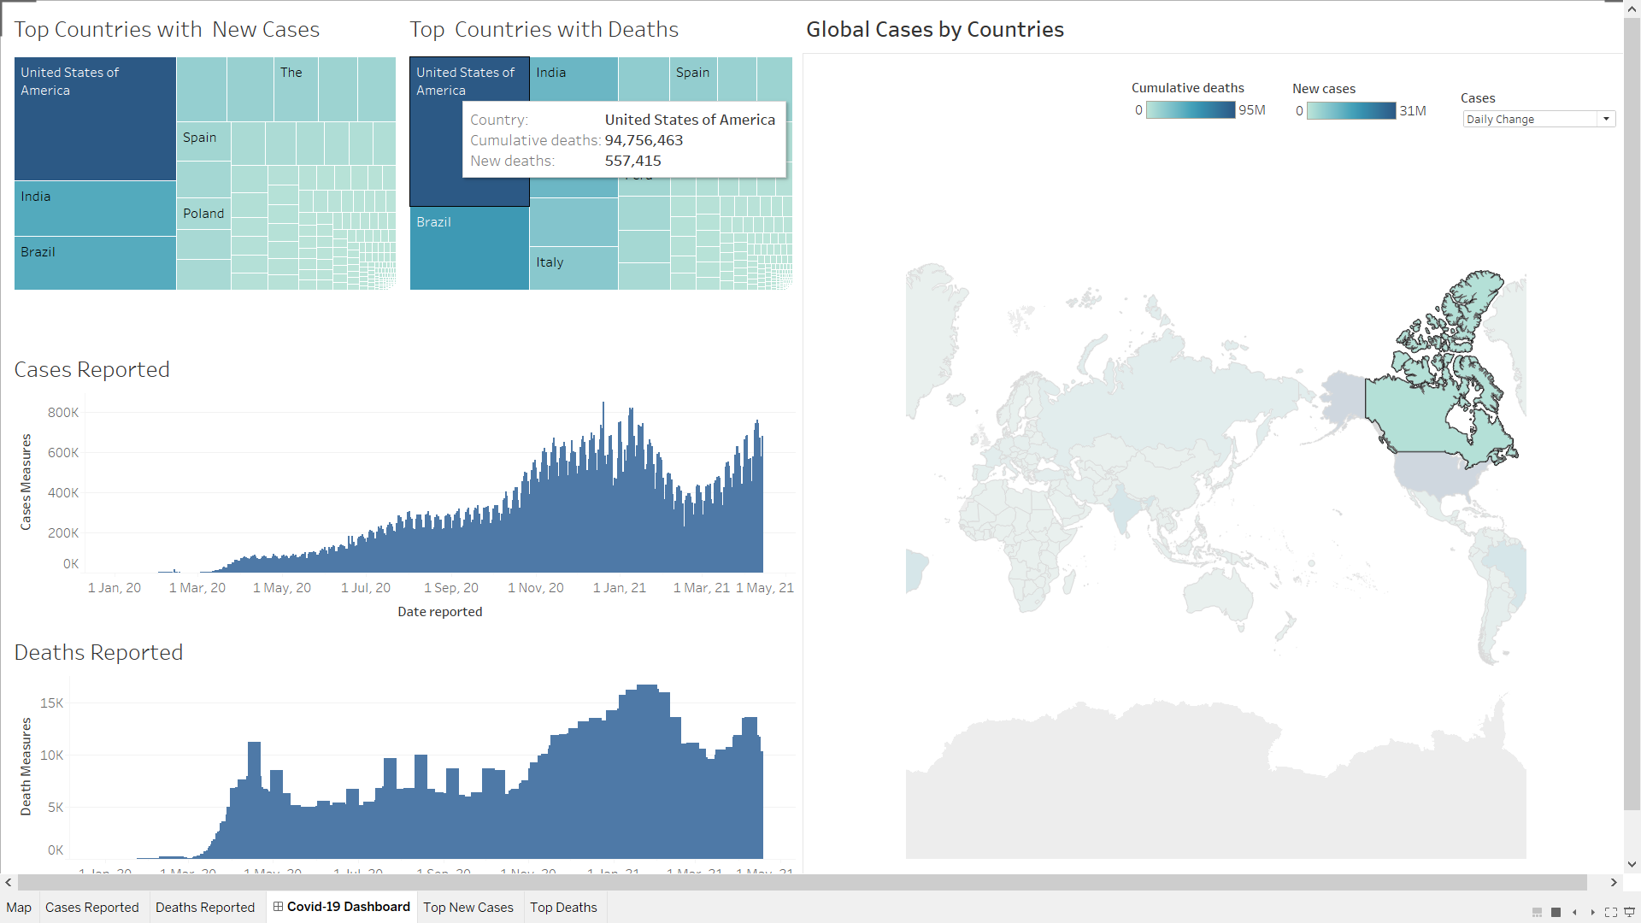

1. Covid-19 with Latest reported counts of cases and deaths, and transmission classification

The below Dashboard gives us the details like transmission causes, total number of cases and deaths and cases and deaths reported in last 24 hours.

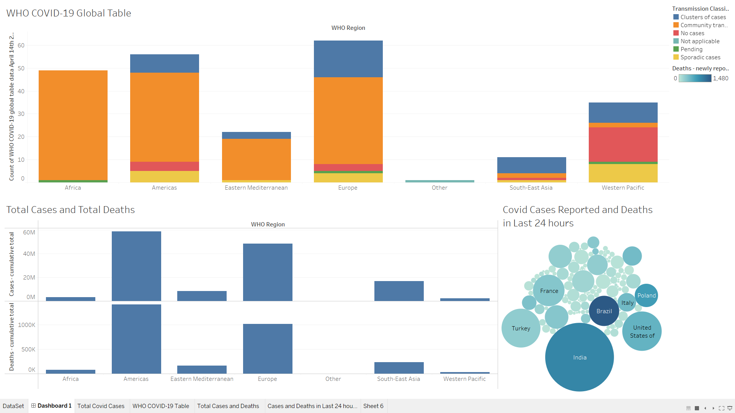

**Conclusion**

Tableau is a very powerful analytics tool which helps to understand the data more.

It was very interesting to learn a new tool which is so much fun to use and play with data to get information from the dataset. I would like to thank Dr. Kalyani for helping us to learn some new technology outside the course syllabus.

Certification of Completion:

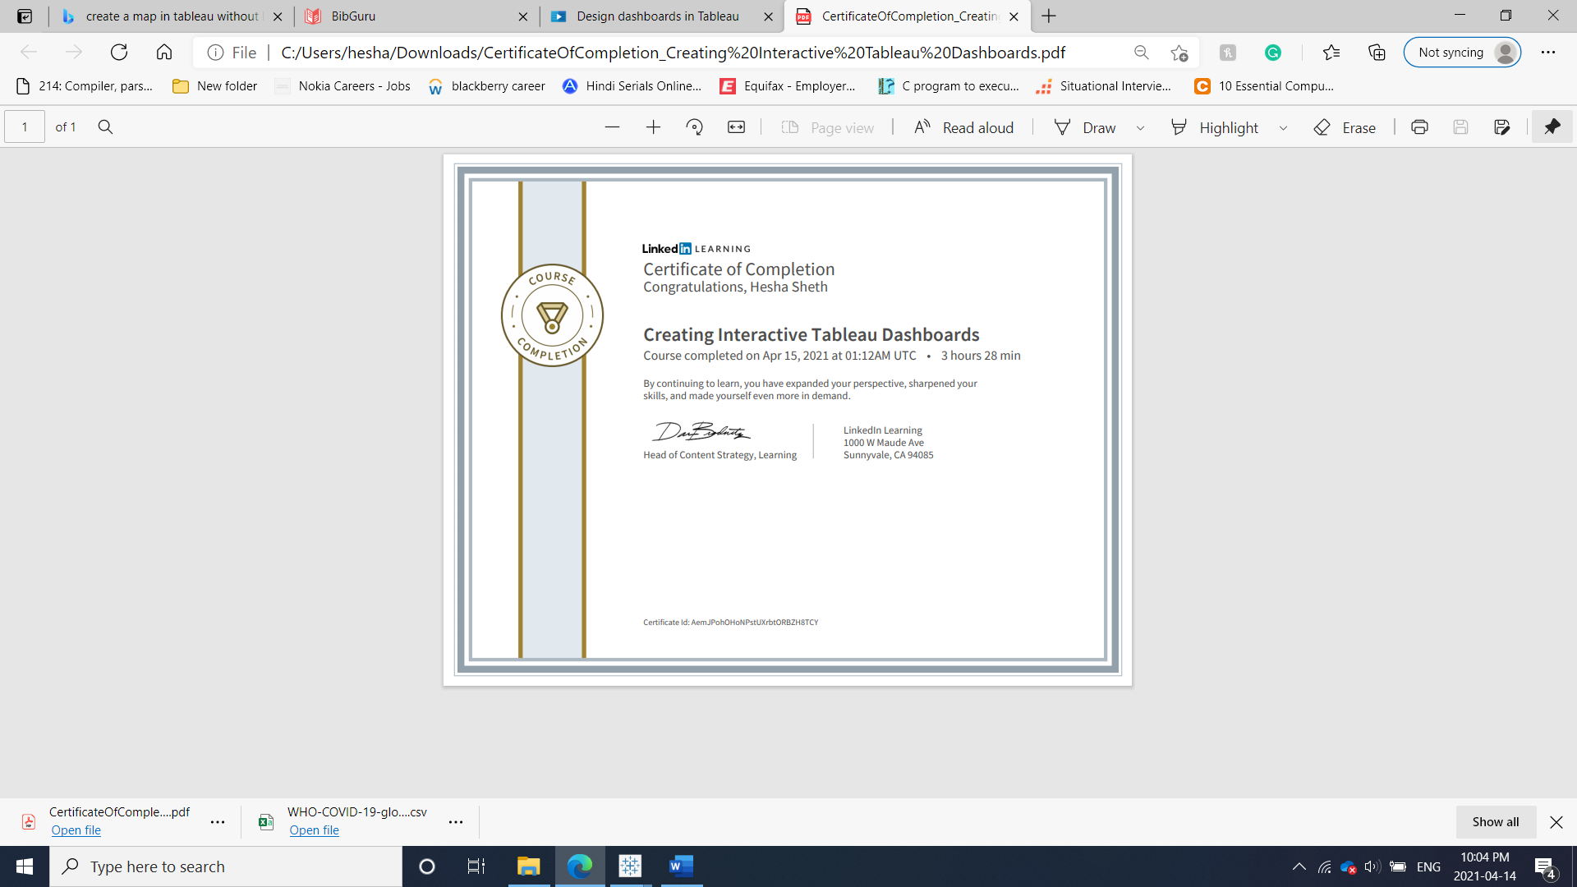

References

|  |  |
| --- | --- |
| [1] | “Tableau: Business Intelligence and Analytics Software,” *Tableau.com*. [Online]. Available: https://www.tableau.com/. [Accessed: 14-Apr-2021]. |
| [2] | “WHO COVID-19,” *Who.int*. [Online]. Available: https://covid19.who.int/info/. [Accessed: 14-Apr-2021]. |
| [3] | *Linkedin.com*. [Online]. Available: https://www.linkedin.com/learning/creating-interactive-tableau-dashboards/design-dashboards-in-tableau?u=56973065. [Accessed: 14-Apr-2021]. |