Visual Task Timeline — Product Discovery & MVP Specification
Comprehensive project handoff document
Prepared from the project discussion to date
Purpose: provide a self-contained handoff for a new ChatGPT conversation, designer, developer, or collaborator. This document captures the product idea, decisions, requirements, UX behavior, examples, open questions, and visual references discussed so far.

1. Executive Summary
The project is a visual task-history tracking application primarily intended for project managers. It is not a conventional to-do list. Its core concept is Project → Task → Timeline/Events. A task remains one continuous entity, while every meaningful action, outcome, request, follow-up, and future action is represented as an event on that task's timeline.
The key differentiator is that the timeline is both historical and forward-looking, and that the visual distance between events represents actual elapsed time. Real project work can branch into parallel paths and later merge back into the main task path.
The intended MVP is deliberately simple: minimum event input, maximum visibility. The timeline is the source of truth from which later AI summaries, delay analysis, project-level follow-up/to-do generation, reporting, and productization can be derived.

2. Product Vision
Create a clean, professional visual workspace that lets a project manager see the complete history of work on a task and understand what happened, when it happened, how long gaps lasted, where work branched, and how the work ultimately returned to the main path.
The product should feel more like a structured, time-aware canvas than a traditional project-management application, while remaining much more organized and chronology-focused than a free-form Miro-style board.

3. Core Product Model
- Project: the container for related work.
- Task: one continuous unit of work, such as “Technical Drawings.”
- Event/Node: one fact/action/state-change in the task history.
- Connection: relationship between events.
- Branch: a parallel path that remains part of the same task.
- Merge: a branch can reconnect to the main path.
- Date/time: the source of chronological positioning.

4. Fundamental Product Principle
Do not split a real task into artificial subtasks such as Submit → Feedback → Revise → Resubmit. Those are events in the history of one task. The task is the continuous entity; the timeline captures everything that happens to it.

5. Representative Real-World Example
Task: Technical Drawings. Drawings are submitted. A customer requests an additional breaker. That request creates a branch in which engineering checks feasibility and performs related work, while the main drawing activity may continue. Once the breaker request has been resolved and reflected in the drawing, the branch merges back into the task's main timeline, followed by the revised/resubmitted drawings.
Conceptual structure:
Submitted drawings
│
├── Customer requests additional breaker
│ ├── Engineering checks
│ └── Engineering updates information
│
└───────────────┐
↓
Updated drawings
↓
Resubmitted drawings

6. Timeline Behavior
The timeline is horizontal and time-aware. Visual distance between nodes should correspond to elapsed time. For example, events two days apart should appear closer than events twenty days apart. The purpose is not merely aesthetic: long gaps should visually expose where time was consumed.
Dates are the source of truth. The system automatically recalculates/repositions the timeline according to event dates. It must not silently rewrite dates merely to make the graph look orderly.
If dates and the visual/order relationship conflict, the system should flag a timeline conflict rather than silently changing history.

7. Event Data — MVP
Minimum input:
- Date/time — defaults automatically to the current creation date/time; user can edit it.
- Description — what happened. No separate event name is required.
- Completion state — done / not done.
- Optional due date — acceptable only if it can be added without making the interface complicated.
The product principle is minimum input, maximum visibility. Personnel, categories, status types, comments, attachments, richer metadata, and similar fields are future extensions, not MVP requirements.

8. Planned/Future Events
Future or uncompleted events are a core feature, not an exception. A user can record a planned action such as “Follow up with customer” before it happens. The event initially appears incomplete and can later be marked done.
A new fact should always be represented by a new event. For example, “Send invoice” is one event and “Customer paid” is a separate event. The user should not rewrite the old event to represent the new fact.

9. Completion State
MVP completion is binary: done or not done. Visually, an incomplete node can appear as an empty circle and a completed node as a checked/completed circle. No separate in-progress state is required for the MVP.

10. Creating Events
Two primary methods were agreed:
- A. Plus control
A plus symbol appears at the end/connection point of an event. Clicking it opens the new-event input.
- B. Drag from connection point
The user can drag directly from the event's connection point to create a new event. This is inspired by node-based tools such as the visual interface shown in the reference screenshot.
The same node-based interaction can be used to create a branch. The interface should not force the user to choose a special “branch mode”; the structure emerges from where the user creates/connects the event.

11. Branching and Merging
Branching is a core capability. A branch is a related parallel path within the same task, not a new task. It may contain multiple events and may remain active for days or weeks.
A branch can merge back into the main task. When a branch has completed work that affects the main task—for example, engineering resolves a customer's request for an additional breaker—the branch can reconnect to an existing or new event on the main path.
Merge interaction: drag a connection from a branch event toward an existing/main event; the target should visibly highlight as a valid merge target; release to establish the connection.

12. Editing
- Edit event description.
- Edit event date/time.
- Mark complete/incomplete.
- Move/reposition an event.
- Delete an event.
The MVP does not require immutable audit history/versioning. That may be considered later.

13. Deleting
Deletion requires confirmation: “Delete this event?” with Cancel and Delete actions.

14. Moving Events and Date Conflicts
The user wants the ability to move an existing node, potentially with explicit movement controls. However, event date remains the source of truth. If a movement/date change produces an inconsistent chronological relationship, the application should flag the conflict instead of silently changing other events.
Example warning concept: “Timeline conflict — event order doesn’t match dates.”

15. Project-Level View
When the user enters a project, the main screen should immediately show all task timelines/activities. There should not be an intermediate screen listing only active tasks and requiring the user to open them one by one.
The preferred visual direction is multiple organized horizontal task lanes stacked vertically. This is more structured and clearer than a completely free-form Miro canvas.
All timelines remain expanded in the MVP. No task-collapse feature is required.

16. Visual Design Direction: Structured + Miro-like
The preferred approach is a hybrid: the information structure is organized like a timeline, while interaction is canvas/node-based like Miro or workflow/node tools.
The product should NOT be a completely free-form Miro board because free positioning can weaken chronology. It should also NOT become a conventional Gantt/project-management UI. The intended mental model is a professional, time-aware project-history map.
Principle: structure the information, but do not restrict the interaction.

17. Navigation and Zoom
The user should be able to see the entire history of a task, including very long periods, while preserving the meaning of time gaps.
- Zoom in / zoom out controls (+ / −).
- Scroll/pan across the timeline.
- Hand-tool style free navigation for large/expanded task views.
- Zoom changes scale; pan changes what is visible; neither changes the underlying chronology.

18. Focused / Maximized Task View
A task should have an expand/maximize control. Activating it opens a larger focused canvas/window where the user can freely navigate the task history.
This focused view should support panning with a hand tool, zooming, and navigating complex branches without being constrained by the project overview.
The project overview is the map; the maximized task view is the workspace for detailed inspection.

19. Event Inspection Popup
Clicking an event opens a contextual popup directly over/next to the node. No right-side detail panel should be used.
The popup may be slightly translucent/floating so the surrounding timeline remains visible. This allows the user to inspect an event while retaining before/after context and continuing to zoom/pan.
Hover is NOT the primary full-detail interaction. Hover previews may be considered later, but click-to-open is the MVP interaction because heavy hover behavior could complicate navigation.

20. Initial Task Creation
A new task timeline starts as a blank/empty timeline with an “Add first event” action. Once the first event exists, connection/plus controls become available for adding subsequent events.
The user does not need to know the full workflow in advance. Unplanned events and branches can be added as real work unfolds.

21. Overall User Journey
- Public homepage explains the product, shows the visual concept, and provides a call to action.
- Authentication can use Google, LinkedIn, or email/password.
- After login, the dashboard shows projects in a simple, user-friendly way.
- User opens a project and immediately sees all task timelines.
- User creates a task and adds its first event.
- User continues the timeline using + or drag.
- Unexpected work is represented as branches.
- Branches can later merge back into the task.
- User clicks nodes to inspect/edit them via contextual popup.
- User zooms/pans to understand the full history and elapsed time.
- User can maximize a task for detailed canvas navigation.

22. Future AI / Product Capabilities
- AI summary of a task's complete history.
- Explain duration and important delays.
- Identify important events or periods.
- Generate customer-ready or management-ready task/project reports.
- Project-level current/future action list derived from the latest timeline state and branches.
- Search old task history.
- Analytics on time spent between events and where delays occurred.
- Potential future identification of waiting states, follow-ups, and other actionable insights.
The timeline/graph is intended to be the source of truth from which these future capabilities derive their data.

23. Productization Roadmap
The first implementation is for personal use and validation. Only after the core concept is useful should it be expanded into a multi-user subscription/SaaS product.
- Personal MVP.
- Real-world personal use.
- Validate the core timeline/branch/merge experience.
- Productize for multiple users.
- Organizations/workspaces.
- Shared projects.
- Permissions and roles.
- Billing/subscriptions.
Multi-user, organization, permissions, and billing concerns should not unnecessarily complicate the initial MVP.

24. Proposed Documentation / Project Framework
- 0. Project Charter
- 1. Discovery
- 2. Scope & MVP
- 3. Solution Design
- 4. Technology & Tools
- 5. Development
- 6. Testing
- 7. Personal Deployment
- 8. Validation
- 9. Productization
- 10. Monetization
- 11. V2 Expansion
- 12. Case Study
The project documentation should also maintain: objective, success criteria, scope/out-of-scope, requirements, assumptions, constraints, risks, dependencies, milestones, deliverables, backlog, technical decisions, architecture, testing plan, change log, decision log, version history, and lessons learned.

25. Current Functional Requirements — Consolidated
- Create projects.
- Create tasks within projects.
- Display all task timelines on the project page.
- Create a first event on a blank task timeline.
- Create subsequent events with a plus control.
- Create events by dragging from a node connection point.
- Create branches from nodes/connections.
- Allow multiple events inside a branch.
- Merge a branch back into the main path.
- Store event date/time.
- Store event description.
- Store done/not-done state.
- Optionally support a due date if it remains simple.
- Automatically position timeline based on event dates.
- Represent elapsed time through visual spacing.
- Flag date/order conflicts.
- Edit event description/date/state.
- Move/reposition events.
- Delete events with confirmation.
- Support future/uncompleted events.
- Click node to open contextual popup.
- Support zoom in/out.
- Support pan/hand-tool navigation.
- Provide a maximized/focused task canvas.
- Keep full timelines visible; do not collapse tasks in MVP.

26. Non-Functional / UX Requirements
- Simple and professional.
- Minimum input, maximum visibility.
- Avoid unnecessary fields and controls.
- Chronology must remain trustworthy.
- Visual spacing must communicate elapsed time.
- Navigation should feel natural on a large canvas.
- The user should not have to move between screens/panels to understand a task.
- The timeline should remain the central source of truth.
- The interface should support real-world, unplanned project activity.

27. Out of Scope for MVP / Later
- Complex audit/version history.
- Large numbers of event metadata fields.
- Rich personnel/category/comment systems.
- Attachments/files.
- Advanced status taxonomies.
- Full multi-user organization/permission system.
- Billing/subscriptions.
- Advanced AI.
- Project analytics beyond what is necessary to validate the timeline concept.

28. Visual References from the Discussion
Two user-provided screenshots were used during discovery to clarify the desired node-connection interaction. They showed a node-based interface where a user can drag from a connection point to create another node/path. The screenshots were used as interaction references, not as a request to copy the source product's visual design.
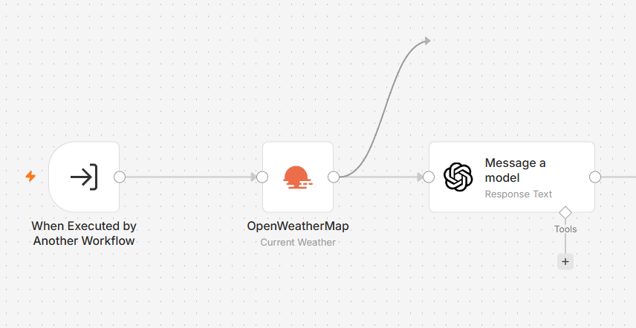
Figure 1. User-provided interaction reference used during branching/event-creation discussion.
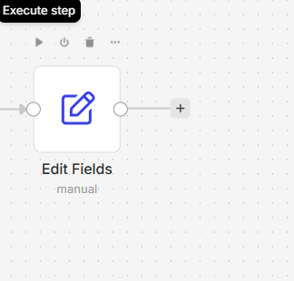
Figure 2. User-provided interaction reference used during branching/event-creation discussion.

29. Decisions Made So Far
- One task is continuous; workflow steps are events, not subtasks.
- Branches belong to the same task.
- Branches can merge back into the main path.
- Events have minimal MVP data: date/time, description, done/not done; due date only if simple.
- Future/uncompleted events are supported.
- New facts create new events instead of rewriting old events.
- Timeline spacing reflects actual elapsed time.
- Event dates are the source of chronological truth.
- Date/order conflicts are flagged rather than silently corrected.
- Two event-creation methods: plus control and drag from connection point.
- Project view shows all timelines immediately.
- Task timelines do not collapse in MVP.
- The visual design is structured timeline lanes + free canvas-like interaction.
- Task can be maximized into a focused canvas.
- Zoom and pan are core navigation.
- Event details open in a direct contextual popup, not a side panel.
- Hover is not the primary detailed interaction.
- MVP should stay simple and avoid unnecessary controls.

30. Open Design Questions
The core interaction model is substantially defined, but several implementation details should remain open until solution design/prototyping rather than being guessed:
- Exact visual node/card shape and styling.
- Exact mechanics for selecting/dragging an event without accidental movement.
- How automatic layout behaves when branches become dense.
- Exact merge-target highlighting behavior.
- How timeline conflicts are displayed.
- Whether an optional due date belongs in the first prototype.
- Exact project-level navigation/toolbar arrangement.
- Exact behavior and sizing of the focused/maximized task canvas.

31. Recommended Next Project Phase
The discovery discussion has now defined enough of the core product behavior to move toward a formal MVP specification and low-fidelity/high-fidelity UX prototype. Technology selection should come after the interaction model is prototyped and the data model is confirmed.
The immediate design exercise should prototype one realistic task end-to-end: normal events → branch → multiple branch events → merge → continued main timeline, with realistic dates showing a short gap and a long gap.

32. Handoff Statement
A new collaborator should be able to use this document as the current source of product-discovery truth. The product is intentionally not yet a finalized technical specification. Where this document identifies an open question, that behavior should be prototyped/discussed rather than invented.

