Genome-wide Identification of Differentially Expressed and Prognostically Relevant lncRNAs in TCGA-BRCA Using Integrated Bioinformatics Analysis

Abstract
Background
Long non-coding RNAs (lncRNAs) are increasingly recognized as key regulators of tumor initiation and progression in breast cancer. However, comprehensive analyses integrating differential expression and survival associations remain limited. This study aimed to identify dysregulated lncRNAs in breast cancer and evaluate their prognostic significance using TCGA-BRCA RNA-sequencing data.
Methods
RNA-seq STAR-count data from TCGA-BRCA were obtained using TCGAbiolinks. A balanced subset of 50 primary tumor and 50 solid tissue normal samples was randomly selected for reproducibility. Differential expression analysis was conducted using DESeq2 with significance defined as adjusted p-value < 0.05 and |log2 fold change| > 1. lncRNA annotation was performed using Ensembl biomaRt. Survival associations were evaluated using Kaplan–Meier and Cox proportional hazards models.
Results
A total of 1553 lncRNAs were significantly dysregulated between tumor and normal tissues. Principal component analysis demonstrated clear separation between tumor and normal samples (PC1 = 32%, PC2 = 15%). Hierarchical clustering of the top 50 lncRNAs showed strong discriminatory capacity. Genome-wide survival screening identified several candidate prognostic lncRNAs, including ZFHX4-AS1 (HR = 1.98, p = 1.98×10⁻⁴) and LINC02668 (HR = 2.26, p = 2.85×10⁻⁴). HOTAIR expression demonstrated significant survival association when stratified using an optimized threshold (log-rank p = 0.0011), though continuous Cox modeling was not statistically significant.
Conclusion
This integrated bioinformatics analysis identifies a panel of differentially expressed and prognostically relevant lncRNAs in breast cancer. These findings highlight potential biomarkers warranting validation in larger independent cohorts.

1. Introduction
Breast cancer remains the most frequently diagnosed malignancy among women worldwide and represents a major cause of cancer-related mortality. Advances in high-throughput sequencing technologies have revealed that a substantial proportion of the human transcriptome consists of non-coding RNAs, including long non-coding RNAs (lncRNAs), which exceed 200 nucleotides in length and lack protein-coding capacity.
Emerging evidence indicates that lncRNAs regulate chromatin remodeling, transcriptional control, RNA stability, and signal transduction pathways. Several lncRNAs, including HOTAIR, have been implicated in breast cancer progression, metastasis, and therapeutic resistance. Nevertheless, systematic identification of differentially expressed and prognostically relevant lncRNAs using integrative computational approaches remains incomplete.
Therefore, we performed a genome-wide bioinformatics analysis of TCGA-BRCA RNA-seq data to identify dysregulated lncRNAs and assess their survival associations.

2. Materials and Methods
2.1 Data Acquisition
RNA-sequencing STAR-count data and clinical information for TCGA-BRCA were obtained via TCGAbiolinks. A balanced subset of 50 primary tumor and 50 solid tissue normal samples was randomly selected using a fixed seed.
2.2 Differential Expression Analysis
Raw counts were analyzed using DESeq2. Genes with ≥10 counts in at least 10 samples were retained. Differential expression significance was defined as adjusted p-value < 0.05 and |log2 fold change| > 1. Log-fold change shrinkage was performed using the apeglm method.
2.3 lncRNA Annotation
Gene annotation was retrieved from Ensembl via biomaRt. lncRNAs were defined based on gene_biotype categories including lincRNA, antisense, processed_transcript, sense_intronic, and sense_overlapping.
2.4 Survival Analysis
Overall survival time was calculated using days_to_death or days_to_last_follow_up. Kaplan–Meier analysis and univariate Cox proportional hazards models were applied. Optimal expression cutpoints were determined using maximally selected rank statistics.
2.5 Statistical Analysis
All analyses were conducted in R. P-values < 0.05 were considered statistically significant.

3. Results

3.1 Global lncRNA Dysregulation
Differential expression analysis identified 1553 significantly dysregulated lncRNAs between tumor and normal tissues. Volcano plot visualization demonstrated extensive transcriptomic alterations, with numerous lncRNAs exhibiting large effect sizes and strong statistical significance.
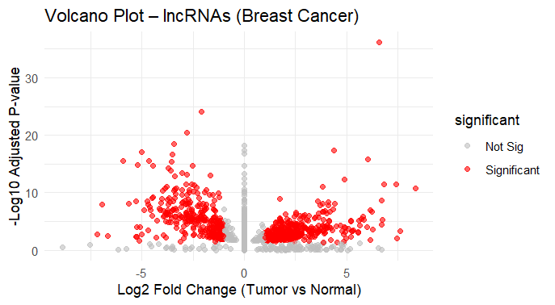
Figure 1. Volcano plot of differentially expressed lncRNAs in TCGA-BRCA.

3.2 PCA Demonstrates Strong Tumor–Normal Separation
Principal component analysis of variance-stabilized expression data revealed distinct clustering of tumor and normal samples. PC1 explained 32% and PC2 explained 15% of total variance, indicating robust disease-associated transcriptomic reprogramming.
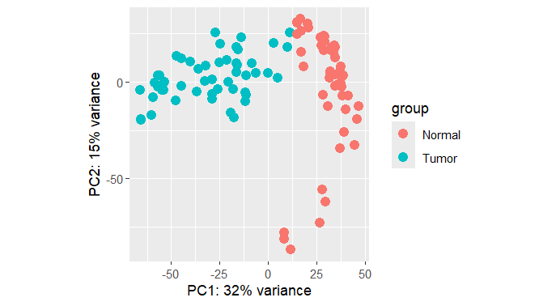
Figure 2. PCA plot showing separation between tumor and normal samples.

3.3 Hierarchical Clustering of Top lncRNAs
Heatmap analysis of the top 50 differentially expressed lncRNAs showed clear separation between tumor and normal tissues, supporting their discriminatory potential.
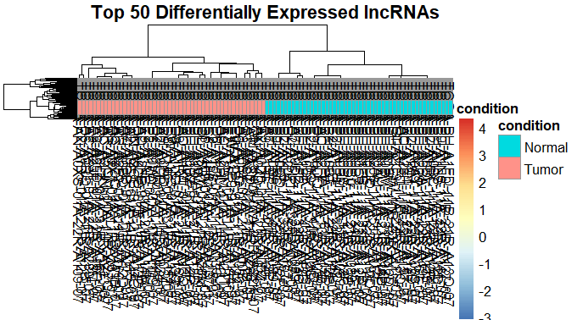
Figure 3. Heatmap of top 50 differentially expressed lncRNAs.

3.4 Survival Analysis of HOTAIR
Kaplan–Meier analysis using median expression cutoff showed a non-significant survival difference (log-rank p = 0.10).
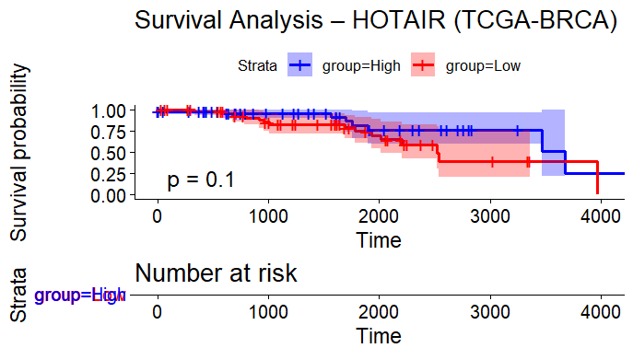
Figure 4. Kaplan–Meier survival curve using median cutoff.
Optimized cutpoint stratification (cutpoint = 4.555827) revealed a statistically significant difference in overall survival (log-rank p = 0.0011). Univariate Cox analysis treating HOTAIR as a continuous variable was not statistically significant (HR = 0.897, 95% CI 0.717–1.121, p = 0.339).
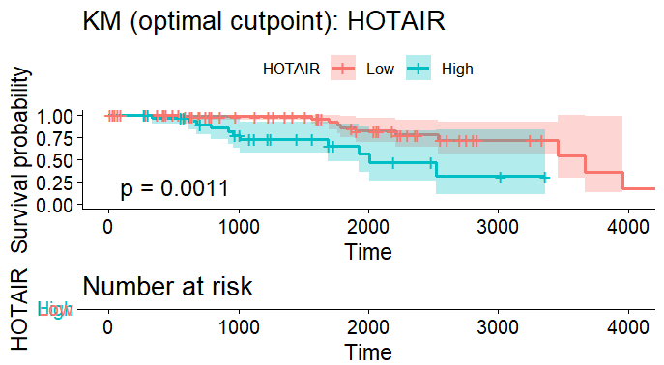
Figure 5. Kaplan–Meier survival curve using optimized cutpoint.

3.5 Genome-wide Survival Screening
Univariate Cox regression screening identified several lncRNAs significantly associated with survival, including ZFHX4-AS1, LINC02668, PDCD6-DT, and LINC02139.

4. Discussion
This integrative analysis demonstrates widespread dysregulation of lncRNAs in breast cancer. Several lncRNAs exhibited hazard ratios exceeding 2.0, suggesting meaningful associations with survival risk. HOTAIR showed threshold-dependent prognostic significance, highlighting potential non-linear survival relationships.

5. Conclusion
This genome-wide bioinformatics analysis identified 1553 differentially expressed lncRNAs in breast cancer and highlighted multiple candidate prognostic biomarkers. Further validation in larger cohorts and functional studies is warranted.

Data Availability
TCGA-BRCA data are publicly available from the Genomic Data Commons.

