

**THE OPEN UNIVERSITY OF SRI LANKA**

**BACHELOR OF SOFTWARE ENGINEERING**

**ACADEMIC YEAR – 2021/22**

**EEI3346 - WEB APPLICATIONS DEVELOPMENT**

**Mini Project**

**DealMart**

**A.H.M.H.S.Abayarathna**

**S92083035**

**Registration Number - 121643035**

**Problems**

Sub -problems

1. cross code

* Many css codes are cross over. Then obviously we do not get the required output

1. Js file are not working

* Some pages have same JavaScript then this files are over crash

1. Change window for small screen.

* Because the screen of a mobile phone is small, all the data on the web page may not be displayed as expected when viewed on a smartphone rather than on a large screen.

Constraints

1. Lack of experience.

* Due to lack of previous experience in creating web pages, I had to face some difficulties in creating the web page. So there were problems with time management as well.

1. Limited time.

* Due to the increase in procedures to problem, it is somewhat difficult to manage all the tasks within the given time frame.

1. Lack of quality images.

* The quality of the photos were reduced due to the fact that I did not have the advanced technical tools to take photos of the products.

**Solutions**

1. Use !important tag to was able to get the output I needed
2. I use two JavaScript files to resolve this problem
3. Use media query to change window sizes.

**Architectural diagram of the system**

**Site Map**

**Used web technologies and examples**

* Browsers.

**Ex**. Google Chrome

* HTML
* CSS
* Programming Languages

**Ex**. JavaScript

VueJs

* Text Editor

**Ex**. Vs Code

**Test Results**

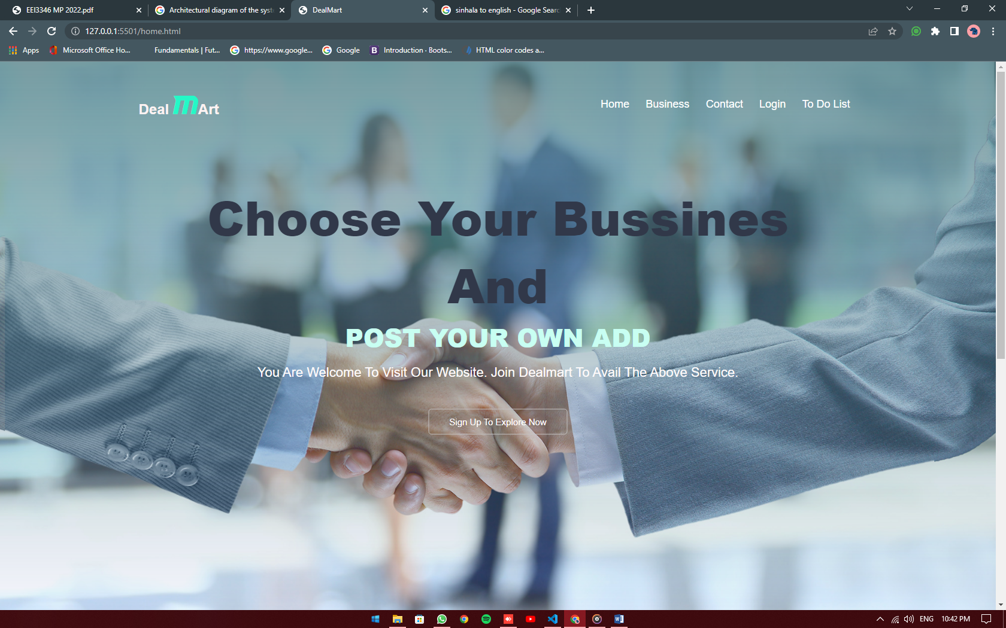

This is home page. Its include business, contact, login, to do list.

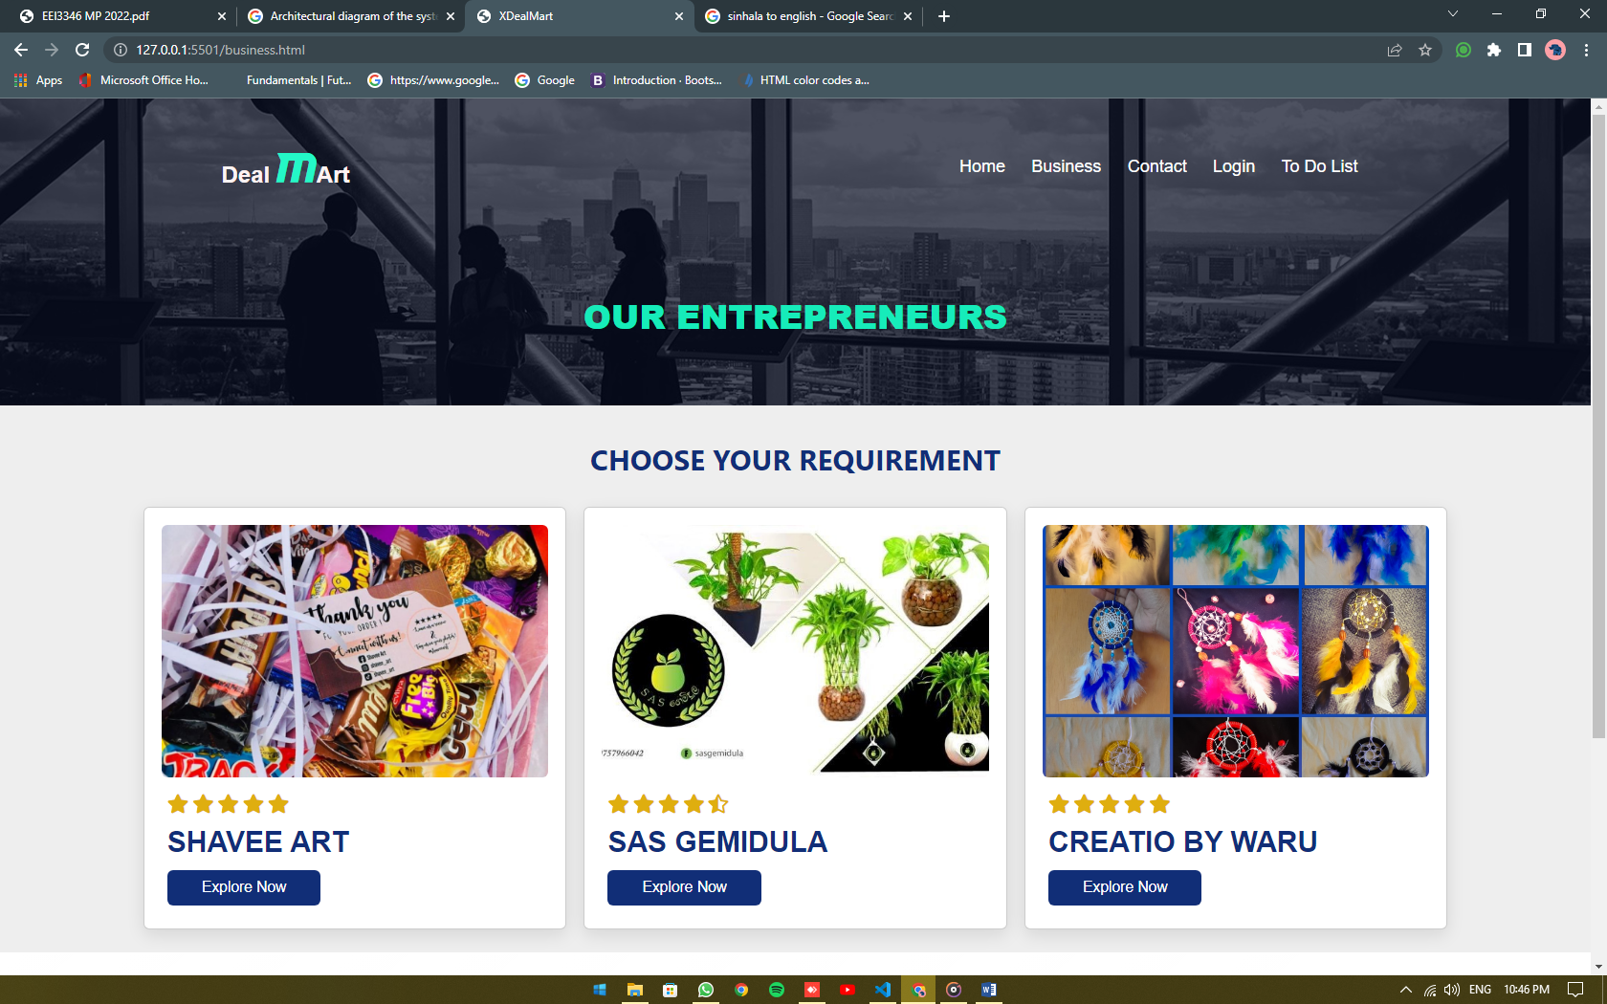

This is Our Entrepreneur’s site. It’s include shave art, SAS gemidula, Creatio by waru.

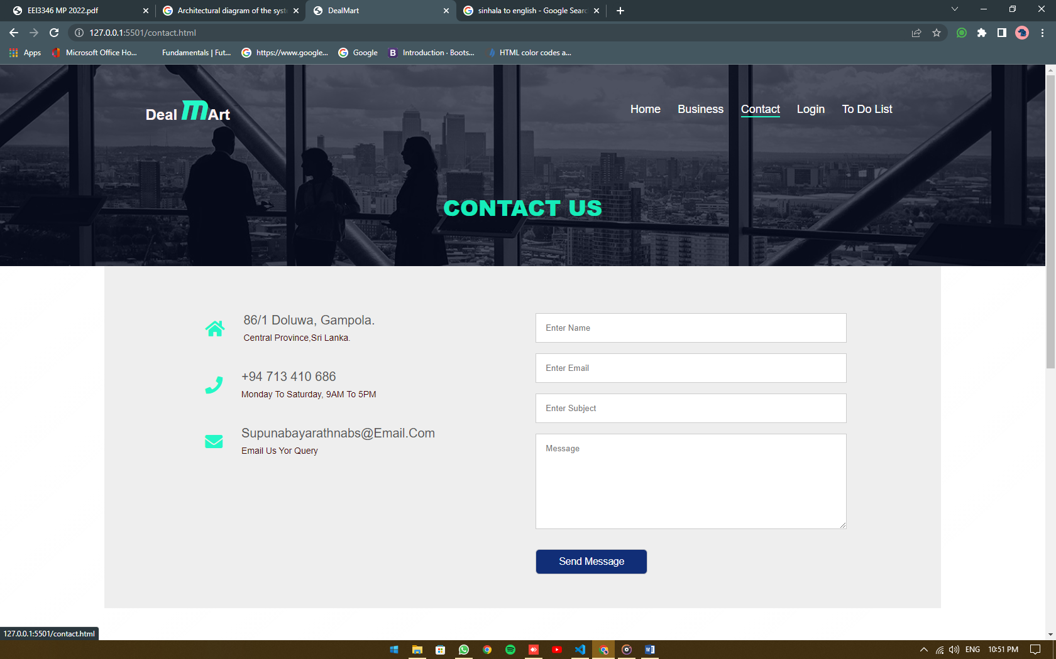

Contact us page

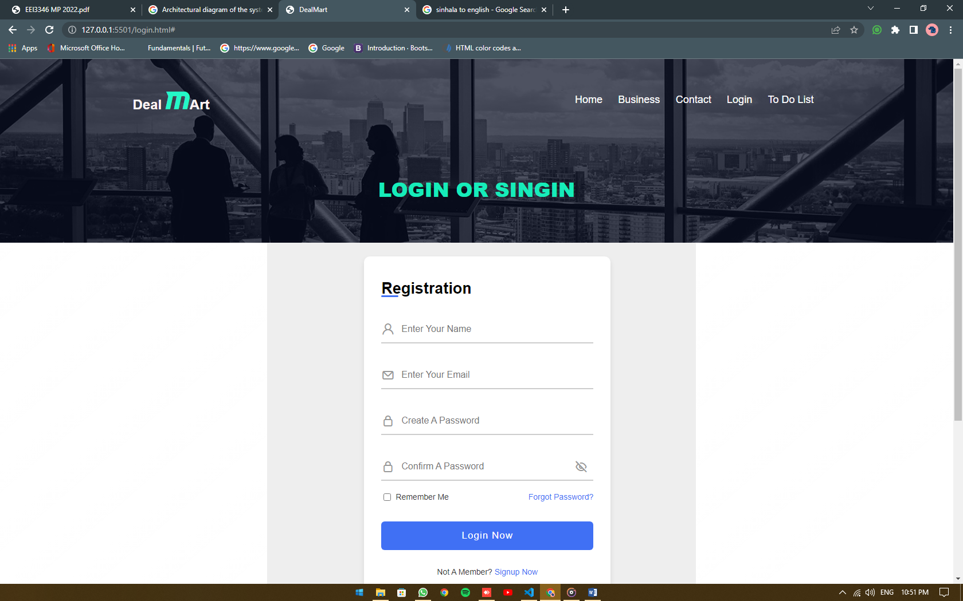

Login & sign in form

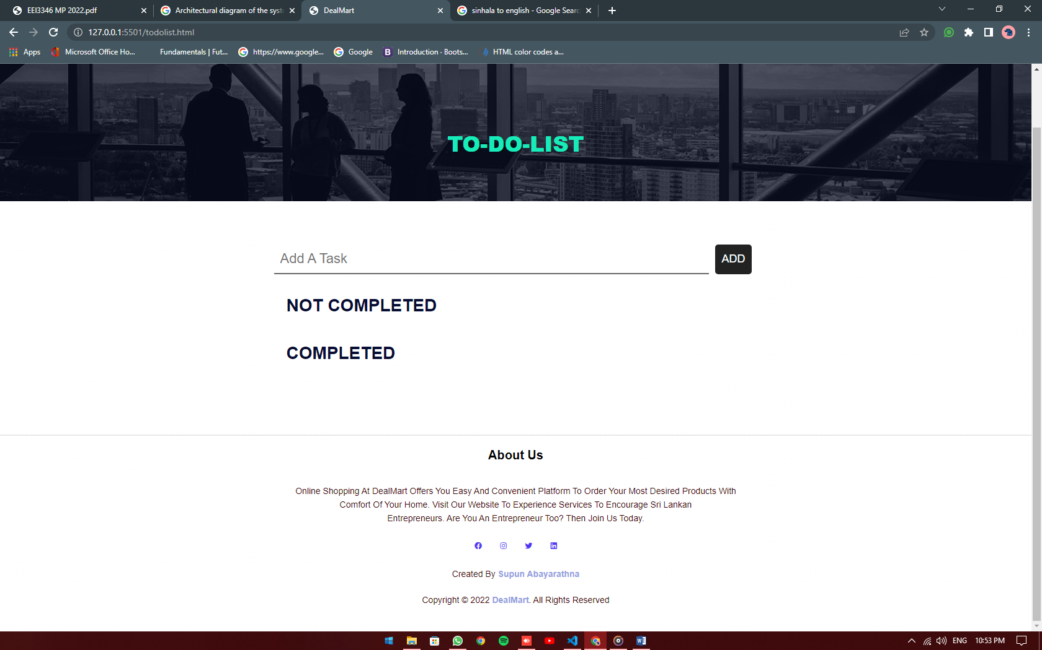

To-Do-List

**Conclusion**

Through this web page I have taken steps to showcase the products of small businesses (home based businesses) in Doluwa area. Through this I have tried to bring the products to the consumers at the rural level. I am sure this will be great incentive for small businesses at the rural level.