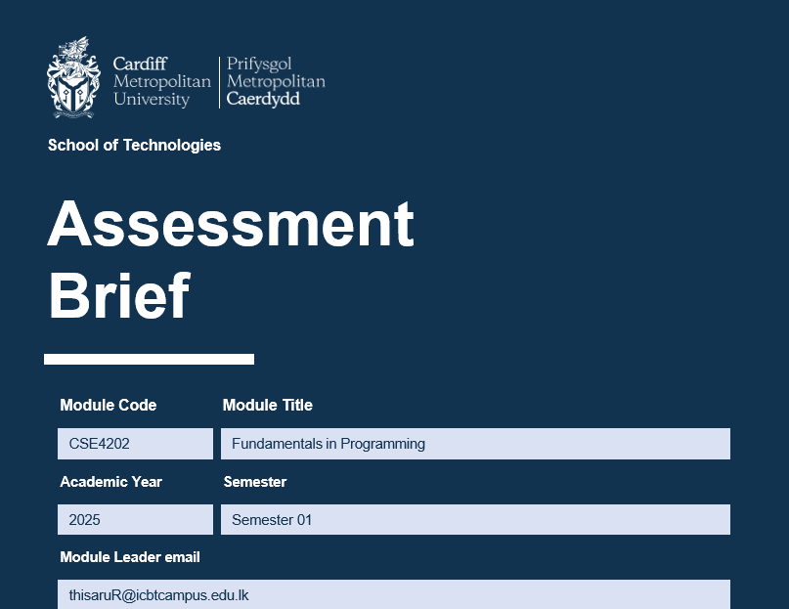

Name- Heshani Oshadi
Student ID – CL/HDCSE/CMU/137/41
Student ID – st20356819

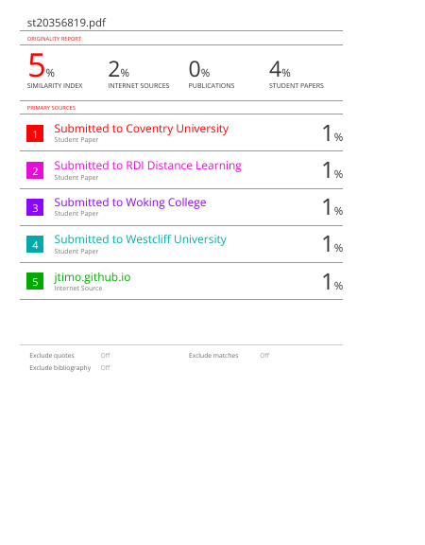

Problem Summary
The Central Perk Smart Café Management System is a café automation program built on Python for the console. Users can use the café menu (with an option to sort by price) to search for available items, order items with quantities, calculate total bills, use discounts, and generate formatted receipts.
Core concepts of programming in Python are supported in this program, including the use of functions, the use of dictionaries, the use of loops, the use of conditional statements, the use of exception handling, and the use of docstrings. The modular structure of the system provides better readability, maintainability, and reusability of code. Overall, this system provides an easy but accurate simulation of the process of managing a real café for learning and academic purposes.

Input-Process-output Analysis

Input Data | Processing Steps | Output Information
User menu option | Read and validate user menu selection. | Selected system function executed.
Menu data (items & prices) | Load and optionally sort the menu by name or price. | Menu displayed to the user.
Item name (search, order) | Check item existence in the menu dictionary. Validate the selected item from the menu. | Item details or “not available” message. Accepted item for ordering.
Quantity | Validate quantity and multiply by item price. | Item subtotal.
Order list | Sum all item subtotals. | Order subtotal.
Order subtotal | Check discount condition (subtotal > LKR 2000). | Discount amount.
Subtotal & Discount | Subtract discount from subtotal | Final payable amount.
Order details | Format and display the receipt. | Printed receipt.

Data Representation Plan

Data type | Data Structure Used | Example | Reason for use
Menu and Price | Dicrionary | 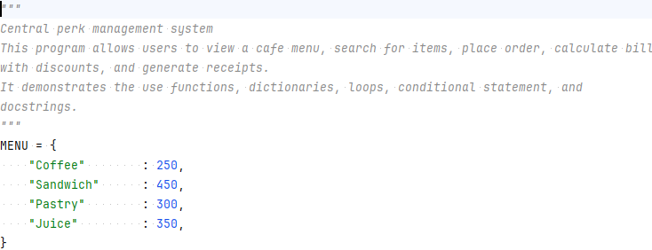 | To store menu items with their prices in key-value format for fast access, and store the price of each item.
order_list | List | 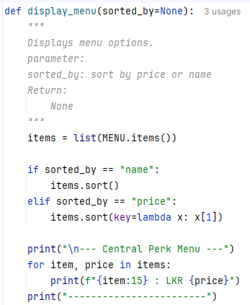 | To store multiple ordered items together in one collection.
name | String | 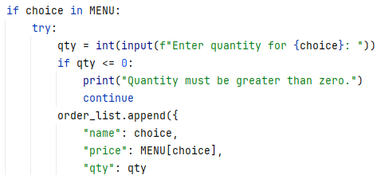 | To store the name of the ordered item.
Qty | Integer | 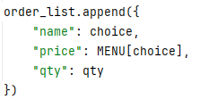 | To store the quantity ordered by the customer.
subtotal | Integer | 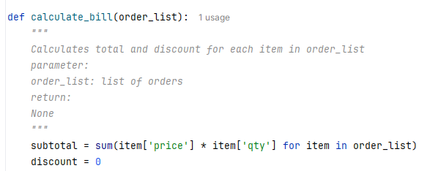 | To store total amount before discount.
discount | Float | 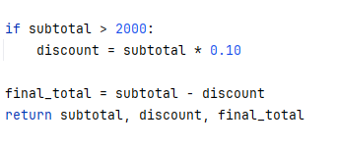 | To store calculate discount value.
Total | Float |  | To store final payable amount.
choice | String | 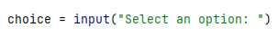 | To store user’s menu selection.
sorted_by | String | 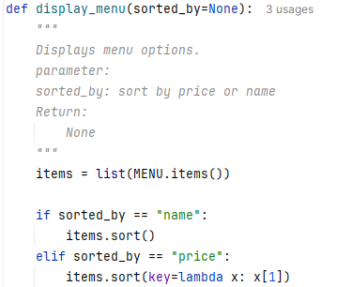 | To decide sorting type.

Function Planning
The program is designed using a modular approach to ensure the code is reusable and easy to debug:
Function Name | Propose | Input | Output
Display_menu () | Display the café menu to the user. Can sort items by name or price. | sorted_by (optional) | The menu list is displayed.
search_item () | Search for a user-entered item in the menu. | Item name | Item details or not found message.
take_order () | Allow the user to select items and quantities and create an order list. | User choices, quantities | Order list
calculate_bill () | Calculate the subtotal, discount, and final total for the order. | Order list | Subtotal, discount, total
generate_receipt () | Display the final receipt with order details and totals. | Order list, subtotal, discount, total | Printed receipt
main () | Control the overall program flow and menu navigation. | User menu choice | Program execution

‘

Algorithmic Logic Discussion
The core logics of this program are built upon Sequence, Selection, and Iteration:
- The program starts after submitting the username and password.
- Then the menu is shown.
- The user has to select an item from the menu and enter a quantity.
- An if statement checks whether the selected item exists in the menu.
- The total price is calculated using a multiplication operation.
- A loop allows the user to order multiple items.
- The final bill appears on the display.

Step No | Process Description for Conditions | Flowchart Diagram (Text Representation) | Explain
1 | Display Menu  - Show a list of available items with prices.  - The user can see all items and their prices. | 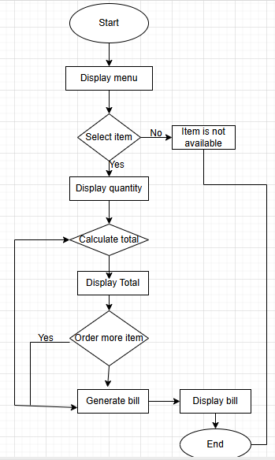 | The program displays all available café items along with their prices, allowing the user to view options before placing an order.
2 | Check Item Availability  - Check if the selected item exists in the menu.  - If yes, continue to calculate the total.  - If no, display error and allow re-selection. | 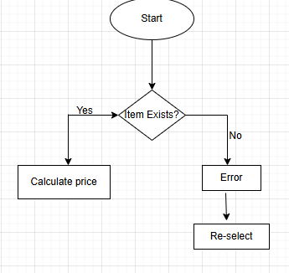 | The system checks whether the selected item exists in the menu. If the item is valid, continue the calculation. If not, show an error and allow the user to select again.
3 | Calculate Total Price  - Multiply the quantity by the price of the item.  - Keep a running total for multiple orders. | 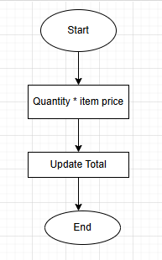 | The program multiplies the item price by quantity and updates the running total for all ordered items.
4 | Multiple Orders  - The program asks the user if they want to orders more items.  - If yes, return to many selections.  - If no, procced to billing. | 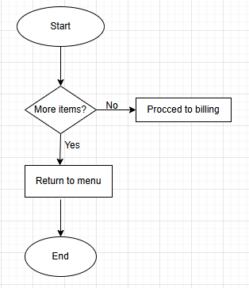 | The system asks whether the user wants to order more items. If yes, return to menu selection. If no, move to billing.
5 | Generate Bill  - Display all ordered items with quantity, unit price, and total amount.  - Show grand total. | 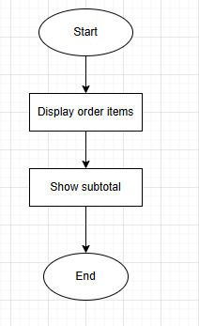 | The system displays all ordered items, including quantity, unit price, subtotal, and total amount.
6 | Payment Processing  - User enters payment amount.  - Check if payment is sufficient.  - If yes, calculate and display balance.  - If no, ask for payment again. | 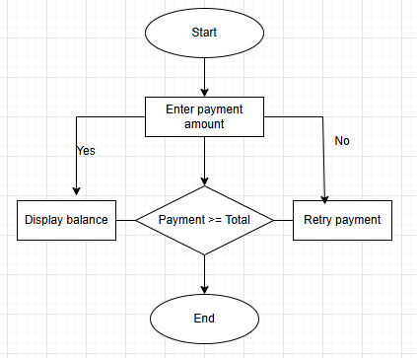 | The user enters the payment amount. The system checks if the payment is enough. If sufficient, calculate balance, If insufficient, request payment again.
7 | End Program  - Display confirmation message.  - Exit the program. | 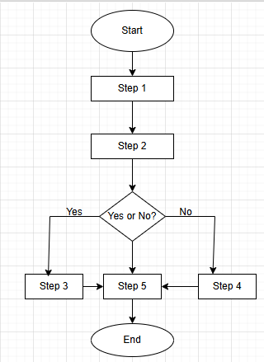 | The program shows a confirmation or thank you message and then exits the system.

Python Program Source File
CLHD\smart cafe.py

Test Plan

The following table shows the test cases executed to verify system functionality.

Test Case No. | Feature | Input Data | Expected Output | Actual Output
TC01 | View Menu | Option 1 | Menu displayed | Menu displayed
TC02 | Sort Menu by Price | Option 2 | Menu sorted by price | Sorted correctly
TC03 | Search Item | Coffee | Item found with price | Item found
TC04 | Search Item | Rice | Item not found | Item not found
TC05 | Place order | Coffee- Qty 3 | Item added | Added
TC06 | Invalid Quantity | abc | Error message | Error message shown
TC07 | Bill calculation | Total>2000 | 10% discount | Discount applied
TC08 | Receipt | Multiple items | Receipt printed | Receipt printed

Test Case

Test Case | Test Scenario | Input Given | Expected Output | Actual Output |  | Screenshot Reference | Status
TC01 | Display main menu | Program started | Main menu option (1-5) displayed | Main menu displays correctly |  | 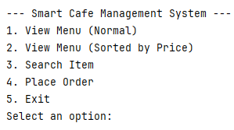 | Pass
TC02 | View menu (normal) | Select option 1 | Menu items with prices shown | Menu display correctly |  | 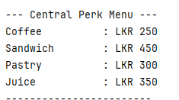 | Pass
TC03 | View menu sorted by price | Select option 2 | Menu sorted by price | Menu sorted correctly |  | 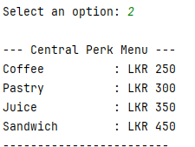 | Pass
TC04 | Search existing item | Enter “Coffee” | Item found with price | Item found and price shown |  | 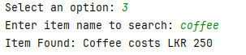 | Pass
TC05 | Search non existing item | Enter “Pizza” | Item not available message | Error message displayed |  | 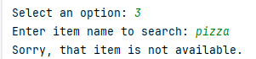 | Pass
TC06 | Add item with valid quantity | Coffee, quantity=2 | Item added to order list | Item added successfully |  | 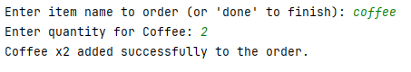 | Pass
TC07 | Enter non-numeric quantity | Coffee, quantity = abc | Invalid input message | Invalid input handled correctly |  | 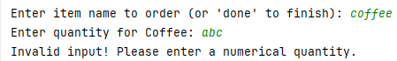 | Pass
TC08 | Bill calculation without discount | Subtotal=<2000 | No discount applied | Bill calculated correctly |  | 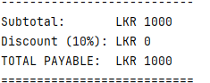 | Pass
TC09 | Bill calculation with a discount | Subtotal>2000 | 10% discount applied | Discount applied correctly |  | 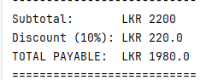 | Pass
TC10 | Generate receipt | Complete order | Receipt with total printed | Receipt generates correctly |  | 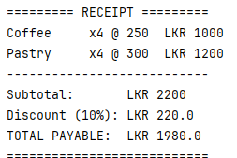 | Pass
TC11 | Exit system | Select option 5 | Exit message displayed. |  | System exited safely. | 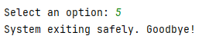 | Pass

Conclusion
The smart management system that the Central Perk Café has utilized has achieved its aim of providing a user-friendly and convenient method for managing fundamental café operations. This is illustrated by the system’s functions, such as menu displays, item searches, order processing, bill calculations, receipt generation, and discount features, as well as a depiction of how real-world business situations can be modeled using Python. Structured functions, clear logics, and appropriate documentation within this program support understanding and maintenance of the software. Developing this project has developed problem-solving skills along with building my understanding of basic Python features, including loops, dictionaries, conditional statements, and error handling. While this system provides limited functionality (i.e. there is no database), it lays a good basis to build on in order to develop future enhancements such as database connectivity, GUI, and user authentication tools.

Reference

- GeeksforGeeks, 2026. Input and output in Python. [online] GeeksforGeeks. (GeeksforGeeks, 2026) GeeksforGeeks Available at: https://www.geeksforgeeks.org/python/input-and-output-in-python/
- Anon. n.d. 2 Data Representation – Python for Engineers and Scientists (V1.5). [online] Available at: (Anon., n.d.) https://jtimo.github.io/python/02_representing_data.html.
- Coderivers, 2025. Python Functions: A Comprehensive Guide with Examples. [online] CodeRivers. (Coderivers, 2025) Available at: https://coderivers.org/blog/examples-of-functions-in-python/.
- Shea, B., 2024. Logic and Computational Thinking with Python. [online] A Little More Logical. (Shea, 2024)Available at: https://mlpp.pressbooks.pub/littlemorelogical/chapter/logic-and-computational-thinking-with-python/.
- Anon. n.d. Getting started — Testplan documentation. (Anon., n.d.) [online] Available at: https://testplan.readthedocs.io/en/latest/getting_started.html.
- Anon. n.d. Conclusion — Introduction to Python. (Anon., n.d.) [online] Available at: https://friendlyuser.github.io/IntroToPython/chapters/conclusion.html.
- Anon. n.d. PEP 8 – Style guide for Python code | peps.python.org. [online] PythoynEnhancement Proposals (PEPs). (Anon., n.d.) Available at: https://peps.python.org/pep-0008/.

