**Media Streaming with IBM Cloud Video Streaming**

**Phase 1: Problem Definition and Design Thinking**

**Team:**

Prisha C (211521104118)

Devadarshini S (211521104035)

Heshiya Gayathri (211521104053)

Deepthi J Mercy (211521104034)

Esha G (211521104042)

**Problem Definition:**

"Media streaming with cloud streaming" refers to the challenge or task of setting up and managing the delivery of audio and video content to end-users using cloud-based infrastructure and services. This involves various steps and considerations, including content storage, encoding, delivery, security, scalability, player integration, analytics, cost management, and global reach. The goal is to stream media content efficiently and reliably to a wide audience while optimizing the user experience and managing the associated costs.

Nowadays people prefer online platforms more than normal cable channels. A survey conducted during December 2,2019 suggests that more than 65% of TV cable subscribers prefer online streaming.

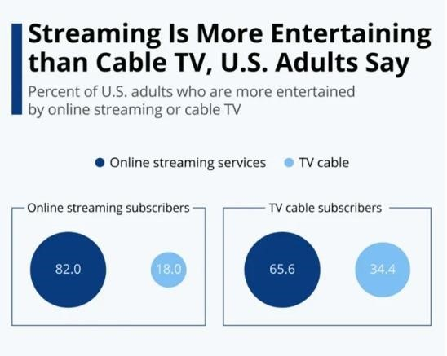

# FIG.1

[Live streaming has become an integral part of the marketing strategy for many brands and individuals due to its **high level of engagement** and **unlimited interaction** it offers .](https://studiofivecorp.com/the-importance-of-live-streaming/) [It is one of the most powerful ways to reach and interact with your audience .](https://manycam.com/blog/why-live-streaming-is-so-important/) Here are some reasons why live streaming is considered important:

1. [**Engagement**: Live streaming has the highest rate of engagement among all content types .](https://studiofivecorp.com/the-importance-of-live-streaming/) [It allows viewers to post comments in real-time, creating an opportunity for interaction with the presenter and other viewers . This instant gratification fosters a deep connection between the viewers and the presenter, creating a sense of community .](https://manycam.com/blog/why-live-streaming-is-so-important/)
2. [**Interaction**: Live streaming offers a level of interaction that no other platform or marketing strategy can match .](https://studiofivecorp.com/the-importance-of-live-streaming/) [Viewers can ask questions, provide feedback, and engage with the presenter during the live stream . This real-time interaction brings the audience closer to the presenter and opens up a great communication channel .](https://manycam.com/blog/why-live-streaming-is-so-important/)
3. **Human Connection**: Live streaming brings a human element to content creation. [The fact that it is live means that anything can happen at any time, making it more authentic and relatable . Viewers can identify with presenters and feel a genuine connection with them .](https://manycam.com/blog/why-live-streaming-is-so-important/)
4. **Flexibility**: Unlike traditional TV, live streaming offers more flexibility in terms of content accessibility. [Viewers can watch live streams on their mobile devices and often have the option to watch recorded versions later .](https://manycam.com/blog/why-live-streaming-is-so-important/)
5. [**Reach**: Live streaming has a huge user base and growing popularity, making it an effective way to reach thousands or more new customers with just a click of a button .](https://neilpatel.com/blog/live-streaming-importance-2018/)

**Design Thinking:**

**Select a Cloud Provider:**

To choose a cloud provider that offers media streaming capabilities. Popular choices include Amazon Web Services (AWS), Microsoft Azure, Google Cloud Platform (GCP), or specialized media streaming providers like Vimeo, Brightcove, or IBM Watson Media. Consider factors like cost, geographic reach, and service offerings when making your selection.

**Content Preparation:**

To prepare media content by encoding and transcoding it into suitable formats and bitrates for adaptive streaming. Most cloud streaming providers offer encoding/transcoding services or integrations with third-party tools.

**Cloud Storage:**

By Uploading media content to the cloud storage provided by your chosen cloud provider.

Ensure proper organization and access controls to manage your content effectively.

**Content Security:**

Implementing security measures to protect your media content. This may include content encryption, token-based access control, and DRM solutions to prevent unauthorized access and piracy.

**CDN Integration:**

To set up integration with a Content Delivery Network (CDN) to distribute your media content efficiently to end-users. Configure caching, edge server locations, and CDN settings for optimal performance and low latency.

**Player Integration:**

Embedding a media player into your web or mobile applications using the provided SDKs or APIs from your cloud streaming service. Customize the player to match your brand and user experience requirements.

**Scalability and Elasticity:**

To Configure auto-scaling rules to handle varying levels of traffic. Ensure that your cloud infrastructure can automatically scale up or down based on demand to maintain a smooth streaming experience during peak periods.

**Monitoring and Analytics:**

To implement monitoring and analytics tools to track the performance of your media streaming service. Monitor viewer statistics, user engagement, and error logs to identify and address issues promptly.

**Cost Management:**

To monitor and manage costs by setting up budget alerts and optimizing resource usage and ensure that we understand the pricing structure of your cloud provider to avoid unexpected expenses.

**Testing and Quality Assurance:**

To conduct thorough testing of our media streaming service before going live. Test on various devices and network conditions to ensure a consistent and high-quality user experience.

**Documentation and Training:**

To document our setup and configurations, including security policies and procedures. Provide training to our team members responsible for managing and maintaining the media streaming service.

**Launch and Monitor:**

To launch our media streaming service to the public or our intended audience. Continuously monitor its performance and user feedback to make improvements and adjustments as needed.

**Scaling and Optimization:**

As audience grows or requirements change, we must be prepared to scale our cloud streaming infrastructure accordingly. Optimize our setup based on performance data and user behavior.

**Stay Informed:**

Keeping abreast of industry trends and updates in cloud streaming technology. Cloud services evolve rapidly, and staying informed can help you take advantage of new features and improvements.

**Customer Support and Feedback:**

Being responsive to user feedback and provide excellent customer support. Address issues promptly to maintain a positive user experience.

**SYSTEM DESIGN:**

✓ **CONTENT UPLOADING:**

1. **Video ingestion:**

As the first step let’s consider uploading data to the platform by creators. Let’s say they upload a video at 4K resolution and .mp4 format to some storage along with title, description, and tag. The storage should be secure, resilient, scalable, and cost effective. For this an ideal storage cloud service is **Amazon s3** service.

1. **Database:**

We need a database to store all tags, descriptions, and title which we’ll need it when we search for a particular video. Using relational database will be a problem as they are not horizontally scalable. So for that we’ll use a NOSQL database called **ElasticSearch** which is used for storing text fields and optimize search for that fields.



**Element Media**

**Convert**



Content



K resolution

4



.mp4



●

 

function

(

step

)



CDN



Title

Description

Tags



DBMS



**ElasticSearch**



Amazon S3



**Rekognition**



Amazon S3



720

p



p

960



1080

p



**FIG.2**

S

ystem

architecture for video

uplo

ading

1. **Video encoding:**

Even if we upload in 4K resolution not everyone can watch in that resolution. It depends on the specs of the device which they are using to view the content. So this 4K resolution needs to be converted into different forms to be consumed by different devices. For this we use AWS service called **Element Media Convert.**

1. **Adult content detection:**

For this we will be using an AIML service from amazon called **amazon recognition**. It gets the video analyses every frame against a presorted database and detects the adult content.

1. **Content Delivery Network:**

Content Delivery Network(CDN) refers to a geographically distributed group of servers located at different places which work together to provide fast delivery of content. This is not only scalable but provides a very low latency to the end user. If a person from India tries to view some video instead of coming to S3, the video will be accessed from CDN, which makes our system cost efficient.

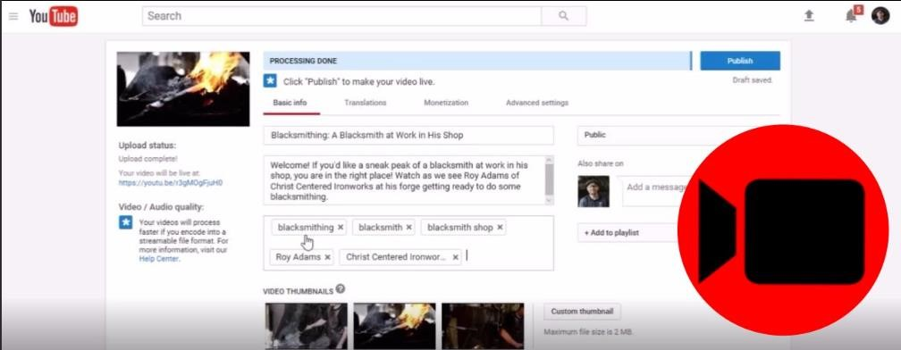

**FIG. 3** Video uploading in YouTube

✓ **VIDEO SEARCHING AND VIEWING**:



DB



●

 



APIG



S3



Static website



CDN



Streaming platform



S3



Video



**FIG.**

**4**

System architecture for

searching and viewing videos

* When you search for a video with it’s name and click search it is not a static content anymore.
* It goes to CDN and searches for the video and comes back populates the screen with relevant videos.
* If it is not in CDN it calls the hosted API gateway and it calls lambda which searches in ElasticSearch Database.
* Then it loads the tags and ids of relevant video into CDN so that if another user searches for the same content it does not need to go back to the database.
* After user clicks on a particular video, with that id it checks in CDN whether the video is cached or not.
* If cached it plays from that CDN else CDN goes to the origin which is the S3 bucket and displays it.
* It also saves the video in particular resolution in CDN so that next user who wants to view the same content can directly view it from the CDN.
* The problem with MP4 format is that it can’t be viewed in chunks.
* So we store them in **HLS format** (http live streaming).
* The HLS format breaks the whole video into chunks and delivers the video chunk by chunk and does not deliver the whole video.
* So if user stops to view the video after some time it only delivers the chunks worth of that time.
* It saves the network bandwidth, faster and cost efficient.

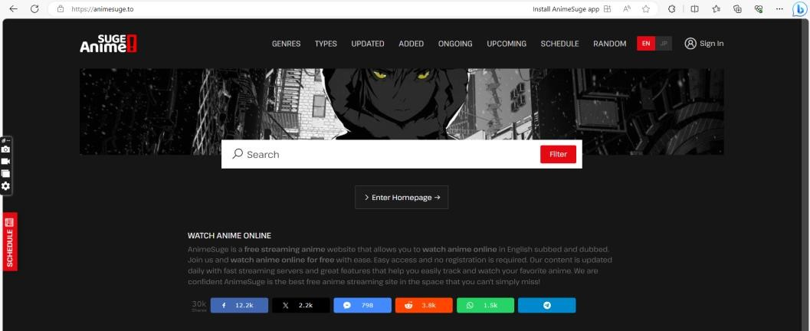

**FIG. 5** Streaming platform

# References

1. [https://www.youtube.com](https://www.youtube.com/)
2. [animesuge.to](https://animesuge.to/)
3. <https://www.netflix.com/>in
4. [JustWatch - Streaming Search Engine for Movies and TV Series](https://www.justwatch.com/in)