**Media Streaming with IBM Cloud Video Streaming**

**Phase 4: Development Part 2**

**Team:**

Prisha C (211521104118)

Devadarshini S (211521104035)

Heshiya Gayathri Saravanan (211521104053)

Deepthi J Mercy (211521104034)

Esha G (211521104042)

**Introduction:**

Media streaming has become an integral part of our digital landscape, revolutionizing how we consume and share multimedia content. In this era of on-demand entertainment, seamless communication, and real-time interaction, the ability to stream media efficiently and reliably is paramount. IBM Cloud, a leader in cloud computing and technology solutions, has emerged as a key player in this dynamic ecosystem. Through its robust infrastructure, cutting-edge technologies, and innovative services, IBM Cloud has enabled businesses and individuals to harness the power of media streaming, delivering content to a global audience with unparalleled speed, security, and scalability.

Media streaming has become an integral part of our digital landscape, revolutionizing the way we consume and share content. IBM Cloud has emerged as a prominent player in this dynamic realm, offering a robust and scalable platform for delivering audio and video content seamlessly across the internet. In an era where instantaneous access to high-quality media is an expectation, IBM Cloud's media streaming solutions provide the necessary infrastructure and tools to meet this demand. This introduction delves into the world of media streaming using IBM Cloud, highlighting the key features and benefits that make it a compelling choice for businesses and content creators in need of reliable, secure, and efficient streaming services.

In an age dominated by digital content consumption, media streaming has emerged as a revolutionary means of delivering audio and video content to a global audience. IBM Cloud, a formidable player in the field of cloud computing and technology services, has harnessed the power of the cloud to facilitate seamless and efficient media streaming solutions. Leveraging cutting-edge technologies and a vast network of data centers, IBM Cloud has become a leading provider for organizations and individuals looking to deliver high-quality media content to users across the globe. This introduction will explore the world of media streaming using IBM Cloud, delving into the key features and benefits that make it a preferred choice for businesses and content creators alike.

**Video upload:**

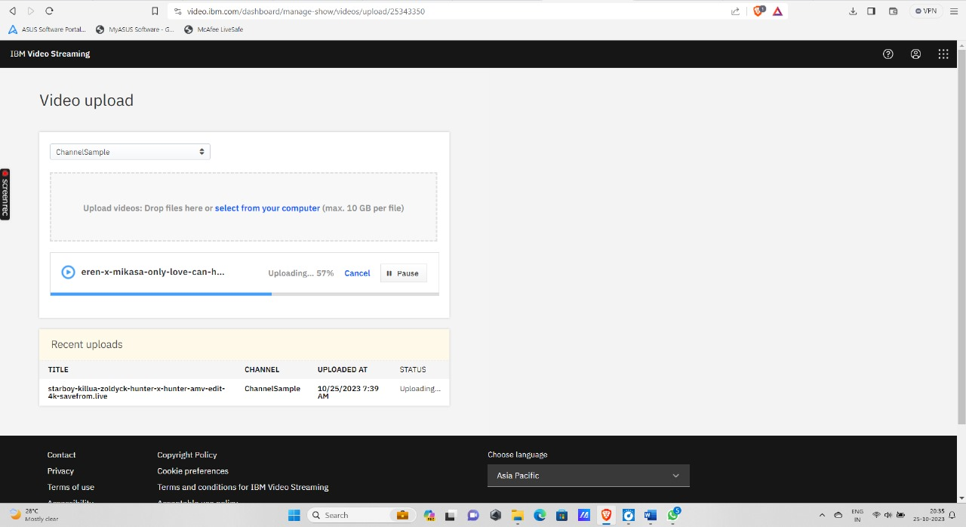

1. **Uploading videos**

You can add videos to your IBM Video Streaming account by [recording your live broadcasts](https://support.video.ibm.com/entries/21650313-Recording-on-Your-Ustream-Channel-using-external-encoders), or by uploading previously recorded content using IBM Video Streaming upload tools.

## Video upload capabilities

### Upload in your browser

### Upload through the API

### Upload using professional services

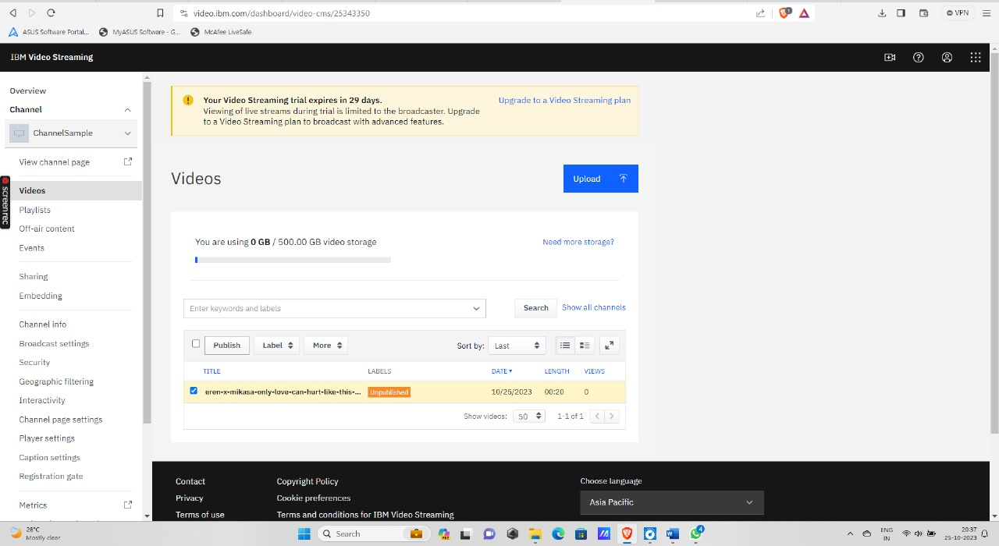

## Video file formats

### Supported formats and file types

* Container: mkv, mp4, mov, flv, avi, wmv,mpeg2
* Video codec: h264, h263, mpeg4 (and variants), vp6, vp8, theora, wmv
* Audio codec: mp3, aac-lc, nellymoser, pcm (16 bit max), speex, vorbis, wma

### **Specifications**

##### **Requirements**

##### Max file size: 10 GB

##### Minimum length: 4 sec

##### Minimum bitrate: 64 kbps

##### **Recommendations**

##### Video Codec: h.264

##### Audio Codec: AAC-LC

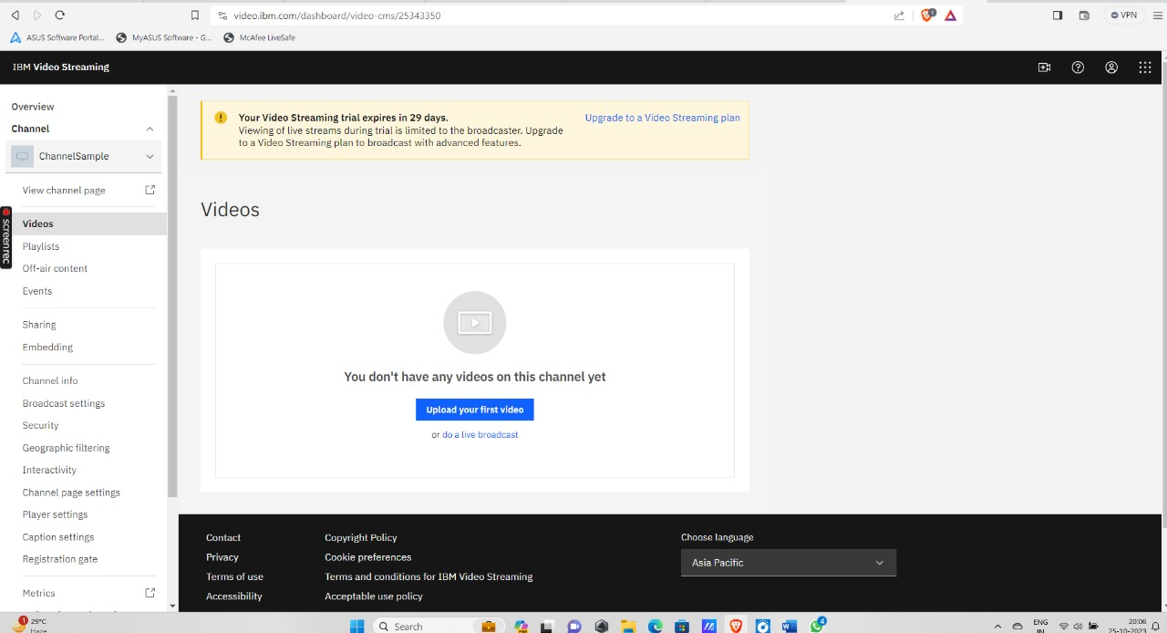

**Streaming integration:**

**Step 1: Choose the Right IBM Streaming Service**

IBM Cloud provides a variety of streaming services to cater to different use cases. It's crucial to select the one that aligns with your specific requirements. Some popular IBM streaming services include IBM Cloud Streaming Analytics, IBM Cloud Video Streaming, and IBM Event Streams for Apache Kafka. Carefully evaluate your project's needs and goals before making a choice.

**Step 2: Provision Your Streaming Service**

Once you've chosen the appropriate streaming service, the next step is to provision it through the IBM Cloud console. During this process, you may need to configure various settings and allocate resources. For instance, in IBM Event Streams, you may create an instance, define topics, and set access controls.

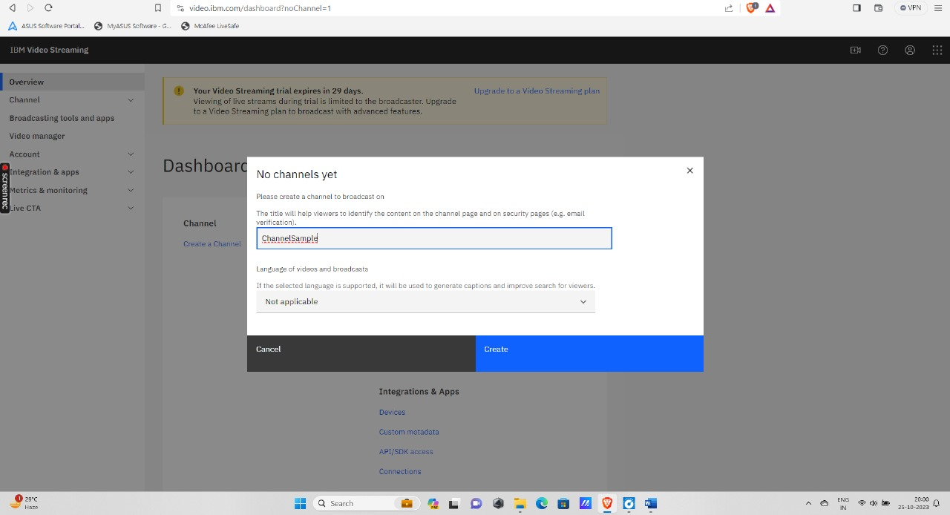

Channel Creation using IBM streaming platform

**Step 3: Develop a Producer Application**

To send data or media to your streaming service, you'll need to develop a producer application. This application can be a web app, a mobile app, or a server-side script. Ensure that your producer application is correctly configured to connect to your chosen streaming service using the provided credentials and endpoints.

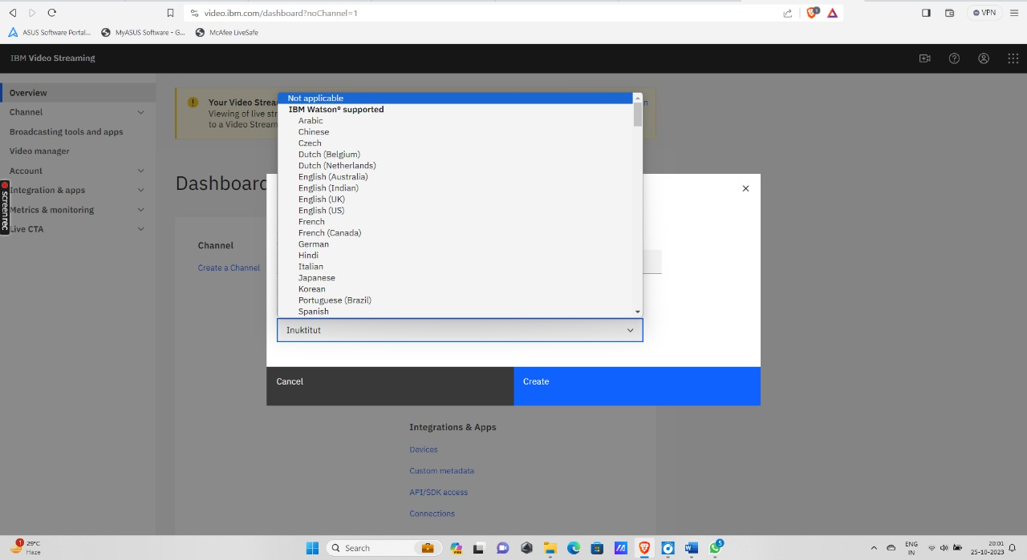

Language selection for channel created

**Step 4: Create a Consumer Application**

If you intend to consume or process the streaming data, you'll also need a consumer application. This application should connect to the streaming service and retrieve or process the incoming data. The consumer application can be designed according to your specific use case, whether it involves real-time analytics, content distribution, or any other purpose.

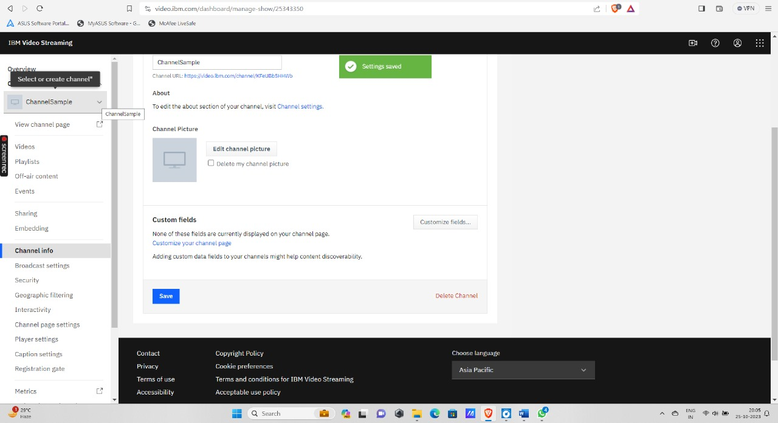

Channel created message

**Step 5: Data Ingestion**

With your producer application in place, you can start sending data to your streaming service. The type of data can vary widely, from sensor readings and log files to video streams and real-time events. The streaming service will take care of distributing this data to your consumer applications in real-time.

**Step 6: Data Processing (Optional)**

Depending on your project's requirements, you may want to apply data processing or real-time analytics to the streaming data. IBM Cloud typically provides tools for data transformation and analysis. This step allows you to derive meaningful insights from the incoming data, which can be a valuable feature for data-driven applications.

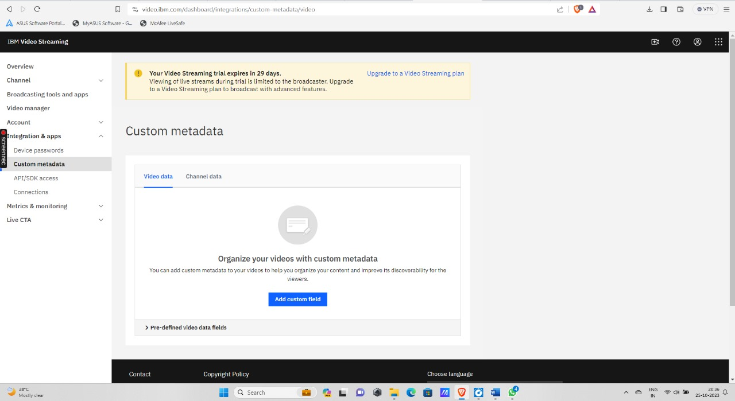

Metadata Storage in IBM Streaming

**Step 7: Scaling and Monitoring**

As your streaming platform grows and the volume of data or media increases, you may need to scale your streaming infrastructure to handle the added load. IBM Cloud services often offer auto-scaling capabilities, which can simplify the process of handling increased demand. Additionally, use monitoring and logging tools to keep a vigilant eye on the health and performance of your streaming applications.

IBM Analytics Console

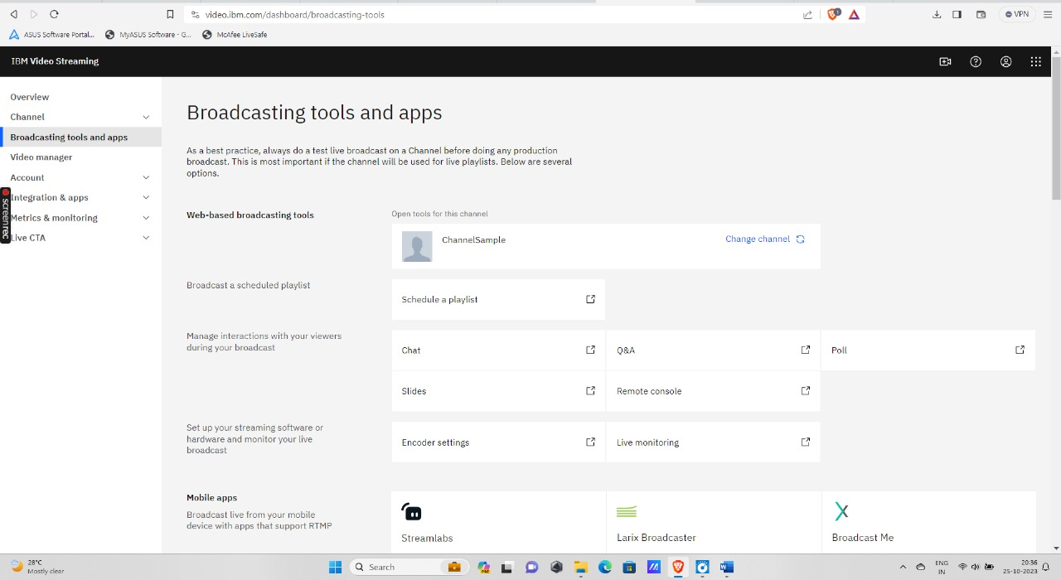

Live broadcasting

**Step 8: Security and Access Control**

Ensuring the security of your data and controlling access to your streaming service is paramount. IBM Cloud streaming services typically offer authentication and authorization mechanisms for this purpose. Properly configure these security measures to protect your data and maintain control over who can access it.

Security

Geographic filtering-allowing access to viewers of this channel

**Step 9: Testing and Optimization**

Thoroughly test your streaming application to ensure it meets your performance and reliability requirements. As you collect data from the usage of your platform, continually optimize your setup to enhance the quality of your streaming service. Regular performance testing and optimizations are essential for a successful streaming platform.

**Step 10: Documentation and Support**

IBM Cloud offers comprehensive documentation and support resources. Familiarize yourself with these resources to troubleshoot any issues that may arise during the integration and operation of your streaming platform. These resources can be invaluable for obtaining expert guidance and making the most of your streaming solution. A screenshot of a computer
Analysis of a live stream using IBM Watson AI