Name: hissah saidan

ID: 201394

GET : 200



GET 404:



GET 200 othercase:

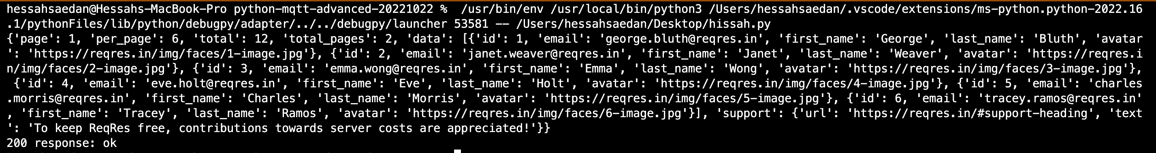

POST 201:



POST 400:



POST 200:

