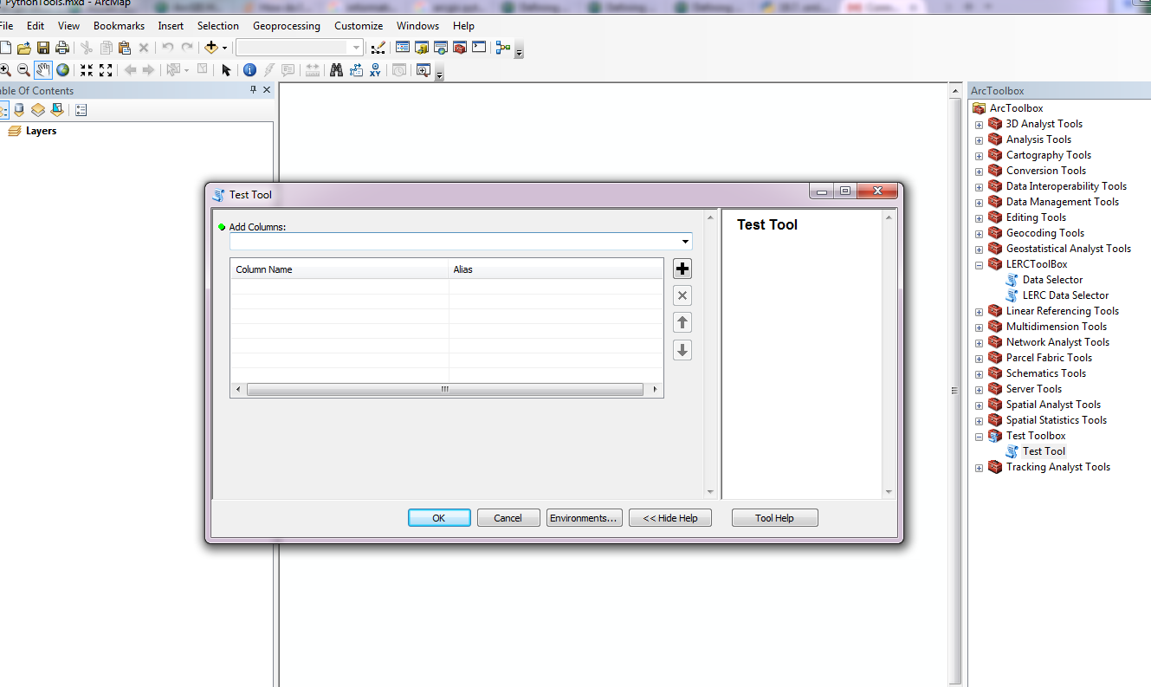

Test tool – Type column name in Add Columns and use tab or ‘+’

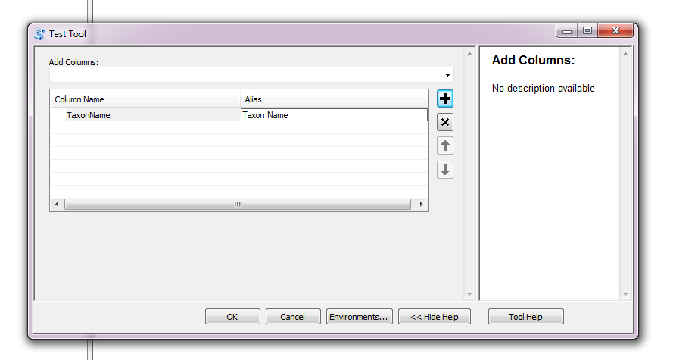

New column appears in the list, fill in alias name.

**NOTE** the Add Columns dropdown can be linked to the SQL database so that only existing columns become available.