Subject: | OOP-JAVA
Name: | Het Patel
ID No.: | 25AIML049
Practical-14
Part A
PROBLEM-1 :
Assemble and test: build a tiny layered app (a model, a service using an ArrayList, and a menu main), then write two or three JUnit @Test methods checking that adding increases the count and an invalid action throws — practice before testing MiniBank.
CODE :
Note.java
public class Note {
private final String text;

public Note(String text) { this.text = text; }

public String getText() { return text; }

@Override
public String toString() { return text; }
}
NoteService.java
import java.util.ArrayList;
import java.util.List;

public class NoteService {
private final ArrayList<Note> notes = new ArrayList<>();

public void add(String text) {
if (text == null || text.isBlank()) {
throw new IllegalArgumentException("Note text must not be empty");
}
notes.add(new Note(text));
}

public int count() { return notes.size(); }

public List<Note> all() { return new ArrayList<>(notes); }
}
NoteApp.java
import java.util.Scanner;

public class NoteApp {
public static void main(String[] args) {
NoteService service = new NoteService();
Scanner in = new Scanner(System.in);
while (true) {
System.out.print("1) Add 2) List 0) Exit > ");
if (!in.hasNextLine()) break;
String choice = in.nextLine().trim();
System.out.println(choice);
if (choice.equals("0")) break;
try {
if (choice.equals("1")) {
System.out.print("Text: ");
String t = in.nextLine();
System.out.println(t);
service.add(t);
} else if (choice.equals("2")) {
service.all().forEach(n -> System.out.println(" - " + n));
} else {
throw new IllegalArgumentException("Unknown option: " + choice);
}
} catch (IllegalArgumentException e) {
System.out.println("Error: " + e.getMessage());
}
}
System.out.println("Bye. Notes stored: " + service.count());
}
}
NoteServiceTest.java
import org.junit.jupiter.api.Test;
import static org.junit.jupiter.api.Assertions.*;

class NoteServiceTest {

@Test
void addingIncreasesCount() {
NoteService s = new NoteService();
s.add("Buy milk");
s.add("Submit lab");
assertEquals(2, s.count());
}

@Test
void blankNoteThrows() {
NoteService s = new NoteService();
assertThrows(IllegalArgumentException.class, () -> s.add(" "));
assertEquals(0, s.count());
}

@Test
void allReturnsCopy() {
NoteService s = new NoteService();
s.add("One");
s.all().clear(); // changing the copy must not affect the service
assertEquals(1, s.count());
}
}
OUTPUT :
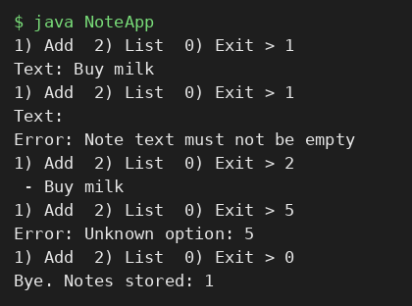
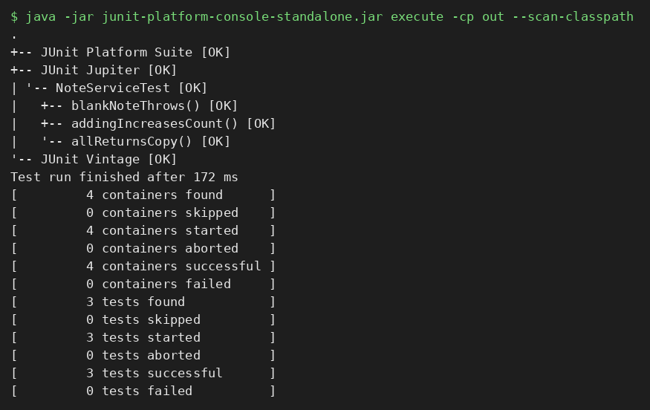
PROBLEM-2 :
(For Advanced Learners – home) Organise that app into packages, build a runnable JAR, and add a test that saves and reloads its data unchanged.
CODE :
src/com/notes/model/Note.java
package com.notes.model;

import java.io.Serializable;

public class Note implements Serializable {
private static final long serialVersionUID = 1L;
private final String text;

public Note(String text) { this.text = text; }

public String getText() { return text; }

@Override
public boolean equals(Object o) { return o instanceof Note n && n.text.equals(text); }

@Override
public int hashCode() { return text.hashCode(); }

@Override
public String toString() { return text; }
}
src/com/notes/service/NoteService.java
package com.notes.service;

import com.notes.model.Note;
import java.io.*;
import java.nio.file.*;
import java.util.ArrayList;

public class NoteService {
private ArrayList<Note> notes = new ArrayList<>();

public void add(String text) {
if (text == null || text.isBlank()) throw new IllegalArgumentException("Note text must not be empty");
notes.add(new Note(text));
}

public ArrayList<Note> all() { return new ArrayList<>(notes); }

public void save(Path file) throws IOException {
try (ObjectOutputStream out = new ObjectOutputStream(Files.newOutputStream(file))) {
out.writeObject(notes);
}
}

@SuppressWarnings("unchecked")
public void load(Path file) throws IOException, ClassNotFoundException {
try (ObjectInputStream in = new ObjectInputStream(Files.newInputStream(file))) {
notes = (ArrayList<Note>) in.readObject();
}
}
}
src/com/notes/App.java
package com.notes;

import com.notes.service.NoteService;
import java.nio.file.*;

public class App {
public static void main(String[] args) throws Exception {
Path file = Paths.get("notes.dat");
NoteService service = new NoteService();
if (Files.exists(file)) {
service.load(file);
System.out.println("Loaded " + service.all().size() + " saved note(s)");
}
service.add("Note added at run " + (service.all().size() + 1));
service.save(file);
System.out.println("Notes now: " + service.all());
}
}
test/com/notes/service/NoteServiceTest.java
package com.notes.service;

import java.nio.file.*;
import org.junit.jupiter.api.Test;
import org.junit.jupiter.api.io.TempDir;
import static org.junit.jupiter.api.Assertions.*;

class NoteServiceTest {

@Test
void saveAndReloadKeepsDataUnchanged(@TempDir Path dir) throws Exception {
NoteService original = new NoteService();
original.add("First");
original.add("Second");
Path file = dir.resolve("notes.dat");
original.save(file);

NoteService reloaded = new NoteService();
reloaded.load(file);
assertEquals(original.all(), reloaded.all());
}
}
OUTPUT :
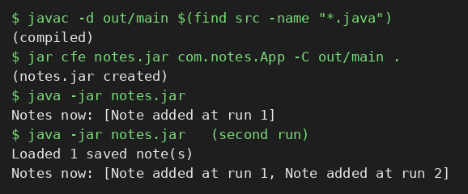
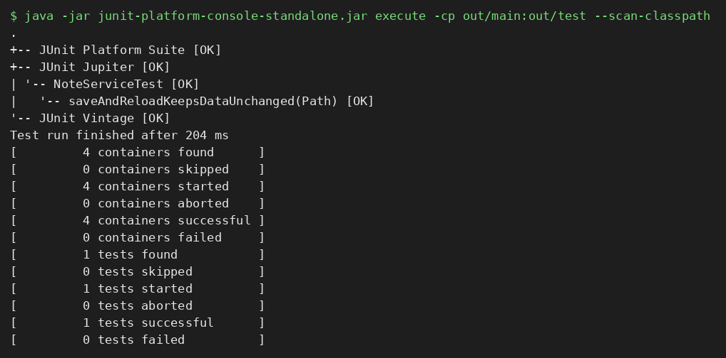
Part B — Project Work (Hour 2): MiniBank
All the parts now exist. In this final capstone lab you assemble MiniBank and finish it to a deliverable standard: a BankService wires the repository, validation and exceptions together and the Practical 1 menu calls real operations; you add safe batch processing and the report; and you test and package the application. This is the Milestone 3 final checkpoint and viva.
Supporting classes (from earlier practicals): the @Id annotation, custom exceptions, Validator, Account, the thread-safe generic Repository<T>, persistence, transaction log and report generator.
CODE :
Id.java
import java.lang.annotation.*;

@Retention(RetentionPolicy.RUNTIME)
@Target(ElementType.FIELD)
public @interface Id { }
BankException.java
public class BankException extends RuntimeException {
public BankException(String message) { super(message); }
}
InsufficientFundsException.java
public class InsufficientFundsException extends BankException {
public InsufficientFundsException(String accountNo, double balance, double amount) {
super("Insufficient funds in " + accountNo + ": balance " + balance + ", requested " + amount);
}
}
InvalidAmountException.java
public class InvalidAmountException extends BankException {
public InvalidAmountException(String message) { super(message); }
}
AccountNotFoundException.java
public class AccountNotFoundException extends BankException {
public AccountNotFoundException(String accountNo) { super("Account not found: " + accountNo); }
}
Validator.java
public class Validator {
public static void amount(double amount) {
if (Double.isNaN(amount) || amount <= 0) {
throw new InvalidAmountException("Amount must be positive: " + amount);
}
}

public static void text(String value, String field) {
if (value == null || value.isBlank()) {
throw new InvalidAmountException(field + " must not be empty");
}
}
}
Account.java
import java.io.Serializable;
import java.util.ArrayList;
import java.util.List;

public class Account implements Serializable {
private static final long serialVersionUID = 1L;

@Id
private final String accountNumber;
private final String ownerName;
private double balance;
private final List<String> history = new ArrayList<>();

public Account(String accountNumber, String ownerName, double balance) {
this.accountNumber = accountNumber;
this.ownerName = ownerName;
this.balance = balance;
history.add("OPEN " + balance + " -> balance " + balance);
}

public String getAccountNumber() { return accountNumber; }
public String getOwnerName() { return ownerName; }
public synchronized double getBalance() { return balance; }
public synchronized List<String> getHistory() { return new ArrayList<>(history); }

public synchronized void deposit(double amount) {
balance += amount;
history.add("DEPOSIT " + amount + " -> balance " + balance);
}

public synchronized void withdraw(double amount) {
if (amount > balance) throw new InsufficientFundsException(accountNumber, balance, amount);
balance -= amount;
history.add("WITHDRAW " + amount + " -> balance " + balance);
}

@Override
public synchronized String toString() {
return accountNumber + " | " + ownerName + " | balance=" + balance;
}
}
Repository.java
import java.lang.reflect.Field;
import java.util.ArrayList;
import java.util.concurrent.ConcurrentHashMap;

public class Repository<T> {
private final ConcurrentHashMap<String, T> store = new ConcurrentHashMap<>(); // thread-safe (Practical 12)

private String extractId(T entity) {
for (Class<?> c = entity.getClass(); c != null; c = c.getSuperclass()) {
for (Field f : c.getDeclaredFields()) {
if (f.isAnnotationPresent(Id.class)) {
try {
f.setAccessible(true);
return String.valueOf(f.get(entity));
} catch (IllegalAccessException e) {
throw new RuntimeException(e);
}
}
}
}
throw new IllegalArgumentException(entity.getClass().getSimpleName() + " has no @Id field");
}

public T save(T entity) { store.put(extractId(entity), entity); return entity; }

@SafeVarargs
public final void saveAll(T... items) { for (T item : items) save(item); }

public T findById(String id) { return store.get(id); }

public ArrayList<T> findAll() { return new ArrayList<>(store.values()); }

public boolean delete(String id) { return store.remove(id) != null; }

public int count() { return store.size(); }
}
StatePersister.java
import java.io.*;
import java.nio.file.*;

public class StatePersister {

public static void save(Account[] accounts, Path file) {
try (ObjectOutputStream out = new ObjectOutputStream(Files.newOutputStream(file))) {
out.writeObject(accounts);
} catch (IOException e) {
System.out.println("Save failed: " + e.getMessage());
}
}

public static Account[] load(Path file) {
try (ObjectInputStream in = new ObjectInputStream(Files.newInputStream(file))) {
return (Account[]) in.readObject();
} catch (IOException | ClassNotFoundException e) {
System.out.println("Load failed: " + e.getMessage());
return new Account[0];
}
}
}
TransactionLog.java
import java.io.IOException;
import java.nio.file.*;

public class TransactionLog {

public static synchronized void append(Path file, String line) {
try {
Files.write(file, (line + System.lineSeparator()).getBytes(),
StandardOpenOption.CREATE, StandardOpenOption.APPEND);
} catch (IOException e) {
System.out.println("Log write failed: " + e.getMessage());
}
}
}
ReportGenerator.java
import java.io.*;
import java.nio.file.*;
import java.nio.file.attribute.BasicFileAttributes;
import java.util.ArrayList;
import java.util.List;

public class ReportGenerator {

public static List<String> generate(Path logsDir, Path reportFile) throws IOException {
double deposits = 0, withdrawals = 0, transfers = 0;
List<String> report = new ArrayList<>();
report.add("===== END-OF-DAY REPORT =====");

try (DirectoryStream<Path> stream = Files.newDirectoryStream(logsDir)) {
for (Path file : stream) {
BasicFileAttributes attrs = Files.readAttributes(file, BasicFileAttributes.class);
if (attrs.size() == 0 || !file.getFileName().toString().endsWith(".log")) {
report.add("Skipped: " + file.getFileName());
continue;
}
report.add("File: " + file.getFileName() + " | size: " + attrs.size() + " bytes");
try (BufferedReader br = Files.newBufferedReader(file)) {
String line;
while ((line = br.readLine()) != null) {
String[] p = line.trim().split("\\s+");
if (p[0].equals("DEPOSIT")) deposits += Double.parseDouble(p[2]);
else if (p[0].equals("WITHDRAW")) withdrawals += Double.parseDouble(p[2]);
else if (p[0].equals("TRANSFER")) transfers += Double.parseDouble(p[3]);
}
}
}
}
report.add(String.format("Total deposits : %.2f", deposits));
report.add(String.format("Total withdrawals : %.2f", withdrawals));
report.add(String.format("Total transferred : %.2f", transfers));
Files.write(reportFile, report);
return report;
}
}
1. Create a class named BankService that uses Repository<Account>, the Validator and the exception classes to provide openAccount, deposit, withdraw, transfer, statement and listAccounts.
CODE :
BankService.java
import java.io.IOException;
import java.nio.file.*;
import java.util.*;

public class BankService {
private final Repository<Account> repo = new Repository<>();
private final Path accountsFile, logsDir, auditFile, dataDir;

public BankService(Path dataDir) {
this.dataDir = dataDir;
this.accountsFile = dataDir.resolve("accounts.dat");
this.logsDir = dataDir.resolve("logs");
this.auditFile = dataDir.resolve("audit.txt");
try {
Files.createDirectories(logsDir);
} catch (IOException e) {
throw new BankException("Cannot create data folder: " + e.getMessage());
}
if (Files.exists(accountsFile)) { // load saved accounts on start-up
for (Account a : StatePersister.load(accountsFile)) repo.save(a);
}
}

private Account find(String no) {
Account a = repo.findById(no);
if (a == null) throw new AccountNotFoundException(no);
return a;
}

private void log(String line) { TransactionLog.append(logsDir.resolve("day1.log"), line); }

@Audit
public Account openAccount(String no, String owner, double initial) {
AuditLogger.record(this, "openAccount", auditFile);
Validator.text(no, "Account number");
Validator.text(owner, "Owner name");
if (initial < 0) throw new InvalidAmountException("Opening balance cannot be negative");
if (repo.findById(no) != null) throw new BankException("Account already exists: " + no);
return repo.save(new Account(no, owner, initial));
}

@Audit
public void deposit(String no, double amount) {
AuditLogger.record(this, "deposit", auditFile);
Validator.amount(amount);
find(no).deposit(amount);
log("DEPOSIT " + no + " " + amount);
}

@Audit
public void withdraw(String no, double amount) {
AuditLogger.record(this, "withdraw", auditFile);
Validator.amount(amount);
find(no).withdraw(amount);
log("WITHDRAW " + no + " " + amount);
}

@Audit
public void transfer(String from, String to, double amount) {
AuditLogger.record(this, "transfer", auditFile);
Validator.amount(amount);
Account a = find(from), b = find(to);
a.withdraw(amount); // fails first if funds are short
b.deposit(amount);
log("TRANSFER " + from + " " + to + " " + amount);
}

@Audit
public List<String> statement(String no) {
AuditLogger.record(this, "statement", auditFile);
return find(no).getHistory();
}

@Audit
public List<Account> listAccounts() {
AuditLogger.record(this, "listAccounts", auditFile);
List<Account> all = repo.findAll();
all.sort(Comparator.comparing(Account::getAccountNumber));
return all;
}

// Supplementary: search by owner name
public List<Account> searchByOwner(String part) {
List<Account> found = new ArrayList<>();
for (Account a : listAccounts())
if (a.getOwnerName().toLowerCase().contains(part.toLowerCase())) found.add(a);
return found;
}

public String processBatch(List<String> commands) throws InterruptedException {
return new TransactionProcessor(this, 4).run(commands);
}

public List<String> report() throws IOException {
return ReportGenerator.generate(logsDir, dataDir.resolve("report.txt"));
}

public void save() {
StatePersister.save(repo.findAll().toArray(new Account[0]), accountsFile);
}

public Path getAuditFile() { return auditFile; }
}
Note: the @Audit annotation and AuditLogger calls inside BankService are the optional Task 5.
Task1Demo.java
import java.nio.file.*;

public class Task1Demo {
public static void main(String[] args) throws Exception {
BankService bank = new BankService(Files.createTempDirectory("mb"));
bank.openAccount("AC0001", "Het Patel", 5000);
bank.openAccount("AC0002", "Samarth Shah", 12000);
bank.deposit("AC0001", 500);
bank.withdraw("AC0002", 2000);
bank.transfer("AC0002", "AC0001", 1000);
System.out.println("listAccounts():");
bank.listAccounts().forEach(a -> System.out.println(" " + a));
System.out.println("statement(AC0001):");
bank.statement("AC0001").forEach(l -> System.out.println(" " + l));
try {
bank.withdraw("AC0001", 1_000_000);
} catch (BankException e) {
System.out.println("Caught " + e.getClass().getSimpleName() + ": " + e.getMessage());
}
}
}
OUTPUT :
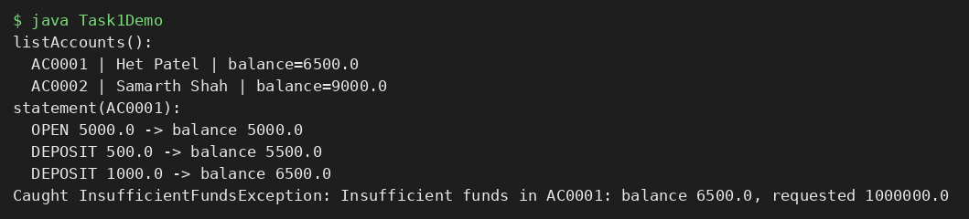
2. Connect the Practical 1 menu so each option calls the matching BankService method; load saved accounts on start-up (Practical 11) and save them on exit.
CODE :
MiniBankMain.java
import java.nio.file.*;
import java.util.List;
import java.util.Scanner;

public class MiniBankMain {
static Scanner in = new Scanner(System.in);

static String ask(String prompt) {
System.out.print(prompt);
String s = in.hasNextLine() ? in.nextLine().trim() : "0";
if (System.console() == null) System.out.println(s); // echo input when piped
return s;
}

public static void main(String[] args) throws Exception {
BankService bank = new BankService(Paths.get("data"));
System.out.println("MiniBank started. Accounts loaded: " + bank.listAccounts().size());
System.out.println("1 Open 2 Deposit 3 Withdraw 4 Transfer 5 Statement");
System.out.println("6 List 7 Search owner 8 Batch 9 Report 0 Save & Exit");

while (true) {
String choice = ask("Choice> ");
if (choice.equals("0")) break;
try {
switch (choice) {
case "1" -> {
bank.openAccount(ask(" Account no: "), ask(" Owner: "), Double.parseDouble(ask(" Opening balance: ")));
System.out.println("Account opened.");
}
case "2" -> { bank.deposit(ask(" Account no: "), Double.parseDouble(ask(" Amount: "))); System.out.println("Deposit done."); }
case "3" -> { bank.withdraw(ask(" Account no: "), Double.parseDouble(ask(" Amount: "))); System.out.println("Withdrawal done."); }
case "4" -> {
bank.transfer(ask(" From: "), ask(" To: "), Double.parseDouble(ask(" Amount: ")));
System.out.println("Transfer done.");
}
case "5" -> bank.statement(ask(" Account no: ")).forEach(l -> System.out.println(" " + l));
case "6" -> bank.listAccounts().forEach(a -> System.out.println(" " + a));
case "7" -> bank.searchByOwner(ask(" Name contains: ")).forEach(a -> System.out.println(" " + a));
case "8" -> System.out.println(bank.processBatch(List.of(
"DEPOSIT AC0001 100", "DEPOSIT AC0002 250", "WITHDRAW AC0001 40",
"TRANSFER AC0002 AC0001 300", "WITHDRAW AC0002 99999", "DEPOSIT AC9999 10")));
case "9" -> bank.report().forEach(l -> System.out.println(" " + l));
default -> System.out.println("Unknown option.");
}
} catch (BankException e) {
System.out.println("Error: " + e.getMessage());
} catch (NumberFormatException e) {
System.out.println("Error: please enter a number.");
}
}
bank.save();
System.out.println("Accounts saved. Goodbye.");
}
}
OUTPUT :
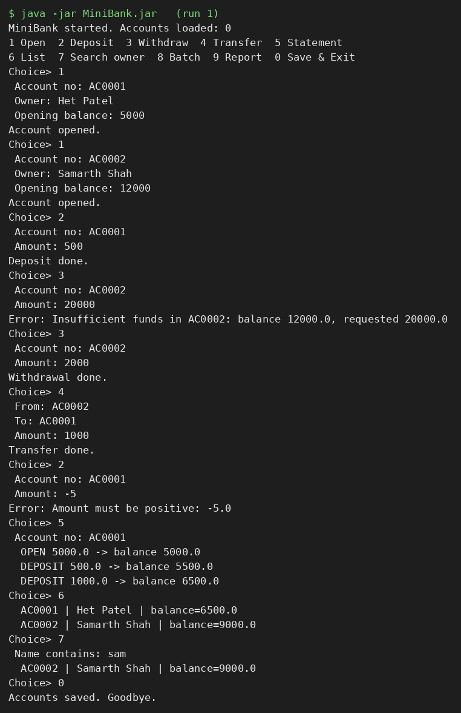
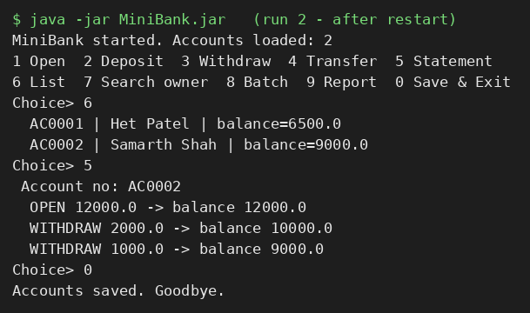
Run 2 starts a fresh JVM: the accounts and their statements are loaded from data/accounts.dat, so the data persists across restarts.
3. Use the TransactionProcessor (Practical 10) over the thread-safe store (Practical 12) to process a batch of transactions safely, and add the report (Practical 11) as a menu option.
CODE :
TransactionProcessor.java
import java.util.*;
import java.util.concurrent.*;
import java.util.concurrent.atomic.AtomicInteger;

public class TransactionProcessor {
private final BankService service;
private final int threads;

public TransactionProcessor(BankService service, int threads) {
this.service = service;
this.threads = threads;
}

public String run(List<String> commands) throws InterruptedException {
ExecutorService pool = Executors.newFixedThreadPool(threads);
AtomicInteger ok = new AtomicInteger(), failed = new AtomicInteger();
List<String> errors = Collections.synchronizedList(new ArrayList<>());

for (String cmd : commands) {
pool.submit(() -> {
try {
String[] p = cmd.trim().split("\\s+");
switch (p[0]) {
case "DEPOSIT" -> service.deposit(p[1], Double.parseDouble(p[2]));
case "WITHDRAW" -> service.withdraw(p[1], Double.parseDouble(p[2]));
case "TRANSFER" -> service.transfer(p[1], p[2], Double.parseDouble(p[3]));
default -> throw new BankException("Unknown command: " + p[0]);
}
ok.incrementAndGet();
} catch (RuntimeException e) {
failed.incrementAndGet();
errors.add("'" + cmd + "' -> " + e.getMessage());
}
});
}
pool.shutdown();
pool.awaitTermination(30, TimeUnit.SECONDS);

StringBuilder sb = new StringBuilder("Batch finished: " + ok + " succeeded, " + failed + " failed");
for (String e : errors) sb.append("\n rejected ").append(e);
return sb.toString();
}
}
The batch (menu option 8) and the report (menu option 9) are wired in MiniBankMain and BankService.processBatch() / report() shown above.
OUTPUT :
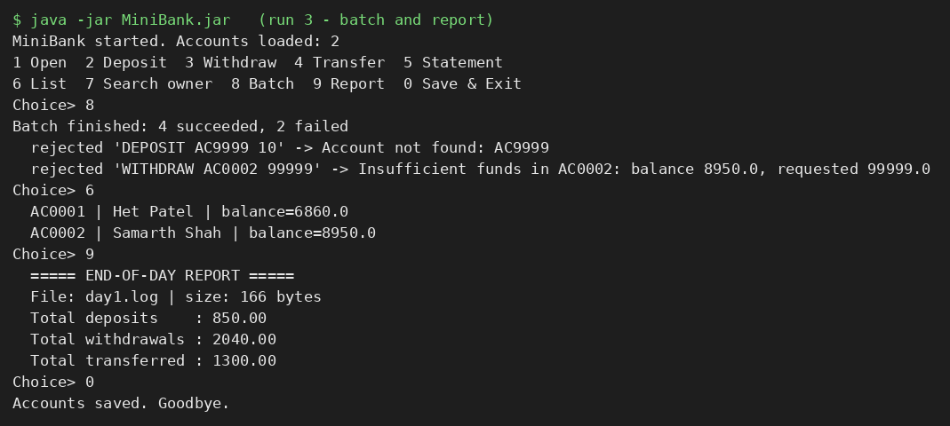
4. Write a few JUnit tests using @Test: a deposit increases the balance; a withdrawal over the limit throws an exception; many concurrent deposits keep the balance correct.
CODE :
BankServiceTest.java
import java.nio.file.Path;
import java.util.ArrayList;
import java.util.List;
import java.util.concurrent.*;
import org.junit.jupiter.api.Test;
import org.junit.jupiter.api.io.TempDir;
import static org.junit.jupiter.api.Assertions.*;

class BankServiceTest {

@Test
void depositIncreasesBalance(@TempDir Path dir) {
BankService bank = new BankService(dir);
bank.openAccount("AC1", "Het", 100);
bank.deposit("AC1", 50);
assertEquals(150.0, bank.listAccounts().get(0).getBalance());
}

@Test
void withdrawOverBalanceThrows(@TempDir Path dir) {
BankService bank = new BankService(dir);
bank.openAccount("AC1", "Het", 100);
assertThrows(InsufficientFundsException.class, () -> bank.withdraw("AC1", 500));
assertEquals(100.0, bank.listAccounts().get(0).getBalance()); // unchanged
}

@Test
void invalidAmountAndUnknownAccountThrow(@TempDir Path dir) {
BankService bank = new BankService(dir);
bank.openAccount("AC1", "Het", 100);
assertThrows(InvalidAmountException.class, () -> bank.deposit("AC1", -5));
assertThrows(AccountNotFoundException.class, () -> bank.deposit("NOPE", 5));
}

@Test
void concurrentDepositsKeepBalanceCorrect(@TempDir Path dir) throws Exception {
BankService bank = new BankService(dir);
bank.openAccount("AC1", "Het", 0);
ExecutorService pool = Executors.newFixedThreadPool(8);
List<Future<?>> jobs = new ArrayList<>();
for (int i = 0; i < 1000; i++) jobs.add(pool.submit(() -> bank.deposit("AC1", 10)));
for (Future<?> f : jobs) f.get();
pool.shutdown();
assertEquals(10000.0, bank.listAccounts().get(0).getBalance());
}

@Test
void saveAndLoadKeepsDataUnchanged(@TempDir Path dir) {
BankService first = new BankService(dir);
first.openAccount("AC1", "Het Patel", 100);
first.deposit("AC1", 25);
first.save();

BankService second = new BankService(dir); // simulates a restart
assertEquals(1, second.listAccounts().size());
assertEquals(125.0, second.listAccounts().get(0).getBalance());
assertEquals("Het Patel", second.listAccounts().get(0).getOwnerName());
}
}
OUTPUT :
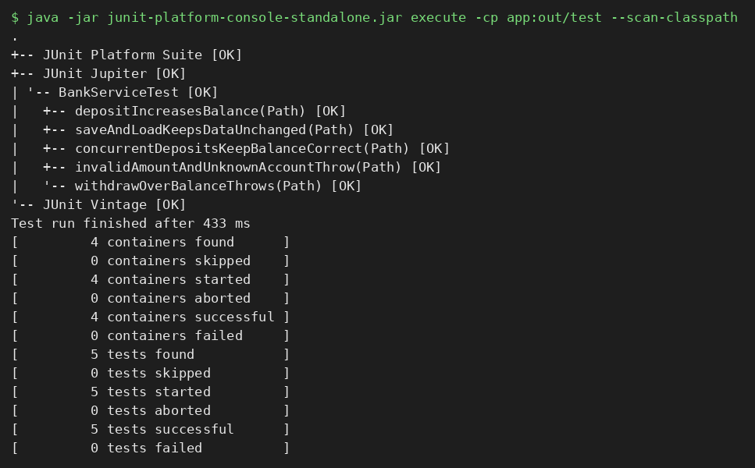
5. (Optional) Add an @Audit annotation and a reflective logger that records which service method was called.
CODE :
Audit.java
import java.lang.annotation.*;

@Retention(RetentionPolicy.RUNTIME)
@Target(ElementType.METHOD)
public @interface Audit { }
AuditLogger.java
import java.lang.reflect.Method;
import java.nio.file.Path;

public class AuditLogger {

// Uses reflection to confirm the calling method really carries @Audit, then logs it
public static void record(Object target, String methodName, Path auditFile) {
for (Method m : target.getClass().getDeclaredMethods()) {
if (m.getName().equals(methodName) && m.isAnnotationPresent(Audit.class)) {
TransactionLog.append(auditFile,
"AUDIT " + target.getClass().getSimpleName() + "." + methodName + "() called");
return;
}
}
}
}
Task5Demo.java
import java.nio.file.*;
import java.util.List;

public class Task5Demo {
public static void main(String[] args) throws Exception {
BankService bank = new BankService(Files.createTempDirectory("mb"));
bank.openAccount("AC0001", "Het Patel", 5000);
bank.deposit("AC0001", 100);
bank.withdraw("AC0001", 40);
bank.listAccounts();
System.out.println("audit.txt written by the reflective logger:");
Files.readAllLines(bank.getAuditFile()).forEach(l -> System.out.println(" " + l));
}
}
OUTPUT :
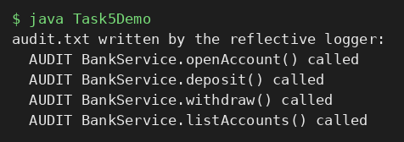
6. Build the final runnable JAR and complete the README.
CODE :
README.md
# MiniBank

A console banking application: model (Account), service (BankService), repository (Repository<T>, found by @Id via reflection), validation and custom exceptions, a thread-safe batch processor, persistence and an end-of-day report.

## Build
mkdir app && javac -d app src/*.java
jar cfe MiniBank.jar MiniBankMain -C app .

## Run
java -jar MiniBank.jar

Accounts are saved to data/accounts.dat on exit and loaded at start-up.

## Test (JUnit 5)
javac -cp junit-platform-console-standalone.jar:app -d out/test test/*.java
java -jar junit-platform-console-standalone.jar execute -cp app:out/test --scan-classpath

## Menu
1 Open, 2 Deposit, 3 Withdraw, 4 Transfer, 5 Statement, 6 List, 7 Search owner, 8 Batch, 9 Report, 0 Save and Exit
OUTPUT :
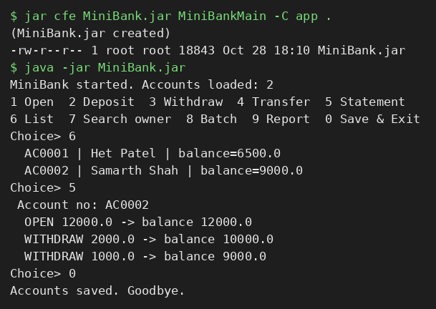
Supplementary Problems
• Add a “search account by owner name” option.
BankService.searchByOwner() does a case-insensitive “contains” match and is menu option 7; searching “sam” returns only Samarth Shah’s account (see OUTPUT of Task 2).
• Add a test that saves and loads state and checks the data is unchanged.
saveAndLoadKeepsDataUnchanged() saves through one BankService, creates a second one on the same folder (a simulated restart) and asserts that the account count, balance and owner are the same (see OUTPUT of Task 4).
Key Questions / Analysis / Interpretation
1. What is a layered architecture (model, service, user interface), and why is it useful?
A layered architecture splits the program into layers that each have one job and only talk to the layer next to them. In MiniBank the model (Account) holds data and its own rules, the service layer (BankService with Repository, Validator and the exceptions) contains the business logic, and the user interface (MiniBankMain menu) only reads input and prints results. This is useful because each layer can be changed or tested alone: the JUnit tests call BankService directly without any menu, the menu could be replaced by a GUI or web page without touching the rules, and the Repository could change how data is stored without affecting the UI. It also keeps classes small and makes bugs easier to locate.
2. How do you assert in JUnit that a method throws an expected exception?
Use Assertions.assertThrows(ExpectedType.class, () -> codeThatShouldThrow()). The second argument is a lambda (an Executable) so JUnit can run the code itself and catch what it throws. The test passes only if an exception of the expected type (or a subclass) is thrown; if nothing is thrown, or a different exception is thrown, the test fails. assertThrows also returns the exception, so its message can be checked too. In this lab: assertThrows(InsufficientFundsException.class, () -> bank.withdraw("AC1", 500)).
3. What does packaging the application as a runnable JAR provide?
A JAR is a single compressed file that bundles all the compiled .class files with a manifest. Adding a Main-Class entry (jar cfe MiniBank.jar MiniBankMain -C app .) makes it runnable, so the whole application starts with just java -jar MiniBank.jar, on any machine with a JRE, without setting the classpath or naming the main class. This makes the program easy to deliver, share and version, and it is the standard way Java applications are shipped.

