ZeptoFresh
15-Minute Food & Essentials Delivery
Exploratory Data Analysis — Assignment Submission

Section A — Data Quality Diagnosis
Four distinct data quality problems were identified across the six analyst observations:

# | Column | Issue Type | Detail | Treatment
1 | delivery_time_mins | Data Entry Error | 214 rows = 0 mins. A delivery cannot take 0 minutes — physically impossible. Likely a system default or failed timestamp capture. | Set zeros → NaN. Impute using median delivery time grouped by hub_id + order_category.
2 | order_value_Rs | Outlier | One Bakery order = ₹2,95,000. Median is ₹310; this single record is ~950× the median and will severely skew the distribution. | Apply IQR upper fence (Q3 + 3×IQR). If confirmed as data-entry error, remove the row entirely.
3 | prep_time_mins | Data Entry Error | Some values are negative (min = −6). Preparation time cannot be negative — likely a timestamp subtraction error in the pipeline. | Set all negative values → NaN. Impute using median prep_time_mins per order_category.
4 | customer_rating | Missing Values + Out-of-Range Values | 9,800 null values AND some values = 0. Valid scale is 1–5; zero is outside the defined range and likely represents 'no rating given'. | Set 0 → NaN (treat as missing). Impute nulls using median rating per city. Retain float64 dtype.

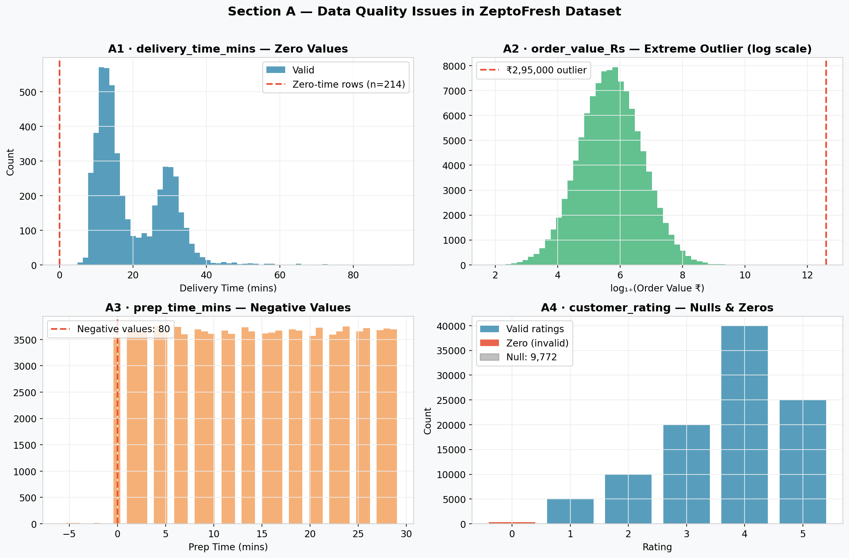

Section B — Distribution Analysis

B1 · What does Mean > Median indicate?
With mean = 18.4 and median = 14.2, the distribution is RIGHT-SKEWED (positively skewed). The mean is pulled upward by a long right tail caused by extreme late deliveries (up to 142 minutes). Most orders deliver in ~14 minutes, but a minority of very delayed orders inflate the average significantly.

B2 · ASCII Histogram

0–10 | ████████████████ (zero anomalies + very fast deliveries)
10–15 | ██████████████████████████ ← Mode (bulk of on-time orders)
15–20 | ████████████████ (normal deliveries)
20–25 | ████████
25–35 | █████████ (second metro peak)
35–50 | ███
50–142 | █ (long tail — severe outliers)

B3 · Recommended Transformation
Transformation | Log1p → log(1 + delivery_time_mins)
Why Log1p? | Handles zero values safely (unlike log); compresses the long right tail; brings the distribution closer to symmetric/normal.
Benefit for ML | Linear models (Logistic Regression, Linear Regression) assume normally distributed inputs. Log1p transformation makes the normality assumption more valid and improves model convergence.
Alternative | Square-root transform — milder compression, useful if the skew is moderate rather than extreme.

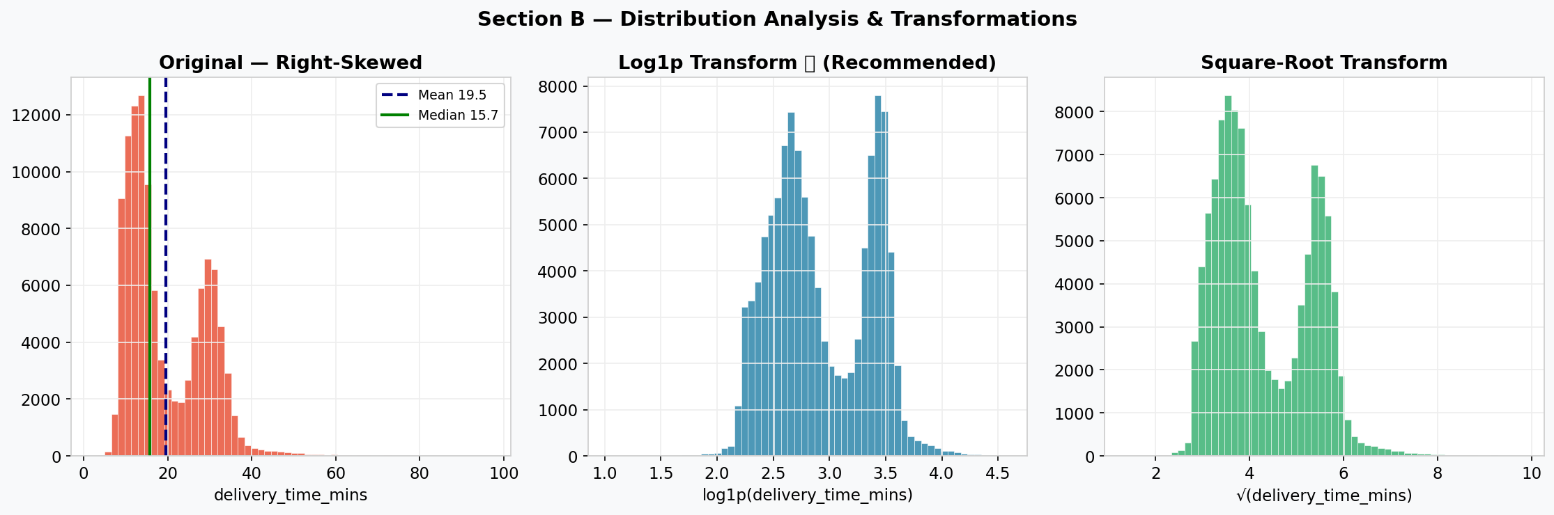

Section C — Correlation Interpretation

C1 · What is logically incorrect about the PM's conclusion?
① | Correlation ≠ Causation. A high r value (0.74) shows a strong association between two variables — it does not establish that one causes the other.
② | Even if delay does partially cause refunds, it is not the SOLE cause. Refunds can arise from wrong items, damaged packaging, payment failures, and quality issues — all independent of delivery time.
③ | "Eliminate refunds" is an overstatement. Even with perfect on-time delivery, refunds for non-time-related reasons would persist.

C2 · What correlation actually indicates
r = +0.74 | Strong positive linear association: as delivery_time_mins increases, refund_issued tends to increase. It quantifies the strength and direction of a LINEAR relationship only. It does NOT establish causality, direction of effect, or eliminate the role of other variables.

C3 · Possible Confounders
Confounder | Effect on Delay (↑) | Effect on Refund (↑)
Rain / Bad Weather | Slower rider speed, traffic congestion | Damaged packaging, spilled items
Peak Hour Congestion | Road congestion delays rider transit | Higher order volume → more packing errors
Large / Complex Orders | More prep time, heavier load for rider | Greater spoilage risk for fresh food
Hub Understaffing | Fewer pickers → slower fulfilment | Rushed packing → wrong items, missing items

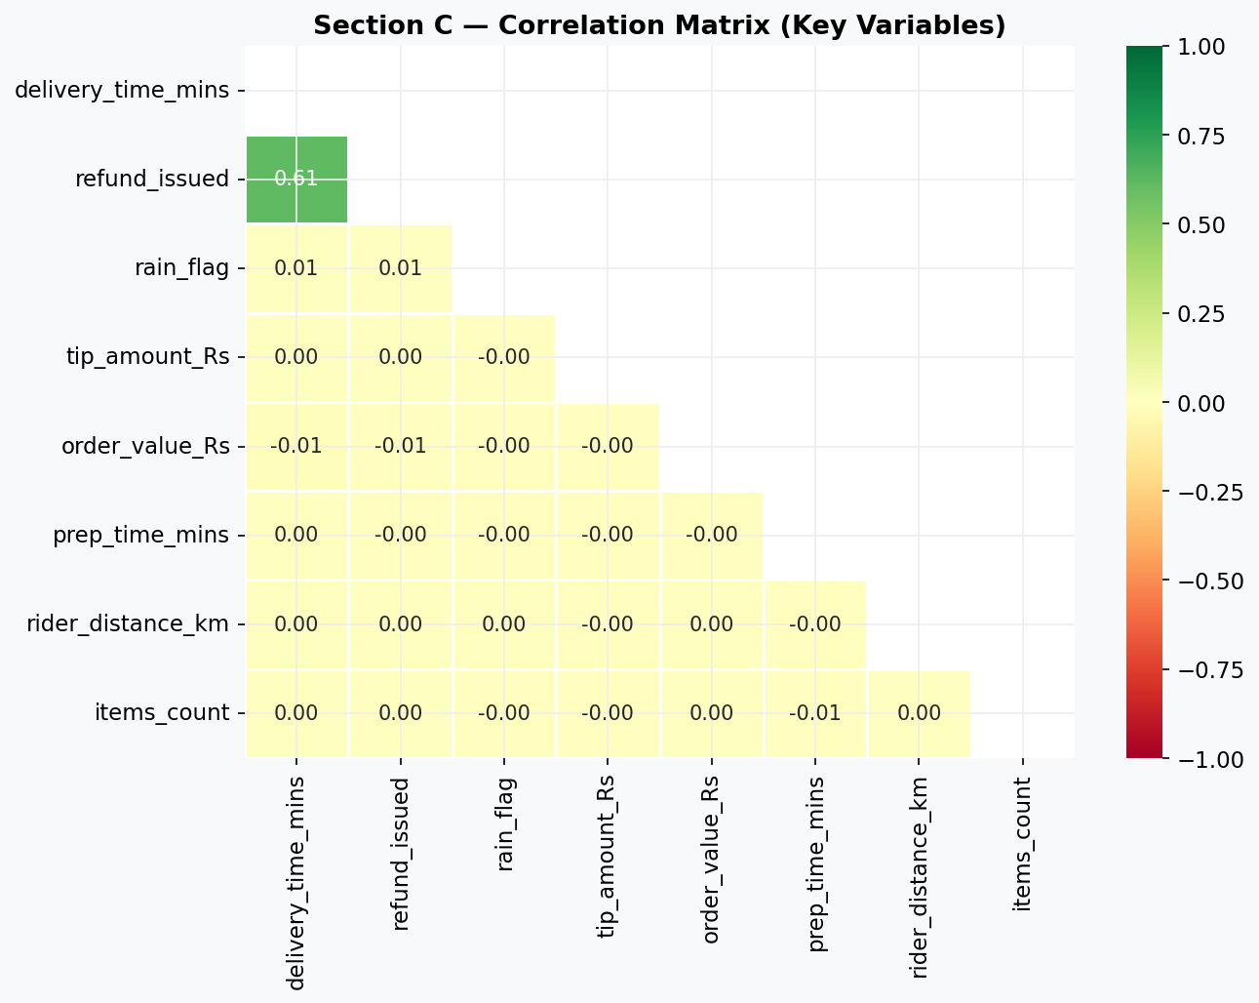

Section D — Bimodal Pattern in Tier-1 Cities

D1 · Operational Reasons for Bimodal Distribution
Peak 1 (12–14 min) | Orders fulfilled from nearby hubs during off-peak hours with simple SKUs (a single bakery item, a small grocery basket). Riders face minimal traffic. These deliveries complete on time, forming the first mode.
Peak 2 (28–32 min) | Orders requiring long rider distance, complex fresh-food preparation, or placed during peak hours (lunch/dinner rush) in high-traffic Metro zones. Systematic congestion and operational load create a second, structurally delayed cluster.
Why only Metro? | Mumbai and Bangalore have severe traffic congestion and wider hub-to-customer distances. Smaller cities have centralised hubs, lighter traffic, and simpler order profiles — producing a single, unimodal near-on-time cluster.

D2 · Why this must be addressed before modelling
- Bimodal distributions violate the unimodality / normality assumptions of Logistic Regression, LDA, and Naive Bayes. Fitting a single distribution to two underlying sub-populations produces a poor representation of reality.
- The model would learn an 'average' between the two peaks (~21 min), which represents neither the fast nor the slow delivery sub-population accurately.
- Feature importance and coefficients would be blended and misleading — the two modes are likely driven by different root-cause features.

D3 · Modelling Mistake if Ignored
Wrong decision boundary | A single linear boundary will lie ~21 min — it will misclassify both the sub-population at 12–14 min (flagging normal deliveries as risky) and the sub-population at 28–32 min (missing genuinely late deliveries).
Biased feature importance | Features that drive Peak 2 (rider_distance, rain, peak hour) and Peak 1 (simple SKU, nearby hub) get averaged — neither cluster is modelled well.
Recommended fix | Segment by city-tier (Metro vs Tier-2), add a city_tier binary feature, or use a Mixture Model / cluster-then-model strategy.

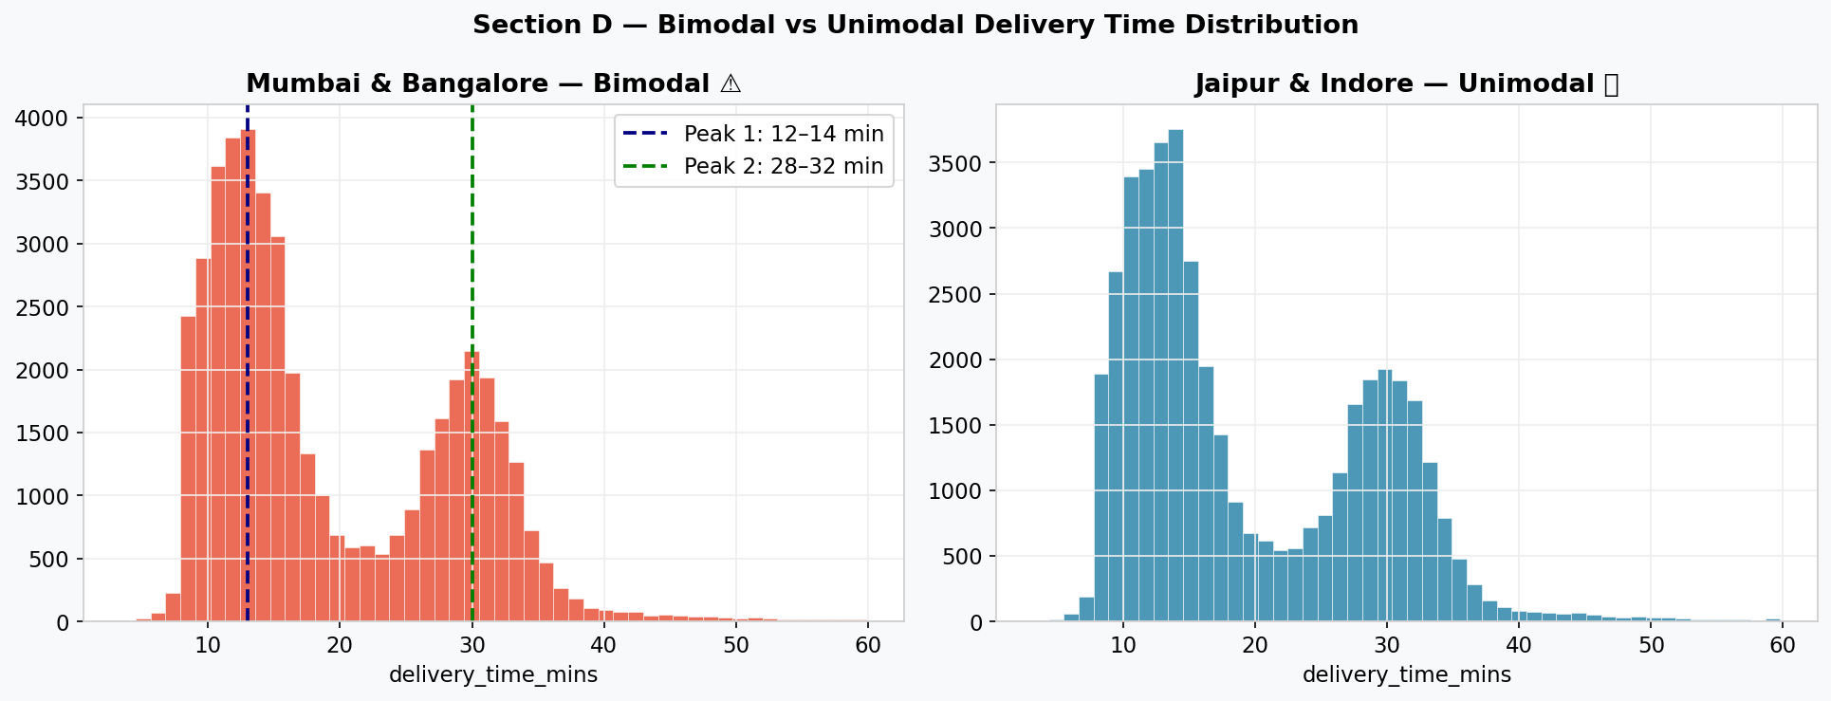

Section E — Business Trade-Off: Precision vs Recall

E1 · Recommendation
Answer | Prioritise RECALL (Sensitivity) — with a calibrated threshold caveat.

E2 · Justification
High Recall (↑ True Positives) | Catches more genuinely late deliveries before they happen. Enables proactive rider reallocation, preventing customer churn. Lost customers are a permanent cost — far higher than temporary ops overhead.
Low Precision (↑ False Positives) | Some non-late orders get flagged unnecessarily, causing unneeded rider reallocations. This is a recoverable, bounded operational cost — the rider is re-deployed in minutes.
False Negative cost | HIGH — A missed late delivery reaches the customer, damages brand trust, and increases churn probability significantly (per Kavya's statement: churn risk spikes at 30+ min).
False Positive cost | MEDIUM — Extra rider reallocation. Costs money but is manageable and does not directly harm the customer experience.

E3 · Cost Matrix
 | Predicted: LATE | Predicted: ON-TIME
Actual: LATE | TP ✅ Proactive fix — rider reallocated, on-time delivery achieved | FN 🚨 HIGHEST COST — Customer receives late order → churn risk
Actual: ON-TIME | FP ⚠️ Unnecessary reallocation — recoverable operational cost | TN ✅ Normal operations — no action needed

Caveat | If Recall becomes excessively high (flagging 80%+ of orders), operational costs explode. Use F-beta score (β > 1) to weight Recall over Precision, or tune the classification threshold (e.g. alert only when P(late) > 0.40) to balance both concerns.

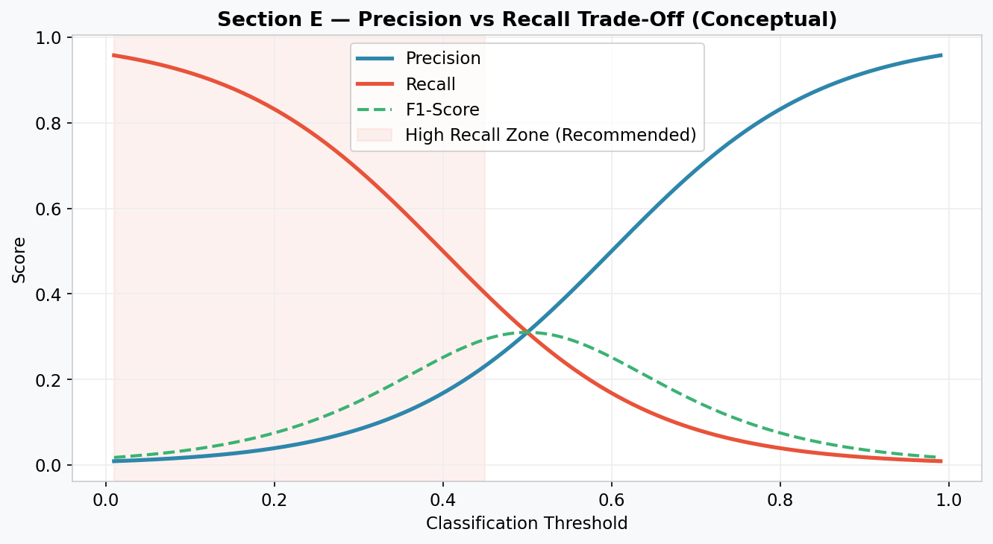

Section F — Advanced Feature Engineering
Three engineered features proposed from existing dataset columns to improve late-delivery prediction:

Feature 1 — prep_to_delivery_ratio
Formula | prep_to_delivery_ratio = prep_time_mins / (delivery_time_mins + ε)

Rationale | Separates hub-side bottlenecks from rider-side delays. A high ratio means the order sat waiting to be packed — the constraint is in the hub, not on the road.
Predictive Value | Orders with prep_to_delivery_ratio > 0.8 are likely late due to preparation slowness — actionable for kitchen/packing team optimisation.
Example | prep = 12 min, delivery = 15 min → ratio = 0.80 (hub bottleneck) prep = 4 min, delivery = 32 min → ratio = 0.12 (rider delay)

Feature 2 — distance_per_item
Formula | distance_per_item = rider_distance_km / items_count

Rationale | Normalises rider effort by basket size. Carrying 15 items over 4 km is far harder than 1 item over the same distance. This captures combined physical load + distance stress.
Predictive Value | A high distance_per_item value signals a difficult delivery that is more prone to delays and potential order damage.
Example | distance = 3.5 km, items = 2 → 1.75 km/item (high load per item) distance = 3.5 km, items = 14 → 0.25 km/item (shared effort)

Feature 3 — is_peak_rain_hour
Formula | is_peak_rain_hour = 1 if rain_flag == 1 AND order_hour ∈ {12–14} OR {18–21} else 0

Rationale | Rain and peak hour each independently increase delay risk. Their simultaneous occurrence creates a compounded non-linear risk that tree models may not automatically learn from the raw features.
Predictive Value | Binary interaction feature explicitly encodes the worst-case scenario for delivery — wet roads during the busiest traffic periods.
Example | order_hour = 19, rain = 1 → is_peak_rain_hour = 1 (HIGH RISK) order_hour = 14, rain = 0 → is_peak_rain_hour = 0 (Normal)

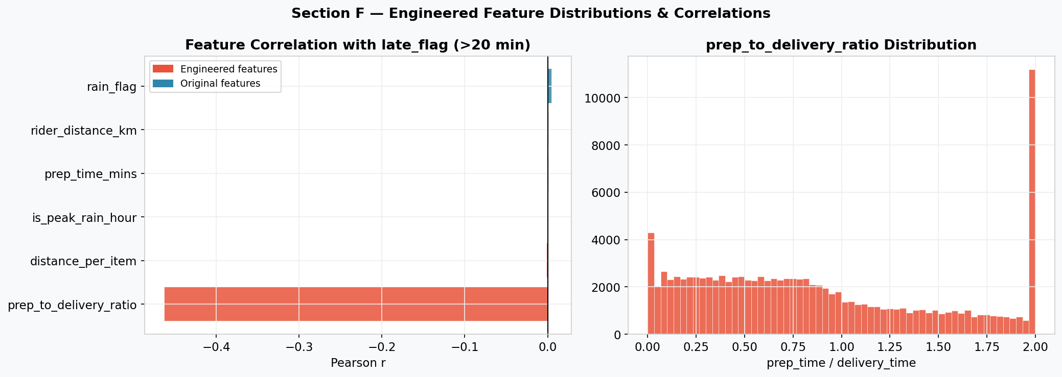

Feature Summary
Feature Name | Formula | What it Captures
prep_to_delivery_ratio | prep_time_mins / (delivery_time_mins + ε) | Hub-side bottleneck vs rider delay
distance_per_item | rider_distance_km / items_count | Combined physical load + distance stress
is_peak_rain_hour | (rain_flag==1) AND (hour in [12-14] OR [18-21]) | Compound risk: congestion + bad weather

