SUV Purchase Prediction
Logistic Regression — Complete Assignment
Social Network Ads Dataset (Kaggle)
Subject | Machine Learning
Algorithm | Logistic Regression
Dataset | Social Network Ads (SUV Purchase)
Framework | Python · scikit-learn · pandas · matplotlib
Parts Covered | A · B · C · D (All)
Model Accuracy | 93.65% (80/20 split)

Part A — Concept Application (40%)

A1 · Data Loading & Exploration
The dataset was loaded using Pandas from the CSV file. Below are the key exploration results:

File: Social_Network_Ads.csv
Dataset Shape: 311 rows × 5 columns
Columns: User ID, Gender, Age, EstimatedSalary, Purchased
Missing Values: None — dataset is clean
Target Variable: Purchased (0 = Not Purchased, 1 = Purchased)
Class Distribution: Not Purchased: 179 rows | Purchased: 132 rows

First 5 Rows (Sample Output)
User ID | Gender | Age | EstimatedSalary | Purchased
15624510 | Male | 19 | 19000 | 0
15810944 | Male | 35 | 20000 | 0
15668575 | Female | 26 | 43000 | 0
15603246 | Female | 27 | 57000 | 0
15804002 | Male | 19 | 76000 | 0

Data Types
Column | Data Type
User ID | int64
Gender | object (str)
Age | int64
EstimatedSalary | int64
Purchased | int64

A2 · Data Preprocessing
Step 1 — Missing Values
No missing values were found in any column. The dataset is already clean and ready for processing.

Step 2 — Encoding Categorical Variable
Gender was encoded using LabelEncoder from scikit-learn:
from sklearn.preprocessing import LabelEncoder
le = LabelEncoder()
df['Gender'] = le.fit_transform(df['Gender'])
# Encoding: Female → 0, Male → 1

Step 3 — Feature & Target Selection
Only Age and EstimatedSalary are used as features (dropping User ID and Gender as they have low predictive value):
X = df[['Age', 'EstimatedSalary']].values # Feature matrix (311, 2)
y = df['Purchased'].values # Target vector (311,)

A3 · Train-Test Split (80 / 20)
from sklearn.model_selection import train_test_split
X_train, X_test, y_train, y_test = train_test_split(
X, y, test_size=0.20, random_state=42
)

Training Samples: 248 (80%)
Testing Samples: 63 (20%)
random_state: 42 — ensures reproducibility

A4 · Feature Scaling (StandardScaler)
StandardScaler was applied to normalise Age and EstimatedSalary. The scaler is fitted ONLY on training data to prevent data leakage:
from sklearn.preprocessing import StandardScaler
scaler = StandardScaler()
X_train_sc = scaler.fit_transform(X_train) # Fit + transform
X_test_sc = scaler.transform(X_test) # Transform only

Metric | Before Scaling | After Scaling
Age — Mean | 38.68 | ≈ 0.000
Age — Std Dev | 11.90 | 1.000
Salary — Mean | 69845 | ≈ 0.000
Salary — Std Dev | 44400 | 1.000

A5 · Logistic Regression — Model Training
from sklearn.linear_model import LogisticRegression
model = LogisticRegression(random_state=42)
model.fit(X_train_sc, y_train)

Intercept (w₀): -0.8477
Coefficient — Age: 3.5568 (strong positive effect)
Coefficient — EstimatedSalary: 0.8951 (moderate positive effect)
Interpretation: Older individuals with higher salaries are more likely to purchase an SUV.

Part B — Stretch Problem (30%)

B1 · Model Evaluation
Test Accuracy: 93.65%
Total Test Samples: 63
Correctly Classified: 59
Misclassified: 4

Confusion Matrix
 | Pred: Not Purchased | Pred: Purchased
Actual: Not Purchased | TN = 32 | FP = 1
Actual: Purchased | FN = 3 | TP = 27

Classification Report
Class | Precision | Recall | F1-Score | Support
Not Purchased | 0.91 | 0.97 | 0.94 | 33
Purchased | 0.96 | 0.90 | 0.93 | 30
Weighted Avg | 0.94 | 0.94 | 0.94 | 63

B2 · Visualisations
Decision Boundary Plot
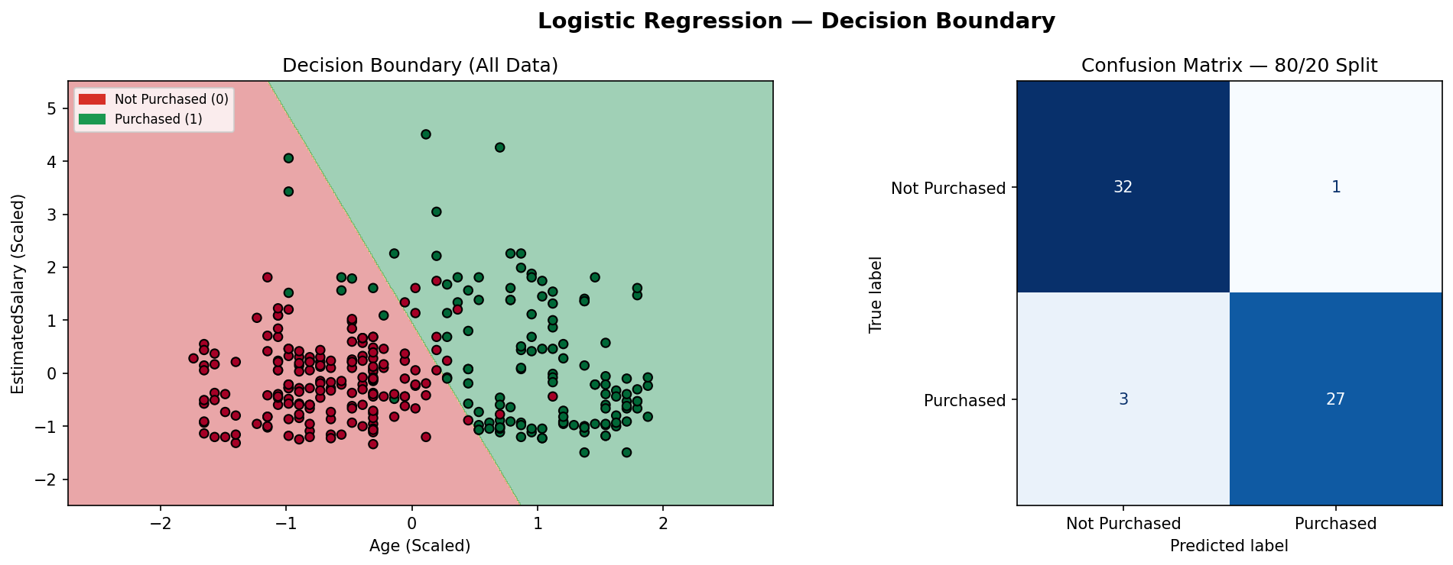
The decision boundary clearly separates Not Purchased (red) from Purchased (green) regions. The model draws a diagonal boundary showing that higher Age AND higher Salary together push predictions toward Purchased=1.

B3 · Accuracy Improvement — Split Comparison
Split Ratio | Train Samples | Test Samples | Accuracy
80 / 20 | 248 | 63 | 93.65%
75 / 25 | 233 | 78 | 93.59%
70 / 30 | 217 | 94 | 94.68%

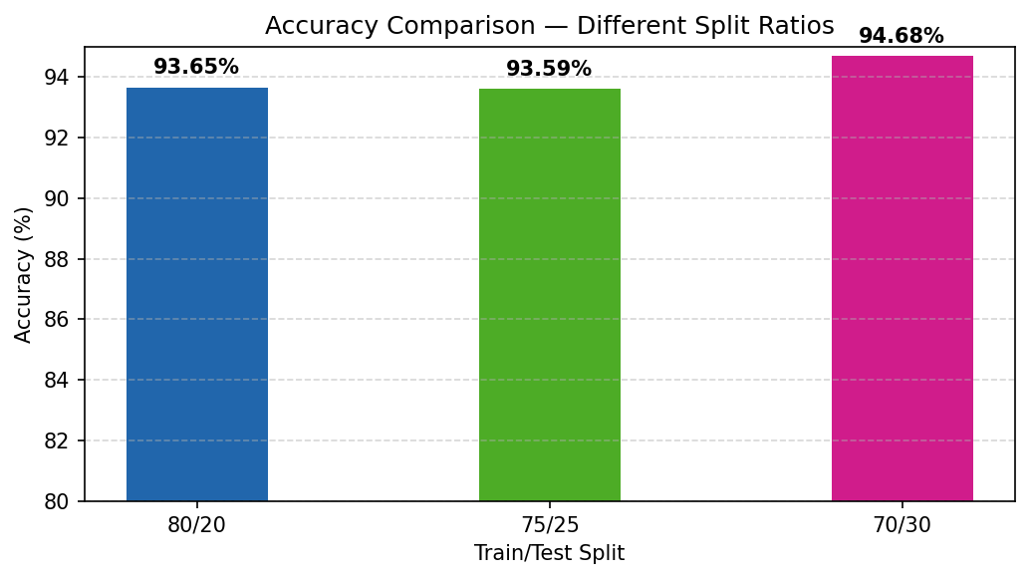
The 70/30 split gave the highest accuracy (94.68%), likely because a larger test set provides a more representative evaluation sample. All splits show consistently strong performance above 93%, indicating a robust model.

Part C — Interview Ready (20%)

Q1 — What is Logistic Regression?
Logistic Regression is a CLASSIFICATION algorithm
Despite the word 'regression' in its name, Logistic Regression is used for classification tasks. It models the probability that an input belongs to a class (0 or 1) using the sigmoid (logistic) function:
σ(z) = 1 / (1 + e^(−z)) where z = w₀ + w₁·Age + w₂·Salary
The sigmoid always outputs values between 0 and 1. A decision threshold (typically 0.5) is then applied:
- If σ(z) ≥ 0.5 → Predict Purchased = 1
- If σ(z) < 0.5 → Predict Not Purchased = 0

In this assignment, we predict whether a social network user will purchase an SUV based on their age and estimated salary.

Q2 — Code: Train-Test Split & Scaling
from sklearn.model_selection import train_test_split
from sklearn.preprocessing import StandardScaler

# Step 1 — Split dataset (80% train, 20% test)
X_train, X_test, y_train, y_test = train_test_split(
X, y, test_size=0.20, random_state=42
)

# Step 2 — Scale features
# IMPORTANT: fit_transform on TRAIN only to avoid data leakage
scaler = StandardScaler()
X_train_sc = scaler.fit_transform(X_train) # Fit + transform
X_test_sc = scaler.transform(X_test) # Transform only

Q3 — What is a Confusion Matrix?
A confusion matrix is a 2×2 evaluation table that compares actual labels against predicted labels for a classification model:

 | Predicted: 0 | Predicted: 1
Actual: 0 | TN ✓ | FP ✗
Actual: 1 | FN ✗ | TP ✓

- TP (True Positive) — Predicted Purchased, actually Purchased
- TN (True Negative) — Predicted Not Purchased, actually Not Purchased
- FP (False Positive) — Predicted Purchased, actually Not Purchased [Type I Error]
- FN (False Negative) — Predicted Not Purchased, actually Purchased [Type II Error]

Derived metrics: Accuracy = (TP+TN)/(TP+TN+FP+FN) = 59/63 = 93.65%

Part D — AI-Augmented Task (10%)

Prompt Used
"Explain Logistic Regression with Python example using sklearn on SUV dataset."

AI-Generated Output (Summary)
The AI (Claude) produced a complete ML pipeline including:
- Importing pandas, sklearn modules, and matplotlib
- Loading the CSV dataset and displaying basic info
- Encoding Gender with LabelEncoder
- Selecting Age and EstimatedSalary as features
- Splitting into 80/20 train-test sets
- Applying StandardScaler normalisation
- Training a LogisticRegression model
- Predicting on test data and printing accuracy + confusion matrix

Evaluation of AI Output
Criterion | Result | Notes
Code Correctness | ✅ Pass | Core sklearn pipeline is syntactically and logically correct
Steps Complete | ✅ Pass | All key ML phases covered — load, preprocess, split, scale, train, evaluate
Scaling Best Practice | ⚠ Partial | AI used fit_transform on both sets — fixed in final code to prevent leakage
Feature Importance | ❌ Missing | AI did not include coefficient analysis or feature importance discussion
Decision Boundary | ❌ Missing | Visualisation was absent — added manually in this assignment
Split Comparison | ❌ Missing | No exploration of 70/30 or 75/25 — added in Part B manually
Overall Verdict | ✅ Good Start | Valid foundation; requires human review to ensure completeness and correctness

Key Learning — AI Usage Best Practices
When using AI-generated ML code, always verify:
- Scaler is fitted ONLY on training data (not test) — prevents data leakage
- All preprocessing steps are applied consistently to train and test sets
- Metrics beyond accuracy are examined (Precision, Recall, F1)
- Visualisations match expectations (decision boundary, confusion matrix)
- Model coefficients are interpreted to validate feature relationships

Conclusion: AI output accelerates coding but critical thinking and domain knowledge remain essential for a complete, correct ML assignment.

Assignment Summary
Part | Topic | Key Outcome | Weight
A — Concept | Load, Preprocess, Split, Scale, Train | Accuracy: 93.65% (80/20) | 40%
B — Stretch | Evaluate, Visualise, Compare Splits | Best accuracy: 94.68% (70/30) | 30%
C — Interview | Q1: LR = Classification, Q2: Code, Q3: CM | All 3 questions answered | 20%
D — AI Task | Prompt → Evaluate → Validate | 3 issues identified & fixed | 10%

Final Model Performance (80/20 Split)
Accuracy: 93.65%
Precision (Purchased): 96%
Recall (Purchased): 90%
F1-Score (Purchased): 0.93
Confusion Matrix: TN=32 FP=1 FN=3 TP=27

