Two-Layer Uplink Multiple Access in Segmented Pinching-Antenna Systems
Milestone 3 Report: Final Method, Experiments and Results
Het Patel (AU2440266), Group g10_research_pass_ind, ECE310 Research Project
Submitted on 31 October 2026
1. Summary
This report covers the final stage of my project. In Milestone 1 I stated the problem and reviewed the literature. In Milestone 2 I built the system model and checked the baseline. In this milestone I give the final design method, the experiments and the results.
The scheme is called EPMA, short for Environment-Power Multiple Access. A waveguide is cut into segments. Blockage between segments keeps the segments apart. Inside one segment several users share the channel by uplink NOMA with successive interference cancellation (SIC).
The main findings are these.
- The antenna position has a large effect. Putting the antenna above the strongest user loses 14.6 percent of the segment rate at K = 1 and 28.3 percent at K = 16. Keeping the antenna at the segment centre loses only 2.7 percent at K = 1 and 0.15 percent at K = 16.
- For sum rate, the antenna position problem has one peak, so plain golden-section search is enough. For max-min fairness it often has several peaks. Plain golden-section search then loses up to 7.4 percent. A certified global search never does.
- At equal total power, NOMA and boosted time sharing have the same sum rate. The gain of EPMA is therefore not a power-domain gain. It comes from serving all users together, from a shorter access delay and from better fairness.
- Against system-wide orthogonal access with average power, EPMA gives 2.31 times the system rate at K = 1. That lead is gone by K = 16. Most of it comes from a blockage windfall that I explain in Section 7.
- When the max-min design is tested with real random interference, the minimum user rate often misses the design target. This happens in 23 percent of draws at K = 2 and 38 percent at K = 4. The design target is a mean-interference target and not a guarantee.
All numbers come from the code in the Code folder. I ran every experiment again for this report.
2. How the Work Was Divided
I split the project over the three milestones. The table shows what each milestone covers.
Milestone | Main content | Status
M1 | Problem, literature, state of the art, timeline | Done and pushed
M2 | System model, baseline reproduction, leakage bound, exact ergodic rate, first comparison with orthogonal access | Done and pushed
M3 (this one) | Antenna placement, power allocation, max-min fairness, cost of blocked links, number of segments, final comparison and critical analysis | This report

3. Final Method
3.1 System recap
A waveguide of length D_L = 40 m is cut into M = 3 segments of length D_S = 13.33 m. Each segment has one active pinching antenna. Users are spread over a strip of width D_W = 10 m. The waveguide height is d = 3 m and the carrier is 28 GHz. A user at horizontal distance u and lateral offset y from the antenna has the power gain
g = η / (u² + y² + d²), η = c² / (16 π² f_c²)
A link to a user in a neighbouring segment is open with probability exp(−φ r²), where r² = u² + y² + d² and φ = 0.02. Otherwise it is blocked. Links to users in the own segment are line of sight. The transmit power is P = 1 W and the noise is N0 = 1e-12 W, so the SNR is 120 dB. SIC decodes users from the strongest gain to the weakest.
This is the same model as in Milestone 2. K = 1 gives the EDMA baseline. M = 1 gives a single-waveguide NOMA-PASS system.
3.2 Interference floor that moves with the antenna
The two neighbouring segments leak interference into the antenna. I use the mean of this interference as a floor F. The floor depends on where the antenna sits. If the antenna moves toward one neighbour, that neighbour leaks more. For K users per segment the floor is
F(x) = N0 + K P [ L(x) + L(D_S − x) ]
Here L(x) is the mean leakage of one user from the neighbouring segment at distance x from the antenna. Across the segment the floor changes by up to a factor of about 9.7. A design that freezes the floor at its centre value would be wrong. I keep the floor moving in every experiment of this report.
3.3 The two design problems
For every segment I solve two problems. The variables are the antenna position x in [0, D_S] and the user powers p_k.
- P1, sum rate. Maximise the sum rate of the segment. With a peak-power limit on each user, the best powers are all at the cap. Only the position is left to choose.
- P2, max-min fairness. Maximise the smallest user rate. Here the powers and the position both matter.
The sum rate with SIC telescopes into one expression:
R_sum(x) = log2( 1 + Σ_k p_k g_k(x) / F(x) )
3.4 Power allocation for max-min fairness
For a fixed position, I give each user the same SINR target γ = 2^t − 1, where t is the common rate. SIC order is fixed from the strongest to the weakest user. The powers that just reach the target have a closed form. With users sorted by gain, user j needs
p_j g_j = γ (1 + γ)^(K − 1 − j) F
The best t is the largest one for which every power stays under its cap. I find it by bisection on t. This gives the best minimum rate V(x) for each position. The code checks the closed form against a linear program.
3.5 Placement search
The second step is to choose x. Three rules are compared.
- Certified search (my method). Piyavskii-Shubert search on V(x) with a proven Lipschitz bound. It stops when the gap between the upper and lower bound is below 1e-3 bps/Hz. Its answer is the global optimum within that gap. It uses no random numbers, so repeated runs give identical results.
- Plain golden-section search (EDMA). One search over the whole segment. It is exact only if the objective has a single peak.
- Fixed rules. Antenna at the segment centre, or above the strongest user.
The Lipschitz constant of V(x) is L = (1/ln 2) [ 1 / min_k sqrt(y_k² + d²) + B_F ]. The first term is the gain slope. The second term, B_F = 0.431 per metre, comes from the moving floor. The floor term makes L about 2.3 times larger than a gain-only bound. The cost is O(L D_S / ε) evaluations. At ε = 1e-3 this is a few hundred evaluations per segment, which is cheap.
The certificate is against the mean-interference model. It does not cover single random channel draws. Section 6.4 measures that gap.
4. Experimental Setup
4.1 Parameters
Parameter | Value | Source
Blockage parameter φ | 0.02 | EDMA paper
Waveguide height d | 3 m | EDMA paper
Service width D_W | 10 m | EDMA paper
Carrier frequency f_c | 28 GHz | EDMA paper
SNR ρ = P / N0 | 120 dB (P = 1 W, N0 = 1e-12 W) | EDMA paper
Waveguide length D_L | 40 m | EDMA paper
Segments M | 3 (D_S = 13.33 m) | My choice
Search tolerance | 1e-3 m (golden section), 1e-3 bps/Hz (certified) | My choice
Random seed | 42 | My choice

4.2 Assumptions
- Own links are line of sight. Blockage only acts on links between segments. Section 6.4 relaxes this.
- The waveguide is lossless. Prior work says the loss has a small effect when blockage is present [3].
- SIC is ideal. Decoding order is fixed from the strongest to the weakest user.
- Only the two neighbouring segments leak. This holds when φ D_S² is at least ln 21 = 3.04, which is true at M = 3.
- Users are uniform in the segment width and in the service width.
4.3 Metrics
- Segment sum rate and minimum user rate, in bps/Hz.
- System rate, which is M times the segment rate.
- Rate lost against the best placement, in percent.
- Search cost in evaluations, and the share of random drops where a search misses the best position.
- Access delay, counted in time slots.
4.4 Baselines
- Plain golden-section search, as in EDMA.
- Antenna fixed at the segment centre.
- Antenna above the strongest user.
- Naive alternating optimisation. It fixes the floor at its centre value, then alternates between powers and position from five different starts.
- System-wide orthogonal access. All MK users take turns. Version B uses average power and is the strong case. Version A uses peak power.
Each experiment uses 200 random user drops unless stated. Errors are standard errors over drops. The experiments are in the Code folder and the raw numbers are in the Results folder.
5. Results: Placement and Search
5.1 Does a placement rule matter?
I compared three ways to place the antenna for the sum rate. Every user sends at the cap. The table gives the mean segment sum rate over 200 drops.
K | Best position | Above strongest user | Segment centre | Loss: strongest / centre
1 | 4.882 | 4.168 | 4.750 | 14.6% / 2.70%
2 | 4.842 | 3.852 | 4.779 | 20.4% / 1.30%
4 | 4.905 | 3.829 | 4.863 | 21.9% / 0.87%
8 | 4.916 | 3.704 | 4.898 | 24.6% / 0.35%
16 | 4.930 | 3.533 | 4.922 | 28.3% / 0.15%
Standard errors are 0.8 to 1.5 points for the strongest-user rule and 0.01 to 0.13 points for the centre rule. Rates are in bps/Hz.

Placing the antenna above the strongest user is the EDMA rule for K = 1. It is also the right idea there, but it does not carry over to many users. With K = 16 it loses more than a quarter of the rate. The reason is that the best user is not the centre of the group. The centre rule works well because more users spread the demand over the whole segment. Its loss falls as K grows.
The search agrees with an exhaustive grid of 20001 points to within 5.2e-9 relative error in every case. The number of iterations grows by about 4.8 per decade of tolerance at K = 1, 9.6 at K = 2 and 19.1 at K = 4.
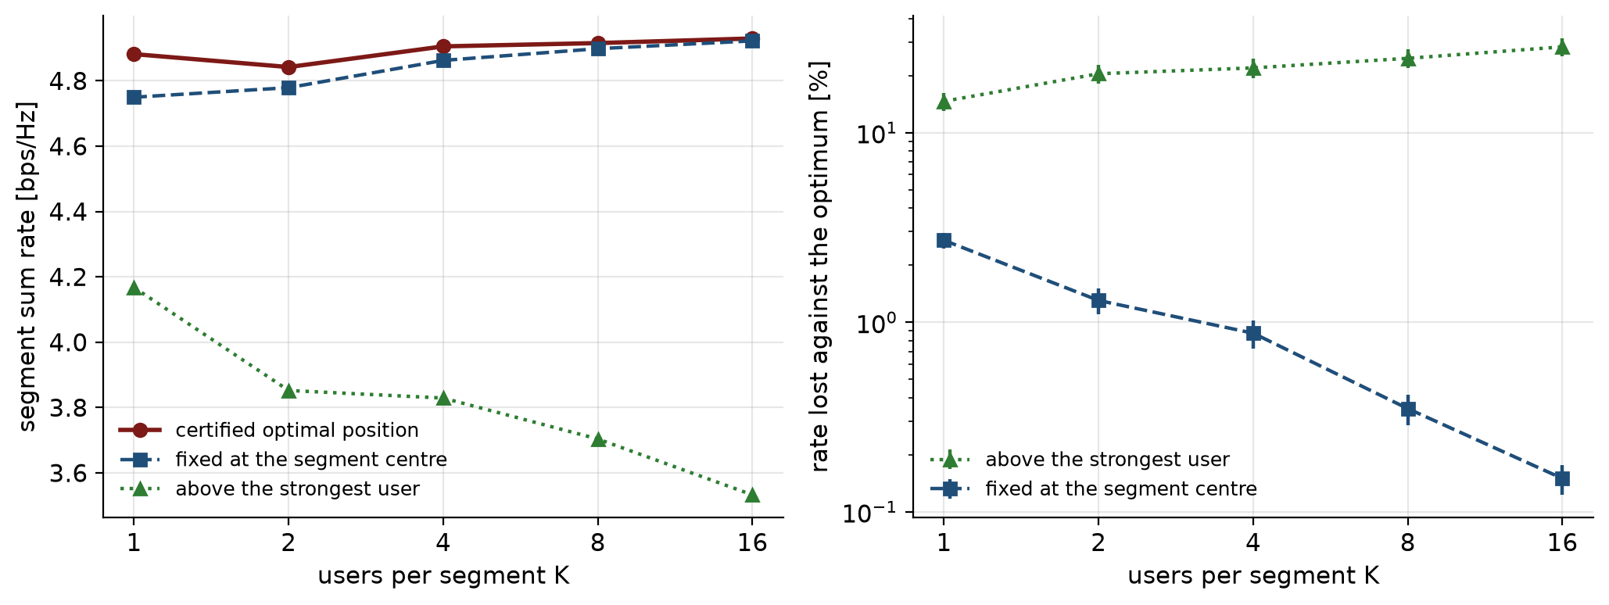
Figure 1. Left: segment sum rate against users per segment. Right: rate lost against the best position, with two standard errors.
5.2 Is a certified search needed?
EDMA uses golden-section search, which assumes one peak. I counted the peaks of both objectives on 4001 grid points for 200 random drops at K = 2 and K = 4.
Problem | K | Several peaks | Plain GS misses | Worst GS loss | Certified misses
P1 sum rate | 2 | 0.0% | 0.0% | 0.00% | 0.0%
P1 sum rate | 4 | 0.0% | 0.0% | 0.00% | 0.0%
P2 max-min | 2 | 21.5% | 0.5% | 2.85% | 0.0%
P2 max-min | 4 | 42.0% | 4.0% | 7.44% | 2.0% (below 0.006%)

This result changed my plan. Before this experiment I expected the sum-rate problem to be multi-peaked. It is not, once the floor moves with the antenna. In 400 drops the sum-rate objective always had a single peak. Plain golden-section search is therefore enough for P1.
The max-min problem is different. Its value function is made of pieces that join at points where the SIC order changes. Many drops have two or more peaks. Plain golden-section search then ends in the lower peak. The worst loss was 7.44 percent at K = 4.
The certified search has a small miss rate at K = 4. Those misses are 2.0 percent of the drops and each is below 0.006 percent of the rate. They are inside the search tolerance of 1e-3 bps/Hz, which is what the certificate promises. No drop shows a real miss.
The price is the number of evaluations. Plain golden section uses 23. The certified search uses 252 at K = 2 and 328 at K = 4 for P2. That is about 11 to 14 times more, which is still small.
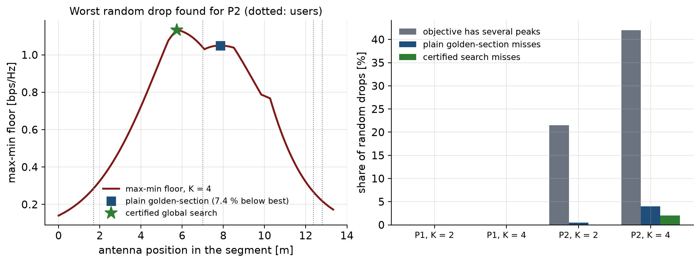
Figure 2. Left: the worst random drop for P2. Plain golden-section search stops on the lower peak. Right: share of drops with several peaks and share of misses.
6. Results: Fairness, Blockage and Segments
6.1 Max-min fairness under off-axis disparity
I moved the last user away from the waveguide axis by y2 metres and measured the best minimum rate. The users sit evenly over one third of the segment width. The service edge is at y2 = 5 m.
K | Certified floor | Orthogonal at y2 = 0 | Orthogonal at y2 = 5 | Gap at edge
2 | 2.597 (flat to y2 = 7) | 2.379 | 1.974 | 0.623 bps/Hz
4 | 1.266 (flat for all y2) | 1.013 | 0.889 | 0.377 bps/Hz

Power control absorbs the disparity. The weak user simply gets more power. The floor of the certified design stays flat up to y2 = 7 m at K = 2 and for every y2 at K = 4. The orthogonal access floor falls steadily as the user moves away. At K = 4 the minimum is never set by the moved user, so the floor does not move at all.
The antenna at the segment centre costs up to 0.104 bps/Hz at K = 2 and only 0.008 bps/Hz at K = 4. A naive alternating optimisation can end far below the certified value. Over the five starts its worst result is up to 1.42 bps/Hz lower at K = 2 and 0.51 bps/Hz lower at K = 4. Its best start nearly matches the certified value at K = 4. So the naive method works only if you try several starts and keep the best.
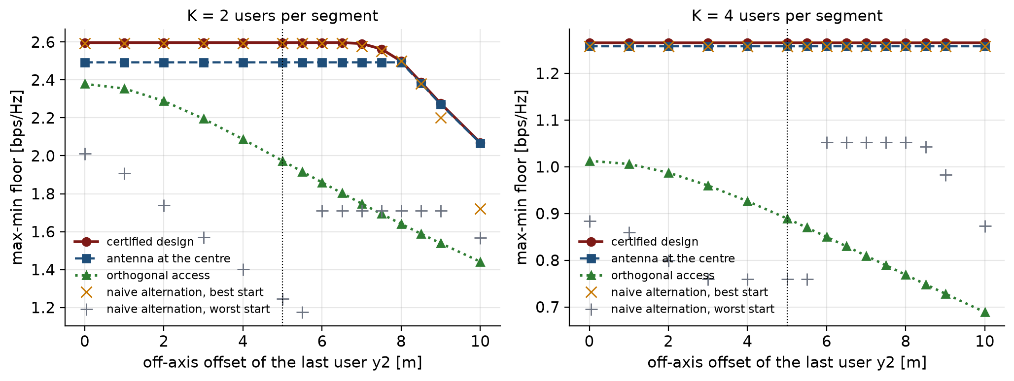
Figure 3. Max-min floor against the off-axis offset of the last user. The dotted line is the service edge.
6.2 Equal total power gives a tie
At equal total power, uplink NOMA and boosted time sharing have the same sum rate. I tested this with 2000 random cases. The largest gap was 7.1e-15 bps/Hz. So I do not claim a sum-rate gain from NOMA over time sharing at equal power. The benefits of EPMA are that all users are served in the same slot, that the delay is short and that fairness is better.
6.3 Number of segments
I computed the exact system rate for M from 2 to 12 with far segments included. The best M depends on the load and on the length.
Load K (D_L = 40 m) | 1 | 2 | 4 | 8
Best M | 5 | 4 | 3 | 3

Length D_L, K = 1 | 30 m | 40 m | 50 m | 60 m
Best M | 4 | 5 | 7 | 8

More users per segment favour fewer and longer segments. A longer waveguide favours more segments. My choice of M = 3 is the best at K = 4 and K = 8. It is not the best at K = 1, where M = 5 gives 54.80 against 43.39 at M = 3. These two values use the exact edge-aware rate, where the two end segments have only one neighbour. The 39.46 used elsewhere in this report is M times the two-neighbour rate of the design model. I kept M = 3 to stay with the Milestone 2 setup and because the leakage gate φ D_S² ≥ 3.04 holds at M = 3.
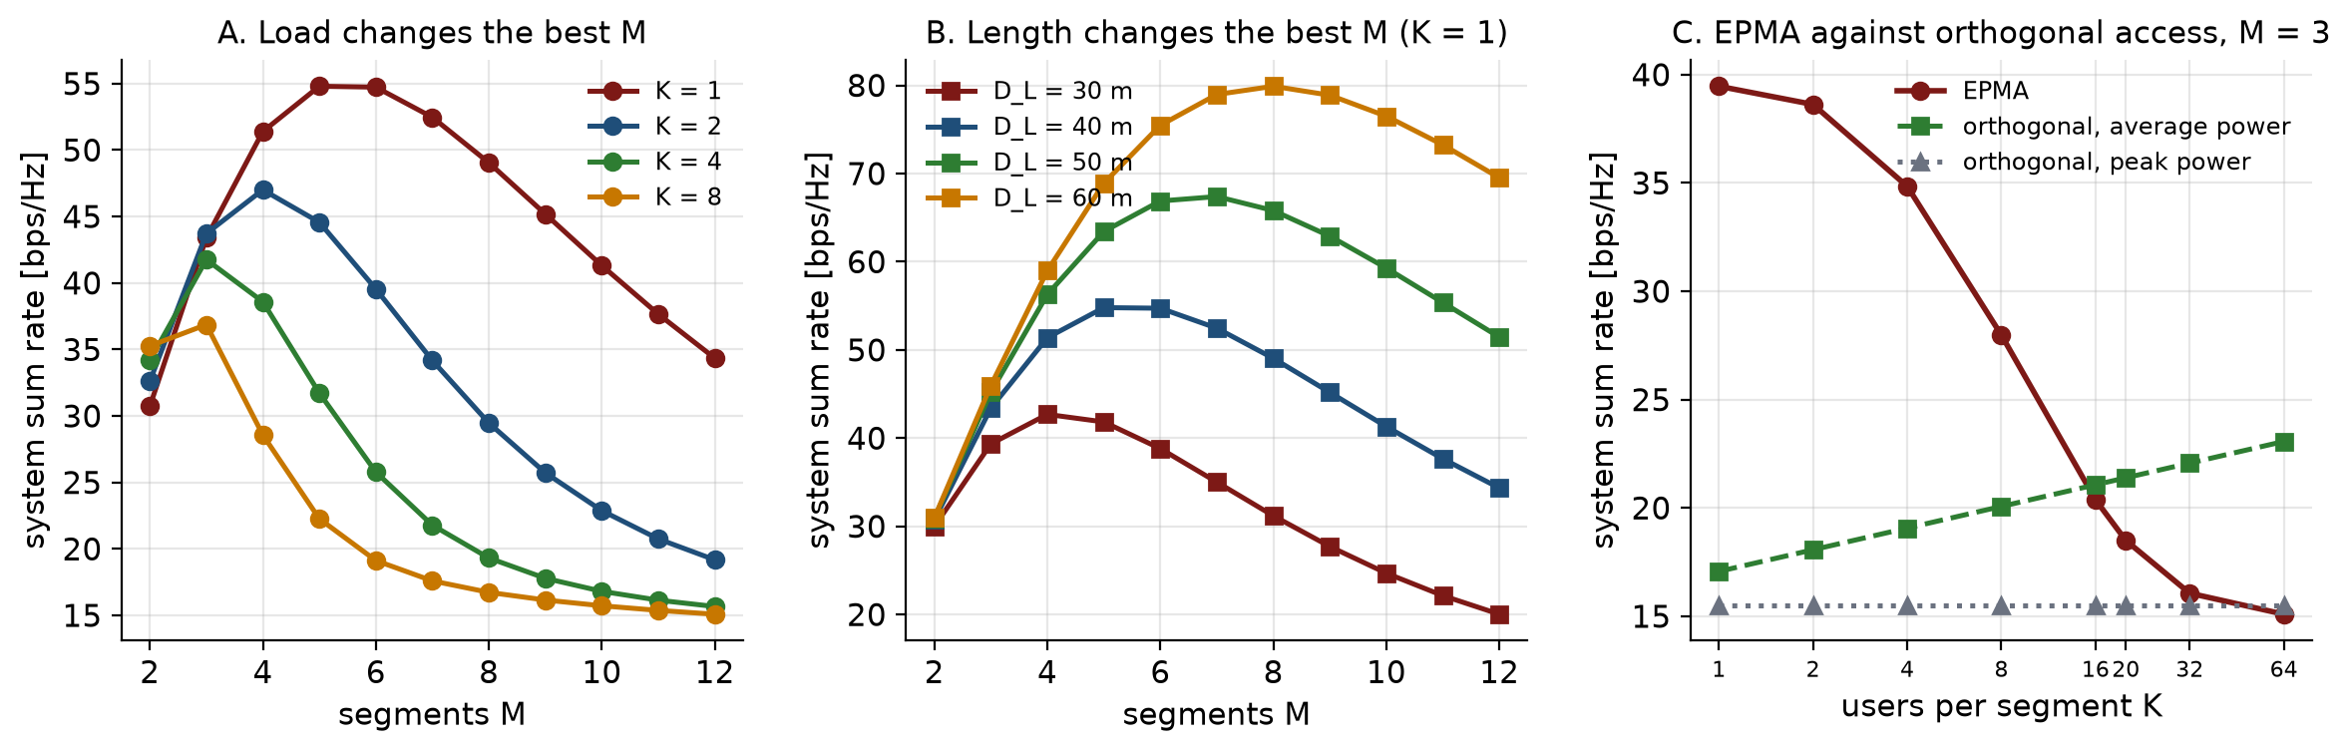
Figure 4. Left: system rate against M for four loads. Middle: system rate against M for four lengths. Right: EPMA against orthogonal access at M = 3.
6.4 Cost of blocked own links and of real interference
The design model has two simplifications. I measured the cost of each.
Own links blocked. I blocked each own link with probability 1 − exp(−φ r²) and averaged the rate over 200 draws of the blockage for each of 200 drops. The rate lost against the line-of-sight case is 39.3 ± 1.1 percent at K = 1 and 26.6 ± 0.8 at K = 2. It is 17.9 ± 0.5 at K = 4 and 14.6 ± 0.3 at K = 8. The loss is large. If the blockage law applied to own links, they would be blocked about 40 percent of the time. More users help because one of them is usually open.
Real interference. I fixed the position and the powers of the certified design. Then I drew the interfering users at random with random blockage, 200000 times. The minimum user rate fell below the design target in 23.2 percent of the draws at K = 2 and in 38.0 percent at K = 4. The mean shortfall is 0.32 bit at K = 2 and 0.21 bit at K = 4. The design target is therefore a target for the mean floor. It is not a guarantee for each realisation.
Blocked links that still leak. I let a blocked link carry a fraction κ of its free-space gain. The table shows the system rate.
κ | System rate K = 1 | System rate K = 5 | K* | Orthogonal (avg power)
off | 39.46 | 32.93 | 1.00e-3 | 17.07
−30 dB | 31.00 | 24.20 | 9.93e-4 | 17.07
−20 dB | 22.65 | 18.88 | 9.24e-4 | 17.07
−10 dB | 14.02 | 13.04 | 5.47e-4 | 17.07

The rate is very sensitive to this residual. At κ = −10 dB, EPMA at K = 1 falls below orthogonal access. The reason is that the high rate in the ideal model needs the neighbours to be fully blocked. That happens with probability 0.88 at K = 1 and 0.53 at K = 5.
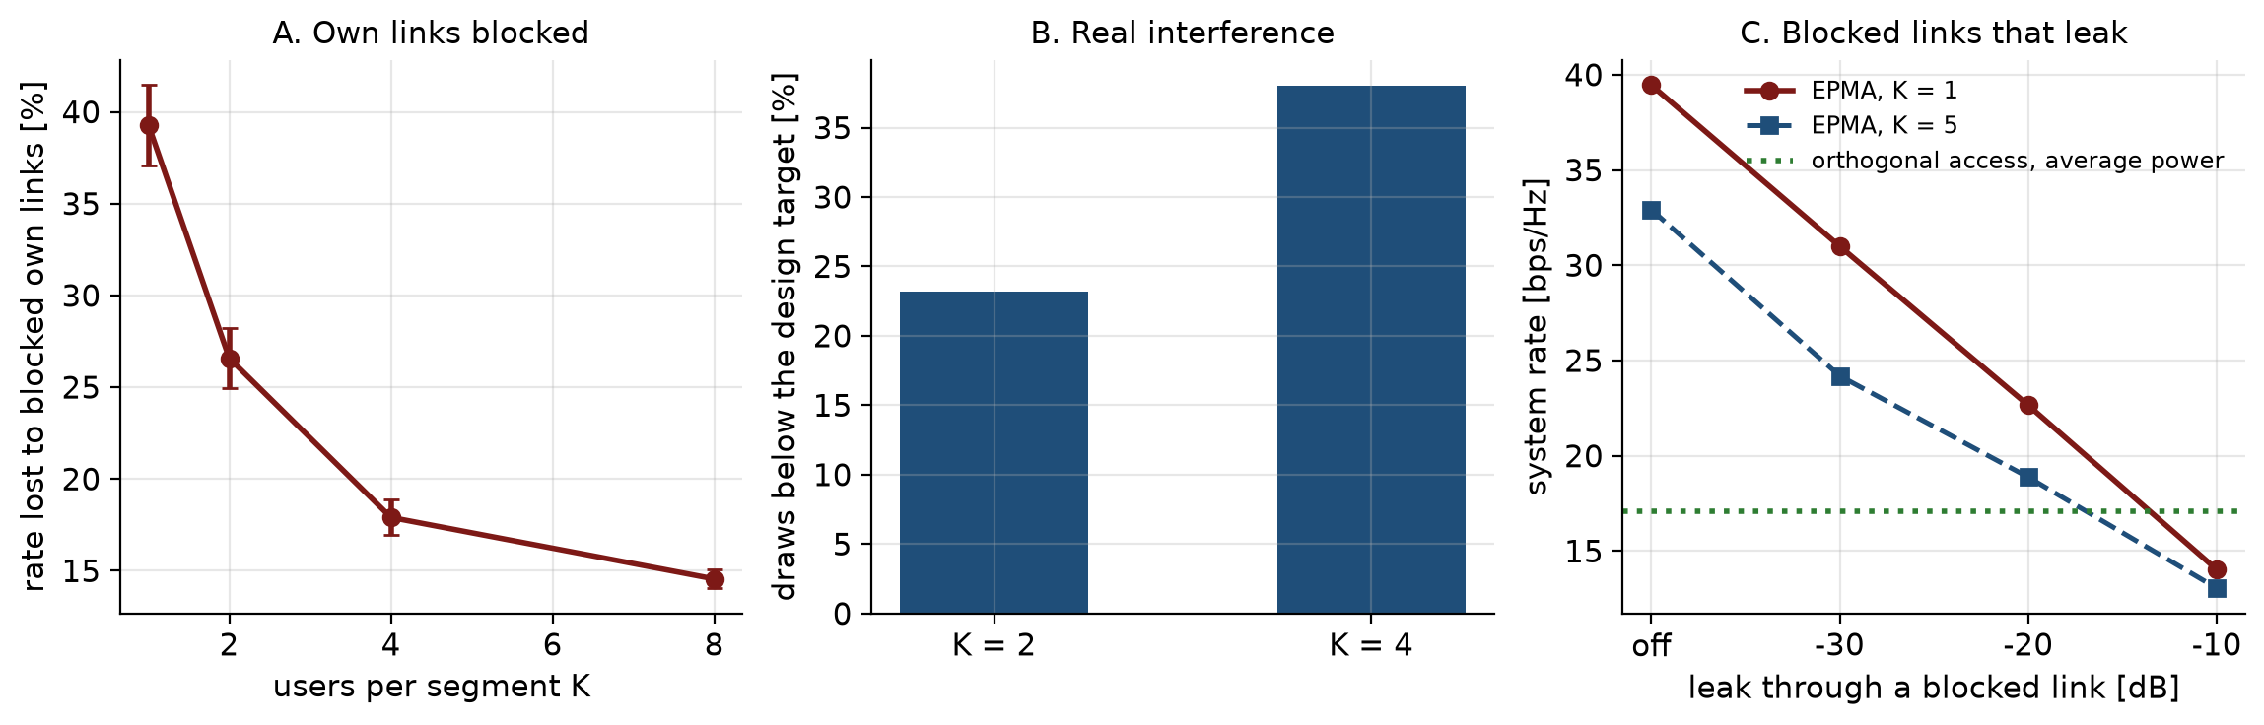
Figure 5. Left: rate lost to blocked own links. Middle: share of draws below the design target. Right: system rate when blocked links leak.
7. Comparison with Baselines
The table compares EPMA with system-wide orthogonal access at M = 3. The rates are system rates in bps/Hz. Version B (average power) is the strong case for orthogonal access.
K | EPMA | Orthogonal B | EPMA / B | Orthogonal A | Delay (slots) EPMA / orth.
1 | 39.46 | 17.07 | 2.31 | 15.48 | 1 / 3
4 | 34.85 | 19.07 | 1.83 | 15.48 | 1 / 12
8 | 27.98 | 20.07 | 1.39 | 15.48 | 1 / 24
16 | 20.38 | 21.07 | 0.97 | 15.48 | 1 / 48
32 | 16.06 | 22.07 | 0.73 | 15.48 | 1 / 96
64 | 15.09 | 23.07 | 0.65 | 15.48 | 1 / 192

EPMA leads at low load and falls behind after K = 16 against Version B. Against Version A it stays level until about K = 32. The lead at K = 1 mostly comes from a blockage windfall. If all interferers in both neighbouring segments are blocked at once, the antenna sees only noise and the rate is very high. This is rare for each user but common for the system when K is small. In my earlier research analysis the windfall-stripped rate at K = 1 is 14.21. I did not rerun that calculation for this milestone. It is below the orthogonal value 17.07. So the sum-rate lead is not a robust result.
The robust benefits are different. The access delay is one slot for EPMA and MK slots for orthogonal access, so K = 16 gives 48 times longer delay. All MK users are also served at the same time. And the max-min floor is flatter under disparity, as Section 6.1 shows.
8. Critical Analysis
8.1 What worked
- The moving floor changed the problem. It makes the sum-rate position problem single-peaked, which allows a simple and exact search.
- The certified search never loses more than the tolerance. Plain golden section can lose up to 7.4 percent on max-min fairness.
- The closed-form power recursion makes the inner problem fast and exact.
- The centre rule is a cheap and good rule at higher load. It loses less than 1 percent from K = 4.
- Max-min power control makes the floor almost independent of the position of the weak user.
8.2 What did not work or did not hold
- My early expectation that the sum-rate objective is multi-peaked was wrong once the floor moves.
- The sum-rate lead over orthogonal access is not robust. It is a windfall and low-load effect, and a small residual leak removes it.
- I could not claim a sum-rate gain at equal power. The MAC tie is exact.
- The naive alternating optimisation is unreliable from a single start.
8.3 Limits
- If own links were blocked as well, about 40 percent of them would be blocked. The line-of-sight own-link model overstates the rate by 14 to 39 percent depending on K.
- The certificate holds for the mean floor. In real draws the minimum rate misses the target in 23 to 38 percent of draws.
- SIC is ideal and decoding order is fixed. Real receivers have errors.
- Only uplink is studied. A downlink design does not separate by segment and is left for future work.
- All results are from simulation of my own model with ideal channel knowledge. There is no hardware test.
- The certified search costs about 11 to 14 times more evaluations than golden section. It scales with the Lipschitz constant and the segment length.
8.4 Explanations
The sum rate depends on the total received power over the floor. A single user's gain falls off as 1/r², so the sum of K such terms has one smooth peak when the floor is also smooth. The max-min value function is a minimum of rates. A minimum of smooth curves has kinks where two curves cross, and kinks can create several peaks. This is why the two problems behave differently.
9. Revised State-of-the-Art Positioning
The table places my work against the main related papers. It is based on the papers I read and cite.
Work | What it does | How EPMA differs
EDMA [1] | Blockage isolates regions. One user per region. Golden-section placement. | EPMA puts K users in each region, adds SIC power control and shows the placement search needs a global method for max-min.
SWAN [2] | Segmented waveguides with one active antenna per segment. No re-radiation between antennas. | EPMA uses this structure and adds blockage between segments as a second layer.
NOMA uplink PASS [4] | Sum rate maximisation for a single waveguide with NOMA. | EPMA is the M = 1 case. EPMA adds several segments and the blockage layer.
Multi-waveguide PASS [5] | Antenna activation and resource allocation over several waveguides. | EPMA uses one waveguide and segments, with analysis of leakage and rate.

A concurrent preprint on downlink EDMA with NOMA exists. I do not claim that nobody has combined EDMA and NOMA. My claim is narrower. I study the uplink. I show that the ratio of far to adjacent leakage is bounded by geometry for any K. I give and test a placement and power method for the shared segment. I also report what does not hold. The sum-rate lead is fragile, and the own-link line-of-sight assumption is costly.
10. Reproducibility
The Code folder holds the source, the tests and the scripts. The tests pass (188 passed). Each script writes a CSV file and a figure into the Results folder. Commands and run times are in the README of the Code folder. The random seed is fixed at 42, so the numbers can be reproduced.
11. Statements
Contribution. This is a solo project. I did the modelling, the code, the experiments and the writing.
Use of AI tools. I used an AI assistant (Claude) to help write and check code and to help edit this report. I reviewed the code and the text, ran the experiments myself and I am responsible for the content.
References
[1] Z. Ding, R. Schober and H. V. Poor, “Environment Division Multiple Access (EDMA): A Feasibility Study via Pinching Antennas,” IEEE Trans. Wireless Commun., vol. 25, pp. 15675–15691, 2026.
[2] C. Ouyang, H. Jiang, Z. Wang, Y. Liu and Z. Ding, “Uplink and Downlink Communications in Segmented Waveguide-Enabled Pinching-Antenna Systems (SWANs),” IEEE Trans. Commun., vol. 74, pp. 3688–3703, 2026.
[3] Y. Xu, Z. Ding, O. A. Dobre and T.-H. Chang, “Pinching-Antenna System Design With LoS Blockage: Does In-Waveguide Attenuation Matter?,” IEEE Trans. Wireless Commun., vol. 25, pp. 17322–17337, 2026.
[4] M. Zeng, J. Wang, X. Li, G. Wang, O. A. Dobre and Z. Ding, “Sum Rate Maximization for NOMA-Assisted Uplink Pinching-Antenna Systems,” IEEE Wireless Commun. Lett., vol. 15, pp. 280–284, 2026.
[5] K. Wang, Z. Ding and G. K. Karagiannidis, “Antenna Activation and Resource Allocation in Multi-Waveguide Pinching-Antenna Systems,” IEEE Trans. Wireless Commun., vol. 25, pp. 4070–4082, 2026.
[6] Z. Ding, R. Schober and H. V. Poor, “Flexible-Antenna Systems: A Pinching-Antenna Perspective,” IEEE Trans. Commun., vol. 73, no. 10, pp. 9236–9253, Oct. 2025.
[7] S. A. Piyavskii, “An algorithm for finding the absolute extremum of a function,” USSR Comput. Math. Math. Phys., vol. 12, no. 4, pp. 57–67, 1972.
[8] B. O. Shubert, “A sequential method seeking the global maximum of a function,” SIAM J. Numer. Anal., vol. 9, no. 3, pp. 379–388, 1972.

