Milestone 2 Report
Two-Layer Uplink Multiple Access in Segmented Pinching-Antenna Systems
ECE 310 Wireless Communications, Monsoon Semester 2026
Group: g10_research_pass_ind
Student: Het Patel (AU2440266)
Project category: Research Project
Date: 11 October 2026
1. Summary of M2 Progress
In M1 I defined the problem and picked EDMA as my baseline. In M2 I moved from reading to building. I fixed the system model and the metrics. I wrote the code and reproduced the baseline paper. Then I ran the first experiments on my own problem.
- I grouped the literature by how each work handles interference and wrote a gap statement (Sections 2 and 3).
- I wrote the problem formulation with the system model, assumptions, metrics and four research questions (Section 4).
- I defined the proposed two-layer system and the method I use to study it (Section 5).
- I reproduced Table I of the EDMA paper with my own code. The largest difference is 0.42 percent (Section 6).
- I ran three first experiments. They cover far-segment leakage, the exact rate of one loaded segment and a comparison with orthogonal access (Section 7).
Main finding so far. At millimetre-wave power, adding users to a segment does not raise the sum rate. The rate of one segment falls as users are added. The gain is that more users are served on the same hardware. The sum rate lead over system-wide time division is large at low load and disappears near K = 16. About 64 percent of the rate at K = 1 comes from lucky blockage events and not from loading. Section 7 explains this.
2. Literature Synthesis
I read the papers in the reference list and grouped them by one question. How does each work keep users from interfering with each other? There are three tools: time, power and geometry. Table 1 compares the main lines of work.
Table 1. How the main lines of work handle interference
Line of work | How it handles interference | What it assumes | What it cannot do for my problem | Refs
Orthogonal sharing (TDMA, FDMA) | Each user gets a private slot, so there is no interference | Users take turns or use separate bands | Capacity is capped by the number of slots. Delay grows with the number of users | [10]
Power-domain NOMA with SIC | Users overlap in power. The receiver removes them one by one | Ideal SIC. Users need pairing and power allocation | Interference grows with the number of users. The channel is treated as fixed | [10]
Pinching antennas on one waveguide | SIC and power control. The antenna position shapes the channel gains | One waveguide or a few. Lossless waveguide. Solved with SCA, alternating optimisation or PSO | No separation by geometry. Many users share one antenna | [3] to [9]
Environment as a resource (EDMA) | Blockage separates regions, so no joint processing is needed | One user and one antenna per region. LoS blockage law | Serves at most M users. Overloading a region is not studied | [1]
Segmented waveguide (SWAN) | One active antenna per segment avoids signal re-radiation | Per-segment feeds. Tractable uplink model | Several users per segment are left to orthogonal access | [2]

What most PASS papers share. They use the power domain. They place antennas and set powers with tools such as successive convex approximation, alternating optimisation and particle swarm search [3] to [6]. Interference between users is handled by SIC, so the channel itself is not used as a resource.
What EDMA changes. EDMA uses the environment. Blockage between regions keeps users apart without any signal processing [1]. This works because the LoS probability falls fast with distance at millimetre wave [12], [13]. EDMA assumes one user per region.
What SWAN adds. SWAN shows that one active antenna per segment avoids a signal re-radiating through the other antennas on the same waveguide [2]. This is why my model keeps one antenna per segment.
Assumptions that repeat. Most works assume ideal SIC, LoS dominance and a lossless waveguide. Loss inside the waveguide has a small effect when blockage is present [11]. I keep all three assumptions and state them in Section 4.
Concurrent work. A recent preprint combines EDMA and NOMA for the downlink with a heuristic method for user pairing and power allocation [14]. It reports simulation results. It treats the downlink. I did not find leakage bounds or closed-form rates for the overloaded uplink in it.
3. Technical Gap Statement
EDMA shows that blockage can separate regions when each region has one user [1]. This caps the number of served users at M. To serve more users the system needs more segments and more hardware. If each region carried K users, the same hardware could serve M times K users. Two things are not known.
- Does the isolation between regions still hold when every region carries K users?
- What does the extra load deliver once SIC separates the users inside a region?
Without answers to these two questions nobody can decide how many users a region should carry or how many segments to build.
4. Problem Formulation
4.1 System model
One waveguide runs along the x axis at height d. The service area under it is split into M regions. Each region is D_S long along the waveguide and D_W wide across it. Each region has one pinching antenna (PA) and K users. All users transmit at the same time on the same frequency. The base station receives each PA through its own RF chain. It separates the K users of a region with SIC. Figure 1 shows the layout.
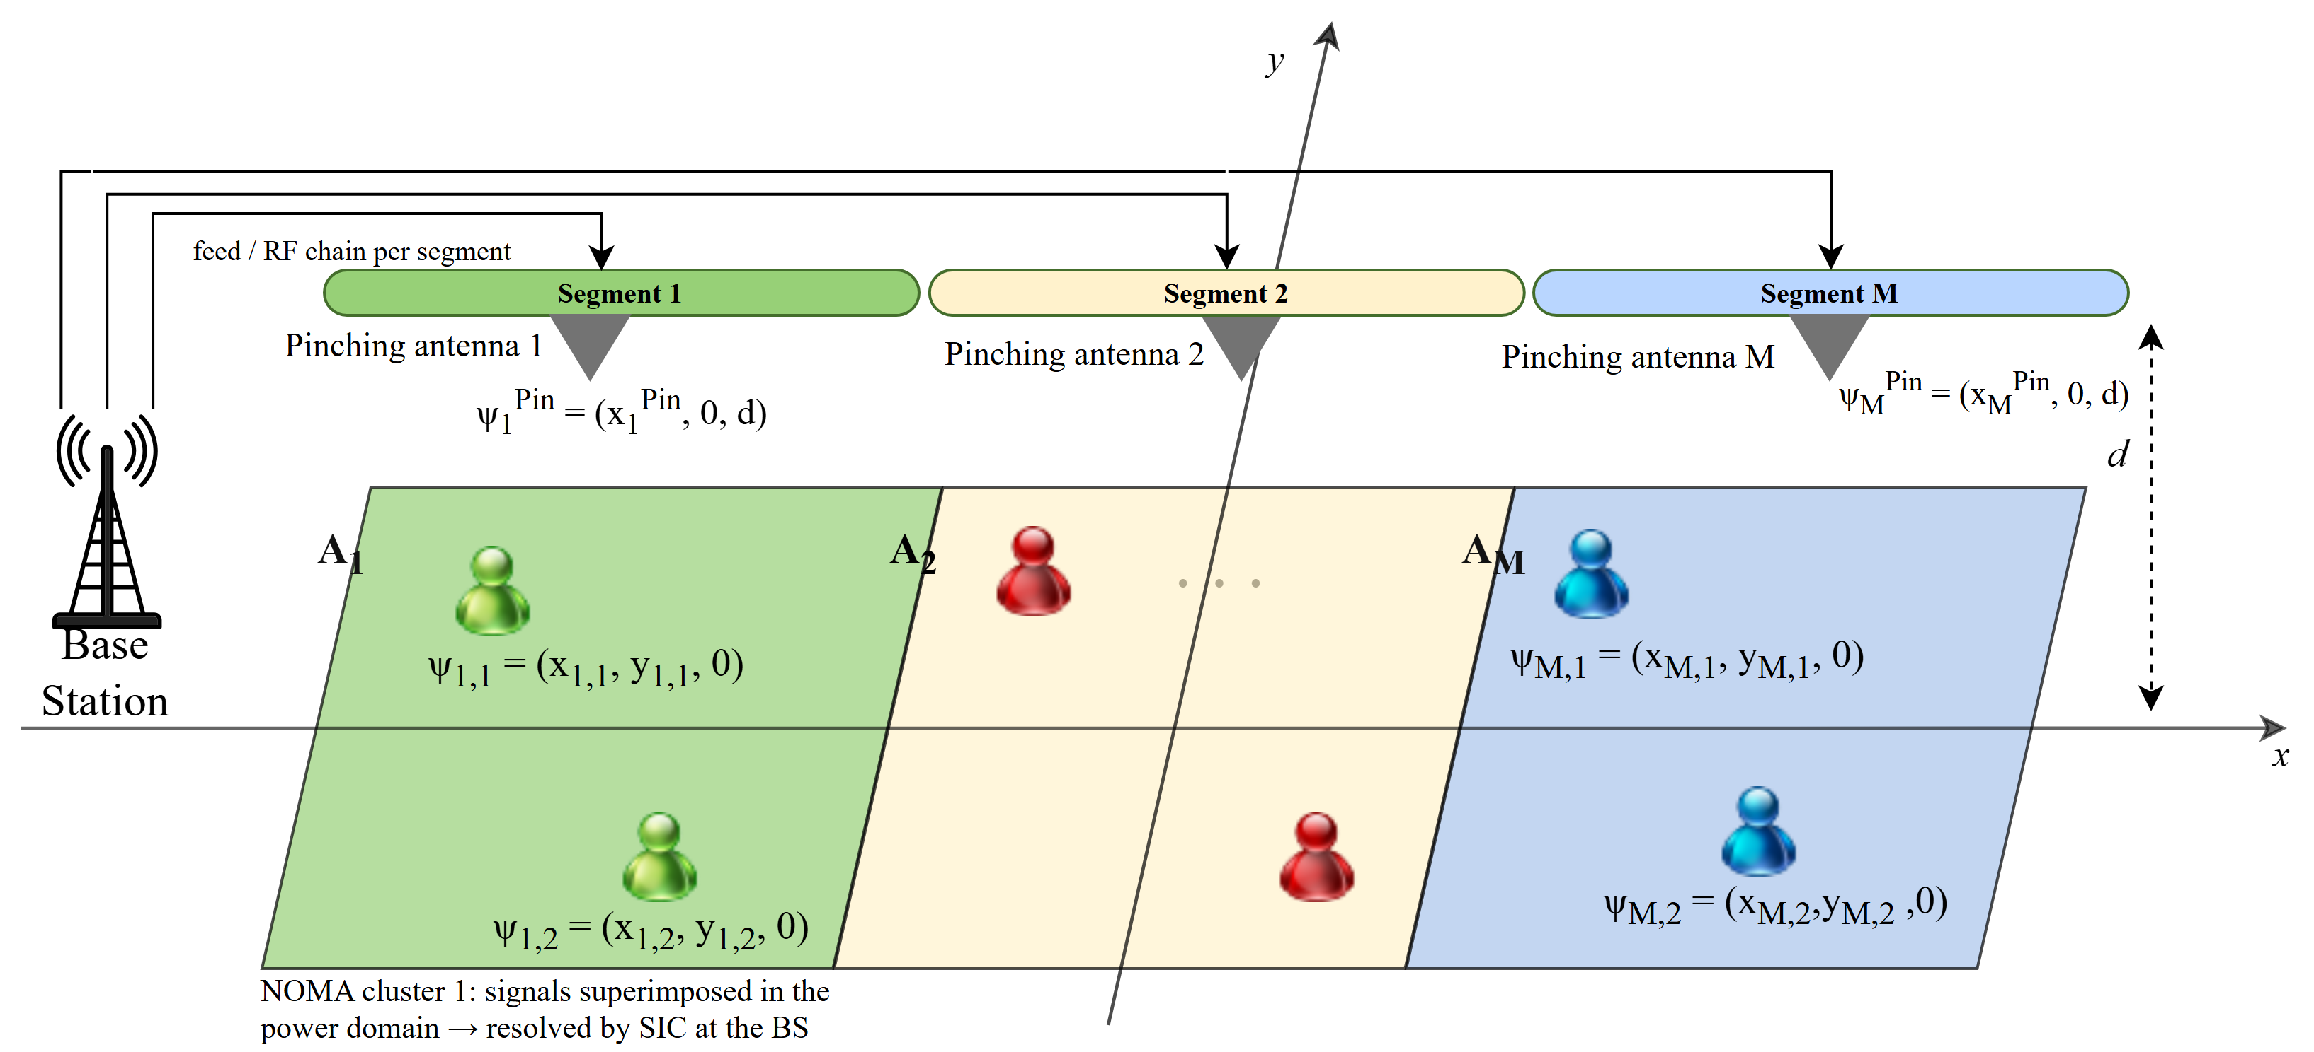
Figure 1. Uplink with one pinching antenna and K users per segment (here K = 2)
Table 2. Parameters used in all experiments
Parameter | Symbol | Value | Source
Carrier frequency | f_c | 28 GHz | EDMA paper [1]
Region width | D_W | 10 m | EDMA paper [1]
Waveguide height | d | 3 m | EDMA paper [1]
Service length | D_L | 40 m | EDMA paper [1]
Blockage parameter | phi | 0.02 per square metre | EDMA paper [1]
Transmit SNR | rho = P/N0 | 120 dB (P = 1 W, N0 = -90 dBm) | EDMA paper [1]
Number of segments | M | 3, so D_S = 13.33 m | My choice
Users per segment | K | 1 to 64 | My choice

4.2 Channel and signal model
A user at distance r from a PA has the free-space power gain below. Here u is the distance along the waveguide and y is the distance across it. The constant eta depends on the carrier frequency.
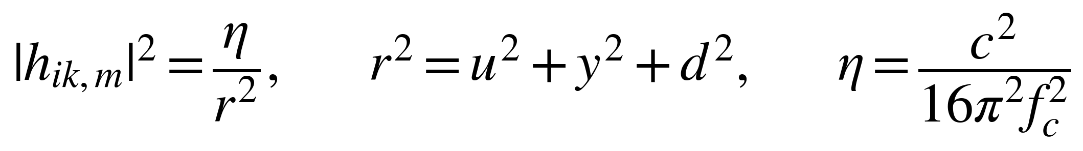
A link is in line of sight with the probability below. Links are blocked independently. The link from a user to the PA of its own region is treated as LoS.
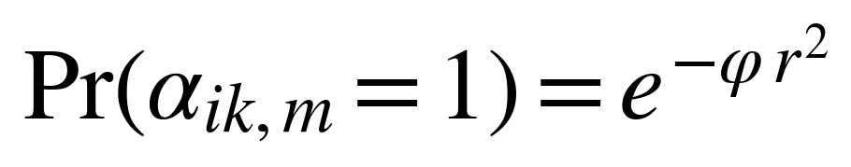
S_m is the power that PA m collects from its own K users. I_m is the leakage from users of other regions. The indicator alpha is 1 when a link is not blocked.
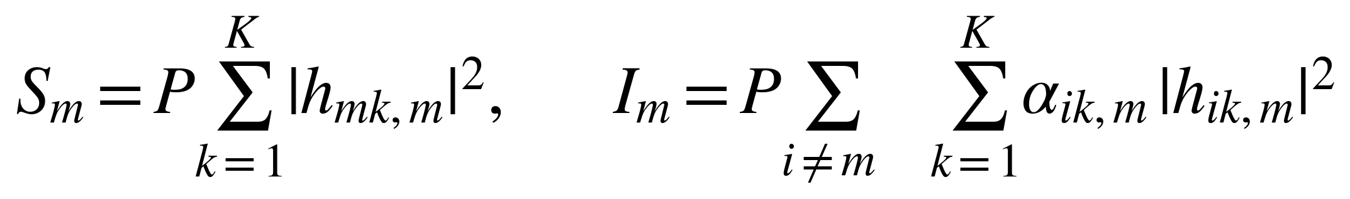
With ideal SIC, the K users of one region share a sum rate that depends on S_m and I_m only.
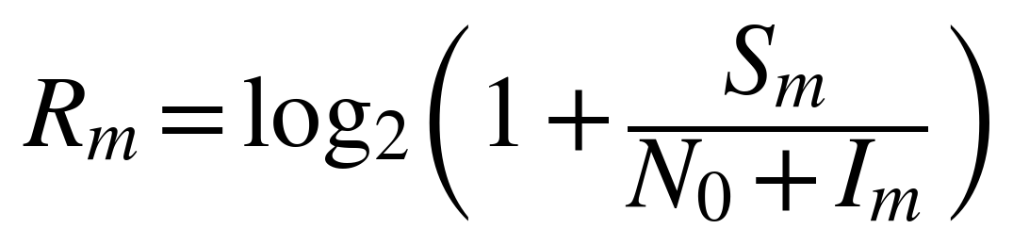
4.3 Assumptions
- Uplink only. Downlink is left for later work.
- One active PA per segment. This avoids signal re-radiation between PAs [2].
- SIC is ideal. This is the usual first-order model and it is optimistic.
- Links inside a region are LoS. This is generous because one antenna cannot guarantee LoS to K users spread over a region. I plan to measure its cost.
- The waveguide has no internal loss [11].
- Users are placed uniformly at random in their region. Antennas are isotropic and there is no small-scale fading.
4.4 Metrics
- Ergodic sum rate of one segment, written R_m, in bps per Hz.
- System sum rate, which is M times R_m.
- Crossover load K*, where the mean leakage equals the noise.
- Gain of loading, written Gamma(K), which is the SINR of K users divided by the SINR of one user.
- Users served at once (M times K) and access delay in slots.
4.5 Research questions
- RQ1. Does the far-segment leakage stay negligible when every region carries K users?
- RQ2. What is the exact ergodic rate of a loaded segment?
- RQ3. What does loading deliver compared with orthogonal access?
- RQ4. Which antenna positions and powers are best, and how fair is the result? This is planned for M3.
5. Proposed System and Methodology
5.1 The two-layer idea
I call the proposed scheme EPMA, for environment-power multiple access. It has two layers. The outer layer is the environment. Blockage keeps neighbouring regions from interfering, as in EDMA. The inner layer is the power domain. Users inside one region transmit together and SIC separates them. The two layers act on different sets of users. The environment handles users in other regions. SIC handles users in the same region.
The scheme reduces to known work in two cases. With K = 1 it is EDMA [1]. With M = 1 it is single-waveguide NOMA-PASS [3]. I use these two cases as consistency checks.
5.2 Method
- Leakage feasibility. Derive a bound on the far to adjacent leakage ratio and check it by Monte Carlo for several K.
- Exact ergodic rate. Derive the rate of a loaded segment as one integral over a Laplace variable and evaluate it by numerical quadrature.
- Monte Carlo cross-check. Simulate the same model directly and compare it with the integral.
- Baseline reproduction. Reproduce Table I of the EDMA paper before building on it.
- Comparison. Compare EPMA with orthogonal access in sum rate, served users and delay.
- Design (M3). Choose antenna positions and powers, and test fairness.
The first bound is below. Adding users multiplies the leakage of every segment by the same factor. The factor cancels in the ratio. So the ratio depends only on phi times D_S squared, and not on K.
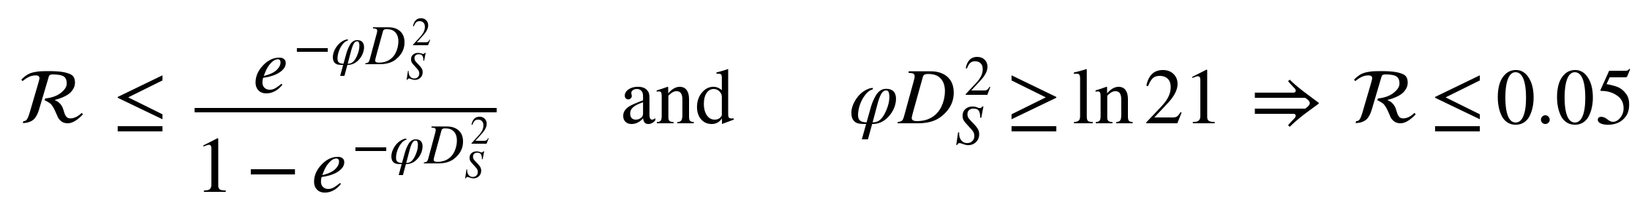
Next, K* is the load where the mean leakage equals the noise. Gamma(K) is the gain of loading. Here L is the mean leakage gain from one adjacent region and rho is the transmit SNR.
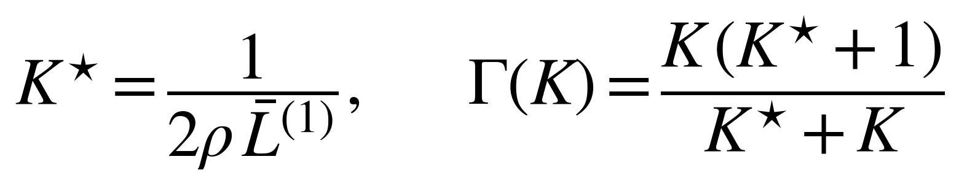
The ergodic rate of one segment is the integral below. The functions g(z) and h(z) are Laplace transforms of the power from one own user and from one adjacent user. The integrand has a removable singularity at z = 0, and I use its limit there. I extend the upper limit until the tail is below 1e-8.
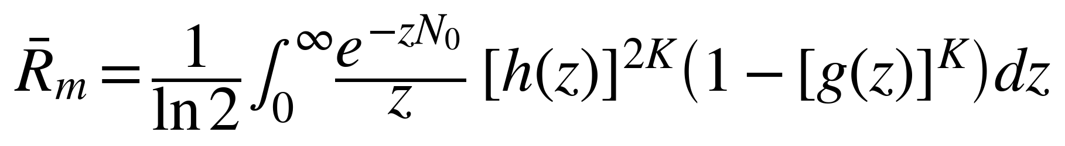
5.3 Implementation and reproducibility
The code is in Python with NumPy, SciPy and Matplotlib. All physical values are in one configuration file. Every Monte Carlo run uses a fixed seed. Seventy-two automated tests check the closed forms, the samplers and the baseline numbers. Four experiment scripts regenerate every table and figure in this report.
6. Baseline Reproduction
I reproduced Table I of the EDMA paper [1]. It gives the system sum rate for one user per segment and M = 3, 5, 7, 9 and 11. Table 3 lists what I reproduced and how.
Table 3. Reproduction record
Item | Record
Baseline | Table I of EDMA [1], one user per segment (K = 1)
Parameters | As in Table 2, with D_L = 40 m and M = 3, 5, 7, 9, 11
Assumptions | One PA per region. Links inside a region are LoS. All other links follow the blockage law. Full interference from every other region
Channel model | Gain eta / r squared. LoS probability exp(-phi r squared)
Algorithm | EDMA scheme: Monte Carlo of the sum rate with the antenna at the x position of the user. TDMA: closed-form integrals for two antenna placements (antenna follows the user, antenna at the region centre)
Simulation setup | 150000 trials per M and a fixed seed for the Monte Carlo. Deterministic quadrature for TDMA
Expected result | The published numbers in Table 4
Obtained result | Table 4. The largest difference is 0.42 percent
Discrepancies | The EDMA scheme differs by at most 0.22 percent. At M = 3 the gap is about four standard errors of my run, so my sampling noise alone does not explain it. The paper does not give its trial count, so its own sampling error is unknown. The centre TDMA values differ by up to 0.42 percent, for example 2.58 against 2.57 at M = 7. The paper rounds to two decimals and does not state its integration settings. I could not check which of the two causes the gap

Table 4. EDMA Table I against my reproduction (system sum rate in bps per Hz, K = 1)
M | EDMA scheme (paper) | EDMA scheme (mine) | Difference | P-TDMA (paper) | P-TDMA (mine) | C-TDMA (paper) | C-TDMA (mine)
3 | 41.07 | 41.15 | 0.19 % | 5.69 | 5.69 | 5.41 | 5.41
5 | 51.80 | 51.80 | 0.00 % | 3.56 | 3.56 | 3.48 | 3.48
7 | 50.28 | 50.27 | 0.02 % | 2.61 | 2.61 | 2.57 | 2.58
9 | 43.91 | 44.01 | 0.22 % | 2.07 | 2.07 | 2.05 | 2.06
11 | 37.15 | 37.07 | 0.21 % | 1.72 | 1.72 | 1.72 | 1.71

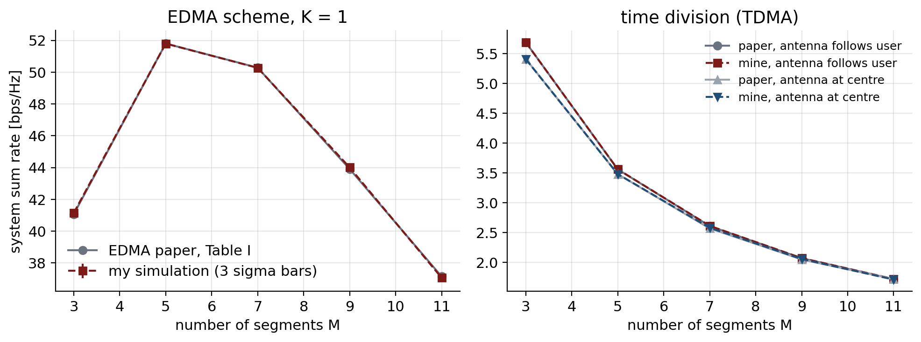
Figure 2. Published numbers and my reproduction. The curves overlap for all M
The reproduction agrees with the paper in the size of the rates and in the shape. The rate peaks at M = 5 in both. I treat this as a pass and I build on the same code.
7. Initial Results
7.1 Far segments stay negligible for every K (RQ1)
I simulated the true far to adjacent leakage ratio for K = 1, 5, 20 and 50 and compared it with the bound of Section 5.2. Figure 3 shows the result.
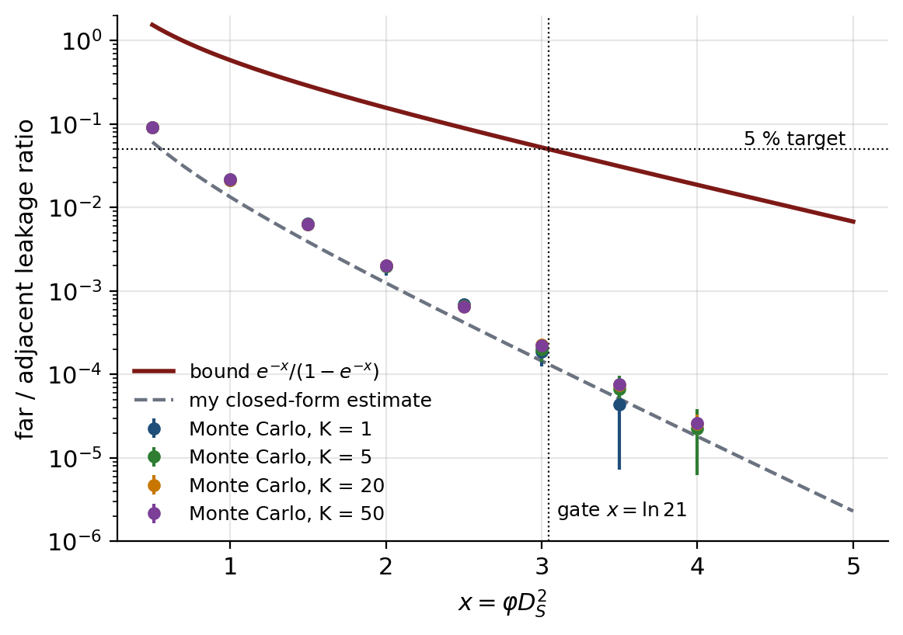
Figure 3. Far to adjacent leakage ratio against phi times D_S squared. Markers are Monte Carlo. Only points above three standard errors are drawn
- The ratio is almost the same for K = 1, 5, 20 and 50. At phi times D_S squared = 1 it lies between 0.021 and 0.022. At 2 it lies between 1.96e-03 and 2.02e-03.
- Every simulated point is below the bound. The largest simulated ratio is 0.059 times its bound.
- At phi times D_S squared = 3 the simulated ratio is between 1.9e-04 and 2.3e-04. The bound there is 0.052. So the true ratio is more than 231 times below the bound.
At my operating point (M = 3, phi times D_S squared = 3.56) the bound is 0.029. So ignoring non-adjacent regions is safe for every load I tested.
7.2 The exact rate matches simulation (RQ2)
I evaluated the integral of Section 5.2 for K = 1, 2, 5, 10, 20 and 50 and simulated the same model with 50000 trials per K. Table 5 compares the two.
Table 5. Ergodic rate of one segment at 120 dB (bps per Hz)
K | Integral | Monte Carlo (mean +/- standard error) | z score | Rate divided by rate at K = 1
1 | 13.155 | 13.138 +/- 0.013 | -1.24 | 1.000
2 | 12.875 | 12.869 +/- 0.022 | -0.26 | 0.979
5 | 10.976 | 10.965 +/- 0.029 | -0.36 | 0.834
10 | 8.471 | 8.433 +/- 0.021 | -1.75 | 0.644
20 | 6.166 | 6.172 +/- 0.022 | +0.28 | 0.469
50 | 5.084 | 5.082 +/- 0.004 | -0.39 | 0.386

The largest z score is 1.75. So the integral and the simulation agree within their sampling error for all six loads. Figure 4 shows the rate against K.
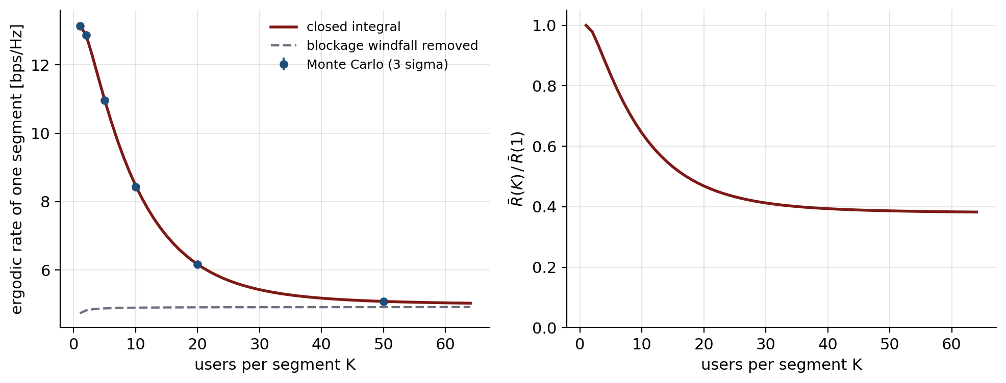
Figure 4. Rate of one segment against the number of users per segment
The rate of one segment falls from 13.15 bps per Hz at K = 1 to 6.17 at K = 20. That is 47 percent of the rate at K = 1. The dashed curve removes the blockage windfall. This is the rate if the leakage always sits at its mean. It is almost flat in K.
7.3 What loading delivers (RQ3)
Crossover load. K* is 1.00e-3 at 120 dB. It grows by a factor of ten for every 10 dB less SNR (Table 6). Even one user per segment is far above K*. So every region is limited by interference at every integer load.
Table 6. Crossover load K* at M = 3
Transmit SNR | Crossover load K*
80 dB | 1.00e+1
100 dB | 1.00e-1
110 dB | 1.00e-2
120 dB | 1.00e-3

Gain of loading. Gamma(K) stays between 1.000 and 1.001 for K up to 64 at 120 dB. So adding users does not raise the SINR of a region. It only splits the same SINR among more users.
Comparison with orthogonal access. I compared the system sum rate of EPMA with system-wide time division, where all M times K users take turns. I used both power models of the EDMA paper. Table 7 and Figure 5 show the result at 120 dB.
Table 7. System sum rate at 120 dB and M = 3 (bps per Hz)
K | Users served | EPMA | EPMA without windfall | Orthogonal, average power | Orthogonal, peak power | EPMA divided by orthogonal (avg) | Gamma(K)
1 | 3 | 39.46 | 14.21 | 17.07 | 15.48 | 2.31 | 1.0000
2 | 6 | 38.62 | 14.46 | 18.07 | 15.48 | 2.14 | 1.0005
5 | 15 | 32.93 | 14.64 | 19.39 | 15.48 | 1.70 | 1.0008
10 | 30 | 25.41 | 14.70 | 20.39 | 15.48 | 1.25 | 1.0009
16 | 48 | 20.38 | 14.73 | 21.07 | 15.48 | 0.97 | 1.0009
20 | 60 | 18.50 | 14.73 | 21.39 | 15.48 | 0.86 | 1.0010
32 | 96 | 16.06 | 14.74 | 22.07 | 15.48 | 0.73 | 1.0010
64 | 192 | 15.09 | 14.75 | 23.07 | 15.48 | 0.65 | 1.0010

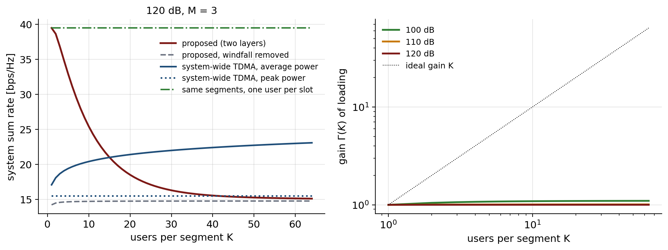
Figure 5. Left: system sum rate against K at 120 dB. Right: gain of loading at three SNR values
- At K = 1, EPMA reaches 39.46 bps per Hz. System-wide time division reaches 17.07. That is 2.31 times more.
- The lead shrinks as K grows. At K = 10 it is 1.25 times. At K = 16 it is 0.97 times. At K = 64 it is 0.65 times.
- EPMA falls below the average-power orthogonal benchmark from K = 16 at 120 dB, from K = 19 at 110 dB and from K = 36 at 100 dB.
- The lead at low load is mostly a blockage windfall. When all interfering links are blocked at once, the rate jumps to its noise-limited value. With this windfall removed, EPMA gives 14.21 bps per Hz at K = 1. That is 64 percent less than the full rate.
- What loading does buy is population and delay. At K = 64 the same three segments serve 192 users instead of 3. All of them are served in one slot. System-wide time division needs 192 slots.
I take three conclusions from this. First, loading does not raise the sum rate at millimetre-wave SNR. Second, the sum rate lead over orthogonal access at low load should not be sold as a gain from loading. Third, the case for EPMA rests on served users, delay and, as I will test in M3, fairness.
7.4 Why I trust these results
- The EDMA baseline is reproduced within 0.42 percent.
- The integral and the simulation agree for six loads (largest z score 1.75).
- The leakage ratio shows no effect of K beyond sampling noise. The largest difference between two loads at the same point is 2.7 combined standard errors, out of about 40 such pairs.
- Seventy-two automated tests pass on the code used here.
These results rest on ideal SIC and on LoS links inside a region. If either assumption is relaxed the sum rates will drop. I will measure this in M3.
8. SOTA Positioning
Table 8 places my work next to the closest existing approaches.
Table 8. Closest existing work and my position
Work | Setting | Interference handled by | Several users per region? | Rate analysis
EDMA [1] | Uplink and downlink | Blockage between regions | No, one user per region | Closed-form gain over TDMA
SWAN [2] | Uplink and downlink | One active antenna per segment | No, orthogonal access for several users | Tractable uplink model
NOMA-PASS uplink [3] | Uplink, one waveguide | SIC and power control | Yes, but no segments | Optimisation algorithms
Multi-waveguide activation [4] | NOMA, several waveguides | SIC and antenna activation | Yes, no blockage isolation | Optimisation algorithms
QoS-aware NOMA [5] | Downlink | SIC with QoS constraints | Yes, no environment layer | Optimisation algorithms
NOMA or OMA [6] | Two users, one waveguide | SIC compared with TDMA and FDMA | Two users only | Optimisation, compared by simulation
EDMA with NOMA [14] | Downlink | Blockage map and SIC | Yes | Heuristic, simulation
This work (EPMA) | Uplink | Blockage between regions and SIC inside regions | Yes, K per region | Closed integral checked by Monte Carlo

Where my work stands. The closest strong work is EDMA [1]. It is my baseline and I reproduced its numbers. I keep its environment layer and ask whether it survives overloading. SWAN [2] gives my one-antenna-per-segment model. NOMA-PASS uplink [3] gives the power layer. My contribution so far is the analysis that joins them. It covers the leakage bound for every K, the exact rate, the crossover load and the honest comparison with orthogonal access.
What I do not claim. I do not claim that EPMA raises the sum rate. My results show that it does not at millimetre-wave SNR. I also do not claim that no other group has looked at EDMA with NOMA. The preprint [14] has.
9. Limits and Next Steps
- The results use ideal SIC. Real receivers will lose some rate.
- Links inside a region are LoS. A blocked own link would lower the rate.
- The numbers are for one geometry (M = 3, 28 GHz). I have not yet shown how they change with the geometry.
- Fairness between users of one region is not tested yet.
Table 9. Plan after M2
Stage | Planned work
M2 (this report) | Model, baseline reproduction, leakage bound, exact rate, first comparison with orthogonal access
M3 (weeks 7 to 10) | Antenna placement and power allocation. Fairness between the users of a region. Cost of blocked own links and weak non-LoS paths. Effect of the number of segments
Final (weeks 11 to 12) | Final report, repository clean-up, final presentation with working code

10. Repository and How to Reproduce
Everything for this milestone is in the folder M2_g10_research_pass_ind. The folder has README.md, Report, Video, Code, Data and Results. The Code folder has src, experiments, tests, config and requirements.txt. To reproduce the results, install the requirements and run the four scripts in Code/experiments. Each script writes its tables and figures to the Results folder. Code/README.md lists the commands.
11. Individual Contribution and Use of AI Tools
This is a one-person project. The literature reading, the model, the code, the experiments and this report are mine. I used generative AI tools as assistants for code help, debugging and wording. I checked every number in this report against the program output, and I can explain each part of the work.
References
[1] Z. Ding, R. Schober, and H. V. Poor, "Environment division multiple access (EDMA): A feasibility study via pinching antennas," IEEE Trans. Wireless Commun., vol. 25, pp. 15675-15691, 2026.
[2] C. Ouyang, H. Jiang, Z. Wang, Y. Liu, and Z. Ding, "Uplink and downlink communications in segmented waveguide-enabled pinching-antenna systems (SWANs)," IEEE Trans. Commun., vol. 74, pp. 3688-3703, 2026.
[3] M. Zeng, J. Wang, X. Li, G. Wang, O. A. Dobre, and Z. Ding, "Sum rate maximization for NOMA-assisted uplink pinching-antenna systems," IEEE Wireless Commun. Lett., vol. 15, pp. 280-284, 2026.
[4] K. Wang, Z. Ding, and G. K. Karagiannidis, "Antenna activation and resource allocation in multi-waveguide pinching-antenna systems," IEEE Trans. Wireless Commun., vol. 25, pp. 4070-4082, 2026.
[5] Y. Xu, Z. Ding, D. Cai, and V. W. S. Wong, "QoS-aware NOMA design for downlink pinching-antenna systems," IEEE Trans. Commun., vol. 73, no. 12, pp. 13611-13625, Dec. 2025.
[6] Q. Ren, X. Mu, S. Lin, and Y. Liu, "Pinching-antenna systems (PASS) meet multiple access: NOMA or OMA?" IEEE Trans. Veh. Technol., 2026, doi: 10.1109/TVT.2026.3683670.
[7] Z. Ding, R. Schober, and H. V. Poor, "Flexible-antenna systems: A pinching-antenna perspective," IEEE Trans. Commun., vol. 73, no. 10, pp. 9236-9253, Oct. 2025.
[8] Y. Xu et al., "Generalized pinching-antenna systems: A tutorial on principles, design strategies, and future directions," IEEE Commun. Surveys Tuts., vol. 28, pp. 5872-5908, 2026.
[9] A. Fukuda, H. Yamamoto, H. Okazaki, Y. Suzuki, and K. Kawai, "Pinching antenna: Using a dielectric waveguide as an antenna," NTT DOCOMO Tech. J., vol. 23, no. 3, pp. 5-12, Jan. 2022.
[10] Z. Ding, X. Lei, G. K. Karagiannidis, R. Schober, J. Yuan, and V. K. Bhargava, "A survey on non-orthogonal multiple access for 5G networks: Research challenges and future trends," IEEE J. Sel. Areas Commun., vol. 35, no. 10, pp. 2181-2195, Oct. 2017.
[11] Y. Xu, Z. Ding, O. A. Dobre, and T.-H. Chang, "Pinching-antenna system design with LoS blockage: Does in-waveguide attenuation matter?" IEEE Trans. Wireless Commun., vol. 25, pp. 17322-17337, 2026.
[12] 3GPP, "Study on channel model for frequencies from 0.5 to 100 GHz (Release 18)," Tech. Rep. 38.901, Dec. 2024.
[13] T. S. Rappaport, E. Ben-Dor, J. N. Murdock, and Y. Qiao, "38 GHz and 60 GHz angle-dependent propagation for cellular and peer-to-peer wireless communications," in Proc. IEEE Int. Conf. Commun., Jun. 2012.
[14] Y. Luo, "Environment-aware resource allocation for pinching-antenna-assisted EDMA-NOMA systems," arXiv:2606.18899, Jun. 2026 (preprint).

