Mutual Fund Analytics
Bluestock Fintech Capstone Project

Final Report
Prepared by: Het Patel
Technology Stack: Python, Pandas, SQL, SQLite, Power BI, Plotly, Seaborn

Index:
- Executive Summary
- Data Sources
- ETL and Data Model Design
- Exploratory Data Analysis: Industry Trend
- Exploratory Data Analysis: SIP and Category Inflows
- Investor Analytics Findings
- Fund Performance Dashboard
- Performance Analytics
- Apha, Beta and Drawdown Analysis
- Advanced Risk Analytics: VaR and CvaR
- Advanced Analytics: SIP Continuity and Investor Cohorts
- Portfolio Concentration and Sector Exposure
- Dashboard Design and Interactivity
- Key Findings
- Limitations
- Recommendations
This report summarizes the complete mutual fund analytics capstone: data ingestion, ETL, exploratory analysis, fund performance analytics, advanced risk metrics, dashboard development, limitations and recommendations.

1. Executive Summary
This capstone project builds a complete mutual fund analytics solution using cleaned mutual fund, NAV, AUM, SIP, investor transaction, holdings and benchmark datasets. The final system combines Python-based ETL, SQLite-style analytical modeling, advanced performance calculations and an interactive Power BI dashboard.
- The dataset covers 40 mutual fund schemes across 10 fund houses and 12 fund sub-categories.
- Latest available AUM snapshot in the dataset is 62.74 lakh crore as of 2025-12-31, led by SBI Mutual Fund at 12.50 lakh crore.
- Monthly SIP inflow peaks at Rs 31,002 crore in Dec 2025, with 9.35 crore active SIP accounts.
- Total folios increase to 26.12 crore by Dec 2025.
- The scorecard ranks Mirae Asset Large Cap Fund - Regular - Growth as the top fund with a composite score of 86.25.
The project shows how raw market and investor datasets can be converted into a decision-support platform for fund selection, risk analysis, investor behavior monitoring and executive reporting.

2. Data Sources
The project uses ten cleaned datasets plus derived analytical reports. Each dataset supports a specific part of the analytical workflow.
Dataset | Business Purpose | Size
01_fund_master_cleaned.csv | Fund scheme master data | 40 rows, 15 columns
02_nav_history_cleaned.csv | Daily scheme-level NAV history | 46,000 rows
03_aum_by_fund_house_cleaned.csv | AMC-level AUM by date | 90 rows
04_monthly_sip_inflows_cleaned.csv | Monthly SIP inflow and SIP account indicators | 48 rows
05_category_inflows_cleaned.csv | Category-wise net inflows by month | 144 rows
06_industry_folio_count_cleaned.csv | Industry folio growth over time | 21 rows
07_scheme_performance_cleaned.csv | Scheme-level returns, risk and ratings | 40 rows
08_investor_transactions_cleaned.csv | Investor transaction-level data | 32,778 rows
09_portfolio_holdings_cleaned.csv | Scheme holdings and sector weights | 322 rows
10_benchmark_indices_cleaned.csv | Benchmark index values | 8,050 rows

These files were used as the authoritative source for report metrics. The dashboard screenshots included later were generated from the same processed data folder.

3. ETL and Data Model Design
The ETL design follows a standard analytical pipeline: raw data ingestion, validation, cleaning, processed CSV output, database loading and dashboard consumption.
- Ingestion: all raw CSV files were loaded using Pandas and inspected using shape, dtypes and head checks.
- Cleaning: dates were parsed, duplicate rows were removed, numeric fields were validated and categorical values were standardized.
- NAV processing: NAV history was sorted by AMFI code and date; missing NAV values were forward-filled where appropriate; invalid NAV values were removed.
- Transaction processing: transaction types were standardized into SIP, Lumpsum and Redemption; amount and KYC status validations were applied.
- Performance processing: return values, expense ratios and risk metrics were validated before scorecard calculations.
- Data model: fund master acts as the main dimension, while NAV, transactions, performance, holdings and AUM act as fact-style analytical tables.
Architecture: CSV files -> Python ETL scripts -> processed CSVs -> SQLite/Power BI model -> EDA notebooks -> risk analytics -> final dashboard and report.

4. Exploratory Data Analysis - Industry Trends
EDA focused on NAV movements, AUM concentration, SIP growth, category inflows, investor demographics, folio growth and sector allocation.
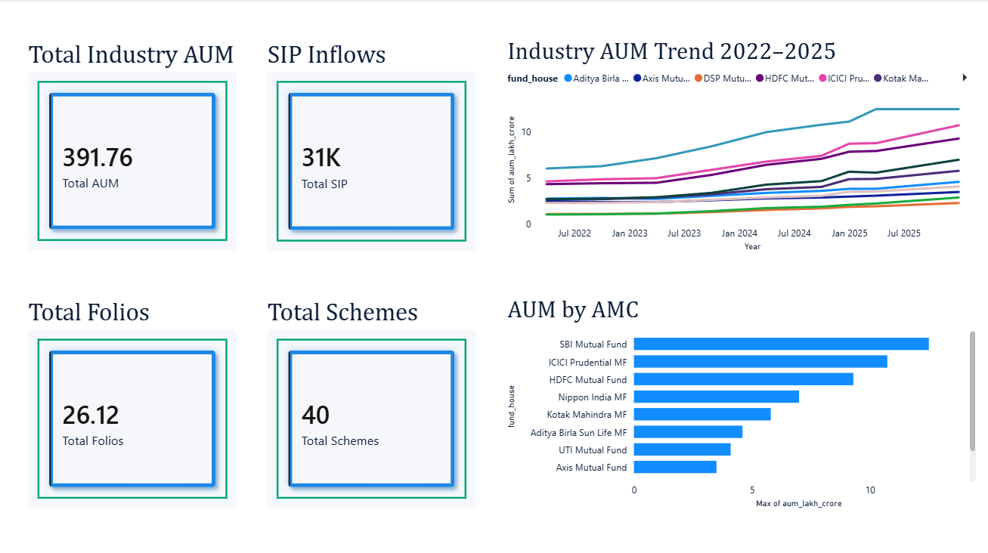
Figure 1: Power BI Page 1 - Industry Overview
The dashboard shows AUM growth by AMC, fund-house level AUM trends and KPI cards for AUM, SIP inflows, folios and schemes. Latest snapshot analysis shows SBI Mutual Fund as the leading AMC at 12.50 lakh crore, followed by ICICI Prudential MF and HDFC Mutual Fund.
Note: the displayed Total Industry AUM card in the screenshot aggregates AUM across all dates. For latest point-in-time reporting, the recommended measure should filter to the latest available date.

5. Exploratory Data Analysis - SIP and Category Inflows
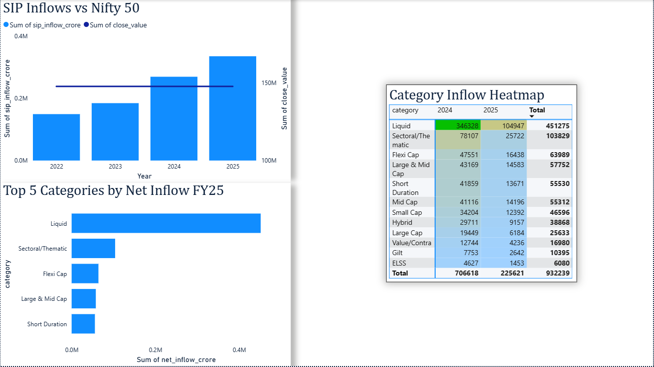
Figure 2: Power BI Page 4 - SIP and Market Trends
SIP inflows show a steady upward trend from 2022 to 2025 and reach Rs 31,002 crore in December 2025. The category inflow heatmap shows Liquid funds as the largest contributor, with total net inflows of Rs 451,275 crore in the category inflow dataset.
Top Categories by Net Inflow
category | Total Net Inflow Crore
Liquid | 451,275.00
Sectoral/Thematic | 103,829.00
Flexi Cap | 63,989.00
Large & Mid Cap | 57,752.00
Short Duration | 55,530.00

6. Investor Analytics Findings
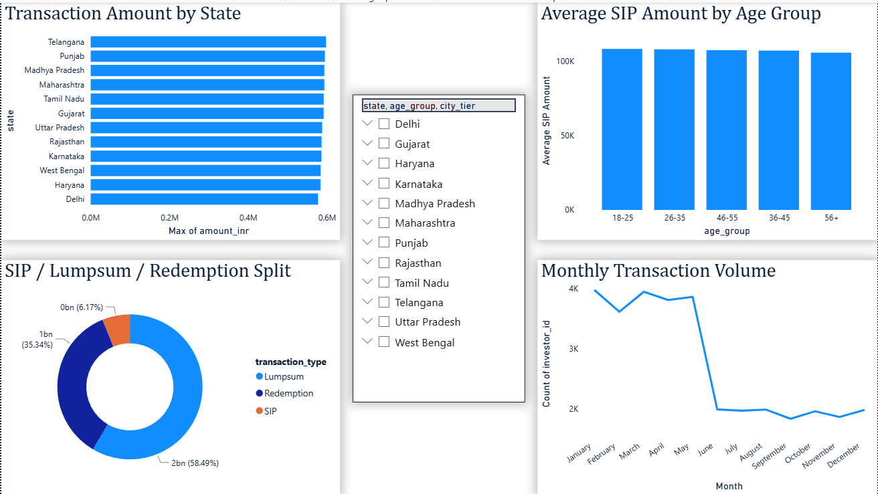
Figure 3: Power BI Page 3 - Investor Analytics
The investor transaction dataset contains 32,778 transactions across 12 states. Total transaction amount is Rs 352.16 crore. Lumpsum transactions dominate by value, followed by Redemptions and SIP transactions.
Transaction Value Split
Transaction Type | Amount INR
Lumpsum | 2059821448
Redemption | 1244525491
SIP | 217233491

For SIP investors, the highest average SIP amount is observed in the 56+ age group at approximately Rs 11,575. The top SIP state by amount is Madhya Pradesh with Rs 2.07 crore.

7. Fund Performance Dashboard
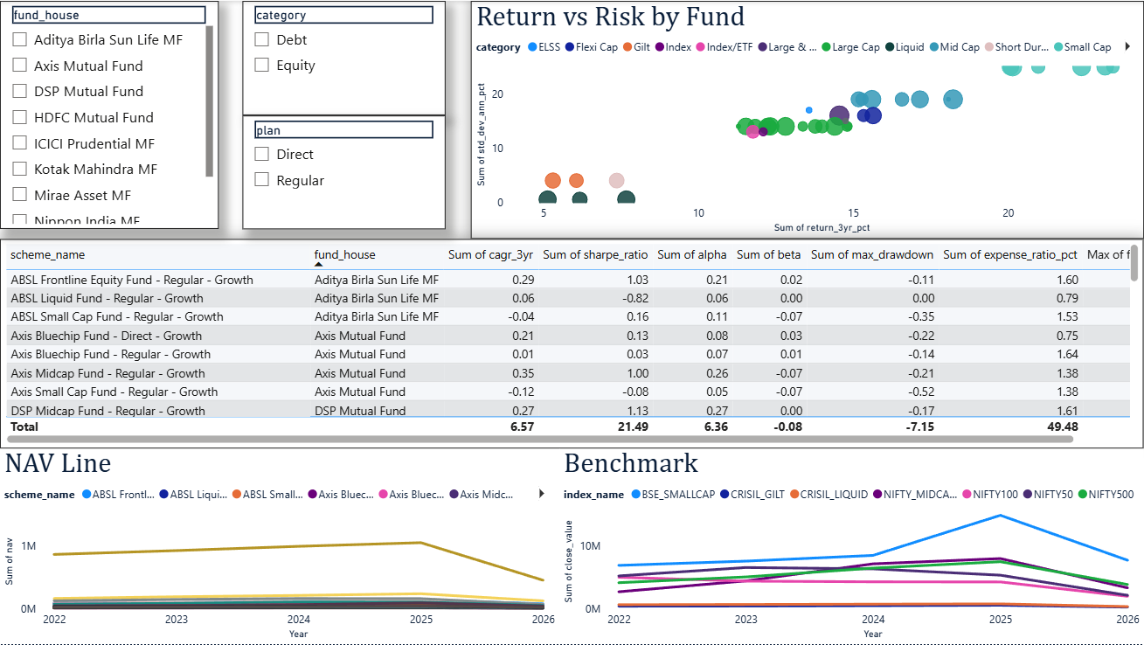
Figure 4: Power BI Page 2 - Fund Performance
The performance dashboard combines risk-return scatter plots, slicers, a fund scorecard table, NAV trend lines and benchmark comparison. This enables fund selection from both return and risk perspectives.
- Scatter plot: compares 3-year return versus annualized standard deviation.
- Scorecard table: ranks funds using return, Sharpe ratio, alpha, expense ratio and drawdown.
- NAV line: tracks scheme movement over time.
- Benchmark line: compares scheme movement with major indices.

8. Performance Analytics
Daily returns were calculated from NAV history using NAV_t / NAV_t-1 - 1. These returns were used for CAGR, Sharpe ratio, Sortino ratio, alpha, beta and drawdown calculations.
Top Funds by Composite Score
scheme_name | fund_house | cagr_3yr | sharpe_ratio | alpha | beta | max_drawdown | fund_score
Mirae Asset Large Cap Fund - Regular - Growth | Mirae Asset MF | 34.00% | 1.45 | 26.98% | 0.02 | -11.27% | 86.25
ICICI Pru Midcap Fund - Regular - Growth | ICICI Prudential MF | 31.78% | 1.18 | 29.26% | 0.00 | -18.19% | 82.25
Kotak Flexicap Fund - Regular - Growth | Kotak Mahindra MF | 29.58% | 1.31 | 27.33% | -0.02 | -12.97% | 82.00
HDFC Mid-Cap Opportunities Fund - Regular - Growth | HDFC Mutual Fund | 32.44% | 1.09 | 27.20% | 0.01 | -16.22% | 80.75
ICICI Pru Bluechip Fund - Direct - Growth | ICICI Prudential MF | 32.49% | 1.03 | 21.19% | 0.02 | -12.59% | 80.00
Axis Midcap Fund - Regular - Growth | Axis Mutual Fund | 35.11% | 1.00 | 26.08% | -0.07 | -20.96% | 77.00
SBI Bluechip Fund - Regular Plan - Growth | SBI Mutual Fund | 30.46% | 1.21 | 23.20% | -0.03 | -15.01% | 74.81
Mirae Asset Tax Saver Fund - Regular - Growth | Mirae Asset MF | 29.18% | 1.23 | 28.27% | 0.02 | -16.40% | 73.69

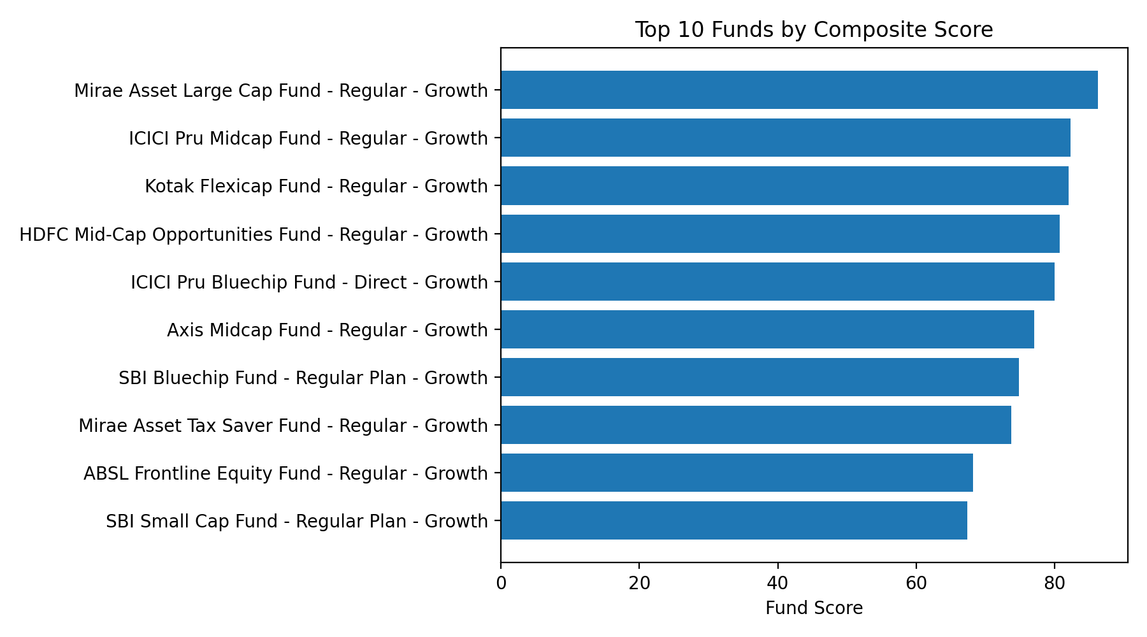
Figure 5: Top 10 funds by composite score

9. Alpha, Beta and Drawdown Analysis
Alpha and beta were estimated using OLS regression of fund daily returns against Nifty 100 daily returns. Alpha was annualized by multiplying the regression intercept by 252. Maximum drawdown was calculated as NAV divided by running maximum minus 1.
Top Funds by Alpha
scheme_name | fund_house | alpha | beta
SBI Small Cap Fund - Regular Plan - Growth | SBI Mutual Fund | 30.34% | -0.02
DSP Small Cap Fund - Regular - Growth | DSP Mutual Fund | 30.06% | 0.01
ICICI Pru Midcap Fund - Regular - Growth | ICICI Prudential MF | 29.26% | 0.00
Mirae Asset Tax Saver Fund - Regular - Growth | Mirae Asset MF | 28.27% | 0.02
Kotak Flexicap Fund - Regular - Growth | Kotak Mahindra MF | 27.33% | -0.02
HDFC Mid-Cap Opportunities Fund - Regular - Growth | HDFC Mutual Fund | 27.20% | 0.01
Mirae Asset Large Cap Fund - Regular - Growth | Mirae Asset MF | 26.98% | 0.02
DSP Midcap Fund - Regular - Growth | DSP Mutual Fund | 26.60% | -0.00

Worst Maximum Drawdowns
scheme_name | max_drawdown | peak_date | trough_date
SBI Small Cap Fund - Direct Plan - Growth | -52.57% | 2023-01-17 | 2025-10-28
Axis Small Cap Fund - Regular - Growth | -51.68% | 2025-05-22 | 2026-05-11
ABSL Small Cap Fund - Regular - Growth | -35.45% | 2024-11-21 | 2026-05-11
DSP Small Cap Fund - Regular - Growth | -31.17% | 2024-05-03 | 2025-01-03
SBI Small Cap Fund - Regular Plan - Growth | -28.71% | 2024-08-28 | 2025-05-14

10. Advanced Risk Analytics - VaR and CVaR
Historical VaR at 95% confidence was calculated as the 5th percentile of the daily return distribution. CVaR was calculated as the average return below the VaR threshold. More negative values indicate higher downside risk.
Funds with Highest Downside VaR
scheme_name | fund_house | risk_category | historical_var_95 | historical_cvar_95
SBI Small Cap Fund - Direct Plan - Growth | SBI Mutual Fund | Very High | -2.69% | -3.24%
Axis Small Cap Fund - Regular - Growth | Axis Mutual Fund | Very High | -2.62% | -3.17%
ABSL Small Cap Fund - Regular - Growth | Aditya Birla Sun Life MF | Very High | -2.60% | -3.25%
Nippon India Small Cap Fund - Regular - Growth | Nippon India MF | Very High | -2.54% | -3.23%
SBI Small Cap Fund - Regular Plan - Growth | SBI Mutual Fund | Very High | -2.45% | -3.06%
DSP Small Cap Fund - Regular - Growth | DSP Mutual Fund | Very High | -2.35% | -3.10%
UTI Mid Cap Fund - Regular - Growth | UTI Mutual Fund | High | -1.92% | -2.33%
HDFC Mid-Cap Opportunities Fund - Regular - Growth | HDFC Mutual Fund | High | -1.90% | -2.35%

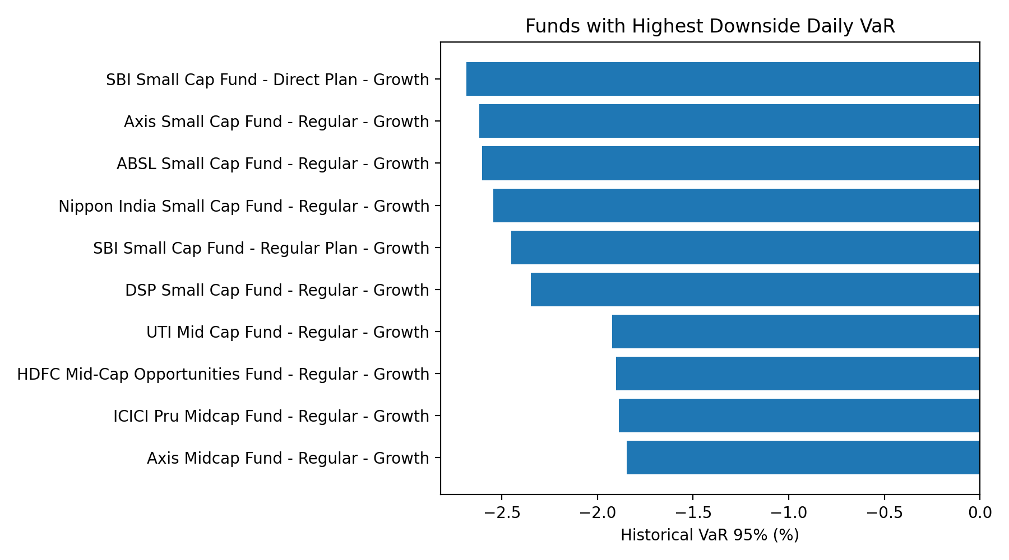
Figure 6: Highest downside daily VaR among funds

11. Advanced Analytics - Investor Cohorts and SIP Continuity
Cohort analysis groups investors by first transaction year. This helps identify whether newer or older cohorts contribute more SIP value. SIP continuity analysis focuses on investors with six or more SIP transactions and flags average gaps above 35 days as at-risk.
Investor Cohort Summary
cohort_year | avg_sip | total_invested | investor_count
2,024.00 | 10,997.00 | 214,978,121.00 | 4,624.00
2,025.00 | 13,505.00 | 2,255,370.00 | 138.00

- For regular SIP investors with six or more SIPs, 97.80% are flagged as at-risk based on average gap above 35 days.
- 2.20% are classified as regular based on the same rule.
- This metric can be used by sales or customer success teams to identify investors who may need reminders or engagement campaigns.

12. Portfolio Concentration and Sector Exposure
Sector exposure was analyzed using portfolio_holdings.csv. The Herfindahl-Hirschman Index (HHI) was calculated as the sum of squared sector weights. Higher HHI indicates a more concentrated portfolio.
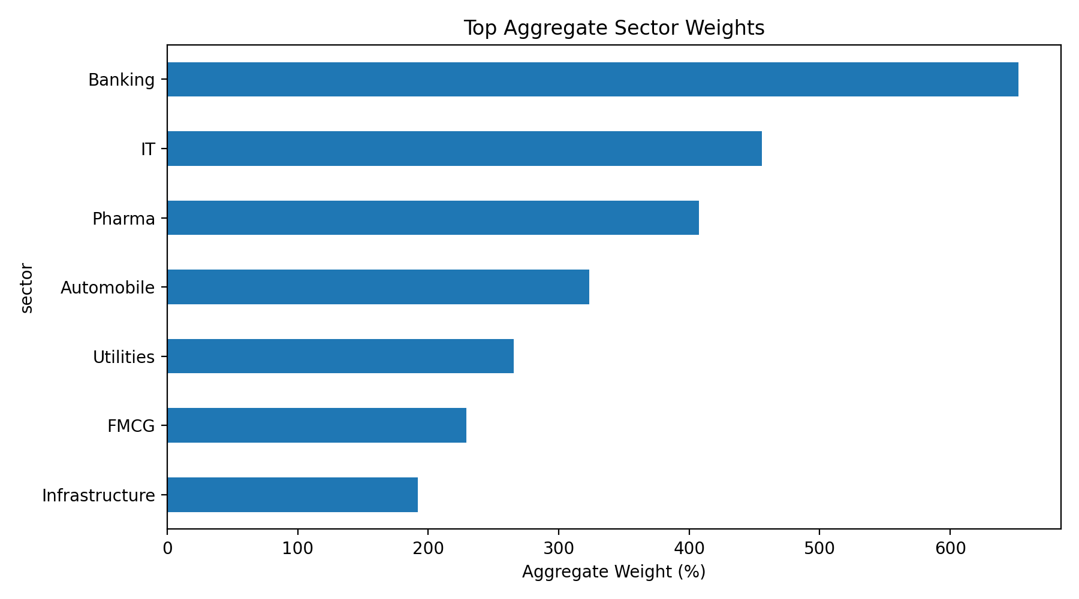
Figure 7: Aggregate sector weights across holdings
Highest Sector Concentration by HHI
scheme_name | fund_house | sub_category | hhi
Axis Bluechip Fund - Regular - Growth | Axis Mutual Fund | Large Cap | 0.21
ABSL Small Cap Fund - Regular - Growth | Aditya Birla Sun Life MF | Small Cap | 0.20
SBI Small Cap Fund - Direct Plan - Growth | SBI Mutual Fund | Small Cap | 0.17
UTI Nifty 50 Index Fund - Regular - Growth | UTI Mutual Fund | Index | 0.17
Nippon India Large Cap Fund - Regular - Growth | Nippon India MF | Large Cap | 0.17
Mirae Asset Emerging Bluechip Fund - Regular - Growth | Mirae Asset MF | Large & Mid Cap | 0.17
ICICI Pru Midcap Fund - Regular - Growth | ICICI Prudential MF | Mid Cap | 0.16
ICICI Pru Value Discovery Fund - Regular - Growth | ICICI Prudential MF | Value | 0.15

13. Dashboard Design and Interactivity
The Power BI dashboard contains four main pages: Industry Overview, Fund Performance, Investor Analytics and SIP & Market Trends. The report uses KPI cards, line charts, bar charts, scatter plots, donut charts, matrix heatmaps and slicers.
- Page 1: Industry Overview - AUM, SIP, folios and scheme-level summary.
- Page 2: Fund Performance - return versus risk, NAV trends and benchmark comparison.
- Page 3: Investor Analytics - geography, transaction types, age groups and transaction volume.
- Page 4: SIP & Market Trends - SIP inflow, Nifty comparison and category inflow heatmap.
- Interactivity: slicers were added for fund house, category, plan, state, age group and city tier. Drill-through can be used from fund table to NAV detail.
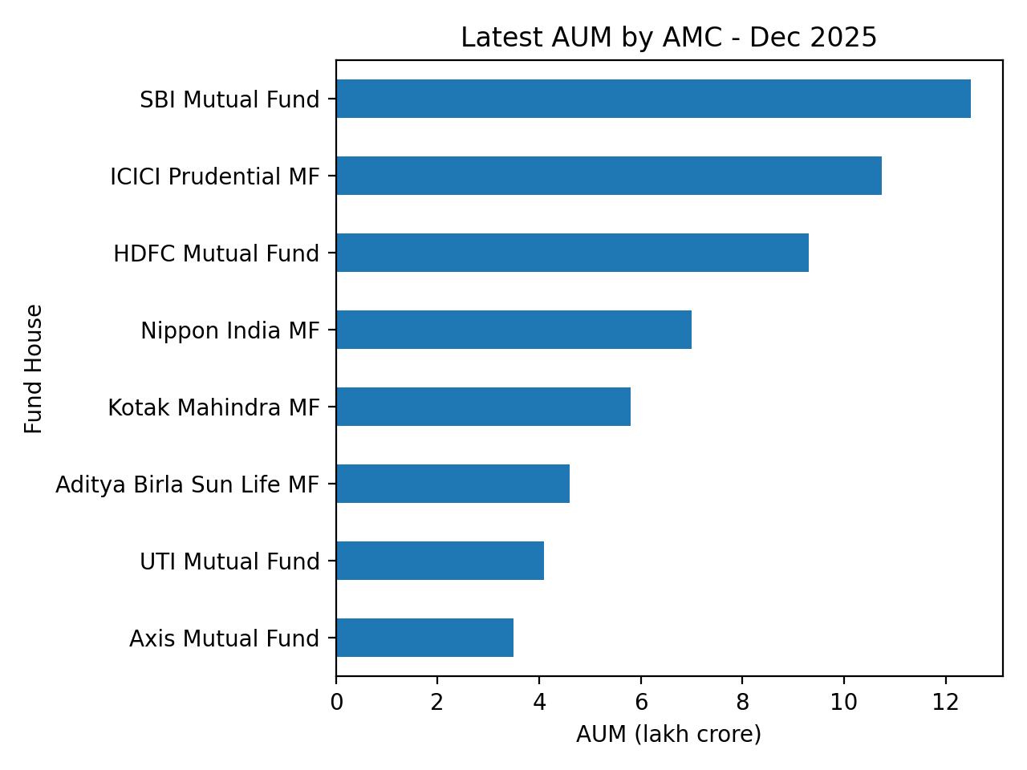
Figure 8: Latest AUM ranking by AMC

14. Key Findings
- SBI Mutual Fund is the leading AMC in the latest AUM snapshot with 12.50 lakh crore.
- SIP inflows reached their highest observed value of Rs 31,002 crore in Dec 2025.
- Folios increased to 26.12 crore by Dec 2025, indicating strong investor participation.
- The top composite fund score belongs to Mirae Asset Large Cap Fund - Regular - Growth with score 86.25.
- Small-cap funds carry the highest downside risk in the VaR table, led by SBI Small Cap Fund - Direct Plan - Growth.
- Liquid funds dominate net category inflows in the category inflow dataset with Rs 451,275 crore.
- Banking is the highest aggregate sector exposure, followed by IT and Pharma.
- SIP continuity analysis flags a high at-risk share, so gap-based retention monitoring is recommended.

15. Limitations
- The analysis depends on the scope and accuracy of the supplied datasets.
- The dashboard AUM KPI currently sums all historical rows; for executive reporting, it should be changed to latest-date AUM.
- The recommender is rule-based and uses risk grade plus Sharpe ratio, not a personalized suitability model.
- Alpha and beta are calculated against Nifty 100 only; different benchmarks may produce different regression results.
- Portfolio holdings are analyzed using available sector weights and may not represent all holdings at all dates.
- The project does not include live automated refresh inside Power BI in the current version.

16. Recommendations
- Improve data accuracy by implementing validated Power BI measures and comprehensive data quality checks across all datasets.
- Enhance the fund recommendation engine by incorporating investor-specific attributes such as age group, investment horizon, and risk profile.
- Strengthen risk analytics through the inclusion of additional performance and risk measures, enabling more comprehensive fund evaluation.
- Improve portfolio analysis by leveraging sector allocation, diversification metrics, and concentration analysis to support informed investment decisions.
- Enhance dashboard interactivity with advanced drill-through functionality, dynamic tooltips, and improved visual storytelling techniques.
- Expand analytical capabilities by integrating forecasting and predictive models to better evaluate mutual fund performance, investor behaviour, and market trends.
Overall, the project meets the capstone objective of transforming mutual fund data into a complete analytics platform with ETL, SQL-ready data, EDA, performance analytics, risk analytics and an executive dashboard.

