**Sales & Inventory Management**



**Made By:**

**Het Solanki (206530307028)**

**Dhruv Prajapati (206530307023)**



# TOLANI FOUNDATION GANDHIDHAM POLYTECHNIC

# CERTIFICATE

***Certificate***

This is to certify that, Mr. Het Solanki Enrolment No:2 06530307028 Mr. Dhruv Prajapati Enrolment No : 206530307023 have completed Part-I IDP Project work having title “Arjun Car Accessories”. They have undergone the process of shodh yatra, literature survey and problem definition.

Guide – IDP Head of Department

**ACKNOWLEDGEMENT**

We deeply express our sincere regards to Prof. Honey Gurnani & Mrs. Karishma Hathi for their expert guidance for completion of our Project work on “SALES & INVENTORY MANAGEMENT SYSTEM”.***”***

We are very thankful to the department of Computer Engineering. For providing us needed help for carrying out test for our program. We are also thankful for providing their valuable help; we thank the staff members and our colleagues for co-operating with us during our project period.

We are thankful to those freeware resources with the use which we were able to finalize our application model.

Lastly, we are thankful to Tolani. F. G Polytechnic library for the books provided to us.

Het Solanki.

Dhruv Prajapati.

**Abstract**

This Project is mainly developed for SALES & INVENTORY MANAGEMENT SYSTEM .

* The Front-end of this Project is **Microsoft Visual Studio 2017**
* Back-end is **SQL Severe 2018**.

SALES & INVENTORY MANAGEMENT is complete end to end solution to cover all aspects of Customers day to day activity and Property buying selling procedure for small and large organization.

This project is developed for an Car Accessory Management Company, “Arjun Car Accessories”.

This is a software which can be used by a Car Accessory Management center for keeping the records of items which is to be transacted for purchase and sell.

In proposed system we do not have to maintain everything manually. Throught this system if any transaction occurs it is corresponding entries is done automatically because database management system gives facility of having relationship between the table.

**The basic objective of developing this project is:**

* Easy to generate report for any transaction.
* It is very much faster than manual system.
* Easy and fastest record finding technique.
* It is very much flexible to work.
* Man power required is very less.
* Data can be stored for a longer period.
* System has powerful logical access vendor in place, each user must be identified by login id and strict password policy is applied to secure the system.
* This Project will also allows Shopkeeper to manage the profit and maintenance cost and this will help them to improve their bussiness.

This system deals with the purchase and sales of the good and maintains the stock. It contains various forms and reports with different function. It has the menus created for different forms and reports. When you click the menu, It opens the related forms about the customer, vendor, Items and Transaction.

**Index:**

1. **Industry Introduction………………………………………..…7**
   1. Type Of industry…………………………………………………………………8
   2. Processes……………………………………………………………….8
   3. Scale Of industry & end users……………………………………………….8
2. **Problem Identification………………………………………………………..9**

2.1 Problem Definition………………………………………………………....10

2.2 Problem Identification……………………………………………………...11

2.3 Process Modification……………………………………………………….12

1. **Whole Industrial Process………………………………………………….....**13

3.1 Problems in the existing system…………………………………………….14

3.2 Problem Study……………………………………………………………...16

1. **Problem Solution Outline……………………………………………………..**18

4.1 E-R Diagram….………………………………………………………………20

4.2 Data Flow Diagram…………………………………………………………..21

4.3 Data Dictionary……………..………………………………………………..25

4.4Hardware and Software Requirements…………………………………........28

4.5 Form Layout………………………………………………………………….30

**Chapter 1**

**Industry Introduction**

**Type Of Industry:**

Arjun Car Accessories. In this Fast generation Sale & Inventory Management will becomes to hard to maintain them manually, instead of this we people are switch on to the Software and automatic Sale & Inventory Management.

* 1. **Processes:**

SALES & INVENTORY MANAGEMENT SYSTEM involves the following processes that are overcomed daily.

* Maintaining of the information’s of clients.
* Maintaining Inventory.
* Maintaining Creditores Account.
  1. **Scale Of Industry & End user’s:**

The Arjun Car Accessories is a small workplace where the SALES & INVENTORY MANAGEMENT SYSTEM would be running and its usage would be limited upto the the desktop version.

**Chapter 2**

**Problem Identification and Definition,**

**Process Modification**

**We identified so many Problems in the current process, which are notified below: -**

* Inventory Management is maintaining client and other vendor related data manually. So, we notified that in this system problems can occur. And we find that Dealer of this client records is difficult because information is stored on paper & when update is needed for information like client name, address, contact number correction is not possible & leads to excessive erasing. Also to maintain these pages is very difficult.
* Only entry is performed on paper when bill given by Admin. Sometimes this process carries out problems.
* Analysis of the client requirement and client need sometime lead to mistake.

**Needed Modifications in Process:-**

* Client Information storage needs maintenance in very elegant manner, and this process needs much care by modifier.
* Bill Receipt should be given to client instead of only records maintenance on paper.
* Day By day buying and sealing Process needs storage in perfect manner & also option is needed for update.

**Data & Fact Gathering Technique:-**

* In order to understand the problems, we carried out in Client search on the process of the Sales & Inventory Management.
* We organized **Group discussion** with Prof. Honey Gurnani and they clearly explained us the process of SALES & INVENTORY MANAGEMENT SYSTEM.

**Chapter-3**

**The Whole Industrial Process and**

**Problem Study**

So, now we have to study process & problems of this System.

**Processes in Brief: -**

* Client information is stored manually and maintenance is on Paper.
* Visitor’s information is also stored manually.
* Day to Day process is maintained in the form paper Records.
* As described upper all processes are manual.

**Detailed Problem Study: -**

* Client & Dealer Information, Stock Management is difficult. As data retrieval is on paper is hard.
* To take care of all manual forms in which client information is written & searching of any client information from this forms is difficult.
* Also searching of Category wise information of Products is difficult
* Managing the billing by date wise is difficult
* Inventory also needs to be maintain manually.

**Any change in Client information is not updated.**

* If any change in client information likes contact no., Name, Address etc. is not properly reflected in original form.

**Technician Details:-**

* Technician information is store manually, as the data retrieval when required becomes difficult.
* Searching of the data become difficult

**Chapter-4**

**The Problem Solution Outline**

* **Solutions**
* **Feasibility Study**
* **Hardware & Software Requirements**
* **E – R Diagram**
* **Data Flow Diagram (DFD)**
* **Use Case**
* **Form Layouts**
* **Data Dictionary**
* **Report Layouts**

**Solutions: -**

The new system allow users to provide details of their properties that are for sale. It also allows users to search for properties that are for sale. Users can also add their requirements regarding the product they want to buy. The business goal for the application is to increase efficiency of registration process and powerful search facilities and capable of matching property with clients and Managing Inventory and Creditors Account as well.

**Why Feasible ??**

* Economically this solution is feasible because solution’s budget is feasible for Service center because already PC is available, and implementation of this software will be beneficial in cost.
* Technically feasible because we can implement problem solutions & also staff is able to work with this computerized system. Existing software is enough for this software implementation.
* Operationally feasible because this system can provide right information at right time in terms of technical performance as compared to existing system & also staff is agree with this software and no any reconstruction or retraining is needed.

**HARDWARE REQUIREMENTS:-**

**Processor : Pentium or equivalent or higher**

**RAM : 512 MB or more**

**Hard disk : 150 GB or more**

**Monitor : VGA/SVGA**

**Keyboard : 104 Keys**

**Mouse : Optical Mouse**

**SOFTWARE REQUIREMENTS:-**

**Operating System : Windows XP/ Windows 7/ Windows 8**

**Front End : VB.NET (Visual Studio 2017)**

**Back End : SQL Server 2019**

**System Design: -**

Before going towards system design we have to understand some on paper concepts as shown in below diagrams : -

**E-R diagram (Entity – Relationship)**

E-R diagrams are used to show Table & columns of that tables & relationship between those Tables.

: - **Specifies Table (Represents entity set)**

**TABLE NAME**

: - **Specifies Column Name (Represents Attributes)**

**RELATION SHIP**

: - **Specifies Relation amongst entities of Tables**

: - **Links Tables (Links attributes to entity sets and entity sets to Relationship)**

**Entities: -** An entity is a person, place, thing of organization about which data are captured, stored or processed.

**Attributes:** - Various types of data that describe an entity are known as attributes.

**DATA FLOW DIAGRAM: -**

DFD diagrams provide a logical model of the system & show the flow of data and the flow of logic involved. DFD shows the passage of data through the system. DFD describes that WHAT takes place in an existing system, NOT HOW the activities are accomplished.

**The top – level DFD diagram is often called a CONTEXT DIAGRAM (Level 0).**

**Symbols : -**

ENTITY NAME

External User

Flow of Data

Process

Data Store

**Database Management :-**

**Account_Master :-**

* This will keeps Creditors Account Informations.

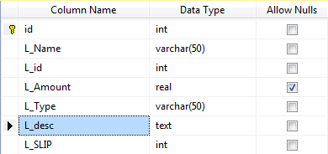

**Activity_Log_Master :-**

* This will keeps Login Information of User. That mean who will logged in & Logged Out from the system at with time for providing complete transparency between employee and manager.

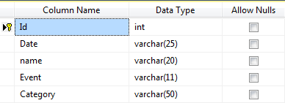

**Admin_Master :-**

* This will keeps Username & Password information of user of the application.

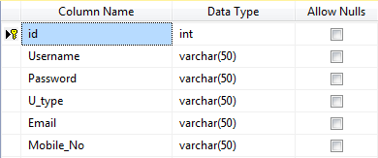

**Configure_Master :-**

* This will be created for generation of Invoice No. & Slip No. for maintaining Sales & Purchase Summary.

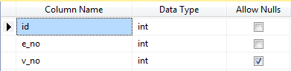

**Customer_Master :-**

* This will keeps Customer Information.

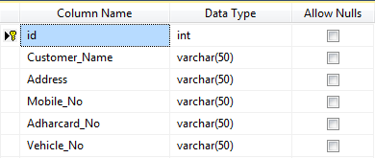

**Dealer_Master :-**

* This will keeps information about dealers.

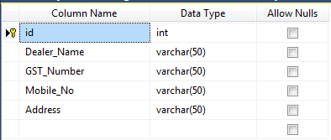

**Expenses_Master :-**

* This will keeps information about expenses.

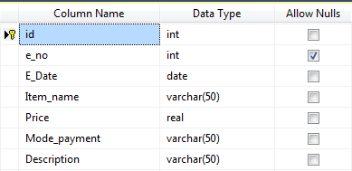

**Product_master :-**

* This will keeps information about Product, their Category, quantity, sale & purchase price etc.

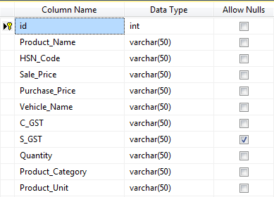

**Shop_Master :-**

* This will keeps information about shop.

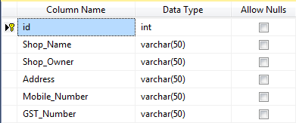

**Vehicle_Master :-**

* This will keeps information about Vehicles of Customer.

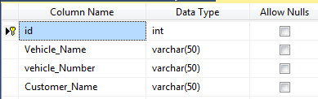

**Purchase_Details :-**

* This will keeps detailed information about purchasing products from dealers.

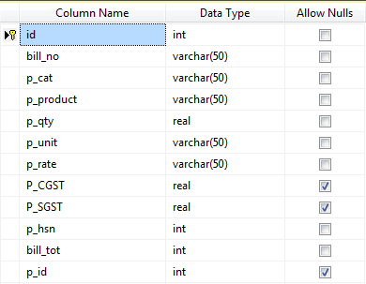

**Purchase_Summary :-**

* This will simply keeps information about purchase bill.

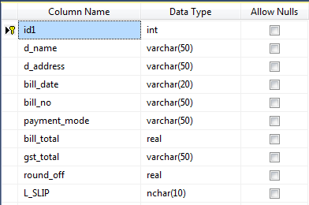

**Sales_Details :-**

* This will keeps detailed information about products that are sold to customer

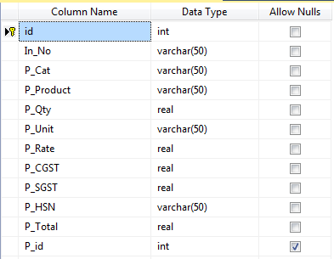

**Sales_Summary :-**

* This will simply keeps information about sale invoice.

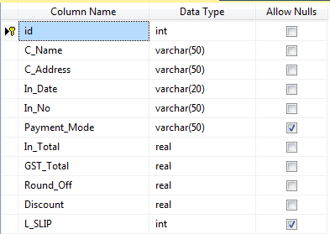

**Project Design**

**Login Page:-**

* This is an login page from where user can be logged into the system.

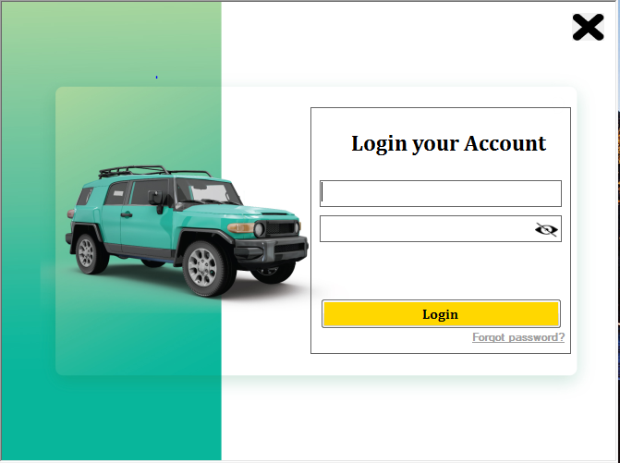

**Forgot Password : -**

* This is an page that allows user to re-create their password if they will forget the password.

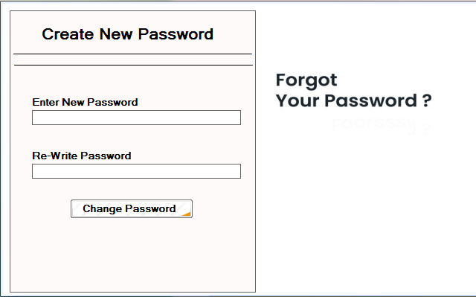

**Customer Master :-**

* This is an interface of Customer Master. It will shows the customer details whose payment Is remaining.

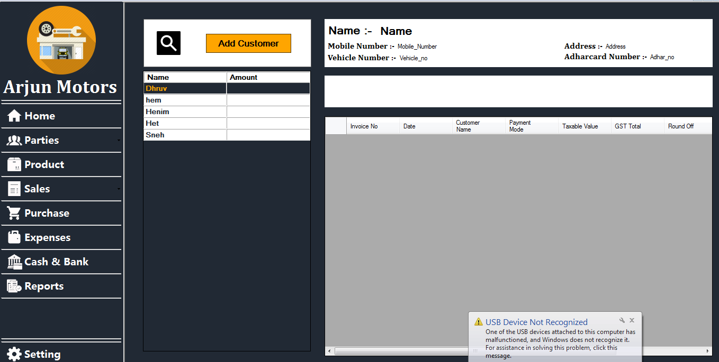

**Add Customer :-**

* This is an form from where customer can be added.

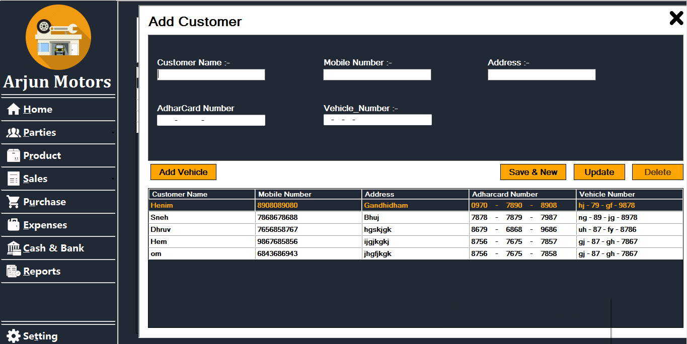

**Add Vehicle :-**

* This form will be used to add vehicle details of the customer

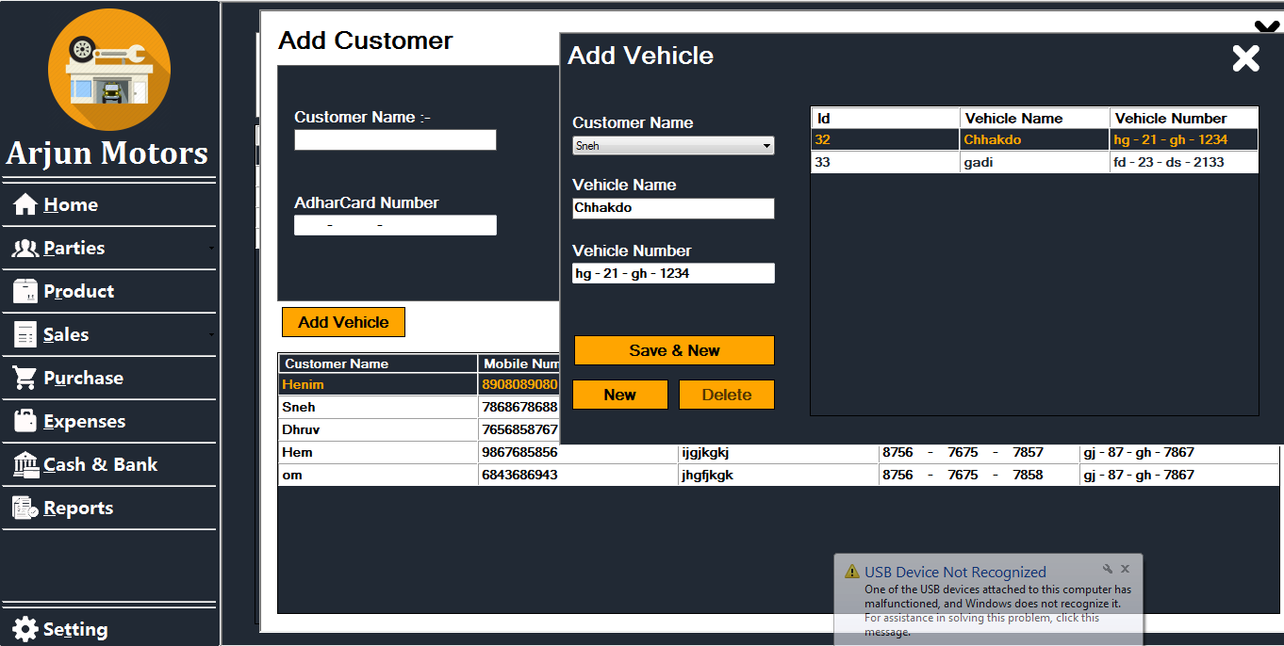

**Dealer Master :-**

* This form will display the Dealer name along with the amount that the shopkeeper needs to pay.

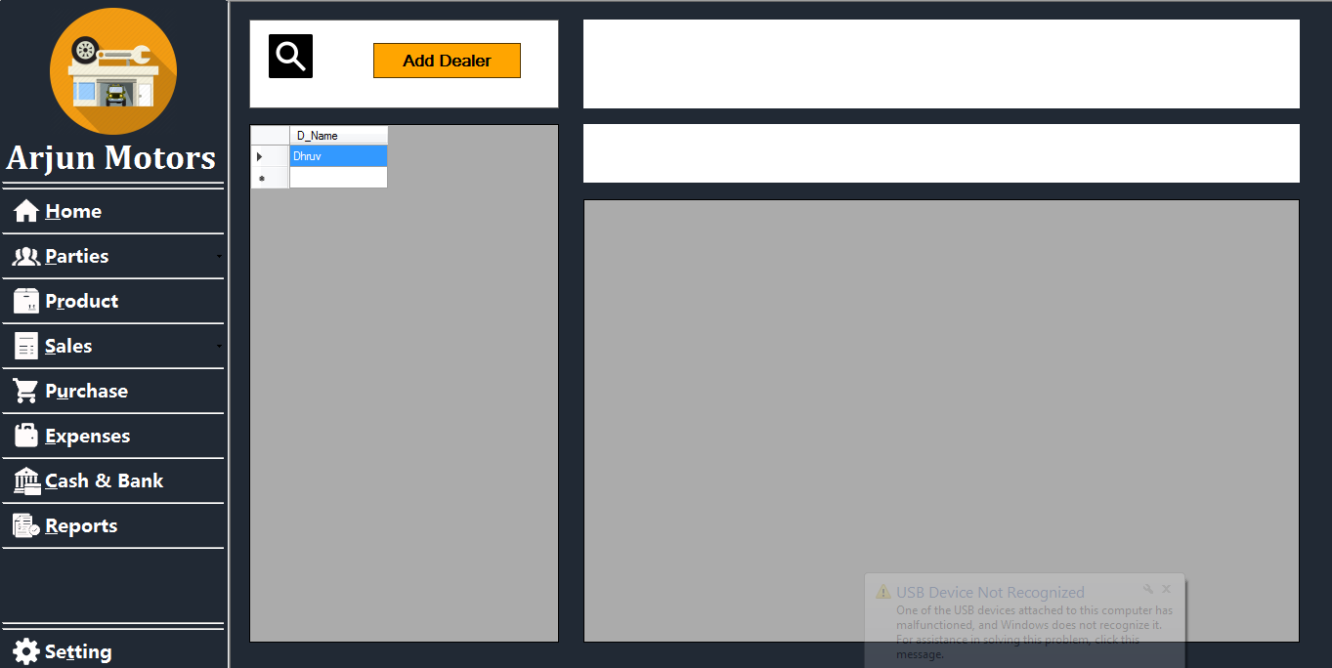

**Add Dealer :-**

* This is an form that allows user to add dealer to their system.

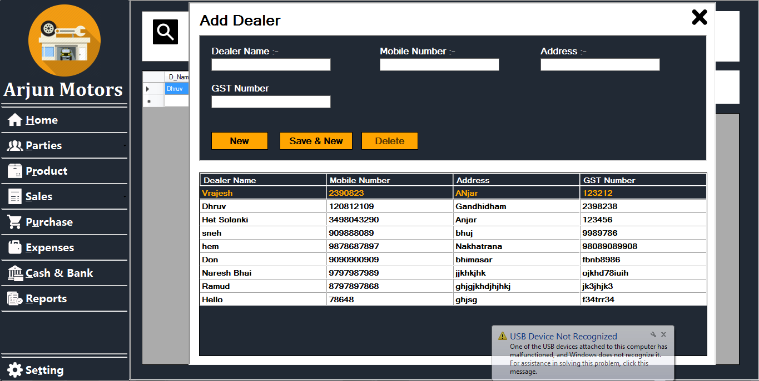

**Product Master :-**

* This is an form that will shows the details of products with their available stock.

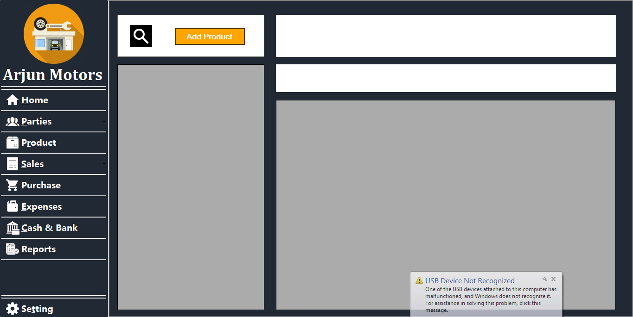

**Add Product :-**

* This form allows user to add product to the system.

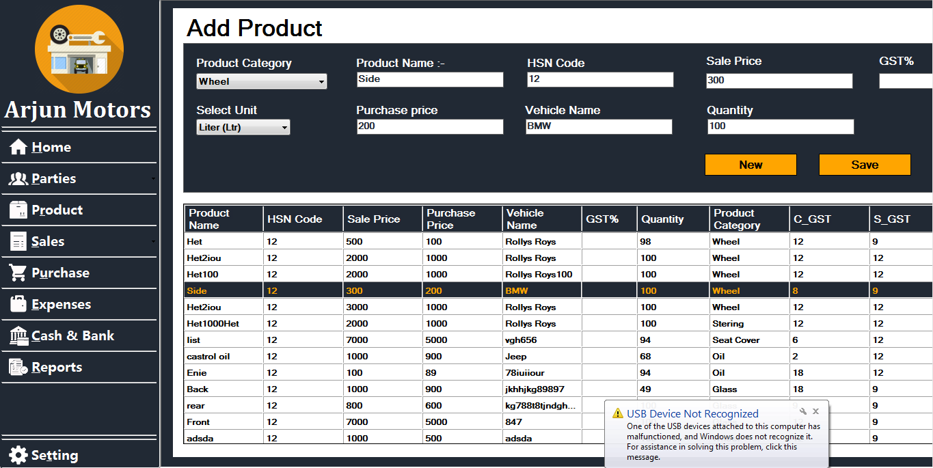

**Sales_Search :-**

* This is an form that allows user to search invoices by customer name, pay of mode and date.

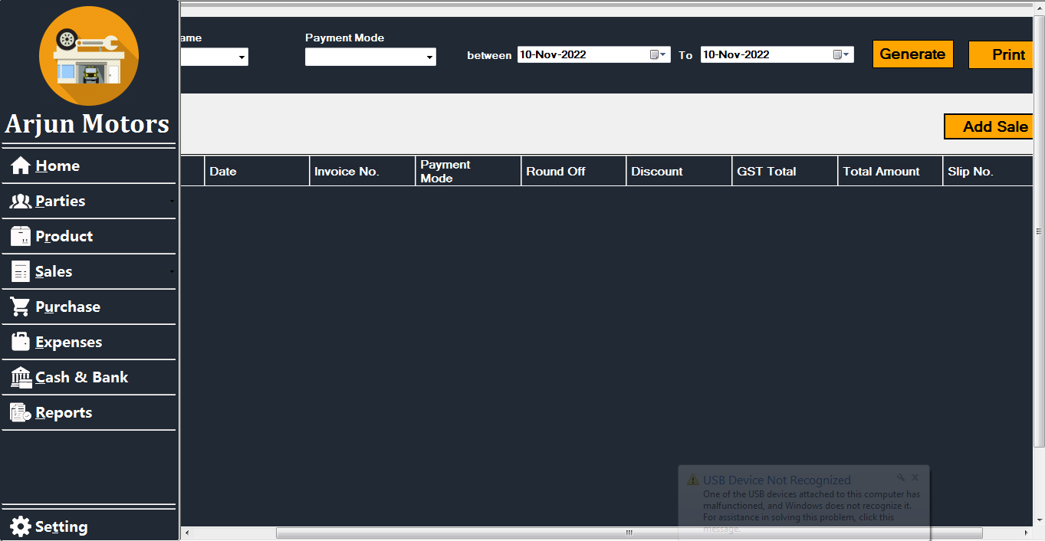

**Sale Entry :-**

* This is an form that allows user to make invoice for the customer.

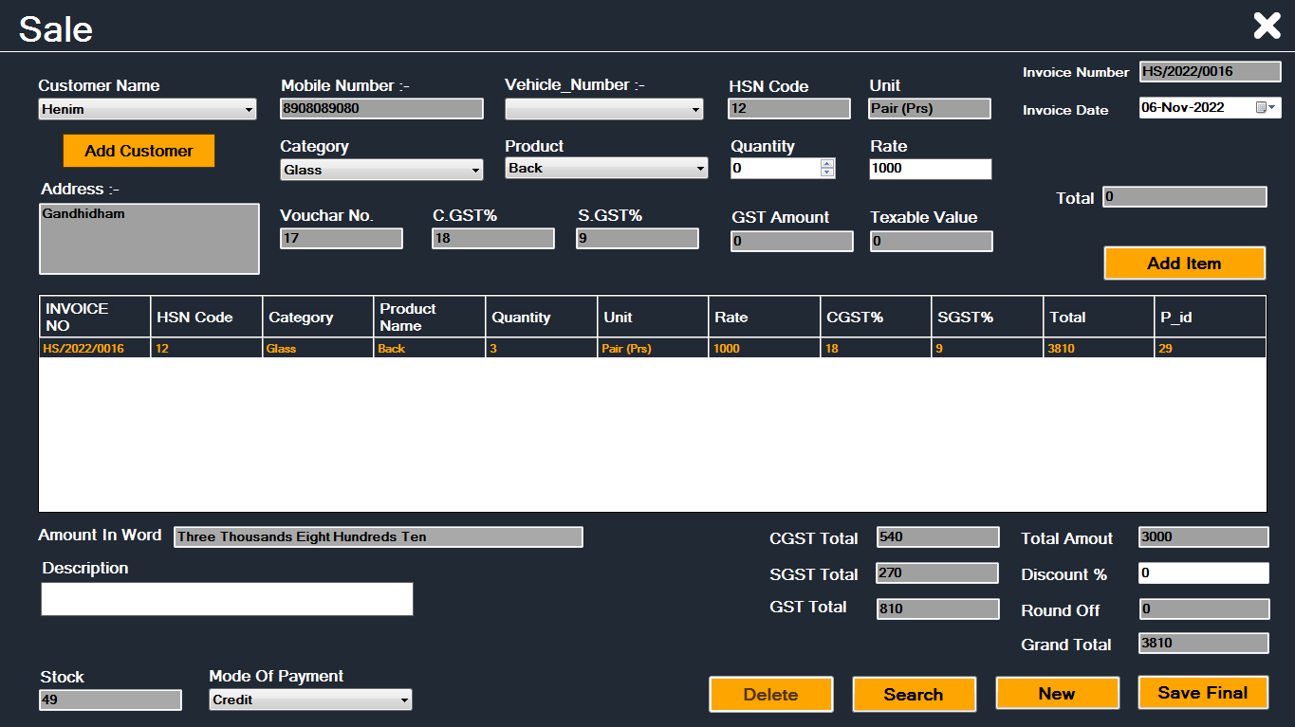

**Purchase_Search :-**

* This is an form that allows user to search bill by dealer name, pay of mode and date.



**Purchase Master :-**

* This is an form that allows user to make purchase bill.

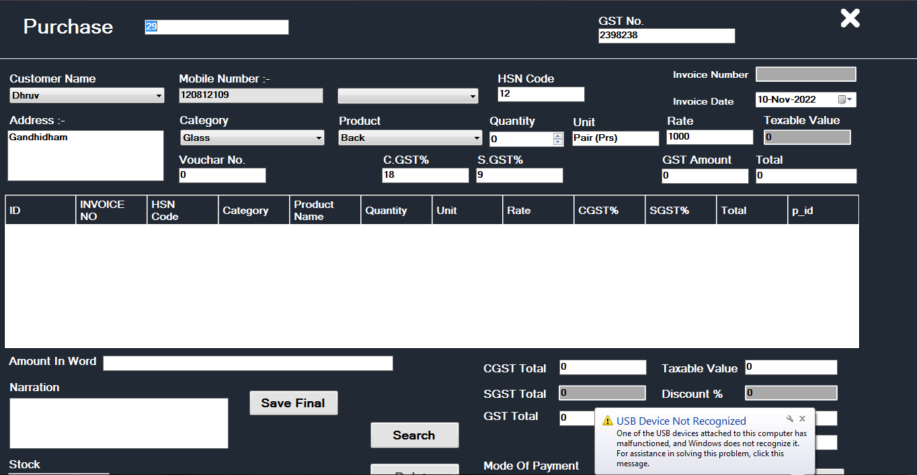

**Expenses :-**

* This is an form that will keeps the track of expenses made for shop.

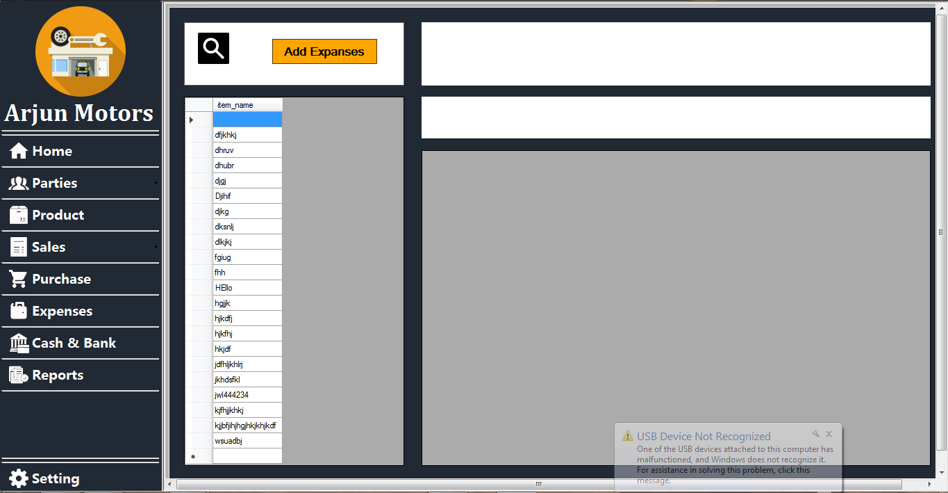

**Add Expenses :-**

* This is an form that allows user to add expenses entry.

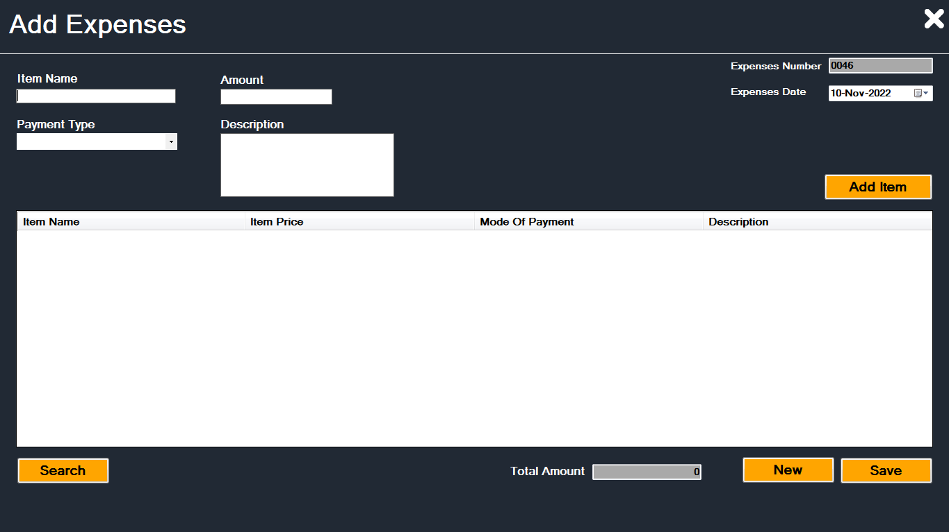

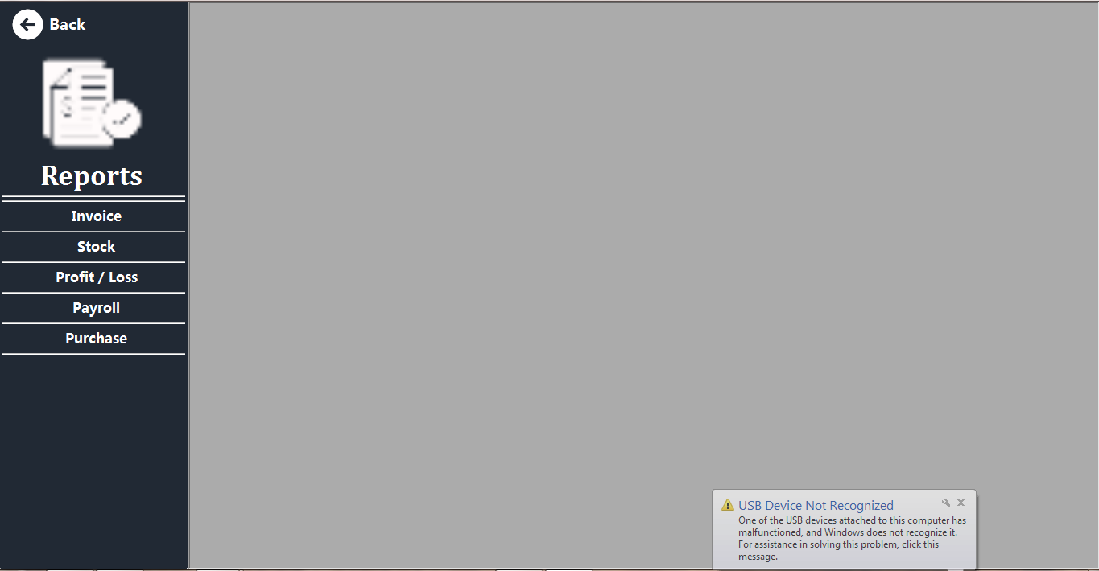

**Sale Report :-**

* This is an Sale Report. Which will gives information about invoice of all the individual customers with saling things and their rates and all of these things.

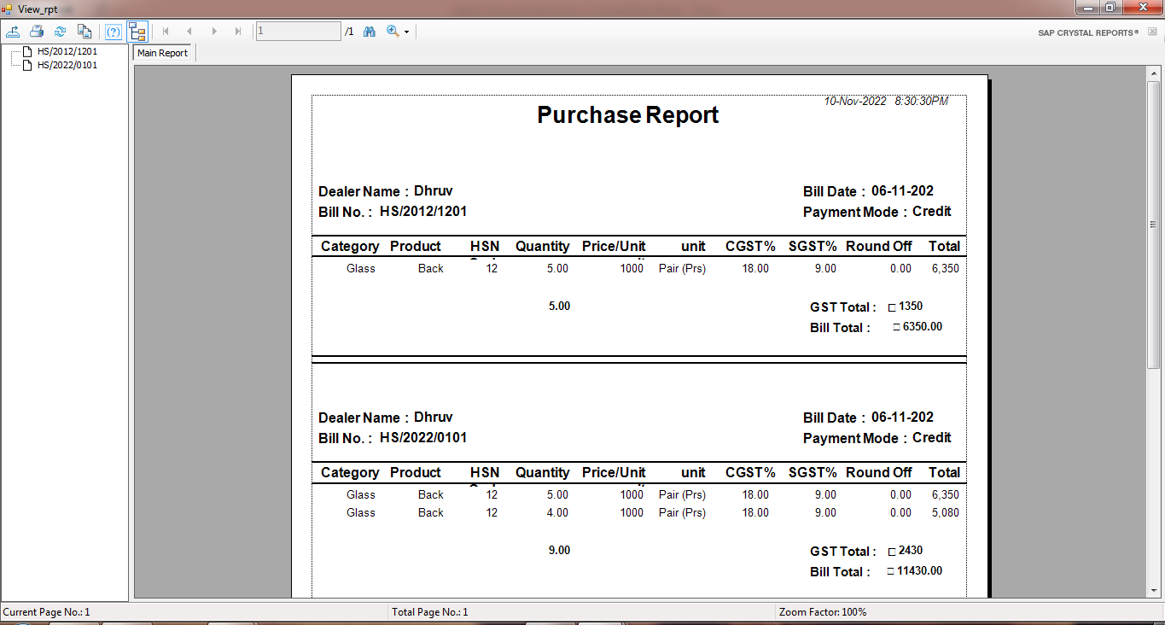

**Purchase Report :-**

* This is an Purchase Report. Which will gives information about bill of all the individual dealer with buying things and their rates



**User Masster :-**

* This form will be used to create system user.

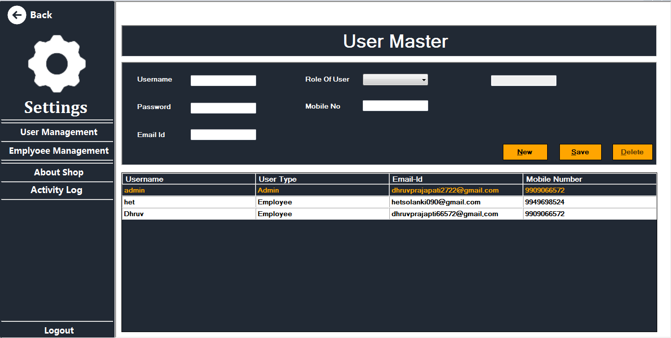

**About Shop :-**

* This form allows user to enter/edit an information about shop.

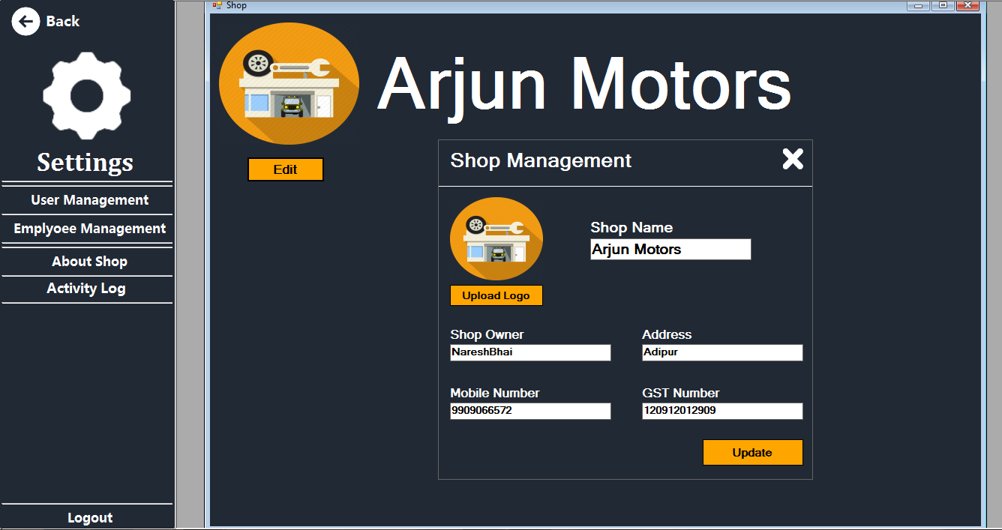

**Active Log :-**

* This will keeps the track of user’s activity login information.

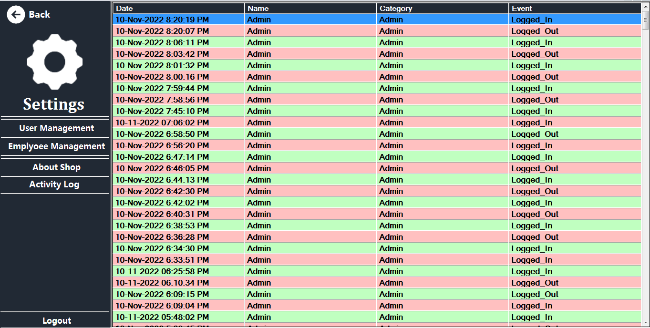

**Context Level (Level 0) DFD :** 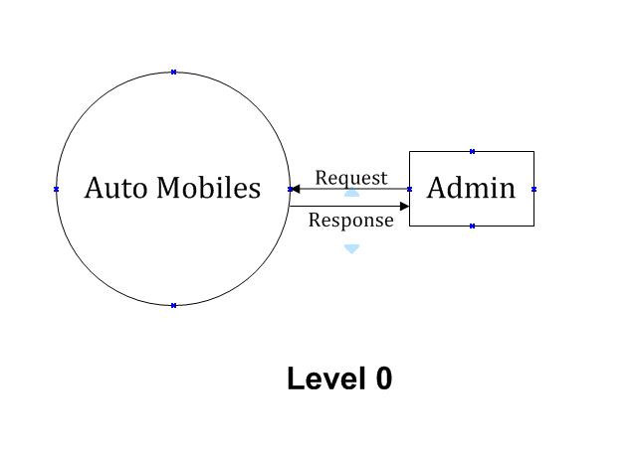

**Level-1 DFD:**