Stroop Task

PSY310: Lab in Psychology

10th September 2026

Hetansh Jalan

AU2420024

GitHub Link
https://github.com/HetanshJalan/Psychology-Experiments

Introduction

The Stroop task is a test of interference in which the person has to respond to one feature of the stimulus but the other feature gives conflicting information. In this colour-word version, the appropriate feature is the colour of the ink, the written word may correspond or not to this feature. When people encounter conflicting information, they often experience a slowing that is known as the Stroop effect (Stroop, 1935).

The task has been extensively employed to study selective attention and cognitive control. Congruent trials contain matching cues whereas incongruent trials involve competition between the cue that must be identified and the competing information received by the word (MacLeod, 1991).

Computerized versions of the stimulus enable the presentation of stimuli and the recording of stimuli responses to be standardized. PsychoPy is an open-source behavioural environment that allows to control the presentation of stimuli and record responses using the keyboard (Peirce et al., 2019).

Aim: In the experiment they tested whether there was any difference in response time for congruent and incongruent colour-word stimuli.

Hypothesis: The prediction was that incongruent and congruent trials would give reaction times of different lengths; the incongruent trials would have longer reaction times because the word and ink colour would give conflicting information.

Method

Participant

Participant was a 20-year-old male undergraduate student. He has run the experiment separately in the University. Participants were asked to participate and informed consent was received prior to the task. In the experimental output, a participant label instead of a personal identifier was used.

Materials

An experiment was conducted using PsychoPy 2026.2.3 with full screen enabled. Approximate display refresh rate recorded was 60.13 Hz. The responses were obtained by a standard keyboard.

The words Red and Blue were written in Red or Blue ink in the stimulus set.

The four combinations were: Red/Red, Red/Blue, Blue/Red, and Blue/Blue. The cases of Red/Red and Blue/Blue were congruent case, but the cases of Red/Blue and Blue/Red were incongruent case. The R key was the Red and the B key was the Blue.
Figure 1


Figure 1. Fixation stimulus reconstructed from the uploaded PsychoPy experiment settings: a white cross displayed for 500 ms.
Figure 2

Figure 2. Red presented in Blue ink (incongruent condition).

Figure 3

Figure 3. Red presented in Red ink (congruent condition).

Figure 4


Figure 4. Blue presented in Red ink (incongruent condition).

Figure 5
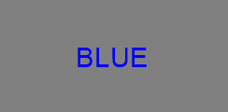
Figure 5. Blue presented in Blue ink (congruent condition).

Procedure

The subject was told to look for the word's colour, but not to read the word, and sat in front of the computer. The R key was used for the "Response" and B key for the "Back" button.

The trials started with a fixation cross that was presented for 500 ms. The word for the colour appeared in the middle of the screen next. Next, the word for the colour appeared in the middle of the screen. The reaction time response component accepted R and B, and measured the time elapsed from stimulus presentation. The stimulus could be programmed up to 5 s but could be terminated when a response was completed.

There were four stimulus conditions in the experiment and 5 repetitions of each condition given. The order was randomized by the trial handler to create 20 experimental trials. The accuracy was automatically recorded with a comparison of each response to the programmed correct response.

Data treatment

Reaction times were exported in seconds and then converted to milliseconds for analysis. The 20 completed trial records were checked for missing responses and accuracy. The observed accuracy was 100% with all 20 responses correct. Descriptive statistics were derived for each condition and for the groups combined (congruent and incongruent). The Stroop effect was determined as the difference between the mean incongruent reaction time and the mean congruent reaction time.

Results

There was 100% accuracy with all 20 trials completed correctly. The overall mean reaction time was 586.44 (SD = 358.74). Congruent trials produced a mean of 524.10 ms (SD = 271.97), whereas incongruent trials produced a mean of 648.78 ms (SD = 434.84). Therefore, the Stroop effect for the observed stimuli was 124.68 ms.
Table 1

Trial | Word | Ink | Condition | RT (ms) | Correct
1 | Blue | Red | Incongruent | 1832.26 | Yes
2 | Red | Red | Congruent | 667.11 | Yes
3 | Red | Blue | Incongruent | 702.13 | Yes
4 | Blue | Blue | Congruent | 548.13 | Yes
5 | Blue | Blue | Congruent | 464.86 | Yes
6 | Blue | Red | Incongruent | 600.61 | Yes
7 | Red | Blue | Incongruent | 736.58 | Yes
8 | Red | Red | Congruent | 1224.77 | Yes
9 | Blue | Red | Incongruent | 464.82 | Yes
10 | Red | Blue | Incongruent | 369.70 | Yes
11 | Blue | Blue | Congruent | 416.34 | Yes
12 | Red | Red | Congruent | 356.14 | Yes
13 | Blue | Red | Incongruent | 371.71 | Yes
14 | Blue | Blue | Congruent | 317.33 | Yes
15 | Red | Blue | Incongruent | 430.14 | Yes
16 | Red | Red | Congruent | 558.44 | Yes
17 | Red | Blue | Incongruent | 517.27 | Yes
18 | Red | Red | Congruent | 371.93 | Yes
19 | Blue | Red | Incongruent | 462.56 | Yes
20 | Blue | Blue | Congruent | 315.96 | Yes
Table 1. Complete trial-level reaction-time data exported from the experiment; times converted from seconds to milliseconds.
Table 2

Condition | n | Mean (ms) | SD (ms)
Red / Red | 5 | 635.68 | 354.15
Blue / Blue | 5 | 412.52 | 99.41
Red / Blue | 5 | 551.16 | 162.71
Blue / Red | 5 | 746.40 | 612.49
Congruent — combined | 10 | 524.10 | 271.97
Incongruent — combined | 10 | 648.78 | 434.84
Table 2. Descriptive statistics by stimulus condition.

Figure 6
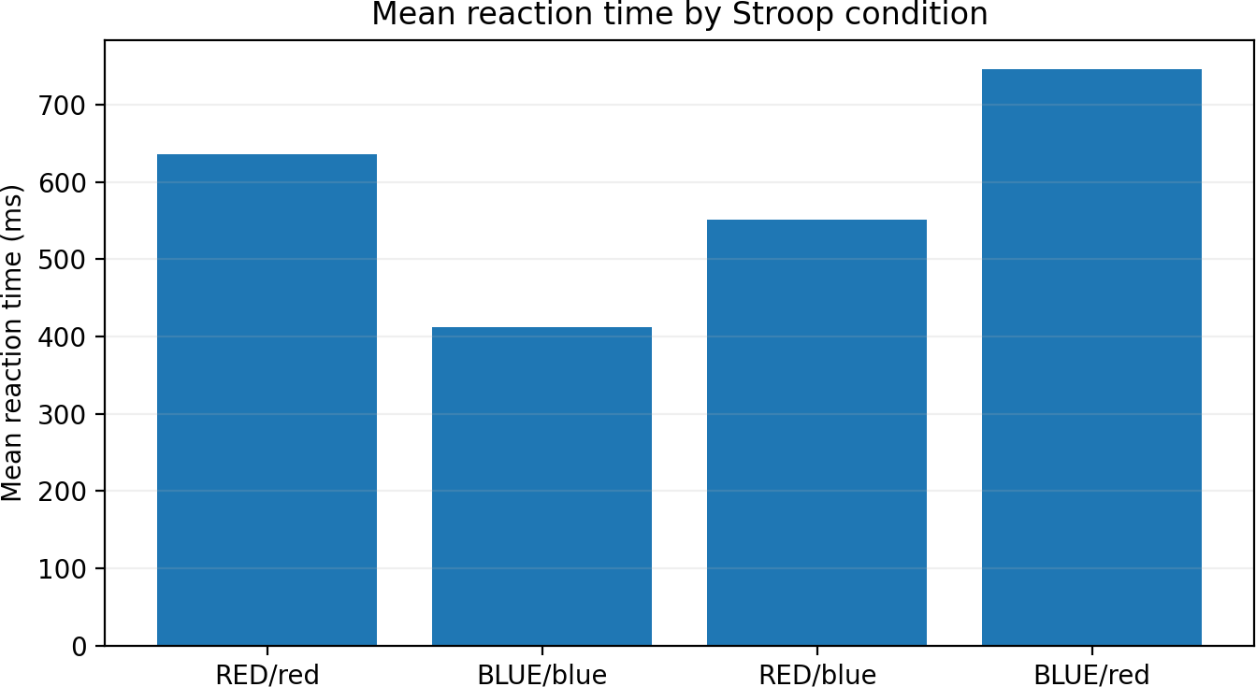

Figure 6. Mean reaction time for each stimulus combination.

Figure 7
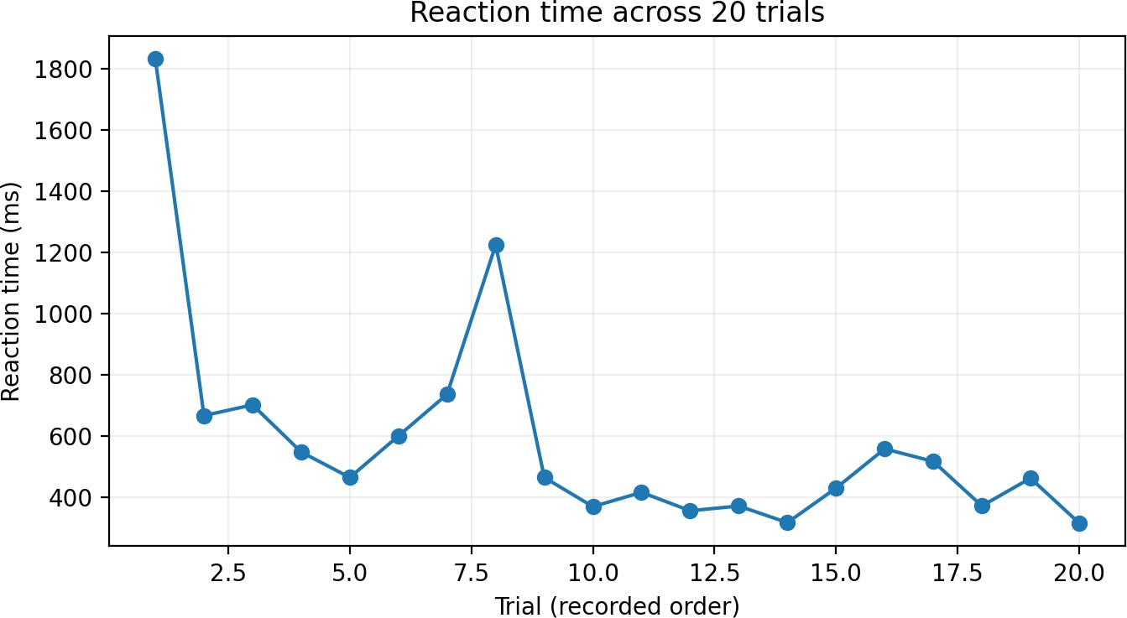

Figure 7. Reaction time across the 20 trials in recorded order.

Discussion

The hypothesis was confirmed by the results. The mean reaction time was found to be longer for the incongruent trials than for the congruent trials, yielding a mean Stroop effect of 124.68 ms. In this participant,
Therefore, there was a colour-word conflict effect on slower responses.

The pattern is based on the central logic of the Stroop paradigm. With congruent trials, the written word and colour of ink are consistent in the direction they point. In incongruent trials, the participant is required to attend to the ink colour and the word gives a conflicting cue. This is equivalent to interference between these two sources of information (Stroop, 1935; MacLeod, 1991) since the longer mean response time in the incongruent condition is.
None of the four single stimulus combinations were the same speed. The incongruent trials averaged Red/Blue = 551.16 ms and Blue/Red = 746.40 ms. The differences between these demonstrate variability across specific word-colour pairs along with the general Stroop effect. The differences between these combinations should be described, as there are only five observations in each combination.
There were 20 recorded trials and the accuracy was 100%. The present data set illustrates the interference pattern mainly in terms of response latency, as no errors occurRed. Randomized computerized presentation also ensured the consistent procedure of the trials (Peirce et al., 2019).
limitations and further directions
Generalizability was restricted in the study due to the small number of trials (20) and participants (one). As a result of the few observations in each condition, individual slow responses can significantly impact means and standard deviations. A larger sample, more trials and pRedefined reaction-time exclusion criteria would be beneficial in future work. Inferential statistics can also be used in a larger study to determine the reliability of the congruent–incongruent difference across participants.
Conclusion
The incongruent trials were on average 124.68ms slower than the congruent trials, and this difference was clearly described in this data set. The experiment illustrates the capacity of competing word and colour information to affect response time, and to elicit response time as a behavioural measure of attentional interference.

References
- MacLeod, C. M. (1991). Half a century of research on the Stroop effect: an integrative review. Psychological bulletin, 109(2), 163.
- Peirce, J., Gray, J. R., Simpson, S., MacAskill, M., Höchenberger, R., Sogo, H., ... & Lindeløv, J. K. (2019). PsychoPy2: Experiments in behavior made easy. Behavior research methods, 51(1), 195-203.
- Stroop, J. R. (1935). Studies of interference in serial verbal reactions. Journal of experimental psychology, 18(6), 643.

