Can the Reconstructor Police the Verbalizer?

Testing reconstruction-based verification of NLA explanations
[Your name]

Executive summary
Natural language autoencoders (NLAs) turn a model’s activations into a paragraph a person can read. The catch, which the NLA paper lists as its first limitation, is that the paragraph is often confidently wrong about specifics. On the public Qwen3.6-27B NLA I worked with, 1,283 of the 2,153 claims the explanations made about their source text were plausible fabrications, 59.6%: right topic, wrong details. These explanations have already been used in a frontier pre-deployment audit, so I wanted to know if the NLA could catch its own mistakes.
The paper hints at a way. The NLA has a second half, a reconstructor that maps the explanation back to the activation. If a claim is true, deleting it should hurt reconstruction more than deleting a plausible false claim. Nobody had tested this beyond a small pilot, so I did, on 2,119 claims with ground truth from the source text.
It does not work, at least not here. After subtracting the cost of deleting length-matched random spans, deletion excess separates TRUE from RELATED_FALSE claims at AUROC 0.477 [0.452, 0.502], with 95% intervals for every estimate in Figure 1a. Rewriting the deletions fluently instead of cutting them out gets 0.516 on a 200-claim subset, no better. The surprise was the third test: scoring a claim on its own, the way you might score a single sentence, gives 0.404. False claims reconstruct better than true ones. I went in expecting a weak signal in the right direction and found a weak signal in the wrong one.
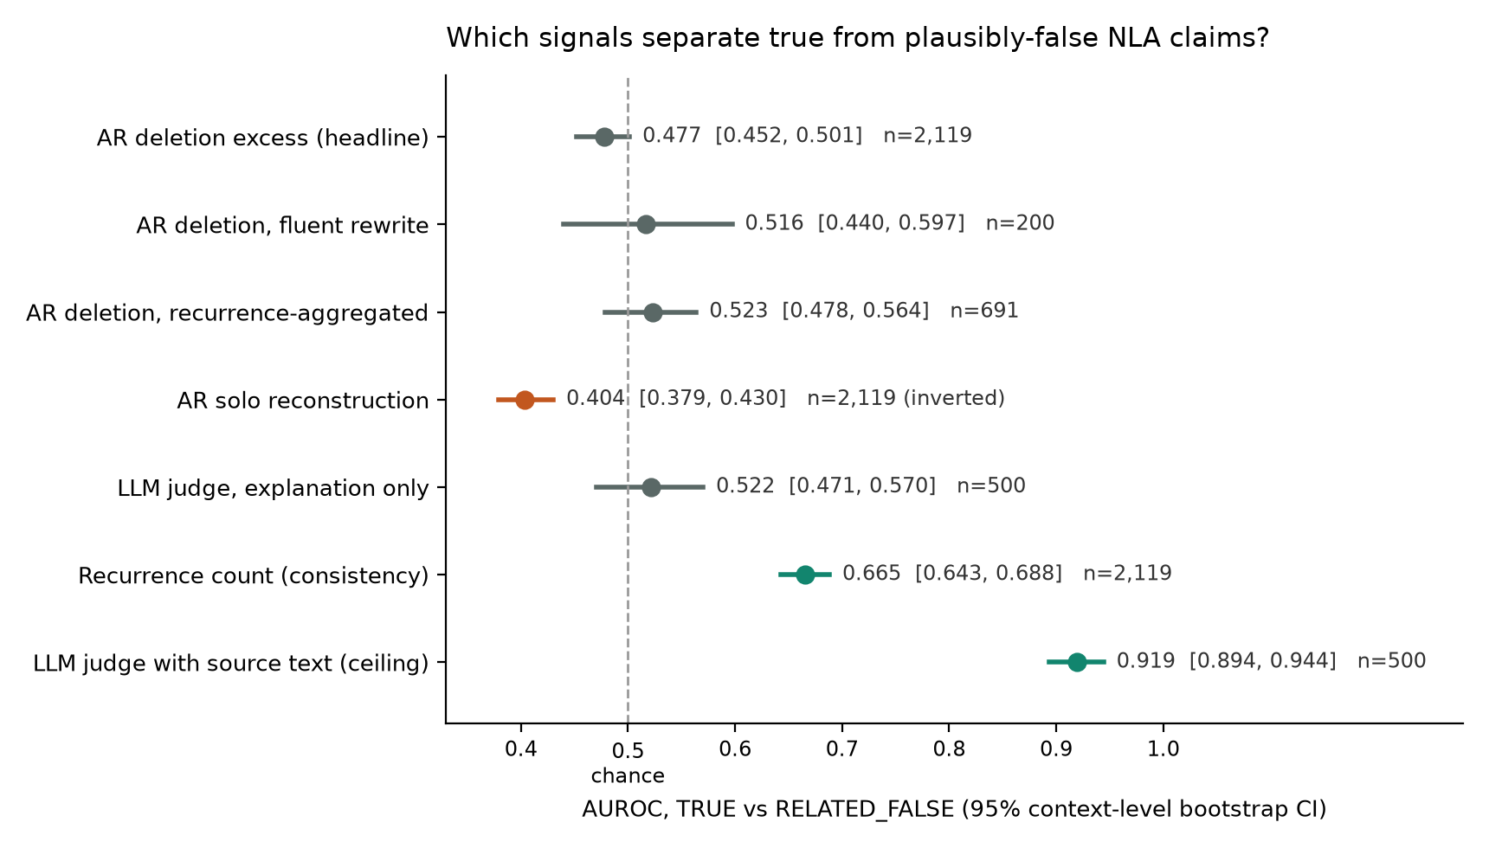
Figure 1a. Every signal tested, with 95% context-level bootstrap intervals.
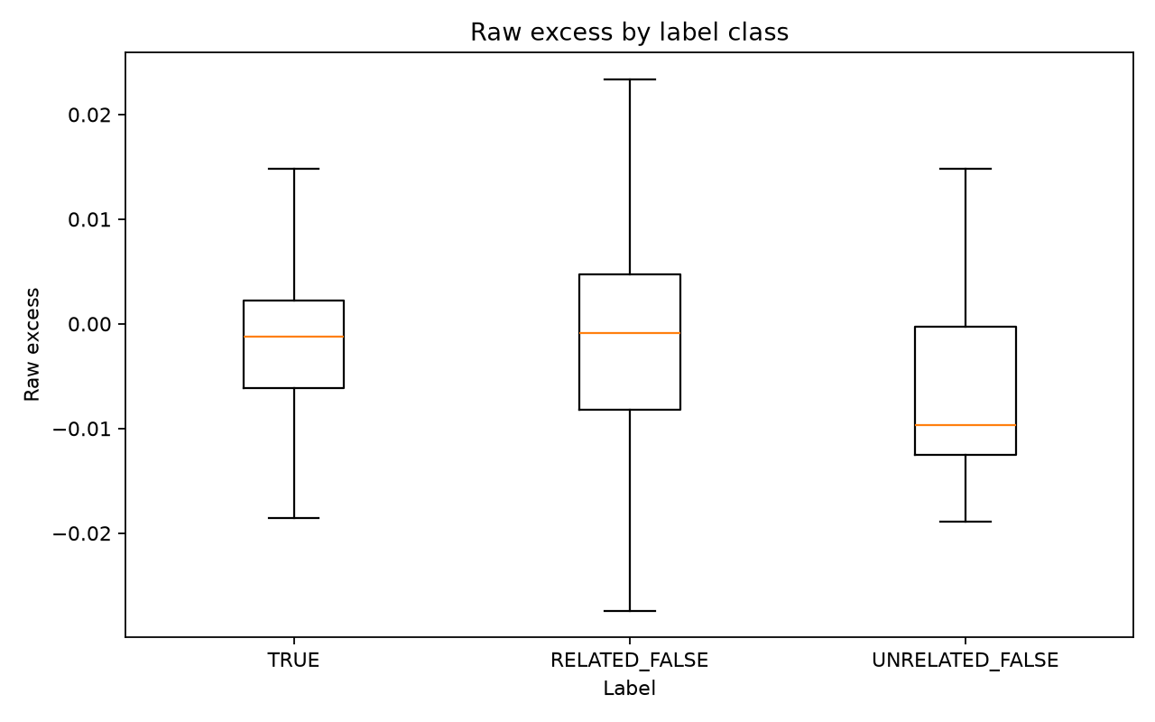
Figure 1b. Deletion excess by claim label.
The controls say why. True claims in this data tend to be safe and generic (“this is a structured review”), while fabrications supply names, dates, and exact continuations, and a specific guess pins down the activation’s topic better than a safe summary does. When I held specificity fixed with matched pairs of paraphrases and same-topic false substitutes, truth cost almost nothing, about 0.001 MSE against per-claim noise of 0.037. The reconstructor is not asleep: genuine explanations reconstruct far better than shuffled text, source copies, or mismatched explanations. It reads meaning and gist closely. It just has no reason to care whether the details are real, because nothing in its training loss ever asked it to.
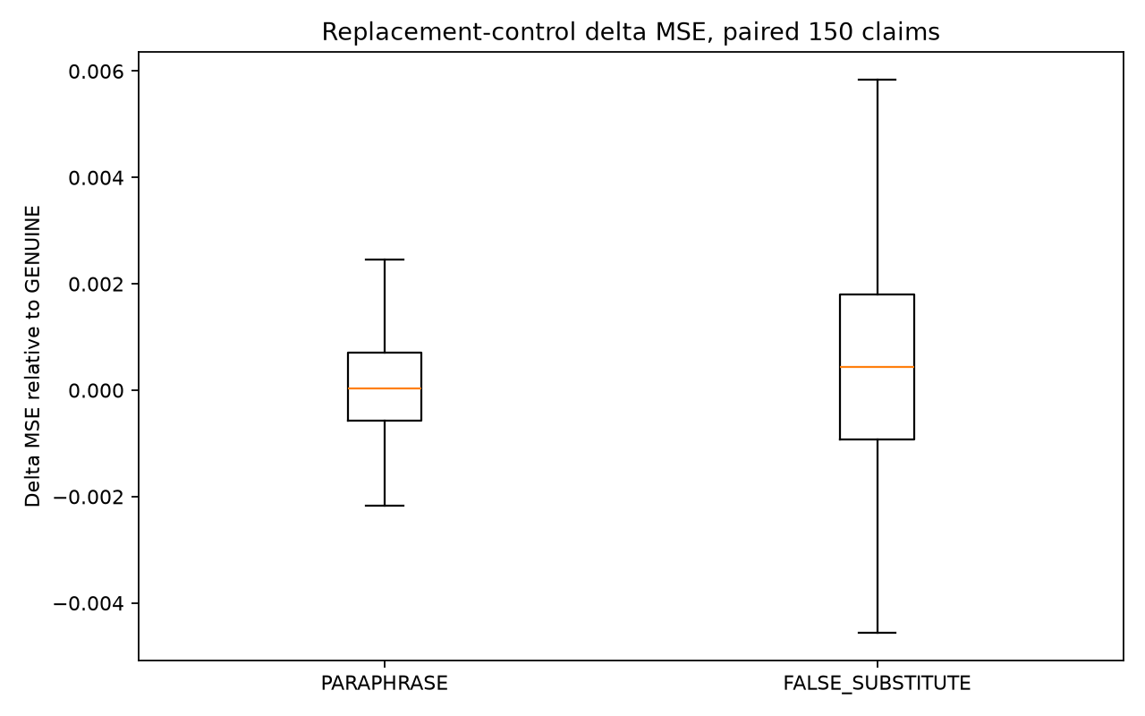
Figure 2a. Meaning-preserving paraphrases versus same-topic false substitutions.
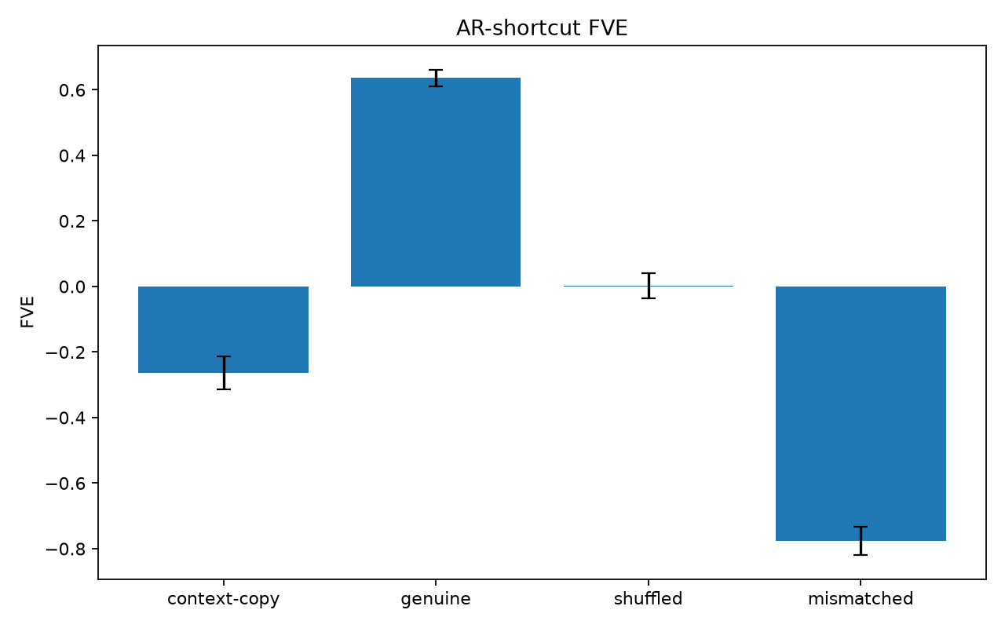
Figure 2b. Reconstruction quality for genuine explanations and shortcut controls.
What does work is boring and cheap: consistency. A claim that keeps reappearing when I decode the nearby token positions is more likely true, AUROC 0.665, and even a crude version of that filter lifts claim precision from 40% to 56% while keeping two thirds of the true claims. Two baselines put this in perspective. A DeepSeek v4 judge that reads only the explanation is at chance, 0.522, fooled by the same plausible fabrications. Given the source text, the same judge reaches 0.920. So the information needed to verify a claim is not in any single explanation, is partly recoverable across resamples, and is only fully there in ground truth that a deployed NLA does not have.
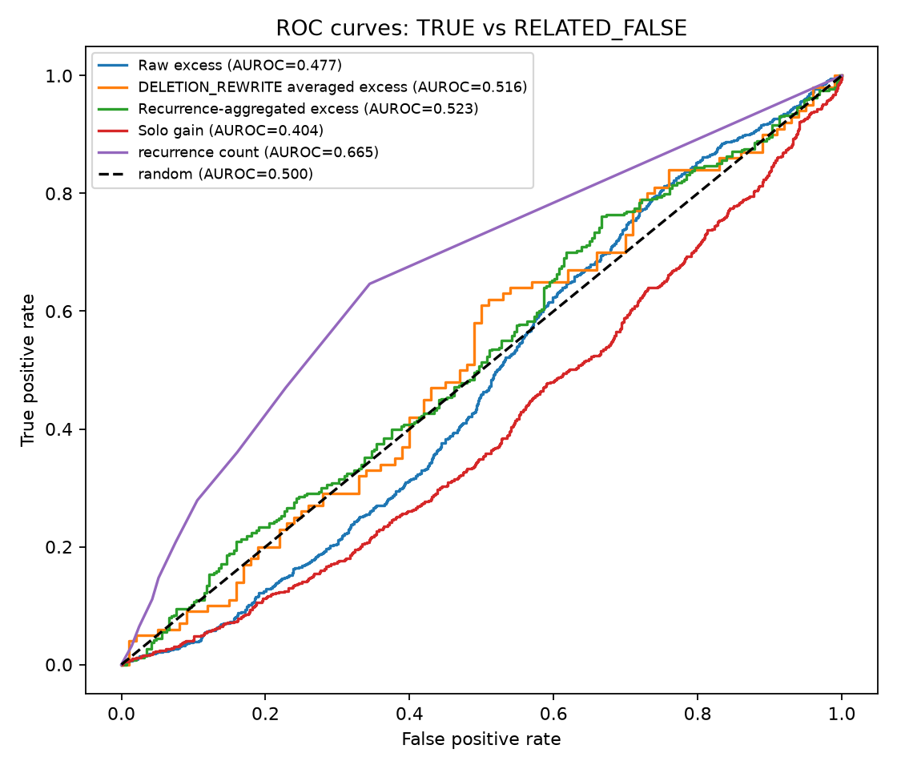
Figure 3a. ROC curves for reconstruction scores and recurrence.
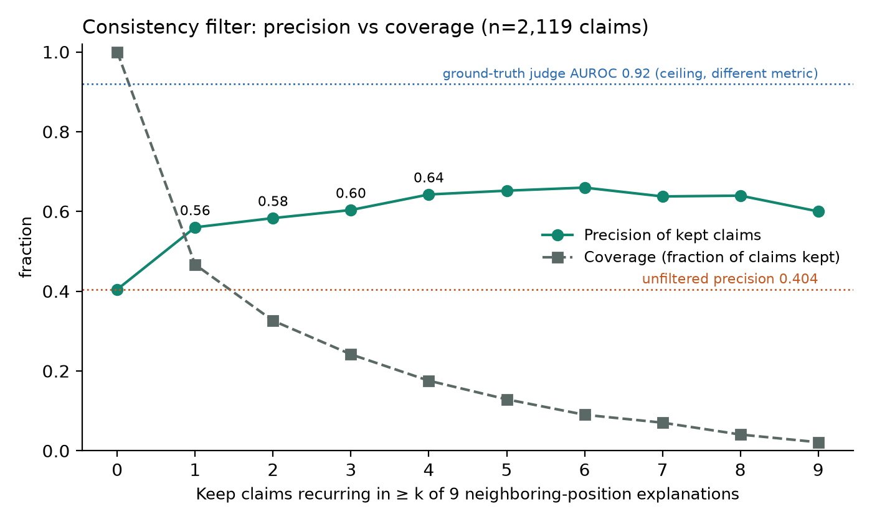
Figure 3b. Consistency filter: precision against coverage as the recurrence threshold rises.
This is one community checkpoint, so I read it as a per-claim verifier failing to replicate, not as a contradiction of Anthropic’s aggregate observation. Both can be true. My next step would be the same experiment on the independently trained Gemma-3-27B NLA, to see whether the inversion and the signal-to-noise gap survive a second model.

Main project write-up

Seven labeled examples
The first five rows are the first five claims of the seed-1 sample drawn for a blind-labeling pass. The sample was fixed by seed before any labels were viewed. The last two are the opposing high-magnitude cases I chose after reading the extreme-case set.
ID | Dataset label | Claim | Check against the source
c173/0/001 | RELATED_FALSE | “Each diff line is annotated with a comment or unchanged marker.” | The source is a grep result followed by ordinary Go logging lines. It contains no diff annotations or unchanged markers.
c180/0/006 | UNVERIFIABLE | “It probably involves a git commit hash or timestamp.” | The visible text ends inside a checkpoint options struct. The claim guesses at fields beyond the cutoff.
c299/0/003 | RELATED_FALSE | “The text is transitioning from genetics to evolutionary game theory.” | The passage remains on Lewontin’s work in population genetics.
c086/0/001 | TRUE | “The text has a formal critical register, structured review covering production, cast, and narrative background.” | A first-person review of the Les Misérables film that touches on production, performances, and story, but in an informal, loosely structured register (“this is America after all”). Blind, I labeled it RELATED_FALSE; the labeling model called it TRUE. A borderline case, included as-is.
c133/0/001 | TRUE | “The feedback has consistent formatting rules.” | The source is regular lint and Go test output with repeated test-name and status formatting.
c079/0/006 | RELATED_FALSE, chosen anchor | “Nov.” repeats an earlier “Nov. 24.” | The source is about golf events in May and June. Deleting the claim raises MSE from 0.256 to 0.896, raw excess +0.630. The mechanical deletion leaves a dangling sentence, so I treat the magnitude cautiously.
c185/0/003 | RELATED_FALSE, chosen anchor | “The log is now listing related file versions in chronological descending order.” | The source contains one grep result and a read call, with no version list. Deleting the claim improves MSE from 1.032 to 0.488, raw excess -0.614. This edit also leaves a punctuation scar.

Setup
I used the public Qwen3.6-27B community NLA at layer 42 with the iteration-300 verbalizer adapter. The smoke run reached 0.782 fraction of variance explained, in line with the released checkpoint trajectory. The dataset contains 300 contexts: 100 pretraining-like web passages, 100 chat and agent transcripts, and 100 knowledge-dense Wikipedia passages. For each context I extracted activations at its final ten token positions. The verbalizer produced one temperature-1 explanation at every position and three extra samples at the final position, giving 3,900 explanations.
The primary explanations were split into 2,971 atomic claims and labeled TRUE, RELATED_FALSE, UNRELATED_FALSE, or UNVERIFIABLE by a fixed labeling prompt that saw the source. 2,153 claims describe the source text and 818 describe model cognition; only the former have ground truth. Among context claims the labels were 860 TRUE, 1,283 RELATED_FALSE, 8 UNRELATED_FALSE, and 2 UNVERIFIABLE. Dropping the 24 claims whose wording could not be located verbatim in their explanation, plus the 10 claims outside the two main labels, leaves the headline set of 857 TRUE and 1,262 RELATED_FALSE. For each eligible claim I scored the full explanation, a mechanical deletion, three length-matched random-span deletions, and the claim by itself. A stratified 200-claim subset also received three fluent deletion rewrites. The main score is:
deletion excess = change in MSE after claim deletion - mean change in MSE after three random-span deletions
Higher scores were fixed in advance to predict TRUE. AUROCs and 95% intervals use 1,000 context-level bootstrap samples, since claims from one context are correlated. The outcome table and pass/fail thresholds were written before scoring.

Results

1. Deletion cost does not separate truth from plausible fabrication
I expected at least a weak signal here. Raw deletion excess gives AUROC 0.477 [0.452, 0.502] for TRUE against RELATED_FALSE. The result is near chance in all three data strata at 0.469, 0.488, and 0.473. Fluent rewrite deletion reaches 0.516 [0.440, 0.597], so the null is not rescued by cleaner editing.
The scale of the noise makes the result easier to understand. The paired false-substitute control changes MSE by about +0.0010. Deletion excess has standard deviation 0.0368, about 37 times larger. Typical edit wording is much smaller: the median within-claim standard deviation across three fluent rewrites is 0.0008. The TRUE-minus-RELATED_FALSE mean gap is -0.0022 with a naive claim-level standard error of 0.0015. Even a real aggregate trend of this size would be buried at the level of one claim.

2. Deletion and solo scoring measure reconstruction weight
The deletion null and solo inversion are two views of reconstruction weight. Deletion asks how much a claim matters inside its explanation. Solo asks how much it carries by itself. Solo gain reaches 0.404 [0.379, 0.430], with related false claims reconstructing better on average.
A specificity effect is a plausible explanation. TRUE claims skew generic, while RELATED_FALSE claims skew toward names, dates, and precise continuations. The paired replacement experiment holds specificity roughly fixed: paraphrases move MSE by about 0.0000 on average, and same-topic false substitutes by about +0.0010, with the false version worse in 93 of 150 pairs. Reconstruction reads the topic and useful detail, but barely registers whether the detail is supported.
The example that made this click for me is 491 versus 490. If an activation weakly carries “around 490,” writing 490 can help reconstruction more than omitting the number, even when the source answer is 491. The training loss rewards reconstruction, KL control, and length. It does not directly reward factual support.
A cleaner individual case is c161/0/003. Its source is a grep result about SessionID, while the NLA invents a repeated Snapshot and BackupPath pattern. Three fluent deletions raise MSE from 0.321 to between 0.349 and 0.352, giving rewrite excess 0.0249. The false detail is useful to the reconstructor even after removing the broken-text concern from the two extreme anchors.

3. The reconstructor reads meaning and gist
The negative result is not explained by a dead reconstructor. Genuine explanations achieve mean FVE 0.637 [0.610, 0.661], compared with 0.002 [-0.037, 0.040] for shuffled explanations, -0.263 [-0.314, -0.212] for source copies, and -0.777 [-0.818, -0.733] for mismatched explanations. Paraphrases barely change MSE, and deletion excess has small correlations with claim length and position, 0.025 and 0.096. The instrument reads broad meaning. Truth is the missing part on this comparison.

4. Stability under resampling is more useful than reconstruction weight
Recurrence across nine nearby token positions reaches AUROC 0.665 [0.643, 0.688], around 0.19 above raw deletion. The explanations were freshly sampled at each position. Weakly encoded specifics can change from one decode to the next, while stronger information reappears. This makes recurrence a rough proxy for encoding strength and connects it to Anthropic’s adjacent-token heuristic.
The practical curve is modest but useful. Precision is 40% without filtering, 56% when keeping claims seen at one nearby position, and 64% at four positions. Coverage falls from 100% to 47% and 18%, so this is a filter with a real cost. A rough mechanical overlap matcher produced these counts and correlates 0.41 with separate recurrence judgments. Better semantic matching may improve the curve, but consistently encoded false associations will still limit it.
The judge baselines locate the bottleneck. DeepSeek given only the explanation reaches 0.522 [0.471, 0.570]. With source text it reaches 0.920 [0.894, 0.944]. Plausible fabrications fool a reader who lacks the source as easily as they fool the reconstructor. The problem is information access, not task difficulty.

5. Relation to Anthropic’s pilot
Anthropic reported that true-claim deletion hurts reconstruction more in aggregate on its Opus 4.6 NLA, while also calling the result noisy per transcript. Both results can hold. Their aggregate trend may exist, but it does not give a usable per-claim verifier on this checkpoint. This study cannot show that every reconstruction-based verifier will fail.
A context fact-check reward could reduce claims that can be checked against the input. It has no answer key for claims about model cognition, which are often the point of an audit. If the solo inversion repeats elsewhere, the guessing pressure may survive in that uncheckable region. Recurrence can still be computed there, though recurrence does not prove that a cognition claim is true.

What I verified
- I hand-labeled two 50-claim samples. On a seed-0 sample whose key I had seen once a week earlier, agreement with the model labels was 46/50 (92%), one TRUE-to-FALSE crossing. On a fresh seed-1 sample I had never seen, agreement was 43/50 (86%) with three TRUE-to-FALSE crossings, and in all three I judged a model-TRUE claim to be RELATED_FALSE. My labels were stricter than the model’s on both samples, so the 59.6% fabrication rate is more likely an undercount than an overcount. A separate pass by a second model family agreed on 43/50 of the seed-0 sample.
- I independently recomputed the headline AUROC from the claim scores. It matched at 0.4774.
- I inspected the high-magnitude cases against their source text and edits. That is where I caught the dangling-text problems in c079/0/006 and c185/0/003, then looked for the cleaner c161/0/003 example.
- I gated the analysis with hand-computable AUROC, score-polarity, context-bootstrap, and edit fixtures. All four golden tests passed before the data path ran.
- I calibrated activation extraction against five released fixtures. The selected layer-42 convention reached cosine similarity 0.9998 to 0.9999 on all five.
- I investigated the only activation-norm tripwire, one row out of 3,000. It was a token-specific spike on the JSON delimiter ":, so I kept and flagged it, then reran the headline analysis without it. The result did not move.
- I used batched generation only after an eight-fixture FVE equivalence check passed, and batched AR scoring only after every row stayed below the 1% relative-difference threshold.

Limitations
This is one Qwen3.6-27B NLA checkpoint. The result needs an independently trained NLA before it supports an objective-level claim.
The labels are model-generated. Human agreement was 92% on an exposed sample and 86% on a clean one, with the disagreements running toward stricter human labels. Label noise of this size cannot create a signal where there is none, but it could dilute a weak one.
The recurrence count uses a crude token-overlap matcher. Its AUROC may understate a better semantic matcher, while its 0.41 correlation with separate judgments shows that the current count is noisy.
Only eight eligible claims were UNRELATED_FALSE, so the easy off-topic comparison is too small to carry much weight. The project is built around the better-powered TRUE versus RELATED_FALSE margin.
Mean genuine-explanation MSE was 1.60 times the smoke reference, so the scored contexts are shifted from the checkpoint fixtures. The FVE and shortcut controls still behave sensibly, but another dataset is worth checking.
Some mechanical deletions damage grammar. The three-rewrite subset addresses this directly and remains at chance, but it is smaller and has a wide interval.
The analysis verifies context claims because they have ground truth. It cannot directly establish the truth of claims about internal cognition.

Next steps
If I had another 20 hours I would not add more controls to this checkpoint. I would rerun deletion and solo scoring on Anthropic’s released Gemma-3-27B NLA using the same contexts, labels, and analysis code. I would add a fresh human label pass and compare recurrence from repeated samples of one activation with recurrence across neighboring positions. If the inversion repeats, I would then test whether context fact-check reward training removes it or only moves it into claims that cannot be checked.

Appendix

Time
Active research time: [INSERT ACTUAL TOGGL TOTAL]
Write-up time: [INSERT ACTUAL WRITE-UP TOTAL]
Excluded from the clock: [INSERT ONLY ITEMS ACTUALLY EXCLUDED, SUCH AS GENERAL PREP, GPU SETUP, OR WAITING]. Unattended agent and GPU runtime while I was not working is treated like waiting for training and is not counted; the hours above are my active time.
[PASTE TOGGL SCREENSHOT HERE]

LLM and agent usage
Models: Claude Fable 5.1 in Claude Code as the primary collaborator for design discussion, orchestration, analysis code, and critique; Claude Sonnet 5 subagents for claim splitting, labeling, paraphrase and rewrite generation, and recurrence judgments, each under a fixed prompt with programmatic gates; DeepSeek v4 for the two judge baselines. Agents wrote the pipeline code, ran the Modal jobs, and produced the figures.
What I did myself: chose the question and the TRUE versus RELATED_FALSE framing, fixed the outcome table and thresholds before scoring, read the claim-splitting and paraphrase previews before each fan-out was approved, hand-labeled 50 claims, read all 40 extreme cases against their source text and edits, wrote the interpretation before any drafting help, and recomputed the headline AUROC and the paragraph-11 standard error independently.
How slop was kept out: every generation stage was gated by asserts on counts, label vocabularies, and span matching; the analysis is gated by four golden tests including a hand-computed AUROC and a sign-flip fixture; activation extraction was calibrated against Anthropic’s released fixtures; batching was adopted only after equivalence checks. The draft of this document was AI-assisted from my interpretation notes, and I then checked every number against the saved metrics files.
How surprised I would be by a major error: very surprised in the headline AUROC, the label distribution, and the controls, which were computed two ways and gated. Moderately surprised in the recurrence counts, which rest on a crude matcher validated only against one noisy reference. Least surprised in the agent-written join between explanation samples and their sibling scores, which I reviewed only through its previews and gates rather than line by line.

Links
- Public repository: [INSERT PUBLIC REPOSITORY LINK]
- Anthropic NLA paper: https://transformer-circuits.pub/2026/nla/
- Qwen3.6-27B NLA checkpoint: https://huggingface.co/ceselder/qwen3.6-27b-nla-rl
- Analysis report: nla-verifier/results/analysis_report.md
- Main metrics: nla-verifier/results/phase6_metrics.json
- Judge baselines: nla-verifier/results/judge_baselines.json
- Consistency-filter data: nla-verifier/results/consistency_filter_curve.json
- Figures: nla-verifier/results/figs/ (forest plot fig5_forest_plot.png, filter curve fig6_consistency_filter.png)

Submission checklist
Remove this checklist before submitting.
- Replace the time, screenshot, name, and repository placeholders.
- Keep the main text under about eight Google Doc pages before the appendix.
- Set Share to “Anyone with the link” and Viewer.
- Open the link in an incognito window and confirm that it works without signing in.

