### **Project Report on Girl Talk Website**

**Project Title**: Girl Talk

**Objective**: The purpose of the Girl Talk website is to create a supportive online platform for users to discuss health, hygiene, and personal experiences. The website allows users to sign up, log in, post messages anonymously, engage in secret chat discussions, and track their menstrual cycles.

### ***Overview of Files and Functionality***

#### **1. index.php**

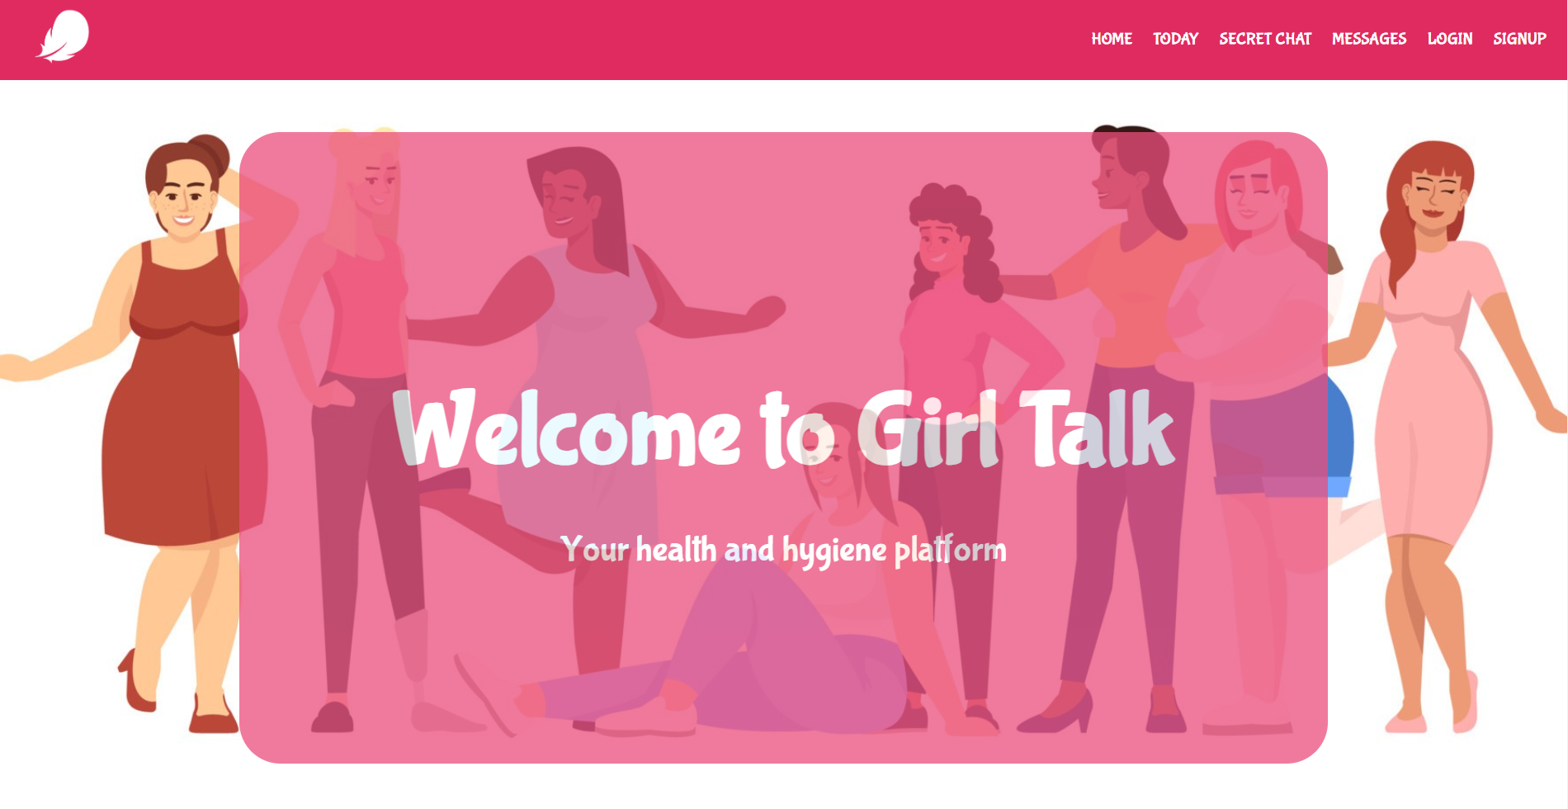

* **Functionality**: The home page of the website. It includes navigation links to various sections like Messages, Secret Chat, and Today. It also provides an introduction to the platform.
* **Features**:
  + Displays a welcome message and the main features of the site.
  + Navigation menu based on user authentication status (logged in or not).

#### **2. login.php**

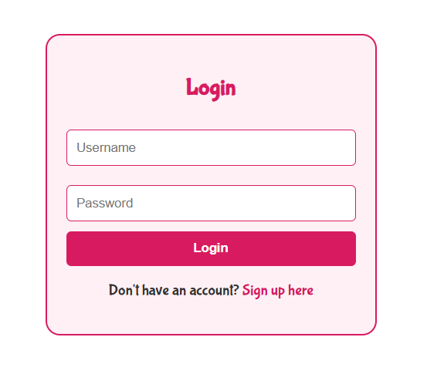

* **Functionality**: Handles user authentication. It allows existing users to log in by entering their username and password.
* **Features**:
  + Validates user credentials against the database.
  + Redirects users to the home page upon successful login.
  + Displays error messages for failed logins.

#### **3. logout.php**

* **Functionality**: Logs the user out by destroying the session.
* **Features**:
  + Clears the session data and redirects the user to the home page.

#### **4. messages.php**

* **Functionality**: A platform for users to post and view messages anonymously.
* **Features**:
  + Displays messages from a text file in reverse order.
  + Allows users to submit their own messages through a form.
  + Uses file handling to save and retrieve messages.

#### 

#### 

#### 

#### **5. secret_chat.php**

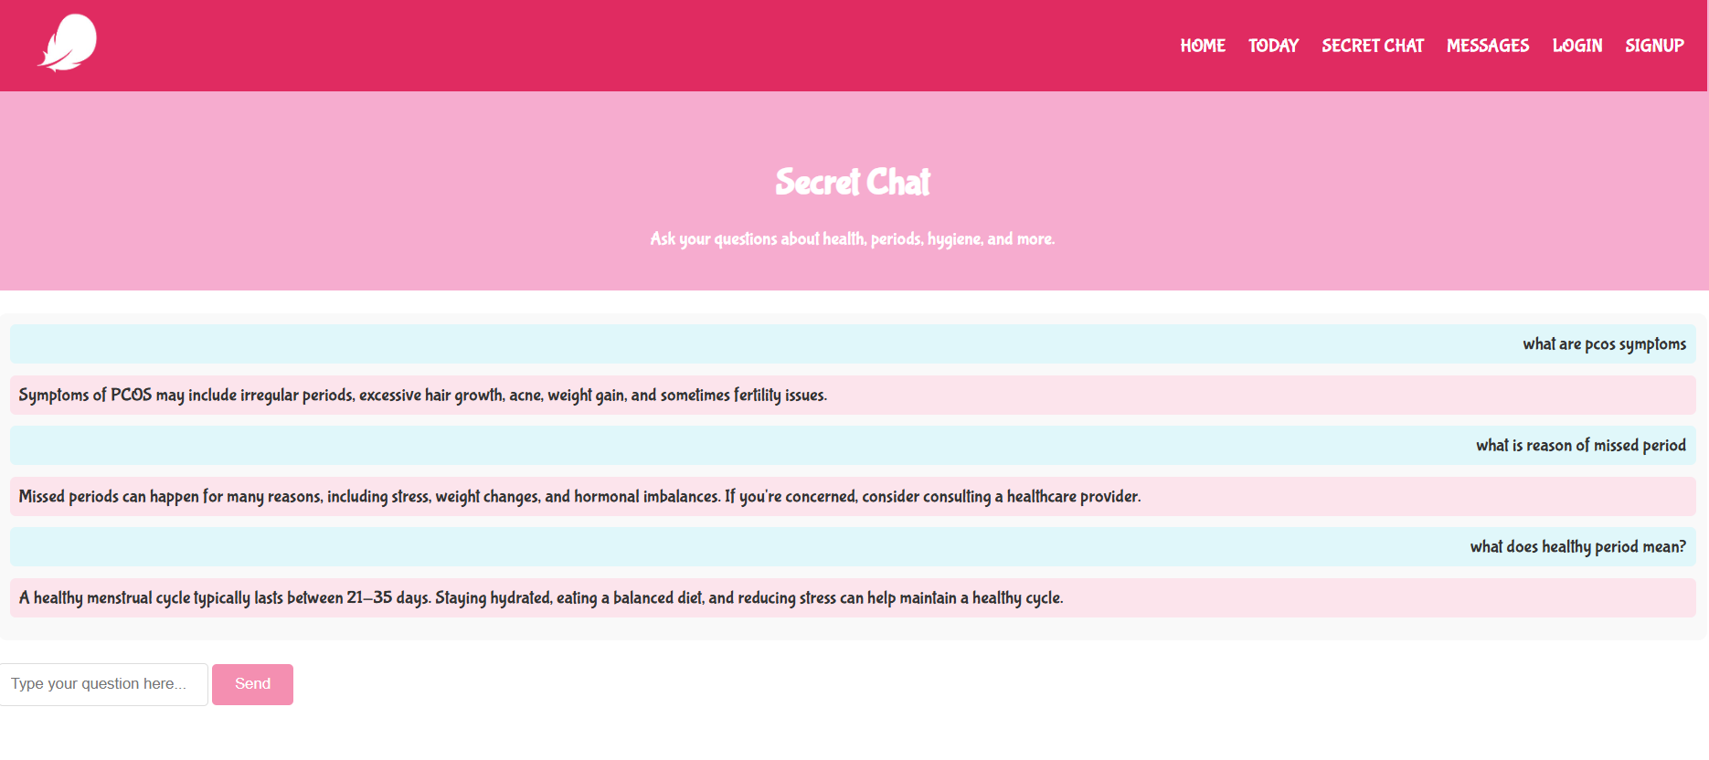

* **Functionality**: A chat interface where users can ask questions related to health and receive predefined responses.
* **Features**:
  + JavaScript functions to display user and bot messages.
  + Predefined responses based on common health inquiries.
  + Provides an interactive chat experience.

#### **6. Signup.php**

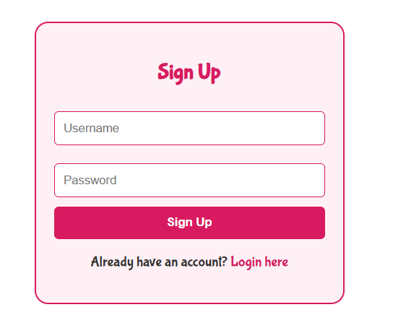

* **Functionality**: Allows new users to register for an account.
* **Features**:
  + Validates username and password inputs.
  + Checks for existing usernames to avoid duplicates.
  + Saves new user credentials securely in the database.

#### **7. today.php**

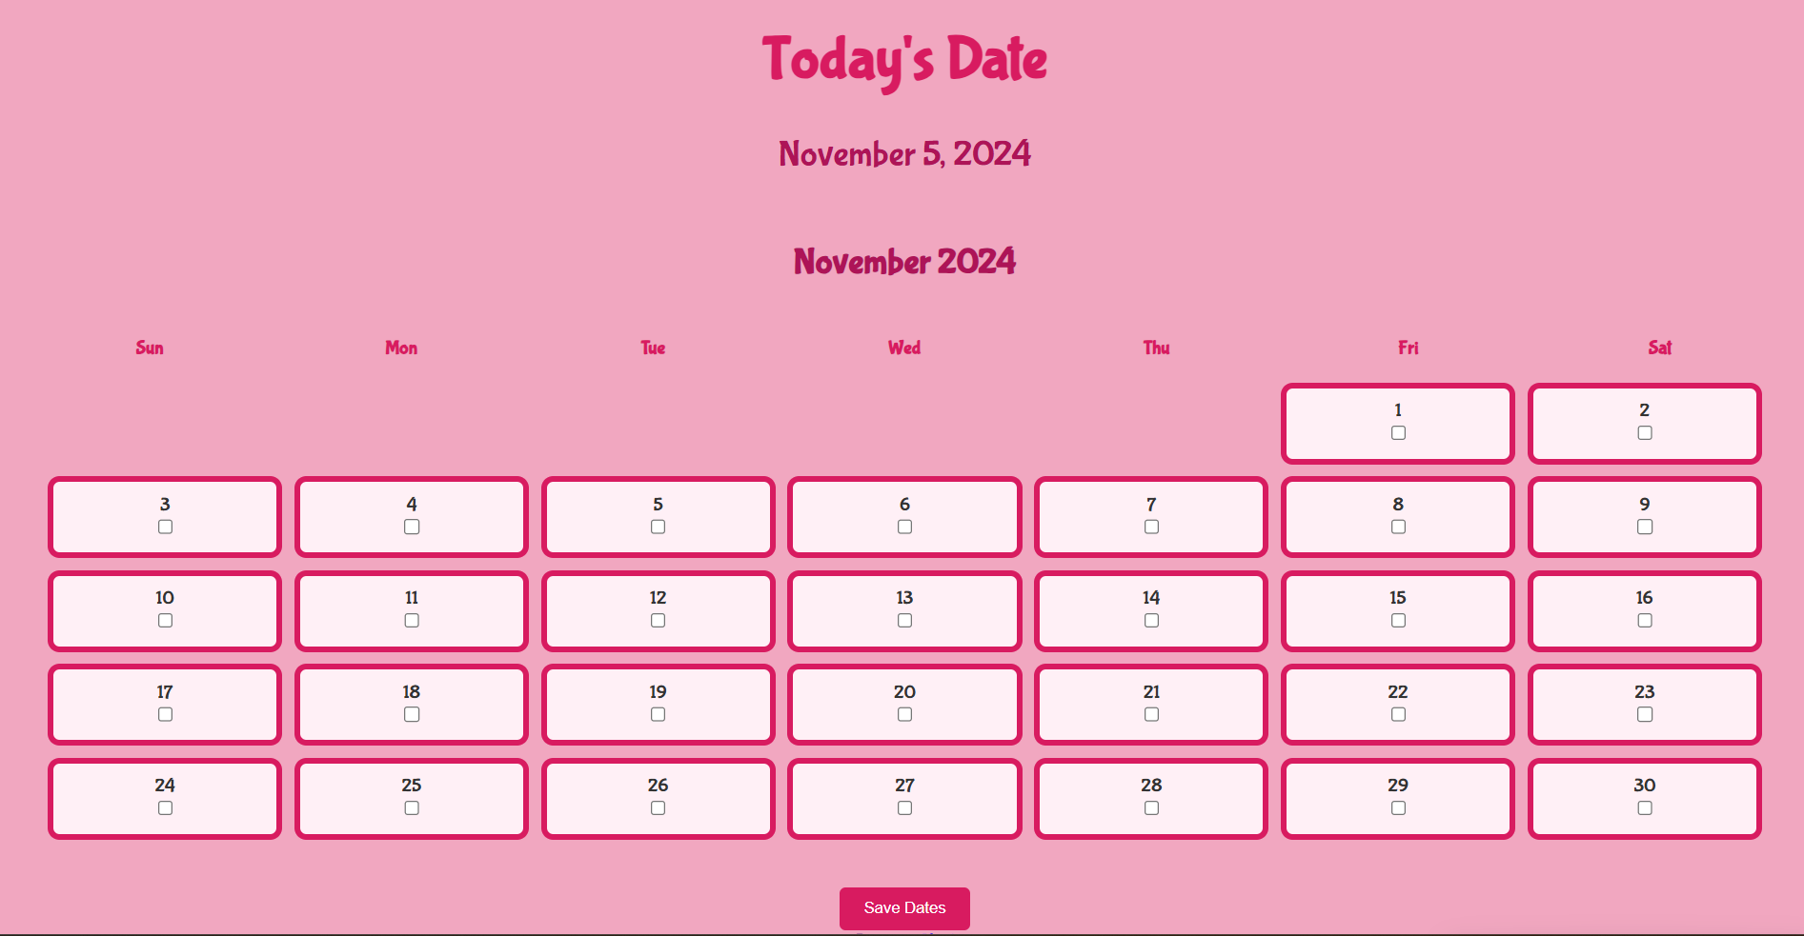

* **Functionality**: Allows users to track their menstrual cycles by selecting dates on a calendar.
* **Features**:
  + Displays a calendar with checkboxes for users to select their period dates.
  + Saves selected dates in the database for retrieval.
  + Navigates between months and years.

#### **8. styles.css and styles2.css**

* **Functionality**: These files define the visual styles for the website.
* **Features**:
  + Styles for headers, navigation, buttons, messages, and chat interfaces.
  + Responsive design elements to enhance user experience.

### 

### ***Database Structure***

**Entity-Relationship Diagram (ERD)**

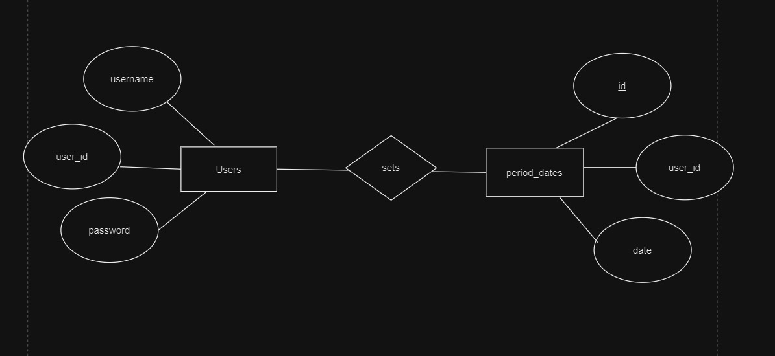

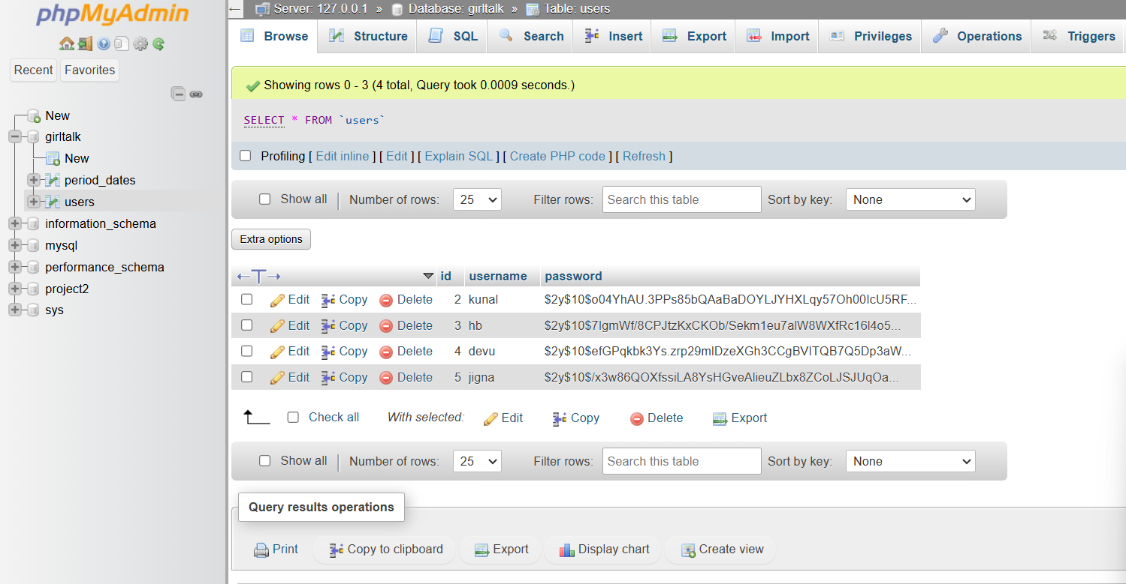

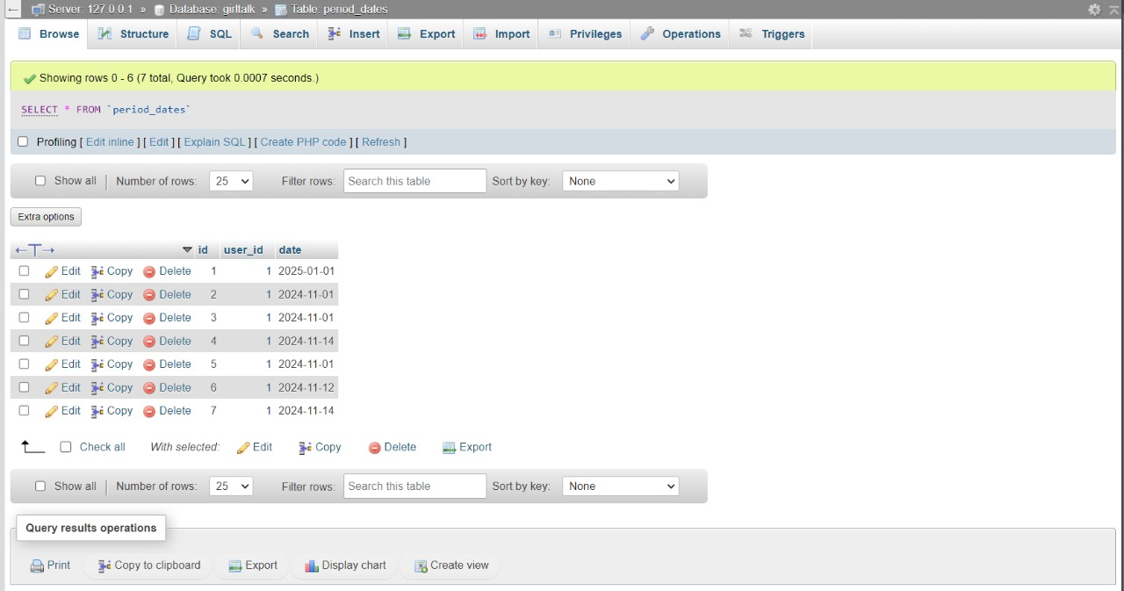

* **Users Table**: Stores user credentials.
  + user_id: Primary key, unique identifier for users.
  + username: User's unique username.
  + password: User's hashed password for security.
* **Period Dates Table**: Stores dates related to users' menstrual cycles.
  + user_id: Foreign key linking to the users table.
  + date: Date of the period

### ***Functionality Explanation***

1. **User Authentication**: The website employs session management to keep track of user login states. Users can register, log in, and log out securely.
2. **Message Posting**: Users can share their experiences anonymously, fostering a community of support.
3. **Secret Chat Functionality**: Users can interact with a bot that responds to common health questions, providing a safe space to seek information.
4. **Menstrual Cycle Tracking**: The calendar feature in today.php allows users to check their periods, enhancing awareness of their health. The data is dynamically saved to the database.
5. **Responsive Design**: The website’s CSS ensures that the layout is user-friendly and visually appealing, which is critical for engaging the target audience.

### ***Conclusion***

The Girl Talk website serves as an essential resource for users seeking support and information on health and hygiene matters. Its interactive features, combined with a clean and appealing design, provide an inviting environment for discussion and sharing. The project effectively combines front-end user experience with back-end data handling to create a cohesive and functional web application.