**Summer Internship Project-3**

**Create an ER model and Db Design Food Items and Ingredients**

**ER Model**

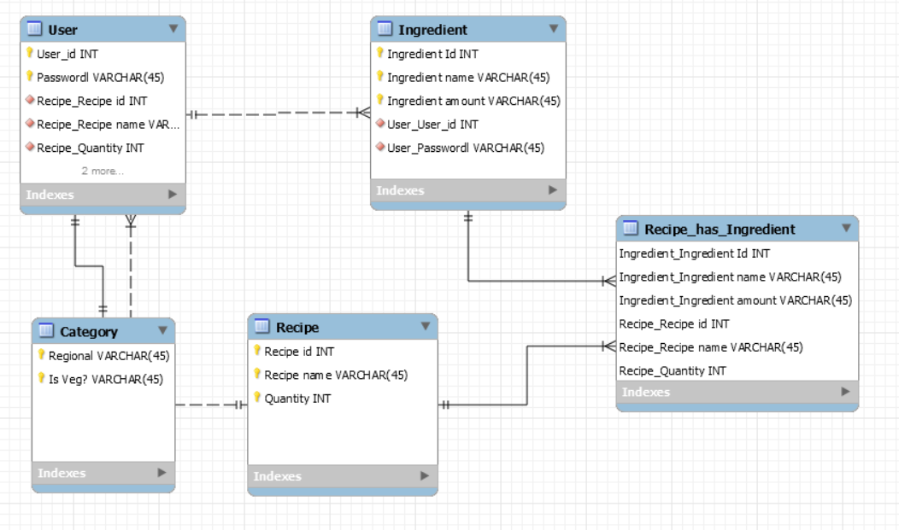

**Normalization**

**1NF**

|  |  |  |  |  |  |  |  |  |  |
| --- | --- | --- | --- | --- | --- | --- | --- | --- | --- |
| User_id | Password | Regional | Is Veg? | Recipe id | Recipe name | Quantity | Ingredient Id | Ingredient name | Ingredient  Amount |
| 1001 | het@nshu | North | Yes | 1 | Kadai Paneer | 1 | 100 | Paneer,Tomato | 100gm |
| 1005 | het@nshu123 | North | No | 8 | Mutton Curry | 2 | 101 | Mutton | 500gm |
| 1008 | het@nshu17 | South | Yes | 6 | Uttapam | 1 | 110 | Rice | 100gm |
| 1100 | het@nshu20 | North | Yes | 1 | Kadai Paneer | 4 | 100 | Paneer,Tomato | 100gm |

**2NF**

|  |  |
| --- | --- |
| Ingredient Number | Ingredient Amount |
| 1 | 100gm |
| 5 | 500gm |

|  |  |  |  |  |  |  |  |  |  |
| --- | --- | --- | --- | --- | --- | --- | --- | --- | --- |
| User_id | Password | Regional | Is Veg? | Recipe id | Recipe name | Quantity | Ingredient Id | Ingredient name | Ingredient  Number |
| 1001 | het@nshu | North | Yes | 1 | Kadai Paneer | 1 | 100 | Paneer,Tomato | 1 |
| 1005 | het@nshu123 | North | No | 8 | Mutton Curry | 2 | 101 | Mutton | 5 |
| 1008 | het@nshu17 | South | Yes | 6 | Uttapam | 1 | 110 | Rice | 1 |
| 1100 | het@nshu20 | North | Yes | 1 | Kadai Paneer | 4 | 100 | Paneer,Tomato | 1 |

**3NF**

|  |  |
| --- | --- |
| Ingredient Number | Ingredient Amount |
| 1 | 100gm |
| 5 | 500gm |

|  |  |  |  |  |  |
| --- | --- | --- | --- | --- | --- |
| Recipe No. | Recipe id | Recipe name | Ingradient Id | Ingredient name | Ingredient  Number |
| 10 | 1 | Kadai Paneer | 100 | Paneer,Tomato | 1 |
| 15 | 8 | Mutton Curry | 101 | Mutton | 5 |
| 25 | 6 | Uttapam | 110 | Rice | 1 |

|  |  |  |  |  |  |
| --- | --- | --- | --- | --- | --- |
| User_id | Password | Regional | Is Veg? | Quantity | Recipe No. |
| 1001 | het@nshu | North | Yes | 1 | 10 |
| 1005 | het@nshu123 | North | No | 2 | 15 |
| 1008 | het@nshu17 | South | Yes | 1 | 25 |
| 1100 | het@nshu20 | North | Yes | 4 | 10 |

**4NF**

|  |  |
| --- | --- |
| Ingredient Number | Ingredient Amount |
| 1 | 100gm |
| 5 | 500gm |

|  |  |  |  |  |  |
| --- | --- | --- | --- | --- | --- |
| Recipe No. | Recipe id | Recipe name | Ingradient Id | Ingredient name | Ingredient  Number |
| 10 | 1 | Kadai Paneer | 100 | Paneer,Tomato | 1 |
| 15 | 8 | Mutton Curry | 101 | Mutton | 5 |
| 25 | 6 | Uttapam | 110 | Rice | 1 |

|  |  |  |  |  |
| --- | --- | --- | --- | --- |
| Product No. | Regional | Is Veg? | Quantity | Recipe No. |
| 1 | North | Yes | 1 | 10 |
| 2 | North | No | 2 | 15 |
| 3 | South | Yes | 1 | 25 |
| 4 | North | Yes | 4 | 10 |

|  |  |  |
| --- | --- | --- |
| User_id | Password | Product No. |
| 1001 | het@nshu | 1 |
| 1005 | het@nshu123 | 2 |
| 1008 | het@nshu17 | 3 |
| 1100 | het@nshu20 | 4 |