25dcs023

Practical6.1:
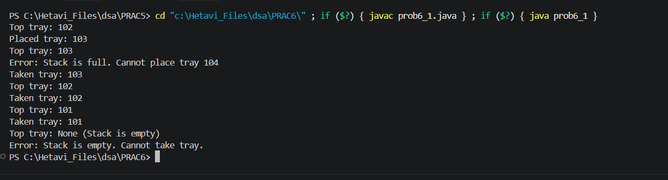

Practical6.2:
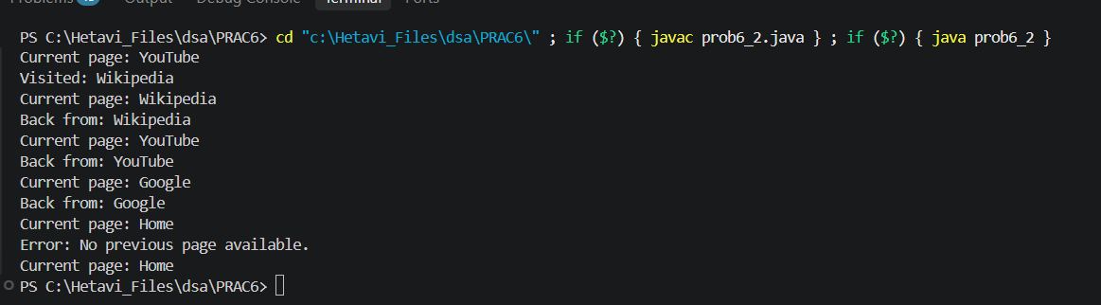

Practical6.3:
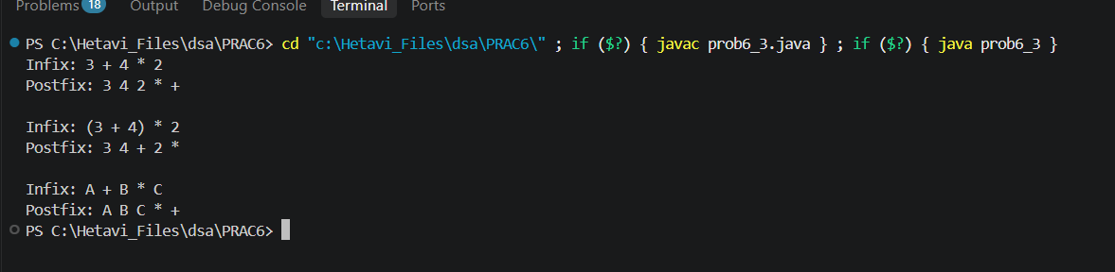
https://github.com/HetaviDesai/DSA-LABA-/tree/main/PRAC6

