25dcs023

Practical8.1:
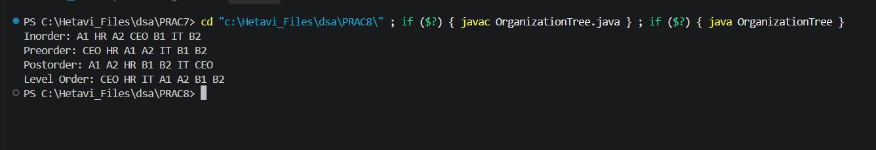

Practical8.2:
