浙江理工大学研究生学位论文修改及定稿表

研究生姓名 | Patience Fero |  | 导师 | 杨君 | 学院 | 应用经济学
专业 | 经济管理学院 |  |  | 答辩时间 | 2026年05月21日
学位论文题目 |  | Does Capital Market Liberalization Drive Digital Transformation? Evidence from Chinese A-Shares' Inclusion in the MSCI Emerging Markets Index
对论文的修改情况说明：
1. Measurement: The digital transformation index is a text-based proxy, so it reflects disclosure intensity rather than direct investment.
2. Identification: Treat TWFE as a benchmark only; use the modern staggered-DID results as the main interpretation.
3. Mechanisms: Financing is better read as structure adjustment, governance evidence needs caution, and knowledge spillover should remain theoretical.
4. Scope: Effects depend on estimator choice, measurement, and firm implementation capacity, and the evidence is China-specific.
5. Abstract revision: Correct the Chinese and English abstracts using the supervisor-provided translation, and make the wording clearer and more accurate.

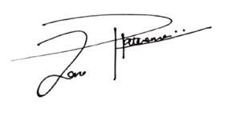
论文作者： 2026年5月 21 日
导师意见（对论文修改情况和定稿意见）

导师： 2026年 5月 21 日

