Vehicle Monitoring System Based on Mobile Devices

Sergey Roytman

Faculty of Computer Science, School of Software Engineering

National Research University Higher School of Economics

Moscow, Russia

siroytman@edu.hse.ru

***Abstract* — Last twenty years, vehicle monitoring systems have experienced significant rise in popularity and complexity. This article describes the key concepts of such systems. After explaining key concepts, this article will offer reason why different set of tools is needed, how it will make a difference and how it will affect the industry.**

***Keywords — programming, vehicle monitoring system, GPS, GPS tracker, Android***

# Introduction

First vehicle monitoring system was developed in 1982 and in 1994 the final of the first twenty-four satellites was launched, and the GPS system was considered fully operational. Since than vehicle monitoring systems were improved dramatically. Modern solutions offer online fleet management systems, which include a wide-range functionality of vehicle monitoring. Commonly such systems are used for monitoring vehicle location, plan vehicle maintenance, observe driver’s productivity and driving style deviations such as over-speeding [1] or alcohol detection [2]. That kind of systems is suitable for fleet management such as delivery trucks, taxi service, public transport, garbage trucks or business trips controlling.

Most of such solutions have a hardware approach to the problem: they require physical GPS tracker, which connects to the vehicle on-board software in order to obtain and send to the server all desired information about the car state. These devices usually are released by the same company which provides the monitoring system service and are to be bought separately. This research goal is to provide and proof solution to this problem in case of using Android applications instead of GPS tracker. That approach will save money for the specific hardware by replacing it with highly spread among vehicle drivers Android devices.

The application installed on Android will already have built-in mechanisms to determine its location and with use of the tools, which have ability to connect to the on-board computer using Bluetooth, it gains ability to completely cover modern vehicle monitoring systems functionality by accessing fuel level, mileage and other metrics available to on-board software.

The research is based on the number of studies, which can be found in “References” block. The newness of this particular research is using Android device as data transmitter instead of other hardware devices.

Expected result of this study is to develop Android application written in Java, web-application consisted of backend server written in C# with help of ASP .NET Core framework and frontend part written in JavaScript and React framework. The Android application will have functionality of recording the vehicle data to the database, managing driver’s tasks and communicate with system operator. Web application will have functionality of aggregating, visualizing and managing the data of vehicles fleet, web application is used by system operator.

The paper is organized in the following way: in the first part of this article modern vehicle monitoring systems principals are observed, in the second part of the article the alternative solution will be taken in sight.

# Existing solutions

Modern vehicle monitoring systems global market and especially Russian one is divided by accordingly small number of companies. This article will pay more attention to the Russian market. In Russia the market dominants are the following companies: Wialon, Omnicomm, Autograph. In general companies provide similar range of functionality with a few differences.

The main difference is GPS tracker devices supportability. GPS trackers in such systems connect directly to the on-board vehicle computer, receive vehicle operational statistics and vehicle location and then send this vehicle data to backend server using built-in SIM card mobile network.

Omnicomm and Autograph have a similar approach: they use self-developed GPS tracker devices. Customization devices for example for the fuel level monitoring are selling separately.

Meanwhile, Wialon – the market leader, which consumes about 40 – 42 percent of Russia’s market share which is roughly about two and a half millions of vehicles [3], have a good advantage. Its main benefit is the ability to consume data from a variety of GPS trackers, it can work with approximately on one thousand and six hundred types of different devices.

# The rest functionality of vehicle monitoring systems is usually provided in a form of a web-application, which gathers incoming vehicle data from the database. Core functionality is almost identical between different solutions.

Such systems provide cure functionality of vehicles and drivers management: create / read / update / delete operations. Tracking vehicles location using GPS technology: synchronization mechanisms, when GPS tracker is offline are also implemented. Monitoring vehicles operational statistics such as fuel level, mileage, vehicle speed, oil level and other metrics customizable by availability of additional devices connected to the vehicle components. Managing vehicle maintenance plans: establish needed maintenance and set time intervals to notify about it repeatedly, keep vehicle health car that provides information about maintenance, accidents and repairs. Drivers tasks: suitable for delivery purposes, tasks are assigned to drivers, they complete tasks and can be rewarded by completed tasks amount afterwards. Highly customizable analytical reports: completed by driver’s tasks, over-speeding, fuel control. Dashboard with statistics over the vehicle fleet: graphics and numbers that represent fleet activity during customizable time period.

The rest of functionality varies between the systems. For example, Wialon also provides geofences [6] – zones on the map, which can be designed by the system operator and used further in event triggers. Event triggers, sends notification to the system’s operator when an event is fired. There is a mechanism for constructing specific events, for example when a vehicle enters or leaves the zone. Wialon integrates with chatbots in order to implement some of the web application functionality in form of chat in some of the popular messenger apps, this virtual assistant is available around the clock and is used for support purposes and some specific destination such as theft prevention [4]. Wialon also provides functionality for passengers count which can be useful in case of taxi fleet management.

# alternative solution

As mentioned above, this paper proposes a different approach to the problem. Instead of using GPS tracker devices using of Android devices is suggested. Android application will connect to special hardware device which purpose is to transmit data from the on-board computer to the application using Bluetooth technology. These hardware devices are approximately five - six times cheaper compared to devices offered by modern vehicle monitoring systems: for example, devices developed by Autograph cost from four and a half thousand rubles to six and a half thousand rubles plus installation of this hardware costs from one thousand rubles to two thousand rubles and devices which are needed for Bluetooth transmission cost approximately one thousand rubles with no special installation needed. Beside that GPS tracker subscription fee is about 250-400 rubles monthly because of built-in SIM card need to reach online and Android device subscription fee is to be paid by vehicle driver and will include all the rest of his mobile network activity therefore a more profitable subscription plan can be chosen. That gives that kind of project persuasive financial reasons.

Service functionality is divided by four parts.

Android application written using Java 8 and Android Studio IDE – is the service part used by vehicle drivers. As was explained above, android application by default have access to the GPS technology – that’s enough for the Minimum Viable Product, but not enough to compete with market dominants therefore additional on-board software Bluetooth adapter is needed, this way application will have access to fuel level, mileage and other metrics. Android application in the foreground service (even then the app is minimized) will be recording these vehicle data at given time interval to local SQLite database and then another foreground service in the given interval of time will check internet connection and send data to something called Geodata Processing Service, details of this service work will be explained further. Application will also have functionality of driver’s task management and chat with the system operator including push notifications.

Mentioned Geodata Processing service is written using C# 8.0 and ASP .NET Core 3.1. Service main purpose is to receive vehicles data from Android devices and store it at the server’s database designed by PostgreSQL database management system. Service is divided from main backend server in order to split the load on the backend.

Backend server is also written using C# 8.0 and ASP .NET Core 3.1. Backend service is responsible for the providing API to manage, aggregate and return the rest of system data. Backend is responsible for retrieving data from the database and storing its schema with the migration mechanism provided by Entity Framework. In general, its functionality is close to functionality of market dominant services: management of vehicles and drivers, return of vehicle data for further visualization, driver tasks, analytical reports and dashboard with statistics over the vehicle fleet, set parameters for Android application such as time interval between recordings and others.

Frontend part of web application is written in TypeScript language and React 16.4 framework. It serves system operators and administrators to manage and analyze vehicle fleet data. It integrates with Firebase Authentication service for authentication and with Google Maps API [5] for visualizing vehicle data on the map.

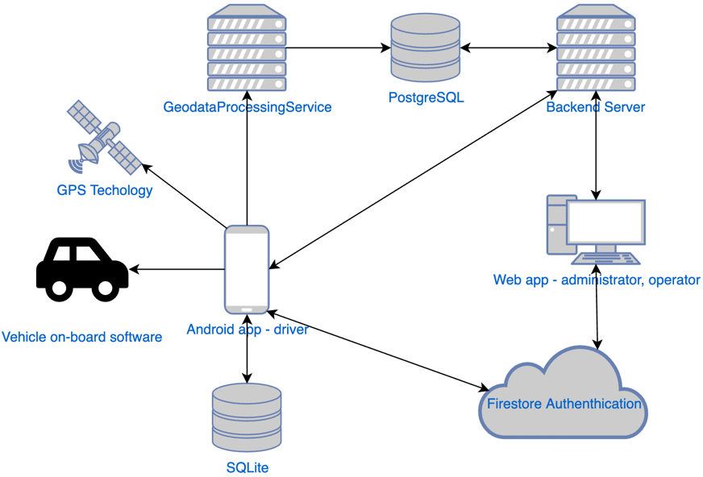

*Fig. 1. Service architecture*

Service target customers are companies, which business relay on vehicle fleet. Commonly these companies have following roles structure: drivers, operators and administrators.   
Drivers are employees who are in charge of vehicles driving. Driver utilize Android application for sending vehicle’s location and other vehicle related data to the Geodata Processing Service, he can manage tasks assigned to him and communicate with the operator by text messages.   
Operator responsibility is to manage system related data (vehicles, drivers, tasks), analyze fleet state with the help of visualizations and analytical reports.

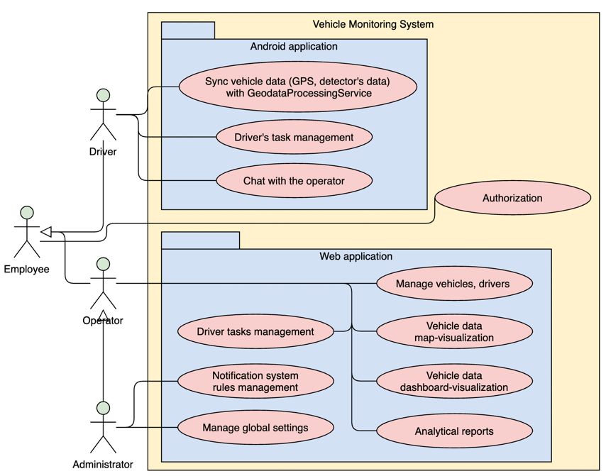Administrator is the role for company-wide system customization: managing rules for the notification system, global settings as frequency of vehicle data retrieval and its synchronization.

*Fig. 2. Service Use Case diagram*

# Conclusion

As suggested by this paper, while vehicles monitoring system market is already divided by historically successful competitors, which use the same approach to the key problem – transmission vehicle data to server, there is a chance that new product with a new approach can find some place to fit in. Proposed solution is capable of saving company’s money on hardware, assuming vehicles drivers already have Android devices, therefore with the android devices cheapness and their wide-spread it can gain some advantage among the competitors.

##### References

[1] Monika Jain, Praveen Kumar, Priya Singh, Chhavi Narayan Arora, Ankita Sharma. ”Detection of Over Speeding Vehicles on Highways”. 4, April 2015. [Online]. Available: <https://ijcsmc.com/docs/papers/April2015/V4I4201599a39.pdf> [Accessed Feb. 18, 2021].

[2] Pratiksha Bhuta, Karan Desai, Archita Keni “Alcohol Detection and Vehicle Controlling”. April 2015. [Online]. Available: <http://www.ijetajournal.org/volume-2/issue-2/IJETA-V2I2P14.pdf> [Accessed Feb. 18, 2021].

[3] Leonid Losich “Infographic: 2,500,000 units on Wialon in figures”. 6, November 2020. [Online]. Available: <https://gurtam.com/en/blog/wialon-units-infographic> [Accessed Feb. 18, 2021].

[4] Elena Bogdanova “Wialon and chatbots by Geoservice to fight car thefts”. 2, April 2020. [Online]. Available: <https://gurtam.com/en/blog/wialon-and-geoservice-chat-bots> [Accessed Feb. 18, 2021].

[5] Verma P. and Bhatia J. S. (2013). “Design and development of GPS-GSM based tracking system with Google Map based monitoring”. June 2013. [Online]. Available: <https://pdfs.semanticscholar.org/c19f/c9aa2d5d57139ac75869aa12d113f3e288a2.pdf> [Accessed Feb. 18, 2021].

[6] Deshmukh P., Bhajibhakre A., and Gambhire S. “Survey of geofencing algorithms”. June 2018. [Online]. Available: <http://www.ijcsejournal.org/Volume3/Issue2/IJCSE-V3I2P1.pdf> [Accessed Feb. 18, 2021].

**Word Count: 1640**