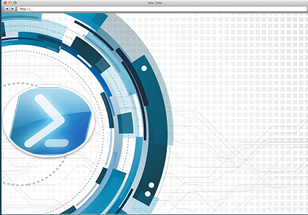

Deliverable #1: Student Assignment Work Plan

|  |  |
| --- | --- |
| **Deliverable #1:  Win500 Assignment** | |
| **Student Name** | **Responsibility** |
| Patrick Tsang | Menu/user interface, sessions, server inventory, auto restart |
| Daniel Ngan | Remote Functions, modules, Endpoint, Jpeg organizer, Firewalls |
|  |  |
|  |  |