Hands-On Activity: Real-Time Game DevelopmentUsing Artificial Intelligence
1. Student & Group Details Student Name1: Yashvi Kadia
Enrollment Number: 23012250210470
Student Name2: Dev Trivedi
Enrollment Number: 23012250210440
Student Name3: Neel Vanparia
Enrollment Number: 23012250210456
Semester: 6
Group Number: 1
2. Game Details
Game 1
• Game Name: AI_CAR_RACING • Game Type: 2D Arcade Ruacing
• Game Description: AI_CAR_RACING is a 2D arcade-style racinggamedeveloped using Python and Pygame. The player controls a car on a roadwhile avoiding enemy vehicles and collecting coins. Each level requires the player to collect 20 coins to advance. The game includes restart logic, alast-chance system, animated background, and multiple car designs toenhance realism and challenge.
• Code Language: Python
Game 2
• Game Name: AI_MOOD_MAZE
• Game Type: 2D Maze-Based Adventure Game
• Game Description:
AI_MOOD_MAZE is a 2D maze-based adventure game developedusingPython and the Pygame library. In this game, the player controls ananimated character that navigates through a garden-themed maze whileavoiding moving obstacles. The game includes multiple levels withincreasing difficulty, time limits, score tracking, and a checkpoint system. Each level is completed by reaching the goal, which is represented as amoving home. The game also features restart logic, clickable restart buttons, and a rule where repeated failures reset the game to Level 1. AI- assisted tools were used to design game logic, animations, and soundintegration, making the gameplay interactive and engaging. • Code Language: Python
3. AI Tools and Prompts Used for Game Development
Game 1 : AI_CAR_RACING
PROMPT:-Create a 2D arcade-style car racing game using Python andthePygame library. The player controls a car driving on a scrolling road withanature-themed background. The game should include multiple enemy cars with different colors and visible wheels. Add collectible coins that continuously spawn on the road; collecting 20 coins should complete the level and increase difficulty. Implement a restart system with a last-chancerule where two crashes reset the game to Level 1. Include smooth roadanimation, collision detection, clickable start and restart buttons, backgroundmusic, and sound effects. Display a clean HUD showing level, coin count, and remaining chances.
Game 2 : AI_MOOD_MAZE
PROMPT:- Create a 2D maze-based adventure game using Python andthePygame library. The game should feature an animated player character navigating through a garden-themed maze while avoiding moving obstacles. Include multiple levels with increasing difficulty, a timer, score system, andlimited lives. Add a checkpoint system so the player can restart fromcheckpoints after failure. Implement clickable buttons for starting the game, restarting levels, and progressing to the next level. If the player fails twiceonthe same level, the game should reset to Level 1. Use smooth animations, natureinspired colors, background music, and sound effects. Ensure cleanHUD display showing level, score, lives, and time.
4. Screenshots of the Game Game 1 Screenshot(s)
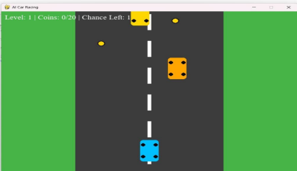Game 2 Screenshot(s)
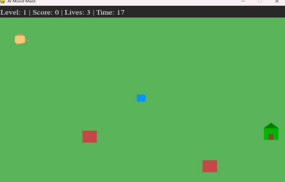
5. Learning Outcomes
Game 1: AI_CAR_RACING
Learn arcade-style game mechanics such as scrolling backgrounds andobject movement.
Understand collision handling and collectible-based level completion. Implement restart systems and failure-handling logic in games.
Improve understanding of animation, sound integration, and real-timegame updates
Game 2: AI_MOOD_MAZE
Understand the fundamentals of 2D game development using PythonandPygame.
Learn to implement player movement, collision detection, and obstacleanimation.
Gain experience with game states, level progression, and restart logic. Develop skills in designing interactive user interfaces.

