Application Control Migration: Solution Options & Design
This document details the transition strategy from the current state legacy AppLocker deployment to a Modern Intune App Management framework, strictly adhering to the generated Functional (FR) and Non-Functional Requirements (NFR).

Step 1: Current State Architecture & Design
The existing architecture relies on a Hybrid-Joined device fleet where AppLocker policies are manually crafted into XML files and deployed via Intune Custom OMA-URI profiles.

Current State Detailed Design diagram

This diagram illustrates the current flow of policy deployment and the dual-management (co-management) state.

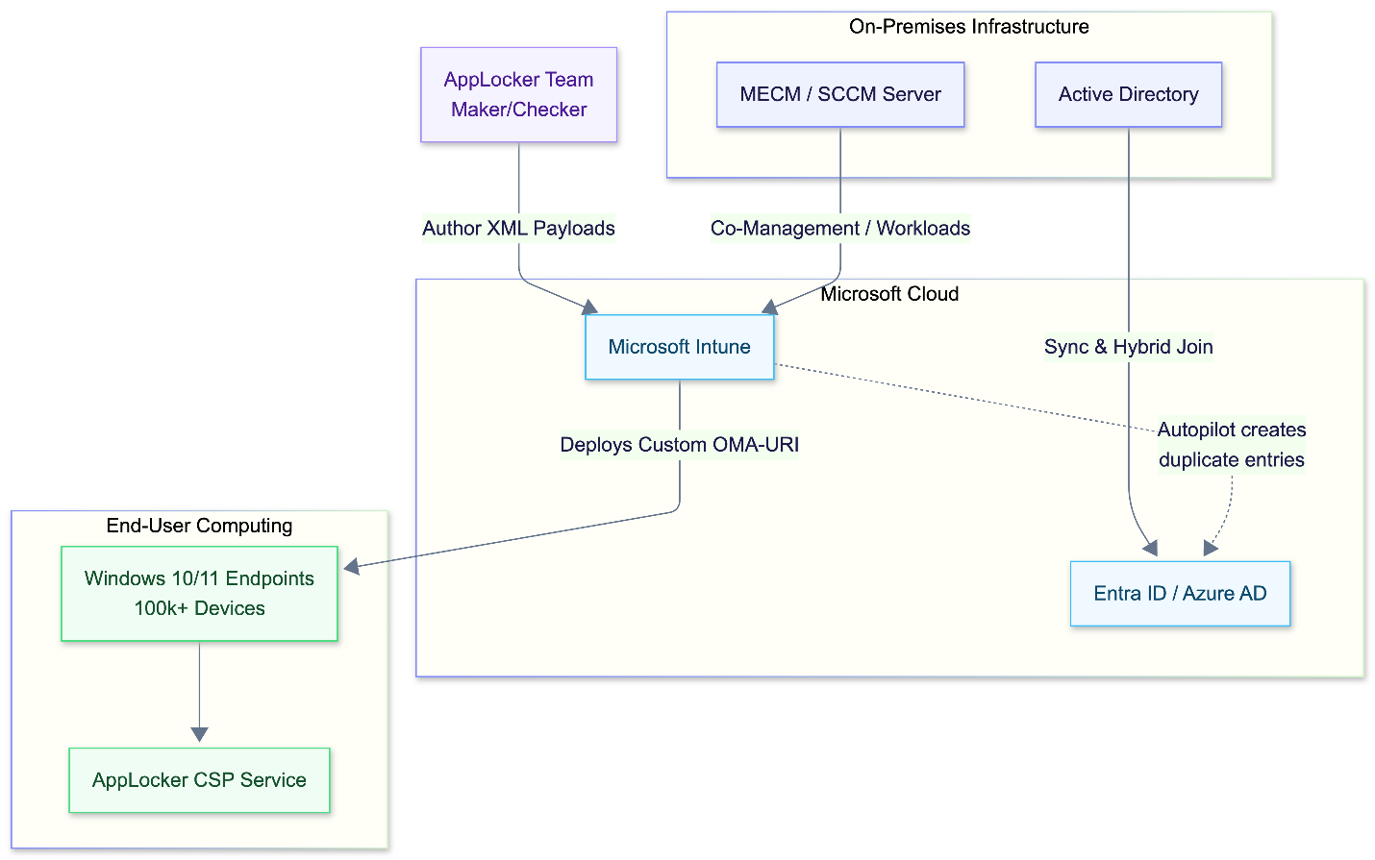

1.2 Policy Lifecycle Sequence Diagram
This sequence diagrams the current Maker/Checker approval workflow and policy enforcement on the endpoint.
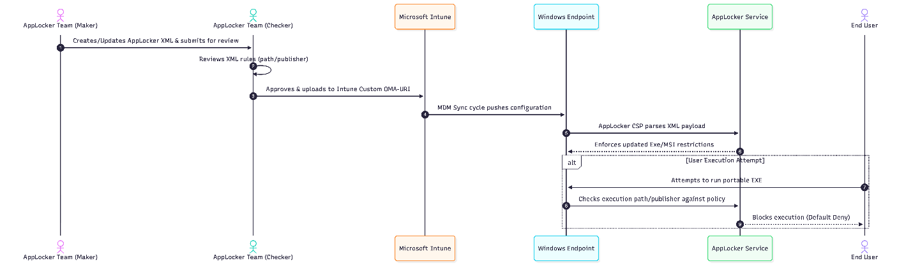

Step 2: Target State Solution Options
To address the documented pain points (specifically FR-01: moving away from XML, and FR-02: managing large portable EXE volumes), Microsoft provides distinct paths for Application Control.

Option 1: Migrate to App Control for Business (Formerly WDAC) - Recommended
App Control for Business (Windows Defender Application Control - WDAC) is Microsoft’s strategic, modern application control technology. It operates at the kernel level (unlike AppLocker which operates at user-mode) and introduces intelligent trust models.
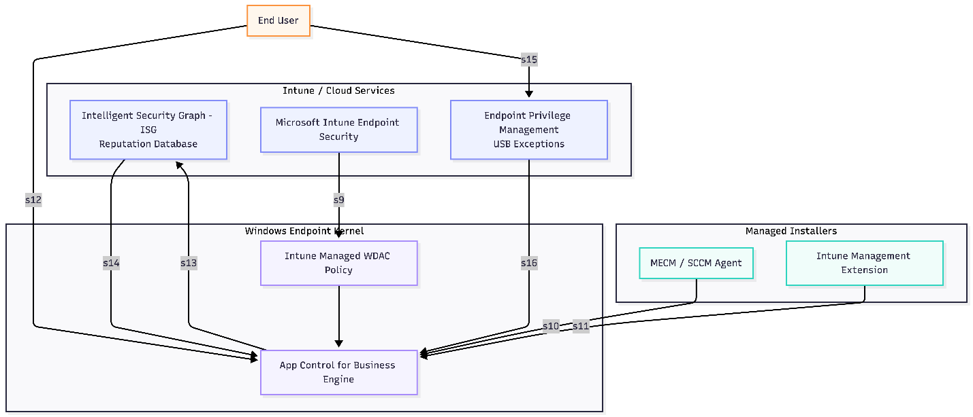
- How it meets Requirements:
  - FR-02 (Portable EXEs): Resolves the massive whitelisting overhead by utilizing the Intelligent Security Graph (ISG). Instead of manually whitelisting thousands of portable EXEs, WDAC queries the Microsoft cloud to determine if the EXE has a known, positive reputation. If it does, it runs automatically.
  - FR-01 (Native Intune): Managed natively through Intune Endpoint Security policies (no raw XML required).
  - Managed Installers: You can designate Intune and MECM as "Managed Installers." Any software deployed by them is automatically trusted, completely eliminating the need to write path rules for standard deployments.
- Microsoft Recommendation & Links:
  - Microsoft explicitly recommends WDAC over AppLocker for modern, cloud-first endpoint security.
  - App Control for Business vs. AppLocker Overview
  - Use Intune to configure App Control for Business

Option 2: Modernize AppLocker via Native Intune Profiles
Instead of moving to WDAC, the organization can retain the AppLocker engine but migrate the configuration out of Custom OMA-URI (XML) and into native Intune Device Configuration profiles.
- How it meets Requirements:
  - FR-01 (Native Intune): Moves away from XML. Intune provides a UI for defining Publisher, Path, and Hash rules.
  - Fails to meet FR-02 efficiently: The team will still suffer from the massive overhead of whitelisting portable EXEs and managing exceptions, as AppLocker does not support ISG reputation checks or Managed Installers.
- Microsoft Recommendation & Links:
  - AppLocker is considered a legacy management tool best suited for environments where WDAC is too restrictive or complex to implement, but it will not reduce the operational burden noted in the Current State.
  - Configure AppLocker policies via Intune

Step 3: Addressing Key Peripheral Friction Points
Regardless of whether Option 1 or Option 2 is chosen, the following architectural fixes must be implemented to satisfy the remaining requirements.

3.1 Fixing Intune Autopilot & Duplicate Entra ID Entries (FR-07)
The Problem: The notes indicate Autopilot is creating duplicate entries in Entra ID, a common issue in Hybrid environments when MECM agents and Intune Autopilot conflict during the Domain Join profile execution. The Solution:
- Ensure the Intune Connector for Active Directory is healthy and localized to the deployment zones.
- Microsoft recommends configuring the Autopilot deployment profile to Skip AD connectivity check if VPN is used, and ensuring that Entra ID Connect syncs the Hybrid device object before the user logs in, preventing the creation of a duplicate cloud-only record.
- Microsoft Docs: Autopilot Hybrid Azure AD join

3.2 Handling USB Execution Exceptions (FR-03)
The Problem: Currently, painful manual exceptions are required just to access USB applications. The Solution (Target State): Implement Microsoft Intune Endpoint Privilege Management (EPM) alongside App Control. Instead of altering the global application control policy for a temporary USB exception, users can right-click the USB executable and request "Run with elevated access." This request routes through a ServiceNow integration (or native Intune approvals), allowing the user temporary execution rights without permanently exposing the attack surface (NFR-04).
- Microsoft Docs: Endpoint Privilege Management

