# Project 1:- Crimes in Los Angeles on Power BI Dashboard

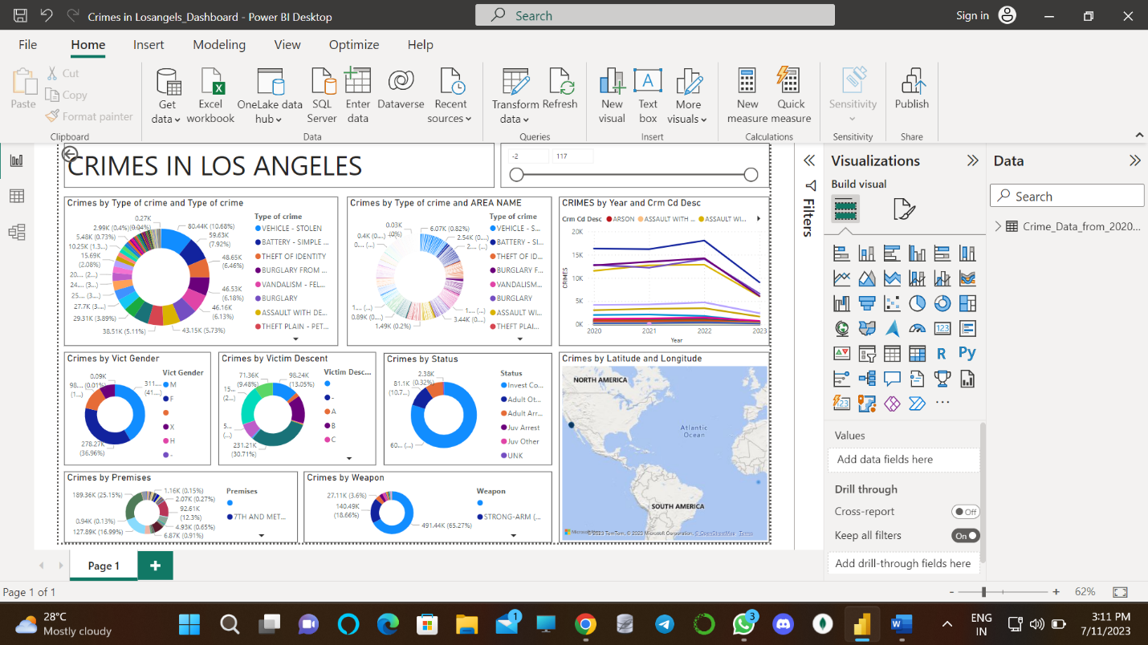

Project description:-

* Showing crimes in Los Angeles, from 2020 onward.
* I displayed crimes by type of crime, age, area, gender, descent, status, premises, weapon and location.
* I used donut charts and map charts to display this information.

Challenges that I have encounter and how I overcome them:-

* This the big dataset. I easily describe it in user readable form using proper tools.

Tools, technologies or programming languages used in this project:

* Microsoft power Bi tool I used here for proper data description.

Key insights or findings derived from the project:

* Also, I added slider here, So we get the actual data of particular type wise by changing the slider.
* Through Microsoft power bi tool, the large data set can easily describe. Also we can use here data in form of pdf, excel and csv.
* Also we can load here data from google Big Query in this Microsoft power bi tool.

Live project implementation link:

https://drive.google.com/file/d/1WCPaVXPfHuZom3TWphQoiTht_DLeGdV3/view?usp=drive_link

Project 2: Flight data prediction in data science

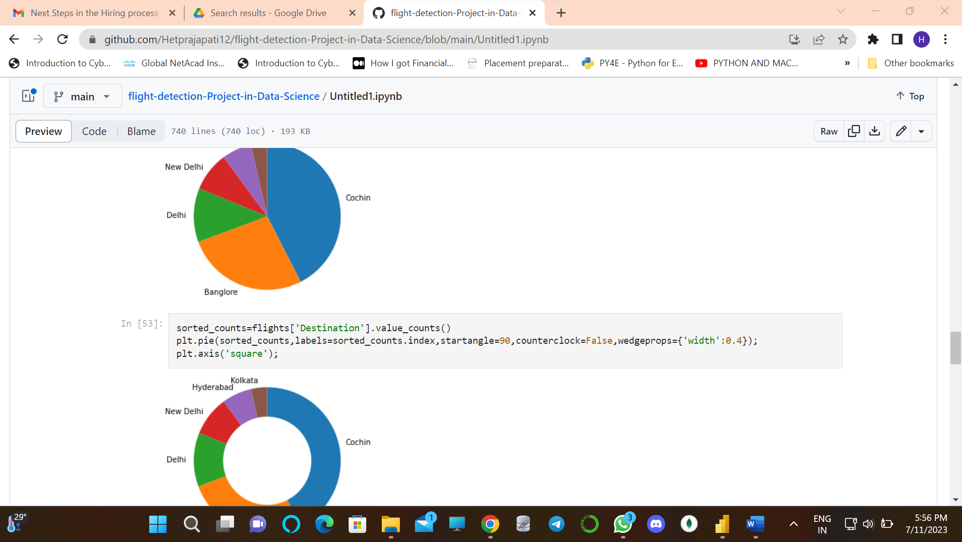

Project description:-

* I created this project name as flight detection project. It’s data science project.
* In this project i fetched the data from flight_data.csv file.
* I used python libraries like Numpy, pandas and matplotlib.
* Also after finding the insights from data , I plotted the graph also.

Challenges that I have encounter and how I overcome them:-

* Plotting graph of various airlines and its count are difficult.
* So by applying commands and algorithms, I solved this issue and plot the data in bar chart.

Tools, technologies or programming languages used in this project:

* Google colab platform I used.
* Python programming language I used.

Key insights or findings derived from the project:

* Finding the insights from flight_data.csv
* Also we can load here data from csv file and analyst the data in user readable form.

Live project implementation link:

* <https://github.com/Hetprajapati12/flight-detection-Project-in-Data-Science/blob/main/Untitled1.ipynb>

Project 3 : **Image to Pencil Sketch with Python**

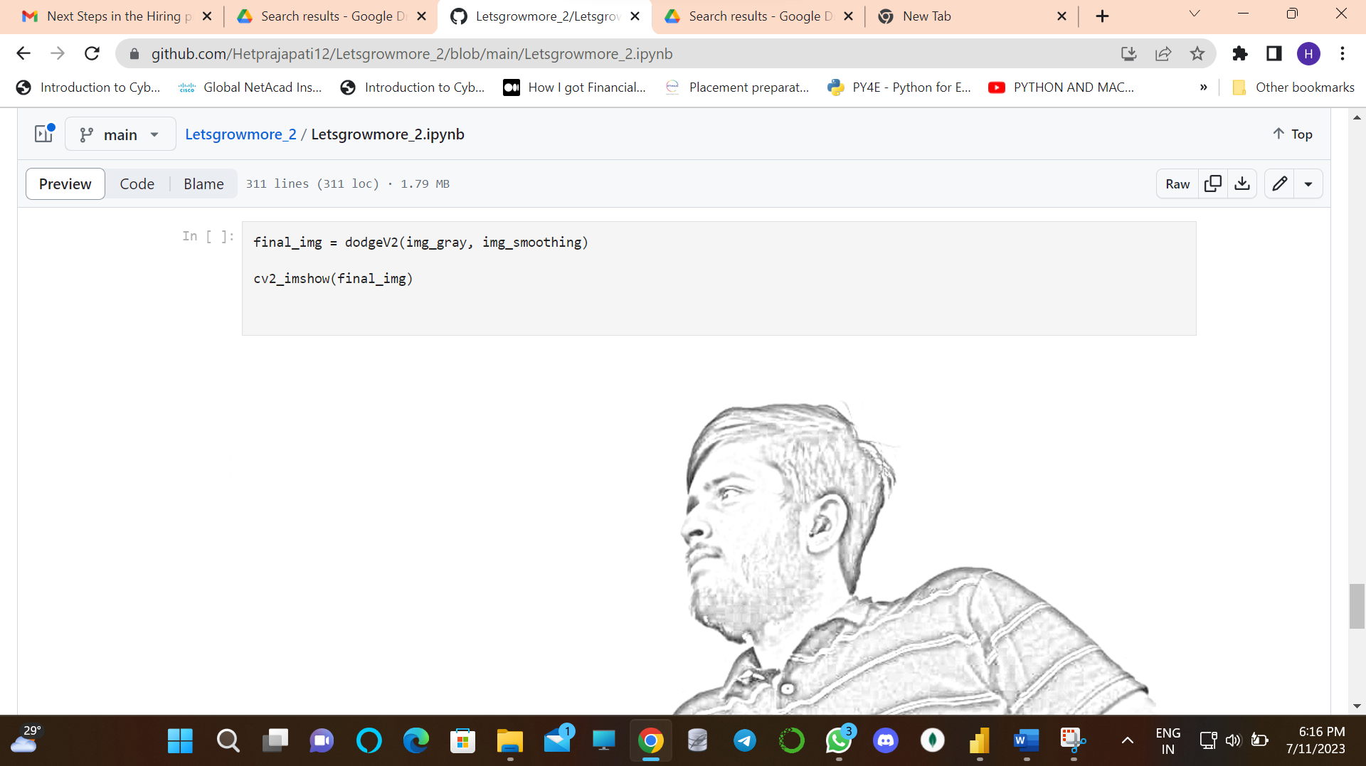

Project description:-

* In this project I convert the RGB image into sketch by applying various image processing techniques.

Challenges that I have encounter and how I overcome them:-

* We did not get proper sketch of image by various online image editing tools.
* Although if we get the sketch by using online image editing tools, the quality of image goes down.
* So with the help of opencv library of Python, I created a sketch of my own image with better quality.

Tools, technologies or programming languages used in this project:

* Google colab platform I used.
* Used openCv commands.

Key insights or findings derived from the project:

* We can convert any old images into sketch and also we can get better image quality.

Live project implementation link:

* <https://github.com/Hetprajapati12/Letsgrowmore_2/blob/main/Letsgrowmore_2.ipynb>
* Project 4 : **Made a device called ‘Aura’**

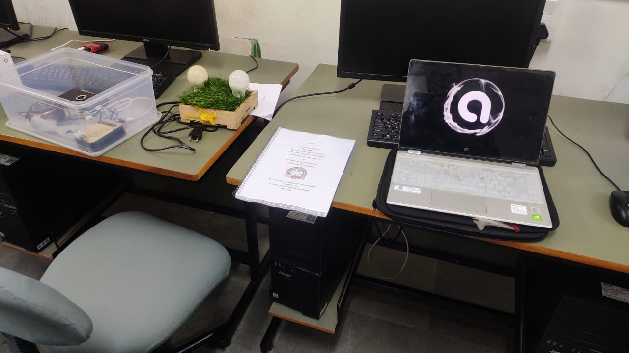

Project description:-

* Me and my team made a device. Through this device we can control the surrounding things like laptop, mobile etc. anything by touch, webapp, website and google assistance.
* We tried to control the surrounding things by brain wave also.

Challenges that I have encounter and how I overcome them:-

* We can not control our lights and fan from different room or location.
* But through our device we can control our lights and fan from different room or location.

Tools, technologies or programming languages used in this project:

* This is IOT technology based device.
* Used RSP 31 microcontroller and relays.
* HTML,CSS, Java script used for making website and webapp.

Key insights or findings derived from the project:

* This device is useful for blind people.

Currently I haven’t the webapp and website because we made this project in group . But yes, I have a presentation ppt and project reports od this our project. The presentation ppt is very amazing. If you want, then I can send you via mail.