
KARNAVATI UNIVERSITY
UNITEDWORLD INSTITUTE OF TECHNOLOGY (UIT)
MINI PROJECT REPORT
ON
“END-TO-END MINI COMPILER WITH COMPILER PHASE VISUALIZATION”
Submitted as a part of the course
COMPILER DESIGN
Submitted By
Student Name | Enrollment No.
Hitik Shah | 202307020106
Het Sharma | 202307020045
Manya Singh | 202307020133
Yashvi Muchhala | 202307020150
Program: B.Tech CSE
Semester: VII
Section: CSE
Under the Guidance of
Dr. Bela Shrimali
Associate Professor
Department of Computer Science & Information Technology
Karnavati University, Gandhinagar
Academic Year: 2026–27
CERTIFICATE
This is to certify that the mini project entitled “End-to-End Mini Compiler with Compiler Phase Visualization” has been successfully completed by the following students of B.Tech CSE, Semester VII, Karnavati University, as a part of the course Compiler Design during the academic year 2026–27.
Sr. No. | Student Name | Enrollment No.
1 | Hitik Shah | 202307020106
2 | Het Sharma | 202307020045
3 | Manya Singh | 202307020133
4 | Yashvi Muchhala | 202307020150
The project has been carried out under the guidance and supervision of the faculty member. The work presented in this report is the original work carried out by the students as part of their mini project.
Faculty Guide
Name: Dr. Bela Shrimali
Signature:
Date:
DECLARATION
We hereby declare that the mini project entitled “End-to-End Mini Compiler with Compiler Phase Visualization” submitted as part of the course Compiler Design is our original work carried out under the guidance of the faculty member.
We further declare that this work has not been submitted previously to any other institution or university for the award of any degree, diploma, or academic certification.
All research papers, datasets, frameworks, APIs, libraries, websites, and other resources used during the development of the project have been appropriately acknowledged and referenced.
Sr. No. | Student Name | Enrollment No.
1 | Hitik Shah | 202307020106
2 | Het Sharma | 202307020045
3 | Manya Singh | 202307020133
4 | Yashvi Muchhala | 202307020150

Date:
Place: Gandhinagar

ACKNOWLEDGEMENT
We express our sincere gratitude to our faculty guide, Dr. Bela Shrimali, Associate Professor, Department of Computer Science & Information Technology, for the guidance, timely feedback and encouragement throughout this mini project. The course's phase-by-phase treatment of compiler design gave this project its structure.
We thank the Unitedworld Institute of Technology (UIT), Karnavati University, Gandhinagar, for offering the Compiler Design course and for providing the academic environment and laboratory resources needed to carry out the project.
We are grateful to the authors of the standard compiler textbooks, especially Aho, Lam, Sethi and Ullman, whose translation schemes for expressions and control flow we followed closely, and to the maintainers of the free tools we used: the GNU Compiler Collection (MinGW), Python and the Chromium-based browsers in which the visual report was tested.
Finally, each team member thanks the others for sharing the work of design, development, testing and documentation, and our families and friends for their patience and support during the project.

ABSTRACT
A compiler translates a program through a sequence of phases, but students usually see only the first input and the final error message. The intermediate results that the theory course talks about, such as tokens, syntax trees, symbol tables and three-address code, stay hidden inside production compilers like GCC, which makes the phases hard to connect with real behaviour.
This project presents an end-to-end mini compiler, written in C (C99), for a small C-like language with int and float variables, arithmetic and relational expressions, if/else, while and for statements, nested block scopes and an optional int main() with return. The compiler is organised as five phases in separate source files: a hand-written lexical analyser, a recursive descent parser that builds an abstract syntax tree with panic-mode error recovery, a semantic analyser that builds a scoped symbol table and performs type checking, an intermediate code generator that emits three-address code as quadruples, and a local optimizer that performs constant propagation, constant folding, branch folding and dead temporary removal. Every phase prints its result to the terminal and to a self-contained HTML report. A small Python server adds a web playground where code typed in the browser is compiled by the same C program and the phases are shown as coloured status lights.
The system was evaluated on 26 October 2026 with 13 functional test cases and 8 automated regression tests. All 13 functional tests and all 8 regression tests passed, and every deliberately inserted error was reported with the correct line number. On the demo program the optimizer reduced the code from 35 to 30 instructions, and a 603-line program compiled in a median of 173 ms. The project shows that a compact compiler of about 1336 lines of C is enough to demonstrate every analysis and synthesis phase taught in the course.
TABLE OF CONTENTS
ACKNOWLEDGEMENT 4
ABSTRACT 5
LIST OF FIGURES 9
LIST OF TABLES 10
CHAPTER 1 – INTRODUCTION 11
1.1 Introduction 11
1.2 Background 12
1.3 Problem Statement 12
1.4 Motivation 12
1.5 Objectives 13
1.6 Scope of the Project 13
CHAPTER 2 – LITERATURE REVIEW 14
2.1 Existing Systems and Research 14
2.2 Comparative Analysis 14
2.3 Research Gap 15
CHAPTER 3 – PROPOSED SYSTEM 16
3.1 Proposed Solution 16
3.2 System Requirements 16
3.2.1 Hardware Requirements 16
3.2.2 Software Requirements 17
3.3 Functional Requirements 17
3.4 Non-Functional Requirements 17
CHAPTER 4 – COMPILER ARCHITECTURE 19
4.1 Overall System Architecture 19
4.2 Architecture Components 19
4.3 Module Responsibilities 20
4.4 Compiler Workflow 20
CHAPTER 5 – COMPILER DESIGN CONCEPTS USED 22
5.1 Lexical Analysis: Tokens, Patterns and Lexemes 22
5.2 Context-Free Grammar and Recursive Descent Parsing 22
5.3 Abstract Syntax Tree 23
5.4 Symbol Table and Scope 24
5.5 Type Checking 24
5.6 Intermediate Code: Three-Address Code and Quadruples 25
5.7 Translation of Control Flow 25
5.8 Code Optimization and Basic Blocks 25
5.9 Error Detection and Recovery 26
CHAPTER 6 – METHODOLOGY 28
6.1 Input Processing 28
6.2 Lexical Analysis 28
6.3 Syntax Analysis 28
6.4 Semantic Analysis 28
6.5 Intermediate Code Generation 28
6.6 Optimization 29
6.7 Output and Visualization 29
CHAPTER 7 – IMPLEMENTATION 30
7.1 Project Structure 30
7.2 Lexical Analyser Implementation 30
7.3 Parser Implementation 31
7.4 Semantic Analyser Implementation 32
7.5 Code Generator and Optimizer Implementation 32
7.6 User Interface and Visualization 33
CHAPTER 8 – RESULTS AND OUTPUT 38
8.1 Test Cases 38
8.2 Sample Outputs 39
Test Case 1 – Valid program with all statement types (TC01) 39
Test Case 2 – Lexical and syntax errors (TC03) 39
Test Case 3 – Semantic errors (TC04) 40
8.3 Compilation Trace 40
CHAPTER 9 – PERFORMANCE EVALUATION 42
CHAPTER 10 – CHALLENGES AND LIMITATIONS 44
10.1 Challenges Faced 44
10.2 Limitations 45
CHAPTER 11 – FUTURE SCOPE 46
CHAPTER 12 – CONCLUSION 47
REFERENCES 48
APPENDIX 50
Appendix A – Source Code 50
Appendix B – Additional Screenshots 50
Appendix C – Sample Programs 50
Appendix D – Test Data 51

LIST OF FIGURES
Figure No. | Figure Title | Page No.
Figure 1 | Overall System Architecture | 19
Figure 2 | Compiler Workflow with Error Handling | 21
Figure 3 | Typed AST for the Statement b = a * 2 + 3; | 23
Figure 4 | Basic Blocks and Control Flow of a for Loop | 26
Figure 5 | Web Playground Request Flow | 33
Figure 6 | Web Playground – Home Page with the Editor | 34
Figure 7 | Compiling the Demo Program – All Five Phases Pass | 34
Figure 8 | Phase 1 Output – Token Table with Line Numbers | 35
Figure 9 | Phase 2 Output – Collapsible AST Annotated with Types | 35
Figure 10 | Phase 3 Output – Symbol Table with Scope and Offset | 36
Figure 11 | Phases 4 and 5 – Quadruples Before and After Optimization | 36
Figure 12 | Command-Line Output of minicc for examples/main.mc (excerpt) | 37
Figure 13 | Lexical and Syntax Errors in the Playground (failed phases in red, error lines highlighted) | 40
Figure 14 | Semantic Errors Reported with Line Numbers | 40
Figure 15 | Compile Time versus Program Size | 43
Figure 16 | Error List in the HTML Report, Grouped by Phase | 50

LIST OF TABLES
Table No. | Table Title | Page No.
Table 1 | Existing Systems and Research | 14
Table 2 | Comparative Analysis | 14
Table 3 | Hardware Requirements | 16
Table 4 | Software Requirements | 17
Table 5 | Functional Requirements | 17
Table 6 | Architecture Components | 19
Table 7 | Module Responsibilities | 20
Table 8 | Token Categories Recognised by the Lexer | 22
Table 9 | AST Node Kinds | 23
Table 10 | Type Rules | 24
Table 11 | Three-Address Instruction Set | 25
Table 12 | Optimizations Implemented | 26
Table 13 | Errors Detected by Each Phase | 27
Table 14 | Source Code Size by Module | 30
Table 15 | Test Cases | 38
Table 16 | Automated Regression Tests (test.bat) | 39
Table 17 | Performance Evaluation | 42
Table 18 | Compile Time and Optimization by Program Size | 42
Table 19 | Sample Programs | 50

CHAPTER 1 – INTRODUCTION

1.1 Introduction
A compiler is a program that reads a program written in a source language and translates it into an equivalent program in a target language, reporting any errors it finds in the source along the way [1]. Compilers make high-level programming possible: the programmer writes readable statements such as b = a * 2 + 3; and the compiler produces the low-level instructions the machine executes.
Classical compiler design divides this translation into a series of phases, each of which transforms one representation of the program into the next [1], [2]:
- Lexical analysis groups characters into tokens such as keywords, identifiers, constants and operators.
- Syntax analysis checks that the token sequence follows the grammar of the language and builds a tree.
- Semantic analysis checks meaning: declarations, scopes and types, and records names in a symbol table.
- Intermediate code generation produces a machine-independent form such as three-address code (TAC).
- Code optimization improves the intermediate code without changing what the program computes.
- Code generation maps the optimized code to a target machine (outside the scope of this project).
The first three phases form the analysis part (the front end) and the remaining phases form the synthesis part (the back end). Two structures are shared by all phases: the symbol table, which stores information about every name, and the error handler, which collects and reports problems found in any phase.
This project implements every phase from lexical analysis to optimization for a small C-like language, and, unlike a production compiler, it shows the output of each phase so that the theory of the course can be seen working on real programs.

1.2 Background
Production compilers such as GCC and Clang are designed for speed and for the quality of the generated machine code. Their internal representations are large, change between versions and are not printed during a normal compilation. A student who writes int x = 5.5; sees at most a warning; the tokens, the tree, the symbol table entry for x and the conversion that the compiler inserted all remain invisible.
Compiler courses therefore rely on hand-worked examples on paper: drawing a parse tree, filling a symbol table, writing quadruples for an if statement. Tool support exists for single topics (for example, automata simulators or parser generators), but these tools cover one phase at a time and use their own notations, so the student still has to connect the phases mentally. A small compiler whose source code is short enough to read, and whose every phase can be inspected for the same input program, closes this gap.

1.3 Problem Statement
The objective of this project is to develop an end-to-end mini compiler in C that translates programs of a small C-like language through lexical, syntax and semantic analysis, intermediate code generation and optimization. Existing production compilers hide their intermediate representations, and existing educational tools cover only isolated phases. Therefore, there is a need for a system that runs all phases on the same program, detects and reports errors with line numbers in each phase, and visualizes the result of every phase in a form that matches the notation used in the course.

1.4 Motivation
- Why this problem: the team found that the phases were easy to describe one at a time but hard to connect; seeing the same statement move from tokens to a tree to quadruples makes the connection obvious.
- Why build it from scratch: generator tools such as Lex and Yacc hide the algorithms the course teaches. Writing the lexer and the recursive descent parser by hand shows exactly how tokens are recognised and how grammar rules become functions.
- Why visualization: a table or tree that appears next to the source line it came from is easier to understand and to explain in a viva than a description.
- Who benefits: students learning compiler design, teaching assistants preparing examples, and the team itself, since each member owns and can explain one phase.
- Limitations of existing approaches: production compilers do not print their phases, and single-topic tools do not show how the phases depend on each other.

1.5 Objectives
- To design a small C-like source language with a grammar suitable for predictive (LL(1)) parsing.
- To implement a hand-written lexical analyser and a recursive descent parser that builds an abstract syntax tree and recovers from syntax errors.
- To implement semantic analysis with a scoped symbol table and type checking for int and float.
- To generate three-address code in quadruple form, including translation of if/else, while and for.
- To implement local optimizations (constant propagation, constant folding, branch folding, dead temporary removal) and show the code before and after.
- To visualize the output of every phase in the terminal, in an HTML report and in a browser playground, and to evaluate the system using predefined test cases.

1.6 Scope of the Project
- Target users: students and faculty of the Compiler Design course.
- Supported language: int and float variables; + - * / % and unary minus; < > <= >= == !=; assignment; if/else; while; for; { } blocks with their own scope; // and /* */ comments; an optional int main() { ... return expr; } wrapper.
- Functional scope: lexical, syntax and semantic analysis, intermediate code generation and local optimization, with error detection in the first three phases.
- Technologies: C99 compiled with GCC; Python standard library for the optional local web server; HTML, CSS and JavaScript for the report and playground.
- Expected usage: classroom demonstrations, self-study and viva explanations; programs are typically a few dozen lines long.
- Current limitations: no target machine code, no user-defined functions other than main, no arrays, pointers, strings or input/output, and no logical operators (&&, ||, !). These are discussed in Chapter 10.

CHAPTER 2 – LITERATURE REVIEW

2.1 Existing Systems and Research
Table 1 summarises the systems and publications that influenced the design of the project.
Table 1: Existing Systems and Research
Sr. No. | Paper/System | Year | Approach | Key Finding | Limitation
1 | Lex and Yacc (Lesk & Schmidt [5]; Johnson [6]) | 1975 | Generate a lexer from regular expressions and an LALR(1) parser from a grammar | Front ends can be produced automatically from formal specifications | Generated tables hide how tokens and productions are recognised
2 | Compilers: Principles, Techniques, and Tools (Aho et al. [1]) | 2006 | Phase-structured compiler with syntax-directed translation to TAC | Standard translation schemes for expressions, control flow and optimization | Textbook examples are worked on paper, not executed
3 | LLVM (Lattner & Adve [7]) | 2004 | Reusable compiler infrastructure built around an SSA intermediate representation | A well-defined IR lets many front ends share optimizers and back ends | IR and code base are far too large for teaching an introductory course
4 | ANTLR (Parr & Quong [8]) | 1995 | Predicated LL(k) parser generator producing recursive descent parsers | Top-down parsers can be generated and still be readable | Requires learning the tool's grammar notation; semantic phases are left to the user
5 | JFLAP (Rodger & Finley [16]); Compiler Explorer [9] | 2006; 2012 | Interactive simulation of automata and parsers; browser view of compiler output | Visual, interactive tools make abstract concepts easier to understand | JFLAP covers single phases; Compiler Explorer shows only final assembly

2.2 Comparative Analysis
Table 2 compares the proposed system with production compilers and with compiler generator tools on the features that matter for learning compiler design.
Table 2: Comparative Analysis
Feature | Production compiler (GCC/Clang) | Generator tools (Lex/Yacc, ANTLR) | Proposed system
All phases on one input | Yes, but hidden | Front end only | Yes, all shown
Token list visible | No | Only with extra code | Yes (table)
Syntax tree visible | Only with debug flags | ANTLR only | Yes (collapsible tree)
Symbol table visible | No | No | Yes (with scope and offset)
Three-address code / quadruples | No (internal IR) | No | Yes
Optimization before/after | No | No | Yes, side by side
Errors with line numbers | Yes | Syntax only | Lexical, syntax and semantic
Syntax error recovery | Yes (advanced) | Depends on grammar | Panic mode
Source small enough to read | No (millions of lines) | Generated code is hard to read | Yes (1336 lines of C)

2.3 Research Gap
The review shows two kinds of existing work. Production infrastructures such as GCC and LLVM are complete but opaque, while educational tools such as JFLAP and parser generators are transparent but cover one phase at a time. Neither shows how one input program flows through all phases, how an error in one phase prevents the later phases from running, or how an optimization changes the intermediate code.
The proposed project addresses this gap with a single small compiler whose phases are implemented by hand in the same notation as the course (tokens, recursive descent, symbol table, quadruples), and whose output for every phase is shown together for the same program, in the terminal and in the browser.

CHAPTER 3 – PROPOSED SYSTEM

3.1 Proposed Solution
The proposed system is a command-line compiler, minicc, written in C99, together with two ways of viewing its results. The flow of a compilation is:
- User interaction: the user writes a program in a .mc file and runs minicc file.mc, types a program directly at the keyboard, or types it into the web playground in a browser.
- Lexical analysis: lexer.c scans the characters and produces an array of tokens with line numbers.
- Syntax analysis: parser.c checks the tokens against the grammar using recursive descent and builds an abstract syntax tree (AST). On a syntax error it reports the line and skips to the next safe point.
- Semantic analysis: semantic.c walks the AST, enters every declared variable into a symbol table with its type, scope, size and offset, and checks uses and types.
- Intermediate code generation: codegen.c walks the typed AST and emits three-address code stored as quadruples, using temporaries t1, t2, ... and labels L1, L2, ....
- Optimization: the optimizer in codegen.c copies the quadruples and simplifies them inside each basic block.
- Output: main.c prints every phase to the terminal and report.c writes report.html, a visual page with one section per phase. The web playground shows the same report beside the editor.
Later phases run only when the earlier phases succeeded, because semantic analysis and code generation need a correct tree. The program exits with status 0 when compilation succeeds and 1 when any error was found.

3.2 System Requirements

3.2.1 Hardware Requirements
Table 3: Hardware Requirements
Component | Requirement
Processor | Any x86-64 processor (tested on AMD Ryzen 5 5600H)
RAM | 512 MB free is sufficient; the compiler uses fixed-size tables (tested on 8 GB system)
Storage | Under 1 MB for the source code and executable (minicc.exe is about 136 KB)
GPU | Not required
Internet Connection | Not required; the report and playground run entirely on the local machine

3.2.2 Software Requirements
Table 4: Software Requirements
Software/Technology | Version/Specification
Operating System | Windows 11 (tested); the C code is portable C99 and also builds on Linux
Programming Language | C (C99 standard) for the compiler; Python 3 for the optional web server
Compiler for building | GCC 6.3.0 (MinGW) with -std=c99 -Wall -Wextra
IDE/Environment | Any text editor (Visual Studio Code was used) and Windows PowerShell
Web playground | Python 3.12.10 standard library (http.server, subprocess); no packages to install
Frontend | HTML5, CSS and JavaScript in any modern browser (tested in Google Chrome)
External libraries | None; only the C standard library

3.3 Functional Requirements
Table 5: Functional Requirements
ID | Requirement
FR1 | Accept a source program from a file, from the keyboard or from the web playground.
FR2 | Recognise keywords, identifiers, integer and float constants, operators and separators, and skip whitespace and comments.
FR3 | Report unknown characters, malformed numbers and unterminated comments with line numbers.
FR4 | Parse the program according to the grammar and build an abstract syntax tree.
FR5 | Report syntax errors with the expected and the found token, and continue parsing after an error.
FR6 | Build a symbol table with name, type, size, offset, scope level and declaration line.
FR7 | Detect undeclared variables, redeclarations, invalid type conversions, invalid operands and misplaced return statements.
FR8 | Generate three-address code as quadruples, including control flow for if/else, while and for.
FR9 | Optimize the intermediate code and show it before and after optimization.
FR10 | Display the output of every phase in the terminal and write a visual HTML report.

3.4 Non-Functional Requirements
- Correctness: optimizations must not change program meaning; for example, division by zero is never folded and integer division keeps C semantics.
- Reliability: the compiler must never crash or loop forever on bad input; the parser always makes progress during error recovery.
- Performance: a typical classroom program (under 50 lines) must compile in well under one second.
- Portability: standard C99 only, no external libraries; the HTML report is a single self-contained file.
- Usability: error messages name the phase, the line and what was expected; the report works in light and dark browser themes.
- Maintainability: one source file per phase with a shared header, so each team member can work on and explain one phase independently.
- Security: the web server listens only on 127.0.0.1, limits input size to 100 KB and stops the compiler after 5 seconds.

CHAPTER 4 – COMPILER ARCHITECTURE

4.1 Overall System Architecture
Figure 1 shows the architecture as implemented. Both user interfaces feed source code into the same compiler executable. Inside the compiler, the five phases are connected in a pipeline; each phase consumes the data structure produced by the previous one. All phases share the error list and the data structure definitions in compiler.h. The two output modules read the results of all phases at the end of the run.
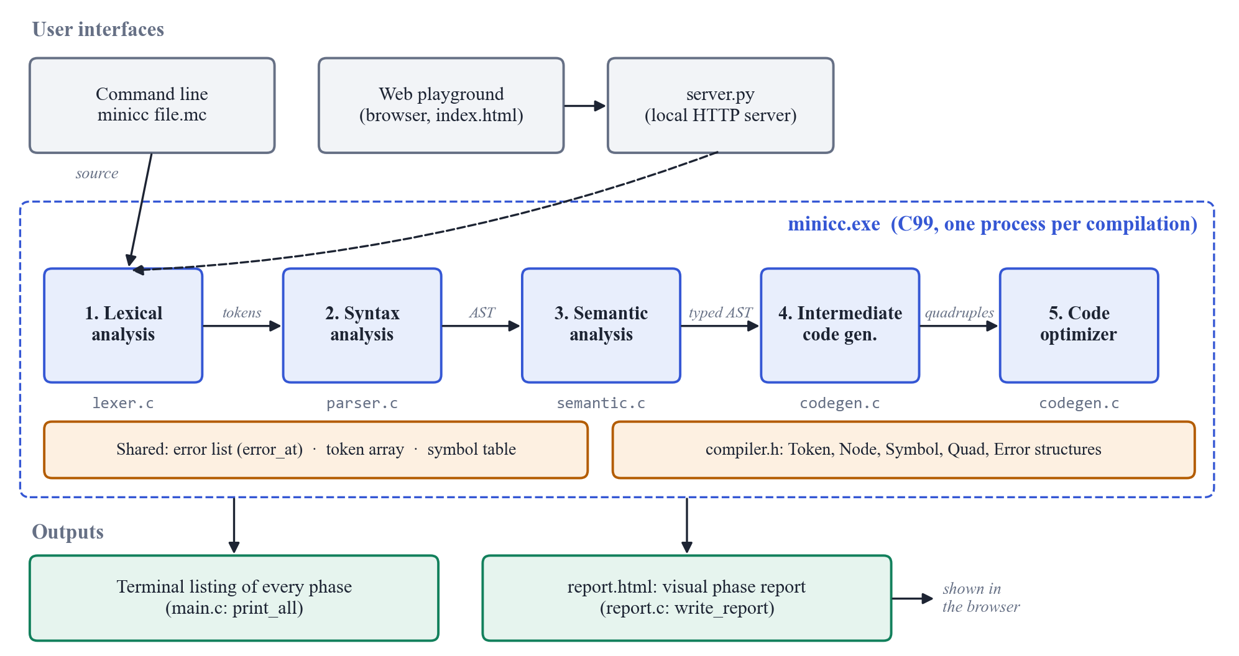
Figure 1: Overall System Architecture

4.2 Architecture Components
Table 6: Architecture Components
Component | Description
User interface | Command line (minicc file.mc) or the web playground (web/index.html) served by server.py.
Shared definitions | compiler.h defines Token, Node (AST), Symbol, Quad and Error and declares the function each phase exports.
Lexical analyser | lexer.c: converts the character stream into the global token array.
Parser | parser.c: recursive descent parser producing the AST; panic-mode error recovery.
Semantic analyser | semantic.c: symbol table with scopes, type checking, annotation of AST node types.
Intermediate code generator | codegen.c (gen_program): emits quadruples from the typed AST.
Optimizer | codegen.c (optimize): local constant propagation and folding, branch folding, dead temporary removal.
Error handler | error_at() in main.c: records phase, line and message for every error.
Driver and terminal output | main.c: reads the source, runs the phases in order, prints every phase.
Visual report | report.c: writes report.html with a phase status banner, tables and tree.
Web server | server.py: receives code from the browser, runs minicc.exe and returns the report.

4.3 Module Responsibilities
The work was divided so that each team member owns one phase and can explain it independently. Table 7 lists the modules and their responsibilities.
Table 7: Module Responsibilities
Module | File(s) | Responsibility
Phase 1 – Lexical analysis | lexer.c | Token recognition, keyword lookup, comments, lexical errors
Phase 2 – Syntax analysis | parser.c | Grammar, recursive descent, AST construction, error recovery
Phase 3 – Semantic analysis | semantic.c | Symbol table, scopes, type rules, semantic errors
Phases 4 and 5 – Code generation and optimization | codegen.c | TAC/quadruples, control-flow translation, optimizations
Shared – Driver and visualization | main.c, report.c, compiler.h, server.py, web/index.html | Phase orchestration, terminal output, HTML report, web playground

4.4 Compiler Workflow
The complete workflow of one compilation is:
Step 1: The source program is read completely into memory (from a file, the keyboard or the web server).
Step 2: The lexer scans it once from left to right and produces the token array, ending with an EOF token.
Step 3: The parser reads the tokens with one token of lookahead and builds the AST, reporting syntax errors.
Step 4: If no lexical or syntax error occurred, the semantic analyser walks the AST, fills the symbol table and annotates every expression with its type.
Step 5: If no error occurred at all, the code generator walks the typed AST and emits quadruples.
Step 6: The optimizer produces an improved copy of the quadruples.
Step 7: The driver prints every phase, writes report.html and exits with status 0 or 1.
Figure 2 shows the same workflow, including the decisions that skip the later phases when errors are found.
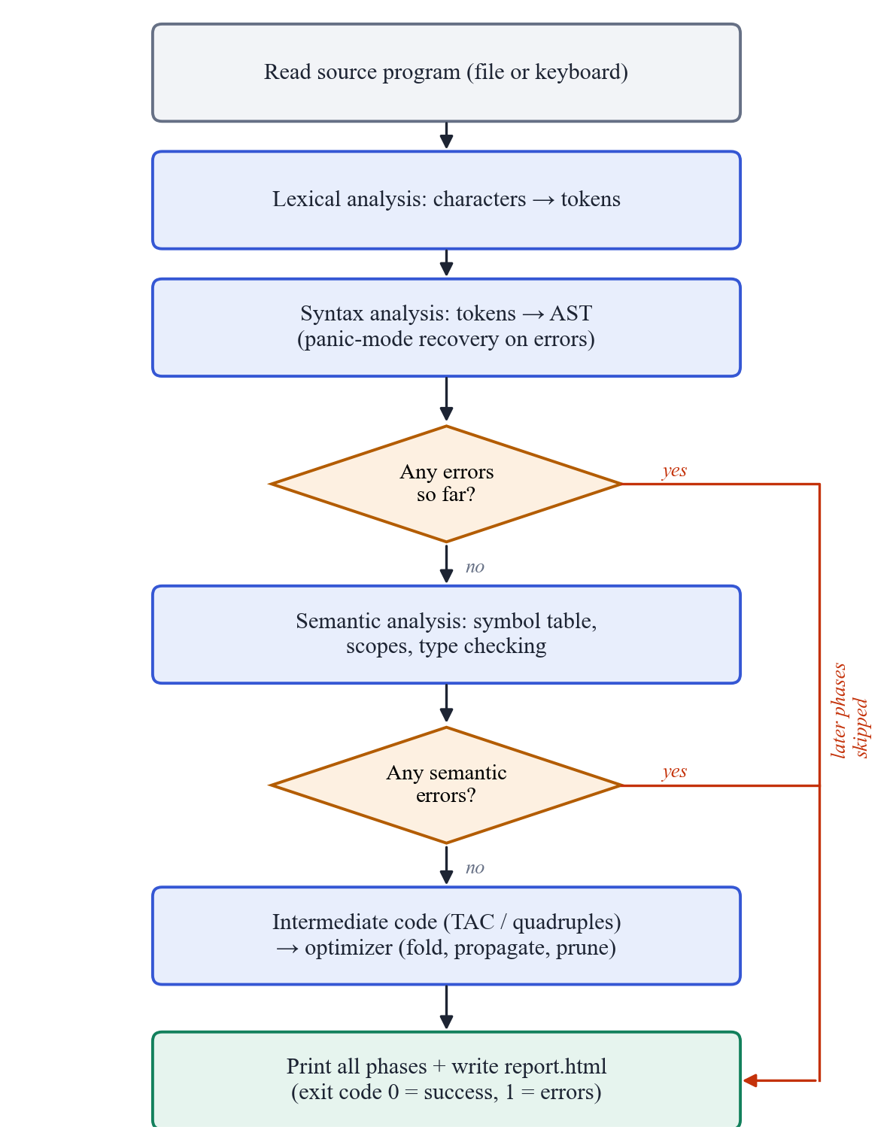
Figure 2: Compiler Workflow with Error Handling

CHAPTER 5 – COMPILER DESIGN CONCEPTS USED
This chapter explains the compiler design concepts implemented in the project and how each one appears in the code.

5.1 Lexical Analysis: Tokens, Patterns and Lexemes
A token is a category of input unit, a pattern describes which strings belong to it, and a lexeme is an actual string in the source that matches the pattern [1]. The lexer recognises the token categories in Table 8. It reads identifiers with the pattern [A-Za-z_][A-Za-z0-9_]* and then checks a keyword table, so keywords need no separate patterns. Operators use the longest match rule: <= is recognised as one token, not as < followed by =.
Table 8: Token Categories Recognised by the Lexer
Category | Tokens / pattern | Example lexemes
KEYWORD | int, float, if, else, while, for, return | while
IDENTIFIER | letter or _ followed by letters, digits or _ | fact, avg, _tmp
INT_CONST | one or more digits | 10, 0
FLOAT_CONST | digits '.' digits | 2.5, 3.0
OPERATOR | + - * / % = == != < > <= >= | <=
SEPARATOR | ( ) { } ; , | ;
END | end of input (added by the lexer) | EOF

5.2 Context-Free Grammar and Recursive Descent Parsing
The syntax of the language is defined by the context-free grammar below (EBNF notation: { } means repetition and [ ] means optional). The grammar has no left recursion and every choice can be made by looking at the next token, so it is suitable for predictive (LL(1)) parsing [1], [14]. The only exception is the program start, where two tokens (int main) are examined to decide whether a main function is present.
program → 'int' 'main' '(' ')' block EOF | stmt* EOF
stmt → decl | assign ';' | if | while | for | block | return
return → 'return' expr ';'
decl → ('int' | 'float') ID (',' ID)* ';'
assign → ID '=' expr
if → 'if' '(' expr ')' stmt [ 'else' stmt ]
while → 'while' '(' expr ')' stmt
for → 'for' '(' assign ';' expr ';' assign ')' stmt
block → '{' stmt* '}'
expr → add [ ('<'|'>'|'<='|'>='|'=='|'!=') add ]
add → mul { ('+'|'-') mul }
mul → unary { ('*'|'/'|'%') unary }
unary → '-' unary | primary
primary → INT_CONST | FLOAT_CONST | ID | '(' expr ')'
In recursive descent, each non-terminal becomes one C function. Operator precedence is encoded by the grammar levels: expr (relational) calls add, which calls mul, which calls unary. Left associativity of + - * / % is obtained with loops instead of left-recursive rules, so a - b - c is parsed as (a - b) - c. Relational operators are non-associative: at most one comparison is allowed per expression.

5.3 Abstract Syntax Tree
Instead of a full parse tree with one node per grammar symbol, the parser builds an abstract syntax tree that keeps only the meaningful structure: operators, operands and statements. Parentheses and separators do not appear in the tree, because their effect is already captured by its shape. Figure 3 shows the AST for b = a * 2 + 3; after semantic analysis has attached a type to every node. Multiplication is deeper in the tree than addition, which is how precedence appears in an AST.
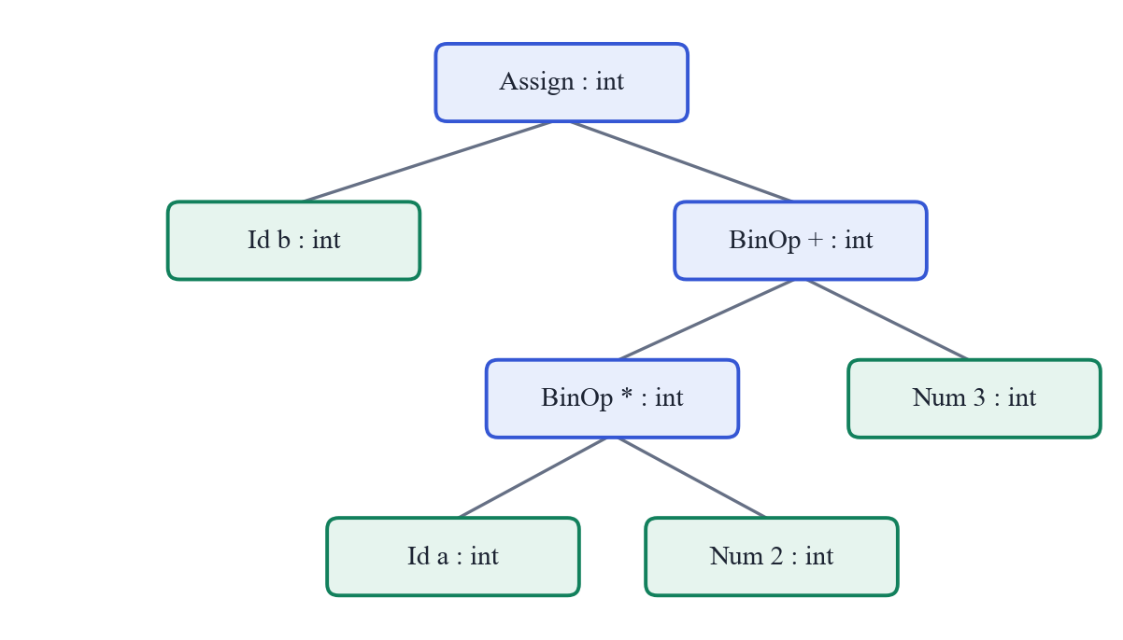
Figure 3: Typed AST for the Statement b = a * 2 + 3;
Table 9: AST Node Kinds
Node | Children | Meaning
Program | list of statements, or one Function | Whole program
Function | body block | int main() { ... }
Block | list of statements | { ... } with its own scope
Declaration | list of Id nodes | int a, b; / float x;
Assign | target Id, expression | x = expr;
If | condition, then statement, optional else statement | if (c) S1 else S2
While | condition, body | while (c) S
For | init assignment, condition, step assignment, body | for (i; c; s) S
Return | expression | return expr;
BinOp | left, right | + - * / % and comparisons
Negate | operand | unary minus
Num / Id | none (leaves) | constants and variable names

5.4 Symbol Table and Scope
The symbol table records every declared name together with its attributes. Each entry stores the name, the type, the storage size (4 bytes for both int and float), the relative memory offset assigned in declaration order, the scope level and the declaration line. The table is organised as an array with a parallel active flag. Entering a block increases the scope level; leaving it marks that level's entries inactive but keeps them in the table so that they can still be displayed. Lookup searches from the newest entry backwards, so an inner declaration shadows an outer one with the same name, as in C. Because the two variables are different, a shadowing variable also receives its own name for the intermediate code: an inner x declared after an outer x appears in the three-address code as x.1 (the number is its position in the symbol table). A dot cannot occur in a user identifier, so these names can never clash.

5.5 Type Checking
The semantic analyser computes a type for every expression bottom-up and stores it in the AST node. The type rules are summarised in Table 10. When an int value is used where a float is needed, the type checker allows it (widening), and the code generator later inserts an explicit conversion instruction. The opposite direction would lose information, so it is reported as an error.
Table 10: Type Rules
Construct | Rule | Result / error
Integer / float constant | Contains a decimal point? | float, otherwise int
a op b (+ - * /) | int op int; any float operand | int; float (int operand widened)
a % b | both operands int | int, otherwise error: '%' needs int operands
a relop b | any numeric operands | int (0 or 1)
x = expr | float into int variable | error: type mismatch
x = expr | int into float variable | allowed, code generator inserts (float)
return expr | inside main, expr is int | error if outside main or if expr is float
Use of a name | must be declared and visible | error: undeclared variable

5.6 Intermediate Code: Three-Address Code and Quadruples
Three-address code (TAC) is a sequence of simple instructions, each with at most one operator on the right side, such as t1 = a * 2 [1]. Complex expressions are broken up using compiler-generated temporaries. The project stores TAC as quadruples, records with four fields: operator, first argument, second argument and result. Table 11 lists the instruction set.
Table 11: Three-Address Instruction Set
op | arg1 | arg2 | result | TAC form
+ - * / % | x | y | t | t = x op y
< > <= >= == != | x | y | t | t = x relop y
uminus | x |  | t | t = - x
itof | x |  | t | t = (float) x
= | x |  | y | y = x
label |  |  | L | L:
goto |  |  | L | goto L
iffalse | x |  | L | ifFalse x goto L
return | x |  |  | return x

5.7 Translation of Control Flow
Boolean conditions are evaluated into a temporary (0 or 1), and the statements are translated with labels and conditional jumps following the standard schemes [1]:
if (c) S1 else S2 while (c) S for (i; c; s) S
t = c L1: t = c i
ifFalse t goto L1 ifFalse t goto L2 L1: t = c
S1 S ifFalse t goto L2
goto L2 goto L1 S
L1: S2 L2: s
L2: goto L1
L2:
A for statement is translated as its initialisation followed by a while loop whose body is the loop body followed by the step. Fresh labels are taken from a counter, so nested statements never clash.

5.8 Code Optimization and Basic Blocks
A basic block is a maximal sequence of instructions that is entered only at the first instruction and left only at the last [1]. In the generated code, every label starts a new block, because control can reach a label from more than one place. Figure 4 shows the blocks of a for loop from examples/main.mc.
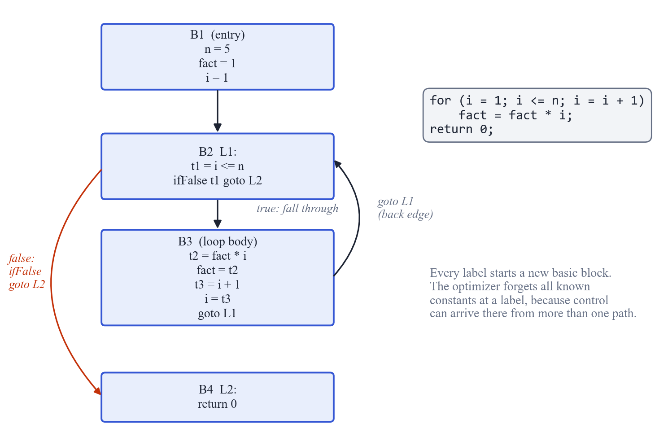
Figure 4: Basic Blocks and Control Flow of a for Loop
The optimizer applies four local transformations, summarised in Table 12. Constant propagation and folding follow the classical data-flow idea of tracking which names hold known constant values [15], restricted to a single basic block: at every label the table of known values is cleared.
Table 12: Optimizations Implemented
Optimization | Example (before → after) | Condition
Constant propagation | a = 5; t1 = a * 2 → t1 = 5 * 2 | a has a known constant value in this block
Constant folding | t1 = 5 * 2 → t1 = 10 | both operands constant; division by zero never folded
Branch folding | ifFalse 1 goto L → (removed); ifFalse 0 goto L → goto L | condition is a constant
Dead temporary removal | t1 = 10 with no later use of t1 → (removed) | temporary is never read

5.9 Error Detection and Recovery
Each phase detects the errors it is able to see. Table 13 lists them. The parser uses panic-mode recovery [1]: after the first error in a statement it stops reporting, skips tokens until it reaches a synchronising token (; or }) and resumes with the next statement. This lets one run report several independent errors while avoiding long cascades of messages caused by a single mistake.
Table 13: Errors Detected by Each Phase
Phase | Error | Example message
Lexical | Unknown character | line 5: unknown character '@'
Lexical | Malformed number | line 2: malformed number '12abc'
Lexical | Unterminated comment | line 3: unterminated comment
Syntax | Missing or unexpected token | line 6: expected ')' but found ';'
Syntax | Code after main() | line 6: expected end of program after main() but found 'int'
Semantic | Undeclared variable | line 9: undeclared variable 'z'
Semantic | Redeclaration in the same scope | line 4: redeclaration of 'x' (first declared on line 2)
Semantic | Type mismatch | line 7: type mismatch: cannot assign float to int variable 'x'
Semantic | Invalid operands | line 8: operator '%' needs int operands, got float % int
Semantic | Misplaced or wrong return | line 4: 'return' used outside of main()
Semantic | Reserved name | 't1' is reserved for compiler temporaries

CHAPTER 6 – METHODOLOGY

6.1 Input Processing
The driver reads the whole source program into a single character buffer. With a file argument it opens the file in text mode; without one it reads standard input until end-of-file, which allows a program to be typed interactively. The web server writes the code received from the browser into a temporary file and runs the compiler on that file, so all three entry points use the same path from this point on.

6.2 Lexical Analysis
The lexer walks the buffer once with a pointer and a line counter. Whitespace is skipped and newlines increase the line counter. Comments are removed here so that the parser never sees them. For each token the lexer records its kind, its lexeme and its line, appending it to a dynamically growing array. Lexical errors are recorded and the offending characters are skipped, so the scan always reaches the end of the input. An EOF token is added at the end so that the parser never reads past the array.

6.3 Syntax Analysis
The parser keeps an index into the token array. Each grammar function inspects the current token to choose a production, consumes the tokens it expects with expect(), and returns a newly allocated AST node. When a token does not match, syntax_error() records the line, the expected item and the found lexeme, and sets the panic flag. The statement-list loop then synchronises and clears the flag, and a safety check advances the position if a statement consumed nothing, which guarantees termination on any input.

6.4 Semantic Analysis
The semantic analyser performs a depth-first walk over the AST. Declarations insert symbols; blocks open and close scopes; expressions are checked bottom-up and their types written into the nodes. When a sub-expression already has an error type, the parent does not report a second error, which avoids cascades such as one undeclared variable producing several type errors.

6.5 Intermediate Code Generation
Code generation is a second depth-first walk over the typed AST. For an expression, the generator returns the name of the place holding its value: a variable, a constant or a new temporary. For statements it applies the translation schemes of Section 5.7. Where an int operand meets a float operand, or an int value is assigned to a float variable, an itof quadruple is emitted first.

6.6 Optimization
The optimizer reads the quadruples in order and writes an improved copy. It keeps a small table mapping names to constant values. For each instruction it first replaces operands with known constants (propagation), then evaluates the instruction if all operands are constant (folding), then updates the table: a copy of a constant records the value, any other definition forgets it. Labels clear the table because they start a new basic block. A final pass removes assignments to temporaries that are no longer read anywhere.

6.7 Output and Visualization
The driver prints a section per phase to the terminal: the token table, an ASCII drawing of the AST with types, the symbol table, the quadruples with their TAC form, the optimized code and the error list. report.c writes the same information to report.html, adding a pipeline banner that marks each phase as passed, failed or skipped, the source with error lines highlighted, and a collapsible tree. The web playground reads the banner's status classes to colour its own phase lights and shows the report beside the editor.

CHAPTER 7 – IMPLEMENTATION

7.1 Project Structure
MiniProject/
├── src/
│ ├── compiler.h shared structures and phase interfaces
│ ├── lexer.c Phase 1: lexical analysis
│ ├── parser.c Phase 2: recursive descent parser, AST
│ ├── semantic.c Phase 3: symbol table and type checking
│ ├── codegen.c Phases 4-5: quadruples and optimizer
│ ├── report.c HTML phase report
│ └── main.c driver, terminal output, error list
├── web/index.html browser playground
├── server.py local web server for the playground
├── examples/ demo.mc, main.mc, errors.mc, semantic.mc
├── tests/ extra test programs and expected outputs
├── build.bat build with gcc
├── test.bat regression tests
├── web.bat start the playground
└── README.md
Table 14: Source Code Size by Module
File | Lines | Purpose
lexer.c | 138 | Lexical analysis
parser.c | 297 | Syntax analysis and AST
semantic.c | 166 | Semantic analysis
codegen.c | 315 | Intermediate code and optimization
main.c | 123 | Driver, errors, terminal output
report.c | 195 | HTML report
compiler.h | 102 | Shared definitions
Total (C) | 1336
server.py / web/index.html | 62 / 171 | Web playground (optional)

7.2 Lexical Analyser Implementation
The core of the lexer is a loop over the characters. The excerpt below shows how operators are recognised: two-character operators are tested first so that the longest match wins, and any character that matches no pattern is reported and skipped.
/* two-character operators first */
TokenKind kind;
int len = 2;
if (p[0] == '=' && p[1] == '=') kind = TK_EQ;
else if (p[0] == '!' && p[1] == '=') kind = TK_NE;
else if (p[0] == '<' && p[1] == '=') kind = TK_LE;
else if (p[0] == '>' && p[1] == '=') kind = TK_GE;
else {
len = 1;
switch (*p) {
case '+': kind = TK_PLUS; break;
case '-': kind = TK_MINUS; break;
case '*': kind = TK_STAR; break;
case '/': kind = TK_SLASH; break;
case '%': kind = TK_PERCENT; break;
case '=': kind = TK_ASSIGN; break;
case '<': kind = TK_LT; break;
case '>': kind = TK_GT; break;
case '(': kind = TK_LPAREN; break;
case ')': kind = TK_RPAREN; break;
case '{': kind = TK_LBRACE; break;
case '}': kind = TK_RBRACE; break;
case ';': kind = TK_SEMI; break;
case ',': kind = TK_COMMA; break;
default:
error_at("Lexical", line, "unknown character '%c'", *p);
p++;
continue;
}
}
add(kind, p, len, line);
p += len;

7.3 Parser Implementation
Each grammar rule is a function. The function for add → mul { ('+' | '-') mul } shows how a loop gives left associativity: each new operator node takes the tree built so far as its left child.
static Node *add(void)
{
Node *n = mul();
while (CUR.kind == TK_PLUS || CUR.kind == TK_MINUS) {
Token op = CUR;
advance();
n = binop(op, n, mul());
}
return n;
}
Error recovery is implemented in the statement-list function. If a statement set the panic flag, the parser skips to the next ; or } unless the statement already ended at one, and it always advances at least one token, so parsing finishes on any input.
static Node *stmt_list(TokenKind end)
{
Node *first = NULL, **tail = &first;
while (CUR.kind != end && CUR.kind != TK_EOF) {
int start = pos;
Node *s = stmt();
if (panic) { /* skip to a safe point, unless the statement already ended at one */
TokenKind last = pos > start ? tokens[pos - 1].kind : TK_EOF;
if (last != TK_SEMI && last != TK_RBRACE) {
while (CUR.kind != TK_SEMI && CUR.kind != TK_RBRACE && CUR.kind != TK_EOF) advance();
accept(TK_SEMI);
}
panic = 0;
}
if (pos == start) advance(); /* always make progress */
if (s) { *tail = s; tail = &s->next; }
}
return first;
}

7.4 Semantic Analyser Implementation
The declare function shows the symbol table insertion: a redeclaration is reported only when the existing symbol is in the same scope, which is what allows shadowing in inner blocks.
static void declare(Node *id, Type type)
{
Symbol *old = lookup(id->text);
if (old && old->scope == scope) {
error_at("Semantic", id->line, "redeclaration of '%s' (first declared on line %d)",
id->text, old->line);
return;
}
if (is_temp_name(id->text)) {
error_at("Semantic", id->line, "'%s' is reserved for compiler temporaries", id->text);
return;
}
if (nsyms == MAX_SYMS) {
error_at("Semantic", id->line, "too many variables (max %d)", MAX_SYMS);
return;
}
Symbol *s = &symtab[nsyms];
strcpy(s->name, id->text);
/* a later variable with an existing name (e.g. shadowing in a block) gets its own TAC name */
strcpy(s->tac, id->text);
for (int i = 0; i < nsyms; i++)
if (!strcmp(symtab[i].name, id->text)) sprintf(s->tac, "%s.%d", id->text, nsyms);
s->type = type;
s->size = 4;
s->offset = offset;
s->scope = scope;
s->line = id->line;
active[nsyms++] = 1;
offset += s->size;
id->type = type;
id->sym = s;
}

7.5 Code Generator and Optimizer Implementation
The translation of a while statement follows the scheme of Section 5.7 directly: two fresh labels, the condition, a conditional jump out of the loop, the body and a jump back.
case N_WHILE:
new_label(l1);
new_label(l2);
emit("label", "", "", l1);
gen_expr(n->kid[0], v);
emit("iffalse", v, "", l2);
gen_stmt(n->kid[1]);
emit("goto", "", "", l1);
emit("label", "", "", l2);
break;
Inside the optimizer, folding is applied after propagation has replaced operands with constants. The helper fold() refuses to fold division or modulus by zero and uses integer arithmetic unless one operand is a float constant, so the folded result is exactly what the program would compute at run time.
/* constant folding */
if (!strcmp(q.op, "itof") && is_const(q.arg1)) {
format_float(atof(q.arg1), folded);
make_copy(&q, folded);
} else if (!strcmp(q.op, "uminus") && is_const(q.arg1)) {
if (fold("-", is_float_const(q.arg1) ? "0.0" : "0", q.arg1, folded)) make_copy(&q, folded);
} else if (q.arg2[0] && is_const(q.arg1) && is_const(q.arg2)) {
if (fold(q.op, q.arg1, q.arg2, folded)) make_copy(&q, folded);
}

if (!strcmp(q.op, "=") && is_const(q.arg1)) remember(q.res, q.arg1);
else forget(q.res);
opt[nopt++] = q;

7.6 User Interface and Visualization
The project offers three views of the same compilation. The web playground (Figure 6) has an editor with line numbers, a list of sample programs, a Compile button (also Ctrl+Enter) and five phase lights. Its request flow is shown in Figure 5: the browser sends the code to server.py, which runs the unchanged C compiler in a temporary folder and returns the generated report.
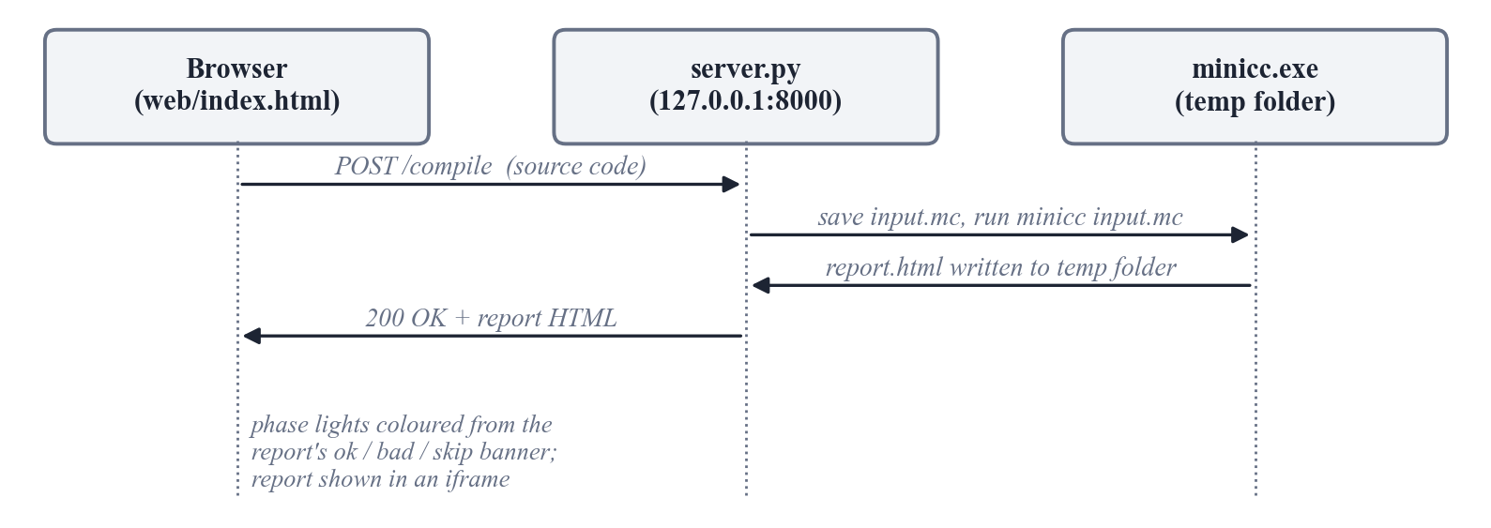
Figure 5: Web Playground Request Flow
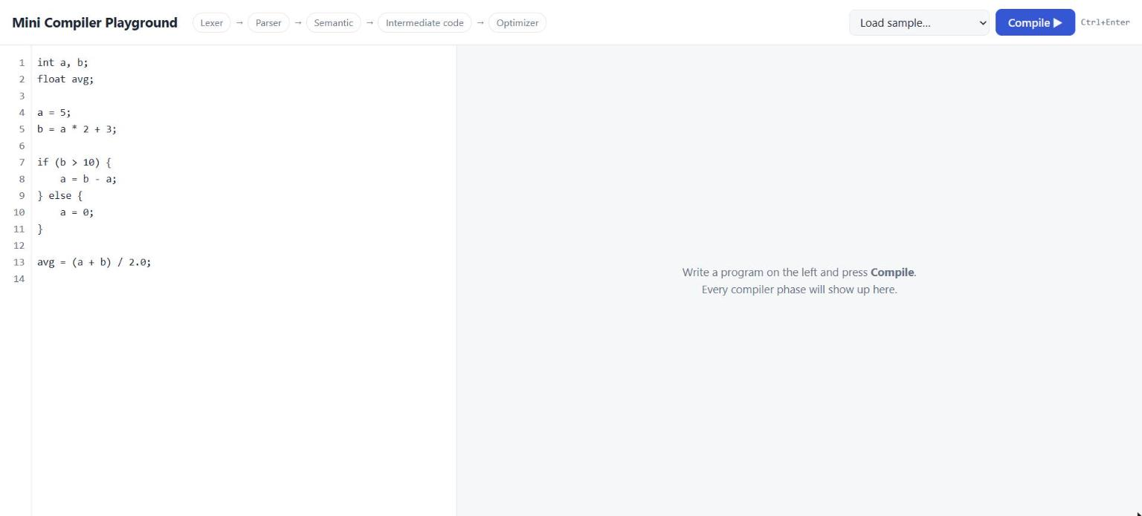
Figure 6: Web Playground – Home Page with the Editor
After compilation, each phase light turns green (passed), red (errors) or grey (skipped), and the full report appears on the right (Figure 7). Figures 8 to 11 show the report sections for the demo program.
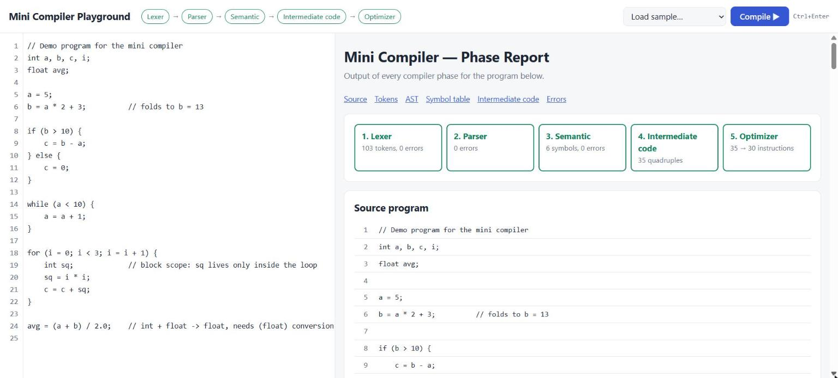
Figure 7: Compiling the Demo Program – All Five Phases Pass
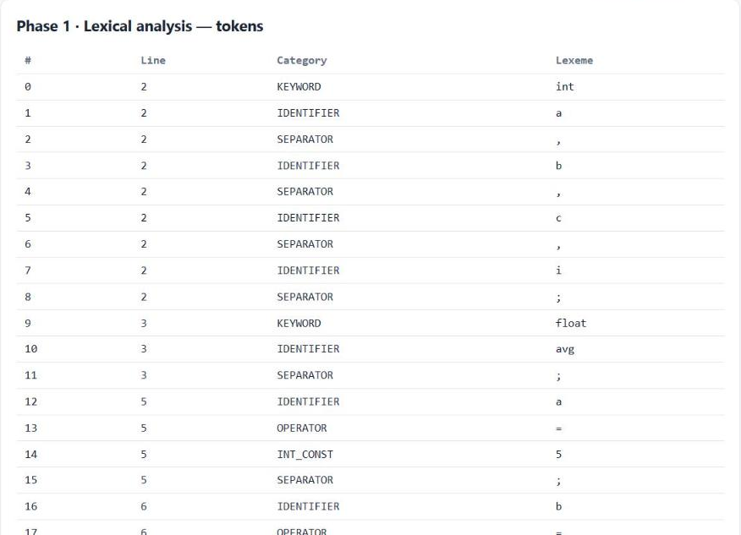
Figure 8: Phase 1 Output – Token Table with Line Numbers
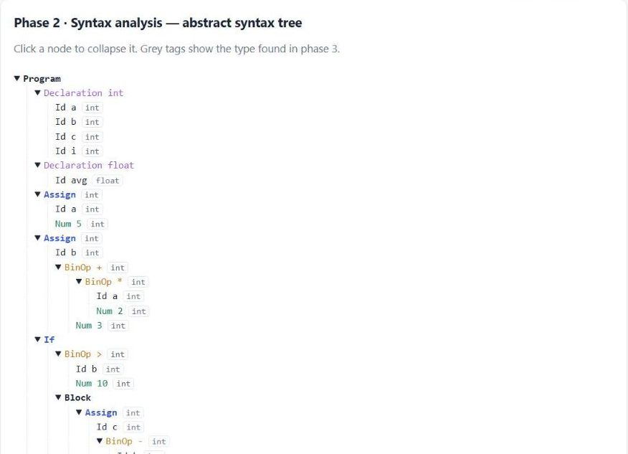
Figure 9: Phase 2 Output – Collapsible AST Annotated with Types
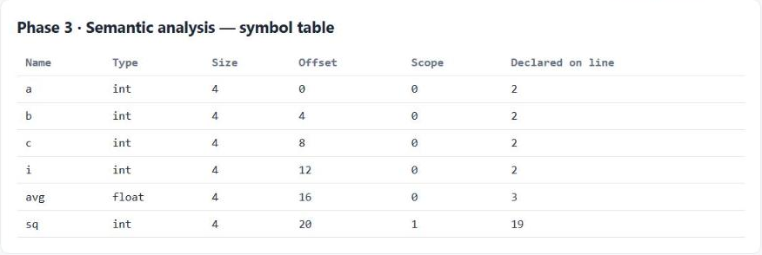
Figure 10: Phase 3 Output – Symbol Table with Scope and Offset
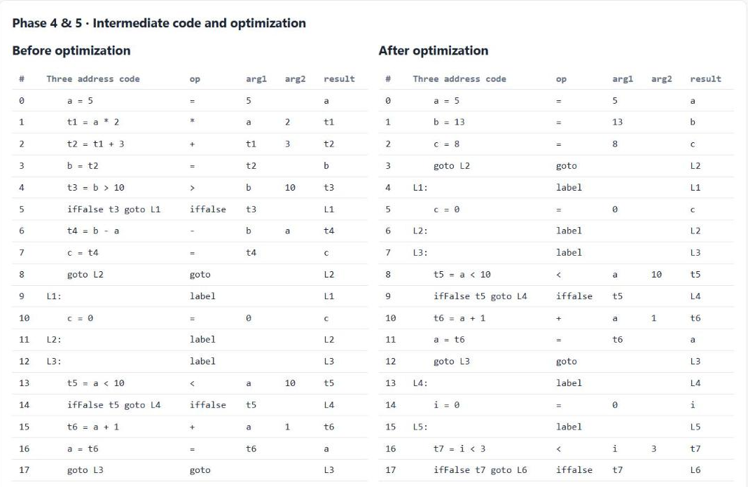
Figure 11: Phases 4 and 5 – Quadruples Before and After Optimization
The same information is printed in the terminal (Figure 12), so the compiler can also be demonstrated without a browser.
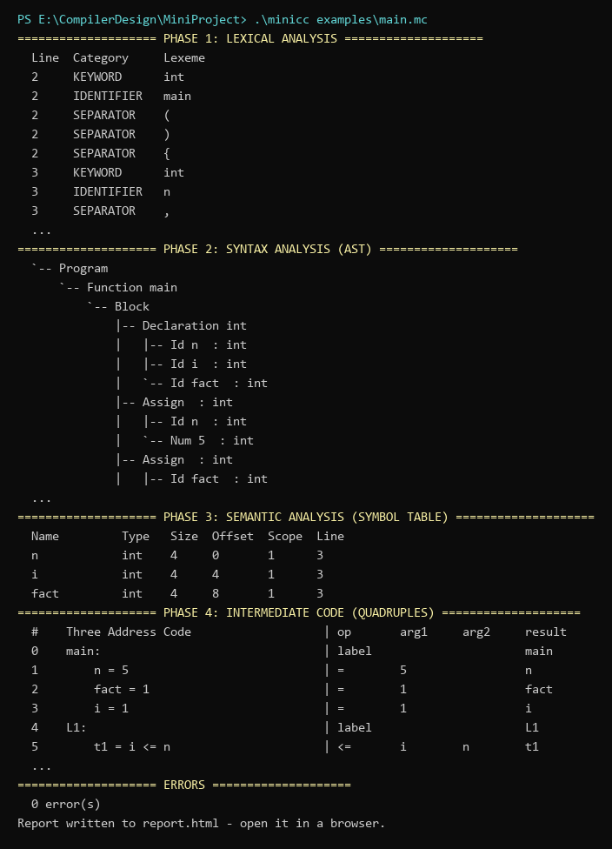
Figure 12: Command-Line Output of minicc for examples/main.mc (excerpt)

CHAPTER 8 – RESULTS AND OUTPUT

8.1 Test Cases
Table 15 lists the functional test cases, all executed on 26 October 2026 with the final build. The Actual Output column is copied from the compiler's output. A test passes when the compiler accepts valid programs with the expected code and rejects invalid programs with the expected error messages and line numbers.
Table 15: Test Cases
Test Case ID | Input | Expected Output | Actual Output | Status
TC01 | Valid program with declarations, if-else, while, for and int/float mixing (demo.mc) | 0 errors; b folded to 13; if-branch decided at compile time | 0 errors; 35 → 30 instructions | Pass
TC02 | Program wrapped in int main() with return 0 (main.mc) | 0 errors; main: label and return 0 in TAC | 0 errors; 14 → 14 instructions | Pass
TC03 | Lexical and syntax errors in one file (errors.mc) | unknown '@' (line 5); missing ')' (line 6); missing '(' (line 7) | Lexical line 5: unknown character '@'; Syntax line 5: expected ';' but found '2'; Syntax line 6: expected ')' but found ';'; Syntax line 7: expected '(' but found 'x' | Pass
TC04 | Semantic errors: redeclaration, type mismatch, % on float, undeclared (semantic.mc) | 4 semantic errors on lines 4, 7, 8, 9 | Semantic line 4: redeclaration of 'x' (first declared on line 2); Semantic line 7: type mismatch: cannot assign float to int variable 'x'; Semantic line 8: operator '%' needs int operands, got float % int; Semantic line 9: undeclared variable 'z' | Pass
TC05 | Optimizer edge cases (optimizer.mc) | 7/0 not folded; k = 4; f = 3.0 then 4.5; while(0) becomes goto | 0 errors; 17 → 11 instructions; total = 7, t1 = 7 / 0, z = t1, k = 4, f = 3.0, f = 4.5, L1:, goto L2 | Pass
TC06 | Operator precedence and unary minus (precedence.mc) | a = 13 and b = 14 after folding | 0 errors; 8 → 2 instructions; a = 13, b = 14 | Pass
TC07 | Nested block scope (shadowing) (scope.mc) | 0 errors; inner x renamed x.1 in TAC; outer x = 2 after optimization | 0 errors; 4 → 3 instructions; x = 1, x.1 = 2.5, x = 2 | Pass
TC08 | Malformed number (badnum.mc) | malformed number error on line 2 | Lexical line 2: malformed number '12abc'; Syntax line 2: expected an expression but found ';' | Pass
TC09 | Unterminated block comment (comment.mc) | unterminated comment error on line 3 | Lexical line 3: unterminated comment | Pass
TC10 | return outside main() (return_outside.mc) | return outside main reported | Semantic line 4: 'return' used outside of main() | Pass
TC11 | main() returning float (main_errors.mc) | float return from main reported | Semantic line 4: type mismatch: main() must return int, not float | Pass
TC12 | Empty program (empty.mc) | 0 errors, 0 instructions | 0 errors; 0 → 0 instructions | Pass
TC13 | Standard C Hello World (unsupported features) (hello.mc) | rejected: '#', '"' and other unsupported characters reported | Lexical line 1: unknown character '#'; Lexical line 1: unknown character '.'; Lexical line 4: unknown character '"'; Lexical line 4: unknown character '!'; … (8 errors) | Pass

In addition, test.bat runs 8 programs and compares the complete output of the compiler with saved expected output files (golden testing). This catches any unintended change in any phase.
Table 16: Automated Regression Tests (test.bat)
Test | Program | Result
1 | examples/demo.mc | PASS
2 | examples/errors.mc | PASS
3 | examples/semantic.mc | PASS
4 | examples/main.mc | PASS
5 | tests/optimizer.mc | PASS
6 | tests/return_outside.mc | PASS
7 | tests/main_errors.mc | PASS
8 | tests/scope.mc | PASS

8.2 Sample Outputs

Test Case 1 – Valid program with all statement types (TC01)
Input: examples/demo.mc (25 lines: declarations, if/else, while, for with a block-scoped variable, and an int/float expression).
Compiler action: all five phases run. The lexer produced 103 tokens, the symbol table contains 6 symbols (sq at scope level 1), the code generator emitted 35 quadruples and the optimizer reduced them to 30.
Output: b = a * 2 + 3 became b = 13; the condition b > 10 was evaluated at compile time, so its ifFalse was removed and c = b - a became c = 8; avg = (a + b) / 2.0 received a (float) conversion. Screenshots: Figures 7 to 11.

Test Case 2 – Lexical and syntax errors (TC03)
Input: examples/errors.mc, containing an unknown character @, a missing ) and an if without (.
Compiler action: the lexer reports the @ and skips it; the parser reports each syntax error and recovers at the next ;, so all three mistakes are found in one run. Semantic analysis and code generation are skipped.
Output: four messages – the three intended errors plus one secondary message (expected ';' but found '2') caused by the skipped @. The phase lights show Lexer and Parser in red and the other phases skipped (Figure 13).
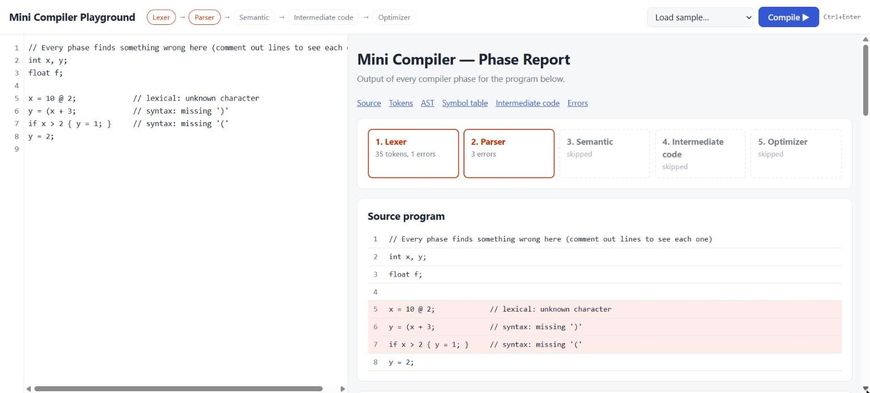
Figure 13: Lexical and Syntax Errors in the Playground (failed phases in red, error lines highlighted)

Test Case 3 – Semantic errors (TC04)
Input: examples/semantic.mc, which is syntactically correct but redeclares x, assigns a float to an int, uses % on a float and assigns to an undeclared z. It also declares a second y inside a block, which is legal.
Compiler action: the semantic analyser reports exactly four errors and accepts the inner y, which appears in the symbol table at scope level 1.
Output: Figure 14.
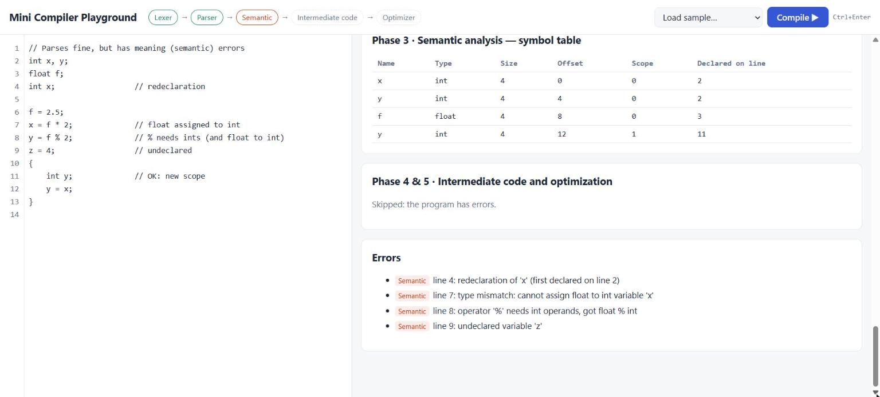
Figure 14: Semantic Errors Reported with Line Numbers

8.3 Compilation Trace
The trace below follows the single statement b = a * 2 + 3; (line 6 of the demo program, with a = 5 on the line before) through every phase:
Source b = a * 2 + 3;
↓
Lexical analysis IDENTIFIER(b) OPERATOR(=) IDENTIFIER(a) OPERATOR(*)
INT_CONST(2) OPERATOR(+) INT_CONST(3) SEPARATOR(;)
↓
Syntax analysis Assign( Id b, BinOp +( BinOp *( Id a, Num 2 ), Num 3 ) )
↓
Semantic b: int (scope 0, offset 4) a * 2 : int ... + 3 : int
↓
Intermediate t1 = a * 2
code t2 = t1 + 3
b = t2
↓
Optimization a = 5 is known → t1 = 5 * 2 = 10 → t2 = 10 + 3 = 13
→ b = 13 (t1, t2 no longer used: removed)

CHAPTER 9 – PERFORMANCE EVALUATION
All values in this chapter were measured on 26 October 2026 on the development machine (AMD Ryzen 5 5600H, Windows 11). Times were measured from Python with time.perf_counter() around a complete run of minicc.exe, so they include process start-up and writing report.html; each value is the median of 20 runs.
Table 17: Performance Evaluation
Metric | Evaluation Method | Result
Test case success rate | Passed functional tests / total | 13 / 13 (100%)
Regression test success rate | Passed golden-output tests / total | 8 / 8 (100%)
Error detection rate | Deliberately inserted errors reported with correct line / inserted errors | 11 / 11 (100%)
Secondary (cascade) messages | Extra messages caused by an earlier error, over TC03 and TC08 | 2
Code reduction – demo program | Instructions after / before optimization | 35 → 30 (14.3% fewer)
Code reduction – optimizer test | Instructions after / before optimization | 17 → 11 (35.3% fewer)
Average compile time (test programs) | Median wall-clock time per program, TC01–TC13 | 15.5–24.2 ms (mean 18.9 ms)
Compile time, 603-line program | Median of 20 runs | 172.9 ms

Table 18 shows how compile time grows with program size, using generated programs made of repeated statements of the form x = x + i * k;. Because x and i start with constant values, the optimizer folds every statement to a single constant assignment, which explains the large reduction in instructions.
Table 18: Compile Time and Optimization by Program Size
Source lines | Tokens | Quadruples | After optimization | Median time (ms)
53 | 414 | 152 | 52 | 38.8
153 | 1214 | 452 | 152 | 59.5
303 | 2414 | 902 | 302 | 104.3
603 | 4814 | 1802 | 602 | 172.9

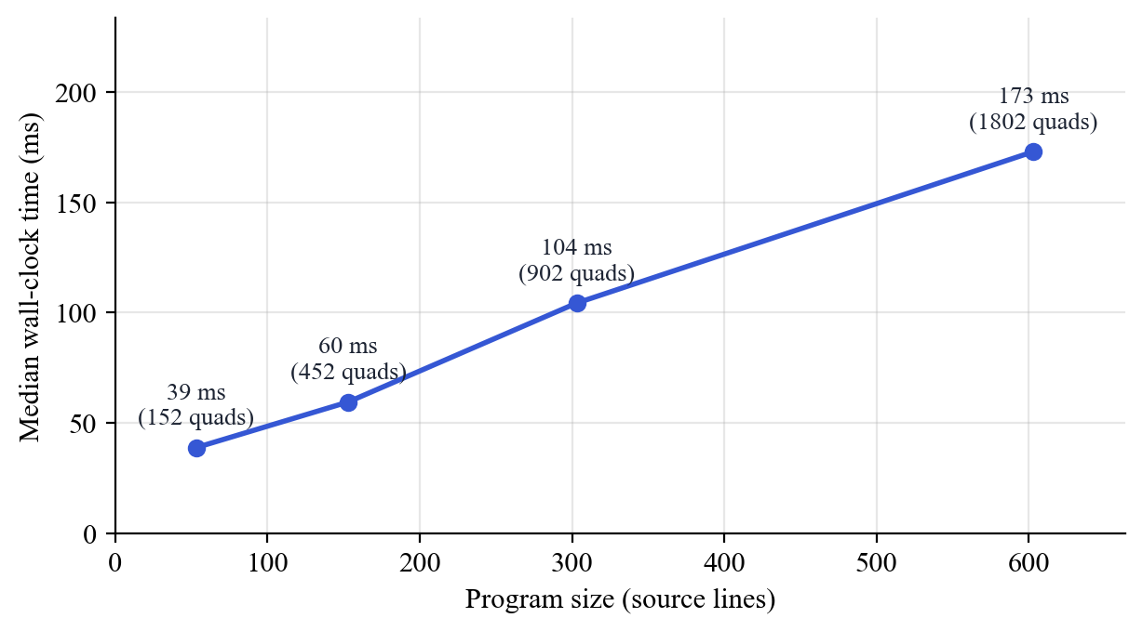
Figure 15: Compile Time versus Program Size
The time grows roughly linearly with program size, as expected for single-pass lexing and parsing and linear tree walks. Even an empty program takes 20 ms, which is the fixed cost of starting the process and writing the report; it dominates for classroom-sized programs. The dead-temporary pass compares every temporary with every instruction, which is quadratic in the worst case; it is not noticeable at these sizes but would need a use-count table for much larger programs.
Optimization effect varies with the program: straight-line code with constants is reduced strongly (TC06: 8 → 2), while loop code whose variables change on every iteration is not reduced (TC02: 14 → 14), because the optimizer correctly forgets all values at loop labels.

CHAPTER 10 – CHALLENGES AND LIMITATIONS

10.1 Challenges Faced
- Error recovery skipping too far. The first version of panic-mode recovery always skipped to the next ;. When the erroneous statement had already consumed its own ;, the parser skipped the whole following statement and reported a confusing error on a later }. The fix was to synchronise only when the statement had not already ended at a ; or }; the regression test errors.mc now checks this.
- Correct constant folding for mixed types. Folding 7 / 2 must give 3 for integers but a float context must not change that. Making int-to-float conversion an explicit itof instruction meant the optimizer always knows which arithmetic to use, so f = 7 / 2 correctly folds to f = 3.0.
- Name clashes with temporaries. Temporaries are named t1, t2, ..., so a user variable called t1 could be mistaken for a temporary by the optimizer. Such names are now rejected in semantic analysis, and the optimizer checks the full pattern t + digits (so a variable like total is never treated as a temporary).
- Shadowed variables in intermediate code (found by testing). Test case TC07 showed that an inner float x and the outer int x were both written as x in the three-address code, so the optimizer carried the inner value 2.5 into the outer variable and produced x = 3.5 instead of x = 2. The fix gives every shadowing variable a unique TAC name (x.1), stored in its symbol table entry; TC07 and a new regression test now confirm x = 2. The same review found that very long identifiers could overflow the quadruple fields, which were then enlarged.
- Termination on any input. Every loop in the parser must consume a token or stop; a progress check in the statement list guarantees that even input such as a stray } cannot cause an infinite loop.
- Tooling on Windows. The available GCC (6.3) needed -std=c99; box-drawing characters for the tree printed incorrectly in the Windows console, so the terminal tree uses ASCII; and PowerShell requires .\ before programs in the current folder, which the build and test scripts account for.

10.2 Limitations
- No target code. The compiler stops at optimized three-address code; it does not generate assembly or run the program.
- Small language. No user-defined functions other than main, no parameters, arrays, pointers, strings, characters, input/output or logical operators (&&, ||, !). A standard C program such as Hello World is therefore rejected (TC13).
- Local optimization only. Constant propagation does not cross labels, unreachable code (for example after a folded goto) is not removed, and there is no common subexpression elimination or loop optimization.
- Simple error recovery. Panic mode can still produce a secondary message after a lexical error (two were observed in testing, Table 17).
- Fixed limits. At most 2048 quadruples, 256 symbols, 100 reported errors and 63 characters per lexeme.
- Web playground needs Python. The browser cannot run the C compiler by itself, so the playground only works while server.py is running on the same computer.

CHAPTER 11 – FUTURE SCOPE
- Boolean expressions with short-circuit evaluation: add &&, || and ! and translate them with jumps (backpatching).
- Functions: parameters, calls and return values, with activation records and a symbol table per function.
- Arrays: declarations, indexing and the address computations they require in three-address code.
- More representations: triples and indirect triples next to quadruples, and a DAG view of each basic block.
- Global optimization: data-flow analysis across basic blocks, common subexpression elimination, dead code and unreachable code elimination, and loop-invariant code motion.
- Control flow graph visualization: draw the basic blocks and their edges in the HTML report.
- Code generation: translate TAC to x86 assembly or to a simple stack machine, together with an interpreter so that programs can actually be run and their results shown.
- LL(1) parsing table display: show FIRST and FOLLOW sets and the predictive parsing table for the grammar.
- Fully browser-based version: compile the C code to WebAssembly so the playground works without a server.
- Cross-platform build: a Makefile or CMake script in addition to build.bat.

CHAPTER 12 – CONCLUSION
The project set out to make the phases of a compiler visible on real programs. Production compilers hide their intermediate representations, and educational tools usually cover a single phase, so students find it hard to connect lexical analysis, parsing, semantic analysis, intermediate code and optimization into one picture.
We designed a small C-like language and implemented a complete compiler front end and middle end for it in about 1336 lines of C99, with one source file per phase. The lexer recognises tokens with a longest-match rule and keyword table; the recursive descent parser builds an abstract syntax tree directly from an LL(1) grammar and recovers from syntax errors in panic mode; the semantic analyser maintains a scoped symbol table with sizes and offsets and enforces the type rules for int and float; the code generator emits three-address code as quadruples using the standard translation schemes for if, while and for; and the optimizer performs constant propagation, constant folding, branch folding and dead temporary removal within basic blocks.
Every phase is visualized three ways: as text in the terminal, in a self-contained HTML report with a phase status banner, tables and a collapsible tree, and in a browser playground where code can be typed and compiled with immediate feedback. The playground reuses the same C compiler through a small Python server, so what is shown is always the real output of the C code.
Testing confirmed the design. All 13 functional test cases and all 8 regression tests passed, and all 11 deliberately inserted errors were reported in the correct phase with the correct line number. The optimizer reduced the demo program from 35 to 30 instructions without changing its meaning, and compilation remained fast, with a median of 173 ms for a 603-line program.
The main limitations are the small language and the absence of target code generation. Both are natural next steps, and the one-file-per-phase structure makes them straightforward to add.
The most important lesson for the team was how closely each phase depends on the data structure produced by the previous one: a careful AST made type checking simple, explicit type information made correct constant folding possible, and clear basic block boundaries made the optimizer safe. Building the phases by hand, rather than generating them, gave every member a working understanding of the algorithms taught in the course.

REFERENCES
[1] A. V. Aho, M. S. Lam, R. Sethi and J. D. Ullman, Compilers: Principles, Techniques, and Tools, 2nd ed., Pearson Addison-Wesley, 2006.
[2] K. D. Cooper and L. Torczon, Engineering a Compiler, 2nd ed., Morgan Kaufmann, 2011.
[3] A. W. Appel, Modern Compiler Implementation in C, Cambridge University Press, 1998.
[4] R. Nystrom, Crafting Interpreters, Genever Benning, 2021.
[5] M. E. Lesk and E. Schmidt, “Lex – A Lexical Analyzer Generator,” Bell Laboratories, Computing Science Technical Report No. 39, 1975.
[6] S. C. Johnson, “Yacc: Yet Another Compiler-Compiler,” Bell Laboratories, Computing Science Technical Report No. 32, 1975.
[7] C. Lattner and V. Adve, “LLVM: A Compilation Framework for Lifelong Program Analysis & Transformation,” in Proc. International Symposium on Code Generation and Optimization (CGO), 2004.
[8] T. J. Parr and R. W. Quong, “ANTLR: A Predicated-LL(k) Parser Generator,” Software: Practice and Experience, vol. 25, no. 7, pp. 789–810, 1995.
[9] M. Godbolt, “Compiler Explorer,” https://godbolt.org, 2012.
[10] Free Software Foundation, “GCC Online Documentation,” https://gcc.gnu.org/onlinedocs/, 2026.
[11] ISO/IEC 9899:1999, Programming Languages – C, International Organization for Standardization, 1999.
[12] Python Software Foundation, “http.server – HTTP servers,” Python 3.12 Documentation, https://docs.python.org/3/library/http.server.html, 2026.
[13] D. E. Knuth, “On the Translation of Languages from Left to Right,” Information and Control, vol. 8, no. 6, pp. 607–639, 1965.
[14] N. Wirth, Compiler Construction, Addison-Wesley, 1996.
[15] G. A. Kildall, “A Unified Approach to Global Program Optimization,” in Proc. 1st ACM Symposium on Principles of Programming Languages (POPL), pp. 194–206, 1973.
[16] S. H. Rodger and T. W. Finley, JFLAP: An Interactive Formal Languages and Automata Package, Jones and Bartlett, 2006.

APPENDIX

Appendix A – Source Code
The complete source code is in the project folder MiniProject/ (structure in Section 7.1). Build with build.bat, run with .\minicc examples\demo.mc, test with test.bat, and start the playground with web.bat.
GitHub Repository: ______________________________
Deployed Link: Not applicable (runs locally; see web.bat)

Appendix B – Additional Screenshots
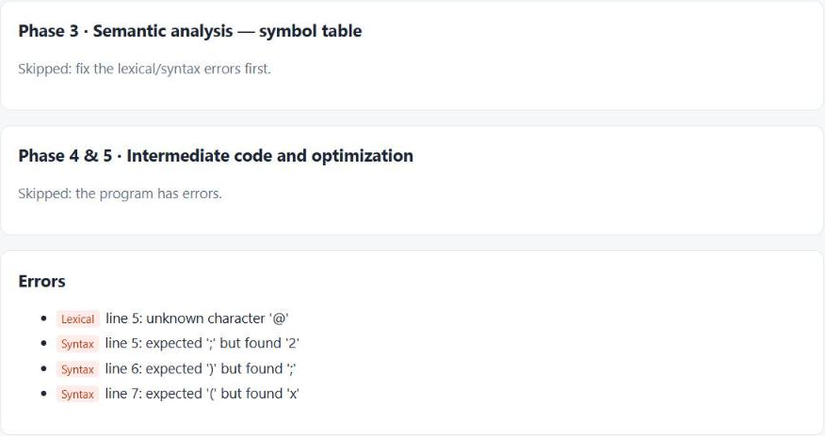
Figure 16: Error List in the HTML Report, Grouped by Phase

Appendix C – Sample Programs
Table 19: Sample Programs
Sr. No. | Program | Purpose
1 | examples/demo.mc | All statement types, block scope and int/float conversion; no errors
2 | examples/main.mc | Factorial loop written inside int main() with return 0
3 | examples/errors.mc | Lexical and syntax errors with recovery
4 | examples/semantic.mc | Semantic errors and legal shadowing in a block
5 | tests/optimizer.mc | Optimizer edge cases (division by zero, negatives, int to float)

The demo program used for most figures in this report:
// Demo program for the mini compiler
int a, b, c, i;
float avg;

a = 5;
b = a * 2 + 3; // folds to b = 13

if (b > 10) {
c = b - a;
} else {
c = 0;
}

while (a < 10) {
a = a + 1;
}

for (i = 0; i < 3; i = i + 1) {
int sq; // block scope: sq lives only inside the loop
sq = i * i;
c = c + sq;
}

avg = (a + b) / 2.0; // int + float -> float, needs (float) conversion

Appendix D – Test Data
The inputs of the additional functional test cases (TC06–TC13) are listed below exactly as they were compiled.
TC06 – Operator precedence and unary minus (precedence.mc)
int a, b;
a = 2 + 3 * 4 - 1;
b = -(a - 20) * 2;
TC07 – Nested block scope (shadowing) (scope.mc)
int x;
x = 1;
{
float x; // shadows the outer x
x = 2.5;
}
x = x + 1;
TC08 – Malformed number (badnum.mc)
int a;
a = 12abc;
TC09 – Unterminated block comment (comment.mc)
int a;
a = 1;
/* this comment never ends
a = 2;
TC10 – return outside main() (return_outside.mc)
// return is only allowed inside main()
int x;
x = 1;
return x;
TC11 – main() returning float (main_errors.mc)
int main() {
float f;
f = 2.5;
return f; // main must return int
}
TC13 – Standard C Hello World (unsupported features) (hello.mc)
#include <stdio.h>

int main() {
printf("Hello, World!\n");
return 0;
}
TC12 is an empty file.

