

KARNAVATI UNIVERSITY
UNITEDWORLD INSTITUTE OF TECHNOLOGY (UIT)

MINI PROJECT REPORT
ON
“End-to-End Mini Compiler with Compiler Phase Visualization”
Submitted as a part of the course

Compiler Design
Submitted By

Student Name | Enrollment No.
Hitik Shah | 202307020106
Het Sharma | 202307020045
Manya Singh | 202307020133
Yashvi Muchhala | 202307020150
Program: B.Tech CSE
Semester: VII
Section: CSE

Under the Guidance of
Dr. Bela Shrimali
Associate Professor
Department of Computer Science & Engineering Technology

Karnavati University, Gandhinagar
TABLE OF CONTENTS
ABSTRACT 4
CHAPTER 1 – INTRODUCTION 5
1.1 Introduction 5
1.2 Background 5
1.3 Problem Statement 6
1.4 Motivation 6
1.5 Objectives 6
1.6 Scope of the Project 7
1.7 Literature Review 7
CHAPTER 2 – OVERVIEW OF THE PROJECT 9
2.1 Proposed Solution 9
2.2 Functional Requirements 9
2.3 Non-Functional Requirements 10
2.4 Architecture Components 10
2.5 Module Responsibilities 11
2.6 Compiler Design Concepts Used 11
2.6.1 Lexical Analysis: Tokens, Patterns and Lexemes 11
2.6.2 Context-Free Grammar and Recursive Descent Parsing 12
2.6.3 Abstract Syntax Tree 12
2.6.4 Symbol Table and Scope 13
2.6.5 Type Checking 14
2.6.6 Intermediate Code: Three-Address Code and Quadruples 14
2.6.7 Translation of Control Flow 14
2.6.8 Code Optimization and Basic Blocks 15
2.6.9 Error Detection and Recovery 15
2.7 Methodology 16
2.7.1 Input Processing 16
2.7.2 Lexical Analysis 16
2.7.3 Syntax Analysis 16
2.7.4 Semantic Analysis 16
2.7.5 Intermediate Code Generation 17
2.7.6 Optimization 17
2.7.7 Output and Visualization 17
2.8 Implementation 17
2.8.1 Lexical Analyser 17
2.8.2 Parser 18
2.8.3 Semantic Analyser 19
2.8.4 Code Generator and Optimizer 19
CHAPTER 3 – TECHNOLOGY USED 21
3.1 Technologies Used 21
3.2 Hardware Requirements 21
3.3 Software Requirements 21
3.4 Project Structure 22
CHAPTER 4 – FLOW CHART OF THE PROJECT 23
4.1 Overall System Architecture 23
4.2 Compiler Workflow 23
4.3 Control Flow of the Generated Code 24
4.4 Web Playground Request Flow 25
4.5 Compilation Trace of One Statement 25
CHAPTER 5 – SCREENSHOTS OF THE PROJECT 27
5.1 Web Playground 27
5.2 Output of Each Phase 27
5.3 Command-Line Output 29
5.4 Error Reporting 30
CHAPTER 6 – RESULTS AND CONCLUSION 32
6.1 Test Cases 32
6.2 Sample Outputs 33
Test Case 1 – Valid program with all statement types (TC01) 33
Test Case 2 – Lexical and syntax errors (TC03) 33
Test Case 3 – Semantic errors (TC04) 33
6.3 Performance Evaluation 34
6.4 Challenges Faced 35
6.5 Limitations 36
6.6 Future Scope 36
6.7 Conclusion 37
REFERENCES 39

ABSTRACT
A compiler translates a program through a sequence of phases, but students usually see only the first input and the final error message. The intermediate results that the theory course talks about, such as tokens, syntax trees, symbol tables and three-address code, stay hidden inside production compilers like GCC, which makes the phases hard to connect with real behaviour.
This project presents an end-to-end mini compiler, written in C (C99), for a small C-like language with int and float variables, arithmetic and relational expressions, if/else, while and for statements, nested block scopes and an optional int main() with return. The compiler is organised as five phases in separate source files: a hand-written lexical analyser, a recursive descent parser that builds an abstract syntax tree with panic-mode error recovery, a semantic analyser that builds a scoped symbol table and performs type checking, an intermediate code generator that emits three-address code as quadruples, and a local optimizer that performs constant propagation, constant folding, branch folding and dead temporary removal. Every phase prints its result to the terminal and to a self-contained HTML report. A small Python server adds a web playground where code typed in the browser is compiled by the same C program and the phases are shown as coloured status lights.
The system was evaluated on 26 October 2026 with 13 functional test cases and 8 automated regression tests. All 13 functional tests and all 8 regression tests passed, and every deliberately inserted error was reported with the correct line number. On the demo program the optimizer reduced the code from 35 to 30 instructions, and a 603-line program compiled in a median of 173 ms. The project shows that a compact compiler of about 1336 lines of C is enough to demonstrate every analysis and synthesis phase taught in the course.

CHAPTER 1 – INTRODUCTION

1.1 Introduction
A compiler is a program that reads a program written in a source language and translates it into an equivalent program in a target language, reporting any errors it finds in the source along the way [1]. Compilers make high-level programming possible: the programmer writes readable statements such as b = a * 2 + 3; and the compiler produces the low-level instructions the machine executes.
Classical compiler design divides this translation into a series of phases, each of which transforms one representation of the program into the next [1], [2]:
- Lexical analysis groups characters into tokens such as keywords, identifiers, constants and operators.
- Syntax analysis checks that the token sequence follows the grammar of the language and builds a tree.
- Semantic analysis checks meaning: declarations, scopes and types, and records names in a symbol table.
- Intermediate code generation produces a machine-independent form such as three-address code (TAC).
- Code optimization improves the intermediate code without changing what the program computes.
- Code generation maps the optimized code to a target machine (outside the scope of this project).
The first three phases form the analysis part (the front end) and the remaining phases form the synthesis part (the back end). Two structures are shared by all phases: the symbol table, which stores information about every name, and the error handler, which collects and reports problems found in any phase.
This project implements every phase from lexical analysis to optimization for a small C-like language, and, unlike a production compiler, it shows the output of each phase so that the theory of the course can be seen working on real programs.

1.2 Background
Production compilers such as GCC and Clang are designed for speed and for the quality of the generated machine code. Their internal representations are large, change between versions and are not printed during a normal compilation. A student who writes int x = 5.5; sees at most a warning; the tokens, the tree, the symbol table entry for x and the conversion that the compiler inserted all remain invisible.
Compiler courses therefore rely on hand-worked examples on paper: drawing a parse tree, filling a symbol table, writing quadruples for an if statement. Tool support exists for single topics (for example, automata simulators or parser generators), but these tools cover one phase at a time and use their own notations, so the student still has to connect the phases mentally. A small compiler whose source code is short enough to read, and whose every phase can be inspected for the same input program, closes this gap.

1.3 Problem Statement
The objective of this project is to develop an end-to-end mini compiler in C that translates programs of a small C-like language through lexical, syntax and semantic analysis, intermediate code generation and optimization. Existing production compilers hide their intermediate representations, and existing educational tools cover only isolated phases. Therefore, there is a need for a system that runs all phases on the same program, detects and reports errors with line numbers in each phase, and visualizes the result of every phase in a form that matches the notation used in the course.

1.4 Motivation
- Why this problem: the team found that the phases were easy to describe one at a time but hard to connect; seeing the same statement move from tokens to a tree to quadruples makes the connection obvious.
- Why build it from scratch: generator tools such as Lex and Yacc hide the algorithms the course teaches. Writing the lexer and the recursive descent parser by hand shows exactly how tokens are recognised and how grammar rules become functions.
- Why visualization: a table or tree that appears next to the source line it came from is easier to understand and to explain in a viva than a description.
- Who benefits: students learning compiler design, teaching assistants preparing examples, and the team itself, since each member owns and can explain one phase.

1.5 Objectives
- To design a small C-like source language with a grammar suitable for predictive (LL(1)) parsing.
- To implement a hand-written lexical analyser and a recursive descent parser that builds an abstract syntax tree and recovers from syntax errors.
- To implement semantic analysis with a scoped symbol table and type checking for int and float.
- To generate three-address code in quadruple form, including translation of if/else, while and for.
- To implement local optimizations (constant propagation, constant folding, branch folding, dead temporary removal) and show the code before and after.
- To visualize the output of every phase in the terminal, in an HTML report and in a browser playground, and to evaluate the system using predefined test cases.

1.6 Scope of the Project
- Target users: students and faculty of the Compiler Design course.
- Supported language: int and float variables; + - * / % and unary minus; < > <= >= == !=; assignment; if/else; while; for; { } blocks with their own scope; // and /* */ comments; an optional int main() { ... return expr; } wrapper.
- Functional scope: lexical, syntax and semantic analysis, intermediate code generation and local optimization, with error detection in the first three phases.
- Expected usage: classroom demonstrations, self-study and viva explanations; programs are typically a few dozen lines long.
- Current limitations: no target machine code, no user-defined functions other than main, no arrays, pointers, strings or input/output, and no logical operators (&&, ||, !). These are discussed in Section 6.5.

1.7 Literature Review
Table 1 summarises the systems and publications that influenced the design of the project.
Table 1: Existing Systems and Research
Sr. No. | Paper/System | Year | Approach | Key Finding | Limitation
1 | Lex and Yacc (Lesk & Schmidt [5]; Johnson [6]) | 1975 | Generate a lexer from regular expressions and an LALR(1) parser from a grammar | Front ends can be produced automatically from formal specifications | Generated tables hide how tokens and productions are recognised
2 | Compilers: Principles, Techniques, and Tools (Aho et al. [1]) | 2006 | Phase-structured compiler with syntax-directed translation to TAC | Standard translation schemes for expressions, control flow and optimization | Textbook examples are worked on paper, not executed
3 | LLVM (Lattner & Adve [7]) | 2004 | Reusable compiler infrastructure built around an SSA intermediate representation | A well-defined IR lets many front ends share optimizers and back ends | IR and code base are far too large for teaching an introductory course
4 | ANTLR (Parr & Quong [8]) | 1995 | Predicated LL(k) parser generator producing recursive descent parsers | Top-down parsers can be generated and still be readable | Requires learning the tool's grammar notation; semantic phases are left to the user
5 | JFLAP (Rodger & Finley [16]); Compiler Explorer [9] | 2006; 2012 | Interactive simulation of automata and parsers; browser view of compiler output | Visual, interactive tools make abstract concepts easier to understand | JFLAP covers single phases; Compiler Explorer shows only final assembly

Table 2 compares the proposed system with production compilers and with compiler generator tools on the features that matter for learning compiler design.
Table 2: Comparative Analysis
Feature | Production compiler (GCC/Clang) | Generator tools (Lex/Yacc, ANTLR) | Proposed system
All phases on one input | Yes, but hidden | Front end only | Yes, all shown
Token list visible | No | Only with extra code | Yes (table)
Syntax tree visible | Only with debug flags | ANTLR only | Yes (collapsible tree)
Symbol table visible | No | No | Yes (with scope and offset)
Three-address code / quadruples | No (internal IR) | No | Yes
Optimization before/after | No | No | Yes, side by side
Errors with line numbers | Yes | Syntax only | Lexical, syntax and semantic
Syntax error recovery | Yes (advanced) | Depends on grammar | Panic mode
Source small enough to read | No (millions of lines) | Generated code is hard to read | Yes (1336 lines of C)

Research gap. Production infrastructures such as GCC and LLVM are complete but opaque, while educational tools such as JFLAP and parser generators are transparent but cover one phase at a time. Neither shows how one input program flows through all phases, how an error in one phase prevents the later phases from running, or how an optimization changes the intermediate code. This project addresses the gap with a single small compiler whose phases are implemented by hand in the notation of the course, and whose output for every phase is shown together for the same program.

CHAPTER 2 – OVERVIEW OF THE PROJECT

2.1 Proposed Solution
The project is a command-line compiler, minicc, written in C99, together with two ways of viewing its results. The flow of a compilation is:
- User interaction: the user writes a program in a .mc file and runs minicc file.mc, types a program directly at the keyboard, or types it into the web playground in a browser.
- Lexical analysis: lexer.c scans the characters and produces an array of tokens with line numbers.
- Syntax analysis: parser.c checks the tokens against the grammar using recursive descent and builds an abstract syntax tree (AST). On a syntax error it reports the line and skips to the next safe point.
- Semantic analysis: semantic.c walks the AST, enters every declared variable into a symbol table with its type, scope, size and offset, and checks uses and types.
- Intermediate code generation: codegen.c walks the typed AST and emits three-address code stored as quadruples, using temporaries t1, t2, ... and labels L1, L2, ....
- Optimization: the optimizer in codegen.c copies the quadruples and simplifies them inside each basic block.
- Output: main.c prints every phase to the terminal and report.c writes report.html, a visual page with one section per phase. The web playground shows the same report beside the editor.
Later phases run only when the earlier phases succeeded, because semantic analysis and code generation need a correct tree. The program exits with status 0 when compilation succeeds and 1 when any error was found. The architecture and workflow diagrams are in Chapter 4 (Figure 2 and Figure 3).

2.2 Functional Requirements
Table 3: Functional Requirements
ID | Requirement
FR1 | Accept a source program from a file, from the keyboard or from the web playground.
FR2 | Recognise keywords, identifiers, integer and float constants, operators and separators, and skip whitespace and comments.
FR3 | Report unknown characters, malformed numbers and unterminated comments with line numbers.
FR4 | Parse the program according to the grammar and build an abstract syntax tree.
FR5 | Report syntax errors with the expected and the found token, and continue parsing after an error.
FR6 | Build a symbol table with name, type, size, offset, scope level and declaration line.
FR7 | Detect undeclared variables, redeclarations, invalid type conversions, invalid operands and misplaced return statements.
FR8 | Generate three-address code as quadruples, including control flow for if/else, while and for.
FR9 | Optimize the intermediate code and show it before and after optimization.
FR10 | Display the output of every phase in the terminal and write a visual HTML report.

2.3 Non-Functional Requirements
- Correctness: optimizations must not change program meaning; for example, division by zero is never folded and integer division keeps C semantics.
- Reliability: the compiler must never crash or loop forever on bad input; the parser always makes progress during error recovery.
- Performance: a typical classroom program (under 50 lines) must compile in well under one second.
- Portability: standard C99 only, no external libraries; the HTML report is a single self-contained file.
- Usability: error messages name the phase, the line and what was expected; the report works in light and dark browser themes.
- Maintainability: one source file per phase with a shared header, so each team member can work on and explain one phase independently.
- Security: the web server listens only on 127.0.0.1, limits input size to 100 KB and stops the compiler after 5 seconds.

2.4 Architecture Components
Table 4: Architecture Components
Component | Description
User interface | Command line (minicc file.mc) or the web playground (web/index.html) served by server.py.
Shared definitions | compiler.h defines Token, Node (AST), Symbol, Quad and Error and declares the function each phase exports.
Lexical analyser | lexer.c: converts the character stream into the global token array.
Parser | parser.c: recursive descent parser producing the AST; panic-mode error recovery.
Semantic analyser | semantic.c: symbol table with scopes, type checking, annotation of AST node types.
Intermediate code generator | codegen.c (gen_program): emits quadruples from the typed AST.
Optimizer | codegen.c (optimize): local constant propagation and folding, branch folding, dead temporary removal.
Error handler | error_at() in main.c: records phase, line and message for every error.
Driver and terminal output | main.c: reads the source, runs the phases in order, prints every phase.
Visual report | report.c: writes report.html with a phase status banner, tables and tree.
Web server | server.py: receives code from the browser, runs minicc.exe and returns the report.

2.5 Module Responsibilities
The work was divided so that each team member owns one phase and can explain it independently. Table 5 lists the modules and their responsibilities.
Table 5: Module Responsibilities
Module | File(s) | Responsibility
Phase 1 – Lexical analysis | lexer.c | Token recognition, keyword lookup, comments, lexical errors
Phase 2 – Syntax analysis | parser.c | Grammar, recursive descent, AST construction, error recovery
Phase 3 – Semantic analysis | semantic.c | Symbol table, scopes, type rules, semantic errors
Phases 4 and 5 – Code generation and optimization | codegen.c | TAC/quadruples, control-flow translation, optimizations
Shared – Driver and visualization | main.c, report.c, compiler.h, server.py, web/index.html | Phase orchestration, terminal output, HTML report, web playground

2.6 Compiler Design Concepts Used

2.6.1 Lexical Analysis: Tokens, Patterns and Lexemes
A token is a category of input unit, a pattern describes which strings belong to it, and a lexeme is an actual string in the source that matches the pattern [1]. The lexer recognises the token categories in Table 6. It reads identifiers with the pattern [A-Za-z_][A-Za-z0-9_]* and then checks a keyword table, so keywords need no separate patterns. Operators use the longest match rule: <= is recognised as one token, not as < followed by =.
Table 6: Token Categories Recognised by the Lexer
Category | Tokens / pattern | Example lexemes
KEYWORD | int, float, if, else, while, for, return | while
IDENTIFIER | letter or _ followed by letters, digits or _ | fact, avg, _tmp
INT_CONST | one or more digits | 10, 0
FLOAT_CONST | digits '.' digits | 2.5, 3.0
OPERATOR | + - * / % = == != < > <= >= | <=
SEPARATOR | ( ) { } ; , | ;
END | end of input (added by the lexer) | EOF

2.6.2 Context-Free Grammar and Recursive Descent Parsing
The syntax of the language is defined by the context-free grammar below (EBNF notation: { } means repetition and [ ] means optional). The grammar has no left recursion and every choice can be made by looking at the next token, so it is suitable for predictive (LL(1)) parsing [1], [14]. The only exception is the program start, where two tokens (int main) are examined to decide whether a main function is present.
program → 'int' 'main' '(' ')' block EOF | stmt* EOF
stmt → decl | assign ';' | if | while | for | block | return
return → 'return' expr ';'
decl → ('int' | 'float') ID (',' ID)* ';'
assign → ID '=' expr
if → 'if' '(' expr ')' stmt [ 'else' stmt ]
while → 'while' '(' expr ')' stmt
for → 'for' '(' assign ';' expr ';' assign ')' stmt
block → '{' stmt* '}'
expr → add [ ('<'|'>'|'<='|'>='|'=='|'!=') add ]
add → mul { ('+'|'-') mul }
mul → unary { ('*'|'/'|'%') unary }
unary → '-' unary | primary
primary → INT_CONST | FLOAT_CONST | ID | '(' expr ')'
In recursive descent, each non-terminal becomes one C function. Operator precedence is encoded by the grammar levels: expr (relational) calls add, which calls mul, which calls unary. Left associativity of + - * / % is obtained with loops instead of left-recursive rules, so a - b - c is parsed as (a - b) - c. Relational operators are non-associative: at most one comparison is allowed per expression.

2.6.3 Abstract Syntax Tree
Instead of a full parse tree with one node per grammar symbol, the parser builds an abstract syntax tree that keeps only the meaningful structure: operators, operands and statements. Parentheses and separators do not appear in the tree, because their effect is already captured by its shape. Figure 1 shows the AST for b = a * 2 + 3; after semantic analysis has attached a type to every node. Multiplication is deeper in the tree than addition, which is how precedence appears in an AST.
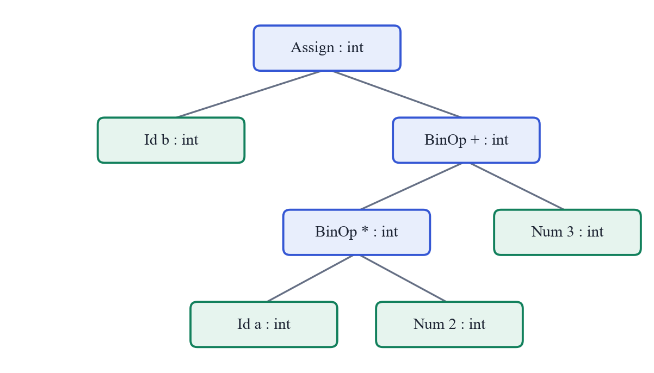
Figure 1: Typed AST for the Statement b = a * 2 + 3;
Table 7: AST Node Kinds
Node | Children | Meaning
Program | list of statements, or one Function | Whole program
Function | body block | int main() { ... }
Block | list of statements | { ... } with its own scope
Declaration | list of Id nodes | int a, b; / float x;
Assign | target Id, expression | x = expr;
If | condition, then statement, optional else statement | if (c) S1 else S2
While | condition, body | while (c) S
For | init assignment, condition, step assignment, body | for (i; c; s) S
Return | expression | return expr;
BinOp | left, right | + - * / % and comparisons
Negate | operand | unary minus
Num / Id | none (leaves) | constants and variable names

2.6.4 Symbol Table and Scope
The symbol table records every declared name together with its attributes. Each entry stores the name, the type, the storage size (4 bytes for both int and float), the relative memory offset assigned in declaration order, the scope level and the declaration line. The table is organised as an array with a parallel active flag. Entering a block increases the scope level; leaving it marks that level's entries inactive but keeps them in the table so that they can still be displayed. Lookup searches from the newest entry backwards, so an inner declaration shadows an outer one with the same name, as in C. Because the two variables are different, a shadowing variable also receives its own name for the intermediate code: an inner x declared after an outer x appears in the three-address code as x.1 (the number is its position in the symbol table). A dot cannot occur in a user identifier, so these names can never clash.

2.6.5 Type Checking
The semantic analyser computes a type for every expression bottom-up and stores it in the AST node. The type rules are summarised in Table 8. When an int value is used where a float is needed, the type checker allows it (widening), and the code generator later inserts an explicit conversion instruction. The opposite direction would lose information, so it is reported as an error.
Table 8: Type Rules
Construct | Rule | Result / error
Integer / float constant | Contains a decimal point? | float, otherwise int
a op b (+ - * /) | int op int; any float operand | int; float (int operand widened)
a % b | both operands int | int, otherwise error: '%' needs int operands
a relop b | any numeric operands | int (0 or 1)
x = expr | float into int variable | error: type mismatch
x = expr | int into float variable | allowed, code generator inserts (float)
return expr | inside main, expr is int | error if outside main or if expr is float
Use of a name | must be declared and visible | error: undeclared variable

2.6.6 Intermediate Code: Three-Address Code and Quadruples
Three-address code (TAC) is a sequence of simple instructions, each with at most one operator on the right side, such as t1 = a * 2 [1]. Complex expressions are broken up using compiler-generated temporaries. The project stores TAC as quadruples, records with four fields: operator, first argument, second argument and result. Table 9 lists the instruction set.
Table 9: Three-Address Instruction Set
op | arg1 | arg2 | result | TAC form
+ - * / % | x | y | t | t = x op y
< > <= >= == != | x | y | t | t = x relop y
uminus | x |  | t | t = - x
itof | x |  | t | t = (float) x
= | x |  | y | y = x
label |  |  | L | L:
goto |  |  | L | goto L
iffalse | x |  | L | ifFalse x goto L
return | x |  |  | return x

2.6.7 Translation of Control Flow
Boolean conditions are evaluated into a temporary (0 or 1), and the statements are translated with labels and conditional jumps following the standard schemes [1]:
if (c) S1 else S2 while (c) S for (i; c; s) S
t = c L1: t = c i
ifFalse t goto L1 ifFalse t goto L2 L1: t = c
S1 S ifFalse t goto L2
goto L2 goto L1 S
L1: S2 L2: s
L2: goto L1
L2:
A for statement is translated as its initialisation followed by a while loop whose body is the loop body followed by the step. Fresh labels are taken from a counter, so nested statements never clash.

2.6.8 Code Optimization and Basic Blocks
A basic block is a maximal sequence of instructions that is entered only at the first instruction and left only at the last [1]. In the generated code, every label starts a new block, because control can reach a label from more than one place (Figure 4 in Chapter 4 shows the blocks of a for loop).
The optimizer applies four local transformations, summarised in Table 10. Constant propagation and folding follow the classical data-flow idea of tracking which names hold known constant values [15], restricted to a single basic block: at every label the table of known values is cleared.
Table 10: Optimizations Implemented
Optimization | Example (before → after) | Condition
Constant propagation | a = 5; t1 = a * 2 → t1 = 5 * 2 | a has a known constant value in this block
Constant folding | t1 = 5 * 2 → t1 = 10 | both operands constant; division by zero never folded
Branch folding | ifFalse 1 goto L → (removed); ifFalse 0 goto L → goto L | condition is a constant
Dead temporary removal | t1 = 10 with no later use of t1 → (removed) | temporary is never read

2.6.9 Error Detection and Recovery
Each phase detects the errors it is able to see. Table 11 lists them. The parser uses panic-mode recovery [1]: after the first error in a statement it stops reporting, skips tokens until it reaches a synchronising token (; or }) and resumes with the next statement. This lets one run report several independent errors while avoiding long cascades of messages caused by a single mistake.
Table 11: Errors Detected by Each Phase
Phase | Error | Example message
Lexical | Unknown character | line 5: unknown character '@'
Lexical | Malformed number | line 2: malformed number '12abc'
Lexical | Unterminated comment | line 3: unterminated comment
Syntax | Missing or unexpected token | line 6: expected ')' but found ';'
Syntax | Code after main() | line 6: expected end of program after main() but found 'int'
Semantic | Undeclared variable | line 9: undeclared variable 'z'
Semantic | Redeclaration in the same scope | line 4: redeclaration of 'x' (first declared on line 2)
Semantic | Type mismatch | line 7: type mismatch: cannot assign float to int variable 'x'
Semantic | Invalid operands | line 8: operator '%' needs int operands, got float % int
Semantic | Misplaced or wrong return | line 4: 'return' used outside of main()
Semantic | Reserved name | 't1' is reserved for compiler temporaries

2.7 Methodology

2.7.1 Input Processing
The driver reads the whole source program into a single character buffer. With a file argument it opens the file in text mode; without one it reads standard input until end-of-file, which allows a program to be typed interactively. The web server writes the code received from the browser into a temporary file and runs the compiler on that file, so all three entry points use the same path from this point on.

2.7.2 Lexical Analysis
The lexer walks the buffer once with a pointer and a line counter. Whitespace is skipped and newlines increase the line counter. Comments are removed here so that the parser never sees them. For each token the lexer records its kind, its lexeme and its line, appending it to a dynamically growing array. Lexical errors are recorded and the offending characters are skipped, so the scan always reaches the end of the input. An EOF token is added at the end so that the parser never reads past the array.

2.7.3 Syntax Analysis
The parser keeps an index into the token array. Each grammar function inspects the current token to choose a production, consumes the tokens it expects with expect(), and returns a newly allocated AST node. When a token does not match, syntax_error() records the line, the expected item and the found lexeme, and sets the panic flag. The statement-list loop then synchronises and clears the flag, and a safety check advances the position if a statement consumed nothing, which guarantees termination on any input.

2.7.4 Semantic Analysis
The semantic analyser performs a depth-first walk over the AST. Declarations insert symbols; blocks open and close scopes; expressions are checked bottom-up and their types written into the nodes. When a sub-expression already has an error type, the parent does not report a second error, which avoids cascades such as one undeclared variable producing several type errors.

2.7.5 Intermediate Code Generation
Code generation is a second depth-first walk over the typed AST. For an expression, the generator returns the name of the place holding its value: a variable, a constant or a new temporary. For statements it applies the translation schemes of Section 2.6.7. Where an int operand meets a float operand, or an int value is assigned to a float variable, an itof quadruple is emitted first.

2.7.6 Optimization
The optimizer reads the quadruples in order and writes an improved copy. It keeps a small table mapping names to constant values. For each instruction it first replaces operands with known constants (propagation), then evaluates the instruction if all operands are constant (folding), then updates the table: a copy of a constant records the value, any other definition forgets it. Labels clear the table because they start a new basic block. A final pass removes assignments to temporaries that are no longer read anywhere.

2.7.7 Output and Visualization
The driver prints a section per phase to the terminal: the token table, an ASCII drawing of the AST with types, the symbol table, the quadruples with their TAC form, the optimized code and the error list. report.c writes the same information to report.html, adding a pipeline banner that marks each phase as passed, failed or skipped, the source with error lines highlighted, and a collapsible tree. The web playground reads the banner's status classes to colour its own phase lights and shows the report beside the editor.

2.8 Implementation

2.8.1 Lexical Analyser
The core of the lexer is a loop over the characters. The excerpt below shows how operators are recognised: two-character operators are tested first so that the longest match wins, and any character that matches no pattern is reported and skipped.
/* two-character operators first */
TokenKind kind;
int len = 2;
if (p[0] == '=' && p[1] == '=') kind = TK_EQ;
else if (p[0] == '!' && p[1] == '=') kind = TK_NE;
else if (p[0] == '<' && p[1] == '=') kind = TK_LE;
else if (p[0] == '>' && p[1] == '=') kind = TK_GE;
else {
len = 1;
switch (*p) {
case '+': kind = TK_PLUS; break;
case '-': kind = TK_MINUS; break;
case '*': kind = TK_STAR; break;
case '/': kind = TK_SLASH; break;
case '%': kind = TK_PERCENT; break;
case '=': kind = TK_ASSIGN; break;
case '<': kind = TK_LT; break;
case '>': kind = TK_GT; break;
case '(': kind = TK_LPAREN; break;
case ')': kind = TK_RPAREN; break;
case '{': kind = TK_LBRACE; break;
case '}': kind = TK_RBRACE; break;
case ';': kind = TK_SEMI; break;
case ',': kind = TK_COMMA; break;
default:
error_at("Lexical", line, "unknown character '%c'", *p);
p++;
continue;
}
}
add(kind, p, len, line);
p += len;

2.8.2 Parser
Each grammar rule is a function. The function for add → mul { ('+' | '-') mul } shows how a loop gives left associativity: each new operator node takes the tree built so far as its left child.
static Node *add(void)
{
Node *n = mul();
while (CUR.kind == TK_PLUS || CUR.kind == TK_MINUS) {
Token op = CUR;
advance();
n = binop(op, n, mul());
}
return n;
}
Error recovery is implemented in the statement-list function. If a statement set the panic flag, the parser skips to the next ; or } unless the statement already ended at one, and it always advances at least one token, so parsing finishes on any input.
static Node *stmt_list(TokenKind end)
{
Node *first = NULL, **tail = &first;
while (CUR.kind != end && CUR.kind != TK_EOF) {
int start = pos;
Node *s = stmt();
if (panic) { /* skip to a safe point, unless the statement already ended at one */
TokenKind last = pos > start ? tokens[pos - 1].kind : TK_EOF;
if (last != TK_SEMI && last != TK_RBRACE) {
while (CUR.kind != TK_SEMI && CUR.kind != TK_RBRACE && CUR.kind != TK_EOF) advance();
accept(TK_SEMI);
}
panic = 0;
}
if (pos == start) advance(); /* always make progress */
if (s) { *tail = s; tail = &s->next; }
}
return first;
}

2.8.3 Semantic Analyser
The declare function shows the symbol table insertion: a redeclaration is reported only when the existing symbol is in the same scope, which is what allows shadowing in inner blocks.
static void declare(Node *id, Type type)
{
Symbol *old = lookup(id->text);
if (old && old->scope == scope) {
error_at("Semantic", id->line, "redeclaration of '%s' (first declared on line %d)",
id->text, old->line);
return;
}
if (is_temp_name(id->text)) {
error_at("Semantic", id->line, "'%s' is reserved for compiler temporaries", id->text);
return;
}
if (nsyms == MAX_SYMS) {
error_at("Semantic", id->line, "too many variables (max %d)", MAX_SYMS);
return;
}
Symbol *s = &symtab[nsyms];
strcpy(s->name, id->text);
/* a later variable with an existing name (e.g. shadowing in a block) gets its own TAC name */
strcpy(s->tac, id->text);
for (int i = 0; i < nsyms; i++)
if (!strcmp(symtab[i].name, id->text)) sprintf(s->tac, "%s.%d", id->text, nsyms);
s->type = type;
s->size = 4;
s->offset = offset;
s->scope = scope;
s->line = id->line;
active[nsyms++] = 1;
offset += s->size;
id->type = type;
id->sym = s;
}

2.8.4 Code Generator and Optimizer
The translation of a while statement follows the scheme of Section 2.6.7 directly: two fresh labels, the condition, a conditional jump out of the loop, the body and a jump back.
case N_WHILE:
new_label(l1);
new_label(l2);
emit("label", "", "", l1);
gen_expr(n->kid[0], v);
emit("iffalse", v, "", l2);
gen_stmt(n->kid[1]);
emit("goto", "", "", l1);
emit("label", "", "", l2);
break;
Inside the optimizer, folding is applied after propagation has replaced operands with constants. The helper fold() refuses to fold division or modulus by zero and uses integer arithmetic unless one operand is a float constant, so the folded result is exactly what the program would compute at run time.
/* constant folding */
if (!strcmp(q.op, "itof") && is_const(q.arg1)) {
format_float(atof(q.arg1), folded);
make_copy(&q, folded);
} else if (!strcmp(q.op, "uminus") && is_const(q.arg1)) {
if (fold("-", is_float_const(q.arg1) ? "0.0" : "0", q.arg1, folded)) make_copy(&q, folded);
} else if (q.arg2[0] && is_const(q.arg1) && is_const(q.arg2)) {
if (fold(q.op, q.arg1, q.arg2, folded)) make_copy(&q, folded);
}

if (!strcmp(q.op, "=") && is_const(q.arg1)) remember(q.res, q.arg1);
else forget(q.res);
opt[nopt++] = q;

CHAPTER 3 – TECHNOLOGY USED

3.1 Technologies Used
Table 12 lists every technology used in the project and what it was used for. The compiler itself uses only the C standard library; everything else is optional tooling around it.
Table 12: Technologies Used
Technology | Version | Used for
C programming language | C99 (ISO/IEC 9899:1999) [11] | The compiler: all five phases, terminal output and the HTML report
GCC (MinGW) | 6.3.0 | Building minicc.exe with -std=c99 -Wall -Wextra [10]
Python | 3.12.10 | Local web server for the playground (standard library http.server and subprocess only) [12]
HTML5, CSS, JavaScript | – | The generated report.html and the browser playground
Windows batch scripts | – | build.bat (build), test.bat (regression tests), web.bat (playground)
Windows 11 and PowerShell | – | Development and testing environment
Google Chrome | – | Viewing the report and the playground

3.2 Hardware Requirements
Table 13: Hardware Requirements
Component | Requirement
Processor | Any x86-64 processor (tested on AMD Ryzen 5 5600H)
RAM | 512 MB free is sufficient; the compiler uses fixed-size tables (tested on 8 GB system)
Storage | Under 1 MB for the source code and executable (minicc.exe is about 136 KB)
GPU | Not required
Internet Connection | Not required; the report and playground run entirely on the local machine

3.3 Software Requirements
Table 14: Software Requirements
Software/Technology | Version/Specification
Operating System | Windows 11 (tested); the C code is portable C99 and also builds on Linux
Programming Language | C (C99 standard) for the compiler; Python 3 for the optional web server
Compiler for building | GCC 6.3.0 (MinGW) with -std=c99 -Wall -Wextra
Editor | Any text editor
Web playground | Python 3 standard library; no packages to install
Browser | Any modern browser (tested in Google Chrome)
External libraries | None; only the C standard library

3.4 Project Structure
202307020045_CompilerDesignMiniProject/
├── src/
│ ├── compiler.h shared structures and phase interfaces
│ ├── lexer.c Phase 1: lexical analysis
│ ├── parser.c Phase 2: recursive descent parser, AST
│ ├── semantic.c Phase 3: symbol table and type checking
│ ├── codegen.c Phases 4-5: quadruples and optimizer
│ ├── report.c HTML phase report
│ └── main.c driver, terminal output, error list
├── web/index.html browser playground
├── server.py local web server for the playground
├── examples/ demo.mc, main.mc, errors.mc, semantic.mc
├── tests/ extra test programs and expected outputs
├── report/ this report
├── build.bat build with gcc
├── test.bat regression tests
├── web.bat start the playground
└── README.md
Table 15: Source Code Size by Module
File | Lines | Purpose
lexer.c | 138 | Lexical analysis
parser.c | 297 | Syntax analysis and AST
semantic.c | 166 | Semantic analysis
codegen.c | 315 | Intermediate code and optimization
main.c | 123 | Driver, errors, terminal output
report.c | 195 | HTML report
compiler.h | 102 | Shared definitions
Total (C) | 1336
server.py / web/index.html | 62 / 171 | Web playground (optional)

Build with build.bat, run with .\minicc examples\demo.mc, test with test.bat, and start the playground with web.bat.
GitHub Repository: ______________________________

CHAPTER 4 – FLOW CHART OF THE PROJECT

4.1 Overall System Architecture
Figure 2 shows the architecture as implemented. Both user interfaces feed source code into the same compiler executable. Inside the compiler, the five phases are connected in a pipeline; each phase consumes the data structure produced by the previous one. All phases share the error list and the data structure definitions in compiler.h. The two output modules read the results of all phases at the end of the run.
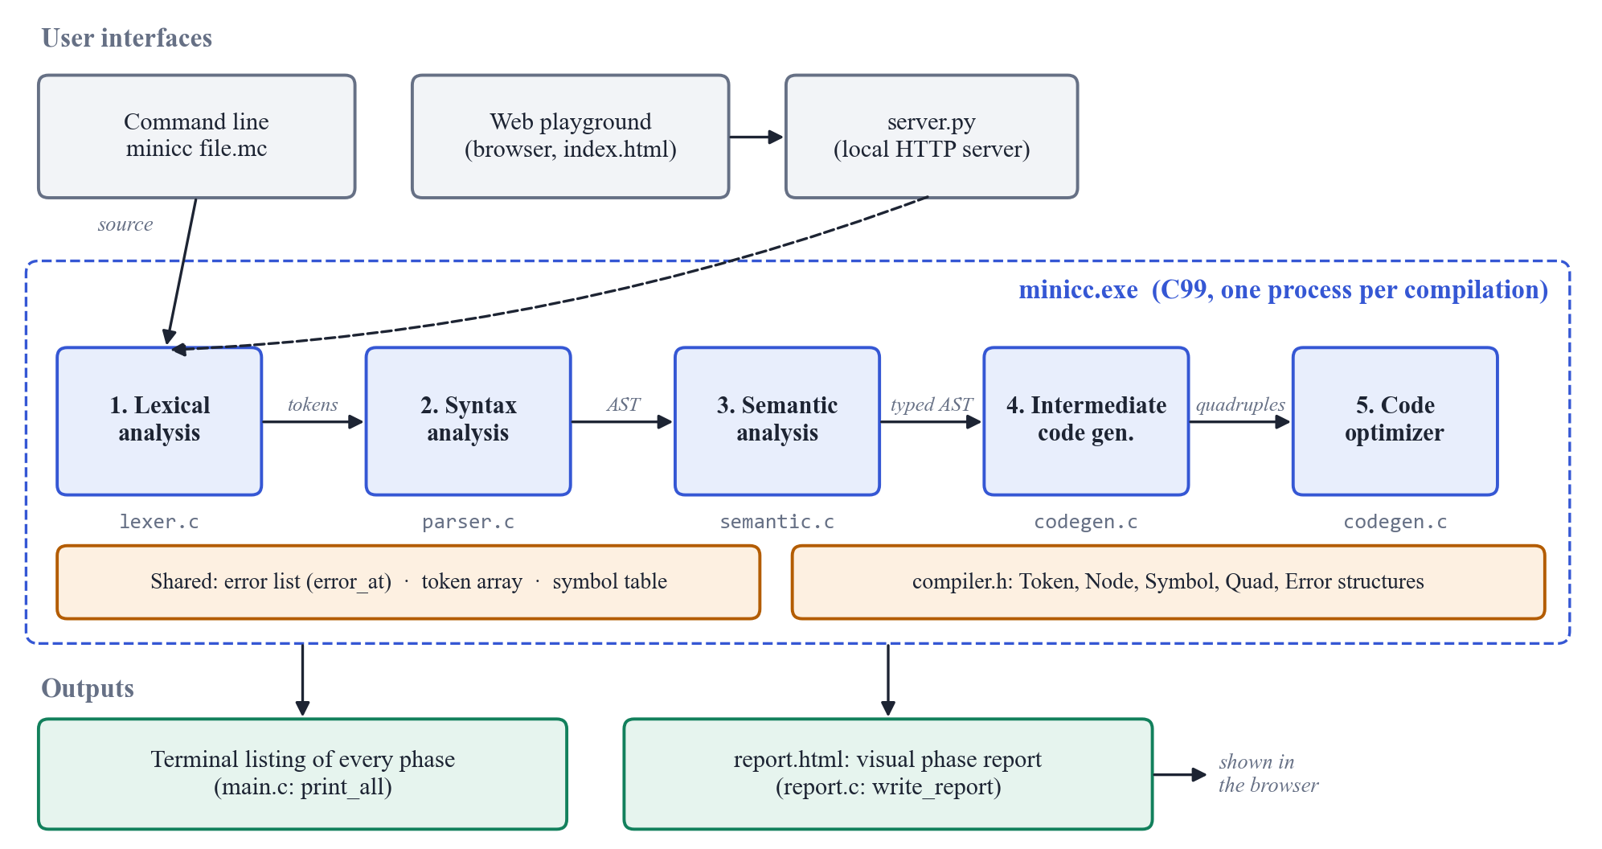
Figure 2: Overall System Architecture

4.2 Compiler Workflow
Figure 3 is the flow chart of one compilation, including the decisions that skip the later phases when errors are found. In words:
Step 1: The source program is read completely into memory (from a file, the keyboard or the web server).
Step 2: The lexer scans it once from left to right and produces the token array, ending with an EOF token.
Step 3: The parser reads the tokens with one token of lookahead and builds the AST, reporting syntax errors.
Step 4: If no lexical or syntax error occurred, the semantic analyser walks the AST, fills the symbol table and annotates every expression with its type.
Step 5: If no error occurred at all, the code generator walks the typed AST and emits quadruples.
Step 6: The optimizer produces an improved copy of the quadruples.
Step 7: The driver prints every phase, writes report.html and exits with status 0 or 1.
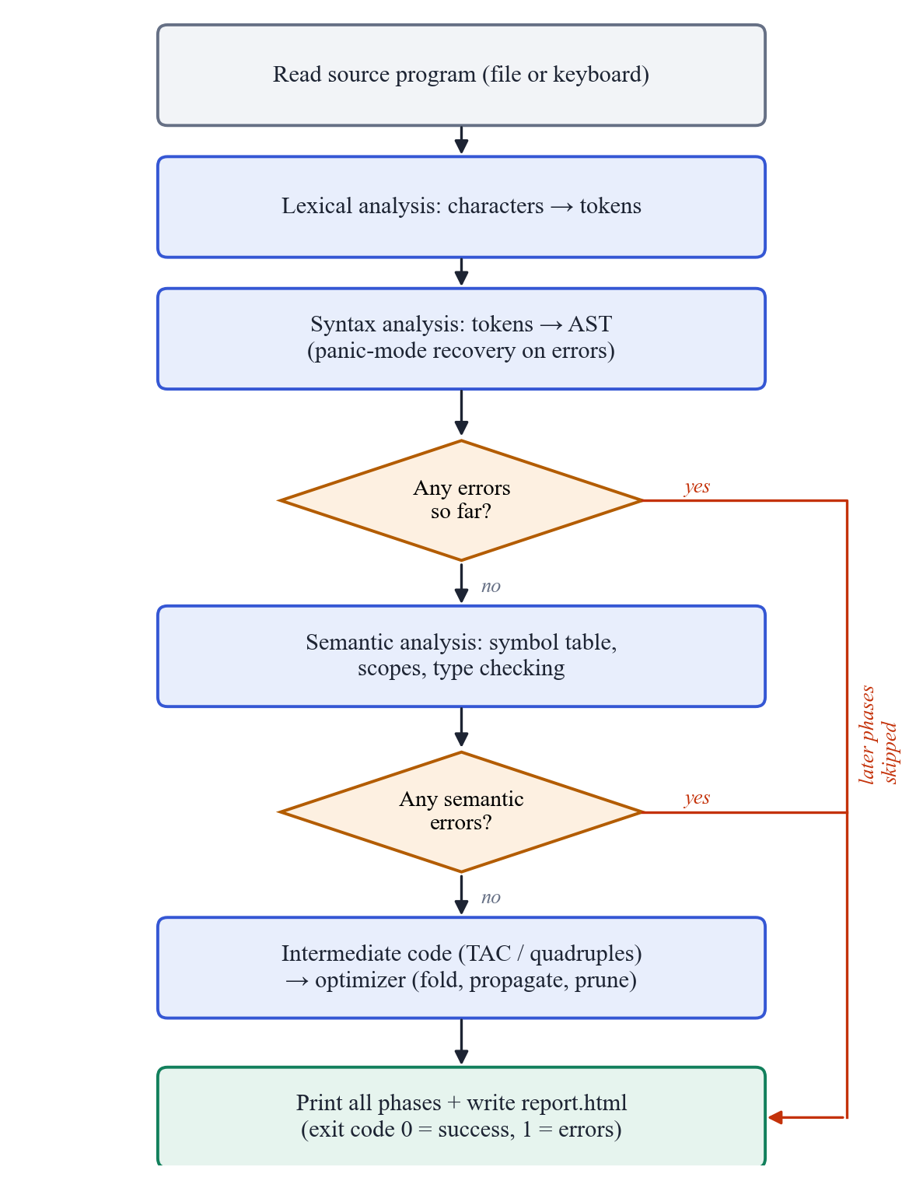
Figure 3: Flow Chart of the Compiler with Error Handling

4.3 Control Flow of the Generated Code
Figure 4 shows the basic blocks of the three-address code generated for the for loop in examples/main.mc, and the jumps between them. The conditional jump leaves the loop; the goto at the end of the body is the back edge.
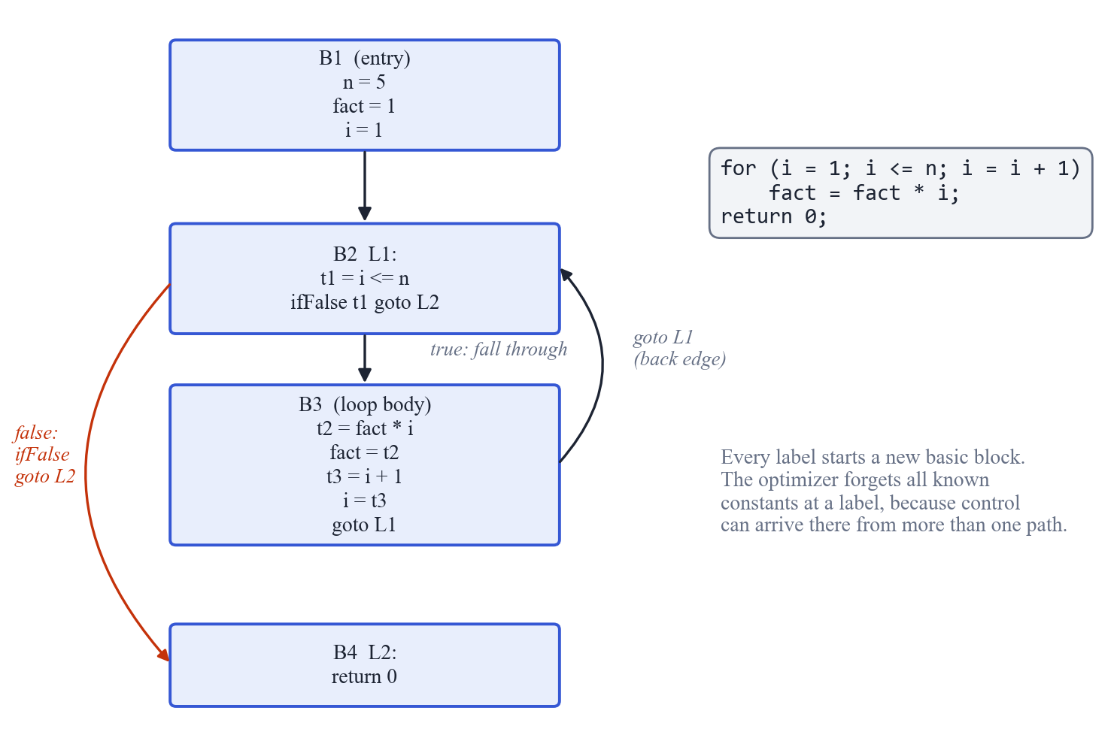
Figure 4: Basic Blocks and Control Flow of a for Loop

4.4 Web Playground Request Flow
Figure 5 shows what happens when Compile is pressed in the browser: the code is sent to server.py, which runs the unchanged C compiler in a temporary folder and returns the generated report.
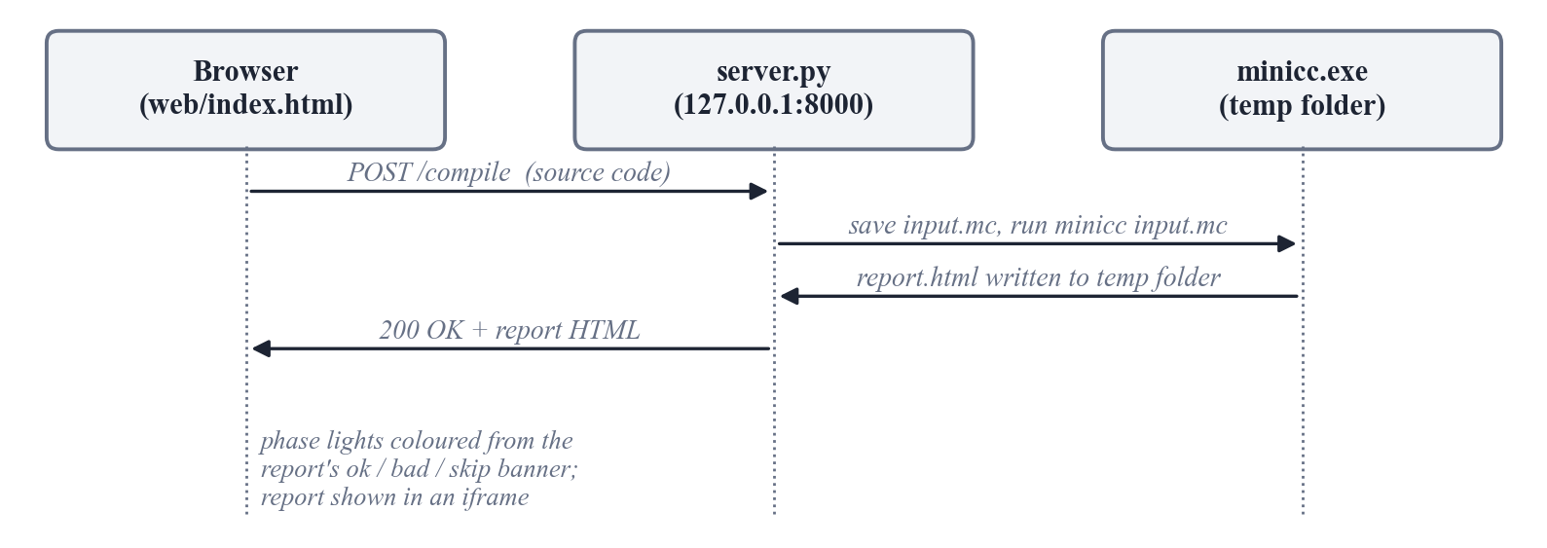
Figure 5: Web Playground Request Flow

4.5 Compilation Trace of One Statement
The trace below follows the single statement b = a * 2 + 3; (line 6 of the demo program, with a = 5 on the line before) through every phase:
Source b = a * 2 + 3;
↓
Lexical analysis IDENTIFIER(b) OPERATOR(=) IDENTIFIER(a) OPERATOR(*)
INT_CONST(2) OPERATOR(+) INT_CONST(3) SEPARATOR(;)
↓
Syntax analysis Assign( Id b, BinOp +( BinOp *( Id a, Num 2 ), Num 3 ) )
↓
Semantic b: int (scope 0, offset 4) a * 2 : int ... + 3 : int
↓
Intermediate t1 = a * 2
code t2 = t1 + 3
b = t2
↓
Optimization a = 5 is known → t1 = 5 * 2 = 10 → t2 = 10 + 3 = 13
→ b = 13 (t1, t2 no longer used: removed)

CHAPTER 5 – SCREENSHOTS OF THE PROJECT

5.1 Web Playground
The web playground (Figure 6) has an editor with line numbers, a list of sample programs, a Compile button (also Ctrl+Enter) and five phase lights.
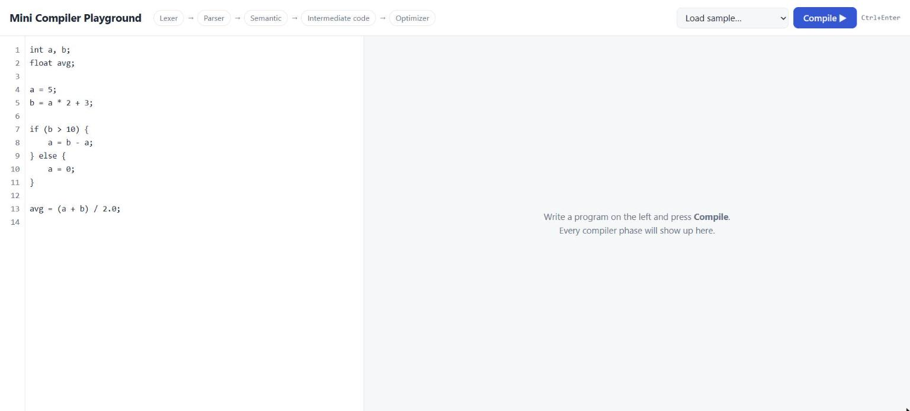
Figure 6: Web Playground – Home Page with the Editor
After compilation, each phase light turns green (passed), red (errors) or grey (skipped), and the full report appears on the right (Figure 7).
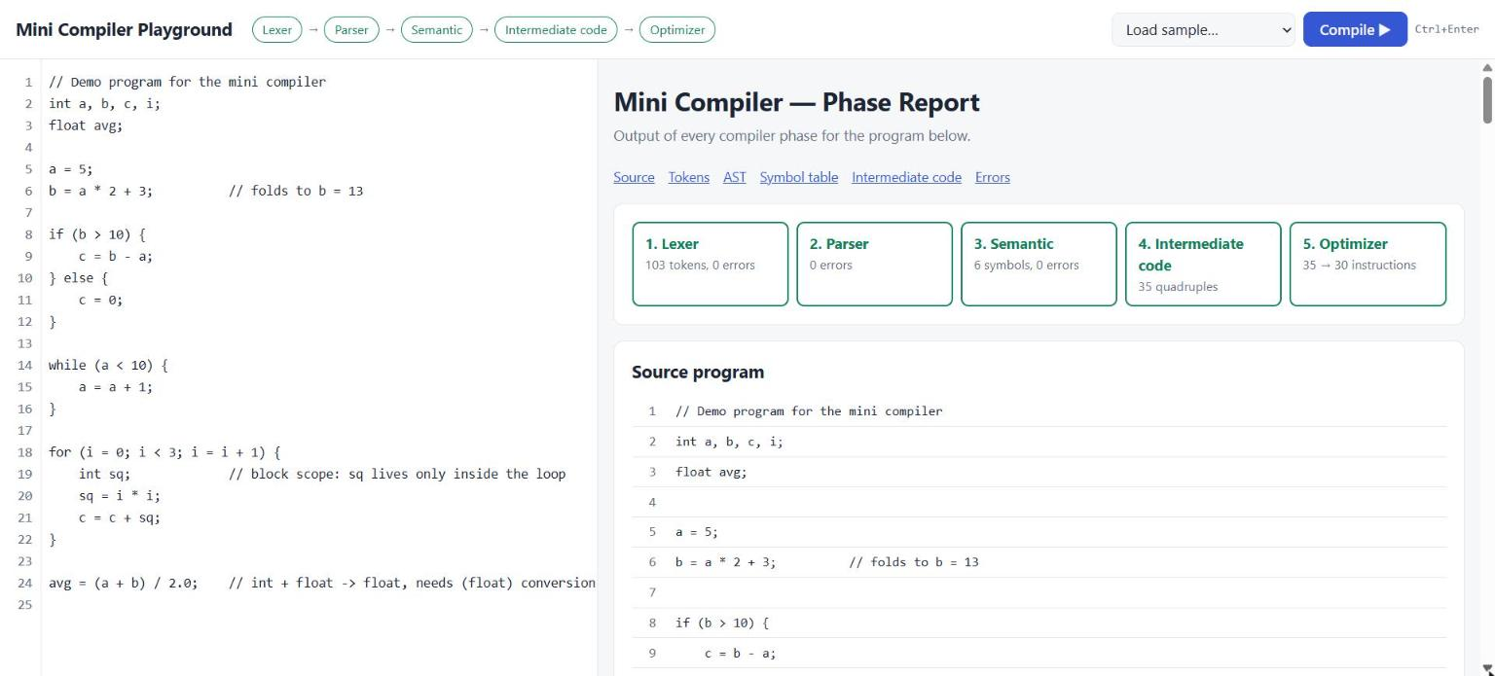
Figure 7: Compiling the Demo Program – All Five Phases Pass

5.2 Output of Each Phase
Figure 8 to Figure 11 show the report sections for the demo program examples/demo.mc.
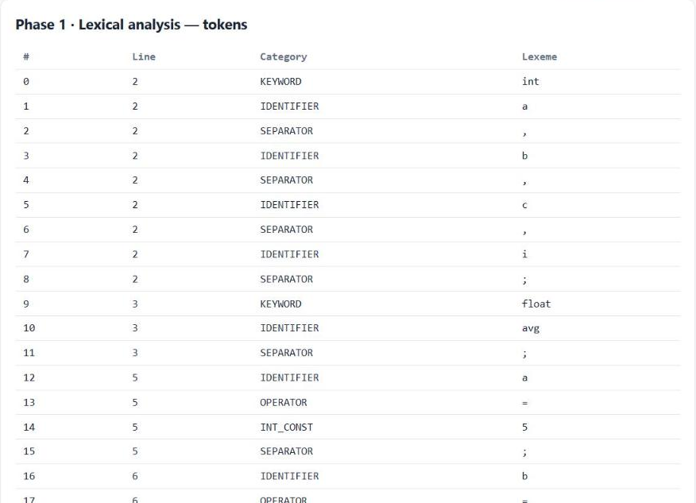
Figure 8: Phase 1 Output – Token Table with Line Numbers
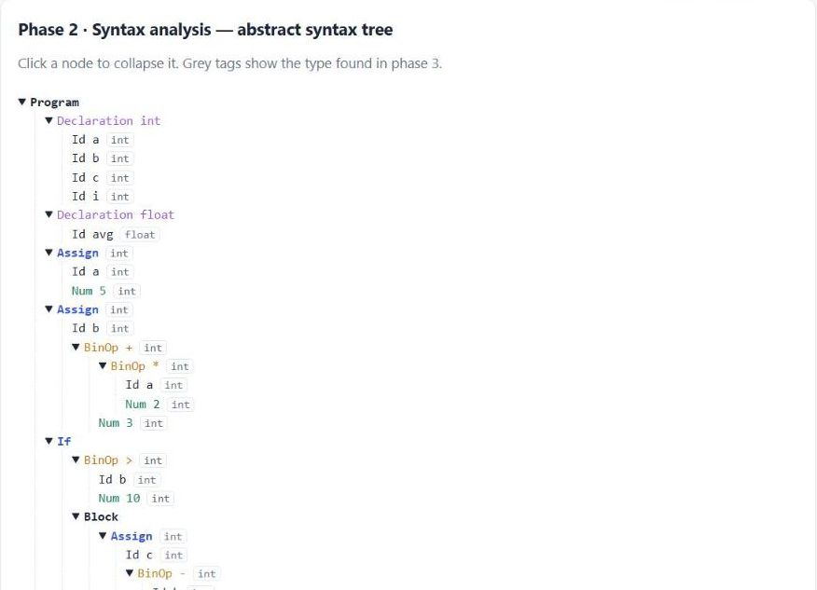
Figure 9: Phase 2 Output – Collapsible AST Annotated with Types
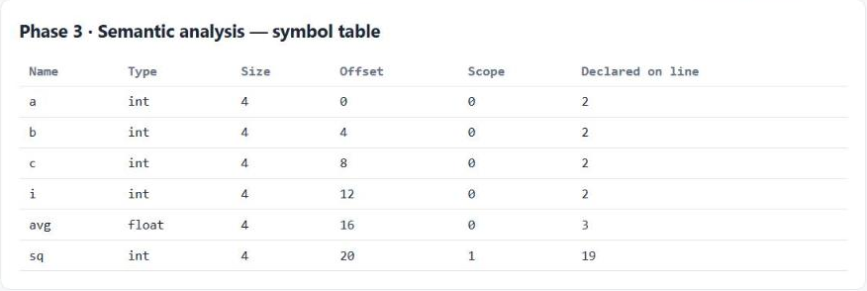
Figure 10: Phase 3 Output – Symbol Table with Scope and Offset
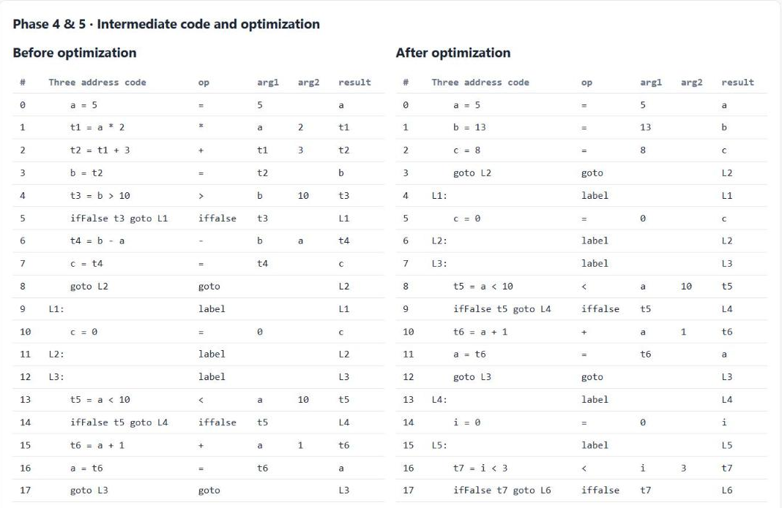
Figure 11: Phases 4 and 5 – Quadruples Before and After Optimization

5.3 Command-Line Output
The same information is printed in the terminal (Figure 12), so the compiler can also be demonstrated without a browser.
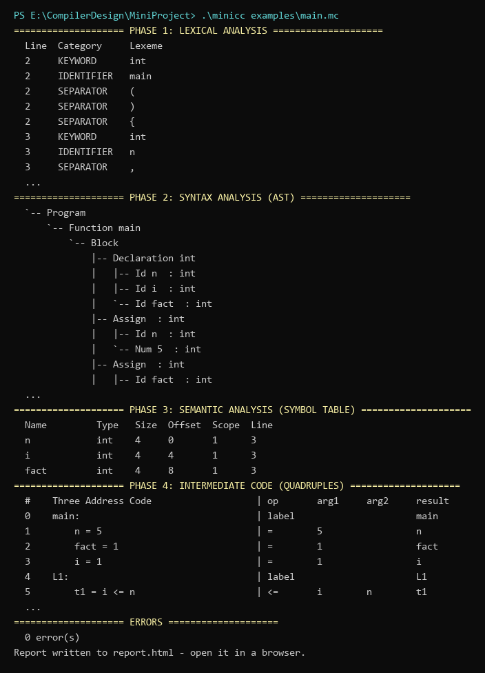
Figure 12: Command-Line Output of minicc for examples/main.mc (excerpt)

5.4 Error Reporting
Figure 13 shows a program with lexical and syntax errors: the failed phases are red, the later phases are skipped and the error lines are highlighted. Figure 14 shows semantic errors, and Figure 15 the error list of the HTML report.
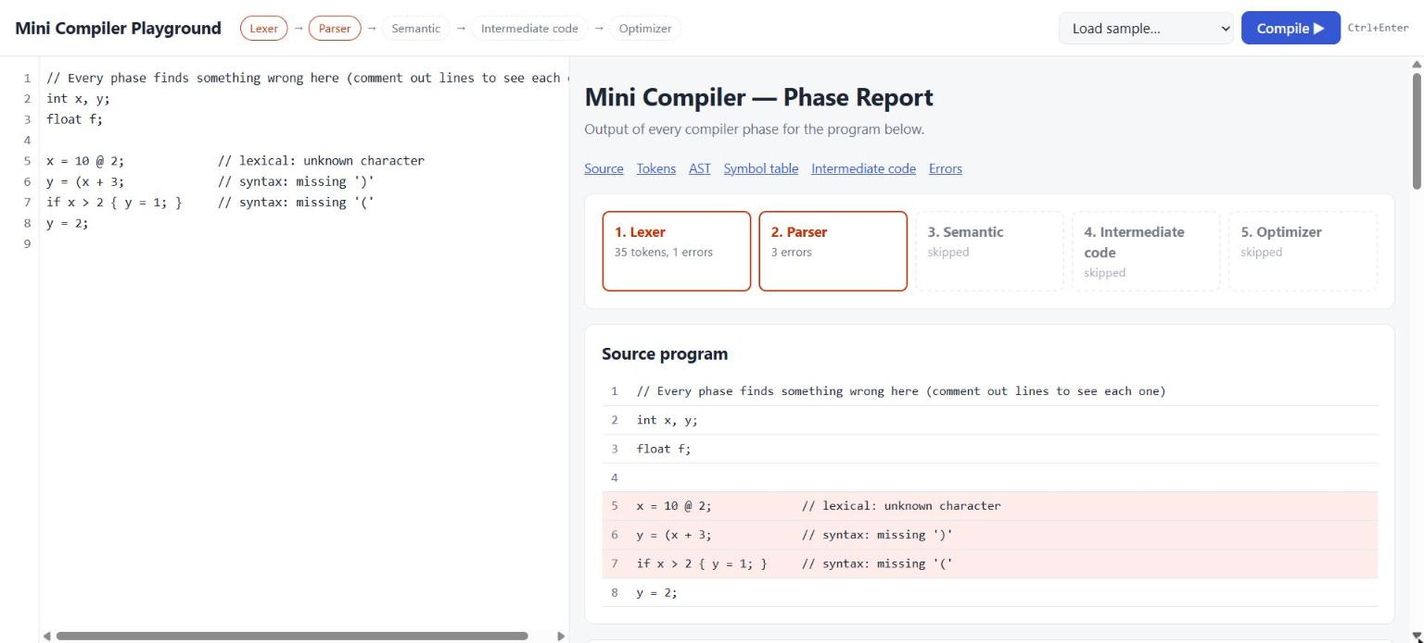
Figure 13: Lexical and Syntax Errors in the Playground (failed phases in red, error lines highlighted)
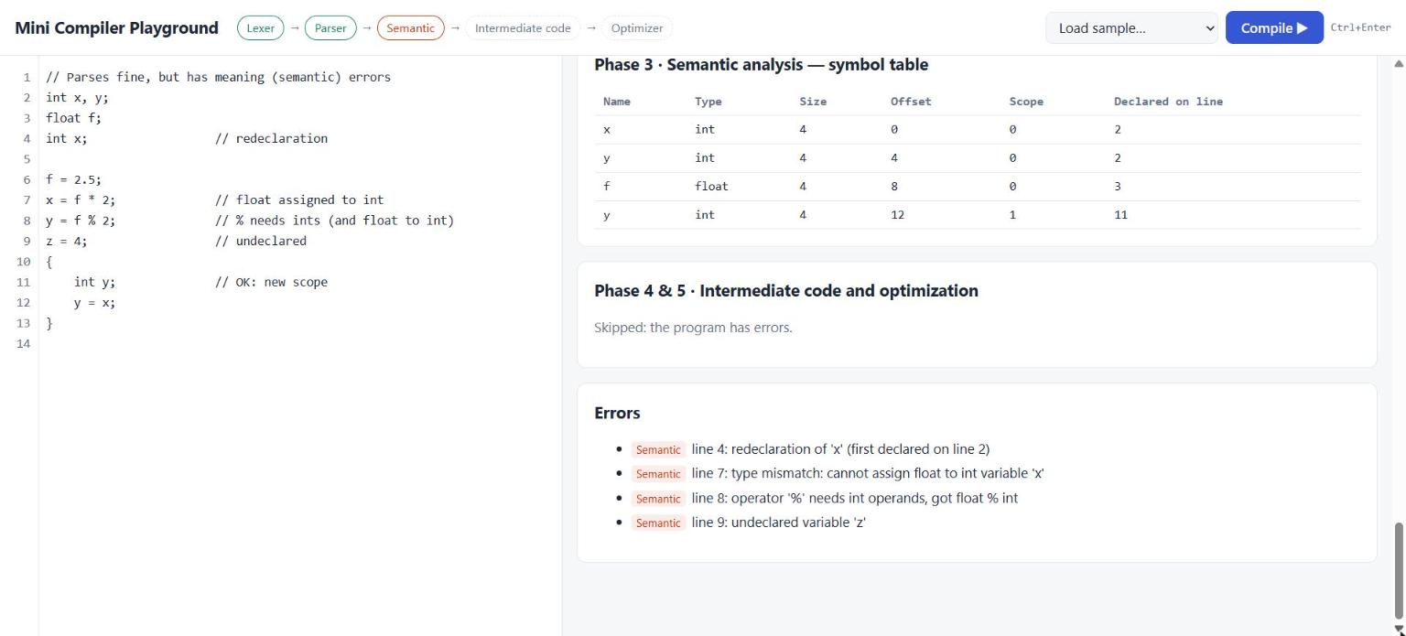
Figure 14: Semantic Errors Reported with Line Numbers
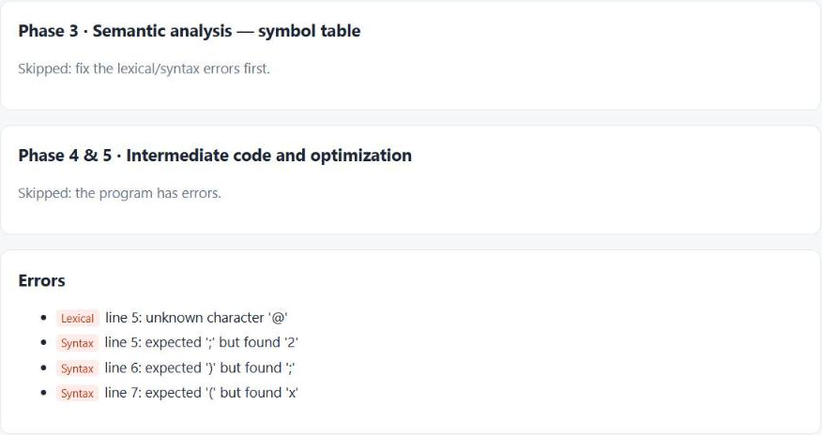
Figure 15: Error List in the HTML Report, Grouped by Phase

CHAPTER 6 – RESULTS AND CONCLUSION

6.1 Test Cases
Table 16 lists the functional test cases, all executed on 26 October 2026 with the final build. The Actual Output column is copied from the compiler's output. A test passes when the compiler accepts valid programs with the expected code and rejects invalid programs with the expected error messages and line numbers.
Table 16: Test Cases
Test Case ID | Input | Expected Output | Actual Output | Status
TC01 | Valid program with declarations, if-else, while, for and int/float mixing (demo.mc) | 0 errors; b folded to 13; if-branch decided at compile time | 0 errors; 35 → 30 instructions | Pass
TC02 | Program wrapped in int main() with return 0 (main.mc) | 0 errors; main: label and return 0 in TAC | 0 errors; 14 → 14 instructions | Pass
TC03 | Lexical and syntax errors in one file (errors.mc) | unknown '@' (line 5); missing ')' (line 6); missing '(' (line 7) | Lexical line 5: unknown character '@'; Syntax line 5: expected ';' but found '2'; Syntax line 6: expected ')' but found ';'; Syntax line 7: expected '(' but found 'x' | Pass
TC04 | Semantic errors: redeclaration, type mismatch, % on float, undeclared (semantic.mc) | 4 semantic errors on lines 4, 7, 8, 9 | Semantic line 4: redeclaration of 'x' (first declared on line 2); Semantic line 7: type mismatch: cannot assign float to int variable 'x'; Semantic line 8: operator '%' needs int operands, got float % int; Semantic line 9: undeclared variable 'z' | Pass
TC05 | Optimizer edge cases (optimizer.mc) | 7/0 not folded; k = 4; f = 3.0 then 4.5; while(0) becomes goto | 0 errors; 17 → 11 instructions; total = 7, t1 = 7 / 0, z = t1, k = 4, f = 3.0, f = 4.5, L1:, goto L2 | Pass
TC06 | Operator precedence and unary minus (precedence.mc) | a = 13 and b = 14 after folding | 0 errors; 8 → 2 instructions; a = 13, b = 14 | Pass
TC07 | Nested block scope (shadowing) (scope.mc) | 0 errors; inner x renamed x.1 in TAC; outer x = 2 after optimization | 0 errors; 4 → 3 instructions; x = 1, x.1 = 2.5, x = 2 | Pass
TC08 | Malformed number (badnum.mc) | malformed number error on line 2 | Lexical line 2: malformed number '12abc'; Syntax line 2: expected an expression but found ';' | Pass
TC09 | Unterminated block comment (comment.mc) | unterminated comment error on line 3 | Lexical line 3: unterminated comment | Pass
TC10 | return outside main() (return_outside.mc) | return outside main reported | Semantic line 4: 'return' used outside of main() | Pass
TC11 | main() returning float (main_errors.mc) | float return from main reported | Semantic line 4: type mismatch: main() must return int, not float | Pass
TC12 | Empty program (empty.mc) | 0 errors, 0 instructions | 0 errors; 0 → 0 instructions | Pass
TC13 | Standard C Hello World (unsupported features) (hello.mc) | rejected: '#', '"' and other unsupported characters reported | Lexical line 1: unknown character '#'; Lexical line 1: unknown character '.'; Lexical line 4: unknown character '"'; Lexical line 4: unknown character '!'; … (8 errors) | Pass

In addition, test.bat runs 8 programs and compares the complete output of the compiler with saved expected output files (golden testing). This catches any unintended change in any phase.
Table 17: Automated Regression Tests (test.bat)
Test | Program | Result
1 | examples/demo.mc | PASS
2 | examples/errors.mc | PASS
3 | examples/semantic.mc | PASS
4 | examples/main.mc | PASS
5 | tests/optimizer.mc | PASS
6 | tests/return_outside.mc | PASS
7 | tests/main_errors.mc | PASS
8 | tests/scope.mc | PASS

6.2 Sample Outputs

Test Case 1 – Valid program with all statement types (TC01)
Input: examples/demo.mc (25 lines: declarations, if/else, while, for with a block-scoped variable, and an int/float expression).
Compiler action: all five phases run. The lexer produced 103 tokens, the symbol table contains 6 symbols (sq at scope level 1), the code generator emitted 35 quadruples and the optimizer reduced them to 30.
Output: b = a * 2 + 3 became b = 13; the condition b > 10 was evaluated at compile time, so its ifFalse was removed and c = b - a became c = 8; avg = (a + b) / 2.0 received a (float) conversion. Screenshots: Figure 7 to Figure 11.

Test Case 2 – Lexical and syntax errors (TC03)
Input: examples/errors.mc, containing an unknown character @, a missing ) and an if without (.
Compiler action: the lexer reports the @ and skips it; the parser reports each syntax error and recovers at the next ;, so all three mistakes are found in one run. Semantic analysis and code generation are skipped.
Output: four messages – the three intended errors plus one secondary message (expected ';' but found '2') caused by the skipped @ (Figure 13).

Test Case 3 – Semantic errors (TC04)
Input: examples/semantic.mc, which is syntactically correct but redeclares x, assigns a float to an int, uses % on a float and assigns to an undeclared z. It also declares a second y inside a block, which is legal.
Compiler action: the semantic analyser reports exactly four errors and accepts the inner y, which appears in the symbol table at scope level 1 (Figure 14).

6.3 Performance Evaluation
All values in this section were measured on 26 October 2026 on the development machine (AMD Ryzen 5 5600H, Windows 11). Times were measured from Python with time.perf_counter() around a complete run of minicc.exe, so they include process start-up and writing report.html; each value is the median of 20 runs.
Table 18: Performance Evaluation
Metric | Evaluation Method | Result
Test case success rate | Passed functional tests / total | 13 / 13 (100%)
Regression test success rate | Passed golden-output tests / total | 8 / 8 (100%)
Error detection rate | Deliberately inserted errors reported with correct line / inserted errors | 11 / 11 (100%)
Secondary (cascade) messages | Extra messages caused by an earlier error, over TC03 and TC08 | 2
Code reduction – demo program | Instructions after / before optimization | 35 → 30 (14.3% fewer)
Code reduction – optimizer test | Instructions after / before optimization | 17 → 11 (35.3% fewer)
Average compile time (test programs) | Median wall-clock time per program, TC01–TC13 | 15.5–24.2 ms (mean 18.9 ms)
Compile time, 603-line program | Median of 20 runs | 172.9 ms

Table 19 shows how compile time grows with program size, using generated programs made of repeated statements of the form x = x + i * k;. Because x and i start with constant values, the optimizer folds every statement to a single constant assignment, which explains the large reduction in instructions.
Table 19: Compile Time and Optimization by Program Size
Source lines | Tokens | Quadruples | After optimization | Median time (ms)
53 | 414 | 152 | 52 | 38.8
153 | 1214 | 452 | 152 | 59.5
303 | 2414 | 902 | 302 | 104.3
603 | 4814 | 1802 | 602 | 172.9

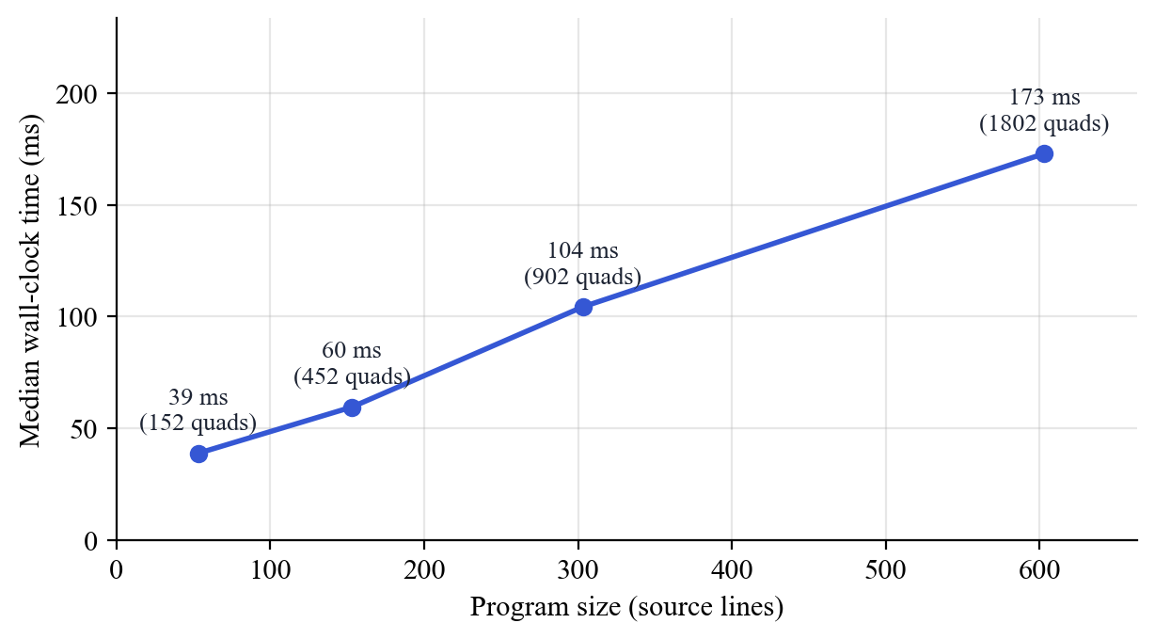
Figure 16: Compile Time versus Program Size
The time grows roughly linearly with program size, as expected for single-pass lexing and parsing and linear tree walks. Even an empty program takes 20 ms, which is the fixed cost of starting the process and writing the report; it dominates for classroom-sized programs. The dead-temporary pass compares every temporary with every instruction, which is quadratic in the worst case; it is not noticeable at these sizes but would need a use-count table for much larger programs.
Optimization effect varies with the program: straight-line code with constants is reduced strongly (TC06: 8 → 2), while loop code whose variables change on every iteration is not reduced (TC02: 14 → 14), because the optimizer correctly forgets all values at loop labels.

6.4 Challenges Faced
- Error recovery skipping too far. The first version of panic-mode recovery always skipped to the next ;. When the erroneous statement had already consumed its own ;, the parser skipped the whole following statement and reported a confusing error on a later }. The fix was to synchronise only when the statement had not already ended at a ; or }; the regression test errors.mc now checks this.
- Correct constant folding for mixed types. Folding 7 / 2 must give 3 for integers but a float context must not change that. Making int-to-float conversion an explicit itof instruction meant the optimizer always knows which arithmetic to use, so f = 7 / 2 correctly folds to f = 3.0.
- Name clashes with temporaries. Temporaries are named t1, t2, ..., so a user variable called t1 could be mistaken for a temporary by the optimizer. Such names are now rejected in semantic analysis, and the optimizer checks the full pattern t + digits (so a variable like total is never treated as a temporary).
- Shadowed variables in intermediate code (found by testing). Test case TC07 showed that an inner float x and the outer int x were both written as x in the three-address code, so the optimizer carried the inner value 2.5 into the outer variable and produced x = 3.5 instead of x = 2. The fix gives every shadowing variable a unique TAC name (x.1), stored in its symbol table entry; TC07 and a new regression test now confirm x = 2. The same review found that very long identifiers could overflow the quadruple fields, which were then enlarged.
- Termination on any input. Every loop in the parser must consume a token or stop; a progress check in the statement list guarantees that even input such as a stray } cannot cause an infinite loop.
- Tooling on Windows. The available GCC (6.3) needed -std=c99; box-drawing characters for the tree printed incorrectly in the Windows console, so the terminal tree uses ASCII; and PowerShell requires .\ before programs in the current folder, which the build and test scripts account for.

6.5 Limitations
- No target code. The compiler stops at optimized three-address code; it does not generate assembly or run the program.
- Small language. No user-defined functions other than main, no parameters, arrays, pointers, strings, characters, input/output or logical operators (&&, ||, !). A standard C program such as Hello World is therefore rejected (TC13).
- Local optimization only. Constant propagation does not cross labels, unreachable code (for example after a folded goto) is not removed, and there is no common subexpression elimination or loop optimization.
- Simple error recovery. Panic mode can still produce a secondary message after a lexical error (two were observed in testing, Table 18).
- Fixed limits. At most 2048 quadruples, 256 symbols, 100 reported errors and 63 characters per lexeme.
- Web playground needs Python. The browser cannot run the C compiler by itself, so the playground only works while server.py is running on the same computer.

6.6 Future Scope
- Boolean expressions with short-circuit evaluation: add &&, || and ! and translate them with jumps (backpatching).
- Functions: parameters, calls and return values, with activation records and a symbol table per function.
- Arrays: declarations, indexing and the address computations they require in three-address code.
- More representations: triples and indirect triples next to quadruples, and a DAG view of each basic block.
- Global optimization: data-flow analysis across basic blocks, common subexpression elimination, dead code and unreachable code elimination, and loop-invariant code motion.
- Code generation: translate TAC to x86 assembly or to a simple stack machine, together with an interpreter so that programs can actually be run and their results shown.
- Fully browser-based version: compile the C code to WebAssembly so the playground works without a server.

6.7 Conclusion
The project set out to make the phases of a compiler visible on real programs. Production compilers hide their intermediate representations, and educational tools usually cover a single phase, so students find it hard to connect lexical analysis, parsing, semantic analysis, intermediate code and optimization into one picture.
We designed a small C-like language and implemented a complete compiler front end and middle end for it in about 1336 lines of C99, with one source file per phase. The lexer recognises tokens with a longest-match rule and keyword table; the recursive descent parser builds an abstract syntax tree directly from an LL(1) grammar and recovers from syntax errors in panic mode; the semantic analyser maintains a scoped symbol table with sizes and offsets and enforces the type rules for int and float; the code generator emits three-address code as quadruples using the standard translation schemes for if, while and for; and the optimizer performs constant propagation, constant folding, branch folding and dead temporary removal within basic blocks.
Every phase is visualized three ways: as text in the terminal, in a self-contained HTML report with a phase status banner, tables and a collapsible tree, and in a browser playground where code can be typed and compiled with immediate feedback. The playground reuses the same C compiler through a small Python server, so what is shown is always the real output of the C code.
Testing confirmed the design. All 13 functional test cases and all 8 regression tests passed, and all 11 deliberately inserted errors were reported in the correct phase with the correct line number. The optimizer reduced the demo program from 35 to 30 instructions without changing its meaning, and compilation remained fast, with a median of 173 ms for a 603-line program.
The main limitations are the small language and the absence of target code generation. Both are natural next steps, and the one-file-per-phase structure makes them straightforward to add.
The most important lesson for the team was how closely each phase depends on the data structure produced by the previous one: a careful AST made type checking simple, explicit type information made correct constant folding possible, and clear basic block boundaries made the optimizer safe. Building the phases by hand, rather than generating them, gave every member a working understanding of the algorithms taught in the course.

REFERENCES
[1] A. V. Aho, M. S. Lam, R. Sethi and J. D. Ullman, Compilers: Principles, Techniques, and Tools, 2nd ed., Pearson Addison-Wesley, 2006.
[2] K. D. Cooper and L. Torczon, Engineering a Compiler, 2nd ed., Morgan Kaufmann, 2011.
[3] A. W. Appel, Modern Compiler Implementation in C, Cambridge University Press, 1998.
[4] R. Nystrom, Crafting Interpreters, Genever Benning, 2021.
[5] M. E. Lesk and E. Schmidt, “Lex – A Lexical Analyzer Generator,” Bell Laboratories, Computing Science Technical Report No. 39, 1975.
[6] S. C. Johnson, “Yacc: Yet Another Compiler-Compiler,” Bell Laboratories, Computing Science Technical Report No. 32, 1975.
[7] C. Lattner and V. Adve, “LLVM: A Compilation Framework for Lifelong Program Analysis & Transformation,” in Proc. International Symposium on Code Generation and Optimization (CGO), 2004.
[8] T. J. Parr and R. W. Quong, “ANTLR: A Predicated-LL(k) Parser Generator,” Software: Practice and Experience, vol. 25, no. 7, pp. 789–810, 1995.
[9] M. Godbolt, “Compiler Explorer,” https://godbolt.org, 2012.
[10] Free Software Foundation, “GCC Online Documentation,” https://gcc.gnu.org/onlinedocs/, 2026.
[11] ISO/IEC 9899:1999, Programming Languages – C, International Organization for Standardization, 1999.
[12] Python Software Foundation, “http.server – HTTP servers,” Python 3.12 Documentation, https://docs.python.org/3/library/http.server.html, 2026.
[13] D. E. Knuth, “On the Translation of Languages from Left to Right,” Information and Control, vol. 8, no. 6, pp. 607–639, 1965.
[14] N. Wirth, Compiler Construction, Addison-Wesley, 1996.
[15] G. A. Kildall, “A Unified Approach to Global Program Optimization,” in Proc. 1st ACM Symposium on Principles of Programming Languages (POPL), pp. 194–206, 1973.
[16] S. H. Rodger and T. W. Finley, JFLAP: An Interactive Formal Languages and Automata Package, Jones and Bartlett, 2006.

