Booth Multiplier

Prepared by: Het Soni *

**Abstract** – Booth multiplier is an algorithm developed by Donald Booth, which used radix-2 (0, +1 and -1) algorithm to recode the multiplier and decrease the number of partial products that are produced during the multiplication process. For an example if we are multiplying a 8 bit number using the simple shift and add technique then we are ought to have 8 partial products but while using the booth multiplier we can recode the multiplier and decrease the number of 1s in and neglecting the 0s and in return the number of partial products are decreased then that of in normal shift and add technique. Booth multipliers are effective and essential need of any processing units or computing units like calculators. They are easy to implement and also they take signed numbers as inputs and give signed numbers as outputs.

# Objectives of Project:

The main objectives of booth multipliers are as follows.

* To Decreases the number of partial products and achieve faster multiplication.
* Booth multiplier takes signed numbers as inputs and gives output in signed form too. So the negative numbers can also be multiplied and we can get the accurate results in faster way.
* Using Verilog HDL to design the booth multiplier using radix-2 algorithm.

# Design of booth multiplier and flow chart:

In booth multiplier we recode the multiplier to decrease the number of 1s and to obtain less number of partial products the recoding is done by using this equation and the respective flow chart for that.

$2^{i+k} -2^{i}=2^{i+k-1}+2^{i+k-2}+ …2^{i+1}+2^{i}$

* Here the ‘ i ‘ is the first 1’s place and the i + k is the last 1’s place.

Recoding and multiplication process…

|  |  |  |
| --- | --- | --- |
| Multiplier | | Multiplicand |
| Bit i | Bit i - 1 |
| 0 | 0 | 0 x multiplicand |
| 0 | 1 | +1 x multiplicand |
| 1 | 0 | -1 x multiplicand |
| 1 | 1 | 0 x multiplicand |

* Flowchart:

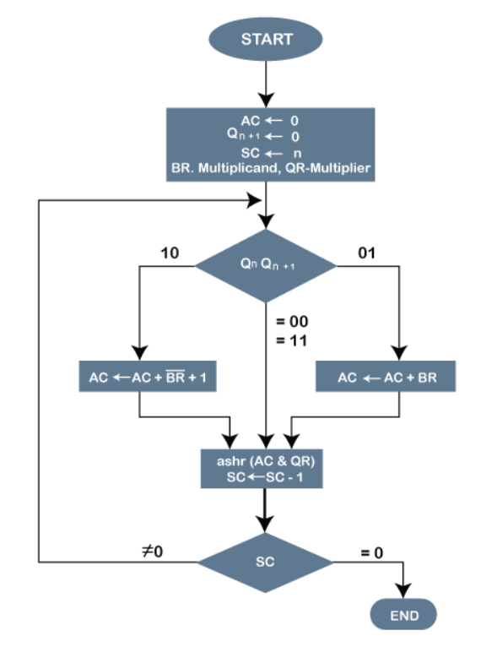

# Simulation Results:

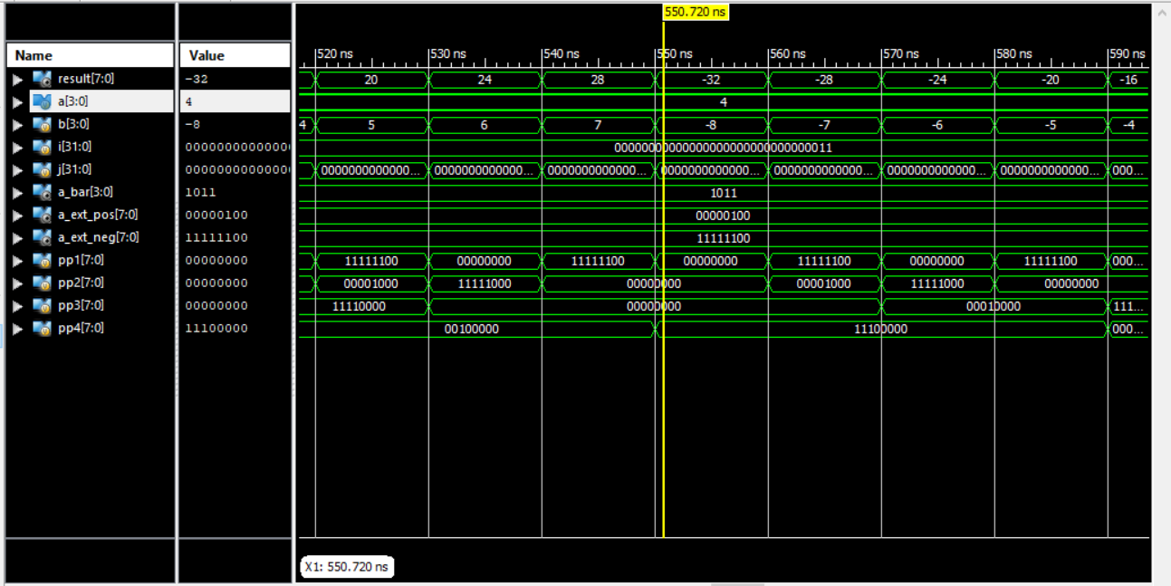

# Applications:

* Booth multiplier plays a major role in digital integrated circuits.
* Booth used **desk calculators** that were faster at shifting than adding and created the algorithm to increase their speed of arithmetic operations.
* One advantage of the Booth multiplier is, it **reduce the number of partial product**, thus make it extensively used in multiplier with long operands (>16 bits). The main disadvantage of Booth multiplier is the complexity of the circuit to generate a partial product bit in the Booth encoding.