**Identifying the best new hospitality sector establishment in Amsterdam**

**Introduction**

Although the outbreak of covid-19 has forced many establishments in the hospitality sector out of business, the recent arrival of vaccines has made the sector’s future look a lot more promising – if regulations go back to normal, there could be a rush among entrepreneurs to fill the gaps left behind by the restaurants and cafés that had to shut down due to the pandemic. This report aims to identify the ideal location for a new establishment in the city of Amsterdam, one of the most frequently visited cities in Europe, and to identify what type of establishment (Indian restaurant, beer bar, etc.) would likely be most successful.

**Data**

Because the city of Amsterdam is large and because most tourist activity occurs in the city centre, only that area has been analysed, and it is defined by the Amsterdam-Centrum borough (which can be found here: https://nl.wikipedia.org/wiki/Amsterdam-Centrum). It is subdivided into 9 neighbourhoods. Data about venues in each neighbourhood have been obtained via the Foursquare API. For each neighbourhood, the most popular venues have been retrieved, along with the venue categories they belong to.

**Methodology**

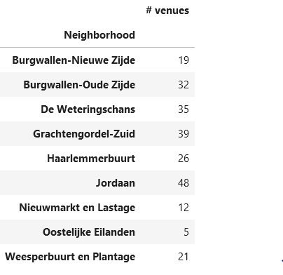Once the data set was obtained, it was filtered so that only venues in the hospitality sector were used in the analysis. Then, a list was made containing the number of venues in a particular category, for a particular neighbourhood. This was used to identify whether there were ‘gaps’ in a neighbourhoods' hospitality sector, i.e., whether a neighbourhood had a low number of venues in a particular category compared to other neighbourhoods.

The total number of venues in a neighbourhood will also play a role in the success of a new establishment, because the competition is obviously higher the more competing venues there are, as does the spread of the venues across the different categories. For example, a neighbourhood with many venues might not be appealing to an entrepreneur wishing to establish a restaurant in the area. But if the area has a comparatively low number of Asian restaurants, a Japanese restaurant might do well in that neighbourhood. Therefore, these numbers have also been extracted from the data set.

**Figure 1: total number of venues per neighbourhood**

**Results**

In figure 1, the total number of venues per neighbourhood is shown. In figure 2-4, show the total number of venues per venue category. In figure 5, the number of ‘recommend’ types of venues per neighbourhood is shown.

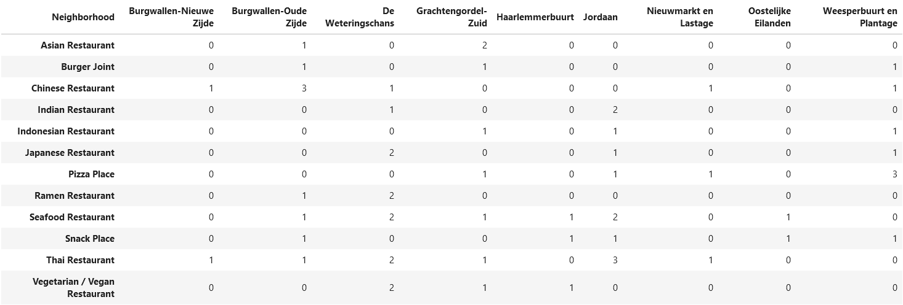**Discussion**

**Figure 3: number of recommend types of venues per neighbourhood**

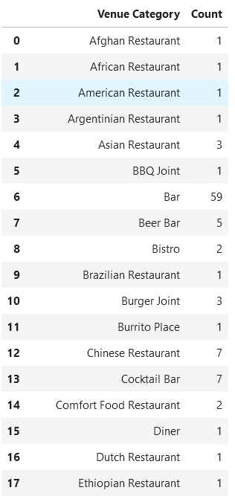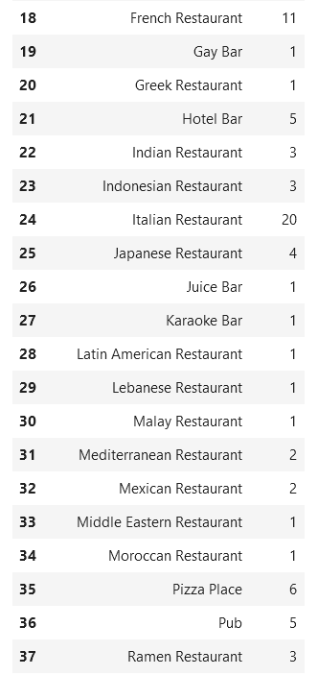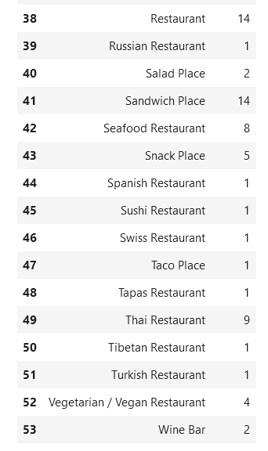

**Figure 2: total number of venues per category**

The most popular venues were, by far, bars, French and Italian restaurants and sandwich places. Due to the high competition, it is not recommended to set up these types of establishments. The numerous niche (meaning 1 or 2 establishments in total) restaurants and bars are also not recommended, as their customer base might already be satisfied by the venues that are already in place.

The recommended types of establishments are those that are neither too prevalent already, nor too niche. These categories are, as can be seen in Figure 2, mostly Asian restaurants. Among these types are also different types of bars, but these are not recommended because there are already numerous bars in the city centre. In Figure 3 the number of venues in the recommended categories in each neighbourhood is shown. There are very few venues of these types in Oostelijke Eilanden and Nieuwmarkt en Lastage. However, these neighbourhoods have low venue count in general, which indicates that there might not be a big enough market for restaurants in these neighbourhoods.

Of the remaining neighbourhoods, especially Burgwallen-Nieuwe Zijde and Haarlemmerbuurt seem promising. Burgwallen-Nieuwe Zijde does not have a high overall venue count, but in terms of the recommended types of establishments it is quite empty. Any of the recommended types, except perhaps those that are already present in the neighbourhood, are therefore likely to succeed.

Haarlemmerbuurt is in a similar position, but in this neighbourhood there are no Asian restaurants at all. This is advantageous, because, for example, a Japanese and a Chinese restaurant in the same neighbourhood might have some overlap in their customer base and will therefore have to compete for the customers in that overlap. Any Asian restaurant in the Haarlemmerbuurt neighbourhood would be the first and would therefore be able to claim the whole potential customer base for itself.

There is another option, which is less promising than the previous two but nonetheless has some potential. The Jordaan neighbourhood has a high venue count, which means there is a big potential customer base and thus the potential for high rewards, and it also has a gap: there is no vegetarian / vegan restaurant. There are other types of restaurants not present in the Jordaan, but these are all similar to other venue categories that *are* already present in the neighbourhood. The vegetarian / vegan restaurant has no such competing categories. This is an interesting option that could be explored further.

**Conclusions**

Using the Foursquare API, the most popular venues in the neighbourhoods of the centre of Amsterdam were obtained. These were then filtered to only contain venues in the hospitality sector and analysed to identify the gaps in each neighbourhood’s hospitality sector. Two main recommendations were made: to establish restaurants of the recommended types (see Discussion) in either Burgwallen-Nieuwe Zijde or Haarlemmerbuurt. A third, less promising option is the establishment of a vegetarian/vegan restaurant in the Jordaan neighbourhood.